Table of Contents

# Preface

# Rapid Reference

## Calling for Help

### BCH

!

### BMC

!

## PALS

### PALS Quick References

#### Vital Signs in Children

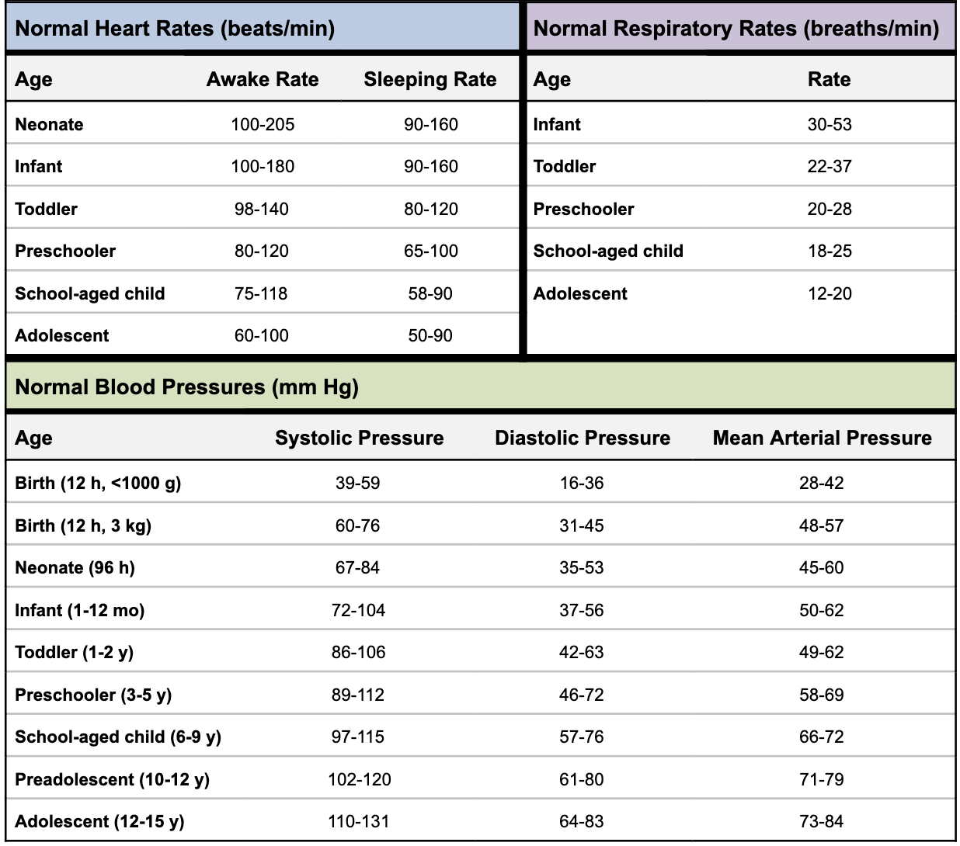

#### Pediatric Color-Coded Length-Based Resuscitation Tape

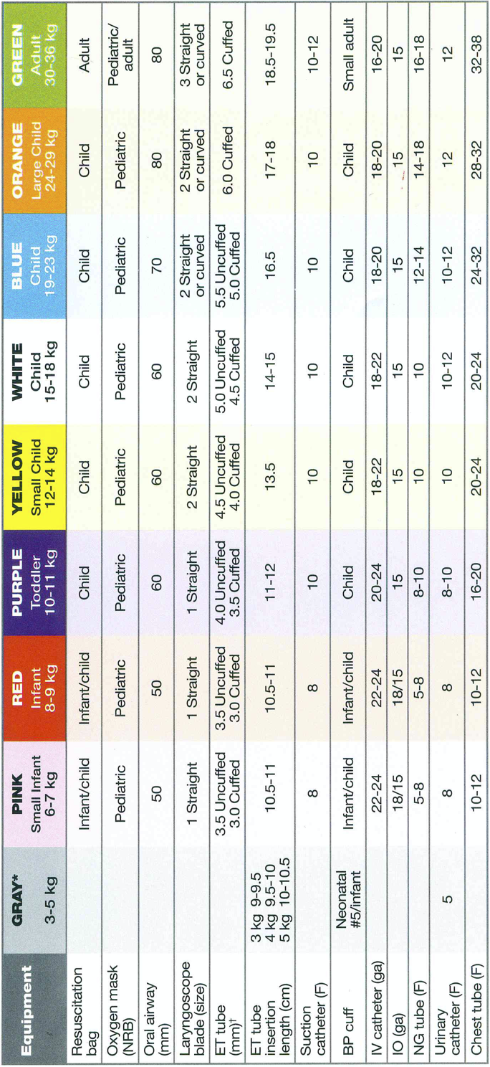

### PALS Algorithms

#### PALS Systematic Approach Algorithm

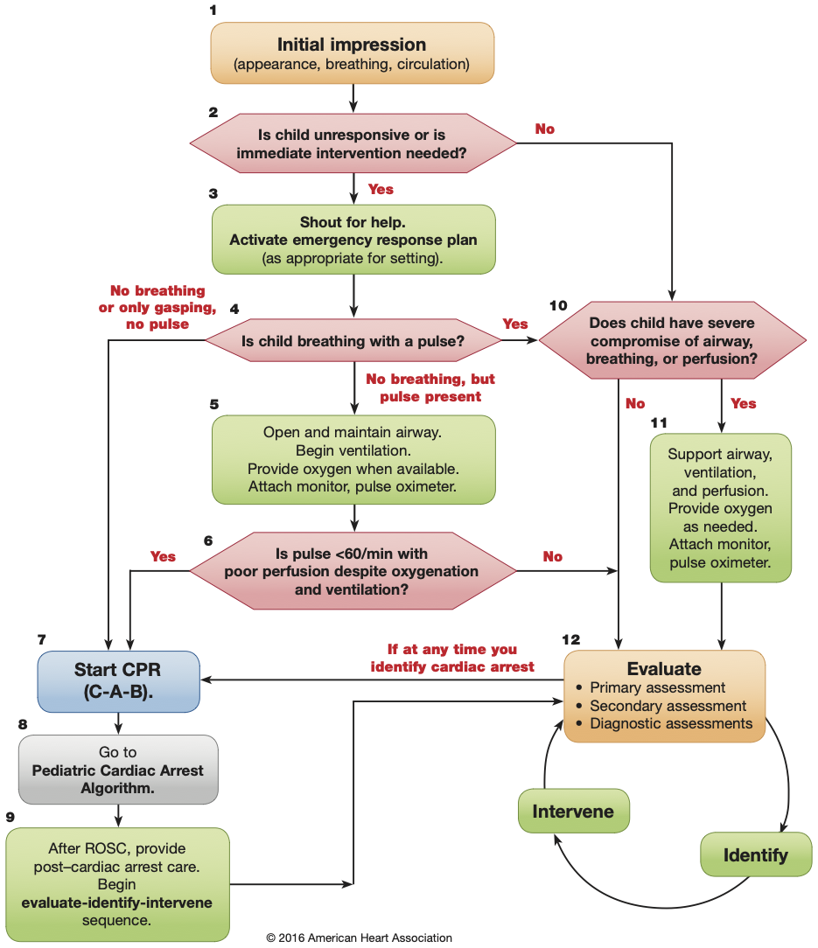

#### Bradycardia with a Pulse and Poor Perfusion Algorithm

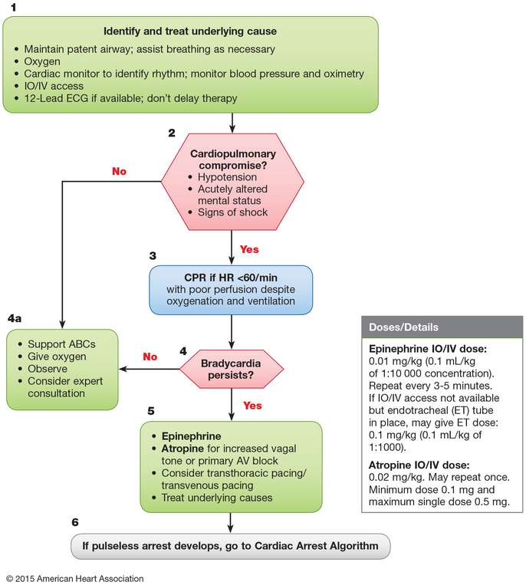

#### Tachycardia with a Pulse and Poor Perfusion Algorithm

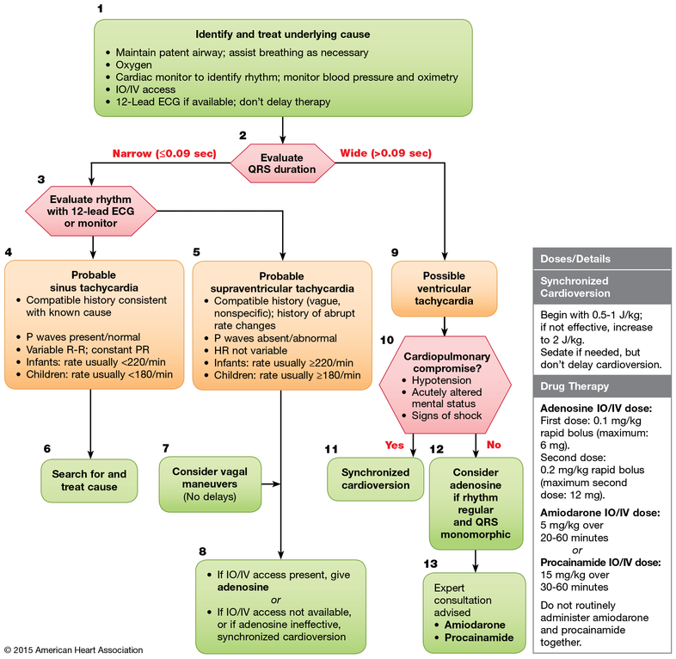

#### Cardiac Arrest

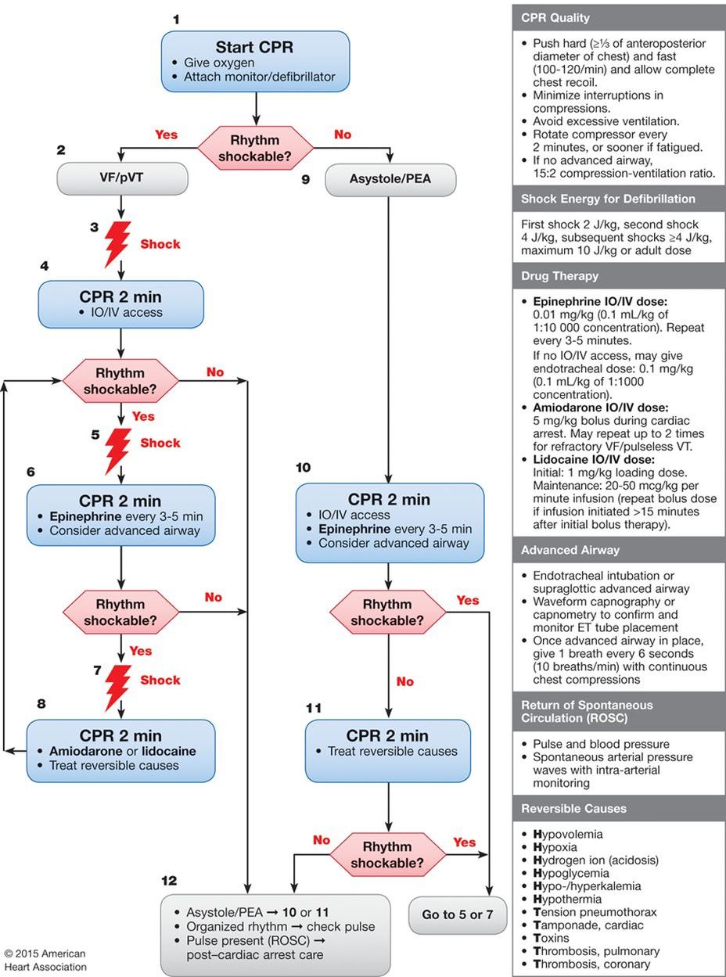 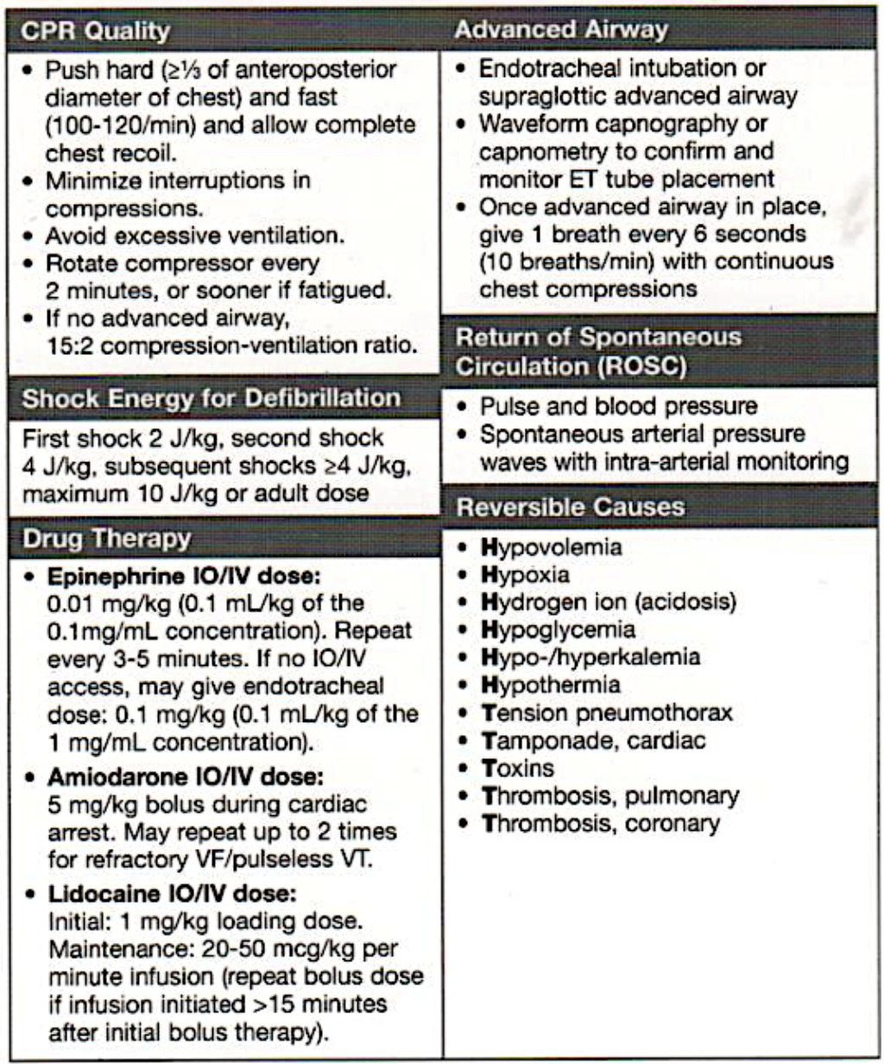

#### Management of Shock After ROSC Algorithm

!

#### Drugs Used in PALS

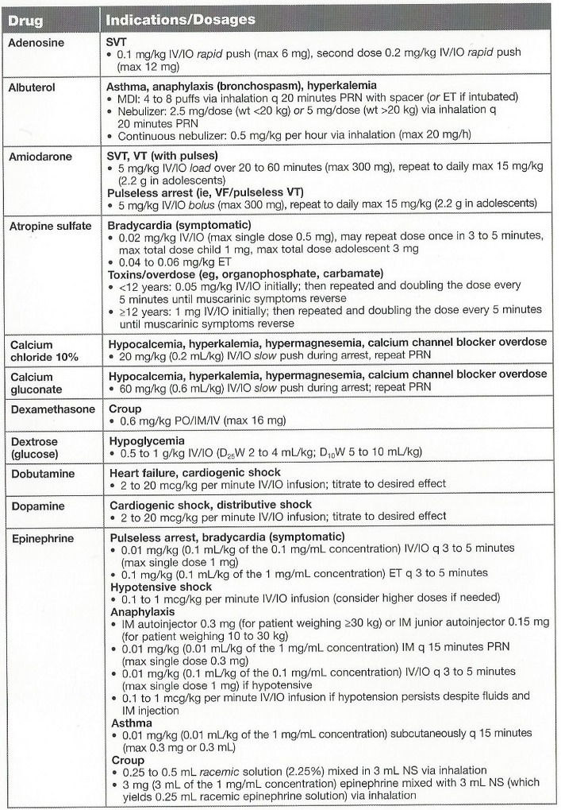 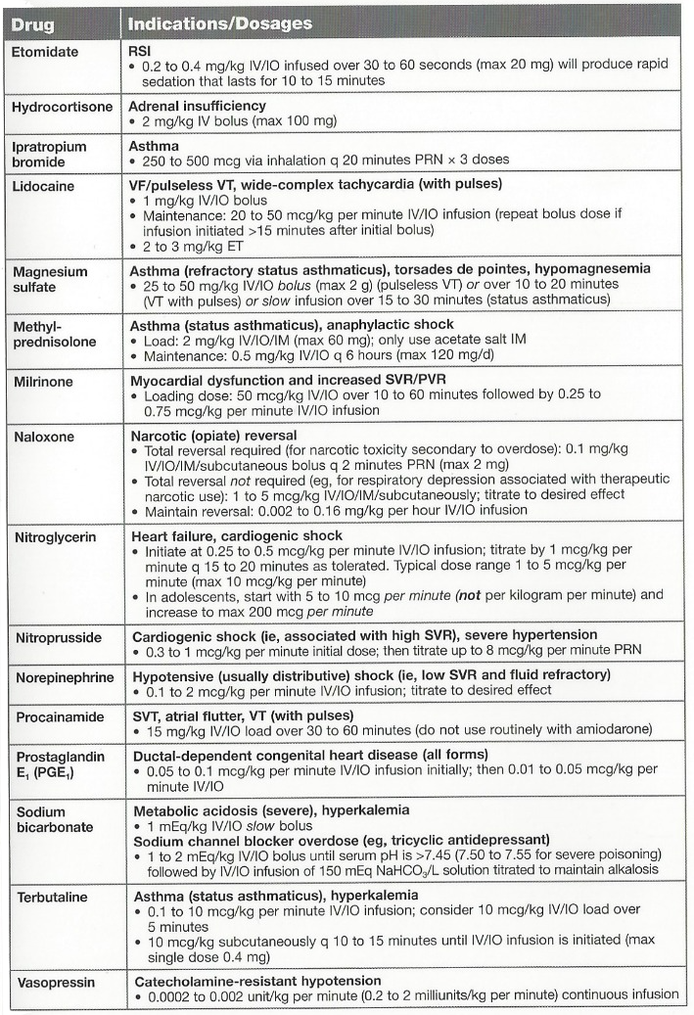

### Shock

#### Recognition of Shock

!

#### Management of Shock

* Oxygen
* Pulse oximetry
* ECG monitor
* IV/IO access
* BLS as indicated
* POCT glucose

##### Hypovolemic Shock

|  |  |
| --- | --- |
| Non-hemorrhagic | Hemorrhagic |
| - 20 mL/kg NS/LR bolus, repeat PRN<br- Consider colloid | - Control external bleeding- 20 mL/kg NS/LR bolus, repeat 2 or 3x PRN- Transfuse pRBCs PRN |

##### Distributive Shock

|  |  |  |
| --- | --- | --- |
| Septic | Anaphylactic | Neurogenic |
| Management Algorithm:- Septic Shock | - IM epinephrine (or autoinjector)- Fluid boluses (20mL/kg NS/LR)- Albuterol- Antihistamines, corticosteroids- Epinephrine infusion | - 20mL/kg NS/LR bolus, repeat PRN- Vasopressor |

##### Cardiogenic Shock

|  |  |
| --- | --- |
| Bradyarrhythmia/Tachyarrhythmia | Other(e.g. CHD, myocarditis, cardiomyopathy, poisoning) |
| Management Algorithm:- Bradycardia- Tachycardia w/ poor perfusion | - 5 to 10 mL/kg NS/LR bolus, repeat PRN- Vasoactive infusion- Consider expert consultation |

##### Obstructive Shock

|  |  |  |  |
| --- | --- | --- | --- |
| Ductal-Dependent(LV outflow obstruction) | Tension Pneumothorax | Cardiac Tamponade | Pulmonary Embolism |
| - Prostaglandin E1- Expert consultation | - Needle decompression- Tube thoracostomy | - Pericardiocentesis0 20 mL/kg NS/LR bolus | - 20 mL/kg NS/LR bolus, repeat PRN- Consider thrombolytics, anticoagulants- Expert consultation |

#### Hemodynamic Parameters in Shock

|  |  |  |  |  |  |  |
| --- | --- | --- | --- | --- | --- | --- |
| Type | Examples | Preload(CVP, PCWP) | Afterload(SVR) | CO(SV*HR) | Mixed Venous O2 (MVO2) | Management |
| **Distributive** | - Sepsis- Anaphylaxis- Severe neurologic injury (loss of α-1 activity) | ↓ | ↓ | ↑ then ↓ | ↑ | - **Sepsis:** Crystalloid (20 cc/kg NS, repeat PRN) + abx- **Anaphylaxis:** Epi + crystalloid- **Neurogenic:** Crystalloid + α-active pressors, (norepi @ 0.05-2 mcg/kg/min) |
| **Hypovolemic** | - Blood loss- GI or Renal losses- ↓ intake | ↑ | ↑ | ↑ | ↓ | - **Crystalloid replacement:** 20 cc/kg, repeat PRN- For blood loss: Consider pRBCs |
| **Cardiogenic** | - Myocarditis- MI- Dysrhythmia | ↑ | ↑ | ↑ | ↓ | Targeted at etiology: **Inotropes,** revascularization, **anti-arrhythmics,** cardiovert |
| **Obstructive** | - Tamponade- PE | ↑ | ↑ | ↑ | ↓ | **Fix obstruction** (pericardiocentesis, thrombectomy/lysis for PE) |

### Respiratory Emergencies

#### Medications to Avoid in Children w/ Neuromuscular Disease

Recall that the use of succinylcholine for intubation of children w/ neuromuscular diseases may trigger life-threatening conditions, such as hyperkalemia or malignant hyperthermia. Several commonly used drugs, such as aminoglycosides, have intrinsic neuromuscular blocking activity that can worsen respiratory muscle weakness.

#### Management of Respiratory Emergencies Flowchart

Summarizes general management of respiratory emergencies and specific management by etiology. Note that this chart does not include all respiratory emergencies; it provides key management strategies for a limited number of diseases.

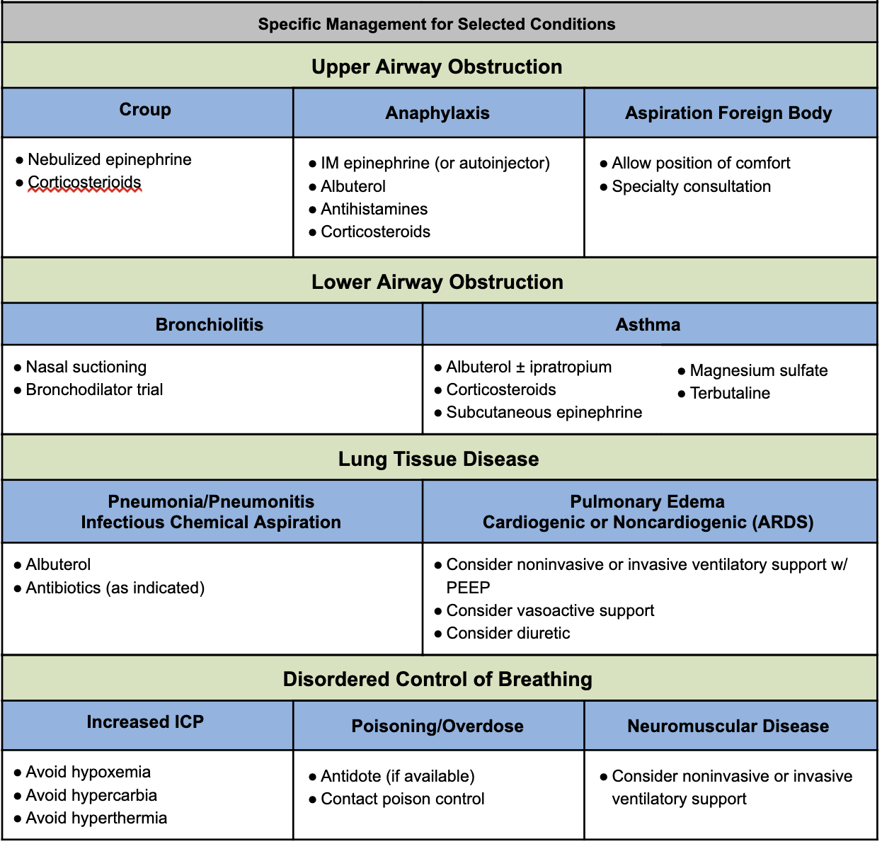

## Infectious Disease

### Sepsis Huddle

#### Huddle Steps (Resident Responsibilities)

1. **Review vital sign trend**
2. **Examine patient** (especially respiratory, mental status, perfusion)
3. **Discuss IV access**
4. **Review antibiotic plan:** New agent(s) needed, delivery priority, need for ID consult
5. **Consider fluid bolus**
6. Discuss plan for repeat assessment

***USE SEPSIS POWERPLAN TO ENSURE STAT IV ANTIBIOTICS AND FLUIDS!***

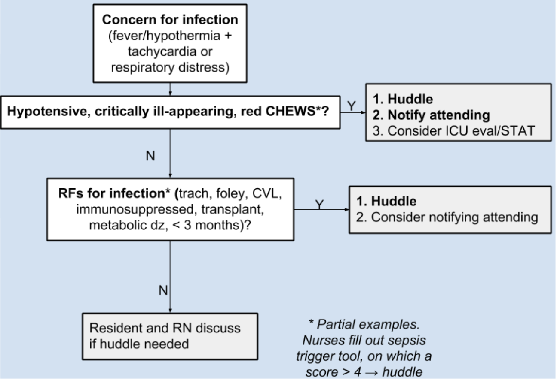

### CSF Analysis

#### Age-Based Ranges for CSF Studies

|  |  |  |  |
| --- | --- | --- | --- |
| Age | WBC (mm^3)Mean (Range) | Glucose (mg/dL)Mean (Range) | Protein (mg/dL)Mean (Range) |
| **Premature** | 9 | 50 (24-63) | 115 (65-150) |
| **Term newborn** | 8.2 (0-22) | 52 (34-119) | 90 (20-170) |
| **0-4 wks** | 11 (0-35) | 46 (36-61) | 84 (35-189) |
| **4-8 wks** | 7.1 (0-25) | 46 (29-62) | 59 (19-121) |
| **>8 wks** | 2.3 (0-5) | 61 (45-65) | 28 (20-45) |

#### Genenral Heuristics for CSF Interpretation

|  |  |  |  |  |  |
| --- | --- | --- | --- | --- | --- |
| Diagnosis | WBC | Glucose | Protein | Opening Pressure | Other |
| **Bacterial meningitis** | ↑, mostly PMNs | ↓ (<60% serum glucose) | ↑↑ | ↑ | +CSF Cx / gram stain, often +BCx |
| **Viral meningitis** | Slightly ↑, mostly lymphocytes | Normal | Normal to slightly ↑ | Normal | HSV may have RBCs in CSF |
| **TB meningitis** | ↑ (PMNs → lymphocytes) | ↓ (<60% serum glucose) | ↑ | Variable | +AFB |
| **Fungal meningitis** | ↑, lymphocytes | ↓ (<60% serum glucose) | ↑ | Variable | Fungal Cx |
| **GBS** | NNormal | Normal | ↑↑ | Normal | So-called “albumino-cytologic dissociation” |
| **SAH** | Normal (accounting for peripheral ratio of RBC to WBC) | Normal | ↑ | Normal to ↑ | Xanthochromia = yellow appearance of CSF, suggests long-term presence of RBCs (to distinguish from traumatic tap) |

## Respiratory

### Status Asthmaticus

#### A-B-C

**Epinephrine** 0.01 mg/kg IM PRN extremis

#### Initial treatment

* **PowerPlans & Order Sets:** ED Asthma Status Plan
* **“Unineb”** = Albuterol + ipratropium combination nebs
  + *NOTE:* 1x Unineb = 3x Combineb
* **Steroids** (if no improvement after first neb or if patient on home steroids)
  + Dexamethasone = dosed q24-48h, 0.6 mg/kg
  + Prednisone/Prednisolone = dosed q12h, 2mg/kg
  + Methylprednisolone 2mg/kg

#### If poor response, add

* **Magnesium sulfate** 40mg/kg (2mg max)
  + Monitor for hypotension, consider NS bolus
* **Continuous nebulized albuterol**
  + Titrate to HR

#### If poor response continues, add

* **Terbutaline:** Loading dose 5-10 mCg/kg IV/SC over 10m. Infusion 0.4 mCg/kg/min IV.
  + EKG, troponin, CK q12h
* Consider **Heliox** 70:30 helium:oxygen mixture

#### If impending respiratory failure

* **Rapid sequence intubation**
* **Mechanical ventilation:** Minimize PEEP, maximize E time. Permissive hypercapnia. Anticipate air leak, pneumothorax, bronchospasm, PEA.

#### As patient improves

“Last on, first off” to peel off therapy

### ABGs & VBGs

* Presented as: **pH / pCO2 / pO2 / HCO3**
* **Venous pH + 0.035 = Arterial pH**
* Look at past VBGs for baseline pCO2 (e.g. chronically elevated in ex-preemies w/ CLD)
* VBGs sufficient to assess acid-base status & clinical response to treatments (in general). **ABG preferred over VBG:**
  + to accurately determine **PaCO2 in severe shock**
  + to accurately determine PaCO2 if hypercapnic (i.e. PaCO2 >45 mmHg)

#### Stepwise Approach to ABG/VBG Interpretation

1. **Compare pH** to normal range
2. Identify the **primary process** that led to the change in pH (using PCO2/HCO3)
3. Calculate the **serum anion gap (SAG)**
   * **SAG = Na+ - (Cl- + HCO3-).** If **>12,** there is a primary AG metabolic acidosis
4. Identify the **compensatory process** (if one is present)
5. Identify if any other disorders are present or there is a **mixed acid-base process using delta/delta = (AG - 12) / (24 - Bicarb)**
   * < 0.4 → pure Non-AG Metabolic Acidosis (NAGMA)
   * 0.4 - 0.8 → mixed NAGMA + High-AG Metabolic Acidosis (HAGMA)
   * 0.8 - 2.0 → a pure HAGMA
   * 2.0 → mixed HAGMA + metabolic alkalosis

#### Normal Blood Gas Values

|  |  |  |
| --- | --- | --- |
|  | Arterial | Venous |
| **pH** | 7.35 - 7.45 | 7.31 - 7.41 |
| **pCO2** (mmHg) | 35 - 45 | 40 - 50 |
| **pO2** (mmHg) | 75 - 100 | 36 - 42 |
| **HCO3** (meQ/L) | 22 - 26 | Same |
| **BE** | -2 to +2 | Same |
| **O2 Saturation** | >95% | 60-80% |

#### Compensation

|  |  |  |
| --- | --- | --- |
| Disorder | Defect | Compensatory Response** |
| **Respiratory Acidosis** | ↑ pCO2 | **↑ HCO3**- *Acute* = **+1** MeQ/L HCO3 for +10 mm Hg PaCO2- *Chronic* = **+4** MeQ/L HCO3- for +10 mm Hg PaCO2 |
| **Respiratory Alkalosis** | ↓ pCO2 | **↓ HCO3**- *Acute* = **-2** MeQ/L HCO3 for -10 mm Hg PaCO2- *Chronic* = **-5** MeQ/L HCO3- for -10 mm Hg PaCO2 |
| **Metabolic Acidosis** | ↓ HCO3 | **↓ pCO2**- pCO2 = 1.5 x HCO3 + 8 +/- 2 (**Winter’s Formula**) |
| **Metabolic Alkalosis** | ↑ HCO3 | **↑ pCO2**- pCO2 **+ 0.6** for + 1.0 mEq/L HCO3 |

** HCO3 = kidneys (**days**). CO2 = lungs (**minutes**). *** **Limits of compensation:** HCO3 = 15-38. CO2 = 10.

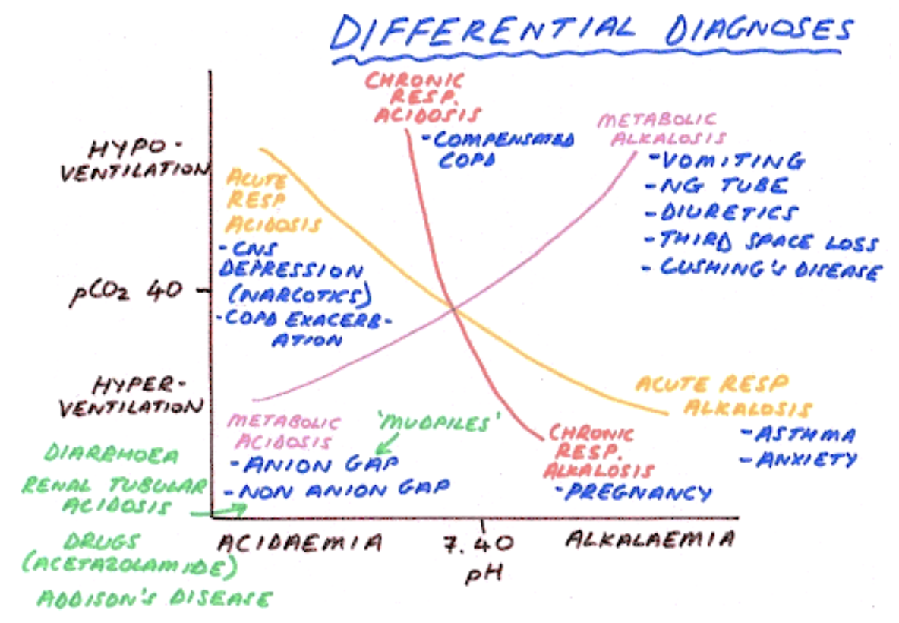

### Respiratory Support for Spontaneously Breathing Patients

|  |  |  |  |  |  |  |
| --- | --- | --- | --- | --- | --- | --- |
| Type | O2 Delivery | CO2 Exit | FiO2 | Rate | Pros | Cons |
| **“Blow By” Oxygen (BBO2)** | O2 tubing or simple mask held by a child’s face | Mouth | **<30%** (limited evidence) | At least 10L/min through a reservoir (such as mask) | Can be used in children who can’t tolerate other methods | Limited and variable O2 delivery |
| **Low Flow Nasal Cannula (LFNC)** | Through nasal prongs attached to tubing | Mouth | **25-40%** (100% O2 delivers variable FiO2 based on placement of nares, patient’s inspiratory effort and minute ventilation) | **1-4L/min** (Rates >2L/min can create Positive airway pressure in newborns/infants) | Mobile, infants can feed w/ low-flow in place, may be better tolerated than a mask | - Cannot reliably deliver high concentrations of FiO2- Prongs can be difficult to keep in position |
| **High Flow Nasal Cannula (HFNC)** |  |  |  | Up to **8L/min** in infants, up to **60L/min** in children/adults |  |  |
| **Simple Mask** | O2 enters mask through a tube | Holes in the side of the mask | **35-50%** (Room air can enter through exit holes, mixing w/ delivered O2) | **6-10L/min** | Can deliver higher concentrations of FiO2 than NC | Cannot reliably deliver precise concentrations of O2 because of mixing w/ room air |
| **Partial Rebreather** | O2 enters the mask through a tube as well as from an **attached reservoir** | Holes in the sides of the mask. Room air can still enter, but not as much as w/ the simple mask. | 50-60% O2 | 10-12L/min |  |  |
| **Non-Rebreather Mask** | O2 enters the mask through a tube as well as from an **attached reservoir w/ a one-way valve** | Two exhalation ports; one is fitted w/ a one-way valve and one allows mixing (fail-safe so that if the O2 delivery port blocked, patient doesn’t suffocate) | Up to **95% O2** | **10-15L/min** | Max FiO2 administered to a spontaneously breathing patient | Stored in the code cart at BCH |
| **CPAP/BiPAP** | *See Critical Care/ICP chapter* |  |  |  |  |  |

### Trach Troubleshooting

#### Tracheostomy Basics

* **Major types:** Shiley or Bivona (more flexible, better for active children)
* **Sizes:** A “3.0” trach has an inner diameter of 3.0 mm, sizes vary by age
* **Cuffed vs. uncuffed:** C**uffs improve air seal and prevent aspiration,** but uncuffed allows spontaneous breathing, improved vocalization, may be appropriate for infants and small children
* **Outer vs. inner cannula:** Outer cannula holds stoma open, inner cannula can be removed for cleaning
* **Fenestration:** Improves vocalization
* **Trach ties:** The part that wraps around the neck to keep trach in place

#### Trach Complications

* **Plan ahead!**
  + Differentiate new (< 7 days) vs. mature stoma (> 7 days)
  + Know if your patient can be ventilated “from above” in event of trach malfunction
  + Know your patient’s trach brand, size, features and have replacement trach at bedside, including one size smaller
* **Decannulation:**
  + Staff assist, call RT urgently
  + If new stoma, do **NOT** blindly replace trach, call ORL instead
* **Obstruction:**
  + **Mucous plugging** → suction, replace inner cannula, etc.
  + **Back-walling** = Distal end of trach obstructs against posterior tracheal wall → call RT, reposition trach, may need longer trach
  + **Tracheal stenosis or granulation tissue** → call ORL, may need to be addressed surgically
  + Consider deflating cuff and ventilating “from above” if possible
* **Bleeding:**
  + Although rare, have high index of suspicion for tracheo-arterial fistula, call ORL
  + Differentiate blood from trach vs. from stoma/trach site

## Status Epilepticus (SE)

### PowerPlans & Order Sets

Neuro Seizure Admit Plan

### Definition

* **Neurologic emergency!**
* Seizure lasting > 30 min or 2 sequential seizures w/o return to baseline
* **Refractory SE** is > 60 min

### Presentation

Generalized SE, focal SE, hemi-convulsive status w/ hemiparesis

### Differential

Sepsis, hypoglycemia, meningitis/encephalitis, skull fracture/trauma, HTN, mass, herniation

### Management

1. **Step 1** (0-5 min):
   * **Monitors, O2, IV access, STAT labs** (glucose, CBC, chem10, LFTs, UA/blood/urine cultures if febrile, urine tox screen, AED levels if relevant)
   * **Lorazepam IV** (0.1 mg/kg/dose. Max 4mg.)
   * If no access: **Diazepam PR** (0.5 mg/kg if <5yo; 0.3 mg/kg if 6-11yo; 0.2 mg/kg if >11yo)
     + *NOTE:* Rapid redistribution → increased risk of seizure recurrence
2. **Step 2** (10-15 min):
   * **REPEAT Lorazepam IV** (0.1 mg/kg/dose. Max 4mg.)
   * *+* **Fosphenytoin IV** (20mg/kg infused over 7 min)
     + *NOTE:* Will decrease BP
   * *or* **Keppra IV** (60 mg/kg IV. Max dose 4500 mg.)
3. **Step 3** (20-30 min):
   * Consult Neurology. Consider LP, EKG.
   * **Phenobarbital IV** (20mg/kg infused over 15-20 min)
     + *NOTE:* Will decrease RR, be prepared to intubate/bag

## Psychiatric

### Anxiety, Agitation & Delirium

#### Definition

Anxiety, agitation, and delirium can often present together and can be difficult to differentiate in the seriously ill child. Management is often similar.

#### Anxiety

Common among children with chronic or life-threatening illnesses. Difficult to separate from physical symptoms; **may exacerbate physical symptoms (pain, dyspnea, etc).**

#### Agitation

Unpleasant state of arousal → loud speech, crying, ↑ motor activity/autonomic arousal

#### Delirium

An acute-onset **disturbance of consciousness that fluctuates throughout the day**

#### Management

* **Non-pharmacologic:** Treat underlying cause, meditation, diaphragmatic breathing, massage, biofeedback therapy, **regulate sleep/wake cycle,** frequent **reorientation to time and place,** frequent reassurance, **minimize use of restraints**
* Pharmacologic
  + Ask Psych team when to use PO vs. IV/IM
  + Onset of action:
    - **PO/enteral:** Usually 30-60 min for beginning of peak effects
    - **IM:** Usually 15-30 min
    - **IV:** Usually 5-15 min

|  |  |  |
| --- | --- | --- |
| Drug | Dose | Notes |
| **Diphenhydramine** (Benadryl) | 1 mg/kg per dose PO/IM/IV- *Limits per 24h*: **_<_7yo:** 50-75mg; **8-12yo:** 75-100mg; **Adolescents:** 100-150mg | - Anticholinergic- Avoid if dehydrated, CF, asthma, previous paradoxical rxn |
| **Lorazepam** (Ativan) | **0.02-0.05 mg/kg q6h PO/SL/IV/SC** |  |
| (**8-12yo:** ~0.5mg. **13yo+:** 1mg.)- *Limits per 24h*: **8-12yo:** 2mg; **Adolescents:** 3mg | - Avoid in delirium- Avoid in pts <7yo |  |
| **Clonidine** | - **_<_7yo:** 0.025-0.05mg first dose- ***8-12yo*:** 0.05mg first dose ***13yo+*:** 0.1mg first dose | Useful w/ hx of ADHD, PTSD, younger children |
| **Clonazepam** | **0.005-0.01 mg/kg PO q8-12h**- Can increase every 3 days up to 0.05-0.1 mg/kg PO q8-12h (max 0.2 mg/kg/day) | Avoid in delirium |
| **Haloperidol** (Haldol) | **0.01-0.02 mg/kg PO q8h** (max 0.5-1 mg)- **Acute agitation:** 0.025 mg/kg PO & can repeat 0.025 mg/kg in 1 hr as needed | IM form for acute agitation, **delirium,** psychosis/mania |
| **Risperidone** | **0.25-0.5 mg PO qPM or divided** (max 3 mg/day) | Order only w/ Psych input |
| **Quetiapine** (Seroquel) | **25 mg q12h PO,** can increase daily by 25mg/dose, to max 100-200 mg q12h) | Order only w/ Psych input |
| **Olanzapine** (Zyprexa) | **1.2-2.5 mg PO daily** (max 5 mg/day) | Order only w/ Psych input |

### Overnight Behavioral Plan

* **PowerPlans & Order Sets:** Agitation (mild), agitation (moderate), agitation (severe), behavioral health safety plan, behavioral restraints
* **Err on the side of more restrictive:** When in doubt, put on a 1:1, order suicide precautions including finger foods, “arms length” if any significant concern for active attempts to hurt self, security at door for elopement risk, security in room if needs hands-on (care companion cannot put arms on/only observe and alert RN and team of concerns)
* **Behavioral Rapid Response (BRR), Call 5-5555:** For active unsafe behaviors. Summons BRT psych RN, on-call psychiatrist (if in-house), ER psych SW (if in-house).
* Never allow patient to get between you and the exit. Always ask for escort (including BRT clinician or PCS clinician). Put lanyards, long-hair, loose clothing away as able, etc.
* **PGY-2s and above are the only people allowed to order physical or chemical IM restraints** (must be 1-time orders, cannot write PRN IM psychotropic meds or PRN physical restraints)

# Adolescent Medicine

## BCH Wards Tips

#### Primary diagnoses

* Eating disorders
* Anovulatory uterine bleeding
* Some primary care patients admitted for Gen Peds issues

#### Format

* Table rounds. Intern fills out and presents Eating Disorder worksheet (will be reviewed on the first day)
* Do NOT write notes daily, but expected to examine patients daily, present thoughtful plans, and write an event note should something significant happen in a given 24hr period

## Adolescent Clinic Tips

### Overview

* Goal skills
  + Taking an effective social history
  + Addressing confidentiality
  + Discussing topics such as sex, contraception, substance use, and weight
  + Performing respectful genital exams
  + Strength-based approaches to management
* Format
  + Scheduled w/ same preceptor multiple times at BCH and BMC
  + Try to schedule patients for return visits w/ you for continuity

### BCH Adolescent Clinic Specifics

* Population
  + 11-25 yo
  + Primarily from the Greater Boston Area and surrounding suburbs
  + Primary and Subspecialty care for patients with eating disorders, reproductive endocrine concerns, and chronic fatigue
  + Primary languages spoken: English and Spanish
* Resources available:
  + Mental health
  + Psychopharm support
  + Nutrition
  + Resource specialist for social needs
  + On-site sexual health counselling and STD testing (including HIV)

### BMC Adolescent Clinic Specifics

* Population
  + 12-22 yo
  + Primarily from Dorchester, Roxbury, Hyde Park, South Boston, and the South End
  + Primary care, first point of medical contact for adolescents new to the United States, and subspecialty care for teen parents, adolescents with substance use disorders, gender diversity, individuals s/p sexual assault, and menstrual disorders
  + Primary languages spoken: English, Haitian Creole, Spanish, and Cape Verdean Creole
* Subspecialty programs & Resources available
  + CATALYST (for adolescents and young adults w/ substance use)
  + Teen and Tot programs (to serve young parents and their children)
  + CATCH (providing gender affirming care to youth of all ages)
  + Sexual assault follow-up clinic
  + Menstrual Disorders Clinic
  + Integrated behavioral health social workers, patient navigators, and a family planner

## HEEADSSS Assessment[1]

Parents, family members, or other involved adults should **NOT** be present during the HEEADSSS interview. Addressing this and the need for confidentiality at the beginning of the visit is important. Before asking adults to leave the room, always ask whether they have any concerns to express or questions to ask and assure them of further interaction once the confidential interview is over. Sometimes having a confidential moment with the adult can also be very informative to the patient’s care.

Consider starting your HEEADSSS assessment by asking about the patient’s **strengths**. A simple question such as “What are your greatest strengths” can go a long way in rapport building and eliciting motivations to engage in healthy behavior change.

**Bold** (green) = essential questions *Italics* (blue) = as time permits Plain text (red) = optional or when the situation requires

### Home

* **Where do you live? Who lives w/ you?**
* **What are your relationships like at home? Who can you talk to at home?**
* *Is there anyone new at home? Has someone left recently?*
* *Have you moved recently?*
* *Have you ever had to live away from home? (Why?)*
* *Have you ever run away? (Why?)*

### Education and/or Employment

* **Do you go to school? Do you work? Or both?**
* **What are your favorite subjects at school? Your least favorite subjects?**
* **How are your grades? Any recent changes? Any dramatic changes in the past?**
* **What are your future education/employment plans/goals?**
* **Are you working? Where? How many hours per week?**
* **Tell me about your friends at school.**
* **Have you ever had to repeat a class? Have you ever had to repeat a grade?**
* *Have you changed schools in the past few years?*
* *Have you ever been suspended? Expelled? Have you ever considered dropping out?*
* *How well do you get along w/ the people at school? Work?*
* Do you feel connected to your school? Do you feel as if you belong?
* Are there adults at school you feel you could talk to about something important? (Who?)

### Eating

* **Do you have any concerns about your body shape, weight, or size?**
* **Have you ever done anything to try to change your weight or body shape such as dieting, vomiting or taking diet pills/laxatives/supplements?**
* **Have there been any recent changes in your weight?**
* **How many meals/snacks do you eat each day?**
* **What do you think would be a healthy diet? How does that compare to your current eating patterns?**
* *Do you eat in front of the TV? Computer?*
* *Does it ever seem as though your eating is out of control?*

### Activities

* **What do you and your friends do for fun? (w/ whom, where, and when?)**
* **What do you and your family do for fun? (w/ whom, where, and when?)**
* **Do you participate in any sports or other physical activities that are heart healthy?**
* *How much time do you spend looking at a screen each day (other than doing your homework)?*

### Drugs

* **In the past year, how often have you smoked tobacco or MJ, vaped, or had alcohol?**
  + If any use disclosed, **ask about other substances and do CRAFFT screen**
  + If no use disclosed, **ask the following questions:**
    - **Do any of your friends drink, smoke, vape, or use drugs? Have you ever ridden in a CAR driven by someone (including yourself) who was “high” or had been using alcohol or drugs?**
* *Is there any history of alcohol or drug problems in your family? Does anyone smoke at home?*
* *Do you ever drink or use drugs when you’re alone?*
* *(Assess frequency, intensity, patterns of use or abuse, and how youth obtains or pays for drugs, alcohol, or tobacco)*

### Sexuality

* **Do you see yourself as a boy, a girl, something different, or you’re not sure?**
* **Are you attracted to other people? If so: boys, girls, both?**
* **Have you ever had sex with anyone? If so, what kinds of sex? How many people have you had sex with?**
* **Unfortunately some young people are forced to have sex. Has anyone ever forced you to have sex?**
* **What are you doing to prevent pregnancy?**
* **What are you doing to protect yourself from STDs and HIV?**
* **Have you or your partners ever had an STD?**
* *How many sexual partners have you had altogether?*
* *Females: Have you ever been pregnant or worried that you may be pregnant? Males: Have you ever gotten someone pregnant or worried that that might have happened?*
* *What percentage of the time do you use condoms during intercourse?*
* *Does anything ever get in the way of always using a condom?*
* *When you and your partner get into fights, what sort of things happen?*

### Suicide & Depression/Mood

* **PHQ2: Over the past two weeks have you felt down, depressed, or hopeless? Over the past two weeks have you had little interest or pleasure in doing things?**
* **Have you thought about hurting or killing yourself or someone else?**
* IF ANY OF THE ABOVE ARE POSITIVE, **perform full PHQ9**
* *Do you have problems with anxiety?*
* *Some young people have had bad things happen to them, and then they have nightmares, flashbacks or feel on-edge/ hyper-alert. Do you have these symptoms?*

### Safety

* **Do you feel safe at home? At school? In your community? With your friends? In your relationships?**
* **Have you ever been bullied? Have you ever bullied someone else?**
* **Have you ever been seriously injured? (How?) How about anyone else you know?**
* **What percent of the time do you wear a seatbelt in the car?**
* **Do you use safety equipment for sports and or other physical activities (for example, helmets for biking or skateboarding)?**
* **Has anyone ever forced you to have sex with them, or hit, punched, kicked, slapped, or physically or sexually hurt you in any other way?**
* **Is there a gun in your home/ do you have access to a gun?**
* *Have you ever been in a car or motorcycle accident? If so, what happened?*
* *Have you gotten into physical fights in school or your neighborhood? Are you still getting into fights?*
* *Have you ever felt that you had to carry a knife, gun, or other weapon to protect yourself? Do you still feel that way?*

## Adolescent Screening Tools

|  |  |  |
| --- | --- | --- |
|  | Screeners | When to use |
| Depression | [PHQ-2](https://www.hiv.uw.edu/page/mental-health-screening/phq-2), [PHQ-A](https://www.aacap.org/App_Themes/AACAP/docs/member_resources/toolbox_for_clinical_practice_and_outcomes/symptoms/GLAD-PC_PHQ-9.pdf) = PHQ-9 modified for adolescents, [PSC-17](https://depts.washington.edu/hcsats/FCAP/resources/PSC-17%20English.pdf) (up to age 15) | - Routine Child Health Maintenance visits - Visits for mood follow-up - When you’re concerned about depression and/or suicidality in your patient |
| Anxiety | [PSC-17](https://www.aacap.org/App_Themes/AACAP/docs/member_resources/toolbox_for_clinical_practice_and_outcomes/symptoms/GLAD-PC_PHQ-9.pdf) (up to age 15), [GAD-7](https://www.integration.samhsa.gov/clinical-practice/gad708.19.08cartwright.pdf), [SCARED](https://www.pediatricbipolar.pitt.edu/sites/default/files/SCAREDChildVersion_1.19.18.pdf) | - Routine Child Health Maintenance visits - Visits for mood follow-up - When you’re concerned that anxiety is a problem for your patient |
| Substance Use | [S2BI](https://www.drugabuse.gov/ast/s2bi/#/), [CRAFFT](https://www.integration.samhsa.gov/clinical-practice/sbirt/CRAFFT_Screening_interview.pdf), [BSTAD](https://www.drugabuse.gov/ast/bstad/#/) | - Routine Child Health Maintenance visits - F/u after visits in the ED for acute intoxication - When you’re concerned that substance use is a problem for your patient |

## Contraception[2]

### Emergency Contraception (EC)

|  |  |  |
| --- | --- | --- |
|  | Notes | Access |
| Ella (ulipristal acetate) | - **Most effective EC pill** to prevent pregnancy **up to 5 days after** unprotected sex - Do NOT give if starting any form of hormonal contraception (ulipristal binds the progesterone receptors and blocks the hormone’s effects) | - **Rx ONLY** - Safe to call in a prescription w/o pregnancy test or seeing patient |
| Plan B One-Step (levonorgestrel 1.5mg) | - Works to prevent pregnancy for the **first 3 days after** unprotected sex - Works less well in patients who are overweight or obese - Discuss with your preceptor if you should recommend a double dose for your overweight patients | - Sold (at cost $$, w/o Rx) to anyone of any age at most pharmacies, though access is still difficult for adolescents. **Much cheaper w/ Rx.** - Safe to call in a prescription w/o pregnancy test or seeing patient |
| Copper IUD (Paragard) | - **Most effective form of EC** (>99%), effective **up to 7 days after** unprotected sex - Can provide up to 12 years of highly effective contraception after placement | Must be placed in a clinic setting by a trained provider |

**For more information** on emergency contraception (EC), please see the following resources: [Bedsider](https://www.bedsider.org/methods/emergency_contraception), [reproductiveaccess.org](https://www.reproductiveaccess.org/wp-content/uploads/2014/12/emergency-contraception.pdf), [Mass.gov EC site](https://www.mass.gov/info-details/emergency-contraception-get-the-facts)

### Shared Decision Making (SDM)

* Collaborative process, allows patients and their providers to make healthcare decisions together, taking into account the best scientific evidence available, as well as the patient’s values and preferences
* Provider role: knowledge of the medical information
* Patient role: expert regarding their own values and preferences

### Applying SDM Principles to Contraceptive Counseling Visits

#### Establish rapport

* “What brings you in today? What’s happening with your birth control?”
* “Why did you decide to choose ____?”
* Ask interactive open-ended questions. The HEEADSSS assessment is a great way to establish rapport for new patients.

#### Assess patient readiness

* “What are important features that your birth control should have?”
* “What did you like/dislike about the birth control methods you used in the past?”
* “Different types of birth control affect your period differently. Some make your period a bit heavier, lighter, sporadic, or may take your period away. Which do you think will be best for you?”

#### Tailor information and discussion to patient preferences/needs

* Your patient says they want a method where they will still have a regular period. Counsel them on the contraceptive ring, patch, pill, and copper IUD and NOT on the shot, implant, or LNG IUDs.
* Your patient says they want a method that is easy to keep private. Counsel them on the contraceptive implant, shot, IUD, and ring and NOT on the pill or patch.
* Your patient has heavy periods and doesn’t want them to be any heavier. Provide information on any method other than the copper IUD.
* Your patient says they absolutely want to have a period every month. Provide more information on the LNG 15 and 19.5mg IUDs, and Copper IUD, and NOT the LNG 52mg IUD (Mirena).
* Use patient’s identified preferences for discussing particular methods. Being knowledgeable of contraceptive mechanisms of action, side effects, and delivery routes is important to provide this tailored information.

#### Discuss contraception side effects

* “Patients who begin the birth control pill may have breast tenderness or a mild headache during the first month. These usually go away.”
* “With the LNG 52mg IUD, you may have spotting for about 4 months after placement, then your period will become lighter. After a year with the IUD, some patients stop getting their period.”
* Many patients feel they do not receive adequate information about side effects, and that providers often overlook possible side effects in counseling discussions. It is important to discuss the specific side effects that patients should expect with the contraception type that is aligned with their preferences.

#### Identify misconceptions about specific contraception methods

* “I’m sorry that your friend had a bad experience with the vaginal contraceptive ring and weight gain. This isn’t typical with most ring users. I support you in using this method because it aligns with your preferences. If you experience weight gain, you can absolutely choose a different option.”
* “I hear your concern that your friend had worsening acne with her IUD. We usually don’t see this in the majority of patients, so it’s not likely that it will happen to you.”
* Respectfully addressing myths or misconceptions about IUD types helps to keep conversations open, while providing patients with accurate information.

#### Ensure access to method discontinuation at any time

* “If you decide you don’t like this birth control, you can switch to something else at any time.”
* “If you decide that you want to stop your birth control, I’m always here to talk about it and to support you.”
* “If for whatever reason you decide that you don’t want the IUD anymore, I will remove it.”
* Patients should be informed at the time of insertion that they can have their IUD removed at any time, and for any reason.
* IUD removal should be provided with the immediacy as “same-day” IUD placement is provided.

**For more information** on contraceptive methods, minor consent laws, as well as medical eligibility criteria and selected practice recommendations, please see the following resources: [Center for Young Women’s Health](https://youngwomenshealth.org/2009/01/28/pros-and-cons-contraceptive-methods/), [Bedsider](https://www.bedsider.org/), [Reproductive Access](https://www.reproductiveaccess.org), [CDC MEC](https://www.cdc.gov/reproductivehealth/contraception/mmwr/mec/summary.html), [CDC SPR](https://www.cdc.gov/reproductivehealth/contraception/mmwr/spr/summary.html), [Guttmacher Institute](http://www.guttmacher.org/state-policy/explore/minors-access-contraceptive-services)

## Tanner Staging[3]

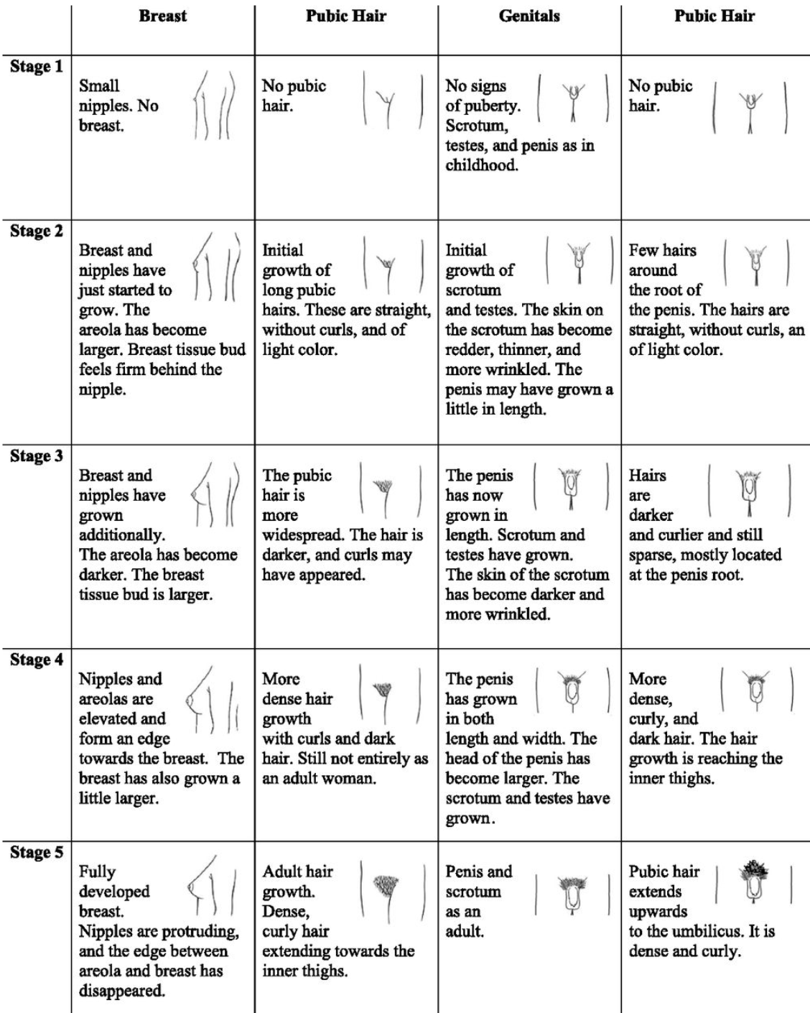

Tanner Stages

## Vaginal Discharge and Infections

****NOTE: Treatments change frequently! Check the [CDC Treatment Guidelines](https://www.cdc.gov/std/treatment/default.htm) or download the “CDC STD Tx Guide” app.**

|  |  |  |  |
| --- | --- | --- | --- |
|  | Signs & Symptoms | Diagnosis | Management |
| Physiologic (leukorrhea) | - Clear, white, or grey discharge; no offensive odor - No burning or itching | - pH *<* 4.5 - Wet mount: epithelial cells w/ no or few leukocytes | Reassurance |
| Candida vaginitis (“yeast infection”) | - Odorless curd-like white clumpy discharge - Intense burning and pruritus | - pH < 4.5 - KOH: No fish odor, +budding yeast and pseudohyphae, +WBC - Vaginitis Panel via vaginal swab (tests for BV, Candida Vaginitis, Trich) | - Fluconazole 150 mg PO (single dose) - Miconazole or clotrimazole intravaginal cream |
| Trichomoniasis | - Malodorous, frothy, yellow-green or cream colored discharge - Pruritus, dysuria | - pH > 4.5 - KOH: Fish odor may be present - Wet mount: WBC and pear shaped organism w/ motile flagella - Vaginitis Panel via vaginal swab (tests for BV, Candida Vaginitis, Trich) - NAAT dirty urine collection | - Metronidazole 2g PO (single dose) or 500mg PO BID for 7 days **Partner:** treat and refrain from intercourse for 7 days |
| Bacterial vaginosis (BV) | - Malodorous, increased mild grey-white discharge - Mild or absent pruritis or burning | - pH > 4.5 - KOH: +Fish odor - Wet mount: >20% clue cells-epithelial cells covered w/ gram negative rods - Vaginitis Panel via vaginal swab (tests for BV, Candida Vaginitis, Trich) | - Metronidazole 500mg PO BID for 7 days, OR - Metronidazole gel 0.75% one applicator (5g) intravaginally daily for 5 days **Partner:** treat if recurrent infection |
| Gonorrhea (GC) | - Majority asymptomatic - Grey-white cervical discharge | GC/CT NAAT vaginal swab or dirty urine | - Ceftriaxone 250mg IM + azithromycin 1g PO (co-tx chlamydia and covers resistant gonorrhea) - Refrain from intercourse x7 days **Partner:** Evaluate and treat contacts w/i prior 60 days |
| Chlamydia (CT) | - Majority asymptomatic - Yellowish vaginal discharge | GC/CT NAAT vaginal swab or dirty urine | - Azithromycin 1g PO x1 - If allergic to azithro, can do doxycycline 100mg PO BID x7 days - Refrain from intercourse x7 days **Partner:** Evaluate and treat contacts w/i prior 60 days |
| Retained tampon | Malodorous discharge | History and PE | Remove tampon |
| Allergic vaginitis | Local pain, vaginal erythema | History of exposure to deodorant spray, scented tampons, etc. | Cessation of sensitizing agent |

## HIV

### Signs & Symptoms

* **Acute HIV infection:** mono-like illness w/ nonspecific sxs (fever, lymphadenopathy, sore throat, rash, myalgia/arthralgia, diarrhea, mucocutaneous ulcers, weight loss, headache) usually ~2-4 weeks after exposure, sometimes up to 10 months after exposure
* Early infection is asymptomatic in 10-60% of cases

### Diagnosis

* **Suspected case:** HIV-1/2 Combo Ag/Ab + RT-PCR HIV viral load test
  + If testing is negative, but very-high risk exposure was recent, repeat test in 1-2 weeks
  + For cases of presumed sexual assault, repeat HIV testing in 6 wks, 3mo and 6mo
* **Routine screening:** Fourth gen HIV-1/2 Combo Ag/Ab reflex to confirmatory subtyping HIV1/HIV2 differentiation immunoassay, followed by viral load testing only if there is a discrepancy

### PEP vs. PrEP

|  |  |  |
| --- | --- | --- |
|  | PEP = Post-Exposure Prophylaxis | PrEP = Pre-Exposure Prophylaxis |
| EBG | Sexual Assault EBG | PrEP EBG |
| What is it? | Always a 3 drug regimen: - **Preferred regimen** (tablets only): Truvada (tenofovir and emtricitabine) + Raltegravir - **Alternative regimen** (if unable to swallow pills): Zidovudine + Lamivudine, + Raltegravir (chewtab) OR Lopinavir/Ritonavir (liquid) | Daily Truvada (tenofovir-emtricitabine) |
| Who’s it for? | Consider PEP if the following three statements apply to the patient: - Isolated anal, vaginal, percutaneous or oral exposure to possibly or definitely HIV infected blood or semen - Exposure occurred within 72 hours of presentation - Patient/family will consent to treatment and agree to follow-up | HIV neg Adolescents/Adults weighing >35 kg and meeting one of the following indications: - Men who have sex with men - Person who injects drugs - Heterosexual men and women at substantial risk of acquiring HIV infection (any sex partner w/ HIV or HIV risk factors, hx of bacterial STI, hx injecting drugs, used non-occupational PEP, survival/transactional sex, been in drug tx program, interest in trying to conceive w/ a discordant partner) |

## Genital Ulcers and Warts

|  |  |  |  |
| --- | --- | --- | --- |
|  | Signs & Symptoms | Diagnosis | Treatment |
| Genital herpes | Grouped vesicles, painful shallow ulcers, tender inguinal adenopathy | - Tzanck smear and viral culture - Antigen testing to determine HSV1 vs. HSV2 can give more information about recurrence prognosis | **First episode:** - Acyclovir 400mg TID x5-10 days, OR - Valacyclovir 1g BID x7-10 days **Recurrent episodes:** - Acyclovir 400mg TID x5 days, OR - Valacyclovir 500 mg BID x3 days **Daily suppressive (maintenance) therapy:** - Acyclovir 400 PO BID - Valacyclovir 500mg-1g PO daily |
| Genital warts | - Single or multiple soft fleshy papillary or sessile painless growths around genitals - No inguinal lymphadenopathy | - **Initial:** clinical presentation - **Final:** Pap test revealing typical cytologic changes | **Goal:** remove exophytic warts; exclude cervical dysplasia before treatment **Medication** (not in preg): - Podophylin 0.5% gel BID x3 days then off x4 days, and repeat up to 4 times; OR - Imiquimod 5% cream 3x/wk on alternate days until resolution (<16 wks) **Prevention:** Gardasil 9-valent vaccine (HPV(6, 11, + 7 others) |
| Syphilis | - **Primary:** Indurated, well defined, usually single painless ulcer “chancre” - **Secondary:** weeks to months later; systemic infection w/ rash, fever, HA, malaise, anorexia, adenopathy - **Latent** → Leads to **Tertiary** in 25%: CNS, cardiac manifestations; gummatous lesions | - **Initial:** FTA-ABS, MHA-TP, dark-field microscopy or DFA test of exudate or tissue - **Final:** VDRL, RPR (reverse sequence screening @ BCH) - False seronegatives seen in first 3 months; presumptive tx recommended | **Primary** and **Secondary:** - Benzathine Penicillin G: 2.4 mil U IM x1 dose - Doxycycline 100mg BID x14 days for allergy/preg **Latent:** infected but no sx - Benzathine Penicillin G: 2.4 mil U IM qweekly x3 wks **Partner:** evaluate if contact w/i 3 mo for primary, 6 mo for secondary, 1 year for latent |
| Chancroid | - Multiple, ragged, painful, non-indurated ulcers - Painful suppurative inguinal adenopathy | - **Initial:** clinical presentation, neg syphilis and HSV - **Final:** culture of *haemophilus ducreyi* | - Azithromycin 1g PO x1 dose - Ceftriaxone 250 mg IM x1 dose - Ciprofloxacin 500 mg BID x3 days - Erythromycin 500 mg TID x7 days **Partner:** evaluate and treat contacts w/i 10 days of symptoms |

## Pelvic Inflammatory Disease (PID)

****NOTE: Epididymitis is the male equivalant of female PID!**

### PowerPlans / Order Sets / EBGs

Pelvic Inflammatory Disease EBG

### Pathophysiology

Infection of upper genital tract (cervix, uterus, fallopian tubes, ovaries)

### Etiology

N. gonorrhea, C. trachomatis or other anaerobic organisms

### Clinical Manifestations

Pelvic pain, dyspareunia, vaginal discharge, fever, menstrual irregularities associated w/ lower abdominal tenderness, adnexal tenderness, and/or cervical motion tenderness

### Physical Exam

Uterine, adnexal, or cervical motion tenderness +/- LQ or RUQ tenderness

### Evaluation

* STI testing (GC/CT, trich, BV, RPR, HIV)
* Consider CBCd, ESR, urine hCG, UA, UCx

### Management

#### Outpatient

* Ceftriaxone 250 mg IM in a single dose PLUS doxycycline 100 mg PO BID for 14 days w/ or w/o metronidazole 500mg PO BID for 14 days

#### Inpatient

* IV regimen A: cefoxitin 2g IV q6h plus doxycycline 100mg PO BID
* IV regimen B: clindamycin 900 mg IV every 8 hours plus gentamicin 3 mg/kg IV q24h
* Following A, B: doxycycline 100mg PO BID for 14 days. If with pelvic abscess, BV, trich, or recent instrumentation also give 14 days of metronidazole.
* Alternative regimens: Levofloxacin +/- Metronidazole; Ofloxacin +/- Metronidazole; Amp/Sulbactam + Doxy

**Partner:** Evaluation and treatment of contacts w/i prior 60 days recommended. Refrain from intercourse in the meantime

## Heavy or Irregular Menstrual Bleeding

### PowerPlans / Order Sets / EBGs

Heavy/Irregular Menstrual Bleeding EBG

### Definition

Abnormalities in the frequency, duration, volume, and/or timing of menstrual bleeding

### Differential Diagnosis

Anovulatory bleeding (most common cause in adolescents), pregnancy (**must rule out** even w/o report of sexual activity), coagulopathy, recent start/stop of contraception

### Clinical Manifestations

* Menses prolonged or cycle shortened w/ frequent menses (normal menses happen every 21-45 days)
* Flow moderate to heavy
* May present w/ anemia leading to orthostasis, fatigue, tachycardia, syncope/ presyncope or exercise intolerance
* Other changes may include: weight change, visual changes, headache, heat or cold intolerance, skin changes (hirsutism or acne), palpitations, cyclic abdominal pain

### Evaluation

* Labs: CBC w/ diff, urine hCG, gonorrhea and chlamydia testing, coagulation studies, von Willebrand panel, TSH, LH, FSH, prolactin, free/total testosterone, DHEAS
* Imaging: Pelvic ultrasound if mass palpable, uterine abnormality suspected, or patient is not responding to typical therapies
* Exam: External GU exam to evaluate for active bleeding, masses, signs of trauma, virilization
* Ask about personal and family history of bleeding

### Management

* Consider NSAID trial (ibuprofen or naproxen), OCPs (screen for estrogen contraindications to determine type of OCP) continuously (occasionally BID-QID) until bleeding stops, daily iron supplements for anemia.
* Send to ED if vital signs unstable or with severe anemia (for further workup for surgical cause of bleed, possible transfusion, and possible tranexamic acid or aminocaproic acid)
* Antiemetic PRN nausea associated w/ hormone therapy

## Amenorrhea[4]

### Definition

* **Primary:** Absence of menses by age 15 or absence of menses 3 years following thelarche
* **Secondary:** Absence of menses for three cycles or for three-six months w/ prior normal menses

### Pathophysiology

* **Primary w/o secondary sex characteristics (no breast development) but normal genitalia (uterus and vagina):** Turner syndrome, abnormal X chromosome, mosaicism, pure gonadal dysgenesis, 17 a-hydroxylase deficiency, hypothalamic failure secondary to inadequate gonadotropin- releasing hormone (GnRH) release, constitutional delay of puberty
* **Primary w/ normal breast development but absent uterus:** Androgen insensitivity, congenital absence of uterus (MRKH)
* **Primary w/ no breast development and no uterus:** 17,20 desmolase deficiency, agonadism, 17 -hydroxylase deficiency w/ 46 XY karyotype
* **Primary and secondary w/ normal secondary sex characteristics:** Hypothalamic causes (idiopathic, phenothiazines, heroin, stress, exercise, weight loss, chronic illness, craniopharyngioma, tuberculous granuloma, meningoencephalitis, polycystic ovary syndrome), pituitary causes (Sheehan’s syndrome, aneurysm, empty sella, tumors), ovarian causes (premature ovarian insufficiency), uterine causes (Asherman syndrome), pregnancy

### Clinical Manifestations

* May see absence of secondary sex characteristics in conjunction w/ amenorrhea

### Physical Exam

* Height, weight
* Signs of malnutrition, androgen excess, thyroid dysfunction
* Tanner stage, breast exam and pelvic exam
* Webbed neck, low set ears, broad shield-like chest in Turner’s syndrome

### Evaluation

* Pregnancy test, TSH, FSH, prolactin, ultrasound to evaluate for presence of uterus
* **Primary w/o secondary sex characteristics or absent uterus:** Karyotype, FSH, Testosterone level.
* **Primary and secondary w/ normal secondary sex characteristics:** Urine pregnancy; FSH; Testosterone level; prolactin level – if elevated, need MRI of head to evaluate for prolactinoma; Progestin withdrawal test: Positive response indicates the production of estrogen w/o normal cycling such as in PCOS (if evidence of hyperandrogenism or elevated testosterone). Negative test w/ low FSH suggests low estrogen state as is seen in hypothalamic amenorrhea from nutritional deficiency. Negative test w/ high FSH indicates ovarian insufficiency.

### Management

* **PCOS:** hormonal contraception or cyclical provera 10mg/day x 10d to induce bleeding
* **Irreversible hypopituitarism or ovarian insufficiency:** Premarin 0.625-2.5 mg/day or transdermal estrogen and Provera 10mg/day medroxyprogesterone 10-14 days per month.
* **Hypothalamic amenorrhea related to nutritional deficiency:** energy re-balance/weight restoration

## Gender Affirming Care

### Why

One of our roles as providers of gender diverse youth is to combat the adverse experiences and risk factors for developing mental health disorders **by building safe communities for our patients and adopting a gender affirming approach to care.**

### How

* Call patients by the name and pronouns that they tell you best describe them in all clinical settings.
* Build our lexicon to help lead our co-workers by example in using appropriate and non-stigmatizing language to affirm the child’s or adolescent’s authentic self and gender identity (see gender-bread person below for review of terminology).
* Ask about gender identity at routine healthcare visits.
* Individuals who identify as transgender have **higher rates** of depression, anxiety, eating disorders, self-harm, and suicide compared to their cis-gendered peers. **Screen** for these when the opportunity arises and provide appropriate referrals/supports PRN.

### Gender Affirming Care Clinics

* At BMC: CATCH
* At BCH: GeMs

### [The Genderbread Person](https://www.genderbread.org/)

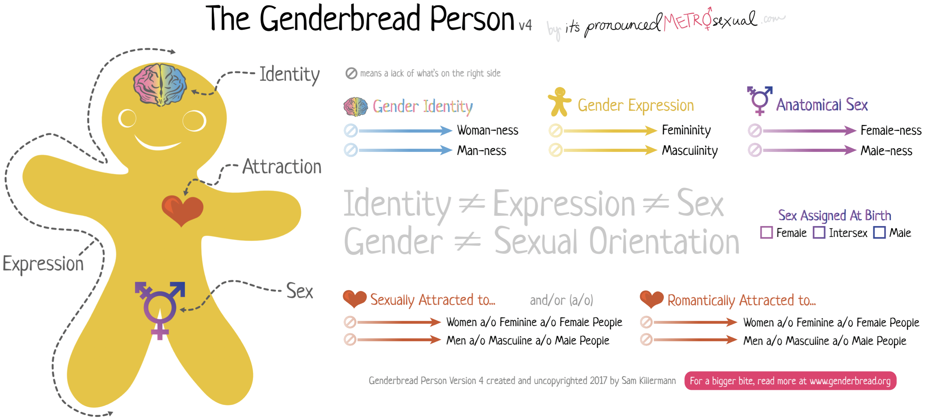

Genderbread Person

## Eating Disorders (ED)

### Anorexia Nervosa (AN)

#### PowerPlans / Order Sets / EBGs

* Restrictive Eating Power Plan and Admission Orderset
* Restrictive Eating EBG

#### Definition

* Restriction of energy intake relative to requirements, leading to a significantly low body weight in the context of age, sex, developmental trajectory, and physical health
* Significantly low weight is defined as a weight that is less than minimally normal or, for children and adolescents, less than minimally expected
* Intense fear of gaining weight or of becoming fat, or persistent behavior that interferes w/ weight gain, even though at a significantly low weight
* Disturbance in the way in which one’s body weight or shape is experienced, undue influence of body weight or shape on self-evaluation, or persistent lack of recognition of the seriousness of the current low body weight

#### Clinical Manifestations

Weight loss, abdominal pain, bloating, constipation, cold intolerance, lanugo, fatigue, weakness, delayed puberty

#### Physical Exam

Low body temp, bradycardia, low blood pressure, orthostasis, lanugo, dry skin and hair, scalp hair thinning, scaphoid abdomen, palpable stool, breast atrophy, hypoestrogenized vaginal mucosa

#### Evaluation

* **Labs:** CBCd, UA, urine pregnancy, chem 10, LFTs, TFTs, and EKG
* **Weight:** Compared to prior growth charts; calculate IBW based off of 50% BMI for age (unless previously tracking on different percentile)

#### Inpatient Management

* Restrictive Eating protocol
  + If 18yo+, then must sign contract in ED agreeing to protocol
* Goal is to medically stabilize (weight >80% of IBW), VSS (HR >50, no longer orthostatic), electrolytes stable (monitor potassium, phos and mag)
* Refeed gradually to target meal plan while monitoring for refeeding syndrome (watch for edema, low phos)
* Weight increase of 0.2kg/day, supplement if not gaining weight; 1750-2000kcal diet to be increased by 250 kcal per day until goal calories met, meals per EBG (set time for meal, replace w/ 120% ensure if <75% complete (either PO or via NG))
* Check electrolytes daily and supplement w/ PhosNaK and/or MVI if abnormal (at BCH the protocol is to start both supplements on admission)
* Activity: Bed rest while orthostatic. No physical activity while inpatient; can earn wheelchair rides, bathroom privileges, etc.
* Consults: Psychiatry, Nutrition
* Supervision: Sitter if active SI, Security if elopement risk

### Bulimia Nervosa (BN)

#### Definition

* Recurrent episodes of binge eating. An episode of binge eating is characterized by both of the following:
  + Eating, in a discrete period of time (eg, w/i any two-hour period), an amount of food that is definitely larger than most people would eat during a similar period of time and under similar circumstances
  + A sense of lack of control over eating during the episode (eg, a feeling that one cannot stop eating or control what or how much one is eating)
* Recurrent inappropriate compensatory behavior to prevent weight gain, such as self-induced vomiting; misuse of laxatives, diuretics, enemas, or other medications; fasting; or excessive exercise
* The binge eating and inappropriate compensatory behaviors both occur, on average, at least once a week for three months
* Self-evaluation is unduly influenced by body shape and weight
* The disturbance does not occur exclusively during episodes of anorexia nervosa

#### Clinical Manifestations

See AN, PLUS: Esophagitis and cavities

#### Physical Exam

See AN, PLUS: Calluses on fingers, cavities, and tooth decay

#### Evaluation

See AN

#### Inpatient Management

See AN, PLUS: Purge precautions (no bathroom privileges (use bedside commode), room searches)

### Acute Refusal of Food Intake Disorder (ARFID)

#### PowerPlans / Order Sets / EBGs

ARFID protocol and PowerPlan

#### Definition

* Persistent failure to meet appropriate nutritional and/or energy needs associated w/ one (or more) of the following:
  + Significant weight loss
  + Significant nutritional deficiency
  + Dependence on eneteral feeding or oral nutritional supplements
  + Marked interference w/ psychosocial functioning
* Disturbance not better explained by lack of available food
* **No evidence of a disturbance in body image**

#### Pathophysiology

* Patients w/ autism, ADHD, and intellectual disabilities are more likely to develop ARFID
* Often have co-occurring anxiety disorder; high risk for other psychiatric disorders

#### Clinical Manifestations

See AN, PLUS: Fear of choking or vomiting, limited range of preferred foods becomes narrower over time, will only eat certain textures of food, etc.

#### Evaluation

See AN

#### Inpatient Management

* ARFID protocol
* Often requires enteral nutrition (many patients will go home on enteral feeds)

## References

**Additional Resources:**

[Society for Adolescent Health & Medicine Resident Curriculum](https://www.adolescenthealth.org/Training-and-CME/Adolescent-Medicine-Resident-Curriculum.aspx)

# Allergy and Immunology

## Adverse Drug Reactions

### Type A vs B ADRs

#### Type A

* Predictable, dose dependent (ex overdose, SEs, drug interactions. 85-95%

#### Type B

Unpredictable hypersensitivity reactions (intolerance, idiosyncracy, immunologic). 10-15%. I - Immediate (mins-hrs) - IgE mediated - Anaphylaxis, angioedema, hives, hypotension, N/V/D II - Delayed (variable) - Cytotoxic - Hemolysis, thrombocytopenia, neutropenia III - Delayed (weeks) - Immune-complex - Serum sickness, arthus reaction, vasculitis IV - Delayed (days to weeks) - Cell-mediated - Contact dermatitis, SJS/TEN, DRESS

### Organ-specific ADRs | Exanthems | Diffuse fine macules/papules days after drug initiation | Allopurinol, aminopenicillins, cephalosporins, AEDs, sulfonamides | |————————|————————————————————————————————————|——————————————————————-| | Urticaria / Angioedema | W/in minutes of drug initiation | B-lactam antibiotics, ACEi | | Fixed Eruption | Hyperpigmented plaques that recur in same site | Tetracyclines, NSAIDs, carbamazepine | | Pustules | Acneiform, Acute generalized eczematous pustulosis | Steroids, sirolimus, antibiotics, CCBs | | Bullous | Tense or flaccid blisters | Furosemide/vanco, capropril/penicillamine | | SJS | Fever, erosive stomatitis, ocular involvement, purpuric macules (face, trunk) w/ <10% epidermal detachment | Sulfa antibiotics, AEDs, oxicam NSAIDs, and allopurinol | | TEN | Similar to SJS but w/ > 50% epidermal detachment | Same as SJS, mortality as high as 50% | | Lupus (skin) | Erythematous / scaly plaques in photodistribution | Hydrochlorothiazide, CCB, ACEis | | Hematologic | Hemolytic anemia, thrombocyto/granulocytopenia | Penicillin, quinine, sulfonamides | | Hepatic | Hepatitis, cholestatic jaundice | acetaminophen, sulfonamides | | Pulmonary | Pneumonitis, fibrosis | Bleomycin, Nitrofurantoin, MTX | | Renal | Interstitial nephritis, MGN | Penicillin, sulfonamides, allopurinol |

### Multiorgan ADRs | Anaphylaxis | Urticaria/angioedema, bronchospasm, GI sx, hypoTN | B-lactam antibiotics, monoclonal Abs | |—————-|————————————————————-|———————————————-| | DRESS | Cutan. eruption, fever, eosinophilia, hep. dysfunction, LAD | AEDs, sulfonamides, minocyc., allopurinol | | Serum Sickness | Urticaria, morbiliform rash, arthralgias, fever | Heterologous abs, infliximab, bactrim, PCN | | SLE | Arthralgias, myalgias, fever, malaise | Hydralazine, Procainamide, Isoniazid | | Vasculitis | Cutaneous or visceral vasculitis | Hydralazine, penicillamine, propylthiouracil |

### Desensitization **Definition**: give increasing doses over hours -> mast cells/basophils unreactive to Ag activation (only for Type I HSRs) **Result**: Temporary tolerance -> patient can receive the drug at usual intervals. When drug is stopped, desensitization ends (d-wk)

## Anaphylaxis

### Definition Acute, life threatening systemic HSR (min-hrs) w/ >= 1/3 of the following criteria: - **Hives plus another system**: acute onset illness (mins-hrs) involving skin/mucosa, or both, and >= 1 of the following: respiratory compromise, reduced BP or symptoms of end-organ dysfunction - **Two systems involved**: >= 2 of the following must occur rapidly after exposure to a likely allergen (mins-hrs): skin-mucosal involvement, respiratory compromise, reduced BP or associated symptoms of end-organ dysfunction, persistent GI symptoms - **Hypotension**: reduced BP after exposure to known allergen (mins-hrs)

### Allergens -Meds (B-lactams, ASA/NSAIDs), food, insects, cold/heat, exercise, latex

### Clinical -Skin involvement in 90%, respiratory in 70%, CV (hypotension) in 45%, GI in 45% -Monitor for biphasic reaction (4-25% occurrence)- sx recur w/in 10h (but up to 72h)

### Severe Reaction -Hypotension w/ wide PP, AMS/confusion, syncope, cyanosis, dyspnea, hypoxia

### Management **Emergent** 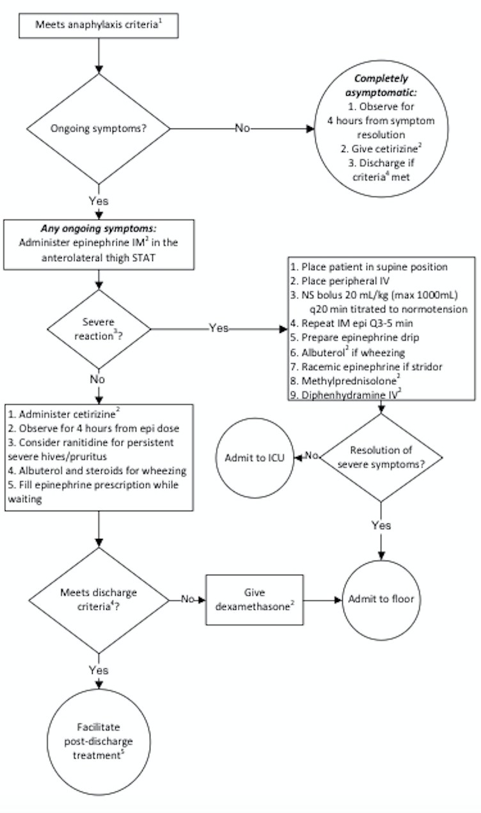

**Inpatient** 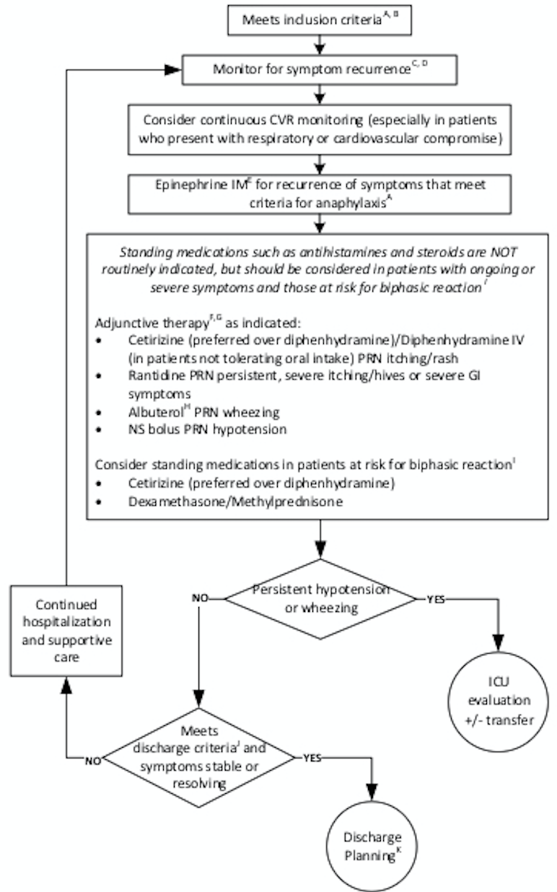

### Med Dosing - Epinephrine IM (1 mg/mL) - 0.01 mg/kg (<10 kg), 0.15 mg/kg (10-25kg), 0.3 (>25 kg) - Cetirizine - 2.5 mg (6mo-2 yrs), 5 mg (2-5 yrs), 10 mg (≥6 yrs) - Diphenhydramine - 1 mg/kg IV/PO (max 50 mg) - Dexamethasone 0.6 mg/kg (max 16 mg) OR methylprednisolone 1 mg/kg (max 60) - Ranitidine - 2 mg/kg PO (max 150 mg) OR 1 mg/kg IV (max 60 mg)

### ED Discharge Criteria No hypotension, resolved wheezing, ≤ 2 doses of Epi

### Post-discharge Treatment 3 days of Cetirizine daily, consider ranitidine, f/u with PCP/Allergy

## Primary Immunodeficiencies

### Pathophysiology - Genetic defects in the adaptive (B- or T-cell) or innate (phagocytes, complement) immune systems lead to recurrent infections - Over 200 distinct disorders: B cell defects (65%), combined B and T cell deficiencies (15%), phagocytic disorders (10%), T cell deficiencies (5%), and complement deficiencies/others (5%)

### Epidemiology The overall incidence is 1:10000, and overall prevalence is 1:2000.

### Clinical - Can be nonspecific and broad **Constitutional**: Poor growth, failure to thrive **GI**: chronic diarrhea. **Derm**: Atopic and non-atopic dermatitis, severe diaper rash, neonatal rash, anhydrosis, as well as delayed separation of the umbilical cord (LAD) **Immuno**: Recurrent infections, autoimmunity Family history of consanguinity or family history of immunodeficiency or unexplained childhood deaths puts a child at higher risk of having or developing a primary immunodeficiency

### Physical Exam **Vital signs**: Growth parameters **General exam**: Note dysmorphisms, including teeth and hair (abnormal in NEMO). Look for infectious sources (sinusitis, otitis, pneumonia, thrush, diaper rash) **HEENT exam**: Note tonsils (absent in XLA) and examine for thrush and other signs of infection such as sinusitis or recurrent otitis media **CV exam**: Note any cardiac anomalies including heart sounds, pulses, perfusion, and overall volume status as cardiac anomalies can be a part of certain syndromes associated w/ immunodeficiency syndromes (e.g.: DiGeorge Syndrome) **Respiratory**: Note symmetry of lung exam, quality of air entry, and lung sounds as pulmonary anomalies may be a manifestation of immunodeficiency syndromes **GI**: A thorough GI exam including abdominal exam for elements like hepatosplenomegaly and rectal exam for possible anal atresia is important **GU**: Primary immunodeficiencies can also lead to GU anomalies; assess for absence/presence of appropriate male/female organs in the correct number **Derm exam**: Skin exam for eczema/dermatitis (i.e. WAS, SCID, hyper IgE syndrome) as well as erythroderma (Omenn Syndrome). Note telangiectasia (AT), warts, granulomas, poor wound healing or ulcers **Neuro**: A thorough neuro exam may also hint at the etiology of an immunodeficiency (ataxia-telangiectasia), an infection such as meningitis, or may help elucidate an alternate cause of symptoms

### Diagnosis **Initial labs**: CBC w/ differential (note especially lymphopenia), chem7, albumin, urinalysis, ESR, CRP, quantitative immunoglobulins (IgG, IgA, IgM, IgE), specific vaccine antibody studies (tetanus, HiB, pneumococcal). **Follow-up labs**: HIV testing. B- and T-cell subset, complement screening (C3, C4, AH50, CH50), vaccine challenge (administer pneumococcal or other vaccine and measure titers 4-6 weeks later), Dihydrorhodamine (DHR) assay (CGD). Leukocyte adhesion defect testing (LAD). **Advanced lab analysis**: T cell proliferation studies (mitogen, antigen), T and B cell memory panels, NK cell function assays, Toll-like receptor assays. Immunodeficiency genetic panel. Whole exome or whole genome sequencing.

### Treatment Varies widely based upon the deficiency. Common therapies include prophylactic antibiotics, IVIG, bone marrow transplant.

## Indications for a Primary Immunodeficiency Evaluation - ≥8 ear infections w/i one year - >2 serious sinus infections w/i one year - >2 pneumonias w/i one year - FTT, poor weight gain, or abnormal growth parameters - Abnormal physical exam suggestive of syndrome - Recurrent skin or organ abscesses - Persistent thrush (mouth/skin), at >12 months of age - Severe or overwhelming infection

* Infection w/ unusual organisms
* Need for intravenous antibiotics to clear infections
* Infections w/ opportunistic organisms (Aspergillus, Pneumocystis)
* Severe forms of viral infections (HSV, VZV, EBV)
* Complications from a live vaccine
* A family history of primary immunodeficiency
* Abn. TRECs on newborn screen x2
* Abn. screening CBC (profound leukopenia, lymphopenia, eosinophilia)

## Diagnostic Approach to Primary Immunodeficiencies

### Initial Labs (most cases) - CBC w/ differential - Quantitative immunolgobulins (IgG, IgA, IgM, IgE) - Specific antibody studies (tetanus, HiB (PRP), pneumococcal)

### Next Step (include w/ initial labs if suspicious of specific disorder) - B- and T-cell subsets - T cell proliferation studies (mitogen, antigen) - Complement screening (CH50, AH50, C3, C4) - DHR (dihydrorhodamine assay for CGD)

### Advanced (Depending on specific history) - T and B cell memory panels - NK cell function assay - Toll-like receptor studies - Specific genetic testing

## Classification of Primary Immunodeficiencies

### B-cell (Humoral): decreased B-cell numbers and/or impaired antibody production

#### Diseases - X-linked agammaglobulinemia - Transient hypogammaglobulinemia of infancy - IgA or IgG selective Ig deficiency

#### Clinical Manifestations - Presents <12 mo old (3-6 mo, due to loss of maternal antibody) - Bacterial infxn (sinusitis, otitis, pneumonia) - Chronic diarrhea, FTT - Bronchiectasis - Enteroviral meningoencephalitis (chronic)

#### Organisms -Encapsulated: S. pneumo, HiB, N. meningitidis, S. typhi -GI: Giardia, Campylobacter -Also: S. Aureus, Pseudomonas, Enteroviral meningoencephalitis

#### Vaccine Issues Do not give live vaccines for severe defects. Vaccination is not necessary if on IgG replacement. Effectiveness of other vaccines is uncertain

### T-cell Defects (Cellular): lack of or decreased number of T-cells

#### Diseases DiGeorge Syndrome, SCID (T-/B+)

#### Clinical Manifestations - Presents at birth/early infancy - Mucocutaneous candidiasis - Severe viral infections - Bacterial, fungal, opportunistic infections - Warts or severe eczema - Chronic diarrhea, FTT

#### Organisms - Candida, PJP, Mycobacterium, S. typhi - VZV, HSV, CMV

#### Vaccine Issues Do not give live virus vaccines if substantial T cell defect

### Combined B/T Cell Defect

#### Diseases - SCID (T-/B-) - CVID - Wiskott-Aldrich syndrome - Ataxia-telangiectasia - X-linked lymphoproliferative disease (XLP) - Hyper IgE syndrome - DOCK8 deficiency - ZAP70 deficiency

#### Clinical Manifestations - Presents during 1st year of life. XLP/CVID can present as teens/adults - Infections (sinusitis, otitis, pneumonia) - Abscesses (recurrent) - Chronic diarrhea, gastroenteritis, FTT - Mucocutaneous candidiasis - Viral/opportunistic/fungal infections - Increased cancer risk

#### Organisms - Candida, PJP, Mycobacterium, encapsulated bacteria - VZV, HSV, CMV infections

#### Vaccine Issues Do not give live vaccines (OPV, BCG, smallpox, YF, live influenza, MMR, MMRV, rotavirus). Effectiveness of other vaccines is uncertain.

### Phagocytic Defects

#### Diseases - Chronic granulomatous disease (CGD), Leukocyte adhesion deficiency (LAD) - Chediak-Higashi syndrome (CHS)

#### Clinical Manifestations - Typically presents in infancy - Poor wound healing - Delayed separation of the umbilical cord (LAD) - Lymphadenitis/abscesses - Catalase (+) bacterial infections (CGD) - Candidiasis - Chronic gingivitis, oral disease - Hepatosplenomegaly

#### Organisms - Catalase (+) bacteria: – S aureus – Pseudomonas – Burkholderia cepacia – Nocardia – Enterobacteria erratia and Klebsiella - Fungal infections: – Aspergillus – Candida albicans

#### Vaccine Issues - Live viral vaccines contraindicated in CH & LAD, but OK in CGD - Live bacterial vaccines are contraindicated. Other vaccines are safe/ effective

### Complement Defects

#### Diseases Classical pathway: - C1q, Cqr, C1s, C2, C4 - Hereditary angioedema (C1-est) - C2: most common in Causasians

Lectin pathway: - MBL, M-/L-/H-ficolin, CL-11, MASPs

Alternative pathway: - Factors D, B, and properdin

#### Clinical Manifestations - Can present at any age - Angioedema of the face, lips, hands, feet, GI tract, throat (C1-inh) - Recurrent sinopulmonary infections - Bacteremia/pyogenic bacterial infections - Meningitis - Autoimmune disease (lupus-like) - Often autosomal dominant inheritance - Associated w/ atypical HUS

#### Organisms Encapsulated bacteria, Neisseria

#### Vaccine Issues - No vaccine contraindications - Refer to CDC guidelines re: additional vaccinations for protection against encapsulated bacteria

## Selected Primary Immunodeficiencies | Disorder | Cell | Gene | Age | Presentation | Labs | |—————————————–|———————————————|—————————————————–|————————–|————————————————————————————————————————————————————————————————————————————————————————————-|—————————————————————————————————————————————————————-| | Chediak-Higashi Syndrome (CHS) | Phagocyte | CHS1, AR | Infancy | -Oculocutaneous albinism, recurrent pyogenic infections (S. aureus) -May present with accelerated phase or HLH: fever, jaundice, hepatosplenomeglay, lymphadenopathy, bleeding, neurologic changes -Lysosomes unable to fuse with phagosomes to lyse bacteria | -Neutropenia -Giant lysosomal granules in neutrophils -Impaired T/NK cell function | | Chronic Granulomatous Disease (CGD) | Phagocyte | Multiple phagocyte oxidases (gp91phox), X-linked/AR | Infancy-adult, most <5yo | -Recurrent bacterial/fungal infections, often w/ encapsulated and catalase-positive organisms -Granulomas and cold abscesses, both superficial and deep -Inability of neutrophils to generate oxidative burst, but chemotaxis and phagocytic function intact | -Normal neutrophil count -Reduced superoxide production when stimulated in vitro -DHR assay | | Selective IgA Deficiency | B-cell | - | >4yo | -Most patients (85-90%) are asymptomatic -Recurrent sinopulmonary infection (H. influenzae, S. pneumo), Giardia lamblia infections, autoimmune disease -Increased risk of anaphylaxis to blood products | -Low IgA, normal IgG/M | | X-linked Agammaglobulinemia (XLA) | Complete absence of mature B-cells | BTK, X-linked recessive | 3-18mo | -Recurrent bacterial infections: sinuses, ear, lung (S. pneumo, HIB, S. pyogenes, Pseudomonas) -Exam: absent tonsils and adenoids | -Low levels of IgG, IgM, IgA -Reduced/absent CD19/20 B-cells | | DiGeorge Syndrome | Normal to severe T-cell immunodef | Del. 22q11.2 & 10p13-14 | Infancy | -Triad: hypoplastic thymus, conotruncal cardiac/aortic arch defects, hypoparathyroidism -Characteristic faces: low set ears, ocular hypertelorism, bulbous nasal tip | -Hypocalcemia -Reduced CD3+ T cells -Abnormal cardiac echo | | Ataxia Telangiectasia (AT) | B- and T-cell | ATM, AR | >1yo | -Progressive cerebellar ataxia, oculocutaneous telangiectasia, diminished/absent deep tendon reflexes -Recurrent sinopulmonary infections -Increased risk of malignancy | -Selective IgA deficiency -Low T-cell numbers -Elevated serum AFP | | Common Variable Immunodeficiency (CVID) | Impaired T-cell function, B-cell maturation | - | Childhood-Adolescence | -Recurrent sinopulmonary infections, autoimmunity, chronic lung disease -Poor response to protein, polysaccharide vaccines (tetanus, PCV) | -Significantly reduced IgG -Reduced IgA and/or IgM | | Hyper IgE Syndrome | B- and T-cell | STAT3, AD | First wks of life | -Papulopustular rash, skin abscesses (S. aureus), eczema, retained primary teeth -Coarse/thickened facial features, frontal bossing, wide alar base of nose | -Eosinophilia -Elevated IgE | | Severe Combined Immunodeficiency (SCID) | B- and T-cell, depending on the type | Multiple (RAG1, RAG2, ADA, Artemis, IL2RG) | Part of newborn screen | -Persistent mucocutaneous candidiasis, FTT, recurrent fevers, chronic diarrhea -Infections with adenovirus/CMV/EBV/RSV can be fatal -Live-attenuated vaccines can be fatal -Immunologic emergency: positive pressure room, urgent work-up and evaluation for bone marrow transplant | -NBS: low TRECs -CXR: absence of thymic shadow -Absolute T-cell count <300, abnormal T-cell proliferation studies, presence of maternal T-cells in circulation |

## Selected Immunodeficiencies | Wiskott-Aldrich Syndrome | B- and T-cell | WAS X-linked | Infancy | -Triad: thrombocytopenia (small platelets), eczema, immunoglobulin abnormalities -Chronic otitis media/sinusitis, infection with encapsulated organisms | -IgG nml, IgM low, IgA/E elevated -Decreased number of T cells -Thrombocytopenia | |——————————————–|—————|————————-|———–|—————————————————————————————————————————————————————————————————————|——————————————————————————————————–| | X-linked Lymphoproliferative Disease (XLP) | T- and B-cell | XLP/SH2D 1A, X-linked R | Childhood | -Fulminant EBV infection (often w/ hepatitis, hepatosplenomegaly, liver failure), often causing secondary hemophagocytic lymphohistiocytosis or aplastic anemia -Inc risk of malignancy, especially lymphoma | -B/T cell numbers normal; function is abnormal -IgG is low, IgM is increased -Anemia, thrombocytopenia |

## Specific Antibody Deficiencies | | Presentation | IgG | IgA | IgM | IgG subclass | Vaccine response | B cells | |——————————|—————————————————————————–|—–|———–|————|——————-|——————|———| | Subclass deficiency | Recurrent severe infections (controversial) | NL | NL | NL | At least 1 is low | LOW | NL | | Selective IgA Deficiency | Asymptomatic or associated w/ autoimmune, GI, atopic disorders | NL | LOW | NL | NL | NL OR LOW | NL | | Hyper IgM Syndrome | Severe infections, including PJP | LOW | LOW | NL OR HIGH | LOW | LOW | NL | | Specific Antibody Deficiency | Often asymptomatic, inadequate antibody response to polysaccharide antigen | NL | NL | NL | NL | LOW | NL | | CVID | Recurrent infections | LOW | NL OR LOW | NL OR LOW | LOW | LOW | NL |

## Characteristics of Selected SCID disorders

### T-, B+, SCID

#### Gene defects - IL2RG (most common form, X-linked) - JAK3 - IL7RA - IL2RA - CD3D/E/Z - PTPRC - CORO1A - ZAP70

#### Treatment Bone marrow transplant or gene therapy (IL2RG)

### T-, B-, SCID

#### Gene defects - RAG1/RAG2 (common) - Artemis (common) - Adenosine deaminase (ADA, common) - PRKDC - AK2 - LIG4 - Cernunnos (NHEJ1)

#### Treatment - Bone marrow transplant or gene therapy (ADA) - ADA can be treated w/ gene therapy or enzyme replacement

## General Approach to the Immunodeficient Patient

Approaching the immunodeficient patient in clinic: - See indications for testing/tests above. - Is antibiotic prophylaxis indicated? - Can they receive immunizations? If they can, have they mounted a sufficient immune response to vaccines (ie. do they need vaccine titers)? - Low threshold for antibiotic use in the event that infection is suspected.

Managing a sick immunodeficient patient: - Obtain blood culture and labs. - Give antibiotics/antivirals promptly. - Determine whether imaging/surgery is indicated (ie. drain an abscess). - Be aware of blood products given. Blood may need to be from CMV- donors, filtered to remove WBCs, and irradiated. - Replace missing immune components (ie. IVIG)

# Cardiology

## Cardiology Rotation Tips

#### Team Structure

* **1 Fellow:** Should be your first stop for everything. **Trust them!** They are fantastic and want to teach.
* **4 Residents:** One will be on outpatient, one post-call (but will round), two there all morning
* **Attendings** (usually 4-5 of them):
  + **General Cardiology:** Most patients are usually on this team.
  + **Heart Failure/Transplant:** You will always round w/ the attending on this team, sometimes there will be a fellow too.
  + **BACH:** Adult congenital. You will round w/ the BACH attending and fellow.
  + **Electrophysiology (EP):** You should see the fellow every day.
  + **Pulmonary Hypertension:** You will occasionally have patients on this service and will round w/ the attending.
  + **Primary Attending:** Cardiology is a team sport, meaning there are multiple physicians on the care team. This is the patient’s longitudinal cardiologist who will check in periodically.
* Of note, there is also an **NP team.** This team is separate from the MD team during the day, but **you will cross-cover them overnight and on weekends/holidays** (which means when you are overnight, you will need to signout to the NP team in the morning).

#### Admissions

You will have a few types of admissions. The main ones will be from the CICU, from the ED, and post-cath:

* **CICU admission:** Go with fellow to 8S (bring a COW) to get sign-out directly from the team caring for the patient. Write transfer note, enter transfer accept order, and perform transfer med rec.
* **ED admission:** Just like any other admission, except the cardiology fellow sees them in the ED and there is a consult note
* **Post-cath:** Usually you won’t get signout on this patient. The fellow will get some signout from the patient’s primary cardiologist. Ask them for more information and do some chart review for more information.

#### Resources

* **Medical Team Coordinator:** Should be your first stop for questions on basically everything non-medical. This includes scheduling a procedure, getting prior authorization for medications, discharge planning, how to put in a specific order, where the food is - really, anything and everything. They are AMAZING.
  + Will also send you a welcome email before the rotation w/ excellent resources. Try to read them!
* **Fellow:** Cardiology is a great time to learn and the fellows are excited about the heart and want to teach. Don’t be afraid to ask them questions about the physiology and pathophysiology.
* **Attendings:** Similarly excited to teach. Many of them will bring a whiteboard on rounds and draw out the physiology of the patient. Feel free to ask them to do so if you want to learn more!

## Disaster Planning

#### Know and use your resources!!!

* **Fellow:** Should always be your first call. Run the list w/ them multiple times a day and at night. Before they go lie down, “disaster round” w/ them and ask all the questions you have about what to do if X happens to Y patient.
* **Nurses:** They have been doing this for longer than we have and know these patients incredibly well. Ask them for tips as well. On midnight rounds, always say hello and ask them what they are worried about for each patient.
* **Code cards:** Carry them w/ you. They have lots of great information on them!
* **CICU:** They are right next door and can get over to the general cardiology floor very quickly. Don’t be afraid to call them. Always better to over call than under call them.

## EKG Approach

* **Paper speed:** Standard 25mm/s → Small box = 0.04s, Big box = 0.2s
* **Standardization marker:**
  + 2 big boxes tall = “full standard” and 10 mm = 1 mV
  + 1 big box tall = “half standard” and 5 mm = 1 mV
  + Limb leads can be in full standard while the precordial are in half standard

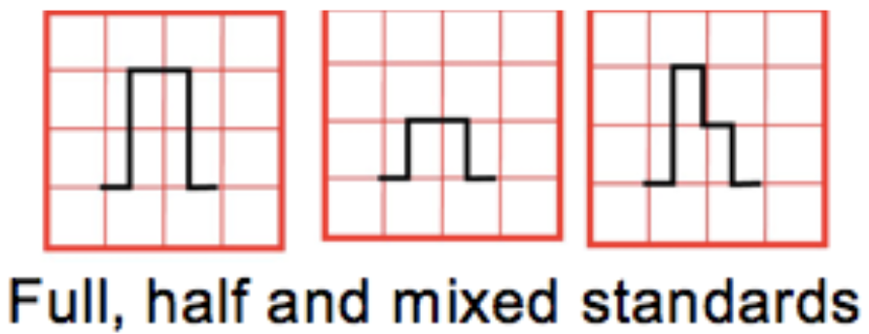

### Ventricular Rate

* 300-150-100-75-60-50 rules if the rhythm is regular, OR
* Count the number of QRS complexes in the rhythm strip (10 seconds) and multiply by 6 (works even if the rhythm is irregular)

### Rhythm

* **Sinus rhythm** = (1) P before every QRS, (2) QRS after every P, and (3) Normal P axis (0-90°, upright P waves in I and aVF)

### QRS Axis

* **Determine axis** by looking at leads I and aVF:
  + ↑ in I, ↑ in aVF = axis between 0 and +90°
  + ↑ in I, ↓ in aVF = axis between -90 and 0°
  + ↓ in I, ↓ in aVF = axis between -90 and 180°
  + ↓ in I, ↑ in aVF = axis between +90 and 180°
* Once you’ve identified axis quadrant, **find the most isoelectric limb lead:**
  + The QRS axis is 90° away from the most isolelectric lead
  + Normal axis varies w/ age (newborn = rightward b/c RV dominance in utero, childhood = leftward b/c LV becomes dominant)
  + Superior axis = AV canal defects, tricuspid atresia and large VSD or left anterior hemiblock
  + Leftward axis in a cyanotic newborn is highly suggestive of tricuspid atresia

### Intervals & Segments

#### PR interval

Atrial depolarization (P wave) and delay at AV node (PQ segment)

* The normal PR interval increases w/ age
* Prolonged PR intervals are seen in AV nodal block (heart block)
* Short PR intervals are seen in pre-excitatory conditions such as WPW
* Variable PR interval can be seen in wandering atrial pacemaker, multifocal atrial tachycardia and Wenkebach-type 2nd degree heart block
* Depressed PR segment may be seen in pericarditis

#### QRS interval

Ventricular depolarization

* The upper limit of normal increases w/ age (0.07 s in newborns to 0.12 s in adults)
* A wide (prolonged) QRS is indicative of depolarization which proceeds independent of the His-Purkinje system or in which depolarization via the His-Purkinje system is aberrant
* This is seen in ventricular arrhythmias, pre-excitation, IV conduction delays and BBB

#### QT interval

Ventricular depolarization (QRS) and repolarization

* QTc normalizes QT interval accounting for HR, calculated w/ Bazett formula: QT (sec) / √RR(sec)
* A normal QTc in the newborn = 0.47 s, it shortens in older children to 0.44, and then elongates to the normal adult values of approximately 0.45 s in men and 0.46 s in women
* Prolonged QTc is seen in congenital long QT syndrome, electrolyte derangements (hypokalemia, hypomagnesemia and hypocalcemia), hypothermia and is caused or worsened by many medications

#### Q wave

Ventricular septal depolarization, which proceeds from left-to-right and inferior-to-superior

* Small q waves should be seen in the inferior and left-facing leads (I,II,V5,V6 and III and aVF).
* Duration should not exceed 0.04 sec and amplitude should not exceed 25% of QRS wave in height
* Abnormally tall or long Q-waves may represent ischemia
* Q waves in V1 and V2 are **always abnormal**

#### U wave

Small deflection often seen closely following the T wave, which may represent repolarization of the Purkinje fibers or after depolarizations w/i the ventricle

* A U wave is a normal finding if it is small (<25% the amplitude of the T wave), there is an isoelectric segment between the T wave and U wave, and if the U wave is upright
* If any of these features are not met, the U wave may be pathologic
* Prominent U waves are seen most often seen in hypokalemia, but can also be seen in other electrolyte derangements, ventricular hypertrophy, LQTS and w/ antiarrhythmic therapy
* Inverted U waves are concerning for ischemia, ventricular hypertrophy or cardiomyopathy
* U waves are often more prominent at slow heart rates (<65 bpm)
* If U waves are large (>25% of the T wave amplitude) and there is no isoelectric segment between the T wave and U wave, they should be included in the QTc calculation (which becomes the QTUc)

#### ST segment

Ventricular repolarization

* Elevation or depression >1mm in limb leads or >2mm in precordial leads is abnormal and is concerning for ischemia if seen in a territorial distribution (especially w/ reciprocal changes in other territories) or pericarditis if diffuse
* Concave “smiling” ST-elevation is often normal, as seen in benign early repolarization, however convex “frowning” ST-elevation is ominous

#### R/S progression

R/S ratio represents the ratio of left to right ventricular forces. R waves in the right precordial leads represent depolarization of the right ventricle, and S waves in these leads represent depolarization of the left ventricle. Pattern reversed in left precordial leads.

* In newborn period of a FT infant, the RV is dominant and as such the R wave in lead V1 should be greater than the S wave
* As a child ages, the LV becomes progressively more dominant until late adolescence when an adult-type R/S progression is seen w/ small R waves and large S waves in V1 w/ large R waves and small S waves in V6

#### T waves

* Normal T wave pattern varies w/ age
  + At birth, all T waves should be upright
  + Over the first days of life, leads V1-V3 invert (V1 first, V3 last) and after 7-10 days of life it is pathologic for there to be upright T waves in lead V1 and represent RV strain if present
* It is normal for the T waves in leads V1-V3 to be inverted in children, and between the ages of ~8-20yo these T waves start to become upright (V3 first, V1 last)
  + However, it is not abnormal for T wave inversion to persist into an individual’s 20s, and this is called a persistent juvenile T wave
* It is **always abnormal** to see an inverted T waves in leads V5 + V6 (ischemia or ventricular strain)
* Peaked T-waves are seen in hyperkalemia and elevated ICP and abnormally flat in hypokalemia

### Chamber Size

#### R atrial enlargement (RAE)

P wave height >2.5 mm (2.5 small boxes) in lead II or tall initial positive portion in V1

#### L atrial enlargement (LAE)

P wave duration >2.5 small boxes (100 msec) in lead II. Notched in lead II or deep/wide terminal negative portion of p-wave in V1.

#### L ventricular hypertrophy (LVH)

* R wave > 98th% in I, II, aVL, V5, V6
* S-wave > 98th% in V1
* Supported by:
  + Inverted T in V5 or V6 (strain pattern)
  + Left axis deviation
  + Left atrial enlargement

#### R ventricular hypertrophy (RVH)

* R wave >98th% in aVR, V1, V2, V4R (or pure R wave > 10 mm)
* S wave >98th% in I, V5, V6
* qR pattern in V1
* Upright T in V1 (pre-adol.) suggests RV strain
* Right axis deviation

#### Strain

QRS-T angle > 90° (diff. between QRS / T axes)

### Normal EKG values by age[5]

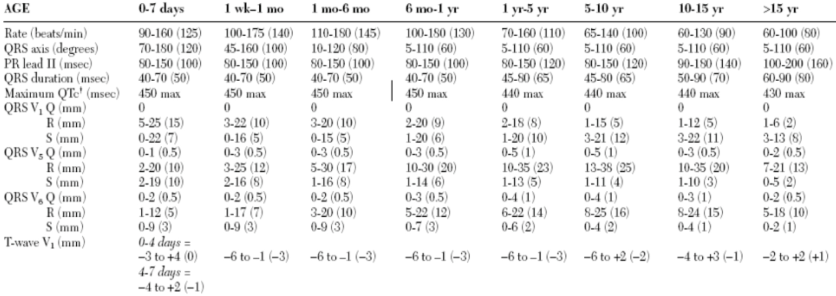

Values are 2nd – 98th percentile (mean)

## Other Cardiac Work-Up

### Chest X-Ray (CXR)

* **Heart size:** >50-60% of thorax is abnormal on PA film (confounded by: poor inspiration, AP technique, thymic shadow)
* **Lung fields:** increased pulmonary blood flow (increased pulm. vasc. markings, engorged vessels) = sign of overcirculation
  + Decreased vascular markings indicate decreased pulmonary blood flow
  + Pulmonary edema and effusions may indicate CHF or left-sided obstructive disease
* **Thymic shadow:** lack of a thymic shadow in neonates should raise suspicion for 22q11 del. and associated cardiac defects
* **Aortic arch:** sidedness (left-sided aortic arch is normal)
* **Heart border:** Left or right atrial enlargement
* **Rib notching:** suggests the presence of collateral vessels, as can be seen in coarctation

### What to do next…

* 4-extremity BP: Upper > Lower (or less commonly R arm > L arm) suggests obstruction of the aorta (e.g. interrupted arch, coarctation)
  + Exception to the rule: L arm > R suggests aortic obstruction w/ aberrant right subclavian
* Pre- and post-ductal O2 sats (measure on R arm and either foot)
* Hyperoxia Test:
  + PaO2 < 100 mm Hg on 100% RA suggests cyanotic congenital heart disease, >200 suggests pulmonary etiology
  + Pulse oximetry can be used as approximation if unable to obtain ABG.
* Consult Cardiology!

### When to start prostaglandins

* After work-up, if high suspicion for cyanotic heart disease, start PGE1 (alprostadil) 0.01 mcg/kg/min as soon as possible
* Monitor for apnea and hypotension
* Consider securing airway if patient requires transport

## Common Cardiology Concerns

### Hyperlipidemia (HLD)

***See*** *Weight Management EBG*\*\*

#### Screening

* When?
  + Screen all kids once at ages 9-11 and again from age 17-21
  + If pt has *>* 1 CVD risk factor, screen every 1-3 years
    - **CVD risk factors:** Dyslipidemia, obesity, HTN, DM, FH of premature CVD, smoking exposure
* How?
  + Fasting lipid panel: Total cholesterol, TG, HDL, LDL-c (not reliable if TG >400)

#### Diagnosis

* TC *>* 200 (borderline is 170-199)
* LDL *>* 130 (borderline is 110-129)
* TG *>* 100 (age 0-9), TG *>* 130 (age 10-19)
* HDL < 45

#### Management

* Repeat and confirm abnormal value in 2 weeks to 3 months (including borderline values)
* Lifestyle changes: Diet changes (+/- nutrition consult, preventative cardiology referral), weight loss, increase exercise
* Consider statin therapy if no response in 6 months (referral to preventative cardiology clinic)
* If high risk for CVD (genetic familial hypercholesterolemia, DM, ESRD, KD, solid-organ transplant recipient, childhood cancer survivor or moderate risk with add’l risk factors), start statin with goal LDL <100

### Hypertension (HTN)

***See*** *Hypertension EBG*\*\* ***See*** *Nephrology chapter* ***for further details, including BP percentiles, discussion of causes of secondary HTN, and treatment\**** See **Critical Care/ICP chapter** for discussion of Hypertensive Emergency*

#### Screening

* All Well-Child Visits > 3yo
* All Well Child Visits < 3yo with HTN risk factors (see EBG)
* All Visits for >3yo with risk factors:
  + BMI >95%ile, renal disease, diabetes, coarctation, hx arch obstruction, known HTN, taking meds known to increase BP

#### Diagnosis

* Children < 13yo: Automatic BP *>* 90%ile for age. Repeat manually. If persistently abnormal, follow EBG.
* Children *>* 13yo: Automatic BP *>* 120/80 mmHg. Repeat manually. If persistently abnormal, follow EBG.

#### Management

* **Elevated BP:** Repeat 6mo → 6mo → further work-up (see below), referral, and/or treatment if abnormal
* **Stage I HTN:** Repeat 1-2wks → 3mo → further work-up, referral, and/or treatment if abnormal
* **Stage II HTN:** Referral (Renal or Cards) and work-up
  + Send to ED if symptomatic (headache, visual changes)

#### Work-up

* Additional history, chem10, UA, fasting/non-fasting cholesterol (total/HDL)
* If <6yo or evidence of abnormal UA or renal function → renal US with doppler
* If Obese, HbA1c and ALT
* Optional: Glucose, fasting lipids, TSH, drug screen, sleep study, CBC

### Evaluating Murmurs (including in a newborn)

#### History

Complete history, family history of murmur/CHD. Symptoms include respiratory difficulty, diaphoresis with exertion or feeds, poor growth. Evaluate if murmur was previously documented.

#### Physical Exam

Pulses, palpation of chest, and auscultation- describe position that is loudest, quality of sound, radiation, presence of thrill. Grades:

* Grade 1: barely audible
* Grade 2: soft, but audible in a busy room
* Grade 3: loud, but without thrill
* Grade 4: loud and thrill present
* Grade 5: very loud, heard with stethoscope partially of of the chest
* Grade 6: very loud, heard with stethoscope off of the chest

#### Is it innocent or pathologic?

* **Features of innocent murmurs:** Grade *<* 2, softer when sitting than supine, short and systolic, minimal radiation, musical or vibratory quality
* **Features of pathologic murmurs:** Grade *>* 3, holosystolic (septal defects, MR, TR), harsh or blowing quality, abnormal S2 (wide splitting, fixed splitting, paradoxical splitting, single S2, loud S2), systolic click (MVP), diastolic murmur (always pathologic), louder in seated/upright position, gallop rhythm, friction rub

#### Work-up

If concerned for pathologic murmur based on above criteria, then obtain: EKG, four-extremity BPs, Cardiology consult for echo

#### Common Innocent Murmurs

* **Vibratory/Still’s murmur:** LLSB/LMSB, musical; age 3-6 most commonly (infant to adolescent)
* **Pulmonary ejection murmur:** LMSB/LUSB, crescendo-decrescendo; all ages
* **Peripheral pulmonary stenosis (PPS):** <1yo, heard at LUSB with radiation to back/axilla
* **Venous hum:** continuous murmur, loudest over the lower neck, age 3-8 yo, disappears when supine

## Arrhythmias & Pacemakers

### Causes of Palpitations

#### Cardiac

PACs, PVCs, sustained or non-sustained tachyarrhythmias

#### Non-cardiac

Hypoglycemia, toxic exposures, pheochromocytoma, increased metabolic demand (fever, anemia), catecholamine response (anxiety, emotional arousal), hyperventilation, POTS, hyperthyroidism

### Premature Ventricular Contractions (PVCs)

#### Presentation

Ranges from asymptomatic → **palpitations, lightheadedness.** Irregular pulse on exam.

#### Presentation

Ranges from asymptomatic → **palpitations, lightheadedness.** Irregular pulse on exam.

#### Pathophysiology

Enhanced automaticity, triggered activity

#### Work-up

* EKG, 24-48hr Holter, chem10, TFTs
* May require echo or exercise testing (dependent upon severity)
* PVCs not coming from the RVOT (which should have a LBBB pattern with an inferior and leftward axis) should raise concern for underlying pathology)

#### Treatment

Usually none

* Treat underlying cause (if one exists, e.g. a drug)
* Beta blockers or CCBs if symptomatic
* If refractory and associated with depressed cardiac function, radiofrequency catheter ablation

### Premature Atrial Contractions (PACs)

#### Presentation

Range: asymptomatic → **palpitations, lightheadedness.** Irregular pulse on exam.

#### Pathophysiology

Enhanced automaticity, triggered activity

#### Work-up

Similar to work up for PVCs

#### Treatment

Rarely required. Beta-blockade can be considered for symptomatic PACs.

### Sinus Bradycardia

#### Presentation

Usually asymptomatic; lightheadedness, SOB, exercise intolerance or syncope and cardiovascular collapse; poor feeding, irritability and/or respiratory abnormalities in infants. By age:

* Newborn to 3 years: < 90-100 bpm
* 3-9 years: < 60 bpm
* 9-16 years: < 50 bpm
* Well trained adult athletes: < 40 bpm

#### Pathophysiology

Conditioning (athletes), increased ICP, medications (beta blockers, digoxin, CCBs, steroids, analgesics and sedatives as well as alpha 2 blockers), structural CHD with sinus node dysfunction, anorexia

#### Work-up

Assess for **perfusion,** history for causes including meds; **EKG.**

#### Treatment

* Observation if asymptomatic
* Treat underlying causes
* Consider pacemaker if symptomatic

### AV Block

|  |  |  |
| --- | --- | --- |
| Degree | PR Interval | Pathophysiology |
| 1st degree AV block | **Prolonged PR interval** Birth - 4 wks: 0.08-0.12 1-3 mos: 0.08-0.13 3-12 mos: 0.08-0.14 1-3 yrs: 0.08-0.15 3-5 yrs: 0.1-0.15 5-8 yrs: 0.09-0.16 8-12 yrs: 0.1-0.17 12-16 yrs: 0.1-0.18 Adult: 0.12-0.20 | Increased vagal tone, idiopathic, acute rheumatic fever (ARF), Lyme dz, hypothermia, cardiomyopathy, electrolyte disturbances (hyperkalemia) |
| 2nd degree AV block, Mobitz I (Wenkebach) | Progressive lengthening of PR → non-conducted P wave | - Usually AT the level of the AV node (does not progress to complete heart block) - Healthy individuals during sleep |
| 2nd degree AV block, Mobitz II | No lengthening of PR interval followed by sudden non-conducted P-wave | Usually BELOW level of AV node (e.g., His bundle pathology)→ may progress to complete heart block |
| 3rd degree AV block (Complete) | Complete AV dissociation | - Narrow QRS (junctional beats) vs. wide QRS (ventricular beats) → may cause hemodynamic collapse - Congenital heart block in infants of mothers w/ SLE (anti-Ro/anti-La Ab), L-TGA, heterotaxy - Acquired heart block: myocarditis, Lyme dz, ARF, MI |

### Supraventricular Tachycardia (SVT)

#### Presentation

Paroxysmal palpitations, chest pain, shortness of breath, dizziness or syncope w/ sudden onset and sudden resolution. HR characteristically invariable and is generally > 220 bpm in infants and > 180 bpm in children

#### Work-up

EKG in SVT shows a (usually) narrow complex QRS, regular rate, +/- retrograde P-waves. SVT with abberancy or antidromic AVRT can be wide complex.

#### Treatment

* **Vagal maneuvers** (ice to face for babies, Valsalva maneuvers, blowing through a straw)
* Give **adenosine** 0.1 mg/kg (max dose 6-12 mg) as a rapid IV push through an IV as close to the heart as possible, followed by very rapid NS flush (this may be repeated at 0.2 mg/kg)
  + Do **NOT** give adenosine if rate is **irregular** at all!
* Immediate **synchronized cardioversion** is indicated if the patient is unstable

### Wolff-Parkinson-White Syndrome

#### Presentation

Episodes of paroxysmal supraventricular tachycardia or asymptomatic/incidental finding on EKG

#### Pathophysiology

Early conduction of atrial impulses to the ventricle defined by short PR interval, wide QRS, delta wave. Creates risk for SVT as well as pre-excited atrial tachycardias which can be life-threatening.

#### Work-up

Echo to r/o structural heart disease (i.e. Ebstein’s anomaly); exercise testing

#### Treatment

Catheter ablation is curative; antiarrhythmic medications prior to ablation

### Ventricular Tachycardia (VT/VTach) and Ventricular Fibrillation (VF/VFib)

#### Presentation

Range: asymptomatic → palpitations, chest pain, dizziness or syncope → hemodynamic collapse and rapid death

#### Pathophysiology

Drugs, electrolyte abnormalities that prolong QT, underlying cardiac disease, inherited arrhythmia syndromes including LQTS, Brugada syndrome, CPVT and ACM can also predispose to these rhythms. Atrial tachycardias in patients with WPW can degenerate into VF. There are also **“benign”** varieties which can occur in young people with structurally normal hearts.

#### Work-up

EKG, electrolytes, blood gas, and tox screen

#### Treatment

* **VTach w/ a pulse:**
  + Consult Cardiology, follow **PALS** algorithm (consider antiarrhythmic medications)
  + **Synchronized cardioversion** 0.5-1 J/kg initially, repeat w/ up to 2 J/kg. May be used w/ or instead of medical therapy
* **VFib or pulseless VTach:**
  + **CPR** immediately
  + **Defibrillate** initially w/ 2 J/kg, repeat at 4 J/kg w/ a maximum of 10 J/kg every 2 mins
  + If not converted, use **epinephrine** (0.01 mg/kg = 0.1 ml/kg of 1:10,000 IV), may repeat every 3-5 mins
  + Consider lidocaine, amiodarone and magnesium sulfate in consultation with Cardiology

### Long QT Syndrome

#### Presentation

Range: incidental findings, family history → syncope, palpitations, arrhythmia, seizures, or sudden death. Often provoked by exercise, strong emotions or diving into cold water.

#### Pathophysiology

* **Congenital:** Ion channelopathies (most common are LQTS1, 2 and 3; autosomal recessive version is called Jervell and Lange-Nielsen syndrome and is associated with sensorineural hearing loss)
* **Acquired:**
  + **Electrolyte abnormalities:** Hypokalemia, hypomagnesemia and hypocalcemia)
  + [**Meds**](www.crediblemeds.org)**:** Macrolides, quinolones, metronidazole, multiple antifungals, most anti-emetics, SSRIs and TCAs, many antipsychotics, multiple antiarrhythmics, methadone and diphenhydramine)

#### Work-up

* EKG w/ prolonged QTc (upper limit of normal 450-460 ms), T-wave alternans, notched T-waves or low resting HR; electrolytes
* Genetic testing may be indicated

#### Treatment

* Adequate magnesium, potassium and calcium level
* Avoid any [medications that may prolong QTc](www.crediblemeds.org) and activities known or suspected to provoke it
* Beta blockers, ICD placement and left thoracic sympathectomy are options for high-risk patients

### Pacemakers

#### Positions

Describe how the pacemaker functions and is programmed:

* **Position 1:** The chamber being paced (A = atrium, V = ventricle, D = dual
* **Position 2:** The chamber being sensed (A, V, D or O = no sensing)
* **Position 3:** Response to a particular sensed event
  + I = a sensed event inhibits pacemaker output
  + T = a sensed event triggers pacemaker output
  + D = dual modes of response (i.e. a sensed event in the atrium inhibits pacemaker output in the atrium, but triggers ventricular pacemaker output w/ a programmed delay to mimic intrinsic AV delay)
  + O = no response to sensed events)

#### Settings

* **AAI:** Atrial demand pacing and is an appropriate mode for patients w/ sinus node dysfunction, but should not be used for patients w/ AV node dysfunction
* **VVI:** Ventricular demand pacing and is used quite uncommonly – results in loss of AV synchrony and can result in a type of cardiomyopathy called pacemaker syndrome (signs and symptoms similar to heart failure)
* **DDD:** Dual chamber pacing- provides more physiologic pacing w/ preserved AV synchrony and may be used in patients w/ both sinus node and AV node dysfunction. This mode of pacing can result in four different rhythms:
  + Normal sinus rhythm (pacemaker does not fire)
  + Atrial pacing w/ a native QRS (pacemaker provides atrial impulse only)
  + AV sequential pacing (pacemaker provides atrial impulse w/ a programmed PR interval mimicking AV node function followed by ventricular impulse)
  + Atrial sensing and ventricular pacing (pacemaker provides ventricular impulse only at intervals mimicking AV node function)

## Acyanotic Congenital Heart Disease (CHD)

### Atrial Septal Defect (ASD)

#### Lesion

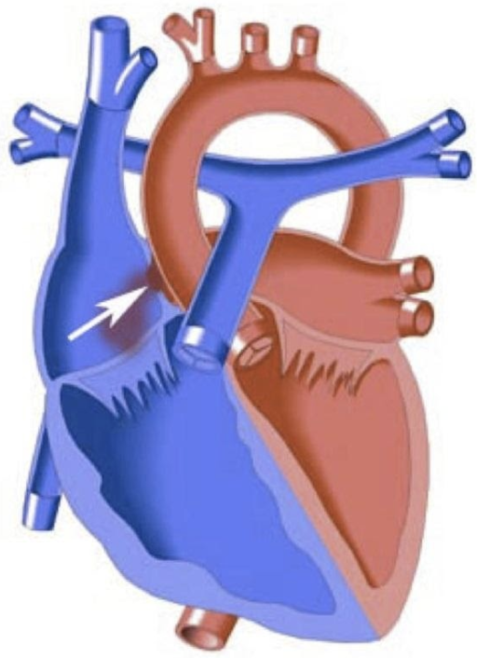

#### Basics

* **Volume** overload
* 4 types based on location and embryologic origin:
  1. Ostium primum: low in septum; can involve AV valve
  2. Ostium secundum: most common; near foramen ovale
  3. Sinus venosus: may involve connection w/ SVC, IVC, often associated PAPVC
  4. Coronary sinus (defect between CS and LA, not truly in atrial septum)
* Amount of L → R shunt depends on side of defect, SVR relative to PVR, relative LV and RV compliance
* PAPVC has similar hemodynamic consequences as ASDs

#### Presentation

* **Hx:** Often asymptomatic, may result in poor growth. When causing significant overcirculation, causes fatigue, dyspnea, CHF and can lead to pulmonary vascular disease (Eisenmenger syndrome). Paradoxical emboli.
* **PE:** Fixed and widely split S2. SEM caused by increased flow across PV, not flow through septal defect. Diastolic rumble if significantly increased volume of flow across the tricuspid valve.

#### Studies

* **EKG:** Enlargement of right-sided chambers, RBBB, RAD. Superior axis in primum ASD.
* **CXR:** Often normal. Overcirculation (increased pulmonary vascular markings). Cardiomegaly.

#### Treatment

* Secundum defects may close spontaneously
* Surgery indicated if symptomatic or is Qp:Qs > 1.5:1. Surgical or transcatheter closure.
* **Surgical goal:** Close the defect and avoid development of irreversible pHTN/Eisenmenger’s syndrome

### Ventricular Septal Defect (VSD)

#### Lesion

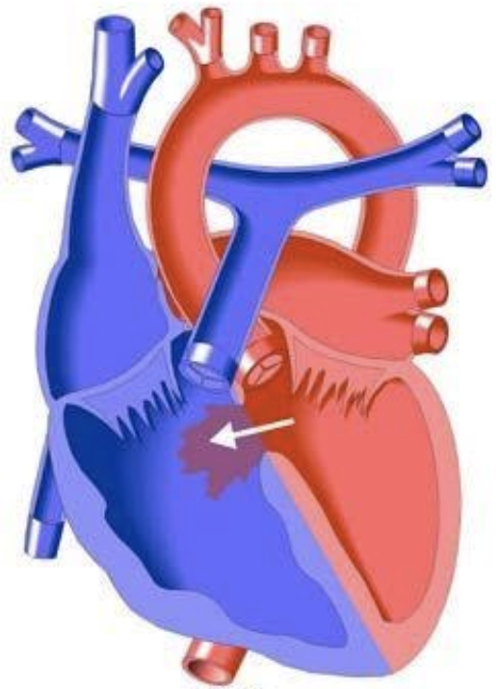

#### Basics

* **Volume** overload and possible **pressure** overload
* Opening in ventricular septum occurs in 1 of 4 locations:
  1. AV canal septum
  2. Conal septum
  3. Membranous septum
  4. Muscular septum
* Degree of shunting determined by size of defect and relative SVR/PVR:
  + If small in size (and pressure restrictive) may not be hemodynamically significant
  + If moderate in size, can cause pulmonary overcirculation and left-sided volume overload
  + If large can expose RV to systemic pressure in addition to volume overload

#### Presentation

* **Hx:** Depends on size. Symptoms occur as PVR decreases during first weeks of life and flow across the defect increases. Sx of CHF include, tachypnea, poor growth, sweating, feed fatigue, dyspnea.
* **PE:** Early or holosystolic regurgitant-type murmur. Smaller defects are louder because of higher pressure gradient across lesion. Large defects may cause very quiet murmurs (may only heard a loud S2). Volume overload can produce a left-sided heave.

#### Studies

* **EKG:** Normal or LAE, LVH, sometimes RVH if defect is large and RV is exposed to systemic pressure OR if pulmonary vascular disease has developed due to chronic overcirculation
* **CXR:** Can be normal, +/- mild cardiomegaly or increased pulmonary blood flow

#### Treatment

* May spontaneously close on its own, especially small muscular types
* Surgery if symptomatic or persistently elevated PVR; otherwise, may observe
* Repair is surgical patch closure or cath device closure
* **Surgical/cath goal:** Close the defect

### Patent Ductus Arteriosis (PDA)

#### Lesion

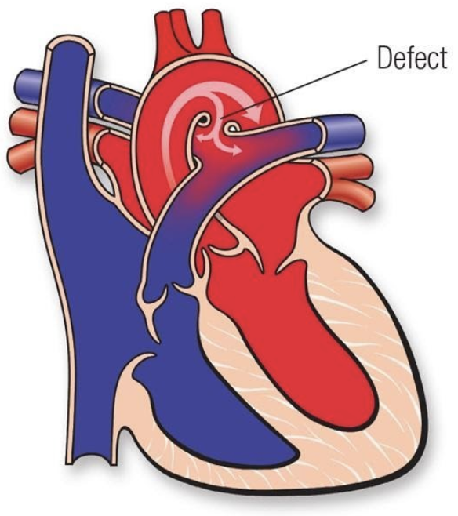

#### Basics

* **Volume** overload
* Common in premature newborns
* Can be asymptomatic, or can cause pulmonary overcirculation, CHF and systemic hypoperfusion

#### Presentation

* **Hx:** Respiratory distress, feeding fatigue, poor growth, CHF
* **PE:** Continuous “machine-like” murmur at LUSB (though murmur can also be systolic only), wide pulse pressure, bounding or palmar pulses

#### Studies

* **EKG:** Often normal, can have LVH or RVH
* **CXR:** Normal, +/- increased vascular markings, +/- cardiomegaly

#### Treatment

* Indomethacin, ibuprofen or acetaminophen in preemies. Less likely to be successful in non-preemies.
* Surgical ligation or cath device occlusion
* **Surgical/cath goal:** Close the duct

### AV Canal Defects (AVCD)

#### Lesion

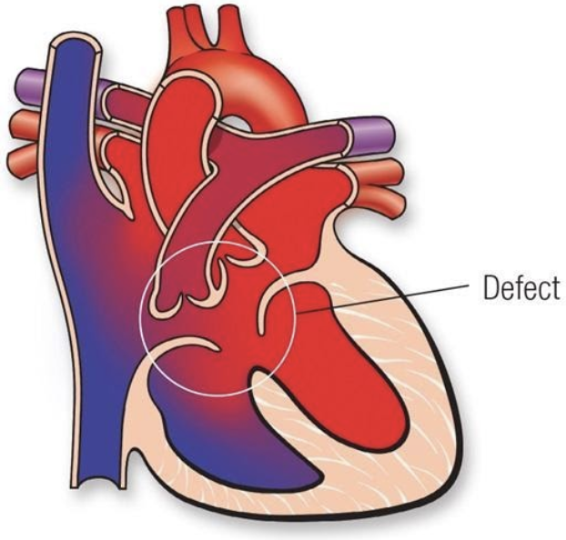

#### Basics

* **Volume** overload
* Components:
  1. Primum ASD
  2. AV-canal type VSD
  3. AV valve defects
* Occurs on a spectrum:
  1. Partial AV canal (ASD, cleft MV)
  2. Transitional AV canal (Cleft MV, ASD and small VSD)
  3. Complete AV canal (ASD, VSD, common AV valve)
* Common in T21
* Can be balanced (equal sized ventricles) or unbalanced (unequal sized ventricles)

#### Presentation

* **Hx:** Presentation similar to that of VSD w/ CHF: poor growth, sweating, feed fatigue, dyspnea. Severity depends on type of defect.
* **PE:** Murmurs of ASD, VSD, MR +/- gallop

#### Studies

* **EKG:** Superior axis; +/- RVH, LVH
* **CXR:** cardiomegaly +/- increased vascular markings

#### Treatment

* Surgery often required before in 1st year of life
* Patch closure of septal defects, often involves valvuloplasty
* **Surgical goal:** Closing defects and achieving AV valve competency
* **Complications:** AV valve regurgitation and stenosis after repair
* Single ventricle palliation may be required for severely unbalanced defects

### Congenital Corrected TGA

#### Lesion

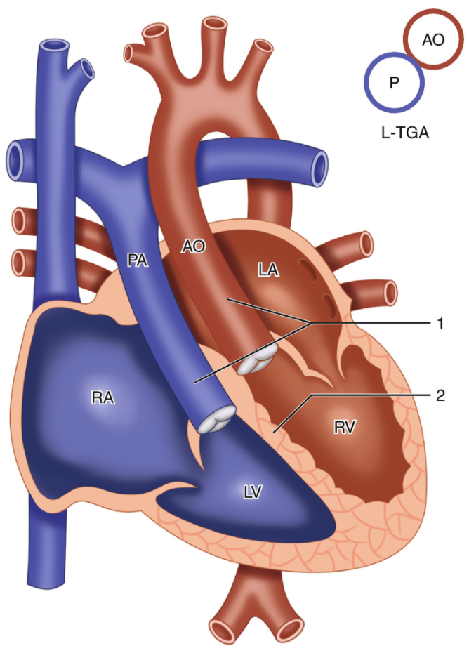

#### Basics

* Transposed great arteries (PA off LV, Ao off RV)
* Segmental anatomy is {S,L,L} or, less commonly, {I,D,D}
* **Blood flow:** LA → RV → aorta → body → IVC/SVC → RA → LV → PA → lungs → pulmonary veins → LA
* 90% associated w/ other cardiac defects (often a VSD, LVOT obstruction, Ebstein-like TV)
* Can have coronary anomalies
* High risk for spontaneous or post-surgical AV block

#### Presentation

* **Hx:** No cyanosis unless other cyanotic defects present. Can present w/ R heart failure in early adulthood as RV cannot tolerate work load as systemic ventricle.
* **PE:** Dependent on associated defects. May have stigmata of right heart failure. May have loud S2 due to anterior position of AoV.

#### Studies

* **EKG:** Q waves in right precordial leads, no Q waves in left-sided leads. Often have conduction system abnormalities including bradycardia and AV block.
* **CXR:** Dextrocardia or mesocardia may be present

#### Treatment

* Conventionally, only associated defects were repaired
* The newer anatomic approach involves the “double switch” operation, which involves an arterial and atrial level switch via baffling or a Mustard-Rastelli procedure if significant PS is present
* Often “training” of the LV w/ PA banding before the LV is made the systemic ventricle is required, unless significant PS or a large VSD is present
* Timing of surgery is a major challenge

### Valvar Pulmonary Stenosis

#### Lesion

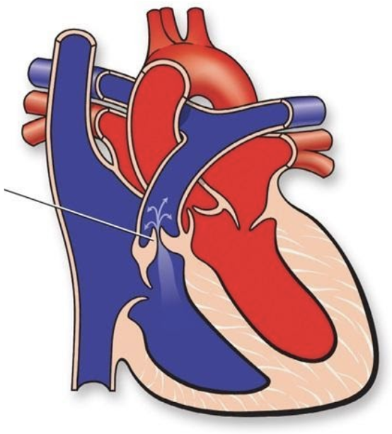

#### Basics

* **Pressure** overload
* Stenotic pulmonary valve, causing increased pressure on RV, TR, may be transmitted to RA
* **Critical** if ductal patency is required for pulmonary blood flow (these children require prostaglandins and early intervention)

#### Presentation

* **Hx:** If mild/moderate, asymptomatic. If severe, RV dysfunction and TR, hepatomegaly. If critical, can present w/ cyanosis.
* **PE:** SEM at LUSB, ejection click, +/-TR murmur. Often worsens in first few months of life, then stabilizes.

#### Studies

* **EKG:** Normal to RAD, RVH. +/- RV strain pattern.
* **CXR:** +/- ↓ vasc markings

#### Treatment

* **If critical,** start PGE
* Repair is balloon valvuloplasty in cath lab. Surgical repair if severely thickened valve, or muscular subpulmonary stenosis.
* **Surgical/cath goal:** Relieve obstruction, will often have some degree of PR afterward

### Valvar Aortic Stenosis

#### Lesion

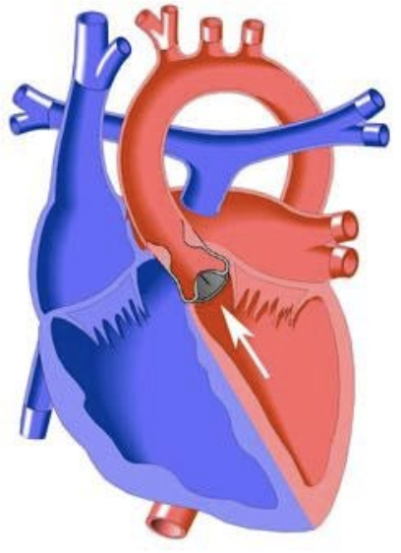

#### Basics

* **Pressure** overload
* LVOT obstruction LVH, systolic and diastolic dysfunction, CHF, MR. Severe LVOTO causes decreased CO.
* **Critical** if ductal patency is required for systemic blood flow
* Supravalvar stenosis common in William’s Syndrome

#### Presentation

* **Hx:** Infants often asymptomatic. Stenosis worsens w/ age, causing CHF or even cardiogenic shock.
* **PE:** Harsh SEM at base radiating to neck, ejection click w/ valvar stenosis, LV heave or tap

#### Studies

* **EKG:** LVH +/- strain pattern
* **CXR:** Normal to cardiomegaly; pulmonary edema possible

#### Treatment

* **If critical,** start PGE to maintain CO
* Repair is cath balloon valvuloplasty or surgical aortic valvuloplasty or valve replacement
* **Surgical goal:** Relieve obstruction, avoid AR

### Coarctation of the Aorta

#### Lesion

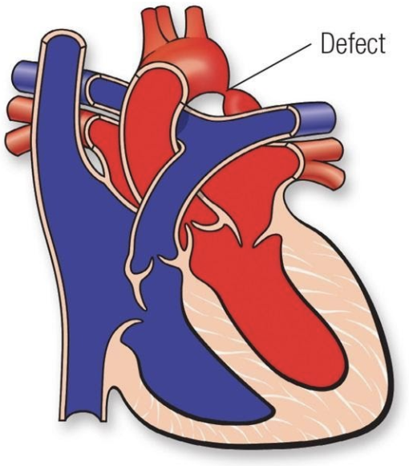

#### Basics

* **Pressure** overload
* Narrowing of the aorta near the aortic isthmus (juxta-ductal)
* If **critical,** requires PGE for systemic blood flow
* Common in Turner Syndrome

#### Presentation

* **Hx:** In infants, often presents as PDA closes: poor growth, sweating, feed fatigue, dyspnea and can present as cardiogenic shock
* **PE:** Upper extremity HTN, w/ drop in lower extremity BPs. SEM at LUSB radiating to back, BP gradient between R arm and legs, brachiofemoral delay and/or decreased/absent femoral pulses.

#### Studies

* **EKG:** RVH in infancy, LVH in children
* **CXR:** Cardiomegaly “3 sign,” rib notching in older children (collateral vessels eroding bone)

#### Treatment

* **Infants:** PGE if signs of shock to maintain CO
* Repair is surgical coarct excision and anastomosis or cath balloon dilation and possibly stenting in older children
* **Surgical goal:** Relief of obstruction
* **Complications:** Re-coarctation

## Cyanotic Congenital Heart Disease (CHD)

### Tetralogy of Fallot (ToF)

#### Lesion

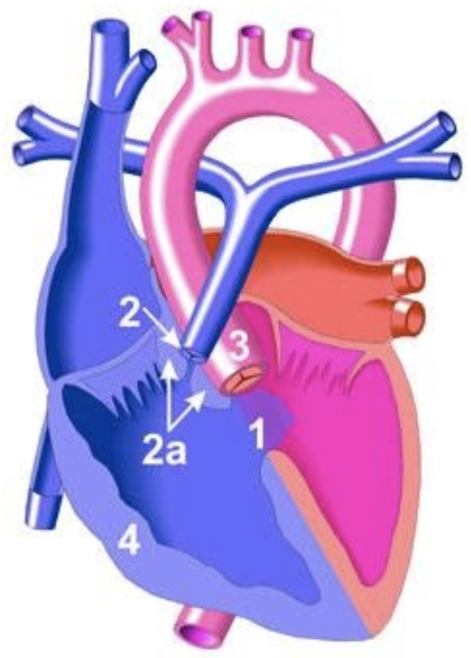

#### Basics

* Anterior malalignment of the conal septum, causing:
  1. Large anterior malalignment VSD
  2. RV outflow obstruction
  3. Overriding aorta
  4. RV hypertrophy
* Degree of cyanosis depends on amount of RVOT obstruction:
  + “Pink Tets” have minimal RVOT obstruction (VSD-like physiology)
  + “Blue Tets” have significant RVOT obstruction
* Pulmonary Atresia and Major Aorto-Pulmonary Collateral Arteries (TOF/PA/MAPCAs) is the most severe variant
* **Hypercyanotic episode (“Tet Spell”)** occurs due to: (1) dynamic worsening of RVOT obstruction, (2) increased PVR, and (3) decreased SVR. Results in cyanosis and, if persistent, acidosis 2/2 right-to-left shunting.

#### Presentation

* **Hx:** May have **“Tet Spells”**
  + Symptoms can range from severe cyanosis to predominantly pulmonary over circulation and volume overload resulting in heart failure depending on degree of RVOTO
  + **“Balanced” tets** (moderate PS, Qp:Qs close to 1) may present only w/ a murmur
* **PE:** SEM at LUSB (2/2 RVOT obstruction, VSD does not cause murmur), absent or soft P2

#### Studies

* **EKG:** RAD, RVH, RAE, RBBB
* **CXR:** “Boot-shaped” heart. Decreased pulmonary markings. +/- right-sided aortic arch. Look for absent thymic shadow (seen in patients w/ 22q11 deletion).
* Coronary artery anomalies are common, may have absent ductus arteriosus

#### Treatment

* PGE if neonatal cyanosis to preserve ductal patency and pulmonary blood flow
* **Acute hypercyanotic episode:**
  1. Decrease PVR: Supplemental O2, morphine, bicarb
  2. Increase SVR: Knees to chest, alpha-1 agonists
  3. Increase systemic venous return
* Beta blockers may be used to prevent infundibular spasm
* **Surgical repair:** Patch closure of VSD and relieve RVOT obstruction (may require muscle bundle resection, patch augmentation of RVOT which may be valve-sparing or a transannular patch). Unifocalization for TOF/PA/MAPCAs. Will often have PR after repair.
* **Surgical goal:** Close VSD, relieve RVOT obstruction

### Transposition of the Great Arteries (TGA)

#### Lesion

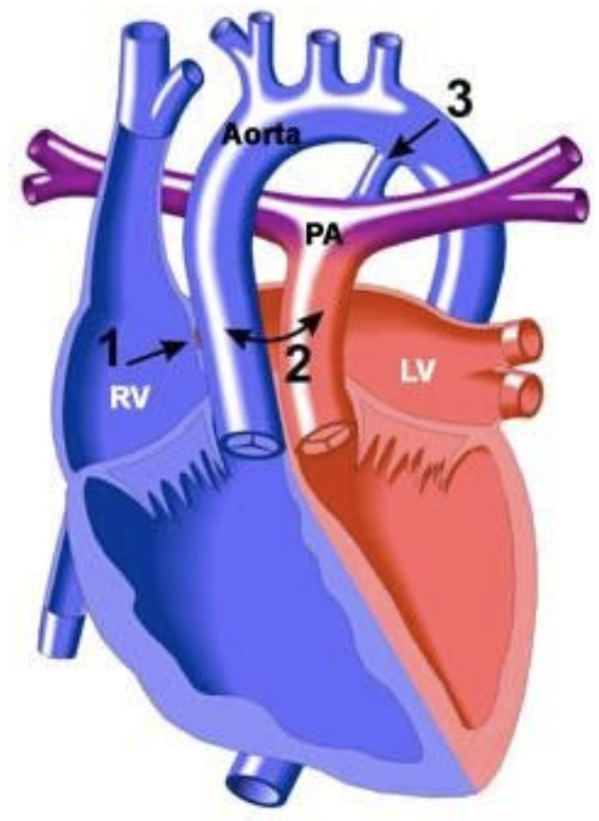

#### Basics

* Aorta arises from RV, pulmonary artery arises from LV w/ D-looped ventricles. May also have a VSD.
* Results in two parallel circulations and severe cyanosis unless **mixing** occurs at the atrial or ventricular level (PDA alone is not sufficient)

#### Presentation

* **Hx:** Profound cyanosis and tachypnea at birth. If large VSD, can have comfortable dyspnea.
* **PE:** Often no murmur if no VSD. +/- single S2.

#### Studies

* **EKG:** May be normal
* **CXR:** “Egg on a string” heart, increased pulmonary vascular markings

#### Treatment

* PGE in newborns
* Often emergent balloon atrial septostomy to ensure mixing of the two parallel circulations
* **Surgical repair:** Arterial switch w/ transfer of the coronary buttons. Older surgeries involved atrial switch (i.e. Mustard, Senning)
* **Surgical goal:** Restore normal connections between ventricles and great vessels

### Total Anomalous Pulmonary Venous Return (TAPVR)

#### Lesion

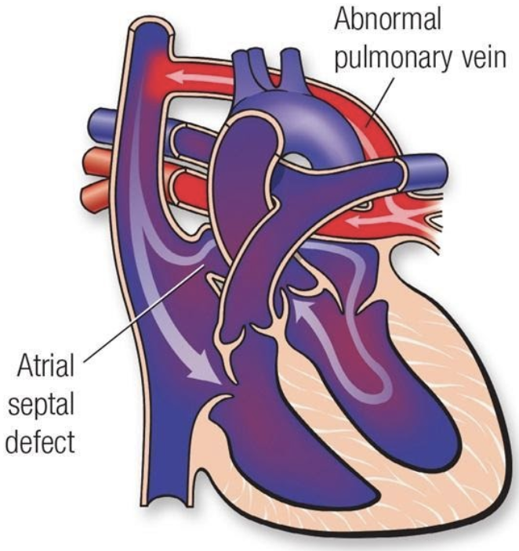

#### Basics

* Pulmonary veins do not return to LA
* Four types:
  1. Supracardiac
  2. Intracardiac
  3. Infradiaphragmatic
  4. Mixed
* Cyanosis is due to **mixing** of oxygenated and deoxygenated blood or pulmonary edema if veins are obstructed (common in infradiaphragmatic type)
  + **Must** have mixing lesion to survive (i.e. ASD)
  + Anomalous connection causes L → R shunt and there is shunting of mixed blood R → L at the atrial or ventricular level, causing cyanosis

#### Presentation

* **Hx:** Can mimic RDS if pulmonary venous obstruction is present. Can present w/ signs of RV volume overload if obstruction is not significant (similar to other left-to-right shunt lesions).
* **PE:** If vein obstruction, single loud S2. If no obstruction, increased RV impulse, SEM at LUSB, diastolic TV rumble. +/- fixed split S2.
* Cyanosis may be mild if Qp:Qs is high and there is no obstruction

#### Studies

* **EKG:** RAD, RVH, +/-RAE
* **CXR:** If pulm vein obstruction, pulm edema (similar to RDS). “Snowman sign” in supracardiac type.

#### Treatment

* Emergent surgery if severe vein obstruction: anastomose pulm venous confluence to LA and close ASD
* Supportive care including O2, inotropes, mechanical ventilation, ECMO as needed
* PGE may worsen cyanosis if there is pulmonary venous obstruction
* **Surgical goal:** Connect pulm veins to LA and close mixing lesion

### Tricuspid Atresia

#### Lesion

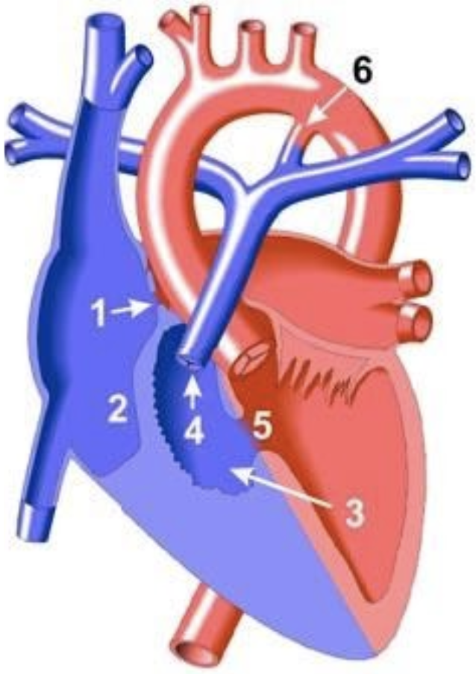

#### Basics

* No outlet from RA → RV. Supply to LA via PFO or ASD.
* Classified based upon great arterial relationship (d-TGA in type II), presence of VSD and degree of PS
  + If no VSD, will have hypoplastic RV and pulmonary atresia
  + If + VSD, variable severity of RV and PA hypoplasia
* Pulmonary blood flow may be PDA dependent

#### Presentation

* **Hx:** Variable timing depending on size of VSD and degree of PS. Usually cyanotic by 2 months w/ cyanosis, tachypnea.
* **PE:** +/- VSD murmur. Single S2.

#### Studies

* **EKG:** RAE, LVH, LAD w/ left/superior axis (distinguishes TA from most other forms of cyanotic disease)
* **CXR:** Usually decreased pulmonary vascular markings. Can have increased if TGA.

#### Treatment

* PGE if cyanotic, to maintain pulm flow
* Some neonates require atrial septostomy
* Manage CHF if present
* **Surgical repair:** Staged palliation: BT shunt → bidirectional Glenn → Fontan
* **Surgical goal:** Make two separate circulations w/ passive blood flow to the lungs and LV-driven systemic flow

### Ebstein’s Anomaly

#### Lesion

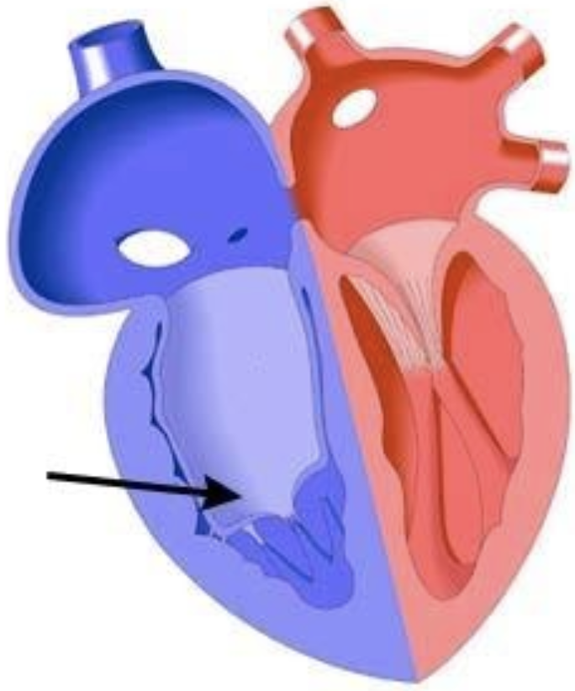

#### Basics

* Tricuspid valve is apically displaced into RV w/ leaflets adherent to RV wall, ASD present. Causes atrialization of the RV and RA enlargement.
* Impaired RV output 2/2 TR, RV dysfunction, possible RVOTO from redundant valve tissue
* Can cause a “circular shunt” in utero (Ao → ductus → retrograde PA → RA → PFO → LA → LV → Ao) and hydrops
* Frequently associated w/ WPW

#### Presentation

* **Hx:** Variable presentation from cyanosis in delivery room and early right heart failure to adults w/ murmurs, arrhythmia or incidental EKG findings based upon degree of TV displacement
* **PE:** Systolic murmur 2/2 TR. Often has gallop.

#### Studies

* **EKG:** RAE, RBBB. May have WPW and may present in AVRT.
* **CXR:** Cardiomegaly, which can be massive and box-like 2/2 RAE. Decreased pulmonary vascular markings can be normal.

#### Treatment

* Consider PGE in neonates w/ severe cyanosis
* Improves as PVR falls
* **Surgical repair:** Variable depending on severity, but may include TVplasty (Cone procedure) or replacement, reduction atrioplasty and ventricular plication. If severe, may require palliation down single ventricle pathway.
* **Surgical goal:** Improve RV function, reduce TR

### Hypoplastic Left Heart Syndrome (HLHS)

#### Lesion

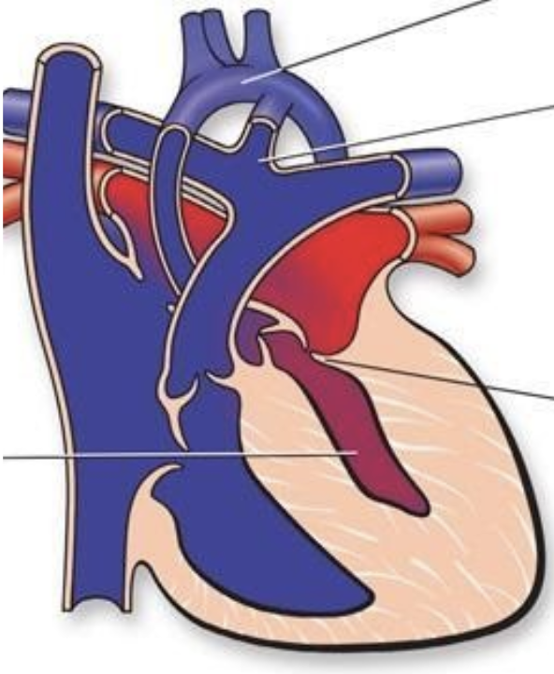

#### Basics

* Group of left-sided obstructive anomalies characterized by underdevelopment of the left heart thought to be secondary to reduced in utero blood flow
* Requires PDA and ASD for survival
* Three types:
  1. MS/AS
  2. MS/AA
  3. MA/AA
* Further classified based upon presence or absence of unrestrictive atrial septal defect
  + If atrial septum is intact (IAS) or restrictive, outcome is poor

#### Presentation

* **Hx:** Presents w/ cyanosis secondary to left atrial hypertension and pulmonary edema if atrial septum intact or restrictive. Presents w/ cardiogenic shock and CHF if atrial septum unrestrictive as PDA closes.
* **PE:** Increased RV impulse, single S2, often no murmur, poor pulses, cool extremities

#### Studies

* **EKG:** RVH, reduced left-sided forces
* **CXR:** Cardiomegaly, ↑ pulm markings

#### Treatment

* PGE to preserve ductal patency and systemic perfusion
* Balloon atrial septostomy if IAS
* **Surgical repair:** Three-stage univentricular palliation:
  1. Atrial septectomy, creation of neoaorta, modified BT-shunt or Sano shunt v. Hybrid procedure
  2. Bidirectional Glenn (superior cavopulmonary anastomosis)
  3. Fontan (total cavopulmonary shunt)
* **Surgical goal:** Separation of pulmonary and systemic circulation w/ passive pulm return and RV-generated systemic flow

### Double Outlet Right Ventricle (DORV)

#### Lesion

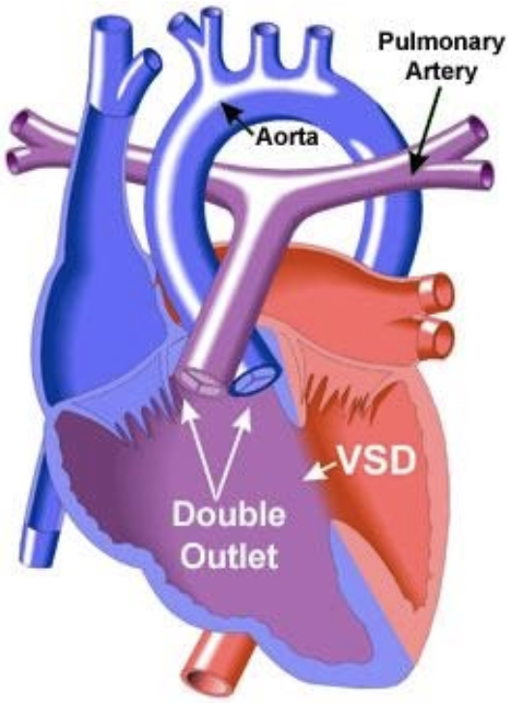

#### Basics

* Family of lesions where both great vessels arise from RV
* VSD always present
* Multiple “types” (dependent on relationship of VSD to great arteries):
  1. TOF-type: Sub-aortic VSD with PS (blood from LV goes predominately into LV)
  2. VSD-type: Sub-aortic VSD with no PS
  3. D-TGA type: Sub-pulmonary VSD
  4. Can also have a “doubly-committed” or “non-committed” VSD

#### Presentation

* **Hx:**
  1. TOF presents like TOF
  2. TGA-type presents like TGA, but usually w/ better mixing
  3. VSD type like VSD
* **PE:** Variable, based on type of DORV

#### Studies

* **EKG:** No hallmark EKG, because of variety of physiology types
* **CXR:** Cardiomegaly and pulm flow depend on degree of PS present

#### Treatment

* Medical management determined by Qp:Qs
* Treat CHF if present
* **Surgical repair:** Depends on physiology
* **Surgical goal:** Separation of pulmonary and systemic circulations versus single ventricle repair

### Truncus arteriosus

#### Lesion

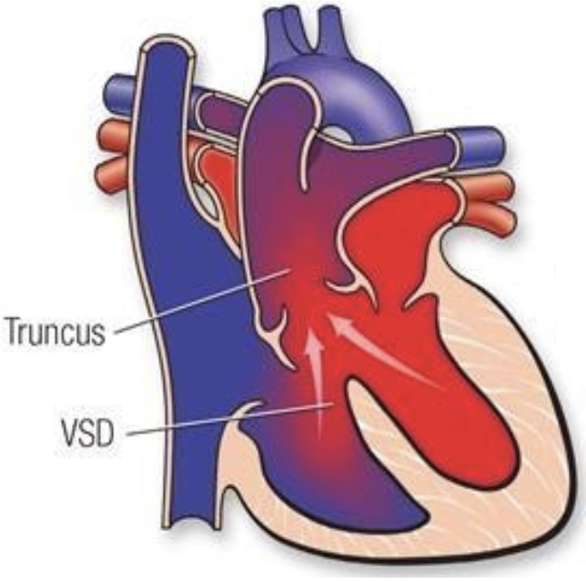

#### Basics

* Failure of embryonic truncus arteriosus to septate
* Associated w/ a VSD, aortic arch and coronary anomalies
* Several subtypes depending on how PAs come off the truncus
* Cyanosis is secondary to **mixing**
* Both ventricles feed both arteries, pulmonary overcirculation worsens as PVR falls
* Associated w/ 22q11 syndrome

#### Presentation

* **Hx:** CHF over first few weeks as PVR falls and dependent on degree of truncal valve regurgitation
* **PE:** loud single S2, ejection click. SEM at LUSB. Diastolic decrescendo murmur from truncal regurgitation. Bounding pulses from diastolic runoff.

#### Studies

* **EKG:** LVH, RVH
* **CXR:** Cardiomegaly. Increased pulmonary vascular markings. +/- right-sided aortic arch.

#### Treatment

* Treat CHF if present
* **Surgical repair:** Division of pulmonary arteries from truncus and placement of RV-PA conduit. Closure of VSD (i.e. Rastelli operation).
* **Surgical goal:** Establishing separated pulmonary and systemic circulations

### Pulmonary atresia with IVS

#### Lesion

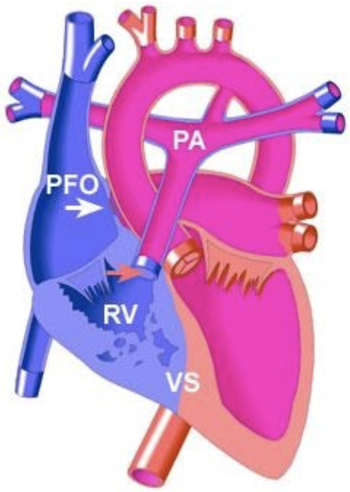

#### Basics

* Either membranous (valve leaflets are fused) or muscular (no valve tissue)
* Pulm flow depends on PDA
* R → L shunt via atrial
* Results in varying degrees of RV hypoplasia
* Can result in RV-dependent coronary circulation wherein large portions of coronaries are supplied by high-pressure RV cavity instead of from aorta

#### Presentation

* **Hx:** Cyanosis at birth that worsens as PDA closes
* **PE:** PDA murmur

#### Studies

* **EKG:** Mild LAD from weak right side, RAE
* **CXR:** ↓ pulm markings

#### Treatment

* PGE in newborns
* Cannot decompress RV if RVDCC → single ventricle palliation
* If non-RVDCC, can establish RV-PA continuity in cath lab or OR, some get “1.5 V” repair if RV hypoplastic

## Surgical Repair of CHD

### Stage 1 Operation (aka Norwood Operation)

#### Indications

Single ventricle heart disease with obstruction to systemic blood flow and hypoplastic aortic arch (prototype HLHS)

#### Goals

1. Establish systemic blood flow (DKS anastomosis creates neo-aortic valve from pulmonary valve, AscAo anastomosed end-to-side to provide coronary blood flow), aortic arch repair
2. Provide pulmonary blood flow:
   1. mBTS (continuous flow, results in diastolic hypotension)
   2. Sano shunt (RV-PA conduit, less diastolic run off, but requires right ventriculotomy
3. Provide adequate mixing at atrial level/left atrial decompression (atrial septectomy)

#### Post-op Sats

75-85%

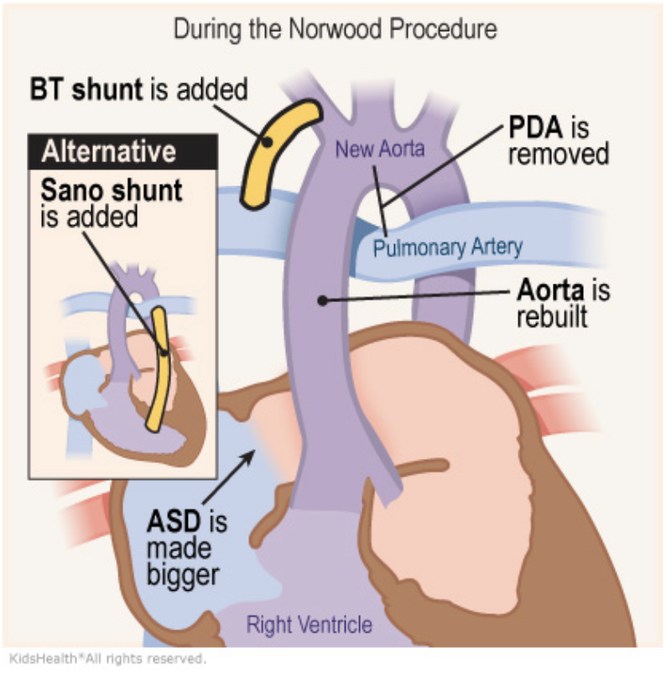

### Bidirectional Glenn

#### Indications

Intermediate step in single ventricle palliation (may be second operation for some (i.e. HLHS)), or first operation for others (i.e. some types of tricuspid atresia)

#### Goals

1. Provide passive pulmonary blood flow (anastomose SVC to RPA)
2. Volume-unload systemic ventricle (takedown mBTS or Sano)

#### Post-op Sats

80s

#### Complications

Results in no hepatic blood reaching the lungs and can lead to pulmonary AVMs

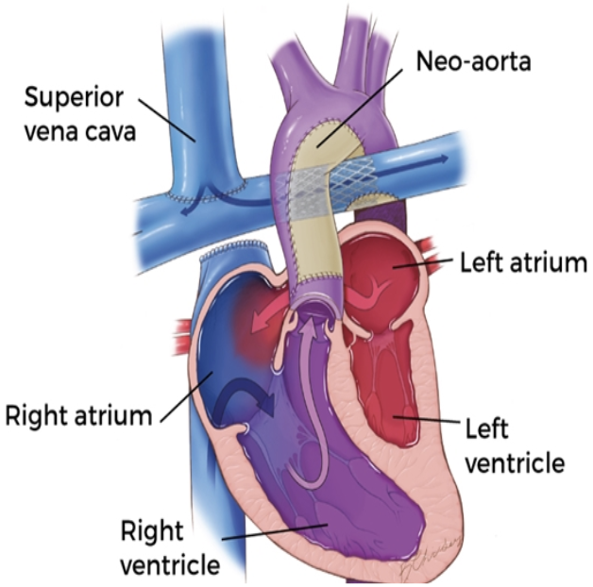

### Fontan

#### Description

Can be “lateral tunnel” (Fontan pathway within lateral atrium) or extra-cardiac. Usually “fenestrated” (small hole connecting Fontan pathway to systemic atrium: obligate right-to-left shunt).

#### Indications

Last stage of single ventricle palliation (common pathway for heterogenous group of conditions)

#### Goals

Increase pulmonary blood flow and provide “hepatic factor” to the lungs to prevent AVMs (IVC connected to PAs via Fontan pathway)

#### Post-op Sats

90%

#### Complications

Results in elevated CVP and chronic low CO, leads to a host of end organ problems including Fontan-associated liver disease, plastic bronchitis and PLE

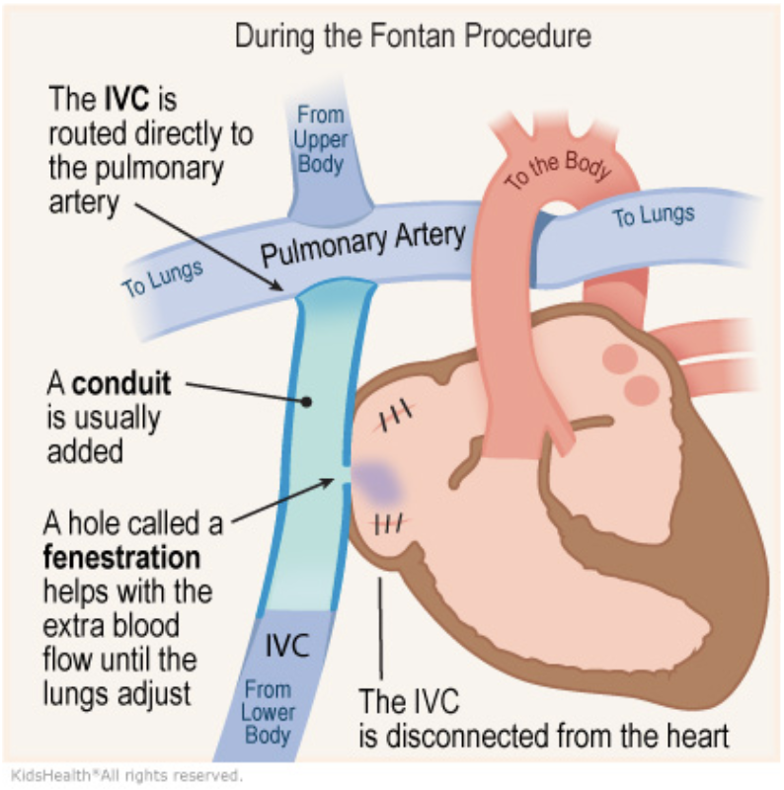

### Arterial Switch Operation

#### Indications

May be used as one component of the “double switch operation” for congenitally corrected TGA, or in some types of DORV

#### Goals

Create circulation that is “in series” rather than “parallel” by connecting translocating aorta and MPA above the valves (coronaries are moved as “buttons” with the aorta)

#### Complications

Post-op issues can include coronary obstruction and supravalvar PS/AS

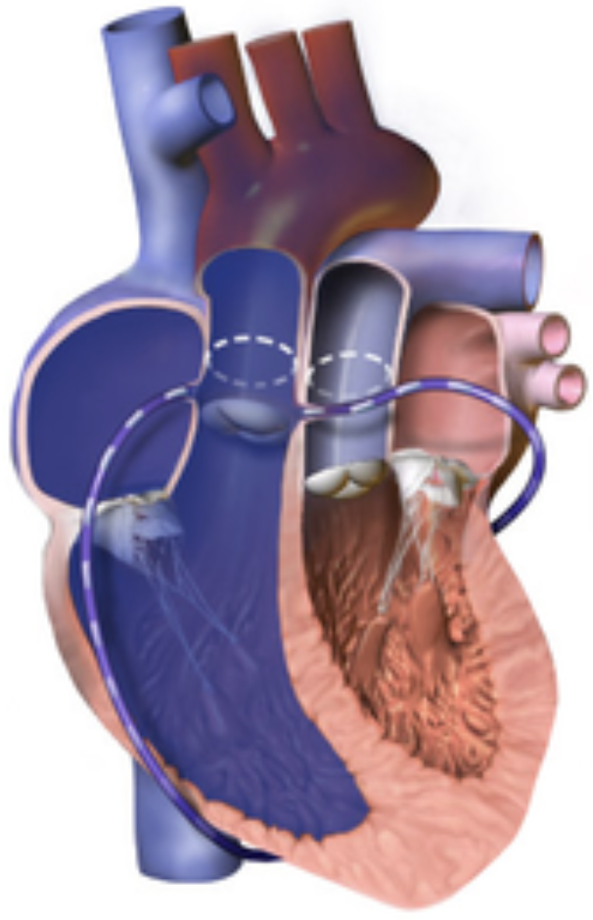 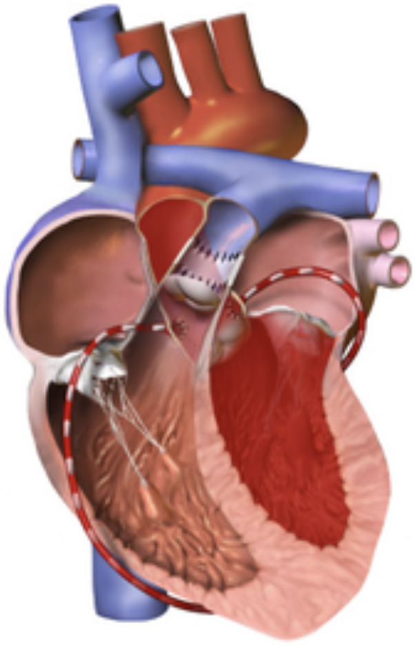

## Catheterization & Caring for the Post-Cath Child

1. Inspect access site (usually femoral or neck) for bleeding or hematoma formation
2. Assess distal pulses and ensure they are intact and equal bilaterally
3. Compare lower extremity warmth, edema and skin color:
   1. Signs of venous thrombus include edema, increased warmth and erythema
   2. Signs of arterial thrombus include pain, pallor, paresthesia/numbness, poor pulses and cool extremities
4. Listen to heart and lung sounds and think about what you should be hearing given what procedures were performed
5. Most patients will require at least one hemoglobin/hematocrit check to ensure they are not bleeding
6. Some patients will require a chest x-ray to ensure they have not developed a pneumothorax and to ensure their device has not migrated

#### Complications

Hematoma, pulseless limb, pulmonary hemorrhage, PTX, bowel ischemia, stroke

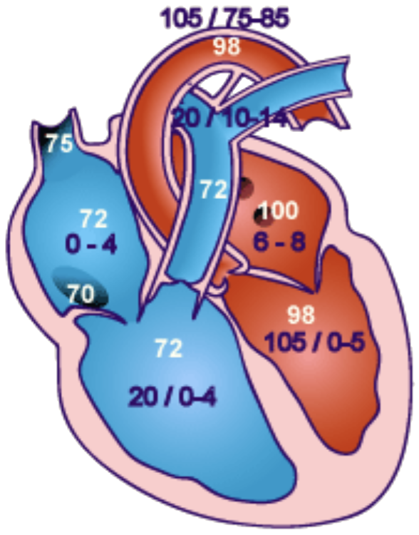

Normal post-cath pressures & sats

## Cardiomyopathy

### Hypertrophic Cardiomyopathy (HCM)

#### Presentation

Often discovered incidentally on EKG (LVH, T-wave abnormalities) or as part of familial screening. If symptomatic: Dyspnea, exertional chest pain, fatigue, presyncope, syncope, palpitations, ventricular arrhythmias and sudden death

#### Physical Exam

Left-sided heave and lateral displacement of the PMI; audible S4 and a harsh mid to late systolic murmur at the mid to lower left sternal border that is louder while standing as well as w/ the Valsalva maneuver (as decreased LV volume worsens the obstruction)

#### Pathophysiology

Autosomal dominant inheritance of mutation in sarcomeric proteins. Myofibrillar disarray and hypertrophy of the LV, most commonly the interventricular septum → LVOT obstruction and diastolic dysfunction (though other patterns of hypertrophy are seen). Associated with some syndromes (i.e. Noonan syndrome).

#### Work-up

* **EKG** may show left axis deviation, LVH w/ or w/o strain, and pathologic septal Q waves in the inferior and lateral leads +/- LA enlargement
* **Echo** w/ diagnostic LV and septal hypertrophy
* +/- Cardiac MRI (to assess tissue characteristics and risk stratify), catheterization, EP studies, genetic testing

#### Treatment

* ICD if high-risk features of history of arrhythmia
* Beta-blockers or calcium channel blockers reduce obstruction and have antiarrhythmic properties
* Septal or left ventricular myomectomy and septal alcohol ablation are sometimes utilized
* Severe cases may require heart transplant

### Dilated Cardiomyopathy

#### Presentation

Signs of right-sided heart failure (peripheral edema, hepatomegaly, JVD) and left-sided heart failure (pulmonary crackles, cold extremities and weak pulses); often tachycardic, tachypneic, DOE

#### Physical Exam

Systolic murmur (representing AV valve regurgitation) may be present w/ an audible S3 or S4

#### Pathophysiology

Systolic dysfunction w/ enlargement of ventricles. Often idiopathic but can be secondary to myocarditis, thyroid disease, metabolic disease, nutrient deficiencies (selenium, carnitine, thiamine), drugs (especially anthracyclines), toxins, radiation, infiltrative processes, muscular dystrophies, familial DCM syndromes.

#### Work-up

* **CXR** w/ cardiomegaly, pulmonary vascular congestion/edema
* **EKG** w/ sinus tachycardia and may show LVH and non-specific ST-T changes; may be low voltages and atrial enlargement; arrhythmias may be present
* **Echo** w/ LV chamber dilation and poor contractility

#### Treatment

Diuretics, ACE inhibitors, digoxin. May require mechanical support (VAD, ECMO) or heart transplant.

### Arrhythmogenic Cardiomyopathy

#### Presentation

Predominately symptoms attributable to ventricular tachyarrhythmia (syncope, SCD, presyncope, palpitations), or less commonly signs of heart failure

#### Pathophysiology

Fibrofatty replacement of the ventricular myocardium leading to dangerous ventricular dysrhythmias (and less often SVT) and ventricular dysfunction. Both ventricles can be involved (RV-dominant, LV-dominant, and biventricluar phenotypes)

#### Work-up

EKG, echocardiogram, EP studies, MRI and genetic testing

#### Treatment

* Beta-blockers, restriction from sports
* If history of VT or VF or have certain high-risk features, should have an ICD placed

### Restrictive Cardiomyopathy

#### Presentation

Signs and symptoms of heart failure (see CHF section below)

#### Pathophysiology

Non-compliant ventricular tissue → **diastolic** dysfunction and atrial enlargement w/ relatively normal ventricular dimensions

#### Work-up

Echo, cardiac cath, +/- cardiac MRI, consider genetic testing

#### Treatment

Heart failure management (see CHF section below). May require heart transplant.

### Left Ventricular Non-Compaction Cardiomyopathy (LVNC)

#### Presentation

Signs and symptoms of heart failure (see CHF section below)

#### Pathophysiology

During fetal cardiac development, the ventricular myocardium begins as a spongy, highly-trabeculated tissue that should become “compacted” ventricular cavity becomes relatively smooth, especially w/i the LV, which doesn’t happen in patients w/ this In patients w/ LVNC

* Can have predominately dilated, predominately restrictive or mixed phenotypes

#### Work-up

Echo, cardiac MRI, cardiac cath, consider genetic testing

#### Treatment

Heart failure management (see CHF section below)

## Congestive Heart Failure (CHF)

#### Presentation

* **Infants:** Tachycardia, tachypnea, feeding difficulty, diaphoresis (particularly w/ feeding) and poor growth
* **Children and adolescents:** Shortness of breath, orthopnea, cough, peripheral edema

#### Physical Exam

Gallops, murmurs (MR/TR), hepatomegaly, edema of ankles or eyelids, tachypnea, tachycardia, crackles, cool extremities, delayed cap refill, weak pulses

#### Pathophysiology

Multiple etiologies, including structural heart disease, arrhythmia, ischemia, cardiomyopathies, myocarditis, severe hypertension, and systemic issues (including severe anemia and severe thyroid disease)

#### Work-up

* **CXR:** Cardiomegaly and pulmonary edema, Kerley B lines
* **EKG:** Atrial or ventricular enlargement, ischemia, arrhythmia
* **Echo:** Depressed systolic function, +/- ventricular dilation and/or hypertrophy
* **Labs:** If severely depressed cardiac output, may have acidosis, elevated lactate, elevated BNP, abnormal electrolytes, and elevated CK and troponin (if myocardial injury is present). If right sided, may have abnormal liver studies.

#### Treatment

* **Diuresis:** Furosemide or other loop diuretic are first-line. Thiazide diuretics and spironolactone also may be used, usually in chronic CHF.
* **Inotropes:** Digoxin increases contractility. Dopamine or epinephrine may be used in sicker ICU patients.
* **Afterload reduction:** ACE inhibitors decreased SVR and may positively impact cardiac remodeling. Milrinone infusion has a similar effect and may be used in sicker patients.
* **Other measures:** O2 and correction of anemia aid O2 delivery. Salt restriction aids diuresis. Treating underlying illness (e.g. infection, arrhythmia, acidosis) can improve contractility. Sedation and mechanical ventilation can decrease demand on the heart.

## Coronary Artery Anomalies

### Anomalous Left Coronary Artery off the Pulmonary Artery (ALCAPA)

#### Presentation

Recurrent episodes of irritability and emesis, as well as **signs of congestive heart failure in infants** (diaphoresis, tachycardia, tachypnea, respiratory distress, weak peripheral pulses and cool extremities +/- gallop or MR murmur)

#### Pathophysiology

Left coronary artery arises from the pulmonary artery rather than left coronary cusp of aortic valve → massive ischemia once PVR falls (reversal of flow from coronaries into PA)

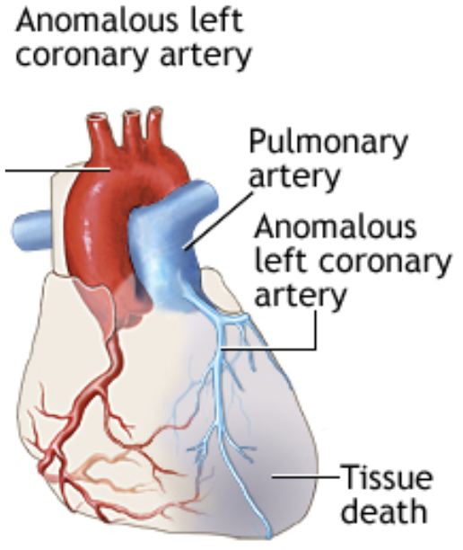

#### Work-up

* **CXR:** Cardiomegaly, pulmonary edema
* **EKG:** Signs of anterolateral ischemia manifest as pathologic Q waves (often very deep, but fairly narrow), inverted T waves and ST-segment elevation in leads I, aVL and V4-V6. Prolonged QTc may also be seen
* **Echo** is definitive, may confirm w/ MR/CT/angiography

#### Treatment

Surgery to reimplant LCA to aorta and patch pulmonary artery

### Anomalous Aortic Origin of a Coronary Artery (AAOCA)

#### Presentation

Range: asymptomatic → massive ischemia and sudden death

#### Pathophysiology

Variation in the number, shape or location of the ostia (origin) of the coronary arteries, usually non pathologic. LCA or LAD arising from the right coronary cusp leads the anomalous vessel to course anteriorly around the aortic valve, placing the vessel between the aorta and pulmonary artery and at risk for compression during times of peak cardiac output.

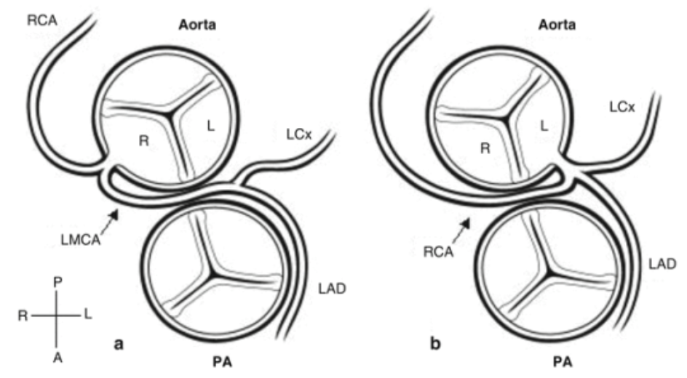

#### Treatment

* Anomalous LCA from the right coronary cusp (picture on L) is always treated w/surgery, even if asymptomatic, due to high risk of sudden death
* Anomalous RCA from the left coronary cusp (picture on R) is also associated w/ increased frequency of sudden death, though to a lesser extent; treatment is controversial

## Pulmonary Hypertension (pHTN)

#### Presentation

**Acute** → sx of R heart failure. **Chronic** → dyspnea w/ exertion and fatigue.

* Can lead to hemoptysis and sudden death from acute R heart failure from pulmonary hypertensive crisis
* May become cyanotic with acute increases in PVR if ASD present (which can preserve CO)

#### Physical Exam

RV heave, +/- TR murmur, cyanosis, clubbing, RHF signs such as JVD, hepatomegaly, peripheral edema

#### Pathophysiology

Mean pulmonary atrial pressure >20 mmHg. Causes are:

* Pulmonary arterial HTN
* Left heart dysfunction/obstruction
* Lung pathology or hypoxemia
* Chronic thromboembolism
* Multifactorial

#### Work-up

* **EKG:** RV hypertrophy often w/ accompanying strain (excessive right-sided forces for age w/ QRS-T angle > 90 degrees). In children, upright T-waves in V1 after 7-10 days of life suggests this diagnosis as can a qR pattern in V1.
* **CXR:** May show mildly enlarged cardiac chambers, underlying lung disease, and prominent proximal pulmonary arteries w/ diminished distal pulmonary vasculature
* **Echo:** May show enlarged or hypertrophied right-sided chambers. Position of the interventricular septum (which should bow into the usually low pressure RV) may flatten or bow into the LV. If present, the TR jet can estimate systolic RV pressure using the Bernoulli equation (upper limit of normal is ~25mmHg). Septal defects may also be used in this manner.
* **Cardiac catheterization** is definitive diagnosis. Mean PA pressures >20 mmHg are diagnostic. Often performed w/ pulmonary vasodilator testing to assess response to potential therapies.

#### Treatment

* Correct underlying cause!
* Counseling to avoid strenuous activity (esp. isometric exertion), avoid alpha adrenergic meds
* **Pulmonary vasodilators** can be used: Remodulin (IV infusion of trepostinil), Bosentan (endothelin receptor antagonist), Sildenafil (phosphodiesterase inhibitor), nifedipine (calcium channel blocker), iNO, supplemental oxygen

## Cardiac Infections

### Myocarditis

#### Presentation

Range: asymptomatic → chest pain, palpitations, syncope, CHF w/ DOE and fatigue

#### Physical Exam

Fever, tachycardia, ventricular arrhythmias, new murmur or cardiogenic shock (poor pulses, hypotension, cool extremities)

#### Pathophysiology

Usually due to **viruses** (coxsackie B, adenovirus and enterovirus, and more recently HHV6 virus and parvovirus B19, measles, mumps, rubella, CMV, HIV, arboviruses, parvovirus, and influenza) or **inflammatory conditions** (Kawasaki disease, ARF)

#### Work-up

* **Labs:** CBC, inflammatory markers, cardiac enzymes, viral serologies, +/- rheumatologic screening if a systemic inflammatory process is suspected
* **CXR:** May show cardiomegaly and pulmonary vascular congestion/edema
* **EKG:** Non-specific. May show sinus tachycardia, arrhythmia, heart block, prolonged QT-interval, bundle branch blocks, abnormal QRS axis, diffusely low voltage QRS complexes (<5 mm in full standard across the limb leads), non-specific ST-T changes, and diffuse ST elevations w/ PR depression if there is coincident pericarditis
* **Echo:** Useful for evaluating cardiac function and ruling out other causes of cardiac dysfunction, but cannot definitively diagnosis myocarditis
* **Gadolinium-enhanced cardiac MRI** that shows late gadolinium enhancement is suggestive of myocarditis, though is somewhat non-specific
* **Endomyocardial biopsy** via right heart cath may be diagnostic, but has low sensitivity due to sampling error

#### Treatment

Largely supportive:

* Tx CHF w/ diuretics, ACE inhibitors, +/- milrinone (can worsen hypotension), inotropes, +/- antiarrhythmics, anticoagulant
* IVIG used but data is limited
* Fulminant myocarditis may require mechanical support with ECMO or VAD

### Endocarditis

#### Presentation

* **Subacute:** Low-grade fevers, myalgias, fatigue, weight loss, exercise intolerance
* **Acute:** Rapid, fulminant, high fevers, toxic appearance (usually *S. aureus*)

#### Physical Exam

Tachycardia, new murmur, splenomegaly, **Roth spots** (retinal lesion), **Janeway lesions** (palms/soles), **Osler nodes** (painful fingers and toes), **splinter hemorrhages**

#### Pathophysiology

Bacteria (usually *S. aureus,* viridans strep, coag neg staph) that damage endothelium and set off clotting cascade leading to fibrin deposition over valve

#### Work-up

* **Labs:** BCx x3 initially, then daily if persistently febrile. CBC w/ elevated WBC, +/- anemia. Elevated ESR and CRP. Microscopic hematuria due to renal emboli.
* **CXR:** May show evidence of CHF or septic emboli
* **EKG:** May show AV conduction defects if vegetation involves conduction system
* **Echo:** TTE is adequate in most kids; TEE indicated only if TTE inadequate. Absence of vegetations on echo does not exclude a clinical dx of endocarditis.

#### Diagnosis

* Pathologic criteria: Pathologic lesions on histology (vegetation/abscess w/ active IE), OR microorganism identified on histology or culture of vegetation/abscess
* Clinical criteria (**Modified Duke Criteria**): 2 major, OR 1 major + 3 minor, OR 5 minor:
  + **Major Criteria:** (1) *>* 2 blood cultures w/ typical organisms (or persistently positive); (2) Endocardial involvement (vegetation, abscess, new valvular regurgitation)
  + **Minor Criteria:** (1) Predisposition; (2) Fever; (3) Vascular phenomena (septic emboli, mycotic aneurysm, ICH, Roth spots, Janeway lesion); (4) Immunologic phenomena (GN, RF+, Osler nodes)

#### Treatment

* **Antibiotics:** Empirically cover *Staph, Strep, Enterococci* (e.g. vanc) → tailor based on sensitivities; generally x4-6 wks
* **Surgery:** If persistent bacteremia despite adequate abx therapy, heart failure, progressive valvular dysfunction, conduction tissue involvement, or large lesion at high risk of embolizing

#### Complications

Heart failure (most common indication for surgery), perivalvular abscess (suspect if new conduction abnormality or persistent bacteremia), pericarditis, septic emboli, metastatic abscess, embolic stroke, renal infarction

### Pericarditis

#### Presentation

Chest pain (often relieved by leaning forward) +/- tachypnea and dyspnea

#### Physical Exam

Friction rub, weak apical impulse, poor perfusion, hepatomegaly

#### Pathophysiology

**Infectious** (bacterial, viral (Coxsackie), fungal, parasitic, TB), **inflammatory** (ARF, SLE, uremia, radition, drugs), traumatic, oncologic, chronic (constrictive pericarditis)

#### Work-up

**EKG** w/ decreased precordial voltages indicate **effusion**; diffuse ST elevation w/ PR depression is seen in **pericarditis**. Electrical alternans may manifest as QRS of alternating amplitude or axis, and is seen in pericardial **effusion.** There may be diffusely low voltage (< 5mm in full standard) QRS complexes in the limb leads.

#### Treatment

NSAIDs and colchicine, treat underlying cause

## References

# Cellular Therapy

## Introduction

Hematopoietic Cell Transplantation (HCT) is a powerful intervention that has the potential to cure numerous malignant and non-malignant disorders. For cancer, HCT allows high dose chemotherapy to be used +/- a graft-vs-leukemia effect (if allogeneic). For non-malignant disorders (hemoglobinopathy, immunodeficiency, primary HLH), the HCT can replace genetically defective cells with those that do not have the mutation.

As you can imagine, whether you are treating a malignant or non-malignant disorder fundamentally affects how you approach a transplant. For malignant disease, it is more important to use myeloablative conditioning (MAC) to try to completely eliminate all cancer cells. By contrast, when treating a non-malignant disorder, a mixed chimerism may sometimes be sufficient to provide functional cure, and reduced intensity conditioning (RIC) is an option. It is less about eliminating all patient bone marrow cells and more about sneaking in enough that work (note: if too few sneak in, they might be kicked out by patient = “graft failure”).

With MAC, there is higher potential for graft-vs-host disease (GvHD), given the high amounts of inflammation that occur, which is usually a precipitating factor for the GvH response. There are also more long-term sequelae of aggressive chemotherapy.

RIC is theoretically gentler with regards to GvHD and chemotoxicity. However, as mentioned, it increases the risk of graft failure, which is a scenario where the patient rejects the graft and can lead to disease recurrence with autologous recovery (bad) or pancytopenia (also bad).

The major risks of transplant are: chemotoxicity, veno-occlusive disease (VOD), transplant associated thrombotic microangiopathy (TA-TMA), infection, GvHD, and graft failure. We will try to outline the clinical and laboratory signs of these complications in the coming sections, along with the approximate time period after transplant one might expect them. Treatments shown reflect common practice at DFCI, but there is considerable variation across institutions.

Overall, transplant outcomes have significantly improved over the past few decades. While we see the sickest patients in our ICU, there are many we don’t see that are now thriving at home.

The cell therapy field is also witnessing some exciting innovations. Using gene editing, there are gene-corrected autologous HCTs being tested for a variety of monogenic disorders. Cytotoxic T lymphocyte therapies are being refined for viremia that is refractory to standard treatment. And, of course, how could we fail to mention CAR T?

## Hematopoietic Cell Transplantation (HCT)

### Graft

* CD34+ cells: the hematopoietic stem cells (HSC) that help reconstitute blood cell lineages in a patient
* T-cells: donor T-cells can recognize patient as foreign → GvHD (bad) or graft-vs-leukemia effect = GvL (good); meanwhile, residual host T cells can recognized donor as foreign → graft failure (bad)
* Other mixed immune cells

### Donor Types

*Everyone has a donor; some are more ideal than others*

Autologous Donor - self

* To rescue a patient’s hemopoietic system after high-dose chemotherapy for solid tumors (not appropriate for other indications)

Allogeneic – Related Donor

* Matched Related Donor (MRD) - biological sibling
  + bone marrow aspirated from sibling shortly before planned transplant
  + cord blood can be used if newly born sibling is known to be a match prior to birth
  + best outcomes; preferable for HCT for non-malignant disorders to optimize risk:benefit ratio
* Haplo-identical Donor – biological parent
  + not first choice but option that is available for most patients
  + may have pre- or post-transplant T-cell depletion to reduce risk of GvHD (see below)

Allogeneic – Unrelated (Matched or Mismatched)

* Sources: peripheral blood stem cells (PBSCs), bone marrow, cord blood (marrow most common at DFCI)
* Higher chance of GvHD and graft failure
* Can T-cell deplete via positive or negative selection
  + Positive selection – CD34+ HSCs isolated using magnetic beads and are used as product for transfusion (most common for PBSCs)
  + Negative selection – giving patients serotherapy like anti-thymocyte globulin (ATG) or alemtuzumab (Campath™) to kill the T-cells in the graft

### Conditioning Regimens

* Myeloablative (MAC)
  + Common regimens: busulfan-fludarabine “Bu/Flu” or Busulfan-Cyclophosphamide “Bu/Cy”
* Reduced Intensity (RIC)
  + Common regimens: Fludarabine-Melphalan-Campath “Flu/Mel/Campath”

*Considerations based on disease indication and any baseline organ damage*

### Timeline

* Patients are admitted 1-2 weeks before stem cell infusion, during which they have central access placed and receive their conditioning regimen to deplete their hematopoietic cells (max effect delayed per below)
* Stem cell infusion occurs on Day 0; the WBC nadir is usually Day +8-12
* Engraftment (ANC >500 x3 days) generally occurs by Day +14-28 depending on the cell source and conditioning used
* Criteria for discharge: neutrophil engraftment, no active infections, patient able to PO or tolerate NG (usually a 6-week admission at minimum)

### Complications

*All patients experience complications; some are inevitable (e.g. mucositis) and we work through them; others we try hard to avoid (e.g. graft failure)*

BEFORE STEM CELL INFUSION

* Anaphylactic/infusion reactions to agents (e.g. DMSO, ATG, Campath™)

DURING STEM CELL INFUSION

* Generally uneventful, but watch blood pressure

AFTER STEM CELL INFUSION

* Mucositis
  + Chemotherapy kills the mucosal layer in the GI tract; extremely painful; patients can’t eat and require TPN for a period of time
* Pancytopenia (before engraftment occurs)
  + Infection, anemia, and bleeding risks
  + Handle with transfusions and infection prophylaxis
  + Aid neutrophil recovery by giving Filgrastim
* Graft-vs-host Disease
  + Risk factors: HLA mismatch, MAC, non-CD34 selected PBSC graft
  + Acute GvHD usually onsets within the first 100 days
    - Skin rash, diarrhea, liver toxicity (not necessarily all)
  + Chronic GvHD onsets after Day +100
    - More scleroderma like, lung disease (bronchiolitis obliterans), joint pain
  + Prophylaxis with: Calcineurin inhibitor (Cyclosporine >> tacrolimus) + methotrexate (MTX) or CellCept (MMF)
  + Treatment with: steroids
* Veno-occlusive Disease (a.k.a. SOS)
  + Risk factors: MAC, busulfan, pre-existing liver dysfunction
  + Usually onsets within first 28 days of transplant
  + Warning signs: weight gain, ascites, painful hepatomegaly, rising LFTs, persistent thrombocytopenia
  + May need PICU admission for hepatopulmonary or hepatorenal syndrome (respiratory failure, AKI)
  + Prophylaxis with: ursodiol, Vit-E
  + Treatment with: defibrotide
* Transplant-associated Thrombotic Microangiopathy (TA-TMA)
  + Systemic endothelial injury → Coombs negative hemolysis (schistocytes!), platelet aggregation with microvascular thrombi (possible organ damage), and subsequent thrombocytopenia
  + Possible signs: *de novo* anemia and thrombocytopenia, schistocytes, new hypertension, elevated LDH, proteinuria, and terminal complement activation (sC5b-C9)
  + Treatment: eculizumab (terminal complement inhibitor)
* Graft Failure (GF)
  + If patient never achieves engraftment or if it is subsequently lost
  + Risk factors: RIC, HLA mismatch, certain conditioning agents
  + May require stem cell boost or second transplant to overcome pancytopenia
* CMV
  + Highest risk when there is a mismatch between donor/recipient status prior to transplant; monitor with weekly PCR
  + Viremia may take off when engraftment occurs
  + Challenge is that effective agents like valganciclovir are myelosuppressive, which can damage the graft
  + Symptoms: diarrhea, pneumonia, ocular disease
* EBV
  + B-cells infected with EBV proliferate but T-cells usually keep them in check
  + With GvHD prophylaxis, T-cells are inhibited and patient can develop post-transplant lymphoproliferative disorder (PTLD)
* Adenovirus, BK virus, HHV6, CLABSI
* Posterior Reversible Encephalopathy Syndrome (PRES)
  + Associated with use of calcineurin inhibitors (e.g. cyclosporine and tacrolimus) used for GvHD prophylaxis
  + AMS/seizures; diagnosed on MRI
* Late effects of chemotherapy
  + Patients get echocardiogram, PFTs, LFTs, kidney function tests prior to transplant as baseline
  + Women may be offered egg preservation
  + Can develop endocrine and reproductive issues, lung damage

## Cytotoxic T Lymphocytes (CTLs)

### Concept

* CMV, EBV, and ADV are common viruses that can have high morbidity/mortality in immunocompromised patients that are s/p HCT
* Current antiviral therapies like cidofovir & valganciclovir may tackle viremia, but they do not address the root cause, which is the lack of virus-specific T cells; this is where CTLs can help
* Steps to making a CTL therapy
  + Matched donor or third party donor provides peripheral blood mononuclear cells (PBMCs)
  + These are exposed to viral antigens in vitro
  + Virally activated T-cells are isolated from the T-cell milieu, expanded, and infused into patient
* Because T-cells are mostly specific to virus, there is less GvHD than with an unselected donor lymphocyte infusion
* To increase efficiency of manufacturing, tri-valent CTLs (specific to CMV, EBV, & ADV) are under investigation

## Chimeric Antigen Receptor (CAR) T-cells

### Concept

* T-cells are genetically engineered to actively target cells that express tumor specific antigens
* First FDA approvals came in 2017 with Kymriah™ and Yescarta™ for treatment of B-cell ALL and lymphoma (CD19-specific CAR)
* Steps to making a CAR T therapy
  + Autologous T-cells isolated from a patient
  + T-cells are genetically modified to express CARs
  + CAR T-cells are expanded in vitro
  + Patient undergoes lymphodepleting chemotherapy
  + CAR T therapy is infused
* What is a CAR?
  + Synthetic protein construct
  + Extra-cellularly, there is a single-chain variable fragment (scFv) that recognizes tumor cell surface antigens
  + Intracellularly, there is a co-stimulatory domain (e.g. CD28, 4-1BB, ICOS) that provides the necessary co-stimulation signal and a T-cell intracellular signaling domain (CD3z)
  + The extra- and intra-cellular domains are connected by a transmembrane fragment
* Who gets it?
  + At DFCI, CAR T is used as a bridge to transplant; ideally a patient with leukemia will be “minimal-residual-disease” (MRD) negative and then get a HCT as consolidation therapy
  + However, if they are MRD+, CAR T can be used to get them into full remission before HCT; other places may not proceed to HCT…it is so new that we are still getting the data for what recommendations should be

### Complications

* Cytokine Release Syndrome (CRS)
  + CAR T-cells are engineered to be activated (intrinsic co-stimulation)
  + Within days of administration, especially if high tumor burden, can have surge of pro-inflammatory cytokines
  + At its worst, this can lead to multi-organ failure and death
  + Prevention: lower disease burden, monitor closely
  + Treatment: tocilizumab
* Neurotoxicity
  + Altered mental status, myoclonus, and seizures have been witnessed with CD19 CAR T
  + Unknown pathophysiology; appears to be reversible

## Emerging Cellular Therapies

### Currently in Clinical Trials

* Gene-edited autologous HCT
  + For monogenic disorders (sickle cell, HLH, IPEX)
  + Still have to improve conditioning regimen to be less toxic
* Next Generation CAR T
  + Extension to solid tumors and additional liquid tumors
  + Built in safety mechanisms to prevent CRS (suicide genes)
  + Built in features to prevent T-cell exhaustion and to assist with solid tumor penetration
  + Multivalency to respond to combinations of antigens
  + Linkage of CAR to T-reg to apply same principal to autoimmunity
* Regulatory T-cells (T-reg) therapy
  + For GvHD and autoimmune disease
  + Working on preventing phenotype switching in vivo
* Mesenchymal Stromal Cell therapy
  + For GvHD and autoimmune disease
  + Working on improving efficacy
* Combined marrow and organ transplant
  + For inducing tolerance to solid organ transplantation
  + Most evidence for combined marrow and kidney transplantation, with some evidence for lung

# Critical Care & ICP

## Vasopressors & Inotropes

* Dopamine
  + Dosing
    - 1-20 mcg/kg/min (1-5 mostly affects DA; 6-10 β1; 11-20 α1)
  + Mechanism
    - DA, β1, α1
  + Considerations
    - Lower doses primarily cause inotropy & chronotropy (β1); DA-mediated splanchnic vasodilation of uncertain clinical significance
    - Higher doses will increase SVR and chronotropy, could decrease CO if afterload-sensitive
    - Can be used w/ norepinephrine for distributive or hypovolemic shock as higher doses increase SVR
* Epinephrine (EPI)
  + Dosing
    - 0.05-1 mcg/kg/min
  + Mechanism
    - β1, β2 > α1
  + Considerations
    - Increases CO, SVR w/ effects on CO > effects on SVR
    - Due to strong inotropic effects, preferred agent for cardiogenic shock
* Norepinephrine (NE)
  + Dosing
    - 0.01-1 mcg/kg/min
  + Mechanism
    - α1 > β1 > β2
  + Considerations
    - Primarily increases SVR, minimal change to HR
* Milrinone
  + Dosing
    - 0.25-1 mcg/kg/min
  + Mechanism
    - Phospho-diesterase (PDE) inhibitor
  + Considerations
    - Positive inotrope and decreases SVR (SVR effect more prominent - BP likely to decrease even if CO increases)
  + Useful for cardiogenic shock (CHF) w/ normal or high BP to reduce afterload and increase CO

## Shock

#### Definition

Metabolic demands of body > delivered oxygen to tissues

* Oxygen delivery (DO2) = content of arterial oxygen (CaO2) x cardiac output (CO)
* CaO2 = (1.34 x Hgb x % O2 Sat) + (0.003 x PaO2)
* CO = SV x HR, SV determined by preload, afterload, and contractility

#### Labs

* **Blood gas** w/ **lactate**
  + Assess pH and bicarb to determine degree of metabolic acidosis due to anaerobic metabolism - note, bicarb on blood gas is calculated based on the pH and pCO2 - obtain chemistry to measure directly
  + Increased lactate associated w/ inadequate tissue O2 delivery in shock states (but can also be elevated if not cleared appropriately, for example in liver failure)
* **Mixed venous saturation (ScvO2) / arterial-venous O2 difference**
  + Normal is 70-75%, normal AVO2d is 25-30%. ScvO2 often low in shock (inadequate delivery for utilization), can be high with hyperdynamic circulation, or may suggest impaired o2 utilization by cells due to injury (usually a bad sign)
  + Most useful from central line terminating in distal SVC, preferably RA; not useful from peripheral VBG
  + True pulmonary arterial saturation (SvO2) no longer routinely utilized
* **CBC** and **blood culture**
  + WBC count to assess infection
  + Hemoglobin to assess oxygen carrying capacity (see CaO2 above)
* **Chem 10** w/ **LFTs**
  + Chemistry to assess solutes (Na, K, Cl, gluc), bicarb, renal function (BUN/Cr), intravascular volume status (BUN:Cr ratio)
  + LFTs to assess liver damage(transaminase/GGT/bilirubin elevations)

### Types of Shock

* Hypovolemic
  + Causes
    - Dehydration, hemorrhage, osmotic diuresis, third-spacing fluid, burns
  + Physiology
    - Not enough fluid in vasculature → decreased preload & CVP → low CO → decr. O2 delivery
  + Findings
    - Dry mucous membranes, oliguria, weak pulses w/ delayed capillary refill
  + Management
    - Fluid resuscitation, stop fluid losses if possible (e.g. treat bleeding)
    - Rapid transfusion protocol if hemorrhage
    - Rapid infuser in ICUs, ED, OR
* Distributive (septic, anaphylactic, neurogenic)
  + Causes
    - **Septic & anaphylactic:** Vasodilation & increased capillary permeability)
    - **Neurogenic:** Loss of sympathetic innervation to vascular tone)
  + Physiology
    - Poor tone and/or leaking of vasculature → low SVR → relative hypovolemia/ preload, low DBP. Contractility may be depressed later in sepsis presentation, CVP will vary.
  + Findings
    - Bounding pulses & brisk capillary refill if capillaries are leaky → warm extremities (**NOT** always true in pediatric septic shock!)
    - Low DBP (especially in neurogenic), widened pulse pressure
  + Management
    - **Vasopressors:** New guidelines are **EPI for “cold”** and **NE for “warm,”** may also see dopamine and vasopressin)
      * Anaphylactic → EPI
      * Neurogenic → NE
* Cardiogenic
  + Causes
    - Arrhythmias, myocarditis, CHF, cardiomyopathy, trauma, **cardiac tamponade, pulmonary embolism**
  + Physiology
    - Poor contractility or ability to relax → ineffective systolic output → decreased CO w/ initial low CVP and high SVR
  + Findings
    - Weak pulses w/ narrow pulse pressure (due to low SBP), pallor, cold extremities, delayed capillary refill, **signs of heart failure** (respiratory distress, hepatomegaly, JVD)
  + Management
    - LIMIT fluid resuscitation (5-10cc/kg)
    - Inotropic agents (low dose dopamine, or epinephrine, less commonly dobutamine)
    - Can consider milrinone if BP normal to decrease afterload
* Obstructive
  + Causes
    - Pulmonary embolism, cardiac tamponade
  + Physiology
    - Ability to produce adequate CO is impaired because of obstruction
  + Findings
    - Tamponade - Pulsus paradoxus or electrical alternans, narrow pulse pressure w/ increased diastolic
  + Management
    - Specific to the underlying cause

### Septic Shock Treatment Algorithm[6]

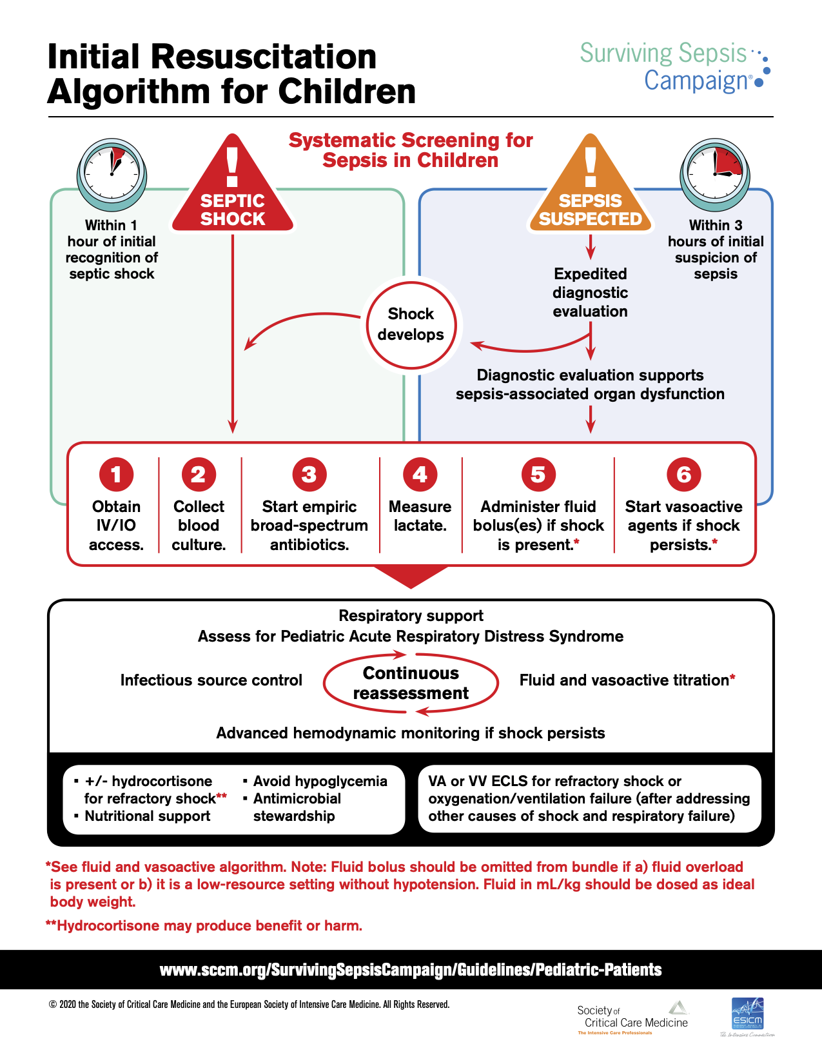 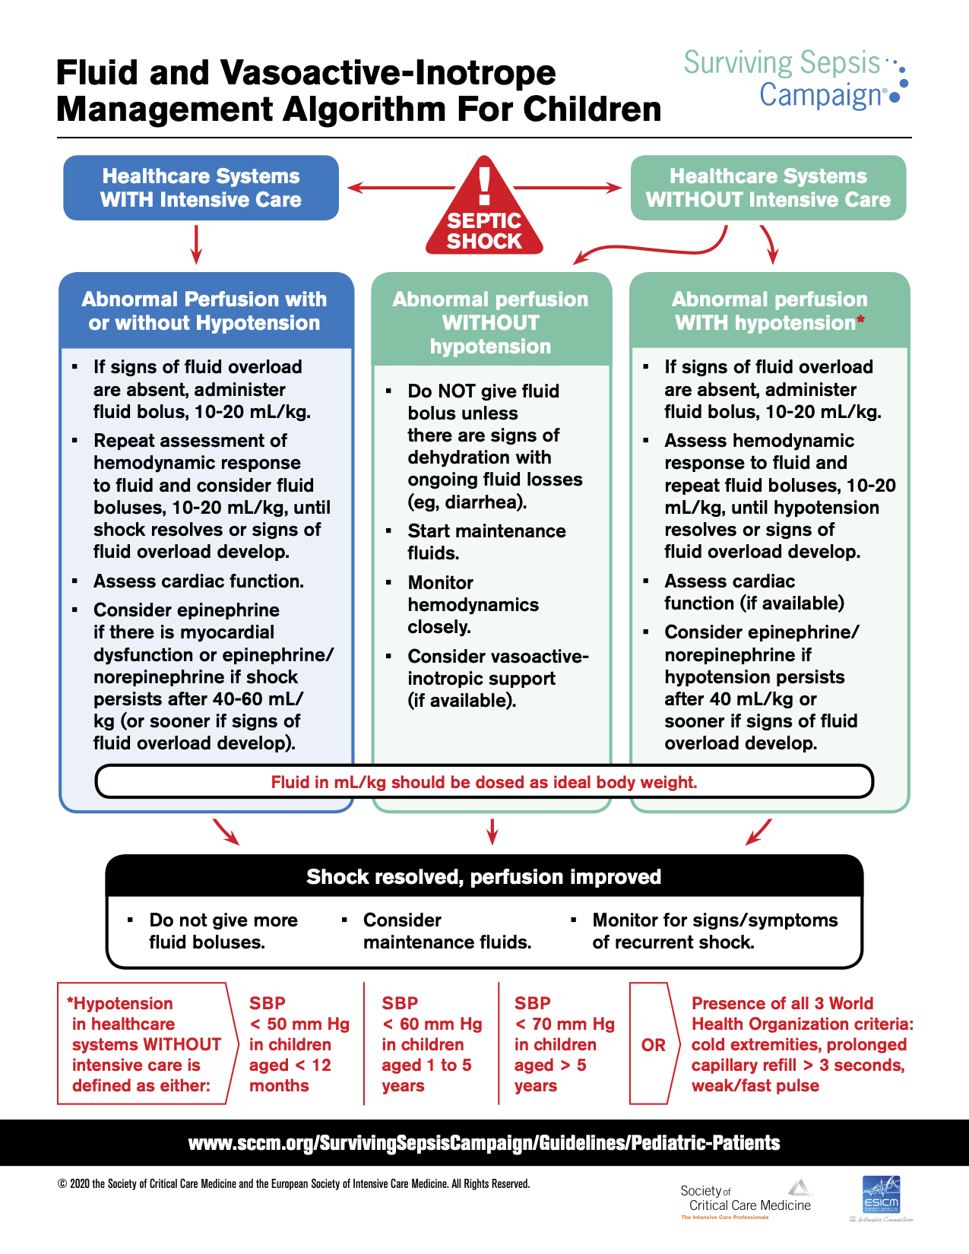

## Analgesia, Sedation & Paralysis

### Analgesics

* **Morphine**
  + Pharmacokinetics
    - Onset: 20 min
    - Duration: 3-5 hrs
  + Bolus Dose
    - IV: 0.05-0.1 mg/kg/dose q1-2h
  + Considerations
    - Can be associated w/ histamine release leading to hypotension, pruritus, flushing
* **Hydromorphone (Dilaudid)**
  + Pharmacokinetics
    - Onset: 15 min
    - Duration: 5 hrs
  + Bolus Dose
    - IV: 0.015 mg/kg/dose q3h
  + Considerations
* **Fentanyl**
  + Pharmacokinetics
    - Onset: Immediate
    - Duration: 30-60 min
  + Bolus Dose
    - IV: 1-2 mcg/kg/dose q1h
  + Considerations
    - Minimal hemodynamic instability w/ bolus doses
    - Large/rapid bolus doses can lead to muscle rigidity, interfering w/ ventilation → administer NMB or naloxone, support breathing

### Sedatives

* **Dexmedetomidine**
  + Pharmacokinetics
    - Onset: 5 min
    - Duration: 1-2 hrs
  + Dose
    - 0.2-2 mcg/kg/hr
  + Considerations
    - Dose-dependent bradycardia is common
    - Can also cause hypertension or hypotension
* **Midazolam (Versed)**
  + Pharmacokinetics
    - Onset: 1-5 min
    - Duration: 2-6 hrs
  + Dose
    - IV: 0.05-0.1 mg/kg/dose q1-2h
  + Considerations
    - Dose-dependent hypotension and respiratory depression
* **Lorazepam (Ativan)**
  + Pharmacokinetics
    - Onset: 15-30 min
    - Duration: 8-12 hrs
  + Dose
    - IV: 0.05 mg/kg/dose q4h-q12h
  + Considerations
    - Same adverse effects as midazolam, longer duration of action
* **Ketamine**
  + Pharmacokinetics
    - Onset: 30 sec
    - Duration: 5-10 min
  + Dose
    - **Intubation:** IV:1-2 mg/kg/dose (load) + 0.5 mg/kg/dose q5min PRN
    - **Conscious sedation:** IV: 0.2 - 1 mg/kg (load) + 0.5 mg/kg q10min PRN
  + Considerations
    - Dissociative (causes trance-like state associated w/ amnesia, but patients still move). Mild analgesic.
    - Myocardial depressant, but also increases catecholamine release
    - Bronchodilator
* **Propofol**
  + Pharmacokinetics
    - Onset: 60 sec
    - Duration: 3-10 min
  + Dose
    - 25-150 mcg/kg/min, bolus 1-2 mg/kg
    - Only credentialed ICU/anesth in non-intubated patients. Attgs can bolus (or fellow under direct supervision). Infusion not to last longer than 12 hrs in children.
  + Considerations
  + Dose-dependent hypotension (vasodilation and myocardial depression)
  + Prolonged/high dose infusions increase risk of propofol infusion syndrome (cardiac failure, arrhythmias, rhabdo, lactic acidosis, among other problems). Children at higher risk.

### Paralytics

* **Rocuronium**
  + Pharmacokinetics
    - Onset: 60-90 sec (high dose); 2-3 min (low dose)
    - Duration: 30-60 min
  + Dose
    - IV: 0.6-1.2mg/kg/dose
  + Considerations
    - High dose (1.2mg/kg) has more rapid onset but also longer duration, can be used for rapid sequence intubation
* **Vecuronium**
  + Pharmacokinetics
    - Onset: 1-2 min
    - Duration: 20-60 min
  + Dose
    - IV: 0.1 mg/kg/dose, or infusion of 0.1mg/kg/hr
  + Considerations
* **Cisatracurium**
  + Pharmacokinetics
    - Onset: 1-3 min
    - Duration: 25-44 min
  + Dose
    - IV: 0.2 mg/kg/dose, or infusion
  + Considerations
    - Undergoes non-enzymatic degradation in circulation, thus duration of action remains same in patients w/ liver/renal dysfxn
* **Succinylcholine**
  + Pharmacokinetics
    - Onset: 30-60 sec
    - Duration: 5-10 min
  + Dose
    - IV: 1-2 mg/kg
  + Considerations
    - See below

## Rapid Sequence Intubation (RSI)

*****NOTE:** Pre-oxygenate w/ 100% O2 for 2-5 min whenever possible!*

### Pre-Med (“Appetizer” 🥗)

* **Atropine**
  + Dosing & Pharmacokinetics
    - 0.02 mg/kg IV/IO (min 0.1mg, max 0.5mg)
  + Considerations
    - **PRO:** Prevents vagal response
    - ***Use if <1yo or <5yo if using succinylcholine!***
* **Lidocaine 2%**
  + Dosing & Pharmacokinetics
    - 1 mg/kg IV
    - Give 2-5 min prior to paralysis
  + Considerations
    - **PRO:** Likely ↓ ICP, RAD

### Induction (“Main Course” 🍔)

* **Ketamine**
  + Dosing & Pharmacokinetics
    - 1-2 mg/kg IV
    - **Duration:** 30-60 min
  + Considerations
    - **PRO:** Bronchodilator, ↑ BP
    - **CON:** ↑ ICP, dysphoria, sialogogue, cardiodepressant
    - ***Contraindications: ↑ ICP, globe injury, psychosis***
* **Propofol**
  + Dosing & Pharmacokinetics
    - 1-4 mg/kg IV
    - **Onset time:** 60 sec
    - **Duration:** 3-10 min
  + Considerations
    - **PRO:** ↓ ICP, anti-emetic
    - **CON:** ↓↓↓ BP, ↓ cardiac output
    - ***Contraindications: Shock, cardiac dysfunction, hypersensitivity***
* **Midazolam**
  + Dosing & Pharmacokinetics
    - 0.1 mg/kg IV/IO
  + Considerations
    - **PRO:** Short-acting
    - **CON:** ↓ BP, respiratory depression
    - ***Contraindications: HD instability***
* **Fentanyl**
  + Dosing & Pharmacokinetics
    - 2-4 mcg/kg IV/IO
    - **Onset time:** 90 sec
    - **Duration:** 30-60 min
    - ***Give slowly!***
  + Considerations
    - **PRO:** Short-acting opiate, hemodynamically neutral
    - **CON:** Apnea, chest wall rigidity
    - ***Contraindications: Hypersensitivity***
* **Etomidate**
  + Dosing & Pharmacokinetics
    - 0.3 mg/kg IV
  + Considerations
    - **PRO:** Best agent for HD stability
    - **CON:** Adrenal suppression, clonic movements
    - ***Contraindications: Septic shock***

### Paralysis (“Dessert” 🍰)

* **Succinylcholine**
  + Dosing & Pharmacokinetics
    - 1-2 mg/kg IV
    - **Onset:** 60 sec
    - **Offset:** 5-10 min
  + Considerations
    - Depolarizing agent
    - **PRO:** Good for laryngospasm
    - **CON:** Not reversible, can provoke hyperkalemia or malignant hyperthermia in susceptible individuals ,
    - ***Contraindications:***
      * ***↑ K+: Renal failure, burns, crush injury, neuromusc. dz, paraplegia***
      * ***Malignant hyperthermia (hx or risk)***
      * ***Pseudocholinesterase deficiency (will prolong effect)***
      * ***Known difficult intubation/upper airway obstruction (can’t be reversed)***
      * ***Globe injury, glaucoma***
* **Rocuronium**
  + Dosing & Pharmacokinetics
    - 1.2 mg/kg IV
    - **Onset:** 2 min
    - **Offset:** 30 min
    - Hepatic > renal excretion
  + Considerations
    - **PRO:** Safe alternative agent, reversible with neostigmine or sugammadex
    - **CON:** Longer onset/offset, transient HTN, hypotension also possible

## Respiratory Support: Ventilation & Oxygenation

### High-Flow Nasal Cannula (HFNC)

#### Definition

Delivery of heated and humidified air and oxygen at rates that exceed spontaneous inspiratory flow

#### Indications & Contraindications

* Indications
  + Respiratory distress/dyspnea to offload work of breathing
  + Asthma
  + Bronchiolitis
  + Tracheomalacia
  + Preoxygenation/apneic oxygenation prior to and during intubation
* Contraindications
  + Hypercarbic respiratory failure
  + Inability to protect airway
  + Impaired or absent spontaneous respiratory drive
  + Facial anomalies or injuries that preclude nasal cannula fit
  + Excessive oral or nasal secretions
  + Active vomiting
  + Bowel obstruction
  + Existing air leak (pneumothorax/pneumomediastinum)
  + Agitation or confusion predicting inability to tolerate

#### Bronchiolitis HFNC Pathway

* Inclusion criteria: Age <2yo w/ dx of bronchiolitis, hypoxia requiring >2L/min LFNC or 35% FiO2, or persistent increased WOB
* Initiate at 1 L/kg/min and adjust FiO2 to goal SpO2 >90%
* Reassess hourly to determine if can wean or need to escalate:
  + **Weaning:** Wait until patient has achieved 8 hr period of stability on current flow rate and FiO2 has been weaned to 21%-30%
    - If current support 1L/kg/min, turn HFNC off and transition to LFNC if still requiring FiO2
    - If not 1 L/kg/min, decrease flow to 1L/kg/min and then turn HFNC off after 8 hr period of stability
    - Monitor patient in setting that can restart HFNC for 8-12 hrs after discontinuation
  + **Escalation:** If no clinical improvement or increased WOB, escalate to 2 L/kg/min and continue to reassess hourly
    - If clinical improvement, can advance to **weaning** pathway
    - If no clinical improvement, consider transition to **NIPPV**

### Non-Invasive Positive Pressure Ventilaion (NIPPV)

#### Interface

Nasal mask, facemask, RAM nasal cannula depending on patient

* Consult w/ RT at BCH or BMC to evaluate patient early for best interface for NIPPV

#### Continuous Positive Airway Pressure (CPAP)

* Provides continuous airway pressure (**PEEP**). FiO2 can be adjusted to improve oxygenation as well.
* **Mechanism:** Alveolar recruitment improved, which improves oxygenation through better V/Q matching
* **Indications:** Hypoxic respiratory failure, obstructive sleep apnea, upper airway obstruction
* **Considerations:** No “breaths” delivered, so patient **MUST** be spontaneously breathing

#### Bilevel Positive Airway Pressure (BiPAP)

* Provides inspiratory pressure (**IPAP**) (compared to PIP), and expiratory pressure (**EPAP**) (compared to PEEP). Can also adjust FiO2 to improve oxygenation.
* **Mechanism:** In addition to alveolar recruitment, delta pressure (IPAP - EPAP) influences tidal volume to improve ventilation (Minute Ventilation = Tidal Volume x Respiratory Rate). IPAP can also reduce work of breathing.
* **Indications:** Hypoxic, hypercarbic or mixed respiratory failure
* **Considerations:** Although you can set a mandatory breath rate in certain BiPAP modes, machine breaths that are not aligned w/ patient efforts do not result in good tidal volumes due to the noninvasive interface; therefore **not a good choice** for patients w/ inconsistent respiratory drive. **Relatively contraindicated** in patients w/ altered mental status or who cannot protect their airway (ie. no cough or gag) from aspiration.

#### Weaning NIV Support

Refer to ICP SCAMP for pathway

* Criteria for **weaning** (must meet 4/5):
  + CV stability (HR and BP wnl for age or at patient baseline)
  + Work of breathing none to mild
  + FiO2 *<* 40%
  + tcCO2 or pCO2 at baseline or wnl
  + Afebrile
* Criteria for **sprinting** from NIV:
  + Clinical stability on goal setting for 4 hrs
  + Tolerating airway clearance measures/suctioning
* Markers of **intolerance to sprinting** (if at any time 2 or more markers shown, resume NIV):
  + Tachypnea increased
  + tcCO2, etCO2 or pCO2 increased by 10
  + Work of breathing increased from none/mild to moderate or severe
  + FiO2 increased to *>* 50% or NC >2 LPM from time of initiation of sprint

### Mechanical Ventilation (MV)

#### Glossary

* **MBR** (mandatory breath rate): # of breaths the ventilator will deliver to patient per minute (vent will ensure patient receives breaths if patient not spontaneously triggering the ventilator)
* **RR:** MBR plus whatever spontaneous breaths the patient takes (breaths above MBR may or may not be supported depending on mode)
* **PIP** (peak inspiratory pressure): Highest pressure the patient will see during the respiratory cycle
* **PEEP** (positive end expiratory pressure): Pressure the lungs see during expiration (helps keep the alveoli open during expiration and prevent atelectasis)
* **TV** (tidal volume): Max volume delivered to the patient during inspiration
* **IT** (inspiratory time): Time over which tidal volume is delivered
* **ET** (expiratory time): Time when inspiratory flow is not being delivered, generally longer than IT (basically what is left over after you have a certain number of breaths per minute w/ a certain Ti)
* **MAP** (mean-airway pressure): (Ti x PIP) + (Te x PEEP) / (Ti + Te)

#### General Principles of Mechanical Ventilation

* Improve **oxygenation** (increase **PaO2**) by recruiting alveoli and optimizing V/Q matching
  + Usually done by optimizing PEEP, MAP, I:E ratio. Can also increase inspired O2 concentration by increasing FiO2.
  + Both atelectasis and overdistension must be avoided
* Improve **ventilation** (decrease **PaCO2**) by increasing alveolar ventilation
  + Adjust variables that influence RR, TV
  + Remember: Lungs need to empty in order for new air from outside (pCO2 = 0) to enter (particularly in patients w/ obstructive physiology (asthma), which may require longer expiratory times)

#### Modes of Ventilation

1. **AC (Assist-Control)**
   * Every breath is machine supported and has the same parameters (PIP, PEEP, Ti), whether patient-triggered or machine-triggered
   * Breaths can be triggered by patient (assisted breaths) or elapsed time if patient not able to trigger (controlled breaths)
   * Risk of overventilation if patient’s spontaneous respiratory rate is high for other reasons (fever, agitation) or if ventilator is inappropriately triggering
   * Can set to pressure control or volume control
2. **SIMV (Synchronized Intermittent Mandatory Ventilation)**
   * Machine will synchronize breath delivery to align w/ patient’s effort, but if patient is not triggering breaths frequently enough, machine provides mandatory breath rate to patient
   * Often paired w/ pressure support ventilation (SIMV + PSV) to support breaths above mandatory breath rate
   * Can set to pressure or volume control:
     + **Pressure Control:** Set pressure, tidal volume changes based on compliance (∆V/∆P)
     + **Volume Control:** Set volume, pressure changes
3. **PRVC (Pressure-Regulated Volume Control)**
   * Ventilator adjusts pressure depending on exhaled tidal volume every 3rd breath
   * Optimizes lowest pressure possible to achieve set tidal volume by constant automated adjustments
4. **PS (Pressure Support)**
   * No mandatory breath rate, no set inspiratory time
   * When patient triggers a breath, machine delivers a set level of pressure above PEEP
   * Inspiratory time of breath determined by patient-driven inspiratory flow (flow cycling) - if patient is “satisfied” (inspiratory flow drops below a certain threshold from peak, because the patient stops actively inhaling), the ventilator will cycle into exhalation

#### Troubleshooting Desaturations on a Ventilator (“DOPE”)

* **D**islodgement (of ETT): Mask ventilate, call staff assist
* **O**bstruction (mucus plug): Suction, call nursing & RT
* **P**neumothorax: Obtain CXR, consider needle decompression if concern for tension physiology
* **E**quipment failure: Bag-ETT to ventilate, call RT

## Extracorporeal Membrane Oxygenation (ECMO)

#### Definition

An extracorporeal circuit designed to provide prolonged pulmonary (**VV ECMO**) or cardiopulmonary (**VA ECMO**) support by removing blood from the native vascular system, performing gas and heat exchange and reinfusing the oxygenated blood into the body.

* **Venovenous (VV ECMO):** Drains systemic venous deoxygenated blood, oxygenates it and removes carbon dioxide, and returns oxygenated blood to the systemic venous system. Provides pulmonary support (blood still goes through native heart and lungs) and is effective in respiratory failure w/ **intact cardiac function**.
* **Venoarterial (VA ECMO):** Drains systemic venous deoxygenated blood, oxygenates it and removes carbon dioxide, and returns oxygenated blood to systemic arterial system. Provides cardiopulmonary support (some blood bypasses native heart and lungs) and is effective in patients w/ **cardiopulmonary failure**.

#### Indications & Contraindications

* Indications
  + Hypoxemic respiratory failure w/ PaO2/FiO2 < 100 or Oxygenation Index (OI) > 40 despite optimized ventilator settings (PIP > 35 cm H20, PEEP > 10 cm H20, MAP > 18 cm H20; failure of high frequency ventilation) (OI = FiO2 * Mean Airway Pressure * 100/PaO2, note, multiply by 100 if (correctly) expressing FiO2 as a decimal; if using percent O2, don’t multiply by 100))
  + Persistent hypercapnic respiratory failure w/ arterial pH < 7.2 refractory to all ventilation modes.
  + Refractory cardiogenic shock
  + Cardiac arrest
  + Failure to wean from intraoperative cardiopulmonary bypass
  + VA ECMO or ventricular assist device (VAD) may be used as a bridge to cardiac transplant
  + VV ECMO is potential bridge to lung transplant in certain circumstances
* Contraindications
  + Lack of reversible etiology of critical illness
  + Irreversible, progresive, severe neurologic compromise
  + Large intracranial hemorrhage prior to ECMO
  + Severe bleeding
  + Severe coagulopathy or refractory thrombocytopenia
  + Unwitnessed out-of-hospital cardiac arrest
  + Presence of Do Not Resuscitate (DNR) Order
  + Pre-existing multiorgan failure

#### Pre-ECMO Initiation

1. Type and cross, arterial blood gas, electrolytes, CBC, coags, lactic acid, LFTs, chem 10
2. Head US in neonates to rule out severe IVH
3. Echocardiogram to evaluate cardiac function and for structural CHD

#### Titration

* Titrate to achieve an **arterial O2 saturation** >90% for VA ECMO and >80% for VV ECMO (there is mixing of oxygenated and deoxygenated blood w/i the RA during VV ECMO), and **mixed venous O2 saturation** of >70% for VA ECMO
* Target normal lactates and arterial BP (measures of perfusion)

#### Complications

* **Bleeding** is the most common complication (30-40% by some estimates), can be life-threatening. May require immediate surgical intervention, brief cessation of heparin infusion or use of plasminogen inhibitors (i.e. aminocaproic acid).
* **Thromboembolism** is infrequent, but can be catastrophic, especially in VA ECMO where embolization is systemic
* **Vessel perforation, dissection, or occlusion,** resulting in **distal ischemia** (latter can be seen in femoral arterial cannulation, treated w/ placement of a distal perfusion cannula)

## Acute Respiratory Distress Syndrome (ARDS)

#### Definition

* Acute respiratory failure not fully explained by cardiac etiology or fluid overload
  + Excludes patients w/ perinatal pulmonary disease
* CXR w/ pulmonary infiltrates (does not have to be bilateral)
* Increased oxygenation index

#### Pathophysiology

* No unifying pathophysiology for ARDS - can be direct injury (pneumonia, traumatic contusion) or indirect (systemic inflammation from sepsis)
* Overall, insult causes alveolar cell damage filling of airspaces w/ exudate. Over ~3 wks, granulation tissue formation occurs which leads to remodeling and fibrosis.
* Alveolar collapse leads to V/Q mismatch

#### Clinical Manifestations

* Respiratory distress out of proportion to underlying disease
* Hypoxemia
* Decreased lung compliance

#### Diagnostic Studies

* CXR: Commonly see bilateral infiltrates, although not required for diagnosis
* ABG: High A-a gradient
* PaO2 to FiO2 ratio is < 300

#### Management

Lung protective ventilatory strategies to reduce ventilator-induced lung injury

* Maintain TV 4-6cc/kg, use PEEP to improve oxygenation (continue increasing PEEP if FiO2 > 0.6 and not hyperinflated). Target SpO2 88-94% (wean if >98%), goal FiO2 < 0.6.
* Permissive hypercapnia (pH 7.15-7.30), PaCO2 60s

## Hypertensive Crisis

#### Definitions

* **Hypertensive Urgency:** Severe elevation in BP WITHOUT evidence of acute end-organ damage
* **Hypertensive Emergency:** BP >Stage II HTN for age WITH evidence of **acute end-organ damage**

#### Etiology

* **Neonates:** Renovascular disease, congenital renal anomalies, BPD, coarctation
* **Children:** Renovascular disease, glomerulonephritis, endocrine disease
* **Adolescents:** Renovascular disease, drugs (cocaine, amphetamines, Serotonin Syndrome)

#### Clinical Manifestations

* **Hypertensive encephalopathy:** Headache, altered MS, vision changes, seizures, acute stroke
* **Myocardial ischemia:** Acute chest pain, dyspnea, orthopnea, cough. Can hear diffuse, fine crackles at lung base, S3 gallop.
* **Aortic dissection:** Chest & abdominal pain, end-organ dysfunction
* **Retinal hemorrhages** and exudates
* **Malignant nephrosclerosis:** Leading to acute renal failure, hematuria, and proteinuria
* **Posterior Reversible Encephalopathy Syndrome (PRES):** Encephalopathic or seizing patient in setting of acute hypertensive crisis w/ neuroimaging findings of reversible vasogenic subcortical edema w/o infarction. Edema usually seen in parietal and occipital lobes.

#### Diagnostic Studies

* 4-extremity BPs
* Fundoscopic exam
* Chem 10 to evaluate for renal impairment
* CBC +/- reticulocyte count and smear to look for microangiopathic anemia
* UA to look for hematuria, proteinuria
* EKG to look for evidence of LVH or myocardial ischemia
* CXR if chest pain or SOB (look for cardiac enlargement, pulmonary edema)
* Head CT or MRI if abnormal neurologic exam or mental status
* Consider tox screen, pregnancy test, endocrine testing to look for underlying cause

#### Management

* **Hypertensive Urgency:** Reduce BP slowly over 24-48 hrs
  + IV Hydralazine/Labetalol OR PO Isradipine/Clonidine
* **Hypertensive Emergency:** Reduce BP by 10-20% over 1st hr, reduce by no more than 25% in first 8 hrs
  + IV Hydralazine or Labetalol bolus, followed by Nicardipine or Labetalol infusion

##### Medications for Management of Hypertensive Crisis

* **Hydralazine**
  + Dosing
    - Start at 0.1-0.2 mg/kg/dose (max 20mg), max 0.5 mg/kg q4h
    - Onset 10 min, duration 4-6 hrs
  + Indications
    - Short-term control of symptomatic hypertension
  + Considerations
    - Not for use in LV dysfunction
    - Potential exists for prolonged hypotension
* **Labetalol**
  + Dosing
    - 0.25-1 mg/kg/dose (max 40mg) as frequently as q5-10min, or continuous 0.25-1 mg/kg/hr
  + Indications
    - Short-term control of symptomatic hypertension
    - For **pheochromocytoma**, use after initiation of an alpha blocker so as to not precipitate hypertensive crisis
  + Considerations
    - Not for use in myocardial dysfunction
* **Nicardipine**
  + Dosing
    - Loading dose 5-10 mcg/kg, then 0.5-3.5 mcg/kg/min
    - Peak effect at 30 min, lasting up to 4 hrs
  + Indications
    - Consider using w/ renal dysfunction
  + Considerations
    - Not for acute heart failure or coronary ischemia
    - **Caution** in infants w/ calcium-dependent myocardium

## Diabetic Ketoacidosis (DKA)

#### Order Set

* DKA ICP Order Set → Look for Excel calculator hyperlink for 2-Bag Method
* Yellow DKA Card

#### Definition

Plasma glucose >200 + Acidosis (pH <7.3 or venous HCO3 <15) + Ketonuria or ketonemia

#### Clinical Manifestations

* Hyperglycemia, vomiting, abdominal pain, dehydration, altered mental status
* History of Type 1 Diabetes or weight loss, polyuria, polydipsia

#### Diagnostic Studies

* **Initial:** Chem 10, beta-hydroxybutyrate, VBG, HgbA1c, consider pancreatic autoantibody panel, TFTs, c-peptide, insulin, urine ketones
* While on **insulin infusion:**
  + Point of care glucose q1h
  + Chem 10, beta-hydroxybutyrate, VBG q2h
* While on **subcutaneous insulin:**
  + Point of care glucose before meals/bed and q2am
  + Chem 10, beta hydroxybutyrate, VBG only PRN

#### Management

1. **FLUIDS:**
   * **NS Bolus:** 10 cc/kg IV x1, may repeat with caution
   * **2-Bag Method** for fluid management (defer if serum K >5 mEq/L)
     + 1.5-2x maintenance rate - use excel calculator to titrate Bag #1 and 2 rates
     + Bag #1 = NS + K Acetate 20 mEq/L + K Phos 20 mEq/L
     + Bag #2 = D12.5W + NS + K Acetate 20 mEq/L + K Phos 20 mEq/L
   * **Goal Dextrose Content** in infusion (based on blood glucose)
     + 300 = 0%
     + 276-300 = 5%
     + 251-275 = 7.5%
     + 201-250 = 10%
     + <200 = 12.5%
2. **INSULIN INFUSION:** Start after 1hr of fluid administration)
   * Start infusion at 0.1 units/kg/hr (for mild DKA, can use 0.05 unit/kg/hr)
3. **SUBCUTANEOUS (subQ) INSULIN:** Start when patient can tolerate PO, vpH >7.3, HCO2 >15, and/or anion gap 14)
   * Give the first rapid- and long-acting subQ insulin 15 min pre-meal. Stop IVF & insulin drip 30 mins after subQ dose.
   * Calculate **total daily dose (TDD)** based on chart in DKA card and per Endocrine consult
   * **Basal-Bolus regimen** = ½ of TDD as Lantus or Tresiba once daily + ½ TDD as Humalog divided in meals

#### Complications

* **CEREBRAL EDEMA:** Headache, emesis, increased BP, change in consciousness/responsiveness, delirium, confusion, unequal/dilated pupils, cranial nerve palsy, papilledema, incontinence, bradycardia, respiratory irregularity or arrest, sudden polyuria
  + Decrease IV rate, raise HOB to 30°
  + Mannitol 1 g/kg IV over 15 min, follow UOP and VS
  + Consider ETT placement for airway control & hyperventilate to pCO2 patient had prior to intubation → slowly normalize over 12-24 hrs
  + Consider STAT head CT once airway is stabilized
* **HYPOPHOSPHATEMIA:** Metabolic encephalopathy (irritability, paresthesias, confusion, seizure, coma), ileus, dysphagia, proximal myopathy, hemolysis
* **HYPONATREMIA:** Presentation varies based on measured sodium (**Na 115-120** = seizure, coma, respiratory arrest. **Na 120-125** = lethargy, headache, obtundation. **Na 125-130** = nausea and malaise.)
  + If symptomatic, infuse 3% hypertonic saline 5 mL/kg IV over 15 min, stop when symptoms resolve
* **HYPOGLYCEMIA:** If BG <200 and anion gap is near to normal, reduce insulin to 0.075 cc/kg/hr, then to 0.05 unit/kt/hr. Discuss with Endocrine prior to decreasing.
* **HYPOKALEMIA:** If symptomatic, give 0.5-1 mEq/kg IV over 2 hrs with goal K=3.5 to 4.5
* **HYPOCALCEMIA:** Decreased BP, tetany, laryngospasm. May result with excess phosphate administration.

## References

# Dermatology

## Key Questions for Taking a Dermatologic HIstory

* When did it start? (ask for timepoints, i.e., “before Christmas?”)
* Does it itch, burn, or hurt?
* When was the first episode?
* Where on the body did it start? Was it present at birth?
* How has it spread (pattern of spread)?
* How have individual lesions changed? (Size, shape, color, itch, bleeding?)
* Is there a family history? (eczema, acne, psoriasis, autoimmune disease)
* What has made it worse or triggered it?
* What have you tried for it? Did it help?
* Hx of atopic triad (asthma, allergies, atopic dermatitis)?
* New exposures: Medications? (Look at external med rec) Travel? Environmental?
* Ask if they brought the medications they are using

## Describing Dermatologic Lesions

### Primary Lesion

|  |  |  |
| --- | --- | --- |
|  | Description of the “family” of a lesion | Appearance |
| Macule | Flat, not palpable; color change; <1cm (e.g., freckle, labial macule) |  |
| Patch | Flat, not palpable; color change; >1cm (e.g., congenital nevus or large birthmark) |  |
| Papule | Raised; <1 cm (e.g. mole, acne) |  |
| Plaque | Raised; >1 cm usual flat topped (e.g. psoriasis) |  |
| Nodule | Raised; round-topped lesion w/ depth; >0.5cm up to 1 cm (e.g. acne) |  |
| Tumor | Very large, round-topped lesion w/ depth, exophytic, endophytic or level w/ skin surface ; >1cm (e.g. strawberry hemangioma of infancy) |  |
| Wheal | Edematous, raised, hive-like |  |
| Vesicle | Small fluid-containing blister <1cm (e.g. chickenpox, shingles zoster) |  |
| Bulla | Large fluid-containing blister > 1cm (e.g. bullous pemphigoid) |  |
| Pustule | Exudate filled; <1cm; can develop into furuncle, then abscess (e.g. pustular psoriasis) |  |
| Telangiectasia | Dilated superficial capillaries |  |
| Verrucae | Soft, tan-colored, cauliflower-like papules (e.g. warts caused by HPV) |  |

### Secondary Changes

Describe the changes that occur superimposed upon the primary lesion

* **Scale:** Flakes of “dead skin”; thickening of outermost layer (stratum corneum)
* **Crust:** Adherent, dried serum, exudate or blood on the skin
* **Desquamation:** Thicker scale that is shedding off
* **Erosion:** Loss of superficial layers of skin (epidermis only involved, does not scar); erosions lead to ulcerations
* **Ulceration:** Loss of deeper layers of skin (extends to dermis, scars)
* **Fissure:** Deep linear cracks in skin
* **Atrophy:** Thinning of skin; can be in the epidermis, dermis, or subcutaneous fat
* **Excoriation:** Erosions due to scratching
* **Lichenification:** Thickened, leather-like skin, normal skin lines accentuated
* **Scar/keloid:** Permanent fibrotic changes that result from damage extending into the dermis, keloids extend beyond the borders of the original defect
* **Umbilicated:** Centrally indented

### Color Descriptor

* **Erythematous:** Blanchable red or pink hue in the skin, indicates vascular dilation; erythema is not a color per se
* **Purpuric:** Violaceous color due to blood pigment
* **Petechial:** Pinpoint, non-blanching bleeding into the skin from capillaries
  + **Purpura** = 1cm, **ecchymoses** > 1cm
* **Hyperpigmentation:** Darker than normal skin color
* **Hypopigmentation:** Lighter than normal skin color

### Lesion Shapes

* **Annular:** Ring-shaped lesion 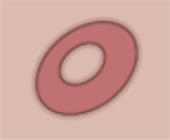
* **Nummular/discoid/round:** Coin-shaped lesion 
* **Arcuate:** Arc-shaped lesion 
* **Linear** Forming a line 
* **Serpiginous:** Wavy like a snake 
* **Figurate/polycyclic:** Lots of different ring shapes, rings within rings 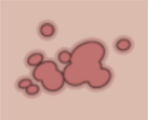
* **Retiform/reticulate:** Web or net-like, following vasculature 
* **Targetoid:** Lesions with a bull’s eye, or concentric rings or varying colors 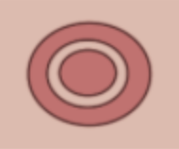

### Distribution

* **Clustered (agminated):** Grouped together in a bunch but not running together
* **Discrete/scattered:** Lesions are separate from one another
* **Acral:** Over distal portions of limbs: finger tips, knuckles, elbows, knees, buttocks, toes, heels
* **Generalized:** Throughout body
* **Photodistributed:** Sun-exposed areas
* **Coalescing:**

## Newborn Derm

### Neonatal Rashes

|  |  |  |
| --- | --- | --- |
| Condition | Description | Appearance |
| Sebaceous hyperplasia | Minute, profuse yellow-white papules frequently on forehead, nose, lip, and cheeks |  |
| Milia/miliaria | 1-2 mm pearly, opalescent cysts |  |
| Neonatal acne (neonatal cephalic pustulosis) | Inflammatory papules and pustules usually w/o comedonal lesions |  |
| Sucking blisters | Solitary or scattered superficial bullae on upper limbs of infants at birth (presumed in utero sucking) |  |
| Cutis marmorata | Evanescent, lacy, reticulated red and/or blue cutaneous pattern when exposed to low environmental temperatures |  |
| Harlequin color change | When infant (usually immediate newborn period and in low birth weight infants) is laying on side, dependent area is deep red and upper half (longitudinally) is pale |  |
| Nevus simplex (“salmon patch,” “stork bite,” “angel’s kiss”) | Small, pink, ill-defined vascular macule usually on glabella, eyelids, upper lip and nuchal area |  |
| Erythema toxicum neonatorum (e tox) | Benign, self-limited evanescent eruption usually in term infants presenting w/ firm, yellow-white papules and pustules w/ a surrounding erythematous flare; palms and soles are almost never affected |  |
| Transient neonatal pustular melanosis (TNPM) | Superficial pustules, ruptured pustules w/ a fine scale, and hyperpigmented macules |  |
| Seborrheic dermatitis | Erythema and greasy scales usually on the scalp (“cradle cap”), face, forehead, trunk, intertriginous and flexural areas including diaper |  |

### Neonatal Birthmarks

|  |  |  |
| --- | --- | --- |
| Condition | Description | Appearance |
| Congenital melanocytic nevus (CNM, moles) | - Often benign neoplasms composed of melanocytes- Small and medium sized CMN have less than 1% risk of malignant transformation; large and giant lesions the risk is higher, ranging from 0-7.6% |  |
| Nevus sebaceous (organoid hamartoma) | - Overgrown epidermis, sebaceous glands, hair follicles, apocrine glands and connective tissue that occurs primarily on scalp or face- Presents as solitary, smooth, yellow-orange hairless patch, often oval or linear. Often becomes more pronounced in adolescence, appearing bumpy, warty, scaly. |  |
| Aplastic cutis congenita | - Absence of skin present at birth that can be localized or widespread- Can be an isolated finding or associated with other developmental anomalies- Large scalp defects should be imaged to r/o underlying bone, vascular, or soft tissue defects |  |
| Congenital dermal melanocytosis (CDM; slate gray patch, Mongolian spot) | Blue or slate-gray macular lesions- Important to always point out to parents and to counsel them to point out to caretakers / daycare, as they can be mistaken for bruises |  |
| Vascular tumors | - Infantile hemangioma, congenital hemangioma, pyogenic granuloma- Hemangioma red flags: Beard distribution (evaluate airway), periocular (ophtho), paraspinal midline, hemangiomatosis (multiple small hemangiomas → evaluate for parenchymal hemangiomas, especially hepatic and CNS), very large hemangioma, associated thrill or bruit, head tilting |  |
| Vascular malformations | Capillary malformation (nevus flammeus/Port wine stain), lymphatic malformations, cutis marmorata telangiectatica congenita (CMTC) |  |

### Diaper Dermatitis

|  |  |  |
| --- | --- | --- |
|  | Contact/Irritant Dermatitis | Candida Dermatitis |
| Epidemiology | Most common cause | 2nd most common cause |
| Physical Exam | Spares creases/skin folds | “Beefy” red rash involving skin folds w/ satellite lesions |
| Management | Topical barrier ointment/paste (petrolatum, zinc oxide) | Topical antifungal (nystatin) |

## Dermatologic Emergencies

### Stevens Johnson Syndrome (SJS)

#### Definition

Skin + 2 or more mucosa. 10-30% BSA.

#### Etiology

Infection & meds (sulfonamides anticonvulsants, NSAIDs, allopurinol, dapsone)

#### Presentation

Mucosal involvement, prodromal fever, sore throat, HA, malaise, erythematous target like lesions forming blisters that rupture

#### Management

* Treat/discontinue underlying cause
* Magic mouthwash for stomatitis, artificial tears for ocular involvement
* Care to avoid scarring and adhesions
* Hospitalize, treat like a burn patient (fluids, electrolytes, pain, prevent infection)

### Toxic Epidermal Necrolysis (TEN)

#### Definition

Skin + 2 or more mucosa. >30% BSA.

#### Etiology

As above in SJS

#### Presentation

Extensive skin and mucosal involvement (conjunctival, oral, genital, pulmonary), large bullae that rupture and leave large erosions (Nikosky +)

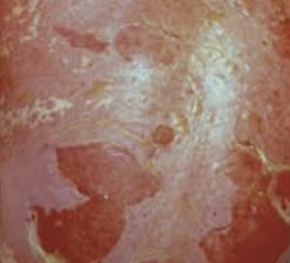

#### Management

* See SJS management above
* Consider IVIG

### Drug Reaction with Eosinophilis and Systemic Symptoms (DRESS)

#### Definition

Potentially life-threatening adverse drug-induced reaction characterized by skin rash, hypereosinophilia, liver involvement, fever, and lymphadenopathy

#### Etiology

Meds (carbamazepine, allopurinol, sulfasalazine, phenobarbital, lamotrigine, nevirapine, etc). Can also be associated w/ some viral infxns (HHV6, EBV, CMV).

#### Presentation

* Onset is usually 2-6 wks after initiation of drug tx
* Rash is often morbilliform or exfoliative and may be associated w/ facial edema
* Systemic symptoms: Fever, lymphadenopathy
* Lab abnormalities: Hypereosinophilia, liver involvement

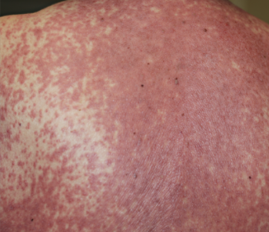

#### Management

* Discontinue offending medication
* Coticosteroids and IVIG may improve sx but evidence is not definitive
* Recovery is prolonged (6+ wks) and may have intermittent flare-ups, 10% mortality rate

### Staph Scalded Skin Syndrome (SSSS)

#### Definition

Exfoliative toxin-producing S. aureus

#### Presentation

Fever, irritability, skin tenderness → diffuse erythema and flaccid blisters → scaling and desquamation

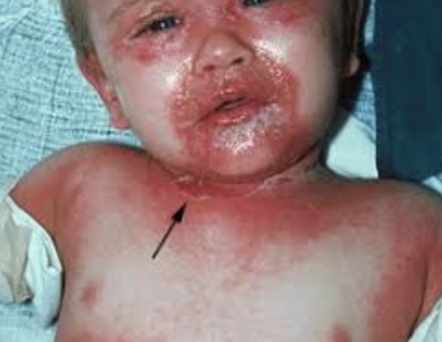

#### Management

Case dependent: Oxacillin, Nafcillin, or Vancomycin

## Common Dermatologic Conditions

### Acne

#### Pathophysiology

Obstruction of pilosebaceous unit by abn keratinization and sebum w/ bacterial proliferation (P. acnes) and inflammation

#### Management

* Depends on type:
  + **Comedonal:** (1) Topical retinoids, (2) benzoyl peroxide and topical abx
  + **Papulopustular:** (1) Maximize topical tx, (2) oral antibiotics, (3) hormonal therapy
  + **Nodulocystic:** Isotretinoin
* Antibiotics: Tetracycline, Doxycycline, Minocycline, Erythromycin
* Tips:
  + Use topical abx in conjunction w/ benzoyl peroxide (to avoid P. acnes resistance)
  + Benzoyl peroxide inactivates tretinoin, so apply benzoyl peroxide in AM and tretinoin in PM
  + OCPs and spironolactone can be considered in female pts
  + May take 6-8 weeks to see improvement
  + Rx: 30-60 gm w/ refills

### Atopic Dermatitis (Eczema)

#### Definition

Chronic inflammatory condition leading to pruritic, erythematous, and scaly lesions

#### Presentation

* Usually presents before 2yo
* Infants (scalp, face, extensor surfaces), children (flexural surfaces)
* Often associated w/ **allergic triad** (w/ asthma + allergic rhinitis)
* Also associated w/ **keratosis pilaris** (hyperkeratotic follicular papules, usually on back of arms but also frequently on lateral cheeks of infants and younger children) and **pityriasis alba** (hypopigmented, flat, indistinct border, usually face)

#### Complications

Superinfection w/ staph and strep (weeping, crusting, pustules) or herpes simplex (vesicles)

#### Management

* **Clinical Pathway:** [Eczema](https://bchfit.tch.harvard.edu/ebg-services/component/pdfAlgorithm?algCode=45612&algVersion=1.3&accessCode=null)
* **Lifestyle:** Eliminate allergens, short baths w/ warm water and mild soap
* **Bleach baths** (decrease bacteria):
  + For a full bathtub of water, add 1/2 cup of bleach
  + For a half-full tub of water, add 1/4 cup of bleach
  + For a baby tub, add 1 teaspoon of bleach per gallon of water
* **Emollients:** Hydrolated Petrolatum, Vaseline™, Eucerin™, Cetaphil™
* **Topical steroids:** (see chart below at end of chapter)
* **Topical immunomodulators:** Calcineurin inhibitors (Tacrolimus ointment (Protopic) 0.03%, 0.1%; Pimecrolimus (Elidel) 1%): used on facial lesions, less risk of tissue injury; approved for >2 years of age
* **Anti-Staph antibiotics** (if bacterial infection): Cephalexin, Trimethoprim-sulfamethoxazole, Mupirocin
* **Antipruritic medication:** Diphenhydramine or Hydroxyzine

### Erythema Multiforme

#### Definition

Usually skin only (minimal mucosa). <10% BSA.

#### Etiology

Infection (HSV, mycoplasma PNA), medications (Penicillins, sulfonamides, NSAIDs, barbiturates)

#### Presentation

Erythematous papules expanding to target-like plaques w/ dusky violaceous centers, found symmetrically on distal extremities and progress proximally

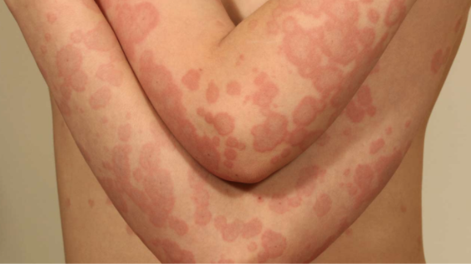

#### Management

Treat/discontinue underlying cause. Supportive care.

### Impetigo

#### Definition

* Contagious superficial skin infection
* Can be primary (direct infection of previously normal skin) or secondary (infection of skin that has already been disrupted)

#### Presentation

* Classified as bullous vs. non-bullous (70%)
  + **Non-bullous impetigo:** Usually occurs on traumatized skin, S aureus (coagulase+) and S pyogenes (GABHS), spread by contact, non-pruritic, no constitutional sx
  + **Bullous impetigo:** More common in infants and young children, caused by S aureus (coagulase+ (same types as TSS and SSSS), bulla develop on intact skin

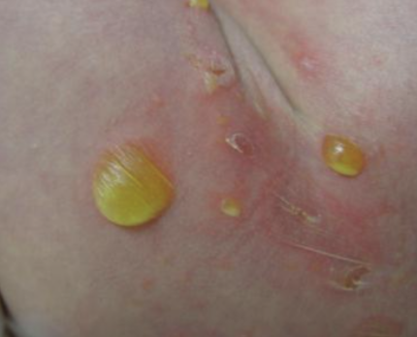 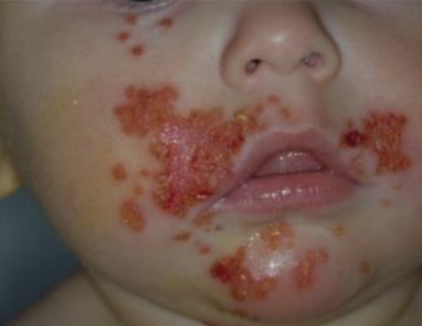

#### Management

* Mupirocin (Bactroban) TID x 7-10 days
* May need oral abx for widespread disease
* If MRSA consideration, clindamycin should be used

### Erysipelas

#### Definition

Infection involving upper dermis and superficial lymphatics, usually from S. pyogenes

#### Presentation

Well-defined demarcation between infected and normal skin

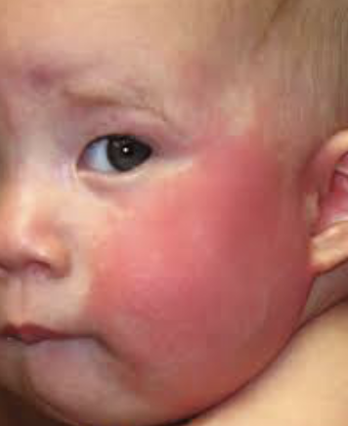

#### Management

* **Localized lesions:** Topical mupirocin 2% ointment
* **Extensive lesions:** Cephalexin, dicloxacillin, clindamycin or erythromycin if PCN-allergic

### Molluscum Contagiosum

#### Definition

Wart-like lesion caused by DNA poxvirus

#### Presentation

* Small flesh-colored, dome shaped, umbilicated papules
* Most common in school aged children. Immunocompromised patient may have extensive disease.
* Transmitted by fomites/close contact. If molluscum in genital area of child, must consider possible sexual abuse.

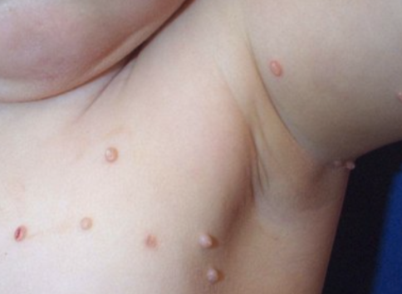

#### Management

Self-limited

### Pityriasis Rosea

#### Presentation

* Single erythematous herald patch followed by collection of smaller patches
* Typically in pts ages 10-35
* Usually lasting between 2-12 weeks

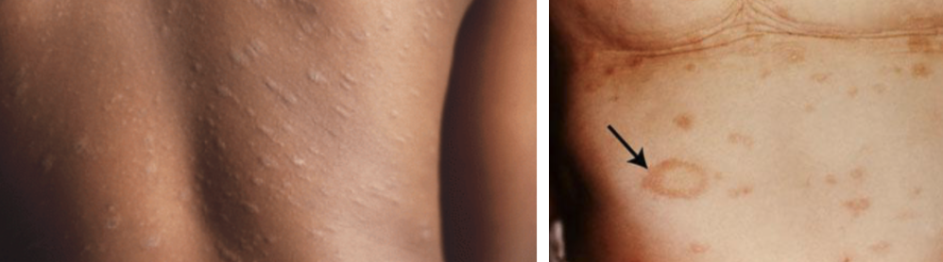

#### Management

* Self-limited
* Counsel patient and family of long duration

### Scabies

#### Definition

Mite infection transmitted by contact

#### Presentation

Rash and severe itching (delayed type IV hypersensitivity) w/ papules, nodules, scaling, and sometimes linear distribution

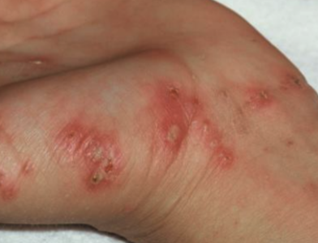

#### Management

* Permethrin (single application has 90-95% cure rate, do not use <2 mos old, can reapply in 7 days)
* Treat all family members and wash clothes and bed linens

### Lice

#### Presentation

Diagnosis usually made by nits (eggs) on hair shafts, adult lice may be difficult to see

#### Management

* 1% Permethrin rinse (Nix) and Pyrtherin (Rid)
* Do not use shampoo/conditioner prior to tx
* Requires retreatment 7-10 days later (not ovicidal)
* Additional methods: Wet combing. Butter, olive oil, mayo, petroleum jelly to suffocate lice.
* Tx of family not usually indicated

### Tinea Corporis

#### Definition

Superficial dermatophytosis

#### Presentation

Scaly erythematous pruritic patch w/ centrifugal spread and subsequent central clearing w/ raised annular border

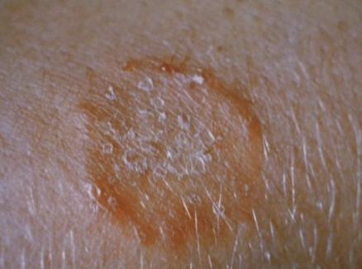

#### Management

* **1st line/localized:** Topical antifungal (may take several weeks to clear)
* **2nd line/extensive:** Oral antifungals (terbinafine, griseofulvin)

### Tinea Capitis

#### Definition

Superficial dermatophytosis

#### Presentation

Scaly erythematous patch that can progress to alopecia w/ inflammation

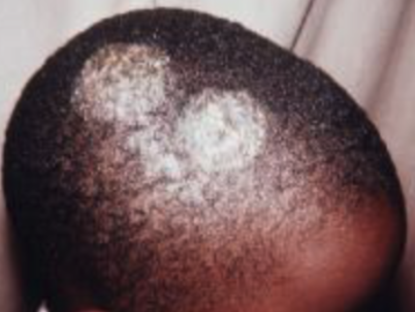

#### Management

Oral griseofulvin or terbinafine

## Cutaneous Signs of Systemic Disease

* **SLE:** Erythematous patches in photodistribution, “malar” face
* **Discoid Lupus:** Annular, scaly plaques, atrophy, and dyspigmentation in photodistribution
* **Juvenile Dermatomyositis:** Erythematous/violaceous scaly, macules, overlying knuckles, face and extensor surfaces
* **HSP:** Purpuric papules and plaques on buttocks and lower extremities
* **Kawasaki Disease:** Erythematous maculopapular to urticarial plaques, edema, desquamation
* **IBD:** Aphthae; erythema nodosum; pyoderma gangrenosum, thrombophlebitis, perianal fissures
* **Graft vs. Host:** Acute onset erythema, papules, vesicles, bulla
* **DRESS:** Diffuse erythema, urticarial macules and plaques

## Drug Eruptions

* **Urticaria:** Penicillins, cephalosporins, sulfonamides, aspirin/NSAIDS, radiocontrast, TNF inhibitors
* **Angioedema:** Aspirin/NSAIDS, ACEi
* **Serum-Sickness Reaction:** Cephalosporins, penicillins, minocycline, bupropion, sulfonamides
* **Exanthematous:** Any drug
* **DRESS:** Phenytoin, phenobarbital, carbamazepine, lamotrigine, allopurinol, sulfonamides, dapsone, minocycline
* **Pustular (acute generalized exanthematous pustulosis):** Beta-lactams, macrolides, clindamycin, terbinafine, calcium channel blockers, antimalarials
* **Acneiform:** Corticosteroids, androgen, lithium, iodines, phenytoin, isoniazid, tetracycline, B vitamins, azathioprine
* **Vasculitis:** Penicillins, NSAIDs, sulfonamides, cephalosporins
* **SJS/TEN:** Sulfonamides anticonvulsants, NSAIDs, allopurinol, dapsone
* **Drug-induced Lupus:** Minocycline, procainamide, hydralazine, isoniazid, penicillamine, carbamazepine, chlorpromazine, infliximab

## Principles of Dermatologic Therapy

The efficacy of any topical medication is related to:

* Active ingredient (inherent strength)
* Concentration of medication
* Anatomic location
* Vehicle (mode in which it is transported)
  + **Ointment:** (e.g. Vaseline). Lubricating, semi-occlusive, greasy, does not sting. Useful for smooth, non-hairy skin, dry, thick or hyperkeratotic lesions.
  + **Cream:** Less greasy, not occlusive, may sting, could cause irritation, vanish when rubbed in. Useful for acute exudative inflammation, intertriginous areas.
  + **Lotion:** Less greasy, less occlusive, may sting, pourable liquid. Useful for acute exudative inflammation (e.g. acute contact dermatitis) and on hairy areas.
  + **Oil:** Less stinging, keratolytic (removes scale). Useful for the scalp, especially for people with coarse or very curly hair.
  + **Gel:** May sting, greaseless, least occlusive, dries quickly. Useful for acne and on scalp/hairy areas without matting.
  + **Foam:** Spreads readily, easier to apply, more expensive, cosmetically elegant. Useful for hairy areas and inflamed skin.
  + **Spray:** Aerosols (rarely used), pump sprays

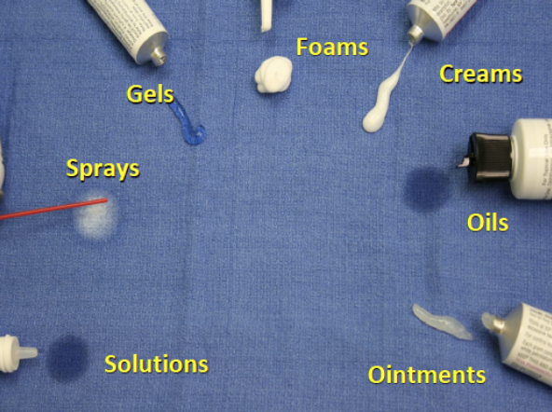

### Quantities of Topicals to Prescribe

* When deciding how much topical to prescribe, think in terms of lesion size and body surface area (BSA)
  + 1 Finger Tip Unit (FTU) = 0.5 grams topical medication dispensed from a 5mm nozzle placed on pad of index finger from distal tip to DIP joint = 2 adult palms = 2% BSA 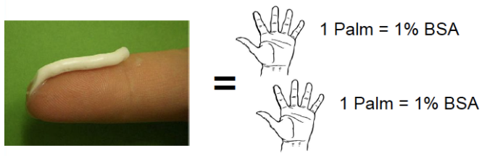
    - *Example:* How much topical medication should you Rx for 2% BSA BID x30 days?
      * 1 FTU = 0.5 grams = 2% BSA
      * 0.5 grams x 2 times per day = 1 gram
      * 1 gram x 30 days = 30 grams
  + Remember that children, especially infants, have a high BSA to volume ratio, which puts them at risk for systemic absorption of topically applied medications

## Topical Steroids

### Classes of Topical Steroids

|  |  |
| --- | --- |
| Potency Class | Common Examples |
| **Class 1:** Superpotent | Betamethasone 0.05% G/O/L, Clobetasol 0.05% C/O/G/S/F, Diflorasone 0.05% O, Halobetasol 0.05% |
| **Class 2:** Potent | Betamethasone 0.05% C, Desoximetasone 0.25% C/ 0.05% G, Fluocinonide 0.05% C/O/G/S |
| **Class 3:** Upper Mid | Betamethasone valerate 0.1%/0.12%F, Diflorasone 0.05% C, Triamcinolone 0.1% O |
| **Class 4:** Mid-Strength | Fluocinolone 0.025% O, Hydrocortisone 0.2% O, Mometasone 0.1% C/L, Triamcinolone 0.1% C |
| **Class 5:** Lower Mid | Desonide 0.05% O, Fluocinolone 0.025%, Hydrocortisone 0.2% C, Triamcinolone 0.025% O/L |
| **Class 6:** Mid | Betamethasone 0.1% C, Desonide 0.05% C, Fluocinolone 0.01% C/S, Triamcinolone 0.025% C |
| **Class 7:** Least Potent | Hydrocortisone 1%-2.5% |

C = cream, G = gel, L = lotion, O = ointment, S = solution, F = foam

* **Potency:** Ointment (thickest, most potent) > Gel > Cream > Lotion (liquidy, easier to spread)
  + Look at the CLASS, not the percentage (e.g. clobetasol 0.05% is much stronger than HC 1%)
* **Uses:**
  + **Class 1** uses: Severe dermatoses over non-facial/non-intertriginous areas, especially good for palms and soles
  + **Class 2-4** uses: Mild-to-moderate non-facial/non-intertriginous dermatoses, okay to use on flexural surfaces for limited periods
  + **Class 5-7** uses: Consider when treating large areas (given likelihood of systemic absorption), also for eyelid/genital dermatoses

### Side Effects of Topical Steroids

* **Local side effects** of topical steroids: Skin atrophy, telangiectasias, striae, acne or rosacea-like eruptions, allergic contact dermatitis, hypopigmentation
* **Systemic side effects** of topical steroids (rare d/t low percutaneous absorption): Glaucoma, HPA suppression, Cushing’s syndrome, hypertension, hyperglycemia
  + Exercise caution w/ widespread use and occlusive methods (e.g. plastic wrap, bandages)
* For all steroids, **do not use for more than 14 days per month.** Instruct patients to use in pulse (a few days at a time) manner.

## Sun Protection

### Types of Sunscreen

|  |  |
| --- | --- |
| Physical Blockers | Chemical Sunscreens |
| - Blocks and scatters UV and visible light- Active ingredients include zinc oxide, titanium dioxide, iron oxide- Less irritating to sensitive skin and immediately effective | - Absorbs light and re-emits energy as insignificant quantities of heat- Active ingredients are benzophenone, avobenzone, oxybenzone- Not as messy, easier to apply, less apparent white sheen |

### Choosing Sunscreen

* Sunscreens are best for protection against UVB and UVA rays
* “Broad spectrum” sunscreens are the best
* SPF 30 blocks 97% of sun’s rays
* “Water resistant” sunscreens need to be re-applied q2h
* Sun’s rays are strongest between 10AM - 4PM
* Good rule of thumb: “If your shadow appears to be shorter than you are, seek shade”
* Avoid sunscreen use in infants less than 6 months of age. Instead use protective clothing, such as long sleeve clothing and a hat w/ brim.

## References

### Additional Dermatology Resources

* [American Academy of Dermatology Basic Dermatology Curriculum:](https://www.aad.org/education/basic-derm-curriculum) Three-Week Pediatrician Rotation for Pediatricians
* [LearnDerm by VisualDx](https://www.visualdx.com/learnderm)

# Emergency Medicine

## Acute Abdominal Pain

### Differential

#### GI

Appendicitis, trauma, pancreatitis, intussusception, malrotation ± volvulus, inflammatory bowel disease, gastritis, bowel obstruction, irritable bowel syndrome, abscess, hepatitis, perforated ulcer, Meckel diverticulum, cholecystitis, choledocholithiasis, constipation, gastroenteritis (particularly with associated mesenteric adenitis)

#### Renal

Urinary tract infection, pyelonephritis, nephrolithiasis

#### GU

Ectopic pregnancy, ovarian cyst/torsion, tubo-ovarian abscess, pelvic inflammatory disease, testicular torsion

#### Oncologic

Wilms tumor, neuroblastoma, rhabdomyosarcoma, lymphoma

#### Other

Henoch-Schonlein purpura, lower lobe pneumonia, sickle cell anemia, diabetic ketoacidosis, juvenile idiopathic arthritis, incarcerated hernia, Streptococcal pharyngitis

### Workup

#### History

Course and characterization, diarrhea, constipation, emesis, melena, hematochezia, fever, last oral intake, menstrual history, vaginal symptoms, urinary symptoms, respiratory symptoms, travel history, diet, pertinent family history

#### PE

* Vital signs, toxic appearance, rashes, arthritis, jaundice
* Thorough abdominal exam, not through clothes - need to visualize abdomen (if concern for appendicitis, check for psoas sign, obturator, Rovsing’s)
* Rectal exam with stool Hemoccult
* Bimanual exam in sexually active females
* Genital exam

#### Studies

* KUB to assess for obstruction, free air; should be done in toxic patients
* Abdominal/pelvic ultrasound
* Consider abdominal CT
* Pelvic MRI for appendicitis if institutionally available

#### Labs

CBC with differential, chemistry, liver and kidney function, ESR, CRP, amylase, lipase, Gonorrhea/Chlamydia/Trichomonas, urine pregnancy

#### Treatment

* NPO, fluids
* “GI cocktail” - multiple antacids
* Consider nasogastric decompression
* Serial abdominal exams
* Surgical/gynecologic/GI evaluation
* Pain control and antibiotics as indicated

## Altered Mental Status

### Differential

Important to maintain a broad differential diagnosis and think systematically - Can use the mnemonic VITAMINS **Vascular**: Stroke, cerebritis, migraine, vasculitis **Infection**: Encephalitis, meningitis, brain abscess, sepsis **Toxins/Trauma**: Environmental/Medication toxins, head trauma **Accident/Abuse**: Epidural hematoma, large subdural, TBI (diffuse axonal injury) **Metabolic**: Hypoglycemia, DKA, thyroid dysfxn, electrolyte abnormality, inborn error of metabolism, hypoxia, hypercarbia, renal, hepatic, endocrine **Intussusception**: Somnolent variant **Neoplasm**: Intracranial neoplasm, paraneoplastic syndrome **Seizure**: Active seizure, subclinical status epilepticus, postictal state Suspicion guided by age and history. Acute-onset altered mental status in an adolescent has a strong probability of being toxin-related.

### Approach

Initial evaluation and stabilization: - Place on monitors, consider access - Primary Survey (ABCDE), POC glucose - Secondary Survey (AMPLE History) - Allergies, Medications, PMHx, Last meal, Events preceding presentation - Acute vs chronic change? How quickly did this occur? - Continue to obtain more detailed history (including exposures, recent travel, possible medications in home, drug use, recent illnesses, possible inciting events, etc) while stabilizing - GCS < 8 often suggests the need for airway management and mechanical ventilation, but decision is case by case

### Physical Exam

* Thorough head to toe examination (including ABCs as above)
* Detailed neurologic exam including fundoscopic exam if possible, mental status
* Cardiorespiratory exam
* Abdominal exam
* Skin exam looking for rashes, signs of trauma

### Studies

***Broad initial workup can include the following, but is strongly guided by history or lack thereof***: - CBC/d - BMP - LFTs - Ammonia - Drug screening: Urine Tox (extended opioid), urine marijuana, serum tox, APAP/ASA/EtOH levels - VBG ***Other workup can be tailored to H&P and PE***: - Blood culture, LP if concerned for infection and/or fever (*see Neuro section for meningitis management) - Abd US if concerned for intussusception - Head CT if concerned for trauma, acute hemorrhage, stroke, increased ICP - Consider coags and other tests for possible medication exposures - Detailed metabolic workup if concerned for underlying inborn error - EEG for seizure or subclinical status (though only useful in active seizure, manage ABCs are the priority)

## Blunt Abdominal Trauma

Sources: **BCH EBG** (Trauma, abdominal), **CHOP Clinical Pathway**, Fleisher GR, Ludwig S, eds. (2010) Textbook of Pediatric Emergency Medicine. 6th ed. Philadelphia: Lippincott Williams & Wilkins.

### Assessment

1. Abdominal wall abrasion, erythema, ecchymosis or seat belt sign
2. Any abdominal tenderness/pain
3. Evidence of thoracic wall trauma
4. Absent or decreased breath sounds
5. Vomiting

### If #1 or >2 of the above present

* FAST sensitivity limited compared to adults but is specific (i.e. positive is valuable)
* Abdominal CT with IV contrast
* Labs: CBC. Can consider LFTs, amylase/lipase, UA, type and screen
* Surgical consult

### Treatment

* Any traumatic findings: admit to trauma surgery service, as a normal CT does not rule out duodenal hematoma which can lead to perforation
* No traumatic findings: observe 4 hrs after CT, reevaluate including: PO challenge, vital signs, repeat abdominal/thoracic exams
* If symptoms worsening, consider imaging or trauma consult if not already obtained
* If symptoms improved, discharge to home with return instructions

## Appendicitis

Sources: **BCH EBG** (appendicitis), **CHOP Clinical Pathway**

### Definition

Inflammation of the appendix caused by obstruction of the lumen

### Pathophysiology

* The appendix is a blind pouch in the RLQ that can become obstructed with a fecalith or lymph tissue. Once it becomes obstructed, it becomes inflamed and edematous which eventually leads to necrosis and perforation.
* Inflammation can also occur as a result of bacterial invasion without obstruction.

### Clinical

* Pain begins in periumbilical region (referred pain) and then moves to RLQ
* Anorexia, nausea, vomiting, and fever
* Young children may not have classic signs and therefore many present with perforation
* Perforation can occur between 24-72 hours after symptom onset if not diagnosed.
  + Perforation can present with high fevers, peritoneal signs, and/or sepsis

### Physical Exam

* Pain on palpation in periumbilical region that migrates to RLQ
* Rovsing’s sign: palpation of LLQ causes pain in RLQ
* Psoas sign: increased abdominal pain when patient flexes right hip against resistance
* Obturator sign: increased abdominal pain when patient’s right leg is raised with knee flexed and then internally rotated at the hip.
* Rectal exam: may have tenderness if appendix is retrocecal.
* If perforated: guarding and/or rebound, or may paradoxically be quite benign

### Studies

* If female, obtain urine HCG
* CBC: poly-predominant leukocytosis (WBC>9, PMN>65%) is strongly associated with appendicitis
* UA may show mild pyuria
* KUB: not indicated in most. may show fecalith, localized ileus, free air (if perforated), SBO in young child without prior surgical history is appendicitis unless proven otherwise
* US recommended if moderate to high risk (based on PAS):
  + US: Positive if hyperemia, thickened wall, echogenic fat, fecalith. Interpretation heavily influenced by pre-test probability. Can be fooled into interpreting as positive if a blind end is not visualized
  + CT with IV contrast or MRI: increased diameter, fat streaking

### Treatment

* Risk stratify based on WBC and U/S findings
* NPO
* Consult surgery
* Antibiotics once confirmed: Cefoxitin 40mg/kg for uncomplicated, Zosyn 75mg/kg if abscess present
* Urgent appendectomy
* If perforated: antibiotics with interval appendectomy

## Acute Chest Pain

Sources: BCH EBG (chest pain), CHOP Clinical Pathway, Uptodate

### Differential

#### Can’t miss

Acute coronary syndrome, myocarditis, pneumothorax, pulmonary embolism, aneurysm

#### MSK

Costochondritis, musculoskeletal strain/trauma, precordial catch (Texidor’s twinge), rib fracture

#### Cardiac (1% of children)

* Ischemia: severe aortic and pulmonary stenosis, hypertrophic or dilated cardiomyopathy, history of Kawasaki disease and subsequent coronary thrombosis, anomalous coronary arteries, familial dyslipidemia, medication or drug induced vasospasm (i.e. cocaine abuse)
* Arrhythmia: SVT or ventricular tachyarrhythmias
* Inflammatory: myocarditis, pericarditis
* Mitral valve prolapse
* Aortic dissection (consider in Marfan, Ehlers-Danlos, Turner, or Noonan)

#### Pulmonary

Pneumonia, asthma, upper respiratory infection causing coughing, hyperventilation, pneumothorax, pleuritis, pulmonary embolism

#### GI

GERD, esophagitis, esophageal spasm. Also consider foreign body ingestion, gastritis, pancreatitis, cholecystitis, peptic ulcer disease, Mallory-Weiss tears, Boerhaave syndrome and hiatal hernias

#### Psych

Anxiety, panic attacks

#### ID

Shingles (herpes zoster infection)

#### Heme

Severe anemia, Sickle cell anemia-related VOE or acute chest syndrome

### History

* Location, chronicity, duration, frequency, severity, quality, radiation of pain
* Precipitating or alleviating factors
* Association with exertion, syncope, or palpitations
* History of inflammatory disorders, hypercoagulable states, connective tissue disease
* Family history of early thromboembolic disease, sudden death, drowning, or congenital heart disease

### Physical Exam

* Complete cardiorespiratory and abdominal exam
* Examination of skin overlying area of pain
* Palpation for reproducible pain
* Concerning findings:
  + Non-innocent heart murmurs (>III/VI in intensity, diastolic, harsh quality, no positional change, louder standing than supine)
  + Clicks, rubs or gallops
  + Abnormal S2
  + Stigmata of connective tissue disease
  + Hepatomegaly
  + Pallor, diaphoresis, or poor perfusion

### Studies

* EKG
* CXR for suspected pulmonary or cardiac disease
* CT w/PE protocol if high suspicion for PE
* Consider CBC, inflammatory markers, D-dimer, troponin, BNP, tox screen as indicated
* Cardiology consult in ED if high risk history, concerning exam findings, abnormal EKG

## Acute Scrotal Pain

Sources: **BCH EBG** (Acute Scrotal Pain), **CHOP Clinical Pathway**, Brenner, JS, Ojo A. UpToDate: Causes of scrotal pain in children and adolescents

### History

* Pain (Onset, Duration, Location, Migration, Severity)
* Anorexia/Nausea (Last meal)
* Vomiting (Time of onset, Last episode, Number of episodes)
* Urine (Dysuria, Quantify urine output, Hesitancy, Urgency, Hematuria)
* Sexual History (Sexually active?, History of STIs, Urethral discharge)
* Fever
* Trauma

### Physical Exam

* Abdomen (Focal tenderness, Guarding/rebound, CVA tenderness)
* Genital (Tanner stage, Inguinal canal abnormality, Scrotal tenderness, Lie of testicles, Tenderness of testicles, Abnormal color of scrotum, Differences in size, Presence/absence of cremasteric reflex)

### Studies

* Imaging: Scrotal US with doppler
* Labs: UA and UCx if fever, dysuria, or concern for epididymitis; GC/CT in sexually active patients.
* Urgently consult urology if suspicion for torsion (TWIST score ≥2), without waiting for imaging results

|  |  |  |  |
| --- | --- | --- | --- |
| Condition | Definition/Pathogenesis | Clinical Presentation | Treatment |
| Testicular Torsion | Rotation of the spermatic cord of the testis → diminished blood flow → infarction -~30% of acute scrotal pain is testicular torsion | -Acute, severe pain -Swollen, high-riding testis, diffusely tender, possibly w/ horizontal lie -Absent cremastmeric reflex -Overlying edema | -Surgical emergency: surgical exploration, detorsion, and fixation of the bilateral testes -Pain control |
| Torsion of the testicular appendage | Rotation of appendix testis (small vestigial structure on the anterosuperior aspect of the testis) → localized infarction | -Localized pain to upper pole of the testes only -Classic “blue dot” sign | -Pain medication, scrotal support, and rest -Pain should resolve in a few days, if not patient needs re-evaluation |
| Epididymitis | Inflammation of the epididymis | -Indolent pain and swelling of epididymis -Dysuria -Penile discharge -Fever -US: Increased blood flow | -Supportive care -Sexually active adolescents: treat like STD -In prepubertal children, may be bacterial or aseptic (traumatic, viral), refer to urology -Antibiotics if UCx positive |
| Orchitis | Inflammation of the testes - Viral (mumps, rubella, coxsackie, echovirus, lymphocytic choriomeningitis virus, parvovirus) and bacterial (brucellosis) infections | -Generalized scrotal swelling, pain, and tenderness -Erythema and shininess of the overlying skin -Increased blood flow on US | -Supportive care -Support of the inflamed testis -NSAIDs and ice packs -Mumps testing if unimmunized |
| Trauma | Blunt vs. penetrating trauma → can cause hematocele, hematoma, testicular rupture, or traumatic epididymitis | -Swelling, pain, and tenderness -Bruising or abrasions -High index of suspicion for concomitant torsion | -Penetrating wounds, rupture, or large hematoceles require surgical repair (Urology) -Antibiotics for wounds -Otherwise, supportive care |
| Vasculitis | Occasionally occurs as part of IgA vasculitis or HSP | -Acute or insidious pain -Signs of systemic illness (fever, abd pain, rash) -US can distinguish from torsion | -Supportive care -NSAIDs and ice packs -Steroids helpful in severe HSP |
| Incarcerated Inguinal Hernia | Herniation of bowel or omentum into the scrotum | -Pain and scrotal mass -Audible bowel sounds -US shows herniated bowel | -Attempt manual reduction immediately -Surgical intervention -Pain control |

## Atraumatic Limp

Sources: **BCH EBG** (limp/irritable hip), **CHOP Clinical Pathway** (septic arthritis), UpToDate: Approach to the child with a limp, UpToDate: Overview of the causes of limp in children, Kocher MS, Zurakowski D, Kasser JR. Differentiating between septic arthritis and transient synovitis of the hip in children: an evidence-based clinical prediction algorithm. J Bone Joint Surg Am 1999; 81:1662

### Differential Diagnoses

#### “Big Four” inflammatory causes

Septic Arthritis, Transient Synovitis, Lyme Arthritis, Osteomyelitis

#### Other inflammatory causes

Myositis, Oncologic, Abscess, Appendicitis, JIA

#### Non-inflammatory causes

Toddler’s fracture, Legg-Calvé-Perthes disease, Slipped capital femoral epiphysis (SCFE), Overuse injuries (Osgood-Schlatter, Sinding-Larsen-Johansson, Patellofemoral syndromes), Torsion of the testicle, Foot foreign body, Poor shoe fit

#### Red flags

Pain at rest, non-weight bearing, pain at night, and pain away from joints; systemic symptoms such as weight loss, fevers; anemia or petechiae

### Workup

#### General approach

Exam → XR any suspected joint → if XR negative, consider labs and use Kocher Criteria to determine hip US or not

#### Physical Exam

* Evaluate for swelling, erythema, fluctuance, point tenderness
* Evaluate ROM or pain on ROM
* Observe how the child naturally holds the leg
* Observe gait
* Rule out foreign body on the sole of the foot

#### Imaging

* X-ray films
* US if hip source suspected and 2+ of Kocher criteria + CRP>2

#### Labs

(if fever, inability to weight bear, or clinical concern for septic arthritis): - CBC, ESR/CRP, BCx, Lyme Titers

#### Kocher Criteria

* Fever > 38.5
* Non-weight bearing
* ESR >40
* WBC >12K

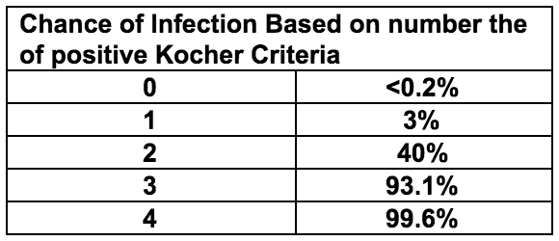

ED_Kocher_Criteria

### Management

**Kocher scores 0-1 generally indicate transient synovitis** **If Kocher criteria >1, consult ortho and consider tapping joint** - Clinically apparent knee/ankle effusion -> tap joint - Irritable hip -> hip ultrasound -> if effusion, tap joint - If no effusion -> MRI to look for osteomyelitis

**Analyze Joint Fluid** - Labs: WBC and differential, Gram Stain, Culture - >50k WBC or gram stain positive → treat as septic arthritis - 25k-50k WBC → possible septic joint, could also be Lyme arthritis, synovitis, other causes - <25k WBC → transient synovitis

### Discharge Criteria

* Non-toxic appearing
* Weight bearing, with rare exception
* Have discussed cases of diagnostic uncertainty with orthopedics
* Reliable caretaker and ability to return if needed
* Discharge with: NSAIDs, signs/symptoms warranting return, 24hr follow-up

## Animal Bites

Sources: AAP Red Book, UpToDate

### Bacteria

* **Cat/Dog**: Pasteurella, anaerobes
* **Cat**: Bartonella henselae
* **Human**: Strep, Staph, anaerobes, Eikenella

### Clinical Presentation

* **Dog**: abrasions, lacerations, puncture wounds, tissue avulsion, or crush injuries
* **Cat**: abrasions, scratches, lacerations, or deep puncture wounds
* **Human**: bruising, abrasions, lacerations in pattern of human teeth; in adolescents, often occur with closed-fist injury
* **Snake**: varies by species, fang marks with evidence of local envenomation (redness, swelling, oozing) or venom spreading (lymphadenopathy, remote swelling, systemic toxicity)
* **Rodent**: similar to cat injuries

### Workup

* Wound cultures are not indicated in clinically uninfected bite wounds
* Gram stain, aerobic/anaerobic wound Cx from the depth of an infected puncture or laceration
* Aerobic/anaerobic BCx in patients with an infected bite wound and evidence of systemic infection
* Plain films to identify bone or joint disruption in deep bite wounds, or to identify subcutaneous gas and/or bony/soft tissue changes if wound is infected
* Head CT for deep bite wounds to the scalp, especially in children <2 yrs of age
* For snake bites, urgently consult Poison Control (1-800-222-1222) and toxicology

### Management and Treatment

Wound care - Control bleeding, assess neurovascular status - Apply local anesthetics for cleaning and closure - Clean with 1% povidone iodine or 1% benzalkonium chloride and irrigate with copious amounts of saline

Primary closure (laceration repair) if: - Dog bite or other cosmetically important bite (face) - Clinically uninfected - <12 hours old on body, <24 hours old on face - NOT located on hand or foot - Sutures needed for hemostasis

Secondary closure (no repair) for all other bite wounds (i.e. cat or human, puncture wounds, and wounds in immunocompromised hosts) Do NOT use adhesive to close bite wounds Antibiotic prophylaxis for all animal bites: - PO: Augmentin, - IV: Unasyn, Zosyn, TMP-SMX+clindamycin - Human: 5-7 days ***- Cat/dog: 7-10 days*** Assess tetanus status - Give tetanus Ig+toxoid if <2 primary immunizations - Give tetanus toxoid if completed primary series but no booster >5 years Rabies prophylaxis for bites by wild animals or if high prevalence of rabies

## Brief Resolved Unexplained Event (BRUE)

Sources: BCH EBG (BRUE), CHOP Clinical Pathway

### Presentation

Report of 1 or more of the following symptoms that are now resolved: - Cyanosis or pallor - Absent, decreased, or irregular breathing - Marked change in tone (hyper- or hypotonia) - Altered level of responsiveness

### Workup

* History of eye deviation, responsiveness, rhythmic movements → consider Neurology consult
* New murmur → EKG, CXR → if abnormal, consult cardiology
* Family history of long QT syndrome, sudden cardiac or unexplained death in 1st or 2nd degree relative before age 35, unexplained drowning or car accident, sibling with h/o SIDS, ALTE, or BRUE → EKG → if abnormal, consult cardiology
* History of paroxysmal cough, pertussis exposure → CBC, pertussis PCR
* Weight concern → further workup for FTT as indicated, consider checking NBS
* NAT concern → see Suspected Child Abuse section

### Management and Treatment

Determine if patient meets low risk criteria: - Age >60 days - Born >or= 32 weeks GA and corrected GA >or= 45 weeks - No CPR by trained provider - Event <1 min - First event - No concerning H&P as above **Low risk** → ED observation on continuous CV monitor and pulse ox for at least 1 hour including 2 observed feedings by RN or MD **High risk** → Admit to inpatient, continuous CV monitor and pulse ox for at least 6 hours (no more than 24 hours) including 2 observed feedings by RN or MD and 2 sleep/awake cycles

Provide CPR training kit to parents/guardians on discharge

## Burns

Sources: CHOP clinical pathway

### Classification: 1st degree

Definition: superficial (epidermis) Symptoms: Erythema, pain Description/Treatment: - Includes sunburn, minor scalds - Does not require fluid replacement; not included in estimate of surface area burned - Usually heals without scarring in 3-5 days

### Classification: 2nd degree

**Superficial partial thickness** Symptoms: Intesne pain, blisters, pink to cherry-red skin, moist, weepy Description/Treatment: -Nails, hair, sebaceous glands, nerves intact -Can progress to deep partial or full-thickness burns -Spontaneous re-epithelialization in 2-3 weeks

**Deep parital thickness** Symptoms: Intense pain, dry and white in color Description/Treatment: Disruption of nails, hair, sebaceous glands, nerves. Skin grafting may be required based on size

### Classification: 3rd Degree

**Full Thickness** Symptoms: Charred black color ± areas dry or white. Pain intense or absent, depending on nerve involvement Treatment: Skin grafting required

### Pathogenesis

Burn injury -> increased capillary permeability -> third spacing, edema, fluid loss

### Estimating Burn Size

* Estimate proportion of total body surface area involved
* Rule of 9’s for adults and older adolescents: 9% for each arm 18% for each leg 9% for head 18% for front torso 18% for back torso
* Rule of 9’s does not apply to children due to differing body proportions, see modification for children below
* Palm of child’s hand = 0.5% of total body surface area, can use to estimate burn size:

**Modified Lund and Browder Chart** 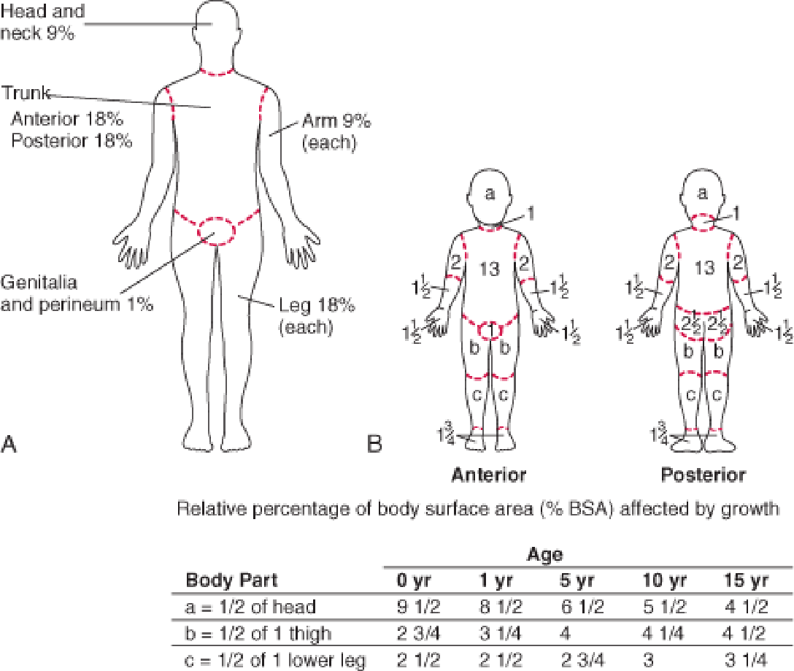

### Workup

* Mechanism of burns (flame, chemical, electrical)
* Closed vs. open space exposure
* Condition of other victims, such as death at the scene
* Duration of exposure
* Associated trauma, such as falls
* Tetanus immunization status
* Always consider non-accidental trauma (See Suspected Child Abuse)

### Treatment

Treatment is based on the depth of burn, proportion of TBSA involved, and if there is airway involvement or other injuries:

**Airway** - Assess for signs of inhalation injury or respiratory distress, snoot in nares, carbonaceous sputum, stridor - Consider intubation for >30%TBSA burned

**Breathing** - Assume carbon monoxide poisoning with severe/closed space burns - Assess stability of the airway - If airway injury, early intubation (use smaller cuffed ETT than necessary for age given continued swelling that will occur)

**Circulation** - For burns >15%BSA or any evidence of inhalation → Parkland formula - Initial bolus of 20 cc/kg NS - Parkland fluid resuscitation formula: good estimate for losses, but underestimates needs of young children <5yo. Provides fluid requirements to be added in addition to normal maintenance fluid requirements - [TBSA burned (%)] x [wt (kg)] x [4mL] = total mL resuscitation required over first 24 hrs → Give 1⁄2 in 1st 8 hours, remainder in next 16 hrs

**Assess urine output**: - Urine output <1mL/kg/hr → 20 mL/kg bolus of crystalloid - Urine output = 1-3 mL/kg/ht → continue parkland formula - Urine output >3 mL/kg/hr →decrease rate to 2/3 Parkland formula

**Pain control**: IV narcotic therapy often necessary (can give IM morphine or IN fentanyl prior to placing IV)

**Wound care**: Cleanse affected area with lukewarm sterile water. Wipe away loose tissue with sterile gauze Leave unruptured bullae intact (do not rupture) Topical antibiotics (Silvadene, Bacitracin) applied directly to burns Admit if: partial thickness burns of >10% TBSA or > 2% full-thickness burns, hands, joints

## Deep Space Neck Infections

### Peritonsillar Abscess

Sources: CHOP Clinical Pathway

#### Definition

Suppurative collection in tonsils with extension into the peritonsillar space

#### Epidemiology

Most common in adolescents

#### Etiology

Polymicrobial, S. pyogenes is most common, less common – anaerobes, S. aureus

#### Pathogenesis

Pharyngitis → progresses to abscess

#### Clinical

Fever, pharyngitis, unilateral pain, muffled (hot potato) voice, trismus, drooling

#### Workup

**History**: Fever duration, neck ROM, PO intake, foreign body, trauma hx, recent ENT surgery, recent abx **Exam**: Peritonsillar fullness. Drooling, displacement of uvula away from affected side, peritonsillar fluctuance, ipsilateral cervical lymphadenopathy **Labs**: Not routinely indicated **Imaging**: Not routinely indicated

#### Treatment

Drainage by ORL: - Bedside needle aspiration in older children may be appropriate - Incision and drainage Antibiotics: Clindamycin or Ampicillin-Sulbactam

#### Complications

Airway obstruction, aspiration PNA, sepsis, jugular vein thrombosis or thrombophlebitis (Lemierre syndrome), carotid rupture, other deep neck space infections, mediastinitis

### Parapharyngeal Abscess

#### Definition

Suppurative collection in the area of the lateral neck from the skull to the hyoid bone.

#### Etiology

Polymicrobial, S. pyogenes, S. aureus, anaerobes.

#### Pathogenesis

Spread of infection into lateral aspect of neck from pharyngitis, tonsillitis, parotitis, otitis, mastoiditis and dental infections

#### Presentation

Symptoms can be subtle. Fever, pharyngitis, neck stiffness, dysphagia/odynophagia, muffled (hot potato voice) trismus, drooling, respiratory distress or stridor.

#### Workup

**History**: Fever duration, neck ROM, PO intake, foreign body, trauma hx, recent ENT surgery, recent abx, chest pain **Exam**: Induration and swelling below the angle of the mandible, medial bulging of the pharyngeal wall, torticollis or difficulty with neck rotation **Labs**: CBC w/diff, aerobic and anaerobic BCx, rapid strep and throat culture, chem if decreased PO, fluid culture if abscess drained **Imaging**: Low suspicion → XR lateral neck → If normal, does not rule out infection High suspicion → Neck CT with contrast (only way to diagnose parapharyngeal abscess)

#### Treatment

* Airway compromise → secure airway, emerg. surgical drainage, IV antibiotics
* Mature abscess (>2.5 cm2) → surgical drainage + IV antibiotics
* Phlegmon → IV antibiotics, re-image in 24-48 hours
* Antibiotics: Ampicillin-sulbactam + vancomycin (severe) or clindamycin (non-severe)

#### Complications

See “Peritonsillar Abscess” above

### Retropharyngeal Abscess

Sources: **CHOP Clinical Pathway**, UpToDate: Retropharyngeal infections in children, UpToDate: Peritonsillar cellulitis and abscess

#### Definition

Deep neck abscess in the potential space between the posterior pharyngeal wall and the deep cervical fascia - Occurs in young children (<5 years) - Retropharyngeal lymph nodes regress as children age, making RPA unlikely in older children

#### Etiology

S. pyogenes, S. aureus, anaerobes

#### Pathogenesis

Spread of infection from nasopharynx via lymph system to retropharyngeal lymph nodes → phlegmon → abscess formation

#### Presentation

Fever, decreased PO, pharyngitis, drooling, dysphagia, neck stiffness (refusal to extend or pain with neck extension), torticollis, trismus

#### Workup

History, Physical, Labs: See “Parapharyngeal Abscess” above **Imaging**: - Low suspicion → XR lateral neck - Greater than 7 mm at C2 (roughly 1⁄2 the width of the vertebral body) or 14 mm at C6 in children - Greater than 22 mm at C6 in adults - High suspicion → Neck CT with contrast

#### Treatment

* Airway compromise → secure airway (highly morbid, prepare for surgical airway concurrently), emergency surgical drainage, IV antibiotics
* Mature abscess (>2.5 cm2) → surgical drainage + IV antibiotics
* Phlegmon → IV antibiotics, re-image in 24-48 hours
* Antibiotics: Ampicillin-sulbactam + vancomycin (severe) or clindamycin (non-severe)

#### Complications

See “Peritonsillar Abscess” above

## Dehydration

Sources: **BCH EBG** (Gastroenteritis), **CHOP Clinical Pathway**

### Definition

* Dehydration = cellular water loss
* Hypovolemia or volume depletion = reduced effective circulating volume

### Presentation

Mottled cool extremities, sunken fontanelle in infants, receded eyes, hyperpnea; sensorium usually remains intact until moderate dehydration; weak cry or stupor suggests shock. Symptoms of underlying etiology will be present (diarrhea, fever, etc.) Regarding dehydration specifically, fussiness, thirst, and lethargy may be present See table below for additional physical examination findings

### Physical Findings of Volume Depletion

|  |  |  |  |
| --- | --- | --- | --- |
| Findings | Mild (3-5%) | Moderate (6-9%) | Severe (>10%) |
| Pulse | Full, normal rate | Rapid | Rapid/weak/absent |
| Systolic Press. | Normal | Normal to low | Low |
| Respirations | Normal | Deep (rate ↑) | Deep, tachypnea |
| Buccal mucosa | Tacky/slightly dry | Dry | Parched |
| Ant. fontanelle | Normal | Sunken | Markedly sunken |
| Eyes | Normal | Sunken | Markedly sunken |
| Skin turgor | Normal | Reduced | Tenting |
| Skin | Normal | Cool | Cool/mottled |
| Urine output | Normal/mildly dec | Markedly reduced | Anuria |
| Systemic signs | Increased thirst | Listlessness | Grunting, coma |

### Differential

* ↑ output (gastroenteritis (most common), diabetes mellitus, diabetes insipidus)
* ↓ intake (gingivostomatitis, viral or bacterial pharyngitis, nausea/vomiting)
* ↑ insensible losses/metabolic demand (bacterial infections with fever such as PNA, meningitis, UTI)

### Workup

Important to establish degree of dehydration: mild (3-5%), moderate (6-9%), or severe (>10%) to guide therapy BCH/CHOP guidelines provide an **Assessment Tool** 10-point (1 point each): - Ill-appearing or decreased activity - Tachycardia for age - Tachypnea or abnormal respirations - Decreased urine output - Sunken eyes - Decreased or absent tears - Dry mucous membranes - Abnormal pulses/perfusion - Cap refill >2 sec - Decreased skin turgor Scoring: <3 = mild, 3-6 = moderate, >6 = severe

**Labs** - Mild or moderate dehydration → may not require laboratory testing - Moderate or severe dehydration → D-stick, chemistry, UA (for urine spec grav) - Low serum bicarbonate useful for determining whether starvation ketosis is present (if anion gap elevated) or excessive diarrhea (if anion gap not present)

### Treatment

#### Mild

Initiate oral rehydration therapy (ORT) - 5-10 mL every 3-5 minutes via bottle, cup, syringe

#### Moderate

Initiate ORT, consider IVF - Similar outcomes but fewer complications and higher satisfaction with ORT in RCTs comparing IV fluids and ORT groups - If ORT fails → obtain D-stick* → 2x 20 mL/kg NS boluses -OR- 20 mL/kg D5NS bolus + 20 mL/kg NS bolus → start 1.5-2x mIVF → transition back to ORT as tolerated

#### Severe

Initiate IVF - Goal 40 mL/kg total within 1 hour: obtain D-stick* → 2x 20 mL/kg NS boluses -OR- 20 mL/kg D5NS bolus + 20 mL/kg NS bolus → start 2x mIVF of D5NS or D5 ½ NS after bolus - Consider alternative diagnosis (septic shock) if persistent hemodynamic abnormalities after 60 mL/kg

#### ORT failure

* 1 emesis despite ondansetron
* Refusal to drink or not consistently drinking
* Oral intake cannot match diarrheal losses
* No improvement in Dehydration Score, VS despite child drinking

#### Ondansetron

(available in liquid, oral-disintegrating, or tablet forms) 8-15 kg = 2 mg PO 15-30 kg = 4 mg PO 30 kg = 8 mg PO

#### Discahrge Criteria

Clinical signs of dehydration improved/mild Caregivers understand ORT instructions and able to perform at home Caregivers understand reasons to return ***Best practice is to first obtain a D-stick, as DKA may present with moderate-severe dehydration, can mimic gastroenteritis, and may be worsened with administration of glucose

## Dental Emergencies

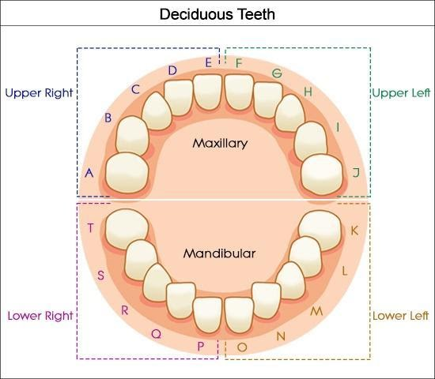 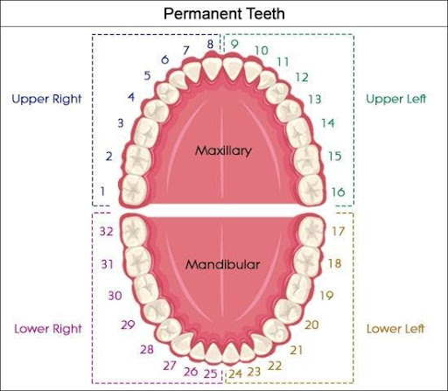 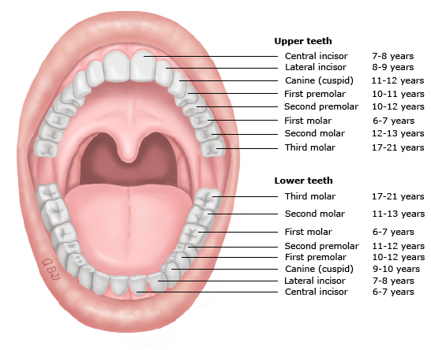 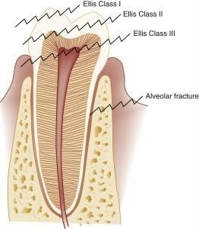

Sources: McTigue DJ, Azadani E. Evaluation and management of dental injuries in children. In: UpToDate, Wiley, JF (Ed), UpToDate, Waltham, MA. (Accessed on February 22, 2020.)

### Avulsion

The tooth is completely displaced from the alveolar ridge; the periodontal ligament is severed, and fracture of the alveolus may occur. Extra-oral dry time < 60 minutes has an increased prognosis of saving the tooth. Primary (“baby”) teeth should not be replaced. If child cooperative, the tooth should be placed into the socket immediately (by the parent before arrival to care if possible). Otherwise, may be placed in a solution with order of preference: save-a-tooth > milk > normal saline. Solution should be chilled but tooth should not be placed directly on ice

### Fracture

**Infraction**: cracked tooth **Enamel only (Ellis I - uncomplicated)**: tooth chipped, pain absent but may be elicited with manipulation. **Enamel and dentin (Ellis II - uncomplicated)**: “yellowish”, tooth chipped with exposed dentin, sensitive to touch and temperature. Cover exposed dentin with calcium hydroxide. Care within 48 hours **Complicated crown fracture (Ellis III - complicated)**: “reddish”, exposure of the pulp and central artery, increased risk of infection. Emergency dental evaluation **Root fracture**: May not also involve the crown. If the crown is not involved, root fracture suggested by mobility of the crown **Alveolar fracture**: causes dislocation of multiple teeth that move with palpation.

### Luxation Injuries

Involve the supporting structures of the teeth, including the periodontal ligament and alveolar bone

#### Concussion

The tooth is neither loose nor displaced; it may be tender with the pressure of biting because of inflammation of the periodontal ligament.

#### Subluxation

The tooth is loose, but not displaced from its socket; the periodontal ligament fibers are damaged and inflamed.

#### Intrusion

The tooth is driven into the socket, compressing the periodontal ligament and fracturing the alveolar socket.

#### Extrusion

The tooth is centrally dislocated from its socket; the periodontal ligament is lacerated and inflamed.

#### Lateral luxation

The tooth is displaced anteriorly, posteriorly, or laterally; the periodontal ligament is lacerated, and the supporting bone is fractured.

### Workup

Determine if tooth is primary or permanent Indication for urgent Dental consult - Avulsed permanent tooth (after reimplantation whenever possible) - Extrusion >3 mm or interfering with bite - Laterally luxated (displaced) teeth that interfere with bite (if not interfering with bite, will often spontaneously revert) - Intruded primary teeth - Fractured teeth when dental pulp is exposed (bleeding from central core of tooth) - Suspected dental root or alveolar fracture (e.g. tooth mobility, pain out of proportion when tooth is wiggled) - Suspected jaw fracture (posterior tooth fracture, jaw tenderness, and/or malocclusion) to obtain panoramic radiographs **Imaging**: consider XR to search for swallowed or buried (in laceration) tooth. Teeth have also been discovered in the lungs.

### Treatment

Reimplantation (while awaiting arrival of dental team…) - Avulsed permanent teeth should be reimplanted immediately, ideally within 15 minutes and up to one hour - Store in save-a-tooth (preferred, available in BCH ED pharmacy), cold milk or saliva if unable to reimplant - Handle the tooth carefully by the crown to prevent damage to the periodontal ligament - Remove debris by gentle rinsing with saline or tap water; do not attempt to sterilize or scrub the tooth - Reimplant manually - Keep the tooth in place by having the child hold it or bite on a gauze pad or clean towel. Uncomplicated fracture of permanent tooth: - Store tooth fragments in tap water to prevent discoloration - Dental follow-up within a few days to bond fracture piece or smooth a fracture Other injuries (infraction, concussion, subluxation) warrant outpatient dental referral

#### General aftercare

* Soft diet for up to 10 days and limit sucking (pacifier or digit)
* Continue brushing with a soft-bristled toothbrush
* Avoid flossing until healing has occurred
* Chlorhexidine mouthrinse for luxation of permanent teeth
* Tetanus prophylaxis, for dirty wounds, avulsed teeth, deep lacerations, or marked luxation injuries
* Antibiotic therapy is indicated for permanent teeth avulsions (<8yrs: amox; >8yrs: doxy) and management of secondary infections

## Epistaxis

Sources: Messner AH. Management of epistaxis in children. In: UpToDate, Post TW (Ed), UpToDate, Waltham, MA. (Accessed on February 22, 2020.) Acknowledgements: Ali Baker

### Pathogenesis

The anterior nasal septum is highly vascularized (Kiesselbach’s plexus) and is subject to exposure due to location. Any factors that cause congestion of nasal vessels, or drying or irritation of the nasal mucosa increases the likelihood of bleeding.

### Etiology

* Trauma (including nose-picking, foreign body)
* Mucosal irritation: allergic rhinitis, viral URI, dry environment
* Anatomic: septal deviation, unilateral choanal atresia
* Tumor: hemangioma, nasopharyngeal angiofibroma, pyogenic granuloma, papilloma
* Vascular abnormality
* Bleeding disorders (coagulation disorders, platelet disorders, blood vessel disorders)
* Inflammatory: Granulomatosis with polyangiitis (GPA), formerly called Wegener’s
* Medications: ASA, ibuprofen, anticoagulants, valproic acid

### Clinical Presentation

* Active bleeding or dried blood
* Nasal mucosa: may be dry, cracked, pale, boggy, or have prominent vessels
* If there is active bleeding, look for vessels involved
* Exclude masses, polyps, foreign bodies
* Exclude underlying bleeding disorder: ecchymosis, petechiae, cutaneous blood vessel disorders

### Workup

No studies are routinely required - Hematologic and coagulation studies if history suggests personal or family history of bleeding disorder - CT or MRI if malignancy is suspected

### Treatment

* Rapid assessment of general appearance, vital signs, airway stability, and mental status
* Sustained pressure on nostrils/anterior plexus (apply for minimum 5-10 min); have child sit up and bend forward at the waist to prevent aspiration or swallowing of blood
* Apply local vasoconstrictor: Oxymetazoline (0.05%, Afrin) preferred to phenylephrine (0.25%)
* Anterior nasal packing (avoid in infants <1yr due to risk of aspiration and airway obstruction) -> evaluate oropharynx to confirm adequate hemostasis
* Chemical cautery (silver nitrate) or electrocautery of actively bleeding vessel
* Indications for ORL consultation: severe epistaxis, troublesome recurrent epistaxis, local abnormalities, need for nasal packing
* Consider referral to Hematology: severe or recurrent bleeding, family history of bleeding disorders

## Febrile Infant

Sources: **BCH EBG** (FUO, Fever 0-1 months, Fever 0-90 days, Fever 1-2 months, Fever/UTI 2-24 months), **CHOP clinical pathway**

### Definition

Temperature ≥38.0 (100.4 C) in infant ≤90 days Temperature ≥38.5 (101.3 C) in child >3 months

### Etiology

* Rates of serious bacterial infection (SBI) in febrile infants/young children range from 7-38% of infants aged 0-28 days seen in emergency department for fever.
* UTI is the most common (5.9%), followed by bacteremia (1%), meningitis (0.3%).

### Pathogenesis

**Bacterial**: UTI, pneumonia, bacteremia, meningitis, cellulitis, enteritis, osteomyelitis **Viral**: Enterovirus, HSV, influenza, RSV, rotavirus, aseptic meningitis **Neonate**: (within first 7 days of life) often vertical transmission **Less common**: recent immunizations, malignancy, medications (antibiotics, antineoplastic drugs, biologics), immunological (Kawasaki), immunodeficiency (HIV, SCID, humoral deficiency), hereditary autoinflammatory syndromes of periodic fever, other periodic fever syndromes

### Most Common Pathogens by Age

|  |  |  |
| --- | --- | --- |
| Age | Bacteremia/Meningitis | Other pathogens |
| 0-28 days | Group B Strep Gram negative enterics (E. coli, Klebsiella) Listeria/Enterococcus | HSV *Conjunctivitis*: Gonorrhea, Chlamydia, S. aureus *Pneumonia*: Chlamydia, S. aureus *Diarrhea*: Salmonella |
| 28-60 days | GBS (Late onset) Gram negative enterics Strep Pneumo N. meningitides Group A Strep Staph | *Pneumonia*: Chlamydia, Staph aureus, Pertussis, RSV and other viruses *Diarrhea*: Salmonella |
| 3-36 mos | Strep Pneumo N. meningitides Group A Strep Staph | *UTI*: E. coli, other GNR, enterococcus |

### Clinical Presentation

* **Non-specific symptoms**: poor feeding, lethargy or irritability. They may have hypothermia instead of fever
* Otitis media/URI symptoms, if present, do not preclude need for further eval.

#### History

Full pre- and perinatal history including GBS status, need for intrapartum antibiotics, evidence of maternal HSV or other infections

#### Physical exam

Bulging fontanelle (Meningeal signs unlikely in infants), respiratory distress or focal lung findings, conjunctivitis, oral lesions, vesicles, cellulitis, rash, vomiting, diarrhea, swelling of a joint or extremity

### Workup

#### Age 0- <1 month (well-appearing)

* Procalcitonin (PCT)
* CBC w/ diff
* Blood Cx
* Cath or SPA UA w/ micro
* Urine Cx
* LP: CSF cell count, protein, glucose, culture, gram stain, HOLD
* CXR if respiratory symptoms
* Consider stool culture if heme+ diarrhea
* Consider HSV testing

#### Age 1- <2 months (well-appearing)

* Procalcitonin (PCT)
* CBC w/ diff
* Blood Cx
* Cath or SPA UA w/ micro
* Urine Cx
* CXR if respiratory symptoms
* Consider stool culture if heme+ diarrhea
* If PCT > 0.2 or WBC <5K or >15K
* LP: CSF cell count, protein, glucose, culture, gram stain, HOLD

### Treatment

* Empiric therapy while awaiting culture results if <28 days, ill-appearing, or meets any high risk criteria (see below table)
* In patients with positive UA or cultures, therapy should be tailored appropriately (empiric is cephalexin 25mg/kg/dose TID for 10 days)

#### Emperic Antibiotic Treatment Based on Age

**Age <= 14 days** Emperic treatment: Ampicillin and Ceftazidime - Gentamicin can replace Ceftazidime - Add acyclovir if CSF pleocytosis or ill-appearing - Use Cefepime instead of Ceftazidime if CSF pleo

**Age 15-28 days** Emperic treatment: Ceftriaxone (50mg/kg) - Add ampicillin and acyclovir if CSF pleocytosis or ill-appearing - Use Cefepime (50mg/kg) instead of CTX if CSF pleocytosis

**Age >29 days** Emperic treatment: Ceftriaxone - Meningitic dose if CSF pleocytosis - Consider vancomycin if suspicion for pneumococcal meningitis

## Foreign Body Aspiration

Sources: **No BCH EBG, No CHOP pathway**. Ruiz FE. Airway foreign bodies in children. In: UpToDate, Hoppin AG (Ed), UpToDate, Waltham, MA. (Accessed on February 22, 2020.)

### Presentation

In acute period, children may have chest pain, wheezing, cough, tachypnea, stridor, resp distress Classic triad is wheeze, cough, and diminished breath sounds (though only present in 57% in one study) In subacute/chronic period after aspiration, children may present with pneumonia (often in the RML as a result of right main-stem FB aspiration)  
Signs and symptoms can vary according to location of FB: - Laryngotracheal: acute respiratory distress, stridor, wheeze, hoarseness - Large bronchi: coughing, wheeze, hemoptysis, choking (most FBs are located in bronchi) - Lower airways: may have little acute distress after initial choking episode

### Workup

#### Physical Exam

* Stridor, hoarseness, inspiratory wheeze suggest upper airway location (wheeze may be monophonic and focal)
* Asymmetric lung aeration and/or focal decreased breath sounds suggest lower airway location

#### Diagnostic Studies

* AP and Lateral CXR and soft tissue neck films
* Expiratory film or lateral decubitus films if lower airway location is suspected (air trapping seen in obstructed lung

### Management

* If complete upper airway obstruction present, perform back blows (child <1 yr of age) or Heimlich maneuver (child >1 yr of age) to dislodge object → PALS *Blind/finger sweeping of the mouth should be avoided*
* Consult Ear-Nose-Throat (ORL) or general surgery for flexible or rigid bronchoscopy in all cases of suspected foreign-body aspiration to visualize the trachea and bronchi and remove object if seen

## Foreign Body Ingestion

Sources: **CHOP clinical pathway**

### Pathogenesis

Average GI transit time is 3.6 days **Anatomical narrowings**: cricopharyngeus muscle, aortic crossover of esophagus, lower esophageal sphincter, pylorus, duodenal sweep, ileocecal junction - Objects > 25 mm diameter unlikely to pass pylorus - Objects > 6 cm length unlikely to pass duodenal sweep **Button batteries**: caustic injury from high pH → injury at anode (narrow portion) of batter → stricture formation (can happen within 2 hours) → aortoenteric fistula is feared complication **Magnets**: Multiple in different bowel segments can adhere and erode through bowel wall causing perforation

### Presentation

Depends on age, location, and nature of FB - **Esophagus**: refusal to eat, dysphagia, drooling, respiratory symptoms - **Stomach**: asymptomatic unless causing gastric outlet obstruction - **Intestine**: asymptomatic unless retained/obstructing, dependent on location

### Workup

Start with XR AP single view neck, chest, abdomen XR lateral for coins, battery, magnet OR if esophageal or unknown location

### Treatment

Depends on symptoms, location, and nature of FB. General principles:

#### Button batteries

EMERGENT GI/ENT/surgery consult, urgent endoscopic removal if esophageal or gastric, otherwise admit and close observation with serial XRs. Sucralfate if esophageal.

#### Coins/Blunt objects

GI/ENT/surgery consult if symptomatic, urgent endoscopic removal if esophageal, otherwise observation (consider admit vs. outpatient f/u)

#### Sharp objects

GI/ENT/surgery consult if symptomatic, urgent endoscopic removal if esophageal or gastric, otherwise admit and close observation with serial XRs

#### Magnets

1 magnet? → treat like blunt object; 2 magnets? → remove if gastric or proximal, or symptomatic, otherwise admit and close observation with serial XRs

#### Food impaction

GI/ENT/Surgery consult, urgent endoscopic removal with biopsies to evaluate for EOE

## Suspected Child Abuse

Source: No BCH EBG; CHOP clinical pathway

### Presentation

#### Skeletal injuries

* **Long bones**: epiphyseal/metaphyseal fracture seen as “bucket handle” or “corner fracture” at the end of long bones, spiral fractures
* **Ribs**: posterior nondisplaced rib fractures due to squeezing of the rib cage (may not be visible on plain film until callus formation)
* **Skull**: fractures >3mm wide, complex fractures, bilateral fractures, non-parietal fractures. These suggest forces greater than those sustained from minor household trauma

#### Bruises

Unusual/protected areas (chest, abdomen, back, buttocks) Patterned Multiple bruises or bruises in different stages of healing, do not fit the history and developmental stage **TEN-4 Bruising Clinical Decision Rule**: - Bruising present in TEN region (torso, ears, neck) < 4yrs of age *OR* - Bruising present in any region < 4mo of age *AND* - No confirmed accident in public setting that accounts for bruising

#### Burns

* Multiple burn sites
* Well-demarcated edges
* Stocking/glove distributions
* Absence of splash marks
* Symmetrically burned buttocks or lower legs

#### Head trauma

* Subdural hematomas
* Retinal hemorrhages
* Skull fractures (see above)

### Workup

* Consult CPT, Social Work
* Skeletal survey (<2yo)
* Noncontrast head CT: good for intracranial hemorrhage and skull fractures
* Brain MRI: If asymptomatic
* Abd or pelvic CT: consider if symptomatic or suggested by physical exam/lab studies
* Consider c-spine MRI if concerned for abusive head trauma
* Dilated indirect ophthalmoscopy exam for retinal hemorrhages
* CBC, CMP, Amylase, Lipase, UA (all patients <7yrs, >7yrs if clinically indicated)
* Bone health labs (if fractures): Ca, Mg, Phos, Alk Phos, intact PTH, 25 Hydroxyvitamin D
* Bleeding disorders labs (if bruising/bleeds): PT/PTT,consider vWF, Factor VIII, IX

## Sexual Assault

Sources: BCH EBG, CHOP Clinical Pathway, UpToDate

### Workup (<12yo)

Medically cleared? - Consider trauma or GYN eval - Work up altered medical status Consult SW

#### Occurred <72 hours:

**Do not interview the child → defer interview and GU exam** - Document parent/guardian statements only (preferably with SW present if available) - Child’s spontaneous statements documented as quotes in evidence kit Urgently consult CPT, Children’s Advocacy Center Forensic evidence collection by ED provider using pediatric kit if patient consents Baseline testing (discuss with CPT): Urine NAAT for Gonorrhea/Chlamydia/Trichomonas, RPR, Hep B Core Ab, Hep B Surface Ab/Ag, Hep C Ab, HIV-1/2 Combo Ag/Ab, urine HCG for pubertal females File 51A (with Social Work)

#### Occurred >72 hours:

Complete history and physical exam, if patient/family consent Baseline testing (see above) File 51A (with Social Work)

### Treatment (<12yo)

Urine NAATs require confirmation prior to treatment with antibiotics Pre-pubertal children should NOT receive STI prophylaxis Update Hep B, tetanus vaccines as needed **Emergency contraception** (if urine HCG negative): - 0-72 hours: Levonorgestrel (Plan B) 1.5 mg PO once - 72-120 hours: Ulipristal (Ella) 30 mg PO once (if no hormonal birth control for 5 days after) Determine need for HIV PEP (see Clinical Pathway)

### Workup (>12yo)

Medically cleared? - Consider trauma or GYN eval - Work up altered medical status Consult SW

#### Occurred <120 hours (5 days):

* Ask for patient consent to receive SANE (Sexual Assault Nurse Examiner) services: 617-647-0710 (BARCC also paged simultaneously)
* Forensic evidence collection by SANE or ED provider if patient consents
* Urine HCG for all females
* STI testing (if patient consents): Urine NAAT for Gonorrhea/Chlamydia/Trichomonas, RPR, - Hep B Core Ab, Hep B Surface Ab/Ag, Hep C Ab, HIV-1/2 Combo Ag/Ab

#### Occurred >120 hours (5 days) ago:

* Call BARCC (Boston Area Rape Crisis Center): 617-492-7273

### Treatment (>12yo)

**STI prophylaxis**: - Gonorrhea + Chlamydia (ceftriaxone 250mg IM x1, azithromycin 1g PO x1) - Trichomonas (metronidazole 2g PO x1) **Emergency contraception** (if urine HCG negative): - 0-72 hours: Levonorgestrel (Plan B) 1.5 mg PO once - 72-120 hours: Ulipristal (Ella) 30 mg PO once (no hormonal birth control for 5 days after) Determine need for HIV PEP (see Clinical Pathway)

### Discharge planning (>12yo)

Contact PCP if patient consents, discuss need for CPT and Child Advocacy Center f/u, ensure appropriate HIV PEP meds/scripts and f/u plan if necessary, use BCH custom d/c instructions. SW will clear patient for d/c and provide resources.

## Syncope

Sources: BCH EBG; Salerno JC. Causes of syncope in children and adolescents. In Uptodate: Wiley JF (Ed), UpToDate, Waltham, MA. (Accessed on February 22, 2020.)

### Differential

#### Common conditions

* Vasovagal
* Breath holding spells (common in 6mo-24mo age range)
* Orthostatic hypotension
* Toxic exposure

#### Life-threatening

* Arrhythmias: ventricular arrhythmias, long QT syndrome (LQTS), Brugada syndrome, catecholaminergic polymorphic ventricular tachycardia (CPVT), congenital short QT syndrome, pre-excitation syndromes such as WPW (which can lead to SVT with a rapid ventricular response)
* Structural: hypertrophic cardiomyopathy, severe aortic stenosis, coronary artery anomalies, arrhythmogenic right ventricular cardiomyopathy (ARVC), dilated cardiomyopathy
* Acute myocarditis
* Pulmonary hypertension
* Vasovagal (neurocardiogenic)
* Heat illness
* Anaphylaxis

#### Other

Hypoglycemia, SVT, bradycardia, POTS  
Rule out mimics: seizure, stroke, TBI

### Workup

#### History and Physical Exam

* Precipitating factors: exercise, acute arousal, postural change, pain or emotion
* Description of event
* Past medical history
* Family history of early cardiac death (<40 years), arrhythmias, cardiomyopathy, sudden drownings or unexplained car accidents, SIDS, LQTS, congenital deafness, HCM
* Exam: including detailed cardiorespiratory and age-appropriate neurologic exam

#### Labs and Imaging

* 12-lead EKG
* Urine hCG for post-pubertal females
* Additional testing not indicated unless concerning H+P (i.e. CBC in menstruating female with pallor, electrolytes if signs of dehydration, etc.)
* Formal orthostatics NOT routinely recommended

Suspect neurologic etiology? → abnl neuro exam, severe headache → neurology consult/referral Suspect cardiac etiology? → syncope w/ chest pain, exertion, palpitations; incr freq of events, non-innocent murmur, frequent PAC/PVC on monitor, abnl EKG → cardiology consult, If FH of concerning cardiac history, otherwise reassuring exam and labs (none of the above), consider outpatient referral within 2 weeks

## Trauma

### ATLS

#### Primary Survey

Assessment of **ABC**: **A**irway (with c-spine protection), **B**reathing, **C**irculation **D**isability/neurologic assessment: AVPU (alert, verbal stimuli response, painful stimuli response, unresponsive; pupil size, symmetry, reactivity) **E**xposure and environmental control: undress patient completely, take precautions to prevent hypothermia

#### Secondary Survey

Head to toe assessment, including history and full physical exam **AMPLE History**: Allergies, Medications, PMHx/Pregnancy, Last meal, Events/Environment leading to the injury

##### Head

Any scalp/skull injury, periorbital or post-auricular bruising, hemotympanum, nasal CSF drainage, loose teeth, concern for midface fracture (pass OGT rather than NGT)

##### Eye

* Pupillary size, hemorrhage, penetrating injury, entrapment
* Corneal reflex
* Contact lenses should be removed

##### Neck

* C-spine tenderness or deformity
* Trachea midline
* Hematoma
* Bruit

##### Chest

* Clavicle deformity or tenderness
* Breath sounds, heart sounds, crepitus
* Chest wall symmetry, paradoxical movement, rib deformity, fracture

##### Abdomen

* Serial exams to evaluate tenderness, distension, ecchymosis
* Shoulder pain suggests subdiaphragmatic process
* Orogastric aspirates with blood or bile
* Splenic laceration suggested by left upper quadrant rib tenderness, flank pain, flank ecchymoses, “seatbelt sign” (suggestive of GI injury)

##### Pelvis

Tenderness, symmetry, deformity, stability

##### GU

* Laceration, ecchymoses, hematoma, bleeding
* Rectal tone, blood, displaced prostate
* Blood at urinary meatus → don’t catheterize, suggests urethral injury
* Evaluate for pelvic fracture or instability

##### Back

Evaluate for step offs along spinal column, tenderness

##### Extremities

Neurovascular: pulse, perfusion, pallor, paresthesias, paralysis, pain

##### Neurologic

* Motor/sensory exam
* Re-evaluation of level of consciousness
* Pupillary response to light

##### Skin

Lacerations, abrasions, contusions

## Mild Traumatic Brain Injury (Contusion and Concussion)

Sources: BCH Minor Head Trauma EBG

### Definition

* Traumatic brain injury induced by biomechanical forces; may be caused by direct blow to head/face/neck or blow causing impulsive force transmitted to the head
* Neuropathologic changes may result, but these reflect a functional disturbance (no changes on neuroimaging) Patient must present with history or physical exam signs of minor head injury *AND*
* In children < 2 years: be alert or awaken to voice or light touch
* In children ≥ 2 years: have normal mental status, normal neurologic exam, and no evidence of skull fracture

### Pathogenesis

* Linear forces: acceleration/deceleration injuries. Less likely to cause LOC, more commonly cause skull fractures, intracranial hematoma, cerebral contusion
* Rotational forces: commonly cause LOC, associated with diffuse axonal injury and concussion

### Presentation

Likely indicators of concussion (any/all of below) - Disorientation or confusion immediately after the event - Impaired balance within 1 day after injury - Slower reaction time within 2 days after injury - Impaired verbal learning and memory within 2 days after injury **Signs/symptoms**: broad range, categorized within somatic, vestibular, oculomotor, cognitive, emotional/sleep - Headache most common > dizziness > difficulty concentrating > confusion Loss of consciousness NOT necessary for diagnosis of concussion

### Workup

#### History

Mechanism of injury, loss of consciousness, whether infant cried immediately, seizure activity, level of alertness after injury, headache, vision changes, and vomiting. - Consider using a **post-concussion symptom checklist** at time of evaluation - both for facilitating history and tracking recovery (different checklists available based on age of patient)

#### Physical

Full neurological exam, scalp abnormalities (hematoma, tenderness or depression), signs of basilar skull fracture (e.g. periorbital ecchymosis, Battle’s sign, hemotympanum, CSF otorrhea or rhinorrhea), bulging fontanelle in infants, c-spine examination

#### PECARN algorithm

To determine need for imaging (Head CT)

**For children less than 2 years**: Any altered mental status or palpable skull fracture * Other considerations: - Non-frontal scalp hematoma - LOC ≥5 seconds - ** Severe mechanism of injury - Acting abnormally per parent

**For children 2 years and older**: Any altered mental status or signs of a basilar skull fracture (retro-auricular or periorbital bruising, CSF otorrhea or rhinorrhea, hemotympanum) * Other considerations: - Any loss of consciousness - History of vomiting - ** Severe injury mechanism - Severe headache

* If 1-2 of above is present, monitor 4-6 hours and obtain head CT if symptoms worsen or don’t improve; If ≥3 above are present, head CT is recommended; If none is present, head CT not recommended ** Severe mechanism of injury: Motor vehicle crash with patient ejection, death of another passenger or rollover, pedestrian or bicyclist without helmet struck by motorized vehicle, falls (>3 feet children < 2 years or > 5 feet for children ≥ 2 years) or head struck by high impact object.

### Treatment

* Intracranial injury or depressed, basilar, diastatic skull fx → NSGY consult & admit
* Simple skull fx (i.e <3 mm, non-depressed, single bone) → consider admit if young (<6 mo), consider SW evaluation (esp if < 2 yrs of age) **Discharge Criteria**: Normal mental status, non-focal neuro exam, able to PO, no social concerns, not <1 mo with isolated skull fracture

Dx of concussion with negative imaging: - DO NOT return to play same day, risk of second-impact syndrome (2nd injury before full recovery → possible cerebral vascular congestion → diffuse cerebral edema) - Physical rest: avoid strict “bed rest,” but limit activity to level that does not provoke/increase sx; sub-symptom threshold, aerobic exercise shown to decrease duration of sx - Cognitive rest: academic adjustments as needed to reduce symptom exacerbation - **Complete cognitive rest and avoidance of screen time NOT recommended** - See Uptodate (“sample school note to guide academic accommodations for children and adolescents with concussion”) for template academic note - PT for patients suffering from vestibular or oculomotor dysfunction - No sports until asymptomatic and cleared by a physician, emphasize individualized course, warn of possible persistent symptoms beyond 1 month (*See Graduated Return-to-Sport Program*) - Refer if: Symptoms > 4 weeks, lack of progression, confounding by coexisting conditions, multiple previous concussions

**Graduated Return-to-Sport Program**

|  |  |  |  |
| --- | --- | --- | --- |
|  | Aim | Activity | Goal |
| 1 | Symptom-limited activity | Daily activities that do not provoke symptoms | Gradual reintroduction of work and/or school activities |
| 2 | Light aerobic exercise | Walking or stationary cycling at slow-to-medium pace; no resistance training | Increase heart rate |
| 3 | Sport-specific exercise | Running or skating drills; no activities with risk of head impact | Add movement |
| 4 | Noncontact training drills | Harder drills (eg, passing drills and team drills); may begin progressive resistance training | Exercise, coordination, and increased thinking during sport |
| 5 | Full-contact practice | After medical clearance, participate in full, normal training activities | Restore confidence and allow coaching staff to assess functional skills |
| 6 | Return to sport | Normal game play | Full clearance/participation |

Recommend **48 hr of relative physical and cognitive rest before beginning the program**. No more than 1 step should be completed per day. If any symptoms worsen during exercise, the athlete should return to the previous step. Consider prolonging and/or altering the return-to-sport program for any pediatric and/or adolescent patient with symptoms over 4 wk.

## Cervical Spine Injury

### Workup & Treatment

Place patient in C-collar prior to history and physical Assess for (based on PECARN data; NEXUS and Canadian C-Spine Rule unclear sensitivity for <10yrs): - Neck pain - Midline posterior neck tenderness - Decreased neck range of motion - Torticollis - AMS (GCS < 14) - Focal neurologic finding - Substantial co-existing injury (distracting injury, especially torso injuries) - Predisposing conditions (Down syndrome, cervical arthritis, Ehlers-Danlos, etc) - High risk mechanisms (MVC where patient partially/completely ejected from vehicle, passenger death, diving, hanging, clotheslining force, axial load force

If **any** of the above are present, recommend C-spine imaging (XR → cross-table lateral and AP, consider open-mouth odontoid if possible) - Consider CT if concern for clinically significant injury, abnl XR, high risk injury mechanism If **none** of the above are present, defer imaging and remove collar. If pain with active ROM, return patient to collar, obtain cervical spine films - If imaging abnormal, consult orthopedics/neurosurgery - If imaging normal, reassess patient, and if persistent midline neck tenderness,, assume cervical sprain and place in long-term C-collar (“Miami J”) → refer to spine clinic → usually able to discharge

## Laceration Repair

### Equipment

* **Basics**: light, mask, sterile gloves & gown, betadine (or other cleansing solution)
* **Irrigation**: sterile bowl, sterile water, 20-50 cc syringes with splash guard (all except water come in irrigation kit)
* **Local anesthesia** or digital block
* **Suture tray** (sterilized and packaged together): forceps, scissors, needle holder, hemostats, sterile gauze
* **Suture material**: Nonabsorbable sutures (monofilament nylon, polypropylene) vs. Absorbable sutures (Vicryl, fast absorbing gut – use for deep wounds and in small children when suture removal would be just as traumatic as placement
  + Sole of foot or over large joints (knee): 4-0 or 3-0
  + Scalp, trunk, extremity: 4-0; Face: 6-0 or 5-0

**Alternatives to sutures**: Dermabond (tissue adhesive) +/- Steri-Strips: use for linear wounds with minimal tension. No removal needed.  
Staples: Best for scalp wounds. Requires remover.  
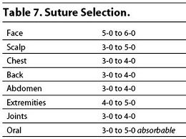 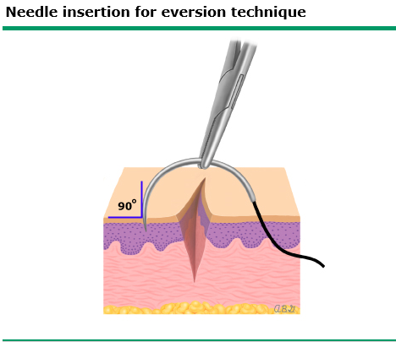

### General Technique

1. Set-up your equipment
2. Local anesthesia

* LET gel (lidocaine, epinephrine, tetracaine) – apply for 15-20 minutes (surrounding skin should be blanched)
* 1% lidocaine (10mg/mL): onset 2-5 minutes, lasts 15-20 minutes. Toxic dose 5mg/kg (0.5cc/kg)
* 1% lidocaine with epinephrine (1:200,000): onset 2-5 minutes, duration ~60 minutes. Generally avoid use in digits, penis, pinna, tip of nose
* Use buffered lidocaine if available (buffered with sodium bicarbonate)

1. Conscious sedation if needed
2. Wound preparation: Expose, explore (for foreign bodies), irrigate, clean periphery
3. Suture/Close:

* **Simple interrupted** - most common stitch, closes superficial layer
* **Deep subcutaneous** - reduces tension of deep wounds
* **Buried horizontal dermal** - closes deep layer in shallow lacs
* **Horizontal/vertical mattress**- reinforce SC tissue, relieves wound-edge tension
* **Corner stitch** - repair flap-type, corner lacerations

1. Clean and dry: Apply topical antibiotic ointment and cover with dry sterile gauze

* **Tetanus prophylaxis**: if have not received tetanus prophylaxis in preceding 10 years (if clean and minor wound) or 5 years (all other wounds) *or* if they have not finished primary series.
* **Antibiotic prophylaxis**: if wound is a bite wound, there is exposed cartilage/joint, or a contaminated wound (esp. on plantar surface)

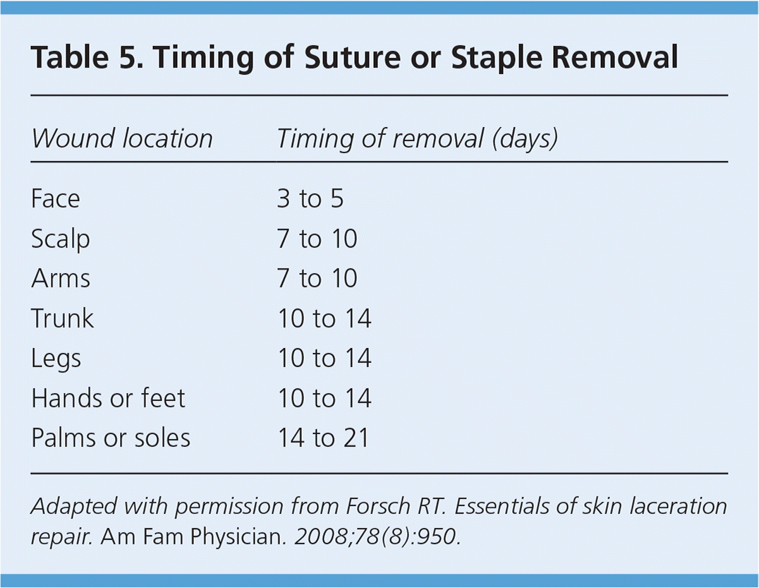

ED_suture_removal_timing

# Endocrinology

## Adrenal Insufficiency

### PowerPlan/Order sets

MICU adrenal stim testing, Endo AMB adrenal disorders

### Definition

Impaired secretion of the adrenal glucocorticoid +/- mineralocorticoid hormones - **Primary**: Failure to produce or secrete adrenal cortical hormones >> - Most common causes: impaired adrenal steroidogenesis (CAH), adrenal destruction (autoimmune or infectious), adrenal dysgenesis >> - Aldosterone deficiency leads to hypotension, hyponatremia, hyperkalemia - **Central**: Impaired pituitary secretion of ACTH or hypothalamic secretion of CRH >> - Most common cause: Exogenous corticosteroid administration >> - Other: Hypothalamic defects (tumor, radiotherapy), hypopituitarism (surgery, infiltration)

### Presentation

N/V, abdominal pain, orthostatic hypotension, lethargy, hypoglycemia **ONLY IN PRIMARY**: - Hyperpigmentation (↑ ACTH→ ↑ POMC→↑ melanocortin) - Hyperkalemia (↓ Aldosterone)

### Diagnostic Studies

* Suggestive: ↓ Na, ↑ K, ↓ Glu, metabolic acidosis
* Confirmatory: AM cortisol & ACTH levels >> - **Primary**: ↓ cortisol, ↑ ACTH >> - **Central**: ↓ cortisol, normal or ↓ ACTH
* If not definitive: ACTH stimulation test

### Acute Treatment

**Adrenal Crisis**: - 20mL/kg NS bolus followed by 1.5-2x D5NS maintenance IVF - Hydrocortisone 50-100 mg/m2 >> - *Hydrocortisone also has some mineralocorticoid effect, so fludrocortisone is not required while a patient is on stress dose hydrocortisone* - Monitor electrolytes & fluid balance

**Stress Dose Steroids**: - Minor (mild URI, T <38): None required - Major (T >38, major surgery, vomiting): hydrocortisone 50 mg/m2 divided q6h

### Maintenance Therapy

* Hydrocortisone 8-20 mg/m2/day divided into 3 doses (higher doses required for infants with CAH)
* **Primary**: Fludrocortisone 0.1-0.2 mg daily
* +/- salt supplementation in infants

## Diabetic Ketoacidosis

### PowerPlan/Order sets

DKA ICP order set, MICU DKA order set, NODM CPG order set

### Definition

* Hyperglycemia: Blood glucose> 200 mg/dL
* Metabolic Acidosis: pH<7.3 ***OR*** HCO3<15 mmol/L
* Ketosis: + Ketones in blood or urine

### Pathophysiology

↓ Insulin→ Hyperglycemia → Osmotic diuresis → Dehydration ↓ Insulin→ ↑ lipolysis→ ↑ FFA → Ketoacidosis ↓ Insulin → Impaired K entry into cells → Total K deficit ***even if plasma K is normal***

### Presentation

Hyperglycemia, vomiting, abd pain, dehydration, AMS Hx: Wt loss, polyuria, polydipsia

### Diagnostic Studies

* D-sticks q1h
* Chem 10, beta-hydroxybutyrate, VBG q2h
* Urine ketones
* HbA1c
* EKG
* Consider pancreatic autoantibodies (refer to CPG for recommendations)

### Treatment

***Please reference DKA card for detailed protocol*** **1) FLUIDS**: **NS Bolus**: Initially give **10-20 mL/kg NS bolus**; may repeat if persistent hypotension - **Fluid Selection**: Fluids at **1.5-2x maintenance if corrected serum Na<135 mEq/L**; slow rate if signs of cerebral edema - Use **2-Bag Method Calculator** (in reference text of DKA PowerPlans): Bag 1 NS plus electrolytes; Bag 2: D12.5 0.45% NS plus electrolytes, hung together w/ insulin on a trifuse. Rates of each fluid are titrated to the **goal dextrose concentration**:

|  |  |
| --- | --- |
| **Plasma K (mEq/L)** | **IV fluid K (mEq/L)** |
| <= 4.5 | 40 |
| >4.5 | 0 |

* **Potassium Content**: Goal K = 3.5-4.5. Use K acetate and K phosphate, NOT KCl because of risk of hyperchloremia and non-gap metabolic acidosis. Max K that can be given is 80 mEq/L
* DO NOT give HCO3 as increases the risk of cerebral edema

**2) INSULIN**: - \***DO NOT give bolus of insulin!** - After 1 hr of NS IVF, start infusion of regular insulin 0.05-0.1 units/kg/hr - Continue insulin infusion until anion gap is closed and patient is ready to eat - **Transitioning from IV to subQ**: Make sure patient has **meal in front of them before turning off drip**, give Humalog & long-acting insulin 15 mins before meal, turn off insulin infusion and IV fluids 30 minutes after subQ injections

**Important Formulas** - Corrected Na: serum Na + (1.6*[plasma glucose – 100]/100) - Anion Gap: serum Na – (Cl + HCO3) **Note: use serum Na, NOT corrected Na - Effective Osmolarity: 2[measured Na + glucose/18]

### Subcutaneous Insulin Regimen

**How to order subcutaneous insulin at BCH** 1. Either type insulin into search tab (or get to this via the NODM admit plan) 2. If not going through NODM, click “insulin .SC injection regimen orderset”  
>> a. You will first be required to select frequency of POCT checks, parameters for RN to notify MD about glucose levels. Now for the insulin… 3. You will most likely order scheduled glargine (Lantus). You will then most likely order lispro (Humalog) for the correction factors and carbohydrate ratios. **These are nested ordersets and can be confusing** >> a. Scroll down to correction factor and select box “insulin lispro 100 unit/mL correction factor Orderset”. Then scroll down to insulin: carbohydrate ratio and select box “insulin lispro 100 unit/mL carbohydrate ratio orderset” >> b. **make sure to click both before clicking “OK” in bottom right** 4. You will then be directed to the nested orderset where you can type in the times of day and doses that you want to give the correction factor and carb ratio >> a. For correction factor you will have to decide if same CF for all times of day versus different times (ex, different for daytime meals vs at night). Click OK and then you will be prompted to carb ratio orderset >> b. Again you will have to decide if same CR for all times of day versus different times

## Hypoglycemia

### PowerPlan/Order sets

ED hypoglycemia critical labs plan, ICP hypoglycemia fasting plan, NICU hypoglycemia plan, Metabolism hypoglycemia admit plan

### Definition

Plasma glucose ≤ 60 mg/dL

### Etiology

**Decreased Production of Glucose** - Decreased release of glucose from liver: glycogen storage diseases, liver failure - Impaired gluconeogenesis: fructose 1,6 diphosphatase deficiency, pyruvate carboxylase deficiency, maple syrup urine disease - Galactosemia, hereditary fructose intolerance - Disorders of fatty acid oxidation (↓FAO → ↓ATP and glycerol production → ↓gluconeogenesis)

**Increased Utilization/Impaired Conservation of Glucose** - Disorders of fatty acid oxidation - Ketotic hypoglycemia (accelerated starvation) - Starvation

**Decreased Production and Increased Utilization of Glucose** - Hyperinsulinemia >> - Endogenous: congenital (transient or permanent), insulinoma >> - Exogenous insulin >> - Sulfonylureas >> - Dumping syndrome, withdrawal of continuous enteral/parenteral nutrition - Counter-regulatory hormone deficiency: growth hormone, cortisol/ACTH - Beta Blockers

### Presentation

* Early manifestations (blood sugar 40-70): sweating, tachycardia, tremor, hunger
* Later manifestations (blood sugar <40): lethargy, irritability, confusion, seizure, coma
* Ask about any medications in home (sulfonylureas, beta blockers, insulin)
* Ask about temporal relationship to feeds

### Diagnostic Approach

### Diagnostic Studies

Critical Labs: **Must be obtained when BG <50**

* Plasma glucose
* Beta-hydroxyburyrate (BOHB)
* CMP
* Insulin
* C-peptide
* Acylcarnitine profile
* UA for ketones
* Free Fatty Acids
* Lactate
* Ammonia
* Cortisol
* Growth Hormone
* Free & total carnitines

### Treatment

* **Conscious**: 15 g of rapid-acting carbs by mouth (4oz juice = 1 tube glucose gel = 4 glucose tablets)
* **Altered Mental Status**:  
  >> - 2mL/kg D10 IVF bolus—> D10 IVF at GIR 4-6 (infants) or GIR 2-3 (older kids) >>> - Higher dextrose infusions NOT recommended: ↑ Insulin→ Worsening Hypoglycemia >> - If no IV access: Glucagon 1mg IM >>> - ***ONLY effective in insulin-mediated hypoglycemia***
* **Monitoring**: q15-20 mins until BG >70, space to q1hr once stable

## Diabetes Insipidus

### PowerPlan/Order sets

MICU DI orderset, Endo AMB DI Plan

### Definition

Failure to produce or respond to antidiuretic hormone (ADH), leading to excessive free water loss and subsequent hypernatremia

### Etiology

* **Central**: Failure of posterior pituitary to secrete ADH >> - AVP mutation, hypothalamic/pituitary defect, trauma, neoplasm, infectious, infiltrative,
* **Nephrogenic**: Failure of kidney to respond to ADH >> - Electrolyte disturbance (↑Ca, ↓K), congenital, medication-induced, tubulopathy

### Presentation

Polyuria, nocturia, increased thirst, polydipsia

### Diagnostic Studies

* Chem 10, serum osmolality
* UA, urine SG, urine osm
* Lab criteria >> - Serum osmolarity > 300 mosm/kg >> - Urine osmolarity < 300 mosm/kg
* Urine output > 4 ml/kg/hr
* Water deprivation test id diagnosis is uncertain
* Vasopressin test to distinguish central vs nephrogenic DI

### Treatment

* **Central Diabetes Insipidus**: vasopressin IV vs PO/intranasal/SC ddAVP >> - Low solute diet to reduce urinary excretion >> - PO/intranasal/SC ddAVP q8-12 hrs >>> - Oral preferred to intranasal due to fewer side effects >>> - SC used in infants due to more accurate dosing >> - Consider addition of thiazide diuretic ( induces volume depletion→ decreased UOP)
* **Nephrogenic DI**: >> - Low solute diet >> - Thiazide diuretics +/- indomethacin to reduce urine output

## Syndrome of Inappropriate ADH (SIADH)

### Definition

Inappropriate antidiuretic hormone release → Hyponatremia, hypoosmolality, and inappropriately concentrated urine with no evidence of renal, hepatic, adrenal, or thyroid dysfunction

### Etiology

* **CNS disease**: Meningitis/encephalitis, tumors, trauma, hydrocephalus, CVA, subdural hematoma, post-op
* **Pulmonary disease**: PPV, bronchiolitis, pneumonia, asthma, CF
* **Neoplastic**: Lymphoma, Ewing sarcoma, lung carcinoma
* **Drugs**: carbamazepine, cyclophosphamide, desmopressin, SSRI’s, etc
* **Acute**: Stress, nausea, pain, general anesthesia

### Pathophysiology

* ADH binds to V2R receptors in collecting tubules→ Insertion of aquaporin channels in apical membrane→ Increased water reabsorption→ Reduced urine output & increased urine concentration→ Increased total body water→ Hyponatremia

### Presentation

* Decreased UOP, hyponatremia, low serum osm and high urine osm
* Patients typically have euvolemic hyponatremia and so do ***NOT*** have peripheral edema/ascites
* Headache, nausea, vomiting, muscle cramps, lethargy, confusion, seizures

### Diagnostic Studies

Diagnostic Criteria: - Plasma Osm <280 - Plasma Na <135 - Urine Osm > 100 - Urine Na > 20

### Treatment

**Maintenance Therapy**: - Fluid restriction +/- salt supplementation - If ineffective: Consider addition of loop diuretics to impair urinary concentration

**If symptomatic** (seizure, AMS ): - Rapid initial correction: 3-5mL/kg of 3% saline over 10-15 mins - Rate of Correction: Increase Na by **no more than 8-9 mEq/L in 24 hrs** - **Risk of central pontine myelinolysis with rapid correction**

## Calcium Homeostasis

|  |  |  |  |  |  |
| --- | --- | --- | --- | --- | --- |
|  | **Calcium** | *Serum PTH** | *25-OHD** | **Alk Phos** | **Phos** |
| **Hypoparathyroidism** | Low | Low | Normal | Normal | High |
| **PTH Resistance** | Low | High | Normal | Normal | High |
| **Vit D Deficiency** | Low | High | Low | Normal/high | Normal/low |
| **Vit D Resistance** | Low | High | Normal | Normal | Normal/low |
| **Renal Disease** | Low | High | Normal/low | Normal/high | High |
| **Hypomagnesemia** | Low | Normal | Normal/low | Normal | Normal |
| **Metastatic Disease** | High | Low PTH High PTHrP | Normal | High | High |
| **Familial Hypocalciuric Hypercalcemia (FHH)** | High | Normal/High | Normal | Normal | Low |
| **Primary Hyperparathyroidism** | High | High or inappropriately normal | Low | Normal/high | Low |

## Hypocalcemia

### Definition

* Normal values are age specific and vary between labs
* Hypoalbuminemia will lower the serum calcium concentration by 0.8 mg/dL for every 1.0 g/dL reduction in serum albumin (below 4 g/dL)

### Etiology

#### Low PTH (Hypoparathyroidism)

**Congenital** - Genetic Syndromes >> - DiGeorge Syndrome >> - Mitochondrial disorders (MELAS, etc.) >> - HDR (hypoparathyroidism, deafness, renal anomaly) >> - Sanjad-Sakati Syndrome (IUGR, hypocalcemia, dysmorphia) >> - Kenny-Caffey Syndrome (dwarfism, cortical bone thickening, hypocalcemia) - Mutations in production of PTH - CaSR activating mutations (autosomal dominant hypocalcemia) - Parathyroid aplasia/dysplasia

**Acquired** - Hypomagnesemia or hypermagnesemia - Autoimmune (APS1 or isolated) - Infiltrative disease (copper/iron deposition) - Acquired post-surgery

#### High PTH

**Renal Failure** - 1a-hydroxylase deficiency iso renal failure - Pseudohypoparathyroidism (end organ resistance to PTH) - Excess phosphate intake

**Low Vitamin D** - Deficient vitamin D intake, intestinal absorption, or dermal synthesis - Hereditary resistance to vitamin D (vit D-dependent rickets type 2) - Defects in vit D metabolism: liver failure, renal failure, drugs that increase CYP450 activity - Genetic disorders: >> - 25-hydroxylase deficiency >> - 1a-hydroxylase deficiency >> - Increased catabolism of vit D mutations

#### Other Causes

**Neonatal Hypocalcemia** - **Early (0-3 DOL)** >> - Exaggeration of normal decline in calcium concentration after birth >> - Asymptomatic, requires nutritional support alone - **Late (4-10 DOL)** >> - Presents as severe neuromuscular irritability or seizure >> - Most commonly from excess phosphate intake in cow’s milk; mechanism unknown, thought that high phos may antagonize PTH secretion - **Maternal Risk Factors**: Diabetes, Vit D deficiency, AED use, hyperparathyroidism, or eclampsia - **Neonatal Factors**: low birth weight, prematurity, IUR, perinatal asphyxia - **Hypocalcemia in setting of other illness**: sepsis, RDS, hyperbilirubinemia, renal failure

**Miscellaneous** - **Hungry Bone Syndrome**: Avid bone mineralization after recovery from severe mineralization defect (e.g., vitamin D deficiency) - **Osteopetrosis**: loss of osteoclast function - **Citrate or Lactate administration** (e.g., from blood transfusion) - **Hypomagnesemia** - **Sepsis**/severe acute illness - **Pancreatitis**: complex formation w/ fatty acids - **Drugs**: bisphosphonates, cinacalcet, foscarnet, chemotherapy

### Clinical Manifestations

* Acute hypocalcemia >> - Tremor, muscle spasms, paraesthesias, tetany (Chvostek, Trousseau signs) >> - Seizures >> - QT prolongation, impaired contractility >> - Psychiatric symptoms (anxiety, agitation, hallucinations)
* Vitamin D deficiency: rickets, muscle weakness, hypotonia, growth retardation; in severe rickets, may see bowed legs or knocked-knees

### Diagnostic Studies

* Albumin and/or ionized calcium to determine if true hypocalcemia
* If hypocalcemia confirmed send PTH, magnesium, phosphate, BUN, creatinine, 25OH-vitamin D
* XR for rickets: shows osteopenia, widening of the metaphysis, cupping/splaying of growth plate, formation of cortical spurs, fractures

### Treatment

* Calcium salts PO for chronic hypocalcemia
* Calcium salts IV for acute hypocalcemia >> - Ca gluconate 100 mg/kg ( = 1mL/kg of 10% solution) >> - CaCl 20 mg/kg ( = 0.2 mL/kg of 10% solution) for emergencies only (irritant, causes necrosis if extravasates)
* Replenish magnesium stores or give vitamin D as appropriate >> - If initiating treatment for vitamin D deficiency, always give calcium along vitamin D to prevent hypocalcemia from hungry bone syndrome
* In hypoparathyroidism, give 1,25 vitamin D (calcitriol) rather than ergocalciferol/cholecalciferol because of decreased 1a-hydroxylation in the kidney
* If hyperphosphatemic, avoid [Ca+] X [PO4] >55 because of risk of metastatic calcification

## Hypercalcemia

### Definition

Normal values are age specific and vary between labs

### Etiology

#### Parathyroid Related

* Primary hyperparathyroidism (adenoma or hyperplasia)
* Secondary hyperparathyroidism
* Tertiary hyperparathyroidism (only in chronic renal failure with chronic secondary hyperpara autonomous overproduction of PTH develops iso parathyroid hyperplasia)
* Familial hypocalciuric hypercalcemia (loss of function CaSR)

#### Increased Bone Reabsorption

* Malignancy (metastatic or PTHrP secretion)
* Hypervitaminosis D -Hypervitaminosis A -Immobilization

#### Increased 1,25 OHD Production

* Granulomatous disease (sarcoid, tuberculosis)
* Subcutaneous fat necrosis in neonates

#### Metabolic Disorders

* Hypophosphatasia (defective alk phos)
* Blue diaper syndrome (defect in tryptophan metabolism)
* Congenital lactase deficiency

#### Medications

* Thiazide diuretics
* Lithium #### Other Adrenal insufficiency, Williams syndrome, thyrotoxicosis, milk alkali syndrome, excess calcium intake, ECMO (mechanism not well understood but thought to be secondary to incr PTH)

### Clinical Manifestations

**“Stones, bones, moans, psychiatric overtones”** - **Renal symptoms**: polyuria, renal stones, nephrocalcinosis - **Musculoskeletal system**: Bone pain, joint aches - **GI system**: paralytic ileus, abdominal cramping, constipation, anorexia, vomiting - **Nervous system**: headache, personality change, proximal muscle weakness  
- In infants, failure to thrive - In severe hypercalcemia (>14 mg/dL) can have lethargy and coma

### Diagnostic Algorithm

*subcutaneous fat necrosis often (not always) has incr 1,25 OHD

### Treatment

* For mild/moderate hypercalcemia, if asymptomatic can monitor without immediate intervention
* For severe hypercalcemia (>12 mg/dL) and/or symptomatic: >> - **Increase calcium excretion**: IV hydration w/ NS is first line; after hydration, may add, furosemide, >> - **Decrease bone resorption**: >>> - Calcitonin: inhibits osteoclast bone resorption, promotes Ca and phos excretion. >>>> - Initial dose IM/subq 2-4 units/kg every 12 hours, may increase to 8 units/kg every 12 hours to a max of every 6 hours. Most patients develop tachyphylaxis w/i 48 hours >>> - Bisphosphonates: inhibit osteoclast activity. Watch for hypocalcemia; also for hypophos and hypomag. >>>> - Pamidronate dose 0.5-1 mg/kg in children
* Note: HD should be considered in patients who have serum Ca conc in range of 18-20 mg/dL and neurologic symptoms
* Primary hyperparathyroidism - parathyroidectomy

# Gastroenterology, Hepatology & Nutrition

## Constipation

### Bristol Stool Chart[7]

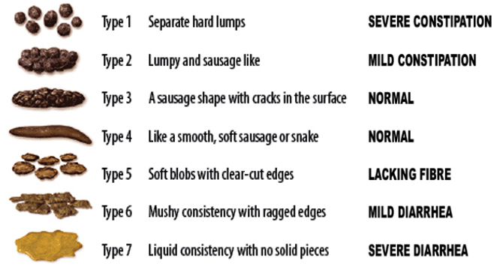

### PowerPlans, Order Sets & Clinical Pathways

* **Clinical Pathways:** [Constipation](https://bchfit.tch.harvard.edu/ebg-services/component/pdfAlgorithm?algCode=Constipation&algVersion=1.4&accessCode=null)
* **PowerPlans & Order Sets:** GI AMB Constipation Plan, GI Constipation Cleanout (GoLYTELY) Plan, Chocolate Bomb Plan, SMOG Enema Plan

### Presentation

Two of the following for 2 weeks and ≥6 mos of age:

* *<* 2 stools/week
* Fecal/urinary incontinence (after toilet trained)
* Painful/hard bowel movements
* Rectal fecal mass
* Large diameter stools that obstruct toilet/require multiple flushes

### Differential

* **95% functional:** Withholding (related to new stressor, anxiety, dev. delay, autism), exacerbated by excess dairy, low fiber, inadequate fluid, toilet training
* **5% organic:** Anatomic (e.g. anal stenosis), hypothyroidism, CF, Celiac, lead poisoning (may see calcifications on KUB), opiates, anti-epileptics, neurologic (e.g. Hirschsprung’s, CP)

### Red Flags

* **Hx:** Onset < 1 month, passed meconium >48 HOL, breastfeeding w/ hard stools, FTT, motor delay, ribbon or bloody stools, bilious emesis, FHx Hirschsprung’s.
* **Exam:** Tight rectum gripping finger, explosive stool and air from rectum upon withdrawal of finger, no anal wink, perianal fistula, midline dimple, lower back hair tuft, lower limb weakness or abnormal tone, abnormal thyroid, severe abdominal distension, fever

### Work-up

* If no red flags → KUB not routinely indicated
* If red flags or signs of systemic illness → Refer to ED/admit, obtain chem10, KUB
* If suspect Hirschsprung’s → Consult GI & Surgery for contrast enema, rectal bx

### Management

See the [Constipation Clinical Pathway](https://bchfit.tch.harvard.edu/ebg-services/component/pdfAlgorithm?algCode=Constipation&algVersion=1.4&accessCode=null) for more even more options than below.

#### Clean Out (evidence of impaction)

* **Inpatient**
  + **Cleanout & Bowel Prep:** MiraLax 34g q30min x4 hrs PO, OR Go-Lytely infusion via NG tube + IVF
    - Follow electrolytes and BUN/Cr if infusing for >12 hrs
    - If Go-Lytely is complete and effluent is not clear, start NS enemas
  + **Chocolate bomb:** 4oz chocolate (or vanilla) ice cream + 15mL senna, + 30mL mineral oil* + 30mL milk of magnesia
    - **Contraindications** to PO mineral oil: Pt at risk for aspiration, age *<* 12 mos, GERD
  + **SMOG enema:** 20 mL normal saline + 20 mL mineral oil + 20 mL glycerin
* **Outpatient** (*>* 12 mos)
  + **Day 1-3:** MiraLax 0.5g/kg (2g in 1 oz fluid) TID + Ex-lax choc ½ square daily, OR fleet mineral oil enema BID (2-12yrs: 2oz, >12 yrs: 4oz)
  + **Day 3 and disimpacted:** Begin maintenance (see below)

#### Maintenance

* Be sure to include constipation education, stool diary, diet review
* **6-12 mo**
  + Maintenance therapy = clean out therapy for this age group
  + **Start with osmotic:** Prune juice (2-6 oz/day in 2-4oz water), OR lactulose 1ml/kg/d BID, OR MiraLax 1g/k/d (mix in 4-8oz liquid, max dose 8.5g)
  + If no relief, trial **glycerin suppository**
* ***>* 12 mo**
  + **Start with osmotic:** MiraLax (10-30kg: 8.5g/day, >30kg: 17g/day), OR lactulose 1g/kg BID
  + If necessary, add **stimulant:** Senna (Ex-lax choc ½ square), OR bisacodyl (Dulcolax), OR milk of magnesia
    - Rx stimulant ***<* 2 wks**
  + **AND** toilet-sitting TID or after meals, reward-based toilet training if age appropriate
* **Reassess after 2-4 wks**

## Diarrhea

### PowerPlans, Order Sets & Clinical Pathways

* **Clinical Pathways:** [Gastroenteritis and Dehydration](https://bchfit.tch.harvard.edu/ebg-services/component/pdfAlgorithm?algCode=DEHYGASTRO&algVersion=1.9&accessCode=null)
* **PowerPlans & Order Sets:** GI Chronic Diarrhea Labs Plan, SSYCE Plan, Stool Studies Plan

### Differential

#### Acute vs. chronic

* **Acute (< 5 days):** Gastroenteritis (viral or bacterial), food poisoning, antibiotic-associated, organophosphate ingestion, hyperthyroidism, disaccharidase deficiency (infants), AOM
* **Chronic (> 2 wks):** Postinfectious lactase deficiency, IBS, IBD, Celiac, CF, milk protein allergy (infants), lactose intolerance, laxative abuse, giardiasis or other parasite, primary immunodeficiency or HIV, SIBO, chemo-induced, secretory tumor (gastrinoma, VIPoma), lymphangiectasia, congenital villous atrophy

#### Most common vs. can’t miss

* **Most common cause of…**
  + **Febrile, non-bloody:** Viral (noro, rotavirus), C. diff
  + **Afebrile, non-bloody:** Viral enteritis, bacterial foodborne, recent abx use, excessive juice (sorbitol), postinfectious lactase deficiency
  + **Febrile, bloody:** Bacterial enteritis (SSYCE)
  + **Febrile, mucusy:** Bacterial enteritis
  + **Afebrile, bloody:** Intussusception (+intermittent severe abd pain and age 6 mos-2 yrs)
* **Life-threatening**
  + **Diarrhea associated w/ sepsis:** Commonly caused by Salmonella spp and toxigenic s.aureus, immunocompromised pts at incr. risk
  + HUS: Bloody diarrhea w/ pallor, purpura, elevated serum BUN or Cr, or hematuria. Do not give antibiotics!
  + **Toxic megacolon:** Severe diarrhea + abdominal distension/peritonitis (+hx Shigellosis, pseudomembranous colitis, Hirschsprung’s, or IBD)
  + **Non-classic presentation of appendicitis:** Age < 5yo w/ small volume mucusy stools
  + **IBD:** Bloody diarrhea + weight loss, fever, fatigue, extraintestinal findings

### Work-up

* **Toxic appearing:** CBCd, retic, chem 10, BCx, stool cx (SSYCE), C. diff toxin, KUB, Abd US
* **Non-toxic** but significant **dehydration:** Chem10
* **Non-toxic** but **febrile + bloody** diarrhea: Stool cx (SSYCE)
* **Recent immigration,** travel to underdeveloped country, significant farm exposure: Stool O+P
* **Recent abx or hospitalization** AND age *>* 12 mos: C. diff toxin
* **Chronic watery:** Stool pH, stool electrolytes and osms, reducing substances, trial of fasting
* **Chronic bloody (occult or gross):** FOBT, fecal calprotectin or lactoferrin, CBC, serum albumin, ESR/CRP
* **Chronic fatty:** Fecal fat (quantitative is gold standard), fecal elastase-1, serum TTG IgA and total IgA

### Interpretation

#### Stool Studies

* Elevated **fecal calprotectin or lactoferrin:** Intestinal inflammation
* Elevated **fecal fat:** Villous atrophy, pancreatic insufficiency
* Elevated **stool Mg or Phos:** Laxative overuse/abuse

#### Differentiating osmotic vs. secretory diarrhea

* **Stool Osmolar Gap** = Stool Osm - (2 x [stool Na + stool K])
* **Osmotic diarrhea** = osmolar gap > 100 mOsm/kg
  + Maldigested carbohydrates draw water into the intestinal lumen (e.g. celiac, pancreatic disease, lactose intolerance)
  + Stool volume **decreases with fasting**
  + Presence of reducing substrates or stool pH<6 suggests carbohydrate malabsorption
* **Secretory diarrhea** = osmolar gap < 100 mOsm/kg
  + Secretion of water into intestine exceeds absorption (e.g. cholera, ETEC, neuroendo tumor, hyperthyroidism, non-osmotic laxative use)
  + Large volume stool that **does NOT** decrease with fasting
* **NOTE:** Many infectious diarrheas are **mixed** osmotic and secretory

### Acute Management

* In a non-toxic child, start with appropriate re-hydration (see [Gastroenteritis and Dehydration Clinical Pathway](https://bchfit.tch.harvard.edu/ebg-services/component/pdfAlgorithm?algCode=DEHYGASTRO&algVersion=1.9&accessCode=null))
* Generally avoid antidiarrheals
* Antibiotics are not indicated for well-appearing child with acute bloody diarrhea

## Acute Gastroenteritis

### PowerPlans, Order Sets & Clinical Pathways

* **Clinical Pathways:** [Gastroenteritis and Dehydration](https://bchfit.tch.harvard.edu/ebg-services/component/pdfAlgorithm?algCode=DEHYGASTRO&algVersion=1.9&accessCode=null)

### Presentation

Diarrhea (>2 loose/watery stools per day), +/- vomiting, fever, anorexia, cramping. Diarrhea usually lasts <1 wk and not more than 2 wks (diarrhea >14 days = “chronic”).

### Pathophysiology

* **Viruses** (**rotavirus**, **norovirus**, enteric adenovirus, calicivirus, astrovirus, enterovirus) are a major cause → Low-grade fever, vomiting, and **watery, non-bloody** diarrhea
* **Bacteria** (SSYCE, C. diff) cause infiltration of mucosal lining → Fever, abdominal pain, **bloody** diarrhea, positive **stool leukocytes**
* **Parasites** (Giardia, Cryptosoporidia, Cyclospora, E. histolytica)

### Management

* **Dehydration score** determines management:
  + If severe, obtain POCT BG + lytes and start IVF
  + Otherwise, oral rehydration solution (e.g. Pedialyte or ½ strength apple juice)
    - **NOTE:** Theoretical risk that high osmolality fluids will worsen diarrhea and hypoNa fluids will lead to hypoNa, but one RCT demonstrated improved outcomes w/ ½ strength apple juice b/c Pedialyte = not tasty
* No evidence for bowel rest or bland diet

### Anticipatory Guidance

* Very common childhood illness (children < 5yo avg 2 episodes/year)
* Fecal-oral transmission. Illness usually begins 12 hrs to 5 days after exposure, and generally lasts for 3-7 days.
* Oral rehydration/breastfeeding must be continued at home. Return to normal diet as soon as can tolerate.
* Do not give antidiarrheals
* Fever is common, give antipyretics

## Clostridium Difficile (C. diff)

### PowerPlans, Order Sets & Clinical Pathways

* **PowerPlans & Order Sets:** C. diff Treatment Plan

### Presentation

* Ranges from **asymptomatic colonization** to **profuse watery diarrhea** to **fulminant colitis** w/ fever and severe illness
  + Asymptomatic colonization w/ toxigenic C. diff is common in neonates (< 28 days) and infants (< 12 mos)
  + **Illness (but not colonization) is rare in children < 2 yo** because they lack cellular machinery to bind C. diff toxin
* **Complications:** Perforation, toxic megacolon

### Pathophysiology

* Anaerobic, Gm+, toxin-producing bacillus. Spores extremely resistant. Toxins disrupt endothelial cytoskeleton → inflammation, necrosis.
* Usually associated w/ antibiotic use (esp. clindamycin, cephalosporins, penicillins), PPIs, immunosuppression, IBD (esp. UC)

### Work-up

* **Stool enzyme immunoassay (EIA)** = high sens/spec. Positives auto-reflex to PCR.
* Stool culture is **NOT** helpful! Do not test if age < 12 mos.
* Sample should be fresh (on ice if outpatient), and usually only one sample is needed to confirm infection
* Place on contact + hand-wash precautions while awaiting stool result

### Management

* **Initial, non-severe:** **Metronidazole** (Flagyl) IV or PO 30 mg/kg/day x10-14 days, OR Fidaxomycin PO
* **Initial tx failure, underlying IBD, or severe disease:** **Vancomycin** PO 40 mg/kg/day (max 125 mg/dose) x10-14 days, OR Fidaxomicin PO
* **Chronic-recurrent** (>3x): Fecal microbial transplantation

## Inflammatory Bowel Disease (IBD)

### PowerPlans, Order Sets & Clinical Pathways

* **PowerPlans & Order Sets:** GI Inflammatory Bowel Disease Admit Plan, GI Inflammatory Bowel Disease Workup Plan, GI Inflammatory Bowel Disease Medications Plan

### Crohn’s Disease (CD)

#### Epidemiology

Onset in teens-20s and 50s-60s. Unusual in < 5yo.

#### Risk Factors

* 200 risk loci associated with both CD and UC, and associated w/ with other autoimmune diseases (ankylosing spondylitis, psoriasis, Celiac)
* Family history, Ashkenazi Jewish heritage, European ancestry
* NOD2/CARD15 mutations (CD). Turner’s Syndrome (CD), smoking (CD), sedentary lifestyle (CD), poor diet (high animal fat intake, low vegetable/fruit intake, Vitamin D deficiency) (UC+CD).

#### Presentation

* **Systemic:** Poor weight gain, stunted linear growth, anorexia, delayed puberty anemia, fatigue
* **GI:**
  + **Early:** Abd pain, RLQ mass (ileal involvement), bloody stools, perianal skin tags, fistulas, and abscesses. Primary sclerosing cholangitis.
  + **Late:** Stricture formation, intra-abd abscesses, colon cancer (8-10y after onset)
* **Extraintestinal:** Erythema nodosum, pyoderma gangrenosum, arthritis, uveitis/episcleritis, nephrolithiasis, osteoporosis, thrombosis

#### Work-up

* High **ESR/CRP,** low albumin, low Hct, **low B12,** +fecal leukocytes, high fecal calprotectin/lactoferrin
* p-ANCA -, **ANCA+** (80% of patients)
* Upper GI/SBFT/MRI/low dose CTE/WCE: **Skip lesions,** “cobblestoning,” aphthous ulcerations, narrowing or obstruction
* **Endoscopy:** Inflammation can occur anywhere in the GI tract from mouth to anus (but most commonly is ileocecal), patchy involvement, colonic aphthous lesions, linear fissures, **rectal sparing,** pseudopolyps, perianal findings (skin tags, fissures fistulae)
* **Biopsy:** Chronic inflammation, noncaseating granulomatous, transmural inflammation

#### Management

* **Corticosteroids:** Systemic, topical (enteric-coated or rectal), or GI-focused (Budesonide, Uceris)
* **Aminosalicylates (5-ASA):** Poor/minimal response in CD. Anti-inflammatory, not immune-suppressing. Timed release, enteric-coated, pH-release, rectal suppository or enema (only in mild disease).
* **Immunomodulators:** Thiopurines (azathioprine, 6-MP – check TPMT activity before starting), methotrexate. Take 2-3 mos to work so require a bridge (steroid or nutritional EEN) to manage acute inflammation.
* **Biologics:** For **Infliximab** (IV) & **adalimumab** (SC) (anti-TNFa), need HBsAg, VZV titer or 2 vaccines, TB within 6 mos to initiate. **Vedolizumab** (anti-integrin) used mainly for maintenance of CD colitis, approved in adults. **Ustekinumab** (nti-IL12/23) used mainly for maintenance, approved in adults.
* **Antibiotics** (ciprofloxacin, metronidazole): Useful in mild active CD
* **EEN:** Formula-based diet that can be used in place of steroids, which is as effective as steroids at inducing remission. Particularly good in growth failure and SI disease.
* **Surgery:** For complications such as stricture, fistula, abscess formation and to remove isolated areas of bowel involvement
* **Specific carbohydrate or anti-inflammatory diets:** As adjuvant
* Use **Pediatric Crohn’s Disease Activity Index (PCDAI)** to measure response

### Ulcerative Colitis (UC)

#### Epidemiology

Onset in teens and young adults

#### Risk Factors

See CD

#### Presentation

* **Systemic:** Similar to CD
* **GI:** Frequent, bloody/mucousy diarrhea, tenesmus, overnight stools, abd pain similar to infectious colitis
  + **Toxic Megacolon:** Can be seen in both but more common in UC. Fever, tachycardia, dehydration, electrolyte disturbance, hypoTN/shock, abd distention, vomiting, severe pain, abrupt change from diarrhea to no/little stools. ↑ risk w/antimotility agents (loperamide or opiates). **STAT abd XR + Surgery consult.**
* **Extraintestinal:** Erythema nodosum, arthritis, thrombosis, PSC

#### Work-up

* High **ESR/CRP,** low albumin, low Hct, +fecal leukocytes, high fecal calprotectin/lactoferrin
* **p-ANCA+** (60% of patients)
* Endoscopy: Friable colonic mucosa w/ **continuous extension from rectum up to proximal colon,** pseudopolyps, “backwash” ileitis, +/- gastritis **Biopsy:** Chronic mucosal inflammation in lamina propria, crypt abscesses

#### Management

* **Corticosteroids** and PO/PR **5-ASA,** as with CD
* **Immunomodulators:** 6-MP (check TPMT activity before starting)
* **Calcineurin inhibitors:** Racrolimus, cyclosporine as a bridge to colectomy
* **Biologics:** **Infliximab** used for induction and maintenance. **Vedolizumab** used mainly for maintenance (UC > CD), approved in adults. **Tofacitinib (Xelganz)** approved for adults.
* **Surgery:** Colectomy can be curative, but requires either ileostomy (undesirable) or ileal-rectal/ileal-anal anastamoses (complicated surgeries, prone to recurrence w/ any residual rectal mucosa)
* **Specific carbohydrate or anti-inflammatory diets:** As adjuvant
* **Probiotics** (VSL#3): <ay be complimentary
* Use **Pediatric Ulcerative Colitis Activity Index (PUCAI)** to measure response (Gastroenterology 2007;133:423-432)

## Malabsorption

### Carbohydrates

#### Presentation

**Frequent, watery** stools

#### Pathophysiology

Caused by: **Pancreatic insufficiency** (e.g. CF) → inadequate amylase; **lactase deficiency** (postinfectious or permanent); **bacterial overgrowth**/alteration of bowel flora (e.g. post-surgical, recent abx use); consumption of **excessive or non-absorbable sugars** (excessive juice consumption); **inadequate absorption** (e.g. Celiac)

#### Work-up

* Fecal pH < 6 (can also be seen transiently in viral enteritis)
* Stool reducing substances > 0.5%. Need fresh stool for this test!
* Breath hydrogen test used to detect lactase and sucralase deficiency (rare); or strict elimination of lactase and reassess clinically

### Fat

#### Presentation

**Greasy, foul-smelling** stools (**steatorrhea**)

#### Pathophysiology

* Caused by: **Diseases affecting bile production/secretion**; **poor enterohepatic circulation of bile salts** (e.g. ileal resection 2/2 short gut or Chron’s); **pancreatic insufficiency** (e.g. CF, Schwachman-Diamond) → inadequate lipase; **Giardia**
* Critically affects absorption of the fat-soluble vitamins A, D, E, and K

#### Work-up

* **Spot fecal fat** (Sudan III stain): Non-specific, but sample can be further tested for:
  + Split fats (fatty acids) = more suggestive of malabsorptive process, vs.
  + Neutral fats = more suggestive of pancreatic dysfunction
* **72 hr fecal fat (Quantitative):** > 5g per 24 hrs suggests malabsorption (diet during these 24 hrs should be >35% fat or ~60g)

### Protein

#### Presentation

Edema, hypoalbuminemia

#### Pathophysiology

* Most commonly caused by **pancreatic insufficiency**  (e.g. CF) → inadequate bicarb and peptidases
* Differentiate from **protein losing gastroenteropathy (PLE),** which is excessive leakage of serum proteins into the gut

#### Work-up

* Serum total protein, albumin
* Stool alpha-1 antitrypsin (for PLE)

## Celiac Disease

### PowerPlans, Order Sets & Clinical Pathways

* PowerPlans & Order Sets: Celiac Disease Plan, Celiac Gene Assessment, GI AMB Celiac Disease (Future) Plan

### Presentation

* **Classic:** Malabsorption (FTT/wt loss, steatorrhea), abd pain, gas, **bloating/distension, constipation or diarrhea,** anemia, non-erosive arthritis, dental enamel defects, aphthous ulcers, dermatitis herpetiformis (pruritic papules/vesicles), neuropsych (ADHD, depression, HA)
  + Can also be completely **asymptomatic**!
* **Infants:** Irritability, wasted extremities and buttocks, distended abdomen

### Pathophysiology

* **HLA-DQ2 or -DQ8** (predisposition, **necessary for dz**) + environmental trigger → antibodies to gliadin (gluten byproduct), tissue transglutaminase (TTG; cross-links and deamidizes gliadin peptides) → **enterocyte destruction**
* ↑ risk in T1DM, autoimmune thyroid dz, Turner and Down syndrome

### Work-up

* **Serologies:** Anti-TTG IgA, anti-endomysial IgA. Always check IgA levels (IgA deficiency can yield false negatives)! Deamidated gliadin peptide (DGP) IgG if < 2 yo or if IgA deficient.
* **Biopsy:** Intraepithelial lymphocytes, villous atrophy, crypt hyperplasia

### Management

* **Gluten-free diet** is the only treatment currently available, but is hard to maintain as is $$ and requires very strict adherence
  + Wheat, rye, barley all contain gluten. Oats often cross-contaminated unless explicitly stated.
  + Tends to be low-fiber, so watch for constipation
  + Sx should start to improve 2-4 wks into GF diet
* Trend TTG until normalized (usually by 12 mos on GF diet); improves after 6 mos. Follow Vitamin D and B12 levels, iron/ferritin PRN, thyroid. Check if immune against Hep B.

## Gastrointestinal Bleeding

### PowerPlans, Order Sets & Clinical Pathways

* PowerPlans & Order Sets: ED Gastrointestinal Bleed Plan, ICU GI Bleed Admit Plan

### Presentation

* **Upper GI bleed (UGIB):** **Hematemesis** (vomiting (or NGT/GT output) of red blood or coffee ground-like material), and/or **melena** (black, tarry stools). Hematochezia in brisk/massive UGIB, or sometimes in infants due to short intestinal transit time.
* **Lower GI bleed (LGIB):** **Hematochezia** (bright red (BRBPR) or maroon-colored blood or fresh clots per rectum). **Melena** in proximal LGIB. **Painful vs. non-painful** is an important distinction.

### Anatomy

UGIB is proximal to **ligament of Treitz** (distal duodenum), LGIB is distal

### Work-up

* **Labs:** CBC, coags, chem10, LFTs, T&S. +/- amylase/lipase. **Guaiac** to confirm it is blood.
  + ↑ BUN (in absence of renal dz) is consistent w/ UGIB, but normal or low doesn’t r/o.
  + Of note, some substances/methods can **interfere w/ stool guaiac tests**
    - **False positive:** Red meat (rare or well done, w/i 72hrs), ferrous sulfate (if stool pH <6), raw peroxidase-rich fruits & vegetables (e.g. broccoli, cauliflower, radishes, turnips), stool obtained during DRE (microtrauma)
    - **False negative:** Vitamin C (>250 mg/day), storage of specimen >4 days, outdated reagent or card
* **Imaging:** Consider XR (r/o foreign body or bowel obstruction/perforation) or abd US (evaluate for signs of portal HTN). Endoscopy and angiography may be diagnostic and therapeutic.

### Differential Diagnosis

#### Upper GI Bleed (UGIB)

Ddx for UGIB in an **infant:**

* Common
  + Swallowed maternal blood (from delivery or mother’s nipples) → w/u: Apt test
  + Esophagitis (from stress, hypoxia, indomethacin, dexamethasone)
* Uncommon
  + Gastric Ulcer

Ddx for UGIB in a **child or adolescent:**

* Common
  + **Esophagus:** Esophagitis (reflux, pill-induced e.g. NSAIDs or tetracycline); Mallory-Weiss tear
  + **Stomach:** Gastritis (NSAIDs, H. pylori, binge drinking); stress ulcer
  + **Duodenum:** Duodenitis (e.g. Crohn’s)
  + **Other:** Swallowed blood from mouth/nasopharynx; facial trauma, tooth extraction, epistaxis; red-colored liquid meds (e.g. tylenol)
* Uncommon
  + **Esophagus:** Esophagitis (viral, candidal, caustic, allergic/eosinophilic); foreign body; duplication cyst; varices (most common cause of severe acute UGIB in children; due to portal HTN)
  + **Stomach:** Gastritis (Crohn’s, portal HTN, CMV); ulcer (e.g. Zollinger-Ellison); Cushing ulcer (↑ ICP); leiomyoma (uterine fibroid); vascular malformation (e.g. Dieulafoy disease)
  + **Duodenum:** Ulcer (e.g. H. pylori, Curling ulcer in burn victims); foreign body; duplication cyst; vascular malformation; hemobilia (intrahepatic bleeding from biliary tree)
  + **Other:** Swallowed blood (e.g. Munchausen by proxy, pulmonary hemorrhage)

#### Lower GI Bleed (LGIB)

Ddx for LGIB in an infant:

* Common
  + Anal fissure (often w/constipation)
  + Milk protein allergy (mucus in stool, diarrhea)
  + Necrotizing enterocolitis
  + Swallowed maternal blood or epistaxis (can present as hematochezia due to rapid transit; w/u: Apt test)
* Uncommon
  + Vascular lesions
  + Hirschsprung enterocolitis
  + Intussusception
  + Intestinal duplication
  + Meckel’s diverticulum
  + Infectious enterocolitis
  + Infantile/very early onset IBD (VEO-IBD)

Ddx for LGIB in a child or adolescent:

* Common
  + Anal fissure (constipation, r/o sexual abuse)
  + Intussusception
  + Infectious enterocolitis (salmonella, shigella campylobacter, E. coli 0157, Yersinia, C. diff)
  + IBD
  + Meckel’s diverticulum (large-volume, painless bleeding)
  + Perianal streptococcal cellulitis
  + Juvenile/inflammatory polyp (painless)
* Uncommon
  + Nodular lymphoid hyperplasia
  + Vascular malformations
  + Intestinal duplication
  + Henoch-Schonlein purpura (HSP)
  + Infectious diarrhea (e.g. CMV colitis. amebiasis)
  + Hemorrhoids
  + Colonic or rectal varices
  + Neutropenic enterocolitis/typhlitis (immunosuppressed)

### Management

* **Initial:** Assess hemodynamic stability and determine need for fluid resuscitation and/or transfusion (establish IV access)
* **In general:** NPO, high-dose PPI (or drip), fluids resuscitation +/- transfusion, correct coagulopathy
* **UGIB:** Sometimes octreotide drip. Endoscopy/angiography.
* **Avoid:** UGI barium contrast studies, sucralfate (Carafate) (can interfere w/ visualization on endoscopy)

## Gastroesophageal Reflux Disease (GER/GERD)

### PowerPlans, Order Sets & Clinical Pathways

* **Clinical Pathways:** [Gastroesophageal Reflux Disease (GERD)](https://bchfit.tch.harvard.edu/ebg-services/component/pdfAlgorithm?algCode=12345&algVersion=1.2&accessCode=null)
* **PowerPlans & Order Sets:** GI AMB Gastroesophageal Reflux Plan

### Definitions

* **GER:** Reflux of gastric constants through LES into esophagus
  + **Physiologic in infants**; peaks around 4mo, typically improves significantly by 12mo
* **GERD** = GER + pathologic consequences (e.g. esophagitis, FTT/ weight loss, aspiration)

### Presentation

* **Infant:** Back arching, Sandifer syndrome, excessive crying (> 3 hrs/day), irritability after feeds
* **Child:** Epigastric pain, heartburn, regurgitation, vomiting, exacerbated by supine position or acidic foods
* **Moderate/severe symptoms:** > 3 days/wk, and/or interfere w/ function
* **Red flags:** Weight loss/FTT, hematemesis, vomiting that is persistent, projectile, or bilious, feeding refusal, dysphagia, recurrent PNA. Should prompt further work-up or endoscopy.

### Management

* **Approach to GERD in a child:** Goal is to differentiate between mucosal disease, abnormal esophageal acid exposure, reflux hypersensitivity and/or functional heartburn driving symptoms
  1. [NASPHGAN **diet and lifestyle changes**](http://chbshare.chboston.org/TS/clinsvc/dom/domqp/Documents1/Forms%20and%20Templates/Rosen_GERD_NASPGHAN_Guidelines.pdf). If no improvement → *Step 2:*
  2. 2 wk trial of **H2RA** (e.g. famotidine). If no improvement → 6-8 wk trial **PPI** (e.g. omeprazole). If no improvement on PPI or if unable to wean acid suppression → *Step 3:*
  3. **Refer to GI** (upper endoscopy +/- pH impedance testing)
* **Approach to GERD in an infant:** Remember, GER is physiologic in infants! Impt to consider feeding difficulties/oropharyngeal dysphagia/aspiration in ddx.
  1. **Reflux precautions:** Elevate HOB, paced feeding, hold upright for 30 min after feed, thicken feeds (Similac SpitUp/Enfamil AR or 1 tsp rice/oatmeal cereal per 1oz formula), avoid tobacco exposure. Specifically counsel that **all infants should continue back to sleep,** even with reflux. If no improvement → *Step 2:*
  2. 2-4 wk trial of **hydrolyzed or amino acid formula, or elimination trials** of cow’s milk and soy from maternal diet if breastfeeding. If no improvement AND severe symptoms (poor weight gain, feeding refusal) → *Step 3:*
  3. 2-4 wk trial of **famotidine or omeprazole**. Counsel caregivers on limited evidence of efficacy and ↑ risk of CAP PNA, GI infections, vitamin deficiencies, and fractures. If severe symptoms persist beyond 12 mos age → *Step 4:*
  4. **Refer to GI**

## Pancreatitis

### PowerPlans, Order Sets & Clinical Pathways

* **Clinical Pathways:** [Pancreatitis, Acute](https://bchfit.tch.harvard.edu/ebg-services/component/pdfAlgorithm?algCode=PANCREATITIS_ACUTE&algVersion=1.4&accessCode=null)
* **PowerPlans & Order Sets:** Acute Pancreatitis Plan, Acute Pancreatitis Critical Care Plan, ED Pancreatitis Plan, GI Pancreatitis Labs Plan

### Presentation

**Epigastric abd pain** w/ band-like pain to back, fever, **N/V,** ileus, jaundice/clay-colored stools

### Pathophysiology

**Gallstones or biliary disease** (30% of pediatric cases), congenital anomalies (e.g. **choledochal cyst,** pancreatic divisum), infectious (**mumps, mycoplasma,** coxsackie, influenza, salmonella, GNRs), drugs (**valproic acid,** L-asparaginase, steroids), systemic dz (**CF w/ pancreatic sufficiency,** Lupus, RA, HUS, Kawasaki, IBD), metabolic (**hyperlipoproteinemia,** hyperCa, DM), EtOH abuse, blunt abd trauma (e.g. handlebar injury), genetic (SPINK1). 10% will have recurrence of disease.

### Diagnostic Criteria

At least **2 out of 3:** (1) Abdominal pain (see above), (2) Amylase or lipase > 3 ULN, (3) Imaging compatible w/ pancreatitis (US, EUS, MRI/MRCP)

### Work-up

* Chem10, **amylase/lipase** (lipase rises earlier, elevated for longer, more specific), lipids, albumin, glucose, LFTs. ALT > 3x ULN has >95% PPV for gallstone pancreatitis.
* **Contrast-enhanced US** to confirm pancreatic inflammation and assess for gallstones or dilated CBD

### Management

Refer to the [Acute Pancreatitis Clinical Pathway](https://bchfit.tch.harvard.edu/ebg-services/component/pdfAlgorithm?algCode=PANCREATITIS_ACUTE&algVersion=1.4&accessCode=null). There are 4 components:

1. **Pain control:** Ketorolac, acetaminophen +/- opiates
2. **Fluids:** NPO x24 hrs w/ NS or LR (if calcium wnl) bolus(es) followed by 2x MIVF
3. **Imaging:** Contrast-enhanced US
4. **Feeding:** Trial enteral feeds at 24 hrs if clinically stable. Interval increases in amylase and/or lipase or mild vomiting should not delay advancing introduction of enteral feeds.

### Complications

SIRS, ARDS, abscess, pleural effusion, pseudocyst (patients require f/u RUQ US in 4-6 wks to assess for pseudocyst)

## Functional Gastrointestinal Disorders (FGID)

### Pathophysiology

Hypersensitivity (visceral nervous system, CNS), motility disturbance, ?microbiome disturbance, psychological factors including caregiver stress, and abnormal responses to both normal and abnormal physiologic stimuli

### Alarm Symptoms

Blood in stool, multiple episodes of diarrhea > daily, persistent fevers, weight loss, nighttime awakenings for pain or to have BM. **CANNOT** be FGID!

### Management

Each diagnosis has its own specific management pearls (see below), but these general principles apply to all:

* Pt/family **education** about FGIDs. Thorough **understanding** of diagnosis and clear **motivation** to overcome it is critical for patient and family. **Language** is important: Can be helpful to describe broadly as “hyperactive/overly sensitive gut nervous system” that needs to be “re-trained”; the word “functional” may be off-putting, so alternatives might be “sensitive stomach” or “irritable bowel” (as appropriate depending on specific diagnosis). Most important is **reassurance** (e.g. have ruled out other concerning diagnoses). Many families are actually accepting and feel relieved to put a name to the symptoms.
* **Judiciously** order labs/imaging **only if** alarm symptoms are present and after introducing possibility of FGID.
* **CBT:** Relaxation training, cognitive restructuring, modifying family response. Also important to **address other psychological comorbidities.**
* **Antispasmodics** (hyoscyamine, dicyclomine). **TCAs or SSRIs** if comorbid anxiety/depression.
* Identify and avoid **food triggers** (e.g. tomatoes/citrus, caffeine, carbonation, greasy, spicy foods).
* **Inpatient:** Consider Magic Mouthwash (AIOH/diphenhydramine/lidocaine/MgOH/simethicone) or hyoscyamine if “something” necessary (e.g. over a weekend)

### Irritable Bowel Syndrome (IBS)

Subtype may be Constipation (**IBS-C**), Diarrhea (**IBS-D**), or mixed/alternating (**IBS-M** or **IBS-A**)

#### Presentation (Rome IV Criteria)

Recurrent abd pain, at least 1 day/wk x3 mos, associated w/: Defecation, change in frequency/form of stool. Look for association w/ excitement or stress.

#### Specific Management

**Probiotics** (lactobacillus or bifidobacteria). Bio-psycho-social approach. Medications to target symptoms, but educate that goal is to **improve rather than cure.** Return to **regular schedules/routines.**

### Functional Dyspepsia (FD)

#### Presentation (Rome IV Criteria)

1x/wk of: Bothersome postprandial fullness (uncomfortably full after regular-sized meal) w/early satiety, epigastric pain/burning

#### Specific Management

Small, frequent meals. Time-limited empiric trials of **acid suppression** or **prokinetics**. Peppermint oil (**IBguard**). Limit fructose, sorbitol. Consider **cyproheptadine** if weight loss. **Sulcralfate** helpful for burning, best to use single dose at night.

### Abdominal Migraine

#### Presentation (Rome IV Criteria)

Paradoxical episodes of acute periumbilical abd pain lasting *>* 1 hr, often i/s/o family hx of migraine. Must be completely asymptomatic between attacks. Note: This is a controversial diagnosis.

#### Specific Management

**Avoid caffeine.** **Ppx:** Cyprohepatdine, propranolol. **Abortive:** Triptan (IV, intranasal), dark/quiet room.

### Functional Abdominal Pain (FAP)

#### Presentation (Rome IV Criteria)

Often **vague, diffuse pain,** almost never focal. Often occurs at times of separation (bedtime or school) and is better over summer, weekends, or vacation.

#### Specific Management

If severe, consider referral to Functional Abdominal Pain Clinic

### Cyclic Vomiting Syndrome

#### Presentation (Rome IV Criteria)

* Stereotypical episodes of intense vomiting separated by wks to mos, completely fine between attacks. Usually presents in 3-7yo, uncommon onset after puberty). Typically happens at night (e.g. before bed), and parents can often tell it is coming (e.g. child is pale). Often i/s/o maternal hx of migraine.
* **Isolated vomiting should always raise concern,** so **need to r/o** malrotation, inborn error of metabolism, increased ICP, UPJ obstruction, pancreatitis, and cannabanoid hyperemesis syndrome (often responsive to hot showers, topical capsaicin cream)

#### Specific Management

See abdominal migraine management above, plus IV hydration and ondansetron PRN

### Functional Nausea

#### Presentation (Rome IV Criteria)

Predominant symptom is nausea. At least 2 mos of all of the following: (1) Bothersome nausea at least 2x/wk generally not related to meals; (2) Not consistently associated w/ vomiting; (3) R/o other medical condition causing nausea.

### Functional Vomiting

#### Presentation (Rome IV Criteria)

At least 2 mos of all of the following: (1) Avg 1+ episodes of vomiting per week; (2) Absence of self-induced vomiting or criteria for eating disorder or rumination; (3) R/o other medical condition causing vomiting

### Rumination Syndrome

#### Presentation (Rome IV Criteria)

At least 2 mos of all of the following: (1) Repeated regurgitation and rechewing or expulsion of food, begins soon after ingestion of meal, does not occur during sleep; (2) Not preceded by retching; (3) R/o other medical conditions, including eating disorder

#### Specific Management

Can use strategies similar to management of habit disorders. Education on diaphragmatic breathing.

## Newborn GI

### Pyloric Stenosis

#### Presentation

* **Immediate postprandial projectile emesis,** “hungry vomiter,” palpable olive-like mass
* 4:1 M:F. Classically presents in **3-6wo infants, but can worsen by 2-3 mos** (rare by 12wo).

#### Pathophysiology

Hypertrophy of pylorus. Risk factors = bottle feeding, maternal smoking.

#### Work-up

BMP (**hyperchloremic metabolic alkalosis**), CBC (should be wnl), bili (unconjugated hyperbili), hemoccult stool (should be neg), **abd US**

#### Management

* Address dehydration and correct alkalosis
* Consult Surgery for pyloromyotomy (definitive treatment)
* Post-op feeding can start within hours

### Malrotation/Volvulus

#### Presentation

Bilious emesis, third spacing, HD instability

#### Pathophysiology

* **Malro:** Arrest in normal rotation in embryonic gut. Misplaced cecum is attached by peritoneal bands (Ladd bands) which cross the duodenum, leading to risk of volvulus. Mostly asymptomatic.
* **Volvulus:** Small bowel twisting around SMA → vascular compromise, ischemia, necrosis

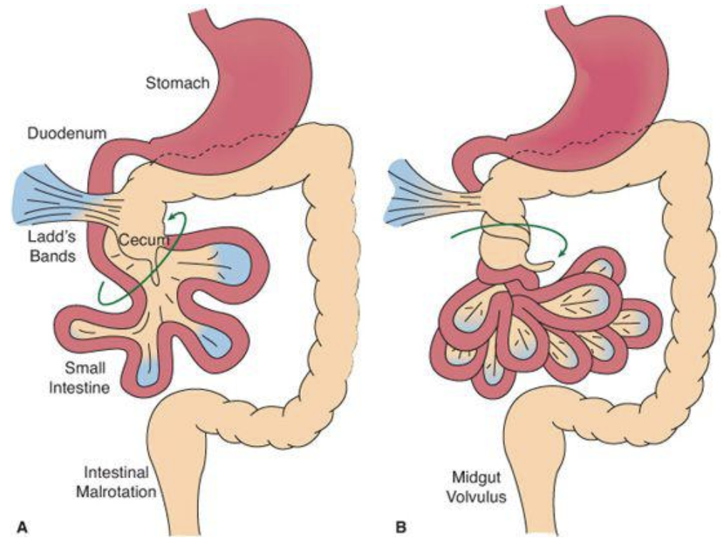

#### Work-up

Depends on clinical stability

* Bilious emesis + signs of sepsis/HD compromise + suspicion for volvulus → rapid resuscitation and surgical exploration
* If HD stable → KUB, upper GI series (corkscrew appearance), abd US (whirlpool sign), CT in adults. Laproscopy if indeterminate.

#### Management

* **Ladd procedure:** Division of Ladd bands, widening mesenteric base, explore duodenum with tube for patency, **appendectomy** (to avoid future confusion w/ abd pain), bowel resection PRN, replacement of bowels in nonrotation
* Post-op, address **short gut syndrome** if relevant

### Biliary Atresia (BA)

#### Presentation

**Jaundice, acholic stools,** hepatomegaly

#### Pathophysiology

* Most common cause of neonatal cholestasis; more common in premature infants
* Grouped into 3 categories:
  1. **Nonsyndromic type:** Most common type (84%). Perinatal and involves an inflammatory process involving intra- and extrahepatic fibro-obliteration → direct hyperbili → biliary cirrhosis, liver failure. Etiology unknown although possibly virus & toxins.
  2. **Biliary Atresia Splenic Malformation** (10% of cases) is associated w/ laterality malformations (e.g. situs inversus, asplenia/polysplenia, malrotation, interrupted IVC, cardiac anomalies)
  3. **3rd type** (6% of cases) is associated w/ other congenital anomalies (e.g. intestinal atresia, imperforate anus, kidney and cardiac anomalies)

#### Work-up

* **Labs:** Bilirubin (conjugated hyperbili >1.0 mg/dl is always considered pathological and warrants workup), liver enzymes (transaminitis, elevated GGTP), obtain TSH/T4 for ddx
* **Imaging:** Abd US (inability to visualize gallbladder or small gallbladder), HIDA scan (looks for excretion of bile from liver)
* **Operative:** Liver biopsy, intra-op cholangiogram

#### Management

* 100% mortality by 2yo if untreated. Early diagnosis (< 8wo) improves prognosis.
* Kasai procedure (hepatoportoenterostomy): Best if done before 2mo. Removal of portal tract remnant followed by Roux-en-Y anastomosis of jejunal loop directly to liver capsule to allow bile drainage. 60-70% of patients undergoing Kasai will eventually need liver transplant (BA = most common indication for pediatric liver transplant)

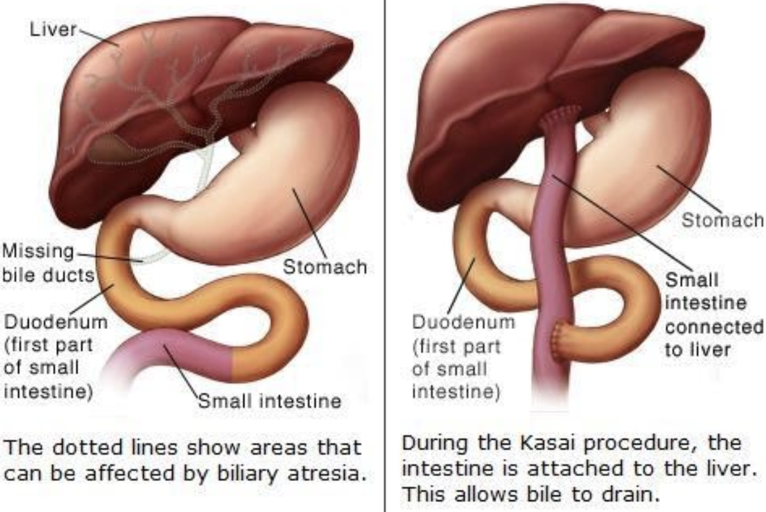

## GI Imaging

### Abdominal XR (KUB)

#### Description

Radiography. **Positions:** PA upright (most common), left lateral decubitus (for closer evaluation of peritoneal free air or to look for air trapping)

#### Used to Evaluate

Abdominal pain or distension, constipation, emesis, concern for mass, concern for ingestion

#### Potential Pathology Visualized

* Constipation (stool burden)
* Ileus, bowel obstruction (dilated loops of bowel)
* Foreign body
* Necrotizing enterocolitis, bowel ischemia (pneumatosis, pneumoperitoneum, air in the biliary tree)
* Bowel perforation (free air under diaphragm)

#### Patient Prep

None

### Modified Barium Swallow (MBS)

#### Description

**Videofluorography** to evaluate the function of the phases of swallowing. Barium-impregnated foods of different consistencies are given to the patient and swallowing function is assessed.

#### Used to Evaluate

Dysphagia; coughing, choking, drooling w/ swallowing; aspiration PNA, known or suspected; neurologic or anatomic disease that may affect swallowing function

#### Potential Pathology Visualized

Swallowing dysfunction (e.g. aspiration or laryngeal penetration), anatomic anomalies (note: esophagram, UGI series, or endoscopy may be better depending on the structural anomaly)

#### Patient Prep

* NPO for several hours (check BCH/BMC policies and/or discuss w/ Feeding Team/SLP)
* Pt needs to be able to cooperate w/ exam (i.e. able to attempt swallowing when fed)

### Upper GI (UGI) Series

#### Description

* **Single Contrast UGI:** Fluoroscopy of esophagus, stomach and duodenum, w/ PO barium as contrast agent
* **Double Contrast UGI:** Fluoroscopy of esophagus, stomach and duodenum, w/ PO barium + sodium bicarbonate crystals (crystals release CO2, which distend the stomach and esophagus)
* **UGI/SBFT** (small bowel follow-through): Single contrast UGI → drink additional contrast and wait 30 min → fluoroscopic evaluation q15 minutes until the enteric contrast reaches terminal ileum

#### Used to Evaluate

* **Single Contrast +/- SBFT:**
  + Severe or persistent abd pain, epigastric pain/discomfort
  + Congenital syndromes associated w/ intestinal malrotation
  + Weight loss or FTT
  + Vomiting
  + Esophageal strictures or foreign bodies
  + Upper GI bleed
  + Bowel dilation in short bowel syndrome
  + Anastomotic stricture or abnormality in post-surgical short bowel syndrome patients
* **Double Contrast:** Evaluation of mucosal integrity

#### Potential Pathology Visualized

Esophageal stricture/foreign body; malrotation; hiatal hernia; gastric outlet obstruction; delayed transit/delayed gastric emptying; gastritis, duodenitis, peptic ulcer disease; duodenal laceration or intramural hematoma; pyloric stenosis (although US is preferred); bowel dilatation post-surgery; anastomotic abnormality

#### Patient Prep

* NPO >2 hrs or NPO >6 hrs is assessing for gallstones
* Must be able to swallow contrast
* Contrast may be placed through an enteral tube if small bowel follow through is desired
* Counsel parents that barium may cause/worsen constipation

#### Considerations

Barium is **contraindicated** i/s/o gastric perforation (use water soluble contrast), high aspiration risk, or colonic obstruction, T-E fistula, esophageal stricture, or in the immediate post-op period s/p GI surgery

### Abdominal CT

#### Description

Cross sectional imaging of abdominal structures. Both IV and oral contrast can be used.

#### Used to Evaluate

Colicky pain; abd trauma (once HDS stable); cancer; liver disease; features of small intestinal Crohn’s disease (fistula, stricture, abscess)

#### Potential Pathology Visualized

Nephrolithiasis, urinary tract calculi (non-con); pelvic or abdo masses (contrast); IBD; SBO/LBO; diffuse liver disease (steatosis, iron deposition disease, cirrhosis); appendicitis; abd trauma

#### Patient Prep

Oral or IV contrast as indicated

### Contrast Enema

#### Description

Contrast agent per rectum: **Water-soluble (gastrograffin)** if bowel perforation suspected, **air** if intussusception suspected

#### Used to Evaluate

IBD; SBO/LBO; intussusception; anastomotic stricture or abnormality in post-surgical short bowel syndrome

#### Potential Pathology Visualized

Lower abd obstruction in the neonate (Hirshprung’s, meconium ileus, ileal atresia); intussusception (diagnostic and therapeutic); dnastomotic abnormality

#### Patient Prep

None

## G-Tubes & J-Tubes

### PowerPlans, Order Sets & Clinical Pathways

* **PowerPlans & Order Sets:** Enteral Tube Obstruction Plan (can also find under Gastrostomy Tube Obstruction Plan)

### Indications

* Inadequate intake (lower threshold in already malnourished, premature, oncologic kids)
* NG/NJ = 1st line, short-term; GT/GJ/JT = if feedings indicated > 2 months

### Tube Troubleshooting

***Before calling for help,*** need to know: **what kind of tube** (type, size), **who placed it** (Surgery, GI, IR), and **how old is the original tract**?

#### Tube Falls Out

* **NEW T-type PEG tubes** placed by GI/Surgery < 6 months ago: **Do not attempt** replacement! Page GI fellow as tube will likely need replacement by IR.
* **Surgically-placed G-tube:** If tract is < 12 wks old, page Gen Surg. If > 12 wks old, replace immediately with same-sized tube. If new tube is not immediately available, use Foley catheter in same French size (or 1 size larger to help dilate the tract). Do not force the tube in, as this can lead to false-tracking. Obtain G-tube study if any concerns for tube malposition.

#### Clogged Tube

Crush 1 tab of sodium bicarb (324 mg) and 1 tab of Viokase 8 (Pancrelipase) in 5mL water. Instill slurry into feeding tube; wait 30-60 min, withdraw, and flush. See Enteral/Gastrostomy Tube Obstruction Order Set.

#### Granulation Tissue

Stabilize tube. Consider silver nitrate vs. triamcinolone cream vs. salt in small amount of water.

#### Contact Dermatitis

Absorbent topical powder, dressing. Consider Aveeno, Dombro, topical antifungal.

#### Cellulitis

Outline erythema and start antibiotics

### Devices

#### Percutaneous Endoscopic Gastrostomy (PEG) Tube

* Usually T-type tube w/ cross-bar to hold internal balloon tight to abdominal wall
* Needs 6 months before conversion to skin-level device. This is done endoscopically with sedation.

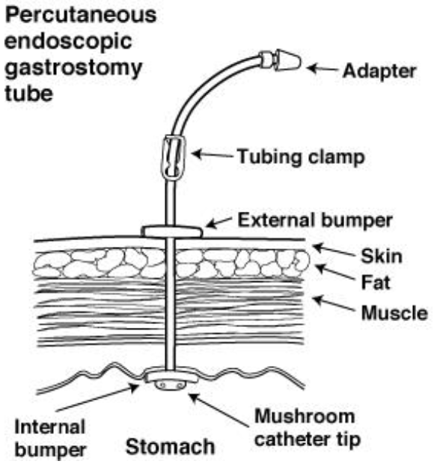

#### Surgically Placed G-Tube

* **MIC-G:** Non-skin level device w/ 3 ports (feeds, meds, balloon). Has round disk flange to hold it to abdominal wall.
* **MIC-KEY:** Skin level button device w/ 2 ports. Tubing swivels, allowing patient to move comfortably. Now using AMT tubes instead of MIC-KEY.
* **Bard button:** Skin level device, slightly smaller than MIC-KEY. Uses plastic bolster rather than balloon.
* **MIC-GJ:** Non-skin level device placed by IR through existing gastrostomy site. Has separate ports for gastric and jejunal.
* **MIC-KEY-GJ:** Skin level button device w/ separate ports for gastric and jejunal. Multiple jejunal exit holes allow for decreased clogging.

#### Jejunal Tube

* No bolus feeds; continuous only, and requires slow advances
* Needs large water flushes (15-30 mL) after medications and feeds to prevent clogging
* Crushed medications can precipitate and should not be given through the J tube (e.g. ciprofloxacin)
* If vomiting, look for intussusception around tube with tube study

## Infant Formulas

See the “Pediatric Formula Guide” on the [BCRP website’s Virtual White Coat](http://thebcrp.com/cards) for more detailed information

### Helpful Math

* **1 oz = ~30 mL**
* Standard infant formula = 20 kcal/oz. Toddler/infant formula (1yo+) = 30kcal/oz

### Types of Formula

#### Cow’s Milk

* **Common brands:** Enfamil (cheapest); Similac Advance (claims to have better calcium absorption); “Step 2” or “next step” versions (babies > 6mo) have more calcium, protein; Preemie versions (Enfacare, Neosure) have 22 kcal/oz, extra calcium, phosphorus

#### Partially Hydrolyzed

* Whey = cow’s milk-based
* **Common brands:** Good Start (made by Nestle, covered by WIC)

#### Soy

* Lactose-free, good for **lactose intolerance** or **galactosemia**
* Can cause **constipation**
* **Common brands:** Prosobee (made by Enfamil); Isomil (made by Similac); Goodstart Soy

#### Hydrolyzed, Semi-Elemental

* **Common brands:** Nutramigen (cheapest, covered by WIC); Alimentum (sweeter taste); Pregestimil

#### Amino Acid-Based, Elemental

* Very expensive $$$$
* **Common brands:** Neocate (covered by WIC); Elecare (higher MCT oil content, less osms)

### Caloric Supplements

* Formulas can be safely concentrated up to **28 kcal/oz**
* If increased renal solute load is undesirable, use carb/lipid caloric supplements instead:
  + Polycose powder (carb-based)
  + Corn oil, medium chain triglyceride (MCT) oil (lipid-based)
  + Duocal (contains both carb and fats, only for infants > 1yo)

## Total Parenteral Nutrition (TPN)

***NOTE:*** **Enteral feeding is always the preferred route of nutrition support!** It ↓ gut atrophy, ↓ infections (boosts gut immune function), ↓ liver damage, and ↓ source of infection from central line.

### PowerPlans, Order Sets & Clinical Pathways

* **PowerPlans & Order Sets:** PN + lipid Orderset, PN Monitoring Plan, PN Profile
* At BCH you write your own PN orders, but Nutrition will always walk you through it step by step!

### Indications

Low birth weight. Abnormal nutritional status (z-score < -2 weight-for-age or weight-for-height, < 2500g). Dysfunctional GI tract. NPO > 4 days. **Always** in consultation with Nutrition Service and Dietitian.

### Access

* If Osm > 900, need central access.
* Calculate % of daily maintenance fluids, consider heart or renal limitations

### Monitoring

* Weight daily, length (<24 mos) weekly, height (>24 mos) periodically, head circumference (<24 mos) weekly
* Fluid balance daily, chem10 daily until stable
* Chem10, LFTs, and TG weekly
* If on PN and minimal feeds for > 1 mo, nutritional labs checked periodically (Se, Cu, Zinc, Iron, Carnitine, CRP, vitamins A/D/E, INR, Manganese, Aluminum, iron studies, essential fatty acid profile)

## Liver Enzymes

|  |  |  |
| --- | --- | --- |
| Pattern | Lab Findings | Ddx |
| Hepatocellular | ↑ ALT (specific), AST, LDH >>> ↑ GGTP, alk phos, bilirubin | - Viral (HepA, CMV, EBV, VSV, HSV, others)- Meds/toxins- Shock (highly elevated, LDH also high)- Autoimmune hepatitis- Steatosis (often subtle ALT elevation)- Celiac disease- Hemochromatosis (↑ ferritin/TIBC >45%)- A1AT- Wilson’s disease (AST>ALT, ↓ ceruloplasmin, ↓ alk phos)- EtOH (AST:ALT >2:1)- Non-hepatic: Adrenal insufficiency, thyroid disease, heart failure, NAT- **Isolated ↑ AST:** Myopathies, cardiomyopathies, hemolysis, strenuos exercise |
| Cholestatic | ↑ Alk phos, GGTP & Direct Bili >> AST, ALT | - Bile duct obstruction/abnormalities (e.g. gallstones)- Infectious hepatitis- Cirrhosis- Meds/toxins (anabolic steroids, amox/clav, erythromycin, bactrim, TPN)- PBC/PSC- A1AT- Alagille syndrome- Inborn errors of metabolism- CF |
| Infiltrative | ↑ Alk phos w/ nl bili (send GGT to determine if from liver or bone) | - Granulomatous disease (e.g. sarcoid, Tb)- Amyloidosis- HCC, liver mets |
| Chronic/end-stage | ↓ Alb, PT, PTT, factor VII, V & serum lipids | Progress of chronic liver disease |

## Infectious Hepatitis

|  |  |  |  |  |
| --- | --- | --- | --- | --- |
|  | Hepatitis A | Hepatitis B | Hepatitis C | Hepatitis D |
| **Transmission** | Fecal-oral, blood | Blood, sex, maternal-fetal (90% vertical transmission rate, but **infants almost always become chronic carriers**; OK to breastfeed) | Blood, sex, maternal-fetal (<5% vertical transmission rate; OK to breastfeed) | Blood, sex (less common). ONLY if **Hep B co-infection!** |
| **Epidemiology** | High in Mexico, S. America, Africa, Asia | 1-2% in US. Higher in Asia and South America. 10-20% in China, sub-Saharan Africa | Seroprevalence 0-1% worldwide | <3% of HBV+ patients |
| **Incubation** | 2-8 wks | 1-4 mo | 1-3 mo | 3-7 wks |
| **Prophylaxis** | Hep A vaccine, pre-/post-exposure w/ polyclonal IgG | Post-exposure w/ **HBIg & HBV vaccine w/i 12 hrs** (newborns born to HBV+, needlesticks) | None | None |
| **Management** | Supportive. Vit K for coagulopathy | Entecavir, tenofovir, peginterferon alfa-2a, IFNa (20-50% will seroconvert, but lots of systemic side effects), lamivudine (high rate of resistance) | Direct-acting antiretrovirals (DAA), specific treatment depends on genotype and age (ledipasvir/sofosbuvir, sofosbuvir/ribavirin or Glecaprevir/Piprentasvir). Treatment for patients < 3 yo should be deferred (until Ribavirin-free DAA available). | IFN-based. Lamivudine is not helpful. |
| **Prognosis** | Usually self-limiting | - Self-limited or progression to chronic HBV/carrier status (esp. neonates)- Cirrhosis in 3%- Increased risk of hepatocellular cancer (yearly RUQ US, AFP level) | - 20-45% spontaneous clearance- Remainder will have slow progression to cirrhosis/hepatocellular cancer if untreated | Worse prognosis and faster progression than HBV alone |

### Hep B Serologies

* **HBsAg** (surface antigen): Indicative of **acute** infection, disappears in 3-6 mos
* **HBsAg** for >6 mos: **Carrier** state
* **HBeAg** (secretory protein) and **HBV DNA** by PCR suggest **active viral replication**
* **Anti-HBc IgM** (antibody to core protein): Secondary indicator of **acute** infection
* **HBsAb** (antibody to surface protein): Neutralizing antibody, suggests **recovery or response to HBV vaccine**

#### Timeline of Hep B Serologies

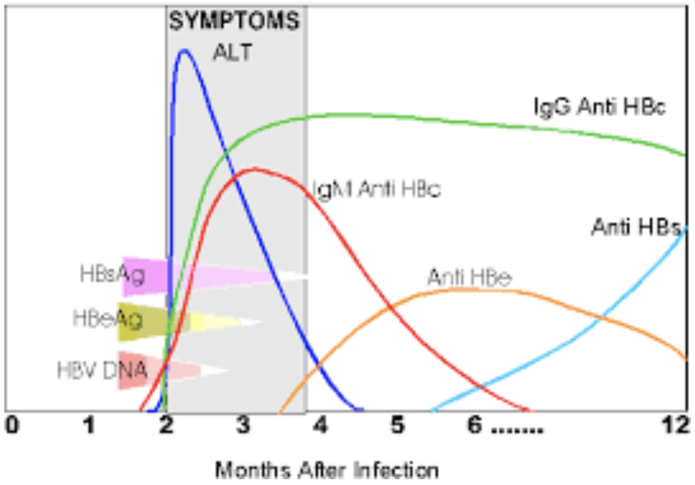

#### Interpretation of Hep B Serologies

|  |  |  |  |  |
| --- | --- | --- | --- | --- |
| Anti-HBc IgM | Anti-HBc IgG | HBsAg | Anti-HBs | Interpretation |
| **POS** | Neg | **POS** | Neg | Acute HBV infxn |
| Neg | Neg | **POS** | Neg | Early acute HBV infxn |
| Neg | **POS** | Neg | **POS** | Resolved acute HBV infxn |
| Neg | Neg | Neg | **POS** | Prior vaccination for HBV (NOT infected) |
| Neg | Neg | Neg | Neg | Not infected |
| Neg | **POS** | **POS** | Neg | Chronic HBV infxn |

## Autoimmune Hepatitis

### Presentation

* Acute vs. subacute. HSM, fatigue, amenorrhea.
* Transaminitis > bilirubin elevation. Hypergammaglobulinemia.
* Typically 10-20yo, affects mostly (75%) females

### Pathophysiology

* **Type 1** (classic, 80% of cases): +ANA, anti-SM and/or anti-nuclear, anti-actin, rarely anti-ASGPR
* **Type 2:** Anti-LKM and/or anti-liver cytosol. Recurrence and fulminant hepatitis more common in Type 2.
* In AIH associated w/ Coombs-positive hemolytic anemia, none of the typical autoantibodies are present

### Work-up

* LFTs, Ig levels, auto-antibodies, coags, consider liver biopsy. Sero-negative AIH exist but are rare.
* Cholangiography if cholestatic w/ c/f “Overlap Syndrome” with PSC

### Management

* Prednisone (18-24m) or azathioprine/6-MP (steroid-sparing; check TPMT enzyme activity first, as low TMPT levels = risk of myelosuppression)
* Monitor LFTs for treatment success
* Relapse more common if tx weaned in first 3 yrs of therapy or during puberty

## Non-Alcoholic Fatty Liver Disease (NAFLD)

### Presentation

**Often asymptomatic.** Fatigue, abdominal discomfort, acanthosis nigricans.

### Pathophysiology

Incompletely understood, but insulin-resistance considered a key mechanism, +/- oxidative injury

### Work-up

* Screen if > 9yo and BMI >94%, or >85% + risk factor (e.g. signs of insulin resistance)
* **ALT** >>> AST, alk phos, GGTP (although LFTs can be normal)
* Abd US, Fibroscan (to assess degree of fibrosis)
* Liver biopsy: If steatosis + hepatocellular injury present, then it is **Nonalcoholic Steatohepatitis (NASH)**

### Management

Diet and exercise counseling, bariatric surgery, consider Vitamin E (limited evidence)

## References

# Hematology

## Anemia [8]

**Table 447-1 Normal Mean and Lower Limits of Normal for Hemoglobin, Hematocrit, and Mean Corpuscular Volume**

### Definition

Anemia is a reduction in hemoglobin concentration, hematocrit. The lower/upper limit of the normal range is set at two standard deviations below the mean for age and sex for the general population.

**Normal Mean and Lower Limits of Normal for Hgb, Hct & MCV**

|  |  |  |  |  |  |  |
| --- | --- | --- | --- | --- | --- | --- |
|  | Hemoglobin (g/dl) |  | Hematocrit (%) |  | Mean Corpuscular volume (mM3) |  |
| **Age (yr)** | **Mean** | **Lower Limit** | **Mean** | **Lower Limit** | **Mean** | **Lower Limit** |
| 0.5-1.9 | 12.5 | 11.0 | 37 | 33 | 77 | 70 |
| 2-4 | 12.5 | 11.0 | 38 | 34 | 79 | 73 |
| 5-7 | 13.0 | 11.5 | 39 | 35 | 81 | 75 |
| 8-11 | 13.5 | 12.0 | 40 | 36 | 83 | 76 |
| 12-14 (F) | 13.5 | 12.0 | 41 | 36 | 85 | 78 |
| 12-14 (M) | 14.0 | 12.5 | 43 | 37 | 84 | 77 |
| 15-17 (F) | 14.0 | 12.0 | 41 | 36 | 87 | 79 |
| 15-17 (M) | 15.0 | 13.0 | 46 | 38 | 86 | 78 |
| 18-49 (F) | 14.0 | 12.0 | 42 | 37 | 90 | 80 |
| 18-49 (M) | 16.0 | 14.0 | 47 | 40 | 90 | 80 |

### Approach to Anemia (by MCV & Retics)

|  |  |  |  |
| --- | --- | --- | --- |
| Reticulocyte count | Microcytic anemia (MCV <80) | Normocytic anemia (MCV 80-100) | Macrocytic anemia (MCV >100) |
| **LOW**(inappropriately low for the degree of anemia) | -[Iron deficiency](https://bchfit.tch.harvard.edu/ebg-services/component/pdfAlgorithm?algCode=IDA&algVersion=1.4&accessCode=null) (see Clinical Pathway)- [Lead poisoning](https://bchfit.tch.harvard.edu/ebg-services/component/pdfAlgorithm?algCode=Lead_Poisoning&algVersion=1.9&accessCode=null) (see Clinical Pathway)- Chronic disease- Aluminum toxicity- Copper deficiency- Protein malnutrition | - Chronic disease- RBC aplasia (TEC, infection, drug induced)- Malignancy- JRA- Endocrinopathies- Renal failure | - Folate deficiency, Vitamin B12 deficiency- Aplastic anemia- Congenital bone marrow dysfunction (Diamond-Blackfan or Fanconi syndromes, Diamond Blackfan anemia)- Drug-induced- Myelodysplasia- Trisomy 21- Hypothyroidism |
| **NORMAL** | - Thalassemia trait- Sideroblastic anemia | - Very acute bleeding- Phlebotomy- Hypersplenism- Dyserythropoietic anemia II |  |
| **HIGH** | - Thalassemia syndromes- Hemoglobinopathies | - Antibody-mediated hemolysis- Hypersplenism- Microangiopathy (HUS, TTP, DIC, Kasabach-Merritt)- Membranopathies (spherocytosis)- Enzyme disorders (G6PD, PK)- Hemoglobinopathies- Acute/chronic bleeding | - Dyserythropoietic anemia I, III- Active hemolysis |

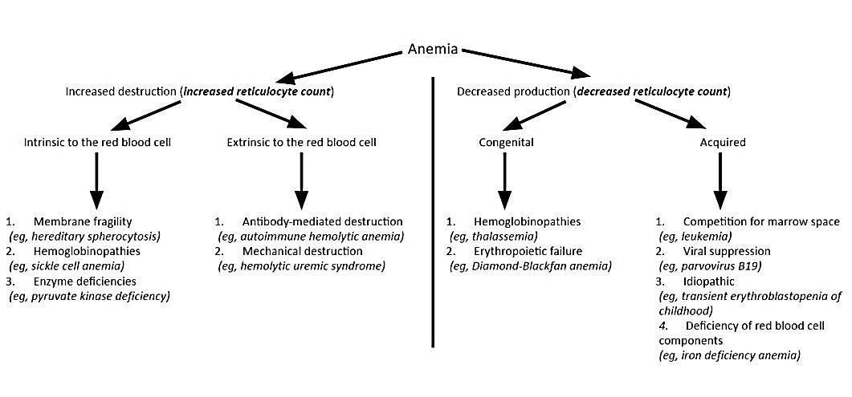

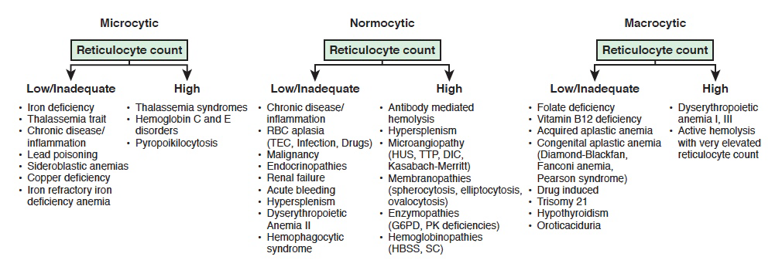

### Microcytic Anemias

|  |  |  |  |  |  |
| --- | --- | --- | --- | --- | --- |
|  | Serum Iron | TIBC | % Transferrin Sat (Fe/TIBC) | Ferritin | Smear |
| **Iron deficiency anemia** | Low | High | Low (<12%) | Low | Hypochromic, microcytic |
| **Anemia of chronic disease/inflammation** | Low | Low | Normal (>18%) | Normal/High | Hypochromic, normocytic or microcytic |
| **Lead poisoning** | High/normal | Low/normal | Normal | High/Normal | Stippled, microcytic |
| **Sideroblastic** | High | Low | High/Normal | High | Ringed sideroblasts (BM) |
| **Hemochromatosis** | High | Low | High | High |  |
| **Alpha/Beta Thalassemia** | Normal | High | Normal | Normal | Microcytic RBCs, target cells (alpha), basophilic stippling (beta) |

#### Thalassemias

|  |  |  |  |
| --- | --- | --- | --- |
|  | Variant | Defect | Clinical/Dx |
| **α** | **α Thalassemia Minima** | 1 α-globin allele | **Asymptomatic** (no anemia) |
|  | **α Thalassemia Minor** | 2 α-globin alleles | - **Minimal anemia** (“α-thalassemia trait”)- Target cells |
|  | **Hemoglobin H disease** | 3 α-globin alleles | - **Hgb H** (4 β-globins)- Microcytic anemia, **chronic hemolytic anemia**- Pallor, splenomegaly, decreased lifespan |
|  | **Hydrops fetalis** | 4 α-globin alleles | - **Hgb Bart’s** (4 γ-globins)- **Fetal edema** → intrauterine death |
| **β** | **β Thalassemia Minor** | 1 β-globin allele | - **↓ β-globin, ↑ Hgb A2** (α2δ2)- **Minimal anemia** (“β-thalassemia trait”) |
|  | **β Thalassemia Major** | 2 β-globin alleles | - **Absent β-globin, Hgb F** (α2γ2) **+ Hgb A2**- **Severe anemia** |

### Sickle Cell Anemia

**** See full section below ****

### Hemolytic Anemias

|  |  |  |  |  |  |
| --- | --- | --- | --- | --- | --- |
|  | Pathophysiology | Smear | Coombs | Clinical/Dx | Management |
| **Drug-Induced** | Drug induces IgG → cross-reacts w RBCs | - Burr Cells- Schistocytes | Direct (+) | Cephalosporins, PCNs, Quinidine, NSAIDs, Methyldopa | Stop drug |
| **Autoimmune Hemolytic Anemia (AIHA)** | **Warm-IgG:**- Primary- Secondary (HIV/EBV, SLE, Drugs (PCN), ALPs/immunodeficiencies, Evans, Transplant, Non-Hodgkin Lymphoma | Microspherocytes | - Direct (+)- IgG +/- C3 | - Asymptomatic vs. life-threatening hemolytic anemia (mainly **extravascular**)- Indirect hyperbilirubinemia, elevated LDH- Splenomegaly- Venous thromboemboli | - **1st line:** RBC Transfusion, Prednisone (long taper over ~3 mos)- **2nd line:** Rituximab- **3rd line:** Immunosuppressants, splenectomy |
|  | **Cold-IgM:**- EBV (mono), mycoplasma | Agglutination | C3+ | - Hemolytic anemia (**intravascular**)- Indirect hyperbilirubinemia, elevated LDH, low haptoglobin- Hemoglobinuria | - RBC transfusion, once Hb is high enough, give IVF support to protect kidneys- Avoid cold (warmed IVF/blood)- **2nd line:** Rituximab, plasmapheresis |
|  | **Paroxysmal Cold Hemoglobinuria (PCH):**- IgG (Donath-Landsteiner Ab)- EBV, mycoplasma | Spherocytes or bland smear | Must ask blood bank to look for **Donath-Landsteiner Ab** | - Hemolytic anemia (**extra/intravascular**)- Indirect hyperbilirubinemia, elevated LDH | - RBC transfusion- Warmed IVF/blood- Keep warm |
| **Mechanical** | - **Microangiopathic:** DIC, TTP,HUS- **Macroangiopathic:** Kasabach-Merritt Phenomenon, AS, prosthetic valves | Schistocytes | Neg | - Hemolysis + thrombocytopenia- **DIC:** Fever, hypotension, prolonged PT/PTT, low fibrinogen- **TTP:** Hemolytic anemia, thrombocytopenia +/- fever, renal insult, and neurologic changes, normal PT/PTT/fibrinogen, low ADAMTS13 activity0 **HUS:** Hemolytic anemia, thrombocytopenia, fever, bloody diarrhea (E Coli)- **Atypical HUS:** Hemolytic anemia, thrombocytopenia, fever (stress trigger) | - **TTP:** Plasmapheresis- **Sepsis:** Treat underlying cause |
| **Hereditary Spherocytosis** | Defect in RBC membrane (vertical interactions, ex/ band 3, ankyrin) | - Spherocytes- +Osm. frag | Neg | - High MCHC- Jaundice/gallstones- Aplastic crisis | - Folic acid- Transfusions PRN- +/- splenectomy |
| **Hereditary Elliptocytosis** | Defect in RBC membrane (horizontal interactions, ex/ spectrin) | Elliptocytes | Neg | - >50% elliptocytes on blood smear- Ranges from clinically silent (no evidence of hemolysis) to chronic hemolytic anemia | None to folic acid +/- splenectomy |
| **G6PD Deficiency** | - Oxidants (fava, sulfa, dapsone, INH, quinine) → hemolysis- **Epidemiology:** Asian, African Am, Middle E.- **Genetics:** X-linked | - Bite cells- Heinz bodies | Neg | Jaundice, dark urine, back pain | - Avoid oxidants- Transfuse |
| **Pyruvate Kinase Deficiency** | PK is required for RBC glycolysis | Decreased PK activity | Neg | - Mild to severe chronic anemia- Gallstones- Iron overload | - Folic acid- Transfusion- +/- Splenectomy |
| **Paroxysmal Nocturnal Hemoglobinuria** | Complement-mediated intravascular RBC lysis | - Absent CD55/59- Increased LDH | Neg | - Pancytopenia0 Venous thrombosis (abd/cerebral)- Hemoglobinuria | - Eculizumab- Iron/Folate |

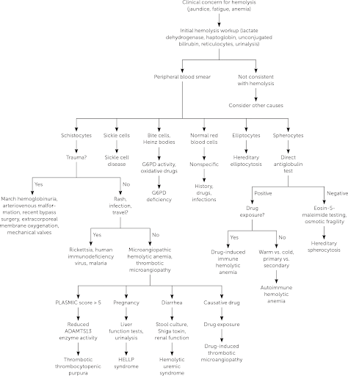

### Other Normocytic Anemias

|  |  |  |  |  |
| --- | --- | --- | --- | --- |
|  | Pathophysiology | Smear | Clinical/Dx | Management |
| **CKD-related anemia** | ESRD → EPO deficiency | Normochromic, normocytic | Side effects of EPO: HTN, HA, flu-like sx | EPO/Fe |
| **Aplastic anemia** | BM failure | Pancytopenia | Pallor/fatigue, infections, bruising | Treat the underlying condition |

### Macrocytic Anemias

|  |  |  |  |  |
| --- | --- | --- | --- | --- |
|  | Pathophysiology | Smear | Clinical/Dx | Management |
| **Folate deficiency** | Alcoholism, AEDs, severe anorexia/dietary limitations | Megaloblastic macrocytic | Pallor/fatigue, atrophic glossitis | PO folate |
| **B12 deficiency** | Pernicious, chronic gastritis, malabsorp, parasite (D. latum), severe anorexia/dietary limitations | -Megaloblastic macrocytic- Increased methylmalonic acid and homocysteine | Pallor/fatigue, subacute combined degeneration, atrophic glossitis, dementia | - IM/IV B12- High dose PO B12- Anti-IF Abs |

### Pediatric-Specific Anemias

|  |  |  |  |  |
| --- | --- | --- | --- | --- |
|  | Pathophysiology | Smear | Clinical/Dx | Management |
| **Anemia of prematurity** | Preterm → decr EPO, decr RBC life, incr phlebotomy |  | Asymptomatic vs. tachycardia +/- apnea | Fe, decreased phlebotomy |
| **Erythro-blastosis** | ABO set-up/Rh disease, minor blood group antigens |  | Jaundice/hyperbili in 1st 24 HOL | Transfusion, phototherapy |
| **Fanconi** | AR/XL mutation → aplastic | Pancytopenia, aplastic | Short, microcephaly, bent thumb, freckles, café-au-lait, ear abnormalities | Transfusion +/- SCT |
| **Diamond-Blackfan** | Pure red cell aplasia | Macrocytic, normal WBC | Short, web neck, shield chest, cleft lip, triphalangeal thumbs | Steroids, transfusion |

#### Newborn Anemia

!

## Sickle Cell Anemia

#### Pathophysiology

Autosomal recessive missense mutation (Glu → Val) at position 6 of B-globin gene

#### Clinical manifestations

* **Vaso-occlusive (pain) crisis:** Ischemia → pain
  + *Triggers:* Cold weather (vasospasm), hypoxia, infection, dehydration, acidosis, alcohol intoxication, emotional stress, pregnancy, exertional stress
  + **Bones:** Most commonly long bones like femur, tibia, humerus, and lumbar vertebrae (femoral head → avascular necrosis)
  + **Joints & soft tissue:** Dactylitis or hand and foot syndrome - painful and swollen hands/feet
  + **Abdomen:** Can mimic an acute abdomen
  + **Renal:** Papillary necrosis → hyposthenuria (inability to concentrate urine)
  + **Lungs:** Acute chest syndrome
  + **CNS:** Cerebral infarction, hemorrhage (young adults), seizures, transient ischemic attacks, cranial nerve palsies, meningitis, sensory deficits, and acute coma
  + **Skin:** Ulceration, especially over bony prominences (malleoli)
  + **Eye:** Retinal hemorrhages, proliferative retinopathy (more common in HbSC)
  + **Penis:** Prevents drainage of blood from the corpus cavernosum leading to priapism
* **Acute chest syndrome (ACS):** Pulmonary infarction → fever, cough, chest pain, SOB, new pulmonary infiltrate on x-ray
* **Fever:** Viral vs. bacterial (including encapsulated organisms: H. flu, S. pneumoniae, N. meningitidis)
  + Children w/ sickle cell anemia also have lower serum IgM levels, impaired opsonization, and sluggish alternative complement pathway activation, so are susceptible to Mycoplasma pneumoniae, Salmonella, Staphylococcus aureus, and Escherichia coli
* **Sepsis:** Strep pneumo is most common cause
* **Hyposplenia:** Splenic autoinfarction → susceptible to infections w/ encapsulated bacteria
* **Osteomyelitis:** Staph > Salmonella, treat w/ CTX/Vanc
* **Aplastic crisis:** Decreased retic/RBCs, parvo B19 infection, pallor, weakness, fatigue
* **Splenic sequestration crisis:** Marked decrease in hemoglobin level despite persistent reticulocytosis, splenic vasoocclusion → rapid splenomegaly, prior to autosplenectomy

#### Diagnosis

* **VOE:**
  + **Labs:** CBCd (compare to baseline Hb), retics, chem10, LFTs, amylase/lipase, T&S
  + **Imaging:** CXR PA & lateral for fever, chest wall pain, hypoxia, or respiratory symptoms
* **Fever:**
  + **Labs:** CBCd (compare to baseline Hb), retics, chem10, LFTs, amylase/lipase, T&S, BCx (for 1st temp >38.5C or 101.3F) and qdaily w/ temp spikes, ABG if hypoxic
  + **Other studies:** UA/UCx (cath all M <6mo, F <2yo, or any child w/ urinary sx), viral panel, throat culture (if suggestive on exam), stool studies (if having diarrhea), LP (if neurologic s/sx)
  + **Imaging:** CXR PA & lateral (if fever, chest wall pain, hypoxia, respiratory symptoms)

#### Management

See sections below on **VOE, ACS,** and **fever**

### Vaso-Occlusive Episode (VOE)

***BMC Sickle Cell Cards:*** NOTE practices may vary at BCH. Should not replace clinical judgment or Pedi Heme consult (place consult order in EPIC and page on-call pager 5731); please page daily after rounds to discuss management as needed, and read daily consult note for detailed recommendations.

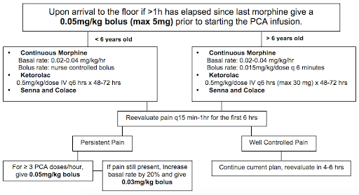 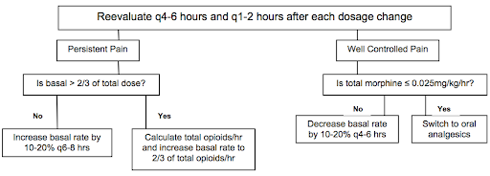

***THE INFORMATION BELOW IS APPLICABLE TO BOTH BMC & BCH:***

#### Fluids, Monitoring, & Labs

* Hydration: D5 1/2NS or D5 NS @ 1.25x maintenance is crucial to lessen sickling
* Continuous pulse oximetry
* Routine labs are not needed for uncomplicated VOE
* DVT prophylaxis should be addressed for all patients per inpatient protocol

##### Pain Management

* **Non-opioid analgesics:**
  + Standing NSAID: **Ketorolac** on admission if proven benefit; after 72 hrs switch to standing ibuprofen q6h
  + Additional modalities: **Ketamine** (refer to Lexicomp for dosage), hot packs, lidocaine patch, distraction, Child Life, relaxation, acupuncture
* **Opioids:**
  + Management and prevention of opioid **side effects:**
    - **Constipation:** Standing stimulant laxative (senna) and daily Miralax w/ admit. Titrate for 1 soft formed stool q1-2d. Escalate PRN, may add Mg citrate, milk of magnnesia, lactulose, methylnaltrexone.
    - **Pruritus and nausea:** Start w/ camphor-menthol lotion for mild itching. Next step is a naloxone drip at 0.5 mcg/kg/h, titrate up to 2 mcg/kg/h q3-4h for significant itching/nausea. Can then add Zofran. Avoid Benadryl given the sedating effect.
    - **Prevent hypoventilation:** Crucially important in preventing atelectasis and ACS! Incentive spirometer 10x/hr while awake and q4h overnight. Bubbles or pinwheel in younger kids. HOB elevated to 30 degrees at all times. Have patient sit up in bed, out of bed to chair, and ambulation as tolerated. Standing albuterol q4-6h for pt w/ asthma, history of wheeze w/ prior VOE, chest or back pain, or any current wheezing or cough. Oxygen overnight PRN (goal O2 sat > 95% or pt’s known baseline; can provide NC O2 at 0.5-1L for mild desats while asleep; does not replace the need for incentive spirometry). Continue any home respiratory therapies (home O2, CPAP, etc).
  + **Titration of PCA/opioids:**
    - Use patient reported pain score (compare to baseline/chronic pain level) AND change in pain AND patient functional status to assess pain control
    - Assess for VOE vs. opioid side effects to help w/ dose adjustment
    - Reassess pain control frequently, especially during first 24 hrs, and adjust PCA as needed w/ goal of providing 2/3 of total opioid dose as basal and 1/3 as demand
    - Consider increasing basal rate by 20% overnight early in the admission to avoid falling behind in pain control while asleep
    - As pain is captured, wean PCA rate and then switch to orals
  + **Weaning to orals:** Please discuss patient specific plan w/ Pedi Heme; details will depend on length of admission, pain tolerance, and patient preference. In general, when pain is well-controlled, replace the basal PCA w/ SCHEDULED long- or short-acting oral medication (MS Contin, oxycodone, or hydromorphone), leaving the PCA demand button. If pain remains well-controlled after 12-24 hrs, then replace PCA demand w/ a standing short-acting medication (often oxycodone, tramadol, or hydromorphone). This step should be considered both a conversion and a wean.
    - **Quick conversion from IV to oral opiates** (meant as a guide, not a mandate):

|  |  |  |  |
| --- | --- | --- | --- |
| Total Basal IV morphine use over 24 hours | Total Basal IV dilaudid use over 24 hours | MSContin dose | If using ONLY oxycodone |
| 10mg | 2.5mg | 15mg PO q12 | 5mg PO q6 |
| 15mg | 4mg | 15mg PO q8 | 5mg PO q4 |
| 20mg | 5mg | 30mg PO q12 | 10mg PO q6 |
| 30mg | 8mg | 30mg PO q8 | 10mg PO q4 |

#### Discharge planning

* Ready for discharge when pain is controlled on oral meds (pain may not be gone at this time)
* Continue standing pain meds x48hrs at home before tapering to PRN
* Anticipate home opioid needs; ask if opioids are available at home, and prescribe meds-in-hand early on day of discharge. If patient prefers to fill meds at home pharmacy, provide Rx early in hospital course (controlled substance prescriptions can now be faxed or sent electronically). Be aware of specific MA prescribing requirements for opioids.
* Schedule follow-up in Heme clinic w/i 1 week (BMC clinic phone # 617-414-4841), appointments are available everyday Mon-Fri

### Acute Chest Syndrome (ACS)

ACS in SCD is multifactorial. Causes include **infection, bronchospasm, inflammation,** and **fat embolization.** It can be very serious and needs to be managed very closely.

#### Optimize ventilation

to prevent serious sequelae from ACS:

* Incentive spirometry 10x per hour while awake and q4h overnight
* Have patient sitting up in bed, out of bed to chair, and ambulation as tolerated
* Examine patients for any drop in O2 saturation — do NOT simply put on oxygen w/o evaluating
* Standing albuterol neb q4-6h for those patients with known benefit, people with a history of reactive airway, asthma, wheeze on clinical exam. Add inhaled corticosteroid only if on one at home
* Consult Pulm for any patient w/ wheezing, severe ACS, or as needed to help optimize respiratory status; please notify Pulm when of their patients are admitted w/ ACS
* Consider high flow NC or BIPAP as appropriate (requires ICU transfer)

#### Fluid balance

needs to be monitored carefully:

* Patients w/ SCD require increased IVF in cases of VOE or fever/dehydration. However, overhydration can worsen ACS.
* In general, use IV + PO at 1x maintenance for patients w/ ACS
* Must have strict I/O’s ordered and reviewed regularly to adjust fluids as needed

#### Other monitoring & labs

* Continuous pulse oximetry
* All patients w/ ACS should have an active **type & screen**
* **DVT prophylaxis** should be addressed for all patients per inpatient protocol

#### Antibiotics

should include coverage for pneumococcus and atypicals (typically ceftriaxone and oral azithromycin):

* See Fever guidelines below for details

#### Transfusions

must be approved by Heme:

* Need to balance need for immediate treatment w/ long term risks of alloimmunization
* If the patient does not have an O2 requirement, we typically attempt medical management w/ abx and aggressive pulmonary toilet for 24hrs before transfusing
* Potential indications for transfusion in ACS include a drop in Hb > 2g/dL below baseline w/o appropriate reticulocytosis, a significant oxygen requirement, or worsening work of breathing
* See Blood Transfusions section below for details

#### Discharge planning

* Stable for discharge when BCx are negative x48hrs and respiratory status is stable/improved
* Should complete a full course of antibiotics to cover both pneumococcus and atypicals
* Schedule follow-up w/ PCP w/o the week and in Heme clinic preferably w/i a week (BMC clinic phone # 617-414-4841), appts at BMC are available every day Mon-Fri
* At BMC, please refer to Pulm for outpatient follow-up (referral for “SCD w/ ACS”)

### Fever

#### Definition

T >38.5C (101.3F) if >2mo

#### Work-up

* Detailed history and physical exam to identify potential source
* **Labs:** CBCd (compare to baseline Hb), retics, chem10, clot (hold for Blood Bank), BCx (for 1st temp >38.5C (101.3F) and qdaily w/ temp spikes), ABG (if hypoxic)
* **Other studies:** UA/UCx (cath all M <6mo, F <2yo, or any child w/ urinary sx), viral panel, throat culture (if suggestive on exam), stool studies (if having diarrhea), LP (if neurologic s/sx)
* **Imaging:** CXR PA & lateral (if fever, chest wall pain, hypoxia, respiratory symptoms)

#### Management

* **Inpatient** management:
  + IV bolus of 10 - 20 ml/kg if dehydrated→ IV fluids @ 1.25 Maint (+/- for fluid intolerance vs. dehydration)
  + **Antibiotics:** Goal administration w/i 30 min of arrival! Draw cultures first. Do not delay treatment while awaiting lab results and CXR. Needs empiric antibiotics even if a source of infection is identified.
    - **Ceftriaxone** 50 mg/kg IV/IM q24h (max dose 1g/day), q12h (max 2g/day) if suspect meningitis. If allergic to Ceftriaxone, consider Levofloxacin or Clindamycin if inpatient.
    - Add **Vancomycin** 40-60 mg/kg/day divided q6h for CNS involvement (including meningitis), septic shock, central line/port, or hx of resistant infection
    - For HD instability or meningitis; consider in pts w/ port or hx of resistant infection
    - Add **Azithromycin** PO for pts w/ positive CXR or respiratory symptoms
* **Outpatient** management and follow-up:
  + Observe in ED for 2 hrs after giving CTX. **Return if:** Temp >38.5C; poor PO intake; lethargy; respiratory symptoms; pain.
  + Follow up in Hematology clinic, PCP’s office, or ED in 24 hours for re-evaluation & 2nd dose of CTX
  + Follow up BCx at 24 and 48 hrs → call PCP regarding ED visit & to assure follow up

### Blood Transfusions in SCD

Blood transfusions in SCD are used to increase RBC mass and oxygen carrying capacity and to decrease proportion of sickle cells. Acute benefits of transfusion must be weighed against the long-term risks, including alloimmunization. Phenotypically matched (ABO, Rh-D, Kell, C, E), sickle negative, leuko-depleted irradiated packed red blood cells are the blood product of choice. More extensive phenotyping needed for patients on chronic transfusion. It may take hours for the blood bank to find matched blood, and even longer in cases of alloimmunization so maintain an active type and screen if you anticipate needing to transfuse a patient.

#### Potential indications for transfusion

* Aplastic crisis/acute anemia (drop in Hb > 2g/dL below baseline) w/o an appropriate reticulocytosis
* Acute chest syndrome (ACS) not responsive to medical management or severe disease/ hypoxemia
* Symptomatic anemia
* Pre-procedure prophylaxis (goal Hb of 10 g/dL)
* Splenic sequestration:
* Hb drop > 2g/dl, drop in platelet count and WBC as well
* Monitor spleen size and labs frequently

#### Amount of blood to transfuse

based on goal Hb:

* mL of pRBC = (desired Hb - current Hb) x (wt (kg) x Blood Vol(ml/kg)) /(Hb of PRBC)
* Blood volume = 80mL/kg for children
* Hb of pRBCs = 18.5g/dL at BMC, avg HCT 60% at BCH
* 1 unit pRBC = 250-350 mL; consider rounding down to a whole unit to avoid extra donor exposure

#### Other considerations

* Premedicate only if history of transfusion reaction
* Need for post-transfusions labs to be dictated by individual case

## Transfusion Medicine

### Consenting a Patient for Blood Products

#### Risks

* Fever, chills, hives/itching, and shortness of breath (can be managed w/ medications)
* Hemolytic transfusion reaction or transfusion-related lung injury (rare)
* Bacterial or viral infection (hepatitis C, hepatitis B, HIV, malaria). Blood is extensively screened to prevent this.

#### Benefits

Improve blood clotting or oxygen delivery

#### Alternatives (may not work as quickly)

* Colony stimulating factor
* Vitamin K
* No treatment (note: parents may not refuse blood products in life-threatening situations)

### Acute Transfusion Reactions

|  |  |  |  |  |
| --- | --- | --- | --- | --- |
|  | Time | Pathophysiology | Clinical/Dx | Management |
| **Anaphylactic** | Sec-Mins | IgA def → anti-IgA/IgG Abs | Shock, urticaria, angioedema, hypoTN | EPI, IVF, O2 Washed RBCs |
|  | Within mins | IgE-mediated, bradykinin-med if ACEi | HoTN, wheeze, N/V/D | ABCs, Epi, Benadryl |
| **Urticarial** | Anytime | Type I HSR (IgE mediated) | Hives, erythema | Benadryl, Wash |
| **Acute Hemolytic** | First 15 mins | ABO/Kidd incomp.→ hemolysis/comp activ. Rh/Kell/Duffy incompatibility → hemolysis +Coombs, Pink plasma | Fevere, chills, back or flank pain, bleeding/DIC | NS/Lasix Monitor for HoTN, AKI/DIC |
| **Febrile non-hemolytic** | 1-6 hrs | Donor WBCs → TNF-alpha, IL 1 / 6 RBC: anti-HLA Plt: donor WBC cytokines | Low grade fever, chills, HA, flushing | APAP, meperidine Leukoreduction |
| **Delayed hemolytic** | >3 days | Anamnestic IgG against exposed Ag (Kidd/Duffy/Kell) → extravasc. hemolysis | Fever, anemia, jaundice, flu-like illness | R/O AIHA (+DAT) |
| **Transfusion-related lung injury (TRALI)** | 1-6 hrs | Pre-Tx stress activates lung endothelial cells and primes PNMs Post-Tx donor anti-HLA Ab → primed PMNs | Fever, SpO2 <90%, PaO2/FiO2 <300 B/l pulm edema | ABCs, O2, mech vent. Dec. in male donor |
| **Transfusion-Assoc. Circ Overload (TACO)** | 1-6 hrs | High risk in elderly, CHF, CKD, chronic anemias | Cardiogenic edema → dyspnea, hypoxemia | Stop, sit up , O2, diuretics, slower rate (1 cc/kg/hr) |
| **Bacterial sepsis** | 15-60 mins | Bacteria >> Viruses in donor blood RBC: Yersinia, PsA, Plt: Staph epi (GPCs) | Fever (>39), rigors, abd sxs, HoTN, shock | Antibiotics Screen |

#### Specialized RBCs

* **Irradiated:** BMT recipients, acquired congenital cellular immunodeficiency, blood from 1st/2nd degree relatives
* **Leuko-reduced:** Chronic transfusion, CMV seronegative at-risk pts (AIDS, transplant), potential transplant candidates, previous febrile nonhemolytic transfusion reaction
* **Saline Washed:** IgA deficiency, Complement-dependent AIHA, allergic reactions w/ RBC transfusion

### Transfusion Products

|  |  |  |  |  |  |
| --- | --- | --- | --- | --- | --- |
| Component | Contents | Volume | Indications | Contraindications | Considerations |
| **Red Blood Cells (RBC)** | Concentrated RBCs | 200-300 mL | Symptomatic anemia (Hgb <7 g/dL); Acute hypovolemia due to hemorrhage | Pharmacologically treatable anemia (eg. iron, folate, B12 deficiencies) | Must be ABO compatible, cross-match compatible Infuse w/in 4 hr or as patient tolerates |
| **Platelets (PLT)** | >5.5×10^10 PLT per 50 ml | 60 mL | Bleeding related to thrombocytopenia or PLT dysfunction; Low PLT count | Patients w/ TTP, HUS or HIT; Not as effective in ITP, DIC, sepsis, uremia, hypersplenism | ABO and Rh compatible w/ patient’s RBC if possible Infuse 5-10 mL/min or as tolerated, usually w/in 1 hour |
| **Leukocyte reduced RBC or PLT** | RBC or PLT w/ WBC: <5×10^6 | Similar to original | RBC/PLT indications plus history of febrile transfusion reactions; At risk of CMV and alloimmunization | See RBC or PLT | See RBC or PLT |
| **Cryo-precipitate (Cryo)** | 80-120 units Factor VIII; 150-250 mg Fibrinogen | 25 mL 40-70% orig. plasma VWF | Fibrinogen deficiency or dysfunction | Safer and more concentrated therapy available (ie, for specific clotting factors) | Consider alternative therapies for specific factor deficiencies Should be ABO compatible if possible |
| **Fresh frozen plasma (FFP)** | 400 mg fibrinogen and 200 units of other clotting factors | 200-250 mL | Clotting factor def. (if specific factor conc. not avail.), lg volume required Severe liver disease Rapid warfarin reversal Vit K def w/ active bleed TTP/DIC: massive crystalloid + RBC transf. w/ ongoing bleeding C1 esterase inhib def. | Safer and more concentrated therapy available (ie, for specific clotting factors) | Should be ABO compatible Infuse 5-10 mL/min or as the patient tolerates Give 10-15 cc/kg |

## Pancytopenia

### Marrow

Decreased cellularity (aplastic, myelofibrosis, chemo), normal cellularity (MDS, PNH), increased cellularity (leukemia, lymphoma, MM, mets)

### Systemic

Spleen (cirrhosis, myelofibrosis), toxin (EtOH, cocaine), nutrition (B12/folate def), rheum (SLE, RA), sepsis

### Meds

NSAIDs, PPIs, sulfas, antihistamine, chemo, anticonvulsants, antiprotozoals, heavy metals

### Infectious

Virus (HIV, HB/CV, CMV/EBV, Parvo), bacteria (Brucella, TB), fungi (Histo), parasites (Leishmania, Malaria, Schisto)

## Thrombocytopenia

#### Definition

Platelets <150,000 → increased risk of hemorrhage, mucosal bleeding, petechiae, purpura, ecchymoses

#### Pathogenesis

* **Decreased platelet production:** Virus (EBV, Hep C, HIV, parvo), meds (chemo, thiazide, linezolid, chloramphenicol), leukemia, myelodysplasia, EtOH, BMF syndromes/aplastic anemia, Vit B12/Folate deficiency, congenital thrombocytopenias (WAS, TAR, MYH9)
* **Increased platelet destruction:** Virus (HIV, HSV/VZV, EBV), meds (heparin), ITP, DIC, TTP, HUS, HIT, HELLP, antiphospholipid syndrome, vasculitis, vascular anomaly (Kasabach-Merritt)
* **Hypersplenism:** Splenomegaly (cirrhosis, portal HTN) -Dilutional/pooling: massive transfusion, hypothermia/neonatal cooling

#### Labs

* Plts <150,000, normal PT/PTT
* **Blood smear:** Poor production (typically normal/small plts), increased destruction (large/giant platelets)

### Causes

|  |  |  |  |
| --- | --- | --- | --- |
|  | Pathophysiology | Clinical/Dx | Management |
| **ITP (immune thrombocytopenic purpura)** | **Autoimmune:** Primary or secondary (Evans, immunodeficiency (ALPs, others), infectious (HIV, Hep), rheum (SLE), transplant, medications/vaccines) | - Plt <100,000- Antecedent viral infection- Diagnosis of exclusion | - Generally self-limited- Close observation- Steroids, IVIG, TPO-RA, immunosuppressants |
| **HIT (heparin-induced thrombocytopenia)** | Heparin → forms complex w/ Plt F4-> immune complex formation → Plt activation/aggreg → thrombosis/thrombocytopenia | Decision to screen based on 4T Score (if >4 poinnts, send ELISA/SRA):- Thrombocytopenia (>50% fall but >20)- Timing of plt fall- Thrombosis or skin necrosis- Other causes | - Stop heparin- Lifelong avoidance. Use argatroban, fondaparinux instead. |
| **TTP (thrombotic thrombocytopenic purpura)** | - Decreased ADAMTS 13 (uncleaved vWF multimers) → plt aggregation → thrombosis → plt consumption + microangiopathic hemolysis (schistocytes)- Primary or Secondary (pregnancy, HIV, rheumatologic dx, transplant)- Congenital TTP can present late | Hemolytic Anemia and thrombocytopenia, +/- renal failure, and neuro | Plasmapheresis, +/- glucocorticoids, +/- Rituximab |
| **Classic HUS (hemolytic uremic syndrome)** | E. coli O157:H7 → plt aggregation → thrombosis → plt consumption + microangiopathic hemolysis (schistocytes) | Hemolysis, uremia, decreased plts, inc, fever, bloody diarrhea | Supportive, IVF, dialysis |
| **Bernard-Soulier** | Decreased GpIb → dec. plt adhesion | Large/decreased plt count | Supportive, perisurgical planning |
| **Glanzmann** | Decreased GpIIb/IIIa → dec. plt agg | Normal plt count | Supportive, perisurgical planning |
| **Antiphospholipid syndrome (APLS)** | Persistent Antiphospholipid Abs w/ thrombosis (arterial or venous) or pregnancy complications → arterial/venous thrombosis (X2 >12 weeks apart) | - +Antiphos. Abs (anticardiolipin Ab, B2 Glycoprotein Ab, Lupus Anticoagulant), thrombocytopenia- Primary or secondary (underlying rheumatologic dx) | - Anticoagulate: LMWH or warfarin for ATE or VTE treatment- Hydroxychloroquine |
| **HELLP syndrome** | Preeclampsia (HTN) + ***H***emolysis, ***E***levated ***L***iver enzymes, ***L***ow ***P***lts | Schistocytes on smear | Induce labor, deliver |

## Hematologic Disorders of the Newborn/Child

### Anemia of Prematurity

#### Pathogenesis

Impaired EPO production; shortened RBC life; iatrogenic blood loss

#### Clinical manifestations

Asymptomatic, apnea, poor weight gain, tachycardia

#### Diagnosis

Hb/Hct, retic, smear

#### Management

Decrease phlebotomy, iron supplementation, transfusions

### Transient Erythroblastopenia of Childhood

#### Pathogenesis

Acquired red cell aplasia (6mo - 5yr)

#### Clinical manifestations

Gradual pallor, fatigue

#### Diagnosis

Normocytic/normochromic anemia, Hb (3-8), retic

#### Management

Self-resolving

### Neonatal Polycythemia

#### Pathogenesis

Erythropoiesis from intrauterine hypoxia. Risk factors: IUGR, maternal DM/HTN, smoking, delayed cord clamping, twin-twin transfusion.

#### Clinical manifestations

Ruddy skin, hypoglycemia, resp distress, cyanosis, apnea

#### Diagnosis

Hct >65% in FT infant

#### Management

If asymptomatic → hydration/feeding. If symptomatic → partial exchange transfusion.

## Coagulation Disorders

*Characterized by coagulopathy and/or hypercoagulability*

|  |  |  |  |
| --- | --- | --- | --- |
|  | Pathophysiology | Clinical/Dx | Management |
| **VWD (von nwillebrand deficiency)** | AD/AR def. of VWF → abnormal mucocutaneous bleeding | - Bruising, mucosal bleeding, menorrhagia- VWF Ag and Activity low, may have decreased FVIII activity and prolonged PTT | - **Bleed:** DDAVP (if responder)- **Severe bleed:** VWF conc.- **Menorrhagia:** OCPs- Avoid aspirin use |
| **Hemophilia** | - X-linked inheritance- **Hemophilia A:** Factor VIII deficiency- **Hemophilia B:** Factor IX deficiency | - Hemarthrosis, ICH, mucosal bleeding, epistaxis, occasional hematuria, GI bleed- Prolonged PTT, decreased FVIII or FIX activity; PT and plt wnl | - **Hemophilia A:** FVIII concentrate (DDAVP for most mild pts)- **Hemophilia B:** FIX concentrate |
| **Vitamin K deficiency** | - Decreased synthesis of FX, IX,VII, II, Protein C, S- **Epidemiology:** Neonates, antibiotics, malabsorption (pancreatitis, celiac, IBD), warfarin use | - Easy bruising, mucosal bleeding, melena, hematuria, ICH (newborns)- Prolonged PT and PTT | - Vit K (PO or IM)- **Acute bleed:** FFP or PCC |
| **DIC (disseminnnated intravascular coagulation)** | - Widespread pathologic intravascular coagulation → plt/factor consumption, hemolysis- Causes: STOP Making Thrombi (***S***epsis, ***T***rauma, ***O***B complications, ***P***ancreatitis, ***M***alignancy, ***T***ransfusion) | - Bleeding from wound/surgical site, hemoptysis, venous/arterial thrombosis → organ ischemia, hypoTN, jaundice, ext. cyanosis- Decreased Plts, fibrinogen, haptoglobin- Increased PT/PTT, D-Dimer, LDH | - Treat underlying cause- Aggressive support- Acute bleed: Plt transfusion + FFP +/- RBC transfusion |
| **Inherited hypercoagulable states** | **Factor V Leiden** | Reduced factor V inactivation by protein | Lifelong anticoagulation in the setting of homozygous inheritance and prior VTE |
|  | **Prothrombinn 20210 mutation** | Increased prothrombin levels |  |
|  | **Antithrombin deficiency** | Reduced inactivation of factor 2 (thrombin) |  |
|  | **Protein C or S deficiency** | Reduced factor 5 / 8 inactivation, purpura fulminans w/ homozygous protein C deficiency |  |

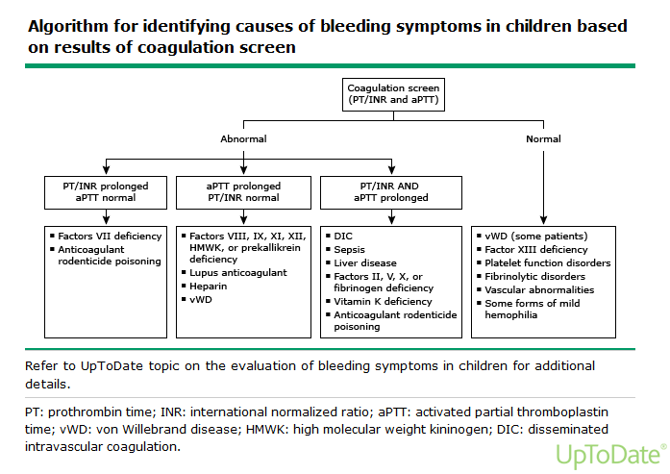

## Antiplatelet / Anticoagulant Medications

|  |  |  |  |
| --- | --- | --- | --- |
| Medication | MOA | Monitor/Reversal | Side Effects |
| **Aspirin (ASA)** | Irreversibly inhibits COX → blocks production of Thromboxane A2 → blocks plt aggregation |  | GI bleed, hyperventilation (resp alkalosis), tinnitus, Reye Syndrome |
| **Clopidogrel** | Inhibits plt ADP receptors → blocks GPIIb/IIIa expression → blocks plt aggregation |  | GI bleed |
| **Abciximab, Eptifatide**(GP IIb/IIIa inhibitors) | Binds plt GP IIb/IIIa → blocks plt aggregation |  | GI bleed, N/V, back pain |
| **Aggrenox** | Inhibits platelet cAMP phosphodiesterase → increases adenosine/cAMP → vasodilation & decreases plt aggregation |  | Dizziness, headache, nausea |
| **Heparin**(continuous infusion) | Binds/activates antithrombin → inactivates thrombin/FXa → inhibits coagulation | - anti-Xa (goal 0.3-0.7)- Protamine sulfate (100%) | HIT, hypersensitivity, narrow therapeutic window |
| **Enoxaparin, Dalteparin**(LMWH, SQ injection) | Binds antithrombin → inactivates FXa→ inhibits coagulation | - anti-Xa (goal: 0.5-1)- Protamine sulfate (60%) | HIT (rare) |
| **Fondaparinux**(direct factor Xa inhibitor, SQ injection) | Binds antithrombin → inactivates FXa → inhibits coagulation | - Not routine, antiXa- No antidote | No risk of HIT (b/c does not bind PF4) |
| **Rivaroxiban, Apixiban, Edoxaban**(direct factor Xa inhibitors, PO) | Binds FXa → inhibition activation of FII (prothrombin→ thrombin) | Not routine, Andexanet alfa (severe/life-threatening bleeding) | Bleeding |
| **Dabigatran**(PO) | Direct thrombin (factor II) inhibitor | Not routine, Idarucizumab (severe/life-threatening bleeding) | Bleeding |
| **Argatroban, Bicalirudin**(continuous infusion) | Direct thrombin inhibitor. Binds thrombin → inhibits coagulation | - Check LFTs prior to starting- Check PTT 2 hrs after initiation and 2 hrs after any dose change (goal PTT 1.5-3x baseline) | Hemorrhage, hypotension |
| **Warfarin**(PO) | Inhibits epoxide reductase → inhibits Vit. K-dependent clotting factors: 2,7,9,10, protein C/S | INR / Start IV Vit K, FFP q4, Kcentra (if severe bleeding) | Bleeding, teratogen, drug-induced interactions (cyt p450), skin necrosis |

## References

# Infectious Diseases

## [Antibiogram+](https://bchfit.tch.harvard.edu/)

The [Antibiogram+](https://bchfit.tch.harvard.edu/) website (also available as a phone app) is an excellent resource that contains [Antibiotic Susceptibilities](https://bchfit.tch.harvard.edu/susceptibilityMatrix) matrices (typically referred to as “the antibiogram(s)”), [Antibiotic Recommendations](https://bchfit.tch.harvard.edu/diagnoses) for commonly encountered diagnoses, and [Dosing Quick References](https://bchfit.tch.harvard.edu/dosingGuidelines) (although you can also always use Lexicomp for this purpose).

## [Antibiotic Susceptibilities](https://bchfit.tch.harvard.edu/susceptibilityMatrix) for Common Pathogens

*****NOTE:*** The antibiograms are **updated annually** based on that year’s susceptibility data, so the digital [Antibiogram+](https://bchfit.tch.harvard.edu/) is always the most accurate resource. The following susceptibilities are based on the BCH Antibiogram+ at the time of publication.

*****ALSO NOTE:*** Sensitivities at **BMC** are **different**! (e.g. higher rates of clindamycin-resistant MRSA)

### Gram Negative Susceptibilities

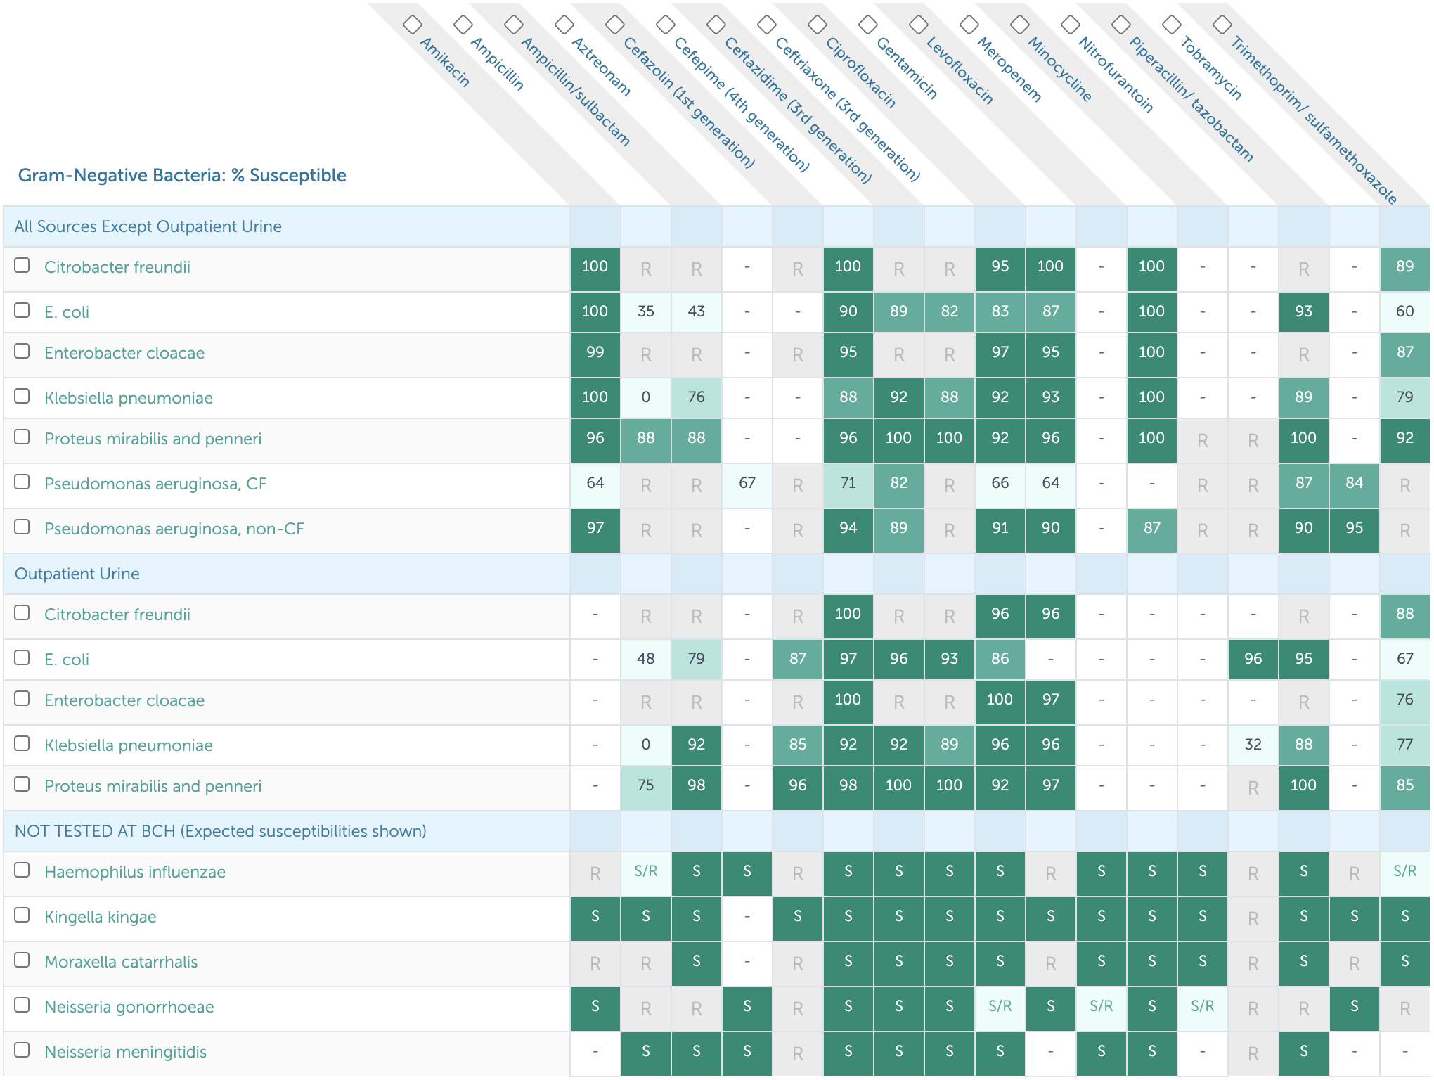

### Gram Positive Susceptibilities

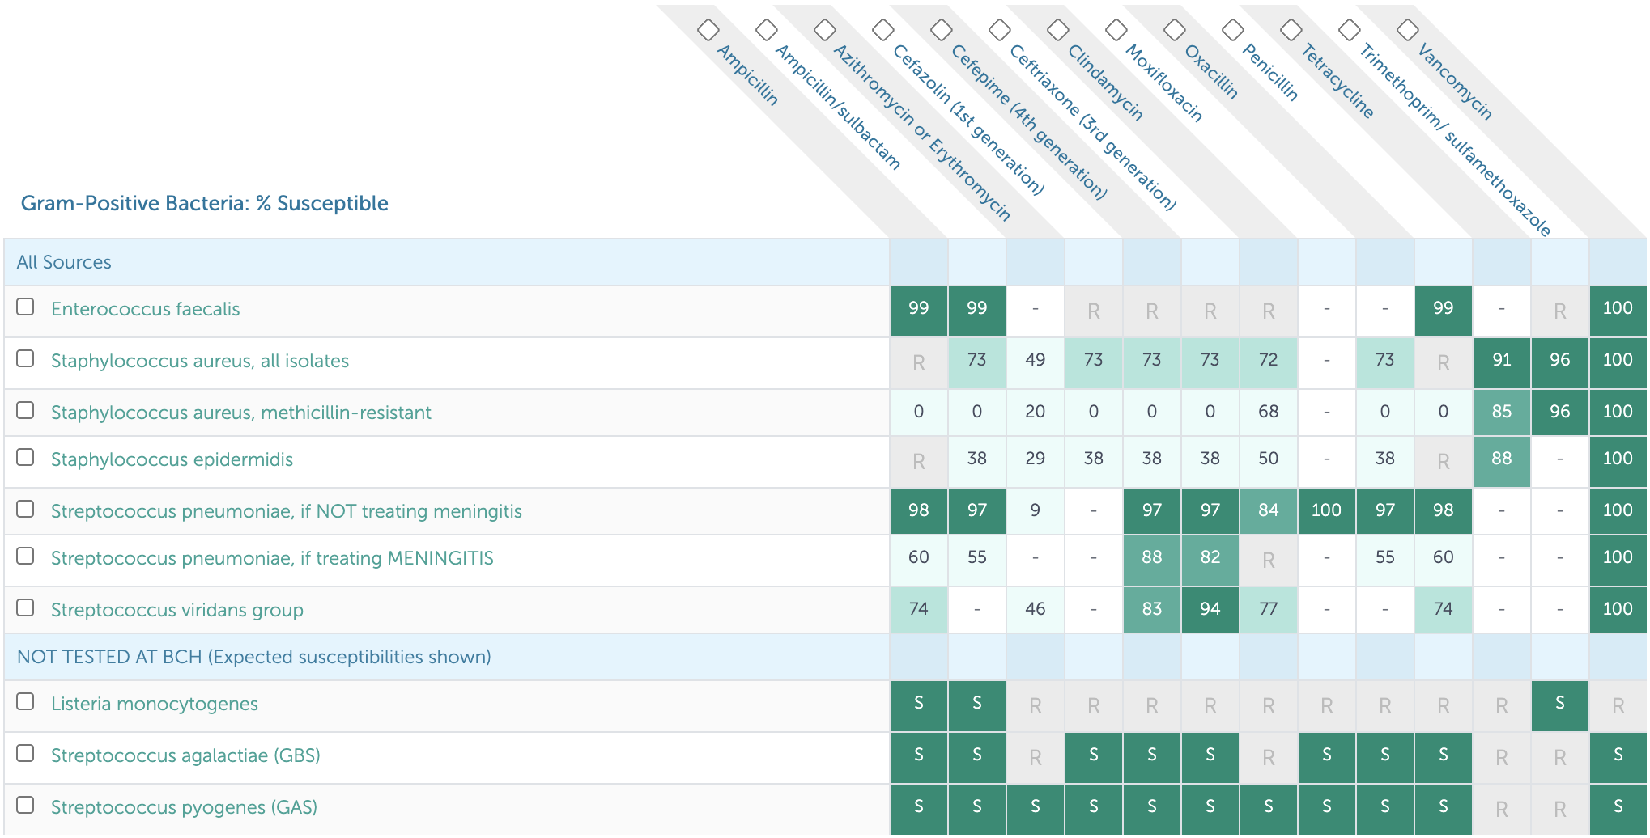

### Anaerobe Susceptibilities

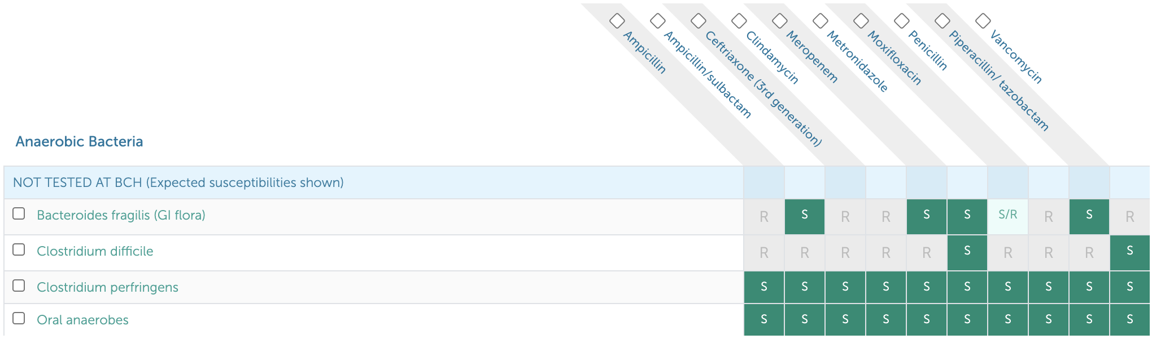

## [Antibiotic Recommendations](https://bchfit.tch.harvard.edu/diagnoses) (Dosing, Duration) for Common Infections

*While these are often first line antibiotic choices, clinical decision-making on antibiotic prescribing should be based on the patient’s entire clinical picture. Also make sure to review patient’s allergy history prior to prescribing.*

### Bone & Joint

* **Osteomyelitis:** Cefazolin 50 mg/kg/dose IV q8h (2g) x 4wks
* **Septic arthritis:** Cefazolin 50 mg/kg/dose IV q8h (2g) x 3wks

### Head & Neck

* **Acute otitis media (AOM):** Amoxicillin 45 mg/kg/dose BID (875 mg) x 5-10 days
* **Acute sinusitis:** Amoxicillin-clavulanate 45 mg amox/kg/dose PO BID (1g) x 10 days
* **Mastoiditis, peritonsillar abscess (PTA), and/or retropharyngeal abscess (RPA):** Ampicillin-sulbactam 50mg ampicillin/kg/dose IV q6h (2g) x 10-14 days
* **Strep pharyngitis:** Amoxicillin 50 mg/kg daily (1g) x 10 days
* **Suppurative cervical lymphadenitis:** Ampicillin-sulbactam 50 mg amp/kg/dose IV q6h (2g)

### Gastrointestinal

* **C. diff:** Metronidazole 10 mg/kg/dose PO QID x 10 days
* **Ruptured appendicitis:** Piperacillin-tazobactam 100 mg pip/kg/dose IV q8h (6g) x 7 days

### Genitourinary

* **PID, outpatient:** Ceftriaxone 50 mg/kg/dose IM x1 (250mg) + Doxycycline 2.5 mg/kg/dose PO BID (100 mg) x 14 days + Metronidazole 10 mg/kg/dose PO BID (500 mg) x 14 days
* **PID, inpatient:** Cefoxitin 40 mg/kg/dose IV q6h (2g) + Doxycycline IV/PO 2.5 mg/kg/dose PO BID (100 mg)
* **Pyelonephritis:** Ceftriaxone 50 mg/kg/dose IV q24h (2g) x 10 days
* **UTI 3-23 months, febrile, healthy, outpatient:** Cephalexin 25 mg/kg/dose TID (500 mg) x 10 days
* **UTI >24 months, healthy, outpatient:** Cephalexin 25 mg/kg/dose PO TID (500 mg) x 3-5 days

### Respiratory

* **Community-acquired pneumonia (CAP), outpatient:** Amoxicillin 30 mg/kg/dose PO TID (500 mg-1g) x 7 days
* **CAP, inpatient:** Ampicillin 50 mg/kg/dose IV q6h (2g) x 7 days
* **CAP, complicated:** Ceftriaxone 50 mg/kg/dose IV q24h (2g) + Vancomycin 15-20 mg/kg/dose IV q6-8h (1g)
* **Aspiration pneumonia:** Ampicillin-sulbactam 50 mg amp/kg/dose IV q6h (2g) x 7 days

### Skin & Soft Tissue

* **Cellulitis, non-purulent:** Cefazolin 25 mg/kg/dose IV q8h (1g) OR cephalexin 25 mg/kg/dose PO TID (1g) x 5-7 days
* **Cellulitis, purulent or abscess:** TMP-SMX 6 mg TMP/kg/dose IV/PO q12h (160 mg) x 5-7 days

## Cellulitis & Abscess

### PowerPlans, Order Sets & Clinical Pathways

* **Clinical Pathway:** [Cellulitis and Abscess](https://bchfit.tch.harvard.edu/ebg-services/component/pdfAlgorithm?algCode=CELLULOABCCESS&algVersion=1.6&accessCode=null)
* **PowerPlans & Order Sets:** Cellulitis and Abscess Pathway Plan

### Etiology

Beta-hemolytic strep, S. Aureus > H. influenzae, Clostridia, S. Pneumo

### Differential

* Erysipelas (upper dermis/superficial lymphatics, clear demarcated tissue)
* Necrotizing fasciitis (pain out of proportion to exam, crepitus, toxic appearing)
* Tenosynovitis (tenderness over flexor sheath, reduced motion)
* Compartment syndrome (early → late: paresthesia, pain out of proportion/with stretch, pallor, pulseless)

### Work-up

* Diagnosis is clinical, based on tenderness to palpation, warmth, erythema, induration, fluctuance, fever
* Obtain US if concerned for abscess
* Circle border of lesion with ink, upload photo to PowerChart w/ Cerner Camera Capture app
* No need for labs (e.g. CBC) or MRSA swab if hemodynamically stable

### Managament

* Treatment duration typically 5-7 days
* **Non-purulent:** Cephalexin/cefazolin, clindamycin
* **Purulent:** 1st Line: TMP-SMX, 2nd Line: Clindamycin, 3rd Line: Doxycycline
* Consider MRSA coverage (TMP-SMX, vanc, linezolid) if: no response to initial therapy, systemic illness, recurrent infection, prior history of MRSA, high prevalence of MRSA in community

## Osteomyelitis

### PowerPlans, Order Sets & Clinical Pathways

* **Clinical Pathways:** [Osteomyelitis](https://bchfit.tch.harvard.edu/ebg-services/component/pdfAlgorithm?algCode=OSTEOM&algVersion=1.3&accessCode=null); [Osteomyelitis, Complex](https://bchfit.tch.harvard.edu/ebg-services/component/pdfAlgorithm?algCode=COMPLEX_OSTEO&algVersion=1.3&accessCode=null)
* **PowerPlans & Order Sets:** Osteomyelitis Admit Pathway Plan

### Etiology

* Hematogenous seeding > direct inoculation vs. contiguous spread
* S. aureus, GAS, S. pneumo, H. flu type b, Salmonella (sickle cell), E. coli (neonates), Group B Strep (<3 mo), Kingella, Bartonella (vertebral), TB

### Presentation

Fever, localized pain, swelling, warmth, reduced ROM/weight bearing

### Differential

Cellulitis, septic joint, fracture, sickle cell crisis, rheumatic disease, bleed/joint effusion, malignancy

### Work-up

CBC, CRP, ESR, BCx, plain film (only + after 10-14 days), MRI (sens 80-100%, spec 70-100%), technetium 99 bone scan

### Treatment

* IV antibiotics +/- surgical debridement, full antibiotic course 4-6 weeks, ortho consult
* 1st line: Cefazolin (does not cover MRSA)
* Clindamycin (recommended for use in staph infections if sensitivities are available or if Cephalosporin allergy)
* Vancomycin if unstable/toxic-appearing
* Ceftriaxone for sickle cell patients (for Salmonella)
* Transition to PO antibiotics when no fever >24 hrs, improved pain/ROM, CRP downtrending, BCx negative x48 hrs

## Septic Arthritis

### PowerPlans, Order Sets & Clinical Pathways

* **Clinical Pathway:** [Septic Arthritis](https://bchfit.tch.harvard.edu/ebg-services/component/pdfAlgorithm?algCode=SEPTICARTHRITIS&algVersion=1.9&accessCode=null)
* **PowerPlans & Order Sets:** ED Septic Joint/Arthritis Plan

### Etiology

MSSA, Strep pneumo, GAS, > MRSA, Kingella, gonorrhea, Lyme

### Presentation

Fever, localized pain, reduced ROM/weight bearing

### Differential

Crystal-induced arthritis, inflammatory arthritis (SLE, reactive, sarcoid), OA, malignancy, hemarthrosis

### Work-up

* CBC, BCx, CRP, ESR, synovial fluid analysis, X-ray, US, consider Lyme Ab, ASLO, DNase-B Ab
* **Kocher Criteria:** (1) ESR >40, (2) WBC >12, (3) Fever >38.5, (4) Non-weight bearing
* Risk of septic arthritis with 0/4 (0.2%), 1/4 (3%), 2/4 (40%), 4/4 (99.8%)

### Treatment

* 1st line: Cefazolin x3 weeks, 2nd line: Clindamycin x3 weeks
* Use ceftriaxone if concern for Lyme, gonorrhea, or GNR
* Add vancomycin if clinically ill-appearing

## Infectious Mononucleosis

### Etiology

EBV (90%) > CMV, acute HIV, HHV6/7, Hep B, Toxoplasma

### Presentation

Fatigue, malaise, fever, dysphagia, LAD, splenomegaly (up to 65%)

### Differential

Viral syndrome, strep pharyngitis, malignancy

### Work-up

* Monospot (poor sensitivity in first week - 75%)
* EBV IgG/IgM titers
* Early Antigen IgG (EA-D IgG, rises in early infection)
* EBNA IgG (negative EA-D and positive EBNA suggests past infection)
* Lymphocytosis >50%, atypical lymphocytes >10%, +/- transaminitis

### Treatment

* Supportive, no contact sports x 3 wks due to risk of splenic rupture
* Avoid amoxicillin/other PCNs for treatment of concomitant strep pharyngitis given risk of associated rash

## Acute Otitis Media (AOM)

### PowerPlans, Order Sets & Clinical Pathways

* **Clinical Pathway:** [Acute Otitis Media](https://bchfit.tch.harvard.edu/ebg-services/component/pdfAlgorithm?algCode=AcuteOtitisMedia&algVersion=1.2&accessCode=null)
* **PowerPlans & Order Sets:** ED Otitis Plan

### Etiology

Strep pneumo, Moraxella catarrhalis, H. flu

### Differential

Otitis media externa, mastoiditis, serous effusion

### Work-up

* Diagnostic criteria
* Moderate-severe TM bulging
* Mild TM bulging + ear pain/pulling
* Intense TM erythema
* Otorrhea not due to otitis externa
* Acute symptoms + bulging TM + reduced TM mobility with pneumatic otoscopy

### Treatment

* Amoxicillin (1st line), augmentin (2nd line)
* Consider tubes if 3 episodes in 6 mos OR 4 episodes in 1 yr w/ 1 episode in the preceding 6 mos
* If no severe symptoms (>39 C temp, ear pain 48+ hrs, severe ear pain), no bilateral symptoms in <24 mo pt, can defer antibiotic treatment

## Influenza

### PowerPlans, Order Sets & Clinical Pathways

* **Clinical Pathway:** [Influenza-Like Illness (ILI)](https://bchfit.tch.harvard.edu/ebg-services/component/pdfAlgorithm?algCode=1012&algVersion=1.7&accessCode=null)
* **PowerPlans & Order Sets:** ED Influenza Plan; Influenza, Respiratory Virus Microbiology Testing Plan; Influenza Immunization Plan

### Etiology

Influenza A (including H1N1) or B

### Presentation

Fever, cough, sore throat, rhinorrhea, myalgias, headaches, fatigue

### Work-up

Clinical + rapid influenza diagnostic test which detects the viral antigen. *At BCH we use PCR test (Influenza A/B, RSV PCR) since other rapid flu tests have low sensitivity.*

### Treatment

* If diagnosis is identified within 48 hrs of symptom onset, antiviral therapy (Tamiflu) should be given for 5 days
* Children at high risk should still be considered for antiviral therapy even after 48 hrs
* **High risk** is defined by: <2 years old, presence of comorbidities (chronic pulmonary disease (asthma), cardiac disease, renal disease, hepatic disease, hematologic disease (sickle cell), neurodevelopmental disorders (CP, seizure disorder), moderate to severe developmental delay, pregnancy, metabolic disorders (including diabetes),chronic immunosuppression, hospitalized with high risk of influenza complication), pregnancy, morbid obesity
* Tamiflu dosing for full-term children:
  + 0-8 mo: 3 mg/kd/dose BID
  + 9-11 mo: 3.5 mg/kg/dose BID
  + Children >12 mo:
    - (<)15 kg: 30 mg/kg BID
    - 15-23 kg: 45 mg/kg BID
    - 23-40 kg: 60 mg/kg BID
    - (>)40 kg: 75 mg/kg BID

### Prophylaxis

* Annual flu vaccination is recommended for every child and adolescent, age 6 mos and older
* Any child with an egg allergy of any severity can receive the influenza vaccine

### Complications

Sinus or ear infections, pneumonia, myocarditis, sepsis

## Fever of Unknown Origin (FUO)

*See Rheumatology chapter for further discussion*

### PowerPlans, Order Sets & Clinical Pathways

* **Clinical Pathway:** [Fever of Unknown Origin (FUO)](https://bchfit.tch.harvard.edu/ebg-services/component/pdfAlgorithm?algCode=FEVEROFUNKNOWNORIGIN(FUO)*&algVersion=1.7&accessCode=null) - includes H&P template!
* **PowerPlans & Order Sets:** Fever of Unknown Origin (FUO) Pathway Plan

### Definition

Fever without a source for > 7 days

### Differential

* **Bacterial:** Endocarditis, mastoiditis, sub-diaphragmatic abscess, liver abscess, perinephric abscess, pyelonephritis, pelvic abscess, osteomyelitis, TB, salmonellosis (including typhoid), lymphogranuloma venereum, brucellosis, bartonella, leptospirosis, tularemia, psittacosis, tick-borne disease (e.g. Anaplasma, Babesia), Q fever, RMSF
* **Viral:** Adenovirus, arboviruses (e.g. West Nile, dengue), primary HIV, CMV, EBV, HBV, HCV
* **Fungal:** Blastomycosis, histoplasmosis
* **Parasitic:** Malaria, toxoplasmosis, visceral larva migrans
* **Granulomatous:** Sarcoidosis, granulomatous colitis
* **Collagen vascular disease:** Systemic juvenile idiopathic arthritis (sJIA), polyarteritis nodosa, SLE
* **Malignancy:** Leukemia, lymphoma, neuroblastoma, Langerhans cell histiocytosis
* **Immunologic:** Primary or secondary immunodeficiency
* **Miscellaneous:** Diabetes insipidus, drug fever, Kawasaki disease, familial dysautonomia (Riley-Day Syndrome), familial Mediterranean fever or other periodic fever syndromes, HLH, infantile cortical hyperostosis (Caffey Syndrome), pancreatitis, serum sickness, ulcerative colitis, thyrotoxicosis

### Work-up

* **History** including thorough ROS, travel history, animal exposures, outdoor activities, insect bites, food exposures, sexual history, IV drug use
* **Exam:** Skin exam, LN palpation, joint exam
* **Labs:** CBCd, chem10, UA/UCx, BCx, HIV, LFTs, LDH, CPK, ESR/CRP, ANA, TST/IGRA, LDH/Uric acid, Procalcitonin, Ferritin, IgG, EBV, CMV, Viral respiratory testing
* **Imaging:** CXR to start; may require abdominal axial imaging (MRI vs. CT)
* Additional work-up as indicated by history and physical, and decided upon with guidance from consulting teams and radiology

### Treatment

* Unless patient is very ill, empiric antimicrobial therapy should be avoided as it often delays diagnosis
* Can observe fever pattern for diagnostic purposes before treating fever
* Glucocorticoids or other immunosuppressive therapy should be withheld until infectious etiology is adequately ruled out

## Urinary Tract Infection (UTI), First Febrile

### PowerPlans, Order Sets & Clinical Pathways

* **Clinical Pathway:** [Urinary Tract Infection, First Febrile, Inpatient](https://bchfit.tch.harvard.edu/ebg-services/component/pdfAlgorithm?algCode=uti2&algVersion=1.4&accessCode=null). Also see: [Fever/UTI, 2-24 Months, Emergent/Urgent](https://bchfit.tch.harvard.edu/ebg-services/component/pdfAlgorithm?algCode=URINARYTRACTINFECTION_2-24MONTHS_EMERGENT_URGENT&algVersion=2.1&accessCode=null) and [Urinary Tract Infection, 2-18 Years Old, Emergent/Urgent](https://bchfit.tch.harvard.edu/ebg-services/component/pdfAlgorithm?algCode=URINARYTRACTINFECTION_2-18YEARSOLD_EMERGENT_URGENT&algVersion=1.5&accessCode=null).
* **PowerPlans & Order Sets:** Urinary Tract Infection Pathway Plan

### Etiology

E. coli, Klebsiella, Proteus, Enterobacter, Citrobacter, Enterococcus, Staph saprophyticus

### Work-up

Inclusion Criteria: 0-24 mos, appropriate work-up for fever completed

* Send **UA and culture (UCx):**
  + Bagged UA if >6mo, cathed UA recommended if pyuria or bacteriuria present
  + UA considered positive if: Trace or more Leuk Esterase OR ≥ 5 WBCs OR Trace or more nitrites
  + UCx considered positive if: > 50,000 CFU of a uropathogen
* Start **IV antibiotics** if: <60 days old, ill-appearing, OR not tolerating PO
* Obtain **renal US** if:
  + 0-24 mos w/ a 1st time febrile UTI
  + Any age w/ recurrent febrile UTIs
  + Any age w/ UTI + family history of renal disease, poor growth, or HTN
  + Failure to respond to appropriate antibiotic therapy
* Obtain **VCUG** if:
  + Any age w/ 2 or more febrile UTIs
  + Any age w/ a 1st time febrile UTI w/ any of the following: (1) Abnormal renal US, (2) T *>* 102.2 and pathogen other than E. coli, (3) Poor growth or HTN

### Treatment

* IV antibiotics if <60 days, ill-appearing, or poor PO
* If <2mo, use Ceftazidime (IV) / Cefdinir (PO)
* If >2 mo, Ceftriaxone (IV) / Cephalexin (PO) Upon discharge, use culture data to direct management

## Bacterial Meningitis

### PowerPlans, Order Sets & Clinical Pathways

* **PowerPlans & Order Sets:** CSF Studies Plan

### Presentation

* Fever, headache, vomiting, meningismus, seizures
* **Kernig sign:** Stretching of hamstring w/ knee extension + back pain
* **Brudzinski sign:** Passive neck flexion, involuntary hip/knee flexion
* **Red flags:** Focal neurological deficits, seizures, papilledema, risk factors for TB (poor clinical outcomes), petechiae on exam (Neisseria)

### Differential

Viral meningitis/encephalitis, brain abscess, increased ICP, neoplasm, ADEM

### Work-up

* **LP:** CSF: WBC count often > 1,000, glucose often < 40 or < half of serum value, protein > 250, cell count w/ > 50% PMNs
* Obtain **imaging** on comatose patients or those w/ focal neurologic deficits **PRIOR to** LP
* Pursue HSV testing (and coverage, see below) if: Maternal history of HSV, child unwell or toxic-appearing, presence of rash c/w HSV, lab abnormalities (pleocytosis, thrombocytopenia, transaminitis in pt <2wks), or pneumonia in pt <2 wks

### Etiology/Management

*Refer to NeoFax for dosing*

|  |  |  |
| --- | --- | --- |
| Age | Organism | Treatment |
| 0-1 mo | GBS, E. coli, L. monocytogenes, S. pneumo | Ampicillin 75-100 mg/kg/day (divided q6-q8h) AND Ceftriaxone (CTX) 50mg/kg/ dose q12h (if no contraindications to CTX). If contraindications to CTX (see below), ceftazidime/Cefepime 50 mg/kg/dose (refer to NeoFax for dosing) |
| 1-3 mos | S. pneumo, E. coli, Neisseria, GBS, L. monocytogenes, H. flu | Ampicillin 50-100 mg/kg/day (divided q6-q8h) AND Ceftriaxone 50 mg/kg/dose q12h |
| 3- 18 mos | N. meningitides, S. pneumo, H. influenzae | Ceftriaxone 50mg/kg/dose q12h AND Vancomycin (dose to goal trough levels of 15-20 for meningitic dosing) |
| Risk factors | HSV | Include HSV coverage (Acyclovir 20 mg/kg/dose q8h) if HSV risk factors above are present |

Contraindications for ceftriaxone in neonates: - Patients < 44 wks PMA w/ hyperbilirubinemia - Patients < 44 wks PMA receiving calcium-containing intravenous fluids or parenteral nutrition), then amp + ceftazidime or cefepime

### Complications

Seizure, stroke, elevated intracranial pressure

## [COVID-19](https://docs.google.com/presentation/d/13P51MYLSvwFDnY2127Lyh69S-WSXdUu4TAyy-H7wr68/edit#slide=id.p)

*Click the link above or use the QR code below to navigate to our one-pager about SARS-CoV-2 and COVID-19.*



### PowerPlans, Order Sets & Clinical Pathways

* **PowerPlans & Order Sets:** COVID-19 (Novel Coronavirus) Evaluation Plan; COVID-19 (Novel Coronavirus) Evaluation Plan - PRE OP ONLY

# Metabolism

## I think this might be metabolic…

* Page Metabolism!
* **Patient is in a metabolic crisis:** see overviews for specific crises (hyperammonemia, metabolic acidosis, etc.)
* **Patient has a known diagnosis:**
  + Look for a **critical contingency plan** in Powerchart
    - Look for “Critical Contingency” on top blue bar
    - Hover over this to see what date contingency note was created
    - Find this note in documents
  + In the ED, find the relevant orderset in **ED Metabolism Plan**
  + On admission, select the relevant **Admit Plan**
  + Clinic notes or the family may have a “sick day plan”
  + Acute Illness Protocols <https://newenglandconsortium.org/for-professionals/acute-illness-protocols/>
* **Patient has no known diagnosis:** see “Differential diagnosis by clinical manifestations”
* **Patient has an abnormal NBS result:**
  + [ACT sheets](https://www.acmg.net/ACMG/Medical-Genetics-Practice-Resources/ACT_Sheets_and_Algorithms.aspx)
  + Info for families: <https://www.newbornscreening.info/>, <https://nensp.umassmed.edu>

## Management of Metabolic Crises

### General Principles

1. Consult metabolism!
2. ABCs: address any need for airway protection, intubation, mechanical ventilation, rehydration, inotropic support
3. Identify the trigger: underlying illness vs dehydration vs incorrect diet - will help metabolism guide management
4. Consider alternate dx: electrolyte imbalance, sepsis
5. Established dx: acute illness protocols above, family should have home / ED illness protocol

**Bill’s Pearls:** Think about the underlying metabolic ***state*** of the patient!

The catabolic state precipitates most problems in decompensating metabolic diseases, anabolic support is focused on giving calories to stimulate insulin secretion and signaling. If someone is really sick and they are hyperglycemic (BG > 250 mg/dL), it would be better to give insulin than to cut the dextrose because the insulin will increase the anabolic support. If you have elevated beta-hydroxybutyrate (blood) or acetoacetate(urine) then you are in a catabolic state and at risk.

Similarly, don’t be falsely reassured by correcting lab values. For instance, you can easily correct hypoglycemia, but the patient could still be catabolic and/or depleted of stores from their illness. They may still decompensate rapidly after therapy is weaned off.

### Acute Metabolic Encephalopathy

#### Definition

Acute global cerebral dysfunction → altered mentation w/ or w/o seizures NOT due to primary structural brain disease (e.g., tumor or hemorrhage) or infection (though some IEMs may cause strokes)

#### Etiologies

Hyperammonemia, metabolic acidosis-hyperlactatemia or ketosis, hypoglycemia, recurrent seizures (‘excitotoxic’ damage), specific toxins, e.g., copper deposition in Wilson’s, electrolyte imbalances

#### Presentation

* May be precipitated by high protein intake, catabolic state (fever/illness/GIB/fast)
* Presents w/ lethargy, AMS, seizures, tachypnea 2/2 metabolic acidosis or central stimulation by inc NH3
* Do NOT rule out IEMs even if: functional neuro disorder, presentation @ older age, sudden onset, no PMHx

#### Management

* Reverse catabolism ASAP and prevent sequelae, do frequent neuro checks
* **Hydration:** 10 mL/kg NS bolus if dehydrated, then D10 NS + 20 mEq/L of KCl (add after ruling out hyperkalemia or after voiding) @ 1-1.5x M, avoid hyponatremia (predisposes to cerebral edema; minimum of 4-5 meq/kg/day of sodium in fluids)
* **Nutrition:** give calories via carbs + IL alone (unless FA ox d/o is on ddx, then no IL) to provide 1-1.5x TEE (120-150 kcal/kg/day), preferably enteral nutrition (enteral carbs → portal vein → maximize insulin release); can give TPN if enteral feeds are not tolerated, start protein w/in 48h
* **Promote anabolism:** nutrition, ↓ counter-regulatory hormones → ensure adequate volume, ondansetron for vomiting if not at risk of long QT, treat infxn/fever/pain, correct hypoglycemia (bolus of 2 or 5 mL of 25 or 10% Dextrose → rule of 50 (i.e., vol*%dex = 50), then infusion to maintain a GIR of 8-12 mg/kg/min [GIR in mg/kg/min = dextrose% x Vol (ml/kg/day) / 144]), maintain normoglycemia if needed with insulin @ 0.1mcg/kg/hr, titrating to maintain glucose between 100-120mg/dL (goal of high GIR = get glucose (i.e., calories), into the cells rather than add to Sosm by causing hyperglycemia), wean GIR slowly to prevent rebound hypoglycemia
* **Cofactor therapy:** try the vitamins below even empirically, but esp if these disorders are on ddx

|  |  |
| --- | --- |
| **Suspected Enzyme Deficiency** | **Cofactor** |
| Propionyl-CoA carboxylase, Beta-methylcrotonyl-CoA carboxylase, Holocarboxylase synthase, Pyruvate carboxylase, Biotinidase deficiency | Biotin (dose depends on disorder) |
| Methylmalonyl-CoA mutase | Hydroxycobalamin 1 mg/day IM |
| BCAA DH (MSUD), Pyruvate DH, Alpha-ketoglutarate DH | Thiamine (B1) 100 mg/day |
| GAII (Multiple acyl-CoA DH) | Riboflavin (B2) 200 mg/day |

* **L-carnitine:** inc urinary excretion of carnitine-bound organic acids → secondary deficiency; carnitine is neuroprotective and non-toxic, give 100mg/kg/day, max 6 g/d, 1st via IV bolus of daily dose, then divide q4-6h, IV or enteral; carnitine controversial in FAOD
* **Toxin removal:** CVVH ideal; can consider PLEX or peritoneal dialysis in neonates (less effective); extracorporeal toxin removal if severe
* **Specific rx:** Address underlying acidosis, hyperammonemia (scavengers), metabolic pathway block

#### Risks of therapy

* *Overhydration*
* *cerebral edema / herniation* (may need ventilation + other modes to control ICP while maintaining cerebral perfusion w/ mannitol, hypothermia)
* protein malnutrition (if no protein >48h)

### Hyperammonemia

**PowerPlan:** Metabolism Hyperammonemia Admit Orderset

#### Definition

Normal ammonia levels vary w/ prematurity, age, and catabolic state; usu 15-35 μmol/L (up to 100 μmol/L in neonates), nl <50 μmol/L. Most IEMs >500, while ↑ NH3 in liver failure, sepsis usually <500

#### Underlying differential diagnosis

UCDs (OTC most common), hyperammonemia-hyperornithine-hypercitrulline (HHH) syndrome, organic acidemias (PA, IVA, MMA), FAODs (MCAD, LCAD, LCHAD), systemic carnitine deficiency, PC deficiency, THAN (esp in preemies), liver failure from any cause, VPA toxicity, infection with urease-positive organism (e.g., Proteus, H pylori), post-transplant idiopathic HA, porto-systemic shunt

#### Pathophysiology

Inc NH3 in brain → astrocytes turn NH3 into Gln → inc intracellular osmolality → cerebral edema. NH3 inhibits α-KG DH → TCA cycle blocked → pyruvate ⇒ lactate, α-KG ⇒ Glu → excitotox/sz → cerebral edema, possible herniation. **Even brief periods of hyperammonemia in infants** may have chronic sequelae

#### Presentation

Headaches, irritability, nausea/vomiting, Lethargy/delirium → coma, sz, opisthotonic posturing; central hyperventilation/resp alkalosis; cerebral edema → inc ICP → HTN + bradycardia, CN VI palsy, encephalopathy

#### Workup

**free-flowing** sample in Na heparin tube w/o tourniquet, send to lab **on ice STAT** w/ chem 10, VBG, CBC/diff, plasma AAs, urine OAs, repeat NH3 at least q6-8h alongside daily chem and others PRN

#### Management

* General measures/ABCs as above.
* Stop protein intake: start hydration and nutrition as described above for goal GIR of 10-12 mg/kg/min, aiming to provide 120-150 kcal/kg/day
* Give ammonia scavengers:
  + Ammunol (sodium benzoate + sodium phenylacetate; ordered by metabolism)
  + May also add Arginine HCl - avoid in Arginase deficiency, central access only
  + Give one dose as bolus over 90 minutes, then second dose over 24 hours
* Consider dialysis for NH3 in critical cases (preferably ECMO-based, requiring NICU transfer) Reintroduce protein w/in 48h to prevent endogenous protein from breaking down

#### Approach to hyperammonemia in neonates

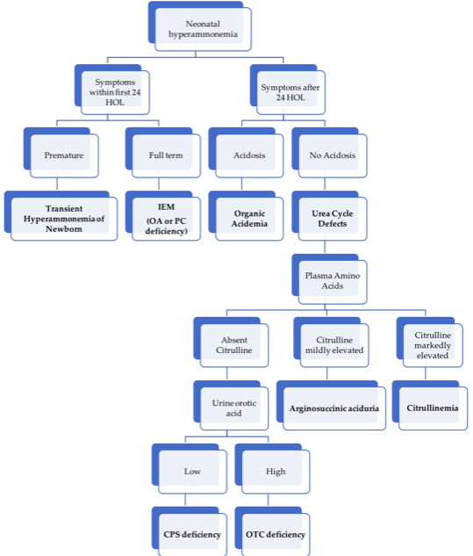

Approach to hyperammonemia workup in neonates.

### Metabolic Acidosis d/t suspected IEM

**PowerPlan:** Metabolism Lactic or Metabolic Acidosis NOS Admit Plan

#### Definition

Arterial blood gas with pH < 7.35, pCO2 < 35, bicarbonate < 22

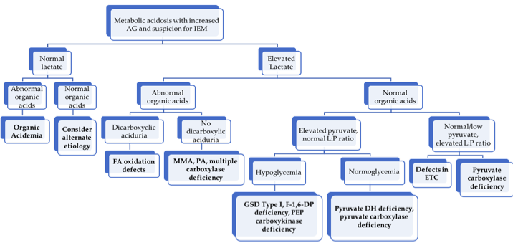

Approach to metabolic acidosis workup.

#### Etiologies

Inherited: organic acidurias, primary lactic acidemias, renal tubular acidosis; ANY metabolic crisis, if left untreated long enough, will progress to metabolic acidosis

#### Presentation

Acute vomiting, dehydration, lethargy, and rapid, shallow breathing, often h/o protein load

#### Physical Exam

* **Organic acidurias:** limb hypertonia/axial hypotonia, large amplitude tremor, myoclonic jerks, pedaling, sustained paraspinal contraction (opisthotonic posturing)
* **RTA:** Failure to thrive, polyuria, and rachitic changes
* **PDH deficiency:** blindness, hypotonia, DD, narrow forehead, frontal bossing, wide nasal bridge, long philtrum, and anteverted nostrils

#### Management

* Work-up as per flow-chart above; also check ketones as a marker for catabolism
* Hydration, caloric intake of 120-140kcal/kg/day, stop proteins initially (esp stop all BCAAs if MSUD is suspected), maintain glucose 100-150 (using high GIR +/- insulin), avoid hypoNa, cerebral edema
* If serum bicarb < 14 meq/L and pH < 7.2, give IV bolus NaHCO3 as 2.5 meq/kg over 30 minutes, then 2.5 meq/kg/day until serum bicarbonate is 24-28 meq/L
* HD = last resort but may be lifesaving in severe refractory cases (especially neonates)

### Seizures d/t suspected IEM

#### Etiology

Alteration of intracellular **osmolality**, depletion of substrates needed for **cellular metabolism** or membrane function, and/or intracellular accumulation of **toxic substances**

#### Underlying differential diagnosis

DDx of ‘seizures in a newborn’ is large, including many IEMs with poor prognosis. Rare but potentially treatable etiologies:

* **pyridoxine responsive seizures**
* **folinic acid responsive seizures**
* serine responsive 3-phosphoglycerate DH deficiency
* sz from **hypoglycemia**
* **biotin responsive** holocarboxylase synthetase deficiency
* biotinidase deficiency

#### Management

* **See neurology section for treatment of status epilepticus**
* avoid AEDs that block mitochondrial fxn (VPA, chloral hydrate) - c/s fosphenytoin, BZDs, and/or levetiracetam
* Correct fever, electrolyte issues, acidosis, hypoglycemia
* If refractory, c/s empiric pyridoxine (100-200 mg IV x1), folinic acid (2.5-5 mg PO once daily), L-serine (200-600 mg/kg/d div 6x/day), or biotin (5-20 mg PO once daily)

### Ketotic Hypoglycemia

*For broader approach to Hypoglycemia, see the Endocrine chapter.*

**PowerPlan:** Metabolism Hypoglycemia Admit Plan

#### Definition

BG < 60 mg/dL, elevated BOHB, likely acidosis  
Gluconeogenic amino acid levels are low on plasma AA analysis

Distinguish from hypoglycemia with:

* lactic acidosis (possible carbohydrate metabolism defect)
* no acidosis but elevated FFA (possible FAOD)
* no acidosis or FFA (likely endocrine-mediated)

#### Etiology

Failure of the catabolic state to maintain euglycemia, typically i/s/o trigger. Glycogen stores are typically depleted (no response from glucagon)

#### Presentation

Very common in children 16 months to 3 years, usually gone by ages 10-12. Possibly related to factors that improve with age (increased muscle mass, decreasing GIR need, decreased head to body size).

#### Physical exam

* Look for skin darkening or other signs of adrenocortical insufficiency
* Enlarged liver (Hepatic glycogen storage disease)

#### Management

* Promote anabolic state (not just correct the blood glucose)
* Start children on D10 containing fluids at 1.5x maintenance rate until they demonstrate the ability to take substantial calories by mouth
* Do not discharge catabolic state reversed (e.g. taking very good PO, ketones clearing, hepatic stores repleting)

### Access in a metabolic crisis

Pay attention to access because it determines your ability to provide anabolic support and give scavengers.

**PIV:** dextrose up to D12.5, continuous ammonul, intralipids  
**G-Tube:** Metabolic formula to assist in detoxification, allows for highest calories/volume, avoid use if vomiting  
**CVL/Port:** Ammonul w/ arginine bolus, high concentration dextrose

**Common caloric values for fluids:**

|  |  |
| --- | --- |
| Fluid | Calories (kcal/mL) |
| **D5** | 0.17 |
| **D10** | 0.34 |
| **D12.5** | 0.425 |
| **Intralipid** | 2.0 |
| **Metabolic formula** (30 kcal/oz) | 1.0 |
| **Pedialyte** | 0.105 |

## Differential Diagnosis by Clinical Manifestations

### Presenting in *Neonatal period* or *early infancy*

#### History

Consanguinity (increased inc of AR disorders), ethnicity (e.g., tyrosinemia in French-Canadians of Quebec), SIDS or intellectual disability in family (all from possible undiagnosed IEMs), relation of symptom to introduction of new food, NBS results

#### Presentation

* Acute and severe, simulating sepsis (lethargy, vomiting, tachypnea, seizures, poor perfusion)
  + classically ex FT, prev healthy, deterioration despite support, usu neg sepsis workup
  + d/t deficiency of a product or excess of toxic substrate, so called “intoxications” - organic acidemias, aminoacidopathies, and UCDs
  + First presentation may be unmasked by a concurrent illness
* Indolent w/ early and persistent neurological deterioration
  + nl pregnancy, no interim healthy pd, d/t energy def: mitochondrial + peroxisomal disorders

##### Encephalopathy

* MSUD
* MMA
* PA
* IVA
* MCD
* UCD

##### Seizures

* B6 responsive seizures
* MCD (biotin)
* Folinic acid responsive
* GLUT1
* 3PGD

##### Hepatic

* Galactosemia
* Fructosemia
* Tyrosinemia
* Bile acid synthesis defects
* Glycosylation defects Ib
* LCHAD

##### Cardiomyopathy

* LC-FAOD
* Pompes

##### Hypoglycemia

* GSD
* FAOD
* Primary hyperinsulinemia

#### Physical exam

* Usually non-specific–hepatomegaly and HD instability may be only signs in a crisis
* Dysmorphisms and other findings may be seen in specific cases:

|  |  |
| --- | --- |
| **Dysmorphisms** |  |
| Peroxisomal disorders (e.g. Zellweger) | Trisomy 21 like facies |
| Pyruvate dehydrogenase deficiency | FAS like facies |
| Lysosomal disorders (I cell disease) | Hurler-like coarse facies |
| Glycosylation defects | Inverted nipples, fat pads/lipodystrophy |
| **Hydrops** |  |
| Storage disorders | Mucopolysaccharidosis, Niemann-Pick |
| Disorders affecting erythropoiesis | G6PD deficiency, pyruvate kinase deficiency |
| Disorders affecting liver | Neonatal hemochromatosis, galactosemia |
| **Skin and hair manifestations** |  |
| Acrodermatitis enteropathica (Zn def) | Vesiculobullous/eczematoid lesions on perioral/perineal areas |
| Hartnup | Pellagra like features |
| PKU | Blonde, fair, blue eyes |
| Congenital Erythropoetic Porphyrias | Photosensitivity with vesiculobullous lesions and scarring |
| Biotinidase deficiency | Rash and alopecia |
| Menkes syndrome (Cu dysreg) | Pilli torti (fragile, kinky hair), sagging skin |
| **Cataracts** | Lowe, galactosemia, Zellweger and variants |
| **Hepatomegaly** | Galactosemia, hereditary fructose intolerance, GSD type Ia & III, LCHAD, Tyrosinemia, hemochromatosis, Zellweger, Lysosomal storage disease |

#### Initial lab workup

Consider the following tests based on your above history and physical:

|  |  |
| --- | --- |
| Lab test | Common associations |
| VBG + chem 10 | Acidosis and increased anion gap in organic acidemias |
| Blood glucose | Hypoglycemia in FAOD, glycogenolysis and glycosylation defects |
| LFTs and coags | Jaundice/hepatitis in tyrosinemia, galactosemia, hemochromatosis |
| Plasma ammonia | Increased in urea cycle defects and organic acidemias |
| Plasma lactate (L), pyruvate (P), and ketoacids (3OHB, AcAc) | Some IEMs have pathognomonic L/P or 3OHB/AcAc ratios |
| CBC w/diff | Neutropenia and thrombocytopenia with IVA, MMA, PA; neutropenia in GSD Ib |
| Blood Culture | Galactosemia a/w increased incidence of E. coli sepsis. |
| Urine pH | >5 in setting of acidosis suggests distal RTA. |
| Urine (non-glucose) reducing substances | Suggestive of galactosuria or fructosuria |
| Urine ketones (if acidosis or hypoglycemia) | As with plasma ketoacids, although B-OHB may be easier to obtain from plasma in infants |

#### Secondary workup

In discussion with metabolism:

* **Urine:** Organic acids, acylglycines, mucopolysaccharides, oligosaccharides
* **Plasma:** AAs (quantitative), carnitine + acylcarnitine, Peroxisomal tests (VLCFA), bile acid analysis
* **CSF:** for amino acids (glycine), lactate, pyruvate, and neurotransmitters, glucose (with corresponding serum glucose 30 min before LP)
* **Imaging:** Brain MRI/MRS, HIDA scan for biliary atresia
* **Auditory + ophthalmologic evaluations**
* *In general pre-prandial samples should be sent for most tests (at least 2-4 hours after last feed)

**Bill’s Pearls:** Plasma AAs

A plasma amino acid panel can tell you if you need to give protein or not, if you see deficiency in multiple amino acids. You can only restrict protein for 24-48 hours before an amino acid deficiency develops. When there is an AA deficiency, the catabolic state is less responsive to dextrose-based anabolic support. In addition to protein synthesis, amino acids have other synthetic and regulatory roles (methionine -> methylation of DNA, synthesis of creatine; leucine -> stimulator of insulin secretion; cysteine -> antioxidant; etc.) you may not otherwise think about.

### Later onset

***About 50% of patients with IEMs present beyond the immediate neonatal period (even as adults!)***

#### History

*Episodic illness* precipitated by mild intercurrent illness, fasting, or change of diet, specific dietary preferences (e.g., autovegetarianism seen in conditions predisposing to hyperammonemia), behavioral issues such as ADHD (partially treated PKU)

#### Presentation

Can be classified into 2 patterns which may overlap:

* Acute, presenting in a metabolic crisis w/ emesis, lethargy, seizures, tachypnea
  + **Encephalopathy**
    - **Without focal findings:** look for predominant acidosis, hyperammonemia or hypoglycemia & work up as outlined above
    - **With focal findings:** homocystinuria with thromboembolic event, mitochondrial disorders with CVA, biotin-responsive basal ganglia disease, some OA (striatal necrosis inorganic acidemias); cerebral edema in UCDs
  + **Recurrent ataxia:** MSUD, OTC, pyruvate dehydrogenase (associated peripheral neuropathy)
  + **Psychiatric symptoms:** UCD’s, porphyrias, homocystinuria, cobalamin C disease, late-onset Tay Sachs
  + **Dehydration** associated with:
    - **Polyuria:** RTA, nephrogenic Diabetes Insipidus
    - **Diarrhea:** glucose or galactose malabsorption, acrodermatitis enteropathica (Zn deficiency), sucrase isomaltase deficiency, congenital chloride diarrhea
    - **Ketoacidosis:** MMA, IVA, PA, DM
    - **Salt losing:** CAH, hypoaldosteronism
  + **Reye syndrome-like:** UCD’s and OA’s, disorders of mitochondrial fatty acid oxidation and ketogenesis
* **Indolent:** FTT, myopathies, neurological sequelae (DD, ID, micro/microcephaly), dysmorphisms

## Aminoacidopathies

**Bill’s Pearls:** high-level approach to Aminoacidopathies

Amino acid concentrations that get excessively elevated can cause cerebral edema (e.g. leucine in MSUD, methionine in homocystinuria). Avoid excessive fluid administration if you think these states are present. The key is to provide metabolic formula that has caloric value and a mixture of amino acids that don’t include the toxic ones (i.e. branched-chain-free formula in MSUD). The goal is to make the toxic amino acid the limiting reagent in protein synthesis and to provide enough calories to stimulate protein synthesis. You don’t get the same effect with dextrose-containing fluids and end up giving more volume.

**PowerPlan if relevant:** Metabolism MSUD Admit Orderset

#### Biochemical defect

Defect in AA metabolism → toxic AA metabolites accumulate

#### Presentation

* May present early (neonatal period) as catastrophic ‘intoxication’-like disease → feeding difficulty, lethargy, tachypnea, and poor perfusion → encephalopathy (e.g., MSUD)
* May present later w/ chronic encephalopathy (e.g., PKU)
* Often NO acidosis or hyperammonemia (vs organic acidemias and UCDs)

#### Workup

* Definitive: quant plasma AAs + sequencing
* May be suggested by NBS, labs w/ hypoglycemia, ketosis, liver dysfxn

#### Management (general approach)

* Restrict culprit AA in diet, monitor plasma AAs carefully
* **Avoid catabolism:** may be with dextrose-containing fluids and/or AA-excluding formulas (encourage new protein synthesis with toxic AA as limiting reagent)
* Cofactor therapy in some cases

|  |  |  |  |  |
| --- | --- | --- | --- | --- |
| Disorder | Enzyme Blockade | Accumulated Substrate(s) | Presentation | Treatment |
| **Phenylketonuria** | Phenylalanine hydroxylase (Phe → Tyr) | Phenylalanine | Neurotoxicity, intellectual deficits, microcephaly, GDD, eczema | Avoid Phe, give special Phe-free diet, consider cofactor tx (sapropterin), enzyme substitution (adults) |
| **Maple Syrup Urine Disease** | Branched-chain alpha-keto acid dehydrogenase | BCAAs: Leu, Ile, Val, Leu is neurotoxic, causes hypoNa | Catabolic stress, high Leu intake → HA, confusion, halluc, lethargy, N/V → coma/death | Stop all Leu, give Leu-free feeds, dex-containing IVF, AVOID hypotonic fluids (cerebral edema) |
| **Homocystinuria** | Cystathionine β-synthase (Hcy → cystathionone) | Homocysteine (chronic toxicity), **Methionine (potentially acute cerebral edema)** | Intellectual disability, tall stature, thrombosis (Hcy is thrombophilic), downward lens dislocation, osteoporosis | Met-free formula, B6 (cofactor for cystathionine β-synthase) in responsive patients, betaine (Hcy → Met), risk of cerebral edema with rapid methionine correction |
| **Tyrosinemia** | Fumaryl- acetoacetase (fumaroaceto-acetate, → fumarate + acetoacetate) | Tyrosine (blood), Succinylacetone (urine) | Liver failure, RTA - due to accumulation of succinylacetone | Nitisinone (blocks early step in Tyr metab - can’t make succinylacetone), Tyr restriction |

## Carbohydrate Metabolism Defects

**PowerPlan if relevant:** Galactosemia Admit Orderset

#### Biochemical defect

Issues with glucose/fructose/galactose metabolism

#### Presentation

* Timing depends on intro to culprit carb (**galactosemia early** d/t breastmilk, **fructose introduced later**) and from timing of spacing feeds (**longer fasting** = need to mobilize glycogen stores → **GSD becomes manifest**)
* Often p/w metabolic crises (lethargy, encephalopathy, HD instability); may have stigmata of toxic deposition (see chart below)

#### Workup

* **NBS:** Galactosemia (NOT hereditary fructosuria or GSD)
* Definitive with enzyme assays from blood (also done on cultured fibroblasts & liver)
* Suggestive labs: hypoglycemia, ketosis, metabolic acidosis, liver dysfunction; reducing substances in urine present in galactosemia + hereditary fructose intolerance

#### Management (general approach)

* Dietary avoidance of the given carbohydrate
* Some hepatic glycogen storage diseases are associated with hypoglycemia (I, III, IV, IX, 0). For sick children that need dextrose-containing fluids, the goal is to keep BG > 77 but below 110. In excess of that, glycogen starts to be stored and can worsen existing accumulation.

|  |  |  |  |  |
| --- | --- | --- | --- | --- |
| Disorder | Enzyme Blockade | Accumulated Substrate(s) | Presentation | Treatment |
| **Classic Galactosemia** | Galactose-1- phosphate uridyl transferase (allows for transfer of Gal-1-P to Glu-1-P) | Gal-1-P, total galactose + urine reducing substances | Hepatomegaly, jaundice, vomiting, cataracts, FTT, lethargy, proximal RTA (Fanconi syndrome), E Coli sepsis after starting galactose-containing feeds (e.g., breastmilk) | No galactose - includes no lactose (milk / dairy) |
| **Hereditary Fructose Intolerance** | Aldolase B (splits F-1-P into DHAP + glyceraldehyde) | F-1-P - urine reducing substances | Similar to classic galactosemia, but no cataracts; occurs w/ fructose-containing foods | No fructose from diet - includes no sucrose or sorbitol |
| **Glycogen Storage Disease (GSD) Type Ia (von Gierke)** | Glucose 6 phosphatase (G6P → glucose + Pi, last step of glycogen breakdown) | G6P → lactate, triglycerides, and uric acid | ~3-6 months: hypoglycemia 3-4 hrs after meal, lactic acidosis, hepatomegaly, hypertriglyceridemia, hyperuricemia, “doll face,” small size | Frequent meals, Uncooked cornstarch 1.5-2.5 g/kg PO q4-6h, avoid sucrose/fructose/galactose, NaHCO3 for acidosis, allopurinol for hyperuricemia |
| **GSD Type IIa (Pompe)** | Lysosomal acid α-glucosidase | Glycogen - accumulates in skeletal and cardiac muscles | Progressive hypotonia, macroglossia, loss of motor, respiratory, and cardiac functions (**cardiomyopathy**). Pilot optional test on NBS | ERT (alglucosidase alfa), management of cardiomyopathy |
| **GSD Type IIIa & IIIb (Cori)** | Debranching enzyme | Glycogen - accumulates in liver and muscle | Similar to Ia but may be milder; IIIb causes neutropenia | Uncooked cornstarch + continuous feeds to maintain normoglycemia, high-protein diet |
| **GSD Type V (McArdle)** | Muscle phosphorylase | Glycogen - accumulates in muscle | Exercise intolerance / cramping, “second wind” phenomenon, myoglobinuria/ rhabdomyolysis | Carbohydrate administration before exercise, high-protein diet |

## Fatty Acid Oxidation Disorders

**PowerPlans if relevant:** Metabolism Fatty Acid Ox Disorder NOS Admit Orderset, LCFAOD Admit Orderset

#### Biochemical defect

Mitochondrial FA oxidation (AKA β-oxidation) = main energy (FADH2 / NADH for **gluconeogenesis** and **ketogenesis**) for **heart, skeletal muscle, neurons** when Glucose is limited (starvation, exercise). Disorders occur d/t decreased carnitine uptake by cells (required for FA transport into the mitochondria), inhibiting entry of FAs into mitochondria, or by blocking β-oxidation. End result = energy-deficient state **without appropriate ketosis**.

#### Presentation

Fasting-induced vomiting, lethargy, coma, and hypoglycemic seizures, occasional hepatomegaly (may be Reye’s-like)

#### Workup

Suggested by **hypoketotic hypoglycemia** +/- liver failure, acidosis & hyperammonemia. Acylcarnitine profile with specific findings. Confirmation w/ DNA mutation analysis (less frequently enzyme testing in cultured skin fibroblasts)

|  |  |  |  |  |
| --- | --- | --- | --- | --- |
| Disorder | Enzyme Blockade | Accumulated Substrate(s) | Presentation | Treatment |
| **Medium-chain acyl-CoA DH deficiency** | MCAD – cannot degrade MC FAs to short-chain FAs and Acetyl CoA | C6, C8, and C10 acylcarnitines | Illness + poor PO → glycogen depletion → HKHG → brain injury, seizures, & death if untreated; excellent prognosis if treated. **On NBS in most states, but may present on DOL 2-3** | Avoid fasting during illnesses, give dex-containing IVF if unable to tolerate PO, carnitine supplementation if low carnitine, **AVOID MCT** |
| **Long-chain / Very long-chain acyl-CoA DH deficiency** | LCHAD/VLCAD | **LCHAD/TFP:** 3-hydroxy-acyl-carnitines (C16-OH) **VLCAD:** unsat long-chain acylcarnitines (C14:1) | More severe than MCAD – rhabdo, CMP, liver failure, and HKHG even w/ rx. LCHAD may have peripheral neuropathy + retinopathy. On NBS in all states | Dietary fat restriction, MCT oil supplementation, avoid fasting; give dex-containing IVF, Serial cardiac evaluations, check CK with illnesses |
| **Primary Carnitine Deficiency** | Defective carnitine transporter (OCTN2) – dec GI absorption / renal reabs. | Elevated urine carnitine, low blood carnitine | CMP + recurrent HKHG, may progress to Reye-like picture. **Blood:** low free carnitine. **Urine:** elevated carnitine excretion | High-dose oral carnitine, avoidance of fasting, dex-containing IVF if unable to tolerate PO |

## Lysosomal Diseases

#### Biochemical defect

Deficiency in lysosomal enzyme → excess intracellular substrate (e.g., GAGs, MPS)

#### Presentation

* Substrate build-up → HSM, coarse facies, short stature, skeletal abnormalities
* If nervous system involvement → intellectual disability, cataracts, neuropathy

#### Workup

**Enzyme assay** on samples of WBCs, serum, or skin fibroblasts

|  |  |  |  |  |
| --- | --- | --- | --- | --- |
| Disorder | Enzyme Blockade | Accumulated Substrate(s) | Presentation | Treatment |
| **Gaucher Disease** | β-glucosidase (glucocerebrosidase) | Glucocerebroside | Type 1:HSM, bone disease, anemia & thrombocytopenia, absence of CNS disease Type 2&3: Primarily neurologic with DD, regression, early death | ERT, substrate reduction therapy |
| **Tay-Sachs Disease** | Hexosaminidase A | GM2 gangliosides | By age 1 - DD, exaggerated startle, sz, macular cherry-red spot | Supportive |
| **Niemann-Pick Disease** | Sphingomyelinase | Sphingomyelin | Massive HSM, cherry red spot, interstitial lung disease; neuronopathic or non-neuronopathic | HSCT for non- neuronopathic |
| **Krabbe Disease** | Galactocerebrosidase | Galactocerebroside | Infantile-onset:By age 1 - irritability, rapid neurologic deterioration,early childhood death. Later-onset: variable | Early HSCT |
| **Metachromatic Leukodystrophy** | Cerebroside sulfatase (arylsulfatase A) | Sulfatides | First years of life (late infantile form): DD/regression; Juvenile form with regression, of dev and beh, then gait; Peripheral neuropathy in adult form | HSCT for juvenile and adult MLD |
| **Fabry Disease** | α-galactosidase | Globotriaosyl- ceramide (GL-3) | X-linked recessive. Acroparesthesias, pain crises, corneal opacities, fatigue, angiokeratomas | ERT |
| **Hurler Syndrome (MPS I)** | α-L-iduronidase | Glycosamino- glycans (GAGs): dermatan + heparan sulfate | Coarse facies, DD, ID, corneal clouding, hearing loss, hernias, dysostosis multiplex | ERT, HSCT |
| **Hunter Syndrome (MPS II)** | Iduronate-2-sulfatase | GAGs as above | X-linked recessive. Similar to MPSI r w/o corneal clouding. | ERT, HSCT |

*ERT = enzyme-replacement therapy. HSCT = hematopoietic stem-cell transplant. Autosomal recessive unless otherwise specified*

## Mitochondrial Disorders / Primary Lactic Acidemias

**Bill’s Pearls:** high-level approach to Mitochondrial disorders

Mitochondrial diseases don’t decompensate acutely like small molecule metabolic diseases. Therapy is focused on decreasing systemic stressors (treat infection, stop catabolism, correct dehydration, etc). Try to **keep the bicarbonate > 16**, otherwise acidemia will impair mitochondrial function. The lactate levels will be what they are – just keep the bicarbonate up and don’t give too much dextrose (D5 ok, D10 negotiable). **Don’t give valproic acid or Lactated Ringers.** Lactate gets the attention but cardiac dysfunction in acute scenarios is the concern. Cardiac cells that have poor mitochondrial function typically hypertrophy, leading to hypertrophic cardiomyopathy and some preload dependence. You are never wrong to get an EKG and call cardiology. Correct dehydration to minimize perfusion-associated lactic acidemia.

If you think someone may have a mitochondrial disease, get a plasma amino acid level with a lactate. Look for elevated alanine as well, because of the high error associated with lactate due to blood draws. True metabolic acidemia should have an anion gap and acidic urine.

#### Biochemical defect

Disorders of **Krebs cycle** and **oxidative phosphorylation**; transmission via mitochondrial genes → defects vary / not all organs are affected equally

#### Presentation

Indolent, progressive neurologic deterioration, +/- poor feeding, vomiting, CMP, myopathy, liver failure, seizures, strokes, blindness, deafness, and nephropathy

#### Workup

* Definitive dx from enzyme assay or DNA testing
* Labs often show **AG metabolic acidosis** and **primary lactic acidosis** +/- hypoglycemia w/ ketosis, liver dysfxn

|  |  |  |  |  |
| --- | --- | --- | --- | --- |
| Disorder | Enzyme Blockade | Accumulated Substrate(s) | Presentation | Treatment |
| **Pyruvate Dehydrogenase Complex Deficiency** | Pyruvate dehydrogenase (Pyruvate → Acetyl CoA + CO2) | Pyruvate → lactate | Lactic acidosis, intellectual disability, hypotonia, seizures, exacerbated by ingestion of carbohydrates | Supplement with carnitine, thiamine, and lipoic acid (cofactors for pyruvate DH complex), high fat / low carb diet or ketogenic diet |
| **Pyruvate Carboxylase Deficiency** | Pyruvate carboxylase (pyruvate + CO2 → oxaloacetate) | Pyruvate → lactate | NH3 (as Asp cannot be formed from OAA) Severe lactic acidosis, hypothermia, hypotonia, hypoglycemia, hyperammonemia, lethargy, vomiting, often death as neonate or w/in 1 year for Type B; Types A & C are milder | High carb and protein diet; Treat metabolic crisis with 10% dex-containing IVF, avoid fasting, NaHCO3 for acidosis, possible liver transplant |

## Organic Acidemias

**Powerplans if relevant:** Metabolism IVA, MMA, PA, Glutaric Acidemia Type I Admit Ordersets

#### Biochemical defect

Defect in AA breakdown → accumulation of organic acid byproducts

#### Presentation

Neonatal lethargy, poor perfusion, vomiting, coma, CVAs, death

#### Workup

* **Definitive:** quant plasma AAs
* Often on NBS (elevated C3 / C5 acylcarnitines)
* Usually p/w severe high **AG metabolic acidosis**, +/- hyperammonemia, hypoglycemia, liver dysfunction, ketosis, and secondary carnitine deficiency

#### Management (general approach)

Stop all protein intake, high-dose carnitine, promote anabolism with D10NS + IL +/- insulin, +/- NaHCO3 for severe acidosis, dialysis for life-threatening acidosis or hyperammonemia

|  |  |  |  |  |
| --- | --- | --- | --- | --- |
| Disorder | Enzyme Blockade | Accumulated Substrate(s) | Presentation | Treatment |
| **Methylmalonic acidemia** | methylmalonyl-CoA mutase deficiency (MM-CoA → succinyl CoA) | Products of BCAAs (Ile, Val, Met) - MMA, methylcitrate, C3 acylcarnitine | Stressor (illness, excess protein intake) → metabolic crisis (high-AG metabolic acidosis, basal ganglia stroke, pancreatitis). Complications: renal dz, intellectual disability. Variable age of onset. | As above, plus Vitamin B12, liver or liver/kidney transplantation, avoid Ile, Val, Met, Thr in diet |
| **Propionic acidemia** | propionyl-CoA carboxylase deficiency (propionyl CoA → MM-CoA) | Products of BCAAs (Ile, Val, Met) - 3-OH propionic acid, methylcitrate, C3 acylcarnitine | Newborn period - profound metabolic acidosis w/ high AG and prominent ketosis → multiorgan dysfunction (cardiac, respiratory, pancytopenia, basal ganglia stroke, pancreatitis), hyperammonemia. Later - cardiomyopathy and dysrhythmias in early adulthood | As above, plus liver transplant, avoid Ile, Val, Met, Thr in diet. **Acutely,** anabolic support, increase carnitine to protect mito from organic acids. Consider bowel regimen (stool can harbor toxic intermediates). |
| **Isovaleric acidemia** | isovaleryl-CoA dehydrogenase (isovaleryl-CoA → → acetoacetate and Ac-CoA) | Products of Leu metabolism (Isovaleric acid and metabolites), C5 acylcarnitine | Neonatal: severe lethargy and obtundation, +AG metabolic acidosis, hypoglycemia, ketonuria, hyperammonemia, odor of IVA in urine, pancreatitis. Infantile/late-onset: FTT, DD, seizures | As above, avoid Leu |
| **Glutaric acidemia type I (GA1)** | Glutaryl CoA DH deficiency | Products of Trp and Lys metab (plasma C5 dicarboxylic (C5DC) acylcarnitine) | Macrocephaly (risk of tearing of bridging veins → subdural hemorrhage), **metabolic basal ganglia stroke** (unlikely after 6y), isolated cerebral acidosis – may not have metabolic acidosis/ketosis/hyperammonemia. **Catabolic stress, fever** → devastating neurologic injury (dystonia, movement disorders). | As above, restrict Trp and Lys in diet, aggressive sick day management. Start D10 at 1.5x mIVF regardless of appearance. If controlled during childhood, outcomes excellent. |

## Peroxisomal Disorders

#### Biochemical defect

Peroxisomes = site for β-ox of VLCFAs, H2O2 degradation, and pipecolic, phytanic, and pristanic acid metabolism, also of bile acid synthesis, plasmalogen formation (for membranes and myelin).

#### Presentation

Dysmorphic facies (as below) alongside shortened proximal limbs, epiphyseal stippling, hypotonia, seizures, encephalopathy, cataracts, retinopathy, hepatomegaly, and cholestasis.

#### Workup

Elevated levels of substrate in question (see below), enzyme assays

|  |  |  |  |  |
| --- | --- | --- | --- | --- |
| Disorder | Enzyme Blockade | Accumulated Substrate(s) | Presentation | Treatment |
| Zellweger Syndrome | Several peroxisomal genes; often PEX1 | VLCFAs and branched- chain FAs | Early neuromotor arrest, seizures, ID, craniofacial anomalies (large fontanel, midface hypoplasia, short pf, incr. neck fat),chondrodysplasia punctata (calcification of cartilage), renal cysts, liver failure - cerebrohepatorenal syndrome, death w/in 1 yr | Supportive care only; no disease-modifying rx |
| Refsum Disease | Defective phytanoyl-CoA -hydroxylase | Phytanic acid | Later onset (adolescence / adulthood) of ataxia, retinitis pigmentosa, ichthyosis, cataracts/night blindness, anosmia, and hearing loss | Restrict phytanic acid intake (found in dairy, beef, lamb, seafood. Cardiac & ophtho surveillance |
| Adrenoleukodystrophy | ABCD1 gene - issues shuttling VLCFAs in to peroxisomes | VLCFAs | X-linked recessive. Seizures, intellectual disability, neuromotor arrest, adrenal insufficiency, hypogonadism, beginning with behavioral changes around age 4-10. | Lorenzo’s oil (special preparation of FAs)-NOT PROVEN. Treat adrenal disease. HSCT |

## Urea Cycle Defects

**PowerPlans:** Several, including for known defects and unknown; search “metabolism urea” in PC for full list

#### Biochemical defect

Deficiency in any of the 6 UC enzymes, which converting toxic nitrogenous metabolites from protein turnover to non-toxic urea for urinary excretion → NH3 accumulation.

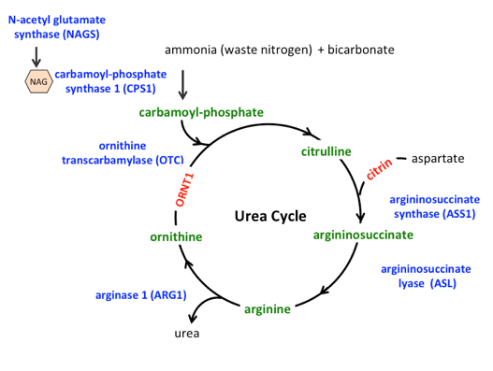

Urea cycle diagram with assocated disorders in blue.

#### Presentation

Interim healthy period → **catabolic stressor** (stress, infection, surgery, or starvation) → vomiting, feeding intolerance, tachypnea (due to central hyperventilation) → encephalopathy and coma, with potentially irreversible brain damage if untreated.

#### Workup

* Labs w/ hyperammonemia and respiratory alkalosis → metabolic acidosis
* Definitive: plasma/urine levels of UCD metabolites and confirm with enzyme testing

#### Management (general approach)

**Bill’s Pearls:** UCD management

Children often look better than their ammonia level. *Start anabolic support when they get to the ED!* If they don’t have access, then get it as fast as you can. If they are not vomiting, protein-free formula run continuously through a G-tube provides more calories than IV fluid and is faster to get going.

* **Acutely:** immediate treatment of hyperammonemia (see full details in Metabolic crisis management section): Stop all protein intake (but no longer than 36-48h), give dex-containing IVF (10-25% @ 1.5xM) and IL (1-3 g/kg/d) through central line, NH3 scavengers (Ammonul = Na benzoate and Na phenylacetate) usually with IV arginine, avoid hypoNa (would exacerbate cerebral edema), prepare for HD (likely if NH3 > 300 μmol/L)
* **Long term:** Low-protein diet, avoid catabolism, include missing UC intermediates, liver transplant

|  |  |  |  |  |
| --- | --- | --- | --- | --- |
| Disorder | Enzyme Blockade | Accumulated Substrate(s) | Presentation | Treatment |
| **Ornithine Transcarbamylase Deficiency** | OTC (carbamoyl phosphate + ornithine → citrulline) - most common | NH3 → cerebral edema. Glutamine elevation. Low arginine and citrulline as cycle is blocked proximally. Elevated **orotic acid** in urine | X-linked recessive. **Hyperammonemic crisis**, typically early on, p/w poor feeding, lethargy, tachypnea, hypothermia, irritability, vomiting, ataxia, seizures, hepatomegaly, coma. **NOT** always evident on NBS, may flag for low citrulline | As above, alongside: citrulline/ arginine, + carnitine, ammonia scavengers such as glycerol phenylbutyrate. **Consider ammonul for acute hyperammonemia** |
| **Citrullinemia** | Arginosuccinate synthetase (citrulline + aspartate → argininosuccinate) | Same as OTC def but with elevated citrulline | Similar to OTC def, but AR inheritance. All states include on NBS | As above, alongside: arginine, glycerol phenylbutyrate, NO citrulline |
| **Arginosuccinic aciduria** | Arginosuccinate lyase (arginosucc → fumarate + arginine) | Same as OTC def but with elevated citrulline and arginosuccinate | Similar to citrullinemia. All states include on NBS | Same as for citrullinemia |
| **Carbamoyl phosphate synthetase (CPS) I deficiency & NAGS deficiency** | CPS I (NH3 + bicarb + Phos → CPS). NAGS is cofactor for CPSI | Same as OTC def but without elevated orotic acid in the urine | Similar to OTC deficiency. NOT always evident on NBS, may flag for low citrulline | Same as for OTC deficiency |

## Glossary

|  |  |
| --- | --- |
| Abbreviation | Term |
| BOHB/3OHB | 3- (or beta-) Hydroxybutyrate |
| 3PGD | 3 Phosphoglycerate dehydrogenase deficiency |
| CAH | Congenital adrenal hyperplasia |
| CPS | Carbamoyl phosphate synthetase |
| CPT-I&II | Carnitine palmitoyl transferase deficiency Type I and II |
| DH | Dehydrogenase |
| FAOD | Fatty acid oxidation defects/disorders |
| FDP | Fructose diphosphate |
| GALT | Galactose-1-phosphate |
| GIR | Glucose infusion rate |
| GLUT1 | Glucose transporter protein type 1 |
| GSD | Glycogen storage disease |
| HHH | Hyperammonemia, hyperornithinemia, homocitrullinuria |
| HMGCoA | 3-Hydroxy-3-methlyglutaryl-CoA |
| IEM | Inborn error of metabolism |
| IVA | Isovaleric acidemia/Isovaleryl-CoA DH deficiency |
| LCAD | Long-chain acyl-CoA DH deficiency |
| LCHAD | Long-chain hydroxyacyl-CoA DH deficiency / 3-Hydroxyacyl CoA DH deficiency |
| L/P | Lactate/pyruvate ratio |
| MCADD | Medium-chain acyl-CoA DH deficiency |
| MCD | Multiple Carboxylase deficiency |
| MMA | Methlymalonic acidemia |
| MSUD | Maple syrup urine disease |
| OA | Organic acidemia |
| OTC | Ornithine transcarbamylase |
| PA | Propionic acidemia/Propionyl-CoA carboxylase deficiency |
| PC | Pyruvate carboxylase |
| PDH | Pyruvate DH |
| PKU | Phenylketonuria |
| TEE | Total energy expenditure |
| THAN | Transient hyperammonemia of the Newborn |
| UCD | Urea Cycle Defect |
| VLCAD | Very long-chain acyl-CoA DH deficiency |

## Resources

**Information for patients and families:** newenglandconsortium.org, https://www.newbornscreening.info/  
**Acute Illness Protocols:** https://newenglandconsortium.org/for-professionals/acute-illness-protocols/  
**Newborn Screen Resources:** https://www.acmg.net/ACMG/Medical-Genetics-Practice-Resources/ACT_Sheets_and_Algorithms.aspx, http://genes-r-us.uthscsa.edu/resources.htm  
**Manifestations/Diagnosis/Treatment reviews** for most genetic/metabolic diseases: https://www.ncbi.nlm.nih.gov/books/NBK1116/

Major classification of IEMs and examples are adapted in part from Rice GM et al, Pediatrics in Review 2016;37.

# Nephrology

## Formulas

|  |  |  |
| --- | --- | --- |
| Formula Name | Formula | Clinical Use |
| **Modified Bedside Schwartz** | $eGFR=0.413×\frac{height_{(cm)}}{SCr}$ | Used ages 1-18 to estimate GFR. |
| **Insensible Fluid Loss** | $IFL_{(mL/day)}=300mL/m^{2}/day$ $BSA_{(m^{2})}=\sqrt{\frac{ht_{(cm)}×wt_{(kg)}}{3600}}$ | Use for patients when replacing insensible fluid plus urine/stool losses. |
| **Total Body Water** | $TBW_{males}=wt_{(kg)}×0.6$ $TBW_{females}=wt_{(kg)}×0.5$ | Use to calculate total body water. |
| **Free Water Deficit** | $FWD_{(L)}=\left(\frac{Current Na^{+}}{Desired Na^{+}}−1\right)×TBW$ | Calculate **water** to be replaced in **hypernatremic** dehydration. |
| **Sodium Deficit** | $Na^{+}Deficit_{(mEq)}=(140−Na_{actual}^{+})×TBW$ | Calculate **Na+** to be replaced in **hyponatremic** dehydration. |
| **Fractional Excretion Sodium** | $FENa=\frac{\left(Urine Na^{​^{+}}×Plasma Cr\right)}{\left(Plasma Na^{+}×Urine Cr\right)}$ | Use in oliguric **AKI** to determine **prerenal** (<1%, sodium-avid) vs. **intrinsic renal** (> 2%, tubular dysfunction) etiology). |
| **Fractional Excretion of Urea** | $FEUrea=\frac{\left(Urine Urea Nitrogen×Plasma Cr\right)}{\left(Plasma Urea Nitrogen×Urine Cr\right)}$ | Use in **AKI** if patient has recently been given **diuretics** (would alter Na+ excretion and therefore FENa), acute GN, or CKD; **prerenal** <35%, **intrinsic renal** > 50%. |
| **Urine Protein/Cr Ratio** | $UPCR=\frac{Urine Protein Spot}{Urine Cr Spot}$ | Normal <0.2. > 3.5 indicates nephrotic-range proteinuria. |
| **Transtubular Potassium Gradient** | $TTKG=\left(\frac{Urine K^{+}}{Plasma K^{+}}\right)/\left(\frac{Urine Osm}{Plasma Osm}\right)$ | Normal = 8-9. Can only use when urine osm > plasma osm and urine Na+ > 25 mmol/L. TTKG < 7 + **hyperkalemia** → aldo deficiency/resistance TTKG > 3 + **hypokalemia** → aldo ↑ vs renal K+ loss |
| **Tubular Reabsorption of Phosphate** | $TRP_{\%}=\frac{1−\left(Urine Phosphate×Plasma Cr\right)}{\left(Plasma Cr×Urine Cr\right)}×100$ | Normal 80-98%. ↓ TRP can be seen in conditions with prox tubular dysfunction, such as Fanconi syndrome/Type 2 RTA |

| **Urine Calcium/Cr Ratio** | | Normal:

0 - 6 months old: ≤ 0.8

7 - 11 months old: ≤ 0.6

≥ 1 year old: ≤ 0.2

Use to assess for hypercalciuria in patients with hematuria, stones, and/or hypercalcemia. | | **Corrected Calcium** | | Use to calculate calcium levels in low albumin states. Albumin = negatively charged, and therefore carries calcium. | | **Calculated Serum Osmolality** | | Use to calculate serum osmolality. | | **Osmolar Gap** | | Osmolar gap > 10 can be caused by toxic alcohols (ethanol, methanol, ethylene glycol, isopropyl alcohol), mannitol, and lorazepam infusions (which contain propylene glycol). |

## Fluid Management

### Dehydration[9]

|  |  |  |  |
| --- | --- | --- | --- |
| Severity | % Volume Loss | Vital Signs | Physical Exam |
| **Mild** | 3-5% | Normal | Oliguria |
| **Moderate** | 6-9% | Inc HR, Orthostatic BP | Decreased skin turgor, delayed cap refill, dry mucosa, sunken fontanelle, oliguria |
| **Severe** | ≥10% | Inc HR, Dec BP | Markedly decreased peripheral perfusion (cool, mottled extremities), lethargy/AMS, deep respirations, anuria |

**PowerPlans:** Gastroenteritis CPG Admit Plan, ED Gastroenteritis Pathway Plan

**Clinical Pathways:** Gastroenteritis Clinical Pathway

**Clinical Pearls:** estimate degree of dehydration by s/sx above to calc amt of fluid necessary to replace.

* Calculate fluid deficit: $FD=Dry Weight−Current Weight$
* If dry weight unknown, estimate: $Est. Dry Wt=\frac{Current Weight}{\left(1−\left(p×\frac{\%Dehydrated}{100}\right)\right)}$, where p=0.6 for boys and 0.5 for girls (as % of total weight is water is 60% in boys and 50% in girls).
* Oral rehydration is preferred to IV rehydration when possible
* If giving IV rehydration: 20cc/kg bolus of normal saline - consider D5NS if hypoglycemic or acidotic, rpt PRN until HDS, if ongoing IV rehydration necessary, start IVF @ maintenance (D5NS unless child is <1 mo, has renal disease, etc); for hypernatremic dehydration, give hypotonic fluids (e.g., D5 ½ NS) **after** volume resuscitation.

###Maintenance Fluid Therapy | Fluid | Dex | Na+ | Cl- | K+ | Ca2+ | Buffer | Osm | |:————-:|:———:|:————–:|:————–:|:————-:|:—————:|:————:|:——:| | **Unit** | g/dL | mEq/L | mEq/L | mEq/L | mEq/L | mEq/L | mOsm/L | | **Plasma** | 0.07-0.11 | 135-145 | 95-105 | 3.5-5 | 4.4-5.2 | 20-30 bicarb | 308 | | **NS (0.9%)** | 0 | 154 | 154 | 0 | 0 | 0 | 308 | | **D5 NS** | 5 | 154 | 154 | 0 | 0 | 0 | 308 | | **D5 ½ NS** | 5 | 77 | 77 | 0 | 0 | 0 | 15 | | **D5 ¼ NS** | 5 | 34 | 34 | 0 | 0 | 0 | 78 | | **3% Saline** | 0 | 513 | 513 | 0 | 0 | 0 | 1026 | | **D5 LR** | 5 | 130 | 109 | 4 | 3 | 28 lactate | 284 |

###Holliday-Segar Method Use for children >14 days old

|  |  |  |
| --- | --- | --- |
| Body Weight | cc/kg/day | cc/kg/hr |
| **First 10 kg** | 100 | 4 |
| **Second 10 kg** | 50 | 2 |
| **Each additional kg** | 20 | 1 |

**Insensible Fluid Loss: $IFL_{(mL/day)}=300mL/m^{2}/day$** , with $BSA_{(m^{2})}=\sqrt{\frac{ht_{(cm)}×wt_{(kg)}}{3600}}$

**Maintenance Electrolyte Requirements:** **Na+:** 2-4 mEq/kg/day / **K+:** 1-2 mEq/kg/day. Choice of fluid depends on age, serum sodium, and degree of dehydration.

**2018 AAP Clinical Practice Guideline:**[10]

* **Bottom line:** when in doubt, use isotonic fluids + KCl and dextrose (e.g., D5NS + 20 mEq/L KCl)
* **Exceptions:** neonates <28d or in NICU, CHF, renal disease, massive burns, hepatic disease, neurosurgical disorders, voluminous diarrhea, DI
* **Why:** avoids iatrogenic hyponatremia (hypotonic fluids + non-osmotic stimuli to ADH release) without a notable increase in iatrogenic hypernatremia or hypertension.
* **Note:** large amounts of NS → hyperchloremic non-gap metabolic acidosis. Keep this in mind when you see a persistent acidosis despite a normal anion gap when correcting patients in DKA!

##Acid/Base ###Simple Acid/Base Disorders | Disorder | pH | pCO2 | HCO3 | |———————–|:—–:|:—————:|—————–| | **Metabolic Acidosis** | **<7.35** | >45 | **<22** | | **Metabolic Alkalosis** | **>7.45** | <35 | **>26** | | **Respiratory Acidosis** | **<7.35** | **>45** | <22 | | **Respiratory Alkalosis** | >7.45 | **<35** | >26 | **Bold** indicates primary disturbance – non-bold indicates secondary response.

Note: lower serum bicarbonate levels (as low as 18 mmol/L) can be physiologically normal in neonates.

* **Acidemia** → pH < 7.35. **Acidosis** → process that makes pH ↓
* **Alkalemia** → pH > 7.45. **Alkalosis** → process that makes pH ↑
* In **respiratory** disorders, the **pH** moves in the same direction as the pCO2.
* Always look at the pH! A high bicarb on a chem often represents a metabolic alkalosis, but could also be a compensation for chronic respiratory acidosis (e.g., in patients with chronic lung disease).

###Metabolic Acidosis **PowerPlans:** Metabolism Lactic or Metabolic Acidosis NOS Admit Plan

**Approach:** is there a concomitant respiratory acidosis / respiratory alkalosis?

Use Winter’s Formula: $Expected pCO_{2}=\left[\left(1.5×HCO_{3}^{−}\right)+8±2\right]$

Calculate Anion Gap, $AG=Na^{+}−\left(Cl^{−}+HCO_{3}^{−}​\right)$

In healthy patients, $Normal=3×albumin±2$**Normal AG MAc:** GI loss (diarrhea, laxative, ureteroenteric fistula) vs renal loss (RTA (see chart), acetazolamide use, renal failure (may also have elevated AG), aggressive rehydration with NS. Calculate urine AG, $Urine AG=(UNa^{+}+UK^{+})−UCl^{−}$ (works b/c urine Cl- = proxy for NH4+ secretion)

* If positive → impaired renal acidification
* If negative → GI loss of bicarb

**Increased AG MAc: MUDPILES**  
**M**ethanol  
**U**remia  
**D**iabetic ketoacidosis/starvation ketoacidosis  
**P**araldehyde  
**I**nfection/**I**soniazid/**I**ron/**I**EM  
**L**actic Acidosis  
**E**thylene Glycol  
**S**alicylates (cause primary metabolic acidosis and respiratory alkalosis)

**Not fitting? Use the “delta gap”:** compares difference between measured and normal AG vs difference between normal bicarb and measured bicarb to answer the question: is each decrease in the bicarb accounted for by an increase in the AG?

$$ΔGap=\frac{\left(AG−12\right)}{\left(24−bicarb\right)}$$

If **yes**, then DGap = 0.8 to 2 → high AG metabolic acidosis (MAc) **alone**

If **no** and DGap < 0.4 → low/normal AG MAc **alone**

If **no** and DGap 0.4-0.8 → low/normal AG MAc **and** high AG MAc

If **no** and DGap > 2 → high AG MAc superimposed on chronic **metabolic alkalosis** or **respiratory acidosis** with metabolic compensation

**Management:** directed at underlying etiology; see Metabolism section for acute management.

####Renal Tubular Acidosis: Hyperchloremic Metabolic Acidosis w/ +Urine AG**  
| | **Proximal (Type 2)** | **Distal (Type 1)** | **Hyperkalemic (Type 4)** | |————————-|——————————————————————————————-|——————————————————————–|——————————————————————| | **Defect** | Bicarb reabsorption | H+ | Inadequate aldosterone | | **Potassium** | Normal/Decreased | Normal/Decreased | **Increased** | | **Urine pH** | <5.5 | >5.5 | <5.5 | | **Renal Stones** | No | **Yes** (high urine pH → CaPhos stones, low urine citrate) | No | | **Clinical Correlates** | **Fanconi Syndrome** (generalized proximal tubular dysfunction → lose glucose, phos, AAs) | Hereditary channelopathies (may be a/w sensorineural hearing loss) | DM, primary adrenal insufficiency, use of ACEIs/aldo antagonists |

###Metabolic Alkalosis **Chloride Responsive** (urine Cl- < 20 mEq/L)**:** loss of gastric secretions (HCl): vomiting, NG tube drainage, thiazide and loop diuretics (urine chloride varies based on when drug was given), CF

**Chloride Resistant** (urine Cl- > 20 mEq/L)**:** **w/ HTN:** primary hyperaldosteronism, CAH, renovascular HTN, Liddle’s syndrome **w/o HTN:** Bartter / Gitelman syndrome, severe K or Mg loss

###Respiratory Acidosis **DDx**

CNS depression

Nervous/Muscular disorders (Guillain-Barre, myasthenia gravis, botulism, muscular dystrophy)

Acute and chronic lung disease

**Workup/Management:** ABG/VBG, CXR, SaO2, escalate respiratory support as needed

###Respiratory Alkalosis **DDx**

Anxiety

Hypoxia

Pain

Salicylates

Urea cycle disorders (during metabolic crisis, hyperammonemia increases respiratory drive)

##Hyponatremia  
**Categorization**

* **Mild:** Na+ < 135 mEq/L
* **Moderate:** Na+ < 130 mEq/L
* **Severe:** Na+ < 120 mEq/L

|  |  |  |
| --- | --- | --- |
| **Hypovolemic** | **Evolemic** | **Hypervolemic** |

|

Nonrenal sodium losses: GI, skin, sequestration

Renal sodium losses: diuretics, cerebral salt wasting, mineralocorticoid/glucocorticoid deficiency

|

SIADH

Psychogenic polydipsia

Reset osmostat

Drug-induced

Hypothyroidism

|

Edematous states: nephrotic syndrome, CHF, cirrhosis

Renal failure (acute or chronic)

|



Serum Osmolality in Hyponatremia

**Presentation**

* Usually d/t underlying cause rather than symptoms from hyponatremia itself.
* Sx occur when hyponatremia evolves acutely (<24h) & include N/V/HA → seizures, coma, and respiratory arrest.

**Workup**

* Chem 10, serum Osm (↓ in true hyponatremia. If ↑, look for hyperglycemia or other osms)
* UA (proteinuria, hematuria, glucosuria), urine Osm. If euvolemic, nl response to hyponatremia = suppress ADH → urine is maximally dilute (osmolality < 100 mosmol/kg, SG ≤1.003).
  + Abnormally conc urine + euvolemic hypoNa = SIADH (whereas ↑ ADH i/s/o hypovolemia = appropriate ↑ in ADH)
  + Urine Na+ (<20 = EABV depletion; >40 = SIADH, cerebral salt wasting, diuretic use, renal failure)

**Management:** address underlying cause (volume if hypovolemic, fluid restriction if eu/hypervolemic), time course to match timing of onset (fast rx for onset <12h, slow rx for slow onset to prevent CPM).

* **Acute, symptomatic:** ICU admit, 3% HTS to raise [Na+] by 3-5 mEq/L (give ~TBW x 5 mEq/L x 2).
* **Chronic, asymptomatic:** calculate Na+ Deficit (mEq) = (140 – Na+actual) x TBW, where TBW = weight in kg x 0.6 for males, 0.5 for females. Then give IVF to account for missing Na+ content; should not exceed 0.5 mEq/L/hr rise in [Na+].
* **SIADH:** restrict free water intake to match insensible losses + UOP; use vaptans if severe.

##Hypernatremia **Definition:** Na+ > 145mEq/L

**Etiology:** **excessive water loss** (GI losses / Diuretics / Central or nephrogenic DI (see endocrine section) / Osmotic diuresis / Increased insensible losses / Impaired thirst mechanism) vs **excessive salt provision**

**Clinical Presentation:** lethargy, irritability, MS changes. Typically presents w/ sx of underlying cause.

**Exam:** check volume status, neurologic exam, mental status.

**Workup:** UA, chem 10, urine osm (appropriate response to hyperNa → ↑ ADH → concentrated urine. Inappropriately dilute urine i/s/o hyperNa → think DI), serum osm (Uosm < Sosm → think DI).

**Management**

1. For hypernatremic dehydration, calculate Free Water Deficit(L) = $\left(\frac{Current Na^{+}}{Desired Na^{+}}−1\right)$ xTBW, where TBW = weight in kg x 0.6 for males, 0.5 for females.
2. Replace ½ of FWD w/in 24h, then remainder over next 1-2 days, and replace maintenance + ongoing losses. Avoid ↓ Na+ by >15 mEq/L over 24h (0.5 mEq/L/hr) due to risk of cerebral edema.

* If due to DI, see endo section for management

##Hypokalemia **PowerPlan:** MSICU Intermittent IV Electrolyte Replacement Orderset

**Definition:** K+ < 3.5 mEq/L

**Etiology:** decreased K+ intake (malnutrition), increased K+ entry into cells (alkalosis → H+ for K+ / insulin / beta adrenergic activity - albuterol, pheo), increased GI losses (diarrhea, vomiting, laxative abuse, copious GT losses), renal losses (diuretics due to loops/thiazides but NOT aldo antagonists, mineralocorticoid excess – primary hyperaldo, hyperreninemic states [p/w HTN, hyperNa, metabolic alkalosis], Type I/II RTA, Gitelman/Bartter)

**Pathophysiology:** low K+ → hyperpolarization of myocytes → lack of inhibition of voltage-gated Na+ channels → ↑ Na+ entry into myocytes and ↑ excitability → cardiac arrhythmias

**Clinical Presentation (generally only K+ < 3):** muscle weakness, fatigue, constipation → ileus, tetany, rhabdo, respiratory muscle failure, EKG changes (ST depression → dec T wave amplitude → U waves)

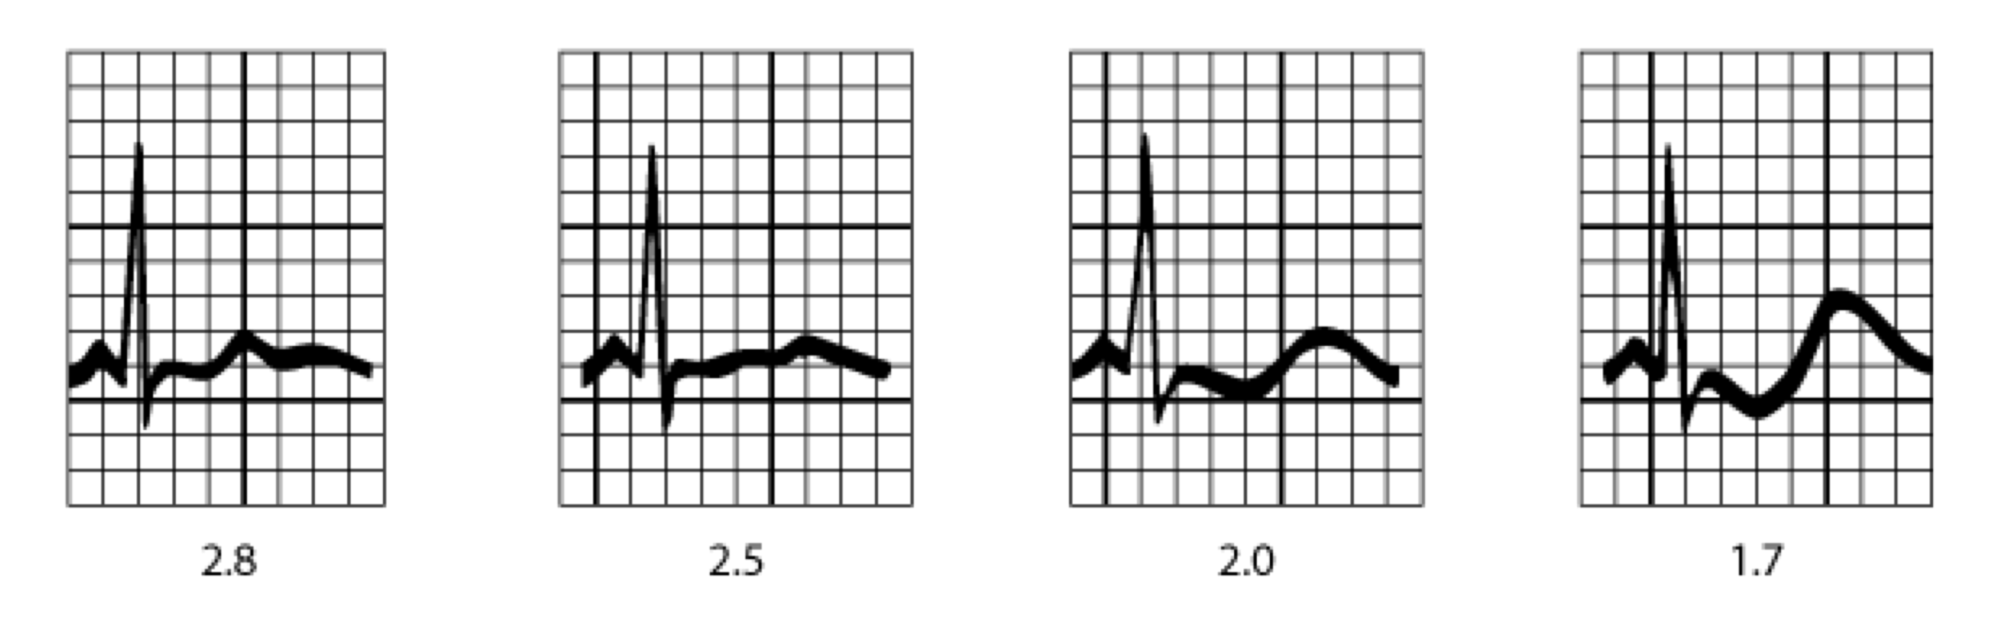

EKG Changes in Hypokalemia

**Workup:** Chem 10, EKG (see above), $TTKG=\left(\frac{Urine K^{+}}{Plasma K^{+}}\right)/\left(\frac{Urine Osm}{Plasma Osm}\right)$ (note: can only use when urine osm >300). TTKG >3 i/s/o hypoK suggests aldo excess.

**Management**

* **Mild to moderate (K+ = 3.0-3.5 mEq/L):** treat underlying d/o, give KCl 1 mEq/kg (max 20 mEq) PO q8-24h OR add KCl to IVF (max conc is 80 mEq/L via PIV).
* **Severe (K+ < 2.5-3 mEq/L or symptomatic, EKG changes):** add KCl to IVF, give KCl 0.5-1 mEq/kg (max 30 mEq) IV x1 (only in ICU!), and should have EKG monitoring during infusion.
* Also correct Mg2+ if low (25-50 mg/kg IV, max 2g/dose) as hypoMg prevents resolution of hypoK.

##Hyperkalemia **PowerPlan:** MICU/MSICU/NICU hyperkalemia Orderset

**Definition:** K+ > 5.5 mEq/L (up to 6.5 may be normal in neonates)

**Etiology:** ↑ K+ intake (TPN, IVF, formula), ↑ K+release from cells [acidosis (K+ efflux allows H+ influx to buffer acidosis), cell lysis (hemolysis, rhabdo, tumor lysis)], ↓ renal excretion [acute or chronic renal failure, hypoaldosteronism (adrenal insufficiency, hyporeninemic hypoAldo, ACE inhibitors – look for hypoNa and metabolic acidosis), K+-sparing diuretics (spironolactone, epelrenone, amiloride, triamterene)], pseudohyperkalemia (hemolyzed blood sample)

**Clinical Presentation:** muscle weakness (LE > UE) → flaccid paralysis, arrhythmias (if K+ > 7). **EKG changes** (in order of appearance): tall peaked T wave, shortened QT → PR/QRS lengthening → “sine wave” QRS → VFib



EKG Changes in Hyperkalemia

**Workup:** Chem 10 (ensure not hemolyzed – free-flowing sample, order STAT), blood gas to assess acid/base status, EKG, TTKG (see above) – low TTKG (<7) in setting of hyperkalemia may indicate aldo deficiency or resistance, plasma renin and aldosterone.

**Management:** if real and with EKG changes.

* **STOP** K+ supplementation, K+-containing IVF, and K+-sparing medications.
* **Stabilize cardiac membrane**
  + Calcium gluconate 10% @ 0.5 mL/kg (=100 mg/kg) IV over 5 min.
  + Calcium chloride 20 mg/kg IV over 5-10 min if impending cardiac arrest.
* **Drive K+ into cells**
  + Insulin 0.1 U/kg, max 10U IV with glucose, infuse over 30 min:
    - <5 yo: D10 (100 mg/mL) @ 5 mL/kg
    - ≥5 yo: D25 (250 mg/mL) @ 2-4 mL/kg IV (max 25g)
  + Albuterol nebs
    - Neonates: 0.4 mg/2 mL NS
    - <25 kg: 2.5 mg/2 mL NS
    - 25-50 kg: 5 mg/2 mL NS
    - 50 kg: 10 mg/2-4 mL NS or 4-8 MDI puffs
  + Bicarb: 1 mEq/kg IV (max 50 mEq) over 10-15 min
    - <6 mo: 2 mL/kg of 4.2% NaHCO3
    - ≥6 mo: 1 mL/kg of 8.4% NaHCO3
  + Intubate + hyperventilate (induce alkalosis)
* **Excrete total body K+**
  + Kayexalate 1 g/kg, max 50g PO/PR q4h PRN
  + Furosemide 1-2 mg/kg IV (max 40 mg or 80 mg if renal insufficiency) q6h PRN
  + Dialysis if emergent or if ongoing source of K+ release (tumor lysis, rhabdo)

##Proteinuria  
**Definition**

* Excessive excretion of urinary protein
* Dipstick: primarily detects albumin
  + Trace = 15-30 mg/dL
  + 1+ = 30-100 mg/dL
  + 2+ = 100-300 mg/dL
  + 3+ = 300-1000 mg/dL
  + 4+ = >1000 mg/dL
* If positive dip, perform **quantitative** analysis
  + **Spot UPCR:** nl <0.2 if ≤2 yo or <0.5 if <2 yo; >2 = nephrotic (see below section on nephrotic syndrome)
  + **Urinary Protein Excretion 24h:** >100 mg/m2 per day = abnormal, ≥1000 mg/m2 per day = **nephrotic**

**Etiology**

* **Glomerular** [inc filtration of macromolecules, esp albumin – may be transient (fever, exercise, stress, seizures, resolves on rpt testing after stressor gone) vs orthostatic (present when standing and not when supine - first morning void) vs persistent (elevated on both supine/upright voids)]
* **Tubular** [inc excretion of low molecular weight proteins, esp β2 microglobulin, that are normally filtered in the glomerulus and reabsorbed in the proximal tubule – may be d/t congenital disorders of proximal tubule (Fanconi syndrome, cystinosis, galactosemia, Lowe syndrome) or with acute tubular injury (ATN, AIN, pyelo)]
* **Overflow** [inc excretion of low molecular weight proteins d/t protein overproduction (multiple myeloma, myoglobin in rhabdomyolysis)].

**Clinical Presentation**

* If significant quantity, protein will be frothy; otherwise varies with cause.
* If nephrotic, may have edema/HTN, may have stigmata of primary dx (oral ulcers, rash, and joint swelling in SLE; abdominal pain and palpable purpura in HSP; h/o recurrent UTIs with VUR, hepatitis and movement d/o in Wilson disease).

**Workup**



Proteinuria Workup

##Hematuria  
**Definition:** red blood cells in the urine

**Etiology**

* **Extraglomerular:** UTI, ureteral trauma, nephrolithiasis, cystitis (any UTI, adenovirus, cyclophosphamide), sickle cell disease or trait, malignancy (bladder CA, Wilms tumor)
* **Glomerular:** glomerulonephritis (see GN section), benign familial hematuria / thin basement membrane disease

**Workup**

* UA (+blood on dip **AND** +RBCs on micro)
* If only +blood, think myoglobin vs hemoglobin
* If red but neg blood/neg RBC, think beets, rifampin, nitrofurantoin, doxorubicin, chloroquine
* If cola- or tea-colored urine, RBC casts, marked proteinuria, or dysmorphic RBCs, think GN
* If blood clots, uniform RBCs, urethral bleeding, think extra-gl
* If h/o trauma, do CTAP
* If s/sx UTI, do UCx
* If s/sx nephrolithiasis, do renal US +/- CTAP
* If c/f GN, send chem 10, CBC w/diff + retic, C3/C4, albumin, ASLO titer, anti-DNase B, ANA, UPCR; consider renal biopsy if concomitant proteinuria/HTN and/or rising serum creatinine

##Nephrotic Syndrome  
**Definition:** syndrome characterized by presence of heavy proteinuria (albuminuria >3 g/24 hours), hypoalbuminemia (<3.0 g/dL), edema, and hyperlipidemia.

**Etiology**

* Minimal change disease (most common in children) – see normal light microscopy but on EM there is diffuse foot process effacement
* Focal Segmental Glomerulosclerosis
* Membranous Nephropathy
* Membranoproliferative GN (may be nephrotic + nephritic)
* SLE (may be nephrotic + nephritic)
* IgA/HSP (may be nephrotic + nephritic)
* Post-infectious Glomerulonephritis (may be nephrotic + nephritic)

**Pathophysiology**

* Abnormalities in glomerular podocytes → increased filtration of proteins, **esp albumin**. Others include clotting inhibitors (Protein C, S, antithrombin III) → prothrombotic state and immunoglobulins → susceptibility to serious infections.
* Increased Na+ retention and hypoalbuminemia → edema
* Decreased oncotic pressure → inc hepatic lipoprotein synthesis → hypercholesterolemia

**Clinical Presentation**

* Edema, typically first appears in periorbital tissue/scrotum, then in dependent areas
* HTN, HLD, increased risk of VTE
* Can present with AKI
* **Exam:** edema, hypertension, assess for extra-renal findings that may suggest a secondary cause for nephrotic syndrome (e.g. infection)

**Workup**

* Chem 10 / C3; see also section on proteinuria
* UA + 24 hour urine collection with protein ≥1000 mg/m2/day OR spot UPCR >3.5
* Consider renal biopsy for diagnosis (see below)

**Management**

* **Empiric steroids** for presumed minimal change disease (if persistent past 1-2 wk).
  + Prednisone 60 mg/m2/day (max 60 mg/day) for 4 weeks.
  + Then prednisone 40 mg/m2/day QOD for 4 weeks w/ gradual taper, generally for minimum total 2-3 months.
  + Consider biopsy if steroid resistant, steroid-dependent, or evidence of steroid toxicity.
* BP Control - **ACE inhibitors or ARBs** are preferred (decrease glomerular pressure → decreased protein filtration).
  + e.g., enalapril 0.08 mg/kg per day (maximum of 5 mg/day), can titrate to maximum dose of 0.6 mg/kg per day (maximum of 40 mg/day) for appropriate BP response
  + Use with caution for GFR < 60 mL/min/1.73 m2.
  + Re-check serum Cr, K+ 3-5 days after starting ACEI/ARB.
* Edema - **salt restriction** (< 2 mEq/kg/day) and **diuretics**.
  + If intravascular volume normal (FENa >2 %) - furosemide 1-2 mg/kg/dose x2 doses.
  + If intravascular volume low (FENa < 2%) and edema is severe (anasarca, pleural effusions, ascites)
    - Albumin 25% 1 gram/kg IV over 4 hours.
    - Give 1 mg/kg IV lasix at the 2 hour point
    - Give 1 mg/kg IV lasix after albumin infusion (4 hour point).
* VTE
  + Consider prophylactic anticoagulation if high-risk (age >12, albumin <2, fibrinogen >6).
  + Treat VTE if present with LMWH
* HLD - consider statin, especially if other ASCVD risk factors are present.

##Nephritic Syndrome  
**Definition:** any of several conditions leading to glomerular hematuria, proteinuria, and potential AKI with azotemia/oliguria, edema, and hypertension.

**Etiology**

* Post-infectious
  + **Group A β-hemolytic strep**, either after pharyngitis or impetigo
  + Other infections: Staph aureus/epi, Pneumococcus, Mycoplasma, viral
* IgA Nephropathy (most common glomerulopathy worldwide)
* SLE Nephritis
* **Membranoproliferative GN:** can be idiopathic or secondary to HBV/HCV or rheumatologic disease
* **Alport Syndrome:** XLR collagen IV mutations, a/w hearing loss, vision changes
* **Goodpasture Syndrome:** autoAb to Type IV collagen in glomerular and alveolar basement membranes → hemoptysis
* **Vasculitis:** HSP, granulomatosis with polyangiitis (lung/sinus/kidney), eosinophilic granulomatosis with polyangiitis (asthma/neuropathy/lung/kidney/skin), microscopic polyangiitis (lung/kidney)

**Clinical Presentation**

* Hypertension
* Hematuria
* Fluid retention/edema
* Sequelae of underlying disease
  + **SLE:** rash, arthritis, oral ulcers
  + **Vasculitides:** hemoptysis, skin ulcers
  + **Alport:** sensorineural hearing loss, vision changes
* Ask about preceding sore throat (usually 2-3 weeks before onset of post strep GN) or current URI symptoms (which can be seen with IgAN).
* Some patients may have rapid progression with development of acute renal failure over the course of several days. Any of the above etiologies can have a rapidly progressive course.
* **Exam:** monitor BP, assess volume status. Look for signs of Lupus or other vasculitides such as rash, abdominal tenderness (HSP), joint swelling/tenderness.

**Workup**

* UA: RBCs + proteinuria. Glomerular bleeding → dysmorphic RBCs and red cell casts.
* Chem 10 / CBC w/ diff + retic / serum albumin / ASLO titer + anti-DNase B / ANA + anti-dsDNA
* **C3, C4:** low C3 seen with post-infectious GN and C3 glomerulopathy; low C3/C4 in SLE; normal C3/C4 in IgAN, pauci-immune GNs (ANCA-associated vasculitis), and anti-GBM disease
* **UPCR:** typically will see proteinuria, sometimes in nephrotic range (nephrotic range protein is UPCR > 3.5).
* If rapidly progressive course or significant renal insufficiency on admission, send anti-GBM Ab and ANCA (for Goodpasture disease and GPA/MPA). Patients with rapidly progressive course should also have renal biopsy.

**Management**

* **Reasons for admission:** hypertension, acute renal failure, volume overload, or electrolyte abnormalities.
* Hypertension typically responsive to diuretics.
* Fluid and sodium restriction during acute phase.
* Patients with RPGN may be treated with pulse dose steroids. *Patients with RPGN due to Goodpasture disease, SLE, or GPA/MPA may be treated with steroids, cyclophosphamide, and plasmapheresis.
* Post-infectious GN is typically self-resolving.
  + Patients suspected to have post-infectious GN should have repeat complement studies sent in 8-12 weeks, at which time complement should return to normal.
  + If still hypocomplementemic, consider other diagnoses such as C3 glomerulopathy or SLE.

##Acute Kidney Injury

**Definition:** acute decrease in GFR per KDIGO criteria.

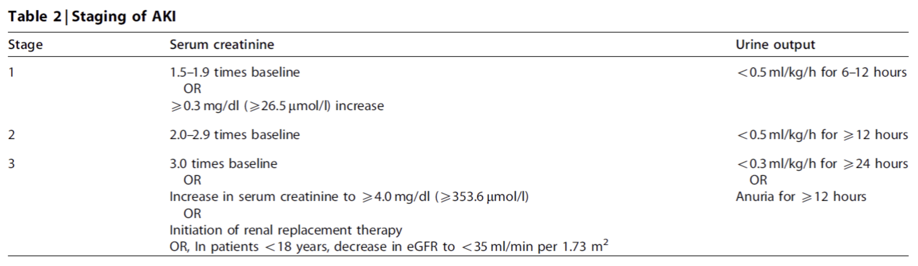

AKI Staging

**Etiology**

* **Pre-Renal:** decreased renal perfusion.
  + Decreased intravascular volume: dehydration, blood loss.
  + Decreased effective circulating volume: shock, heart failure, cirrhosis.
* **Renal:** intrinsic renal parenchymal disease.
  + Glomerular disease: glomerulonephritis, nephrotic disorders.
  + Vascular: vasculitis.
  + Tubulointerstitial: ATN (ischemia/progression of pre-renal AKI, aminoglycosides, myoglobin, uric acid in tumor lysis syndrome), interstitial nephritis (NSAIDs, penicillins).
* **Post-Renal:** obstructive uropathy (posterior urethral valves, tumor, large stones, etc). Needs to be bilateral obstruction to develop renal failure in a patient with otherwise normal kidneys.

**Clinical Presentation**

* Fluid retention: edema, decreased urine output.
* Hematuria with intrinsic kidney injury (glomerulonephritis, ATN).
* Uremia: nausea/vomiting, GI bleeding, pericarditis, pruritus, mental status change.
* **Exam:** look for hypertension and edema (periorbital and peripheral).

**Workup**

* Urine Studies
  + UA
    - Hematuria, proteinuria, red cell casts suggests glomerulonephritis.
    - Muddy brown casts suggests ATN.
    - Urine eosinophils suggests acute interstitial nephritis (not a great test, may be positive even if only 1 eosinophil).
  + Urine electrolytes to calculate fractional excretion sodium (FENa).
 $FENa=\frac{\left(Urine Na^{​^{+}}×Plasma Cr\right)}{\left(Plasma Na^{+}×Urine Cr\right)}$

   - FENa < 1% suggests prerenal; FENa > 2% suggests intrarenal.
* Blood Labs: Chem 10, CBC w/ diff, consider CK if history suggestive of rhabdomyolysis.
* Renal US to look for hydronephrosis, obstructive uropathy, renal scarring.

**Management**

* Correct associated electrolyte issues (hyperkalemia, hyponatremia, hypocalcemia, acidosis).
* Manage hypertension (see section below).
* Fluid management
  + Small NS bolus (5-10 cc/kg) if hypovolemic or in pre-renal failure.
  + Reassess volume status and continue to give small boluses until patient is euvolemic.
  + Replace insensible losses plus 1:1 urine/stool output.
$IFL_{(mL/day)}=300mL/m^{2}/day$

$BSA_{(m^{2})}=\sqrt{\frac{ht_{(cm)}×wt_{(kg)}}{3600}}$

* Indications for dialysis: AEIOU
  + **A**cidosis
  + **E**lectrolyte anomalies refractory to medical management (hyperK/phos)
  + **I**ngestions (Li+, ASA)
  + **O**verload
  + **U**remia (pericarditis, encephalopathy)

##Chronic Kidney Disease

**Definition**

* Irreversible kidney damage and reduction in kidney function; may be progressive.
* Requires 1 of 2 of the following (2012 KDIGO Clinical Practice Guideline):
  + For age ≥ 2 yo
    - GFR < 60 mL/1.73 m2 for > 3 mo
    - GFR > 60 mL/1.73 m2 alongside evidence of structural kidney damage or other marker of abnormal renal function (proteinuria, albuminuria, renal tubular d/o).
  + For age < 2 yo → GFR < 1 std dev below mean = mod dysfunction, < 2 std dev = severe.
* Severity stratified by GFR from G1 (normal, ≥ 90) → G2 (60-89) → G3a (45-59) → G3b (30-44) → G4 (15-29) → G5 (< 15) = ESRD / dialysis-dependence.

**Etiology**

* Congenital causes (renal aplasia, reflux, PKD, obstructive uropathy) in ~60%.
* Glomerular disease (FSGS, membranous nephropathy, MPGN, SLE nephritis, etc.).
* Other: HUS, Alport syndrome, cystinosis, interstitial nephritis, tumors.

**Pathophysiology:** multiple possible insults leading to intraglomerular HTN and glomerular hypertrophy → nephron loss → hyperfiltration in remaining nephrons → further glomerular damage → glomerulosclerosis, proteinuria, fibrosis.

**Clinical Presentation**

* Edema + HTN
* Proteinuria / hypoalbuminemia
* Anemia (due to EPO deficiency)
* Dyslipidemia / accelerated ASCVD
* Vitamin D deficiency with secondary hyperparathyroidism
* Electrolyte derangements: hyperkalemia, hyperphosphatemia, hypocalcemia, metabolic acidosis
* Growth failure, delayed puberty, and intellectual disability
* Complications of uremia: pericarditis, platelet dysfunction, encephalopathy

**Workup**

* Chem 10
* CBC w/diff + retic + iron studies
* UA w/ UPCR
* 25-OH Vitamin D, PTH
* Fasting lipid panel
* If etiology uncertain: see sections on proteinuria/hematuria, consider renal U/S and bx.

**Management**

* Stage G1/G2
  + Monitor kidney function closely.
  + Educate about nephrotoxin avoidance (NSAIDs, contrast, smoking, obesity, dehydration).
  + BP control w/ ACEI/ARB based on guidelines from the ESCAPE Trial.[11]
    - Using ramipril (starting at 6 mg/m2/d and inc dose / adding other agents as needed).
    - Targeting 50th-%ile BP for age, sex, and weight vs 90th-%ile slowed rate of progression to ESRD.
* Stages G3 and above: as above and add the following.
  + Prepare for possibility of transplant, ideally prior to dialysis (HD vs peritoneal).
  + Na+-restricted diet (2-3g/d) +/- diuretics (furosemide 0.5-2 mg/kg/d, HCTZ 1-3 mg/kg/d).
  + Management of hyperkalemia (low K+ diet, diuretics), acidosis (sodium bicarb), hypocalcemia/hyperphosphatemia (Vitamin D, calcimimetics, phos binders).
  + Rx anemia to goal Hgb 10-12 g/dL w/ EPO-stimulating agents (erythropoietin alfa, darbepoetin alfa).
  + In pts with significant uremia, consider preoperative DDAVP to prevent bleeding.

##Hemolytic-Uremic Syndrome

**Definition**

* **Hemolytic Uremic Syndrome:** microangiopathic hemolytic anemia + AKI + thrombocytopenia
* **Thrombotic Thrombocytopenic Purpura:** triad of HUS + fever + neurologic changes

**Etiology**

* Principally affects children under the age of five years.
* 90% due to shiga toxin; of those 70% due to *enterohemorrhagic E. Coli*.
* Occurs in 6-9% of EHEC infections; usually begins 5-10 days after diarrhea onset.
* Non-diarrheal (atypical) HUS associated can be due to S. pneumo infection or due to defects in the complement system (e.g., mutations in complement regulatory proteins).

**Pathophysiology**

* **HUS:** Shiga toxin binds to receptors in glomerular, colonic, and cerebral cells → promotes adhesion and aggregation of platelets onto endothelial cells → thrombocytopenia and RBC shearing (microangiopathic anemia); in kidney, glomerular damage.
* **TTP:** due to deficiency or immune-mediated inhibition of ADAMTS13, a metalloproteinase responsible for breakdown of vWF. No vWF cleavage → coagulation occurs at a higher rate, particularly in microvasculature → platelet consumption → thrombocytopenia and microthrombi → microangiopathic hemolytic anemia.

**Clinical Presentation**

* Microangiopathic hemolytic anemia → jaundice, pallor, dark urine.
* Thrombocytopenia → petechiae, bleeding.
* Acute renal failure → HTN, edema.
* Other systems
  + **Central nervous system:** seizures, coma, stroke
  + **Cardiac:** dysfunction due to ischemia, uremia, fluid overload
  + **Pancreas:** transient DM
  + **Liver:** hepatomegaly, increased serum transaminases
  + **Heme:** in addition to anemia and thrombocytopenia, leukocytosis is common in diarrhea-induced HUS; the prognosis is worse with increased white blood cell counts.

**Workup**

* **CBC w/diff + retic:** anemia, thrombocytopenia w/ appropriate reticulocytosis.
* **Smear:** schistocytes
* ↑ LDH, ↓ haptoglobin, Coombs negative (evidence of intravascular hemolysis).
* **Chem 10:** evidence of acute kidney injury, elevated BUN/Cr
* **LFTs:** elevation in transaminases, unconjugated hyperbilirubinemia
* **UA:** possible proteinuria, hematuria.
* Stool culture: causative pathogen
* Head CT if any change in MS or abnormal neurologic exam.

**Management**

* Treatment mainly supportive; judicious fluid management (see section on AKI), correct electrolyte abnormalities, transfuse RBCs if needed (avoid platelets unless actively bleeding, as this may worsen the TMA process), manage hypertension.
* If significant CNS involvement or if TTP is suspected, consider plasmapheresis.
* For non-STx mediated (atypical) HUS, consider eculizumab (anti-C5 antibody; prevents activation of terminal complement pathway).
* 5-10% mortality; 5-10% progress to ESRD. Inc WBC, seizure, or CVA = poor prognostic factors.

##Hypertension

**Definition**[12]

|  |  |  |
| --- | --- | --- |
|  | **Children 1-13 Years Old** | **Children > 13 Years Old** |
| **Normal** | <90th percentile | <120/<80 mmHg |
| **Elevated BP** | ≥90th percentile to <95th percentile or 120/80 mmHg to <95th percentile (whichever is lower) | 120/<80 to 129/<80 mmHg |
| **Stage 1 HTN** | ≥95th percentile to <95th percentile +12 mmHg or 130/80 to 139/89 mmHg (whichever is lower) | 130/80 to 139/89 mmHg |
| **Stage 2 HTN** | ≥95th percentile + 12 mmHg or ≥140/90 mmHg (whichever is lower) | ≥140/90 mmHg |

*Percentiles determined by gender, age, and height.

**Blood Pressure Levels for Boys**[13]

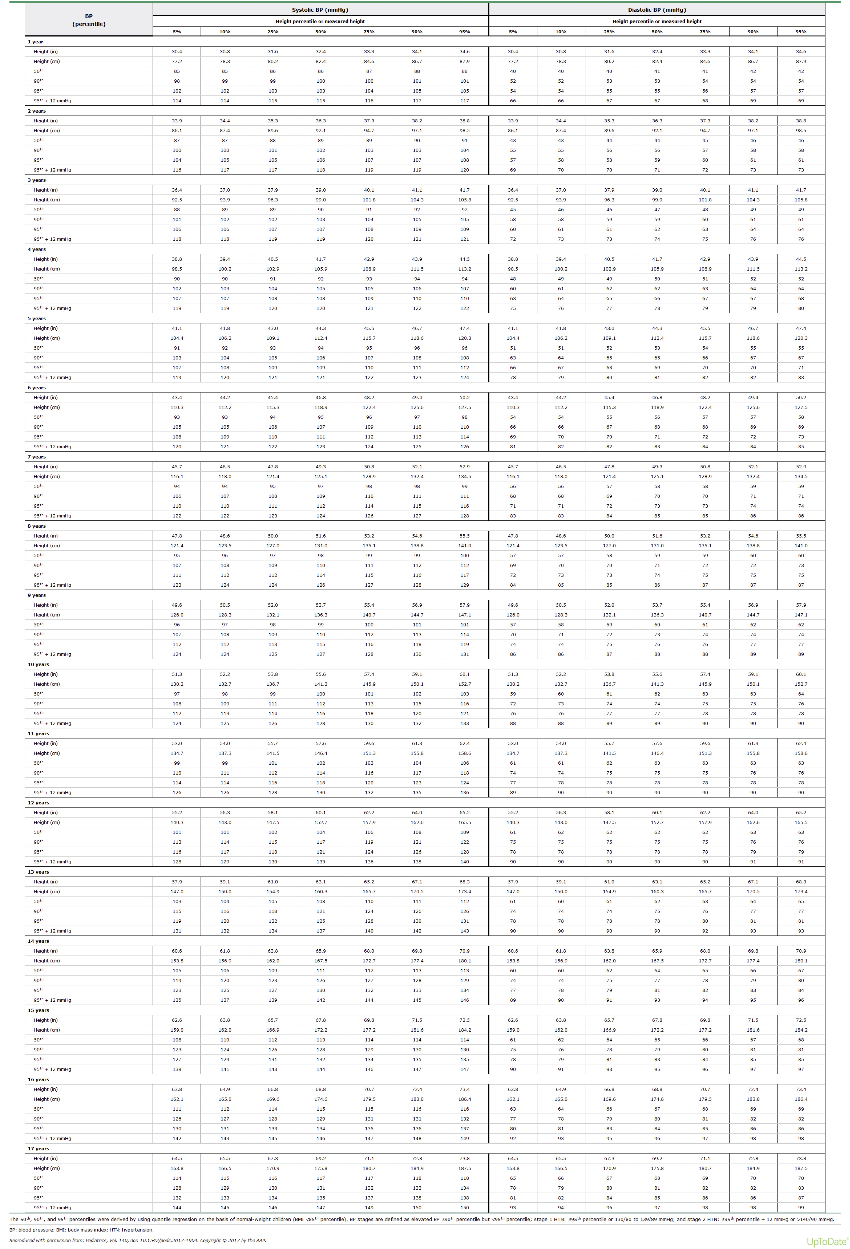

BP Levels for Boys

**Blood Pressure Levels for Girls**[14]

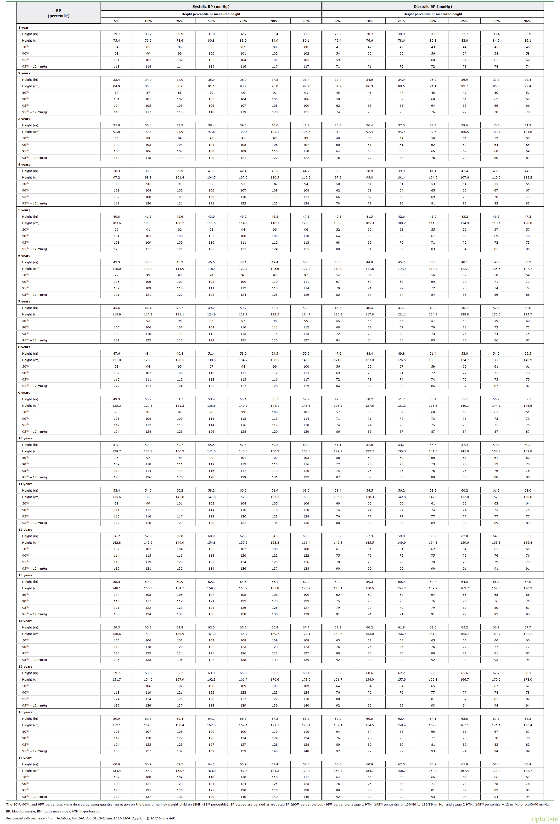

BP Levels for Girls

**Etiology**

* **Essential Hypertension**
  + Most common etiology in older children; increasing incidence with rise in obesity.
  + More likely in children who are overweight, postpubertal, and/or have a family history of hypertension.
* **Secondary Hypertension**
  + Suspect in child <6, w/o family hx HTN, if acute rise in BP, or past hx suspicious of underlying etiology.
  + **Renal Parenchymal Disease**
    - Glomerulonephritis, both acute and chronic
    - Renal scarring from pyelonephritis, VUR → CKD.
  + **Renovascular**
    - Renal artery stenosis: fibromuscular dysplasia, Neurofibromatosis I, Williams Syndrome
    - Thromboembolism (e.g., h/o UAC)
    - Aortic coarctation
    - Vasculitis: Takayasu’s arteritis, polyarteritis nodosa
  + **Endocrine**
    - Hyperthyroidism
    - Catecholamine excess: pheochromocytoma, neuroblastoma, exogenous catecholamines (cold medications, cocaine, amphetamines)
    - Corticosteroid excess: exogenous or endogenous (Cushing’s)
    - Mineralocorticoid excess: congenital adrenal hyperplasia, primary hyperaldosteronism
  + **Neurologic:** intracranial hypertension, familial dysautonomia

**Clinical Presentation**

* Depends on etiology; essential hypertension often asymptomatic and discovered on routine blood pressure screening.
* Renal parenchymal disease: may present with hematuria, edema.
* Catecholamine excess: headache, flushing, sweating, tachycardia.
* Hyperthyroidism: sweating, diarrhea, tachycardia.
* Hypertensive emergency can present with headache, altered mental status, chest pain, dyspnea (see section on hypertensive emergency).

**Workup**

* **Phase 1: Confirmation**
  + Manual auscultatory measurement with appropriate-sized cuff on 3 separate occasions.
    - Bladder width: > 40% of upper arm circumference.
    - Bladder length: > 80% of upper arm circumference.
  + Consider BP measurements at school, home, or ambulatory BP monitoring.
* **Phase 2: Screening Studies**
  + Urinalysis (microscopic if positive).
  + Chem 10 + uric acid (if concern for oncologic etiology, can also be elevated in essential HTN).
  + Renal ultrasound with doppler interrogation.
  + If obese, add HgA1c and ALT.
* **Phase 3: Directed Testing**
  + Determine etiology (tests to consider based on history, PE, screening results).
    - TFTs
    - Plasma/urine catecholamines and metanephrines
    - Renin/aldosterone
    - DMSA scan to identify renal scarring in the setting of severe VUR.
    - Renal arteriography
  + Assess for end-organ damage.
    - Echocardiogram (?LVH)
    - Dilated eye exam (?retinal changes)

**Management**

* For essential hypertension, can consider dietary/lifestyle modifications as first-line approach for patients with Stage 1 hypertension and no evidence of end-organ damage.
* Pharmacologic therapy typically indicated for patients with Stage 2 hypertension, symptomatic hypertension, evidence of end-organ damage, or Stage 1 hypertension that does not improve after 4-6 months of lifestyle modifications.
* Choice of pharmacologic agent depends on underlying etiology.
  + For renin-mediated hypertension (renal artery stenosis, renal scarring), ACE-inhibitor usually best choice (e.g., enalapril 0.08 mg/kg/day).
  + For volume-related hypertension (e.g., glomerulonephritis) use diuretics (e.g., HCTZ 1-3 mg/kg once daily).
* General principle is to choose one medication and increase dose until reach maximum recommended dose, then add an additional agent until hypertension controlled.
* **For treatment of hypertensive emergency, refer to hypertensive emergency section in critical care chapter.**

##Urinary Tract Infections

**Definition**

* **Age < 2 mo:** ≥ 50,000 CFU/mL of a uropathogen OR 10,000-50,000 CFU/mL with pyuria on UA
* **Age ≥ 2 mo:** significant bacteriuria (≥100,000 CFU/mL of single uropathogen from clean catch or ≥50,000 CFU/mL of uropathogen from cath sample) with associated inflammatory response (+LE/nitrite/WBC – except if due to Enterococcus, Klebsiella, or PsA) and lower urinary tract symptoms (if appropriate age)
* **Cystitis:** infection of urinary bladder
* **Pyelonephritis:** infection of upper urinary tract (kidneys and ureters)

**Etiology**

* ~90% due to E coli; others include Enterococcus, Proteus, Pseudomonas, and Enterobacter
* Adenovirus may cause acute infectious cystitis
* **Risk factors**
  + **Ages 2-23 months:** age <12 mo, max T ≥ 39 °C, nonblack race, female sex, uncircumcised male, no additional source of fever identified
  + **Ages ≥ 2 years**
    - Female sex (shorter urethra, wetter periurethral environment)
    - Lack of circumcision (in male infants)
    - Sexual activity (receptive vaginal intercourse – S saprophyticus; unprotected insertive anal intercourse)
    - Urinary tract anomalies (bladder stones, constipation, urinary retention, posterior urethral valves, VUR)
    - Bladder catheterization or instrumentation (predisposes to PsA, coag-neg Staph)
    - Sickle cell disease
    - DM or other immunosuppressive conditions

**Pathophysiology**

* **Newborns:** rare in first 6d life. May be due to hematogenous spread or ascending infection. Hematogenous spread more likely among preterm infants. Congenital anomalies of the kidney and urinary tract may predispose to UTI.
* **Beyond newborn period:** colonization of periurethral area by uropathogens → attachment of pathogens to uroepithelium → inflammatory response. Inflammation of upper urinary tract (pyelonephritis) → renal scarring → HTN, ESRD.

**Clinical Presentation**

* **Age < 2 years:** fever may be sole manifestation, esp when ≥ 39 °C (102.2 °F).
  + Concomitant upper respiratory infection or AOM does not r/o UTI.
  + May have concomitant poor feeding, irritability, or FTT.
  + May cause conjugated hyperbilirubinemia.
* **Age ≥ 2 years**
  + Cystitis: dysuria, urinary frequency, hematuria, suprapubic pain and TTP
  + Pyelonephritis: fever, flank/back pain, nausea/vomiting, headache

**Workup** **Don’t Forget the UTI Clinical Pathway**

* **Age < 2 mo:** catheterized UA + urine culture
  + Obtain blood culture given risk of urosepsis.
  + Strongly consider LP (1-3% of infants with UTI have bacterial meningitis).
  + Obtain renal/bladder U/S and consider VCUG if abnormal, if UTI is recurrent, or if pathogen other than E. Coli is identified.
  + If ultrasound suggests renal damage - consider DMSA scan after resolution of acute illness.
* **Age 2 mo-2 years**
  + *UTI Risk Score*
    - Two points if: temp ≥40oC, no alternative source of fever, female.
    - One point if: temp Temp ≥39oC, male uncircumsized <12mo, male circumsized <6 mo, fever ≥2 days, sibling w/ VUR, prior UTI.
  + Low pre-test probability of UTI → consider starting with POCT UA on bagged urine sample. If normal, stop. If abnormal, obtain catheterized UA and send for culture. Do NOT send a bagged sample for culture.
  + High pre-test probability of UTI (female w/ risk score ≥2, male w/ risk score ≥3) → obtain catheterized UA and send for culture.
* **Age ≥ 2 years:** clean catch UA → if +LE, nitrite, or WBC, send for culture. Consider empiric antibiotics for ≥1+ LE and nitrite, ≥1+ LE +/- nitrite, or ≥10 WBC/hpf.
* Consider baseline creatinine if initiating nephrotoxic antibiotics .
* Consider CRP and procalcitonin: CRP <2 mg/dL helps exclude pyelo, while procalcitonin >0.5 ng/mL can help confirm pyelo.

**Management**

* Neonate 0-1 month (consult reference for preterm neonates): **See BCH Clinical Pathway for Fever 0-1 month for additional recommendations.**
  + ≥35 wk GA and ≤7 days old
    - Ampicillin 50 mg/kg IV q8h
    - Cefotaxime 50 mg/kg/dose q8h **OR** Gentamicin 4 mg/kg IV q24h
  + ≥35 wk GA and >7 days old
    - Ampicillin 50 mg/kg IV q6h
    - Cefotaxime 50 mg/kg/dose q12h **OR** Gentamicin 5 mg/kg IV q24h
* Infant/Child/Adolescent
  + **Duration:** 5-7 days if afebrile, 7-10 days if febrile.
  + **1st line:** cephalexin 25 mg/kg/dose PO TID (max 500 mg/dose) vs ceftriaxone 50 mg/kg/dose IV q24h (max 2 g/dose).
  + **2nd line:** TMP/SMX, amoxicillin-clavulanate, cefdinir, cefuroxime, ciprofloxacin (for adolescents with pyelo), nitrofurantoin (for adolescents with cystitis).
* If Grade III-V VUR is identified on VCUG, can consider prophylactic antibiotics, though the decrease in UTIs is exactly matched by an increase in MDROs as the etiology for UTI, when present.[15]

##Nephrolithiasis

**Definition:** deposits of minerals within the kidney or the urinary tract.

**Risk Factors:** underlying risk factors are present in ~75-85% of children.

* PMHx or FHx of stone
* Abnormal urinary system anatomy (ADPKD, UPJ obstruction)
* Previous urological surgery
* Metabolic disorder → solute excess (hypercalciuria, hyperoxaluria, hyperuricemia) or ↓ levels of inhibitors of stone formation (hypocitraturia, hypomagnesemia)
* Chronic predisposing condition (IBD, CF, lymphoproliferative disorder, GSD, RTA)
* Medications predisposing to stone formation (diuretics, steroids, topiramate, high dose vitamin C)
* Recurrent UTIs

**Etiology:** majority of stones are CaOx, followed by CaPhos, struvite, cystine, and then uric acid.

**Clinical Presentation:** classic symptoms of abdominal/flank pain, hematuria, and dysuria

* Younger children tend to lack the classical symptoms.
* If diagnosed with UTI and not getting better with abx, consider nephrolithiasis.
* **Admission criteria:** Admit if unstable VS, inadequate pain control, poor hydration.

**Workup**

* Urine studies
  + Can do POCT UA, but consider formal if trying to clarify hematuria; UCx if c/f infection.
  + Begin straining urine.
  + Majority of urine/stone testing can wait until outpatient follow-up.
* Imaging
  + US preferred, but may miss small or ureteral stones.
  + If no stone on US ± CT (may not need if normal anatomy and no other s/sx).

**Management:** see Nephrolithiasis Clinical Pathway for additional recommendations.

* **Pain Control**
* Hyperhydration
* Diet: low Na+, but no Ca2+ restriction

## References

# Neurology

## Neurologic Emergencies

### Status Epilepticus

#### PowerPlan

See new BCH Guidelines

#### Definition

Seizure lasting > 5 min (or > 30 minutes, at which there may be long-term consequences), or two sequential seizures w/o return to baseline in between. Neurologic emergency. If seizure is refractory to multiple drugs, considered refractory SE.

#### Presentation

May be generalized SE, focal SE, or non-convulsive (including absence, aura continua, aphasic)

#### Differential

Epilepsy, electrolyte derangement, febrile status, meningitis/encephalitis, space occupying lesion, stroke, hypertensive emergency/PRES, PNES

#### Red Flags

Refractory to treatment, focal neurologic deficits on examination

#### Work-up

Initial labs include glucose, chem, UA/blood/urine cultures if febrile, urine tox screen, AED levels in patients taking AEDs, LP if concerns for CNS infections, imaging if examination is focal. Work up is considered following treatment.

#### Management

ABC’s, correct electrolyte disturbances, call relevant Neurology consult service, administer rescue meds as below, **consider activating Code Blue or anesthesia stat x5-5555**

* **First line** (0-5 min): IV lorazepam (Ativan) 0.05 - 0.1 mg/kg/dose (max 4 mg). If no access, diazepam (Diastat) PR: (0.5 mg/kg if < 5yo; 0.3 mg/kg if 6-11yo; 0.2 mg/kg if > 11yo)
* **Second line** (5-15 min): Repeat benzos x1 at same dose if no response in 5 min
  + Fosphenytoin IV: 20 phenytoin equivalents/kg/ dose (max 1500 mg)
  + Levetiracetam IV: 30 mg/kg (max 4500 mg) over 5-15 minutes. Dosing range 20-60 mg/kg.
* **Third line** (15-20 min): Phenobarbital 20/mg/kg IV push, monitor for resp. depression
  + Give Levetiracetam (60mg/kg IV) OR Fosphenytoin (20 mg PE/kg/dose), whichever was not previously given
  + Consider repeat Fosphenytoin (10 mg PE/kg/dose IV) OR Valproic Acid (Depakote) (20 mg/kg IV)

#### Complications

Cardiac arrhythmia, cerebral edema, hypotension, rhabdomyolysis, dehydration, pneumonia

### Increased Intracranial Pressure (ICP)

*See Critical Care/ICP chapter*

### Stroke[16]

#### PowerPlans, Order Sets & Clinical Pathways

* **PowerPlans & Order Sets:** Neuroscience ICP Admit Plan; Neuro Stroke Plan
* **Call for help!** *Please call a* ***Code Stroke (x52170)*** *if symptom onset < 5 hrs prior!*
* **Other resources:** See Neurology Card

#### Pathophysiology

Acute-onset neurologic dysfunction due to impaired blood supply to the brain; ischemic or hemorrhagic

#### Presentation

Any acute-onset focal neurologic finding including unilateral weakness or numbness, visual loss, aphasia, altered mental status, new-onset focal seizures

#### Differential

Seizure, demyelinating process, Todd’s paralysis following focal seizure, hemiplegic migraine

#### Red Flags

* Risk factors include trauma, vasculitis/vasculopathy, infection, tumor/malignancy, prothrombotic state, leukocytosis and anemia
* Risk factors for arterial ischemic stroke include Sickle Cell Disease and Cardiac Disease
* Risk factors for venous stroke are IBD, auto-immune disorders, infections and dehydration

#### Work-up

Brain MRI/MRA w/ stroke protocol (includes DWI/ADC, FLAIR, T2, T1, susceptibility sequences), +/- MRV. TTE to look for cardiac causes. Serum labs to look for coagulopathy. If newborn, add metabolic studies.

#### Management

ABC’s! Head of bed flat; IVF at maintenance, target SBP 50-90th percentile for age. Maintain euglycemia and normothermia, treat seizures, consider PICU admission and neurosurgical consult. Stroke in sickle cell is treated with exchange transfusion.

#### Complications

Malignant edema which may lead to herniation, hemorrhagic conversion (consider STAT CT for change in exam)

## Weakness

### Guillain-Barré Syndorme (GBS)[17]

#### Pathophysiology

Monophasic demyelinating neuropathy. Antibody and complement-mediated injury to myelinated peripheral nerves. At least half of cases are preceded by viral infection (EBV, mycoplasma, c. jejuni, CMV). Vaccines are also implicated.

#### Presentation

Progressive motor weakness (ascending) & areflexia +/- autonomic dysfunction. May also complain of pain. Children may refuse to walk.

#### Differential

Spinal cord lesion (transverse myelitis, hematoma), acute flaccid myelitis, tick paralysis, toxic neuropathy

#### Red Flags

Weakness of muscles of respiration can indicate need for intubation

#### Work-up

CSF profile classically w/ albuminocytologic dissociation (elevated protein w/o leukocytosis). EMG is not helpful early in the disease course.

#### Management

IVIG or plasmapheresis. Consult PT.

### Miller-Fisher variant of Guillain-Barré[18]

#### Pathophysiology

Antibody-mediated (anti-Gq1b) demyelination of the cranial nerves w/ or w/o peripheral nerve involvement

#### Presentation

Defined by the presence of areflexia, ophthalmoplegia and ataxia; viral illness usually precedes symptoms. Sensorium remains intact.

#### Differential

Guillain-Barré Syndrome, myasthenia gravis, spinal cord lesion, MS

#### Red Flags

Weakness of muscles of respiration can indicate need for intubation

#### Work-up

MRI of the brain and spine; LP if no space-occupying lesion. CSF profile similar to that of GBS w/ albuminocytologic dissociation (elevated protein w/o leukocytosis).

#### Management

IVIG 2g/kg over 2-5 days

### Myasthenia Gravis[19]

#### Pathophysiology

Antibody blockade of the post-synaptic ACh receptor at the neuromuscular junction

#### Presentation

* Fatigable weakness (symptoms worse at the end of the day)
* Diplopia and ptosis can be provoked by sustained upgaze, arm weakness can be provoked w/ repetitive arm pumps
* Weakness tends to present in the muscles of the face, causing dysphagia, dysphonia, drooling, dysarthria (bulbar symptoms)
* **Myasthenic Crisis:** Presents w/ inability to clear secretions or maintain oxygenation (precipitated by infection, surgery, stress, meds, etc)

#### Differential

Botulism, Miller Fisher variant of GBS, brainstem lesion, thyroid ophthalmopathy

#### Red Flags

Check how high the patient can count in a single breath, NIFs, check sustained up-gaze; evaluate neck flexion/extension (sensitive test for diaphragmatic strength) to assess need for intubation

#### Work-up

Ice pack for eval of ptosis (should improve as cold slows acetylcholinesterase activity). Check for antibodies (anti-AChR, anti-MuSK). EMG (decrement in muscle potentials on repetitive nerve stim). CXR to screen for thymoma.

#### Management

Avoidance of drugs which may exacerbate MG (see uptodate table). Monitor FVC/NIF and intubate for FVC < 15 mL/kg and NIF < -20. Suctioning, NG tube.

#### Management

See below: IVIG (0.4 g/kg/d x 5d), plasmapheresis if severe

#### Complications

Respiratory failure, pulmonary infections, death

### Bell’s Palsy

#### PowerPlans, Order Sets & Clinical Pathways

* **Clinical Pathways:** [Facial Palsy](https://bchfit.tch.harvard.edu/ebg-services/component/pdfAlgorithm?algCode=FACIALPALSY&algVersion=1.6&accessCode=null)

#### Pathophysiology

Acute paralysis of the peripheral facial nerve. Pathogenesis viral (most commonly HSV) but also may be post-viral or immune-mediated (VZV, Hepatitis, HIV, Lyme, EBV).

#### Presentation

Weakness in the upper and lower face, pain, tingling in ipsilateral ear canal, taste changes, impaired lacrimation and hypersensitivity to sound

#### Differential

Otitis media, trauma, tumor, TB, Ramsay Hunt syndrome, malignant hypertension, mastoiditis

#### Red Flags

Signs of increased ICP, focal neurologic findings, other cranial neuropathies

#### Work-up

Exclude other cause (i.e. HTN, trauma, active herpetic lesions c/w RHS). Consider MRI, Lyme serologies if indicated by history/exam.

#### Management

* **Watchful waiting:** Eye ointments/artificial tears to maintain hydration, eye patch or taping eyelid closed while sleeping, use of corticosteroids controversial (most kids have complete spontaneous recovery). Valacyclovir/acyclovir if HSV suspected, doxycycline if Lyme is suspected May-November. Consider MRI if other symptoms present.
* **Empiric corticosteroids:** Prednisone 2 mg/kg once daily x 5 days w/ 5-day taper (max 60 mg/dose). Start w/i 3 days of symptom onset.

#### Complications

Corneal ulcers if absent blink reflex/incomplete closure of palpebral fissure

### Acute Flaccid Myelitis (AFM)[20]

#### Pathophysiology

Inflammation of gray matter of spinal cord (anterior horn cells). Most commonly associated with enterovirus D68 or A71. Historically poliovirus. May also be caused by adenovirus, flavivirus and West Nile virus.

#### Presentation

Limb weakness following non-specific viral symptoms (fever, cough, rhinorrhea, vomiting/diarrhea). Median onset ~5 days (range 0-28 days). May have hyperacute presentation (rapid progression <6 hours). Quadriparesis at presentation in ~1/3 of cases. May have UMN pattern due to involvement of lateral corticospinal tracts. May include bowel/bladder symptoms and/or cranial neuropathies.

#### Differential

Spinal cord infarct or mass lesion, GBS, myasthenia, transverse myelitis/NMO

#### Red Flags

Respiratory failure. Signs of brainstem encephalitis (Entero A71 - autonomic instability/shock, ataxia, cranial nerve involvement, AMS).

#### Work-up

* MRI brain and spine w/wo contrast (Spinal gray matter T2 hyper-intensities, MRI may be normal <72 hrs)
* CSF analysis (lymphocytic pleocytosis (mean ~210), mild elevation of protein)
  + Note: Generally unable to detect viral RNA in CSF
* Nasopharyngeal and rectal swabs for viral PCR (or fecal)
* Serologies for mimics (anti-MOG)

#### Management

* Supportive care. ~30% require mechanical ventilation.
* Immune therapies (glucocorticoids, IVIG, PLEX relatively contra-indicated given direct viral infection)

#### Complications

Respiratory failure. Rare cases of A71 causing brainstem encephalitis with non-cardiogenic pulmonary edema and rapidly fatal cardiopulmonary failure.

## Hypotonia

### Approach to Neonatal Hypotonia

#### Pathophysiology

Central (UMN) vs. peripheral (LMN) injury or dysfunction leading to decreased tone, which is resistance to passive stretch of the muscle at joints, often but not always associated w/ weakness

#### Presentation

Head lag, frog-legged positioning, slip-through on vertical suspension, U-shape on horizontal suspension. Failure to meet developmental milestones. Also with dysphagia, FTT.

#### Differential

Central (HIE, TORCH, brain malformations, IEM, genetic disorders, mitochondrial disease, hemorrhage/stroke) vs. peripheral (SMA, myasthenia gravis). Maternal drugs.

#### Red Flags

Respiratory insufficiency/failure. Developmental regression.

#### Work-up

1. Reflexes are the most important examination maneuver (you can tap a finger to assess a baby’s reflexes)
   * Areflexia indicates a peripheral process and need for non-urgent EMG
   * Present reflexes indicate a central process
2. Next is the presence of appendicular hypertonia, which is an increased resistance to passive stretch (and hyperreflexia) of the limbs despite the axial hypotonia (muscles of the neck and trunk), which can indicate perinatal injury and can be non-urgently assessed w/ MRI
3. Septic work-up, LFTs, ammonia, chemistry, CK, consider genetic work-up

#### Management

New therapies for SMA (nusinersen, zolgensma)! Otherwise, depends on etiology. Typically supportive, using EI for children under age 3 or the school for older children w/ emphasis on PT and OT, ST as needed for dysphagia.

#### Complications

Dependent on the underlying cause but sometimes associated w/ cognitive dysfunction in addition to developmental delay

### Infantile Botulism[21]

#### Pathophysiology

* C. botulinum produces toxin that interferes w/ release of acetylcholine at NMJ (disrupts vesicle binding to the pre-synaptic membrane)
* In infancy, C. botulinum colonizes intestinal tract in situ
* Contamination of honey or corn syrup, dusty environments near construction/agricultural soil disruption are culprits
* In adults, paralysis results from ingestion of the toxin

#### Presentation

Descending paralysis, often starting w/ ophthalmoplegia (may involve pupillary response), followed by weak cry, dysphagia and progresses to weakness of respiratory muscles

#### Differential

GBS Miller Fisher variant, hypermagnesemia, SMA, Myasthenia Gravis

#### Red Flags

Weakness of muscles of respiration can indicate need for intubation

#### Work-up

Isolation of organism in stool. EMG: short-duration, low-amplitude motor unit potentials.

#### Management

* ICU care for severe presentation, may require ventilator support
* Immune globulin
* Avoid aminoglycosides (produce pre-synaptic neuromuscular blockage)
* Treat w/ BIG prior to confirmation of stool/EMG if clinical suspicion is high

#### Complications

Apnea, respiratory failure, sudden infant death

## Neuroimmunology

### Multiple Sclerosis (MS)[22]

#### Pathophysiology

T lymphocytes attack oligodendrocytes, affecting myelin (autoimmune-mediated demyelination); known genetic (HLA subtypes) and environmental (smoking, latitude, vit D) risk factors

#### Presentation

* Repeated episodes focal deficits (optic neuritis, weakness, numbness) separated in time
* Imaging often shows lesions separated by space w/i the CNS

#### Differential

ADEM (often a first presentation of MS- multiple lesions causing altered sensorium), NMO spectrum disorder (neuromyelitis optica), MOG-antibody associated demyelinating disease, malignancy, nutritional deficiency, leukodystrophy, mitochondrial disorder, CNS vasculitis, ophthalmologic disease

#### Red Flags

* Presentation is broad and variable
* Seizure (indicating gray matter involvement), fever should lead you to rethink the diagnosis
* Weakness of muscles of respiration and/or mental status changes can indicate need for intubation

#### Work-up

* Definitive diagnosis requires repeated episodes over time
* LP reveals CSF w/ elevated protein count +/- presence of oligoclonal bands (must be compared w/ serum). MRI is imaging modality of choice.
* The presence of 3+ white matter lesions on T2 imaging especially if perpendicular to the ventricles sensitive for diagnosis (Dawson’s fingers)

#### Management

Acute exacerbations require short-course of steroids. Load w/ methylprednisolone (30 mg/kg; maximum 1g), treat for 3-5 days. Neuroimmunology consult for disease-modifying drugs.

### Acute Disseminated Encephalomyelitis (ADEM)[23]

#### Pathophysiology

Central demyelinating disorder, presumed immune-mediated mechanism

#### Presentation

Encephalopathy + lethargy, headache, vomiting, focal neurological symptoms

#### Differential

Multiple Sclerosis, infectious/toxic/metabolic encephalitis, leukodystrophy

#### Red Flags

Decreased level of arousal can indicate need for intubation for airway protection

#### Work-up

MRI brain and spine w/ and w/o contrast (T2 weighted MRI reveals confluent increased signal intensity throughout white matter, specifically corpus callosum and periventricular region). LP (CSF can be normal or have elevated protein or WBC).

#### Management

High dose IV methylprednisolone; IVIG and plasma exchange may help refractory cases

#### Complications

* Typically a self-limiting, monophasic course
* Multiple episodes raise concern for MS/MOG-associated demyelination

### Transverse Myelitis[24]

#### Pathophysiology

Combined demyelinating and inflammatory disorder. Wide variety of associations:

* May present as part of demyelinating disorder (MS, NMO)
* Associated with various rheum conditions (SLE, RA, scleroderma, etc)
* Idiopathic cases largely thought to be post-infectious (30-60% preceded by viral illness)

#### Presentation

Acute to subacute development (nadir 4 hrs to 21 days) of weakness (commonly UE), sensory deficit, autonomic disturbance. Although initially flaccid, spasticity often follows. Autonomic symptoms include urinary/fecal incontinence, urinary retention, sexual dysfunction.

#### Differential

* **Non-inflammatory:** Compressive myelopathy (neoplasm, vertebral body compression fx, spondylosis, herniation); spinal infarct; nutritional deficiencies (B12, vitamin E, NO toxicity)
* **Inflammatory:** Demyelinating disease syndrome (MS, ADEM, NMO); rheum disease (SLE, sarcoid, Sjogrens); infections (enterovirus, HIV, WNV, Lyme)

#### Red Flags

Rapid onset of paraplegia/spinal shock

#### Work-up

* Spinal MRI w/wo contrast (T2 hyperintensities; no mass lesion)
* Brain MRI (r/o central lesions c/w MS)
* CSF studies (basic + IgG index, oligoclonal bands, cytology, VLDR) abnormal in 50% of cases
  + Expect lymphocytic pleocytosis (children > adults with mean ~136/mm), elevated protein, elevated IgG index
* Serologies (AQP4, MOG, ANA, Ro/SSA, La/SSB)
* Infectious studies (HIV, VZV, EBV, VLDR, WNV, enterovirus)
* B12, MMA

#### Management

High dose IV steroids (methylpred 30 mg/kg daily). PLEX if refractory disease or acute motor impairment. Relapsing disease may require long-term immunomodulation (mycophenolate or rituximab).

#### Complications

Progression to multiple sclerosis (risk factors include brain MRI abnormalities, oligoclonal bands, mild or asymmetric disease)

### Autoimmune Encephalitis (NMDA Receptor Antibody Encephalopathy)[25]

#### Pathophysiology

* Antibodies bind to NR1 subunit of NMDAR and cause receptor endocytosis and subsequent neurologic dysfunction
* Ovarian teratomas are an important cause in girls < 18 (31 %); tumors rare in males
* Overall, a rare disease

#### Presentation

Acute (<3 mos) behavior and personality changes (including depression/anxiety/psychosis), seizures, insomnia, stereotyped movements and autonomic instability

#### Differential

Viral encephalitis, neuroleptic malignant syndrome, psychosis, catatonia

#### Red Flags

Autonomic instability

#### Work-up

* MRI Brain typically w/ lesions
* EEG can show slowing and delta brush
* ELISA test of Ab against NR1 subunit of NMDA receptor (autoimmune encephalitis panel) is diagnostic
* Look for tumor w/ US/MRI of abdomen/pelvis

#### Management

* If applicable, tumor resection
* Methylprednisolone 30mg/kg (max 1g) IV daily x5d, IVIG 2g/kg over 2 to 5 days and plasma exchange are all first line treatments

#### Complications

Autonomic instability, seizures

## Neuropsychiatric

### Functional Neurologic Disorder[26]

#### PowerPlans, Order Sets & Clinical Pathways

* **Other resources:** Refer patients to <www.neurosymptoms.org>

#### Pathophysiology

Inorganic cause of neurologic symptoms, thought to be due to inappropriate signaling and heightened pain sensation as response to stress

#### Presentation

* Can present w/ weakness or paralysis, nonepileptic seizures, sensory or somatic complaints
* Often w/ comorbid anxiety or depression
* **Inconsistencies on exam:** Distractibility, inconsistencies between confrontational testing and function, sensory symptoms in non-dermatomal distribution

#### Differential

Stroke, GBS, transverse myelitis or other spinal disorder, seizures

#### Red Flags

Sudden-onset weakness of one side, dermatomal distribution, spinal level of weakness, areflexia, altered mental status

#### Work-up

* Thorough history and physical, including medical and psych, review prior labs or imaging, ask about psychological stressors
* Depends on positive clinical findings rather than negative tests
* Exam maneuvers
  + Hoover’s sign: involuntary extension of weak leg when contralateral leg flexes against resistance 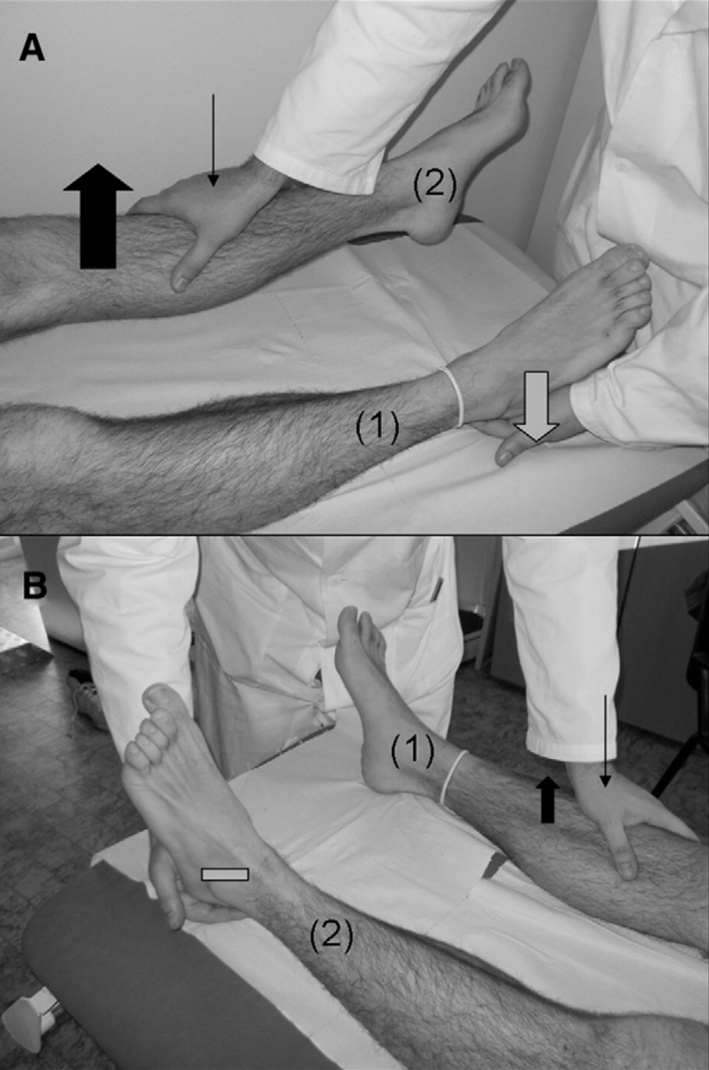
  + Hip abductor sign: hip abduction weakness in affected leg returns to normal during contralateral hip abduction against resistance of unaffected leg
  + Drift without pronation sign: when asked to hold arms out with palms up and eyes closed, weak arm drifts without pronating (as would be seen with UMN lesions)
  + Arm drop: weak arm held above face and released, will stay suspended or move to miss hitting face, can be tested during non-epileptiform seizures
  + Midline splitting: complete sensory loss on one side, split exactly midline

#### Management

PT/OT, psychotherapy, pain management, supportive care, education

## Headache

### Migraine

#### PowerPlans, Order Sets & Clinical Pathways

* Clinical Pathway: [Headache/Migraine, Emergent/Urgent](https://bchfit.tch.harvard.edu/ebg-services/component/pdfAlgorithm?algCode=MIGRAINE&algVersion=2.4&accessCode=null)

#### Pathophysiology

Cortical spreading depression: Neurons fire in a sequential manner across the surface of the brain (causing an aura). Associated w/ irritation and dysregulation of blood vessel tone of the overlying meninges, causing pain.

#### Presentation

Unilateral throbbing headache (bilateral sometimes in young children), visual aura, photophobia, phonophobia, nausea, vomiting, relieved by rest

#### Differential

Venous sinus thrombosis, concussion, tension type headache, intracranial mass lesion

#### Red Flags

Any symptoms suggestive of increased ICP (i.e. papilledema, nerve palsy, positional headache, morning emesis, encephalopathy, wake from sleep w/ headache), focal neurological deficits, change in character from typical headache, progressive worsening of headaches, neck stiffness

#### Work-up

Clinical diagnosis, consider MRI for red-flag symptoms

#### Management

* See treatment algorithm in [Migraine Clinical Pathway](https://bchfit.tch.harvard.edu/ebg-services/component/pdfAlgorithm?algCode=MIGRAINE&algVersion=2.4&accessCode=null) as above

### Tension Headache

*See Headache section of Neurology Reference Card*

### Concussion

*See Sports Medicine chapter*

### Idiopathic Intracranial Hypertension (Pseudotumor Cerebri)

#### Pathophysiology

Syndrome of increased ICP due to impaired absorption at the arachnoid granulations. Risk factors: obesity, drugs (tetracyclines, retinoids, OCPs)

#### Presentation

* Patients have frontal, positional HA worse upon awakening
* Visual disturbances, visual loss, +/- dizziness
* Examination reveals papilledema

#### Differential

Venous sinus thrombosis, intracranial mass lesion, migraine headache, tension headache

#### Work-up

MRI/MRV required in children w/ HA and papilledema to rule out mass/hydrocephalus, venous sinus thrombosis. LP w/ elevated opening pressure is diagnostic.

#### Management

Acetazolamide 15-25 mg/kg/day (decreases rate of CSF production). Follow-up with Ophtho.

#### Complications

Vision loss, optic neuropathy

## Seizures

### Febrile Seizure

#### PowerPlans, Order Sets & Clinical Pathways:

* **Clinical Pathway:** [Seizure, Febrile](https://bchfit.tch.harvard.edu/ebg-services/component/pdfAlgorithm?algCode=FEBSEIZE&algVersion=2.1&accessCode=null)

#### Pathophysiology

Decreased threshold for seizure due to fever and immaturity of the CNS, often familial

#### Presentation

* **Simple:** < 15 min, generalized, occurred once in 24 hrs
* **Complex:** > 15 min, focal, or occurred *>* 2 times in a 24 hr period
* Most commonly seen between 6mo and 6yo, w/ peak presentation between 12-24 mos

#### Differential

Meningitis, encephalitis

#### Red Flags

AMS, neck stiffness, lethargy, status epilepticus, focal deficits lead to consideration of meningitis/encephalitis

#### Work-up

If examination is normal, no further work-up is required

#### Management

Reassurance and anticipatory guidance. For complex febrile seizures > 15 minutes, prescribe rectal Diastat. Antipyretics not shown to decrease risk.

#### Complications

30-50% recurrence rate. Minimally increased risk of epilepsy compared w/ the average population, slightly greater for those w/ complex febrile seizures.

### First-time Unprovoked Seizure

#### Pathophysiology

Typically idiopathic (likely genetic), but sometimes symptomatic from underlying brain lesions

#### Presentation

* **Focal:** Unilateral symptoms +/- AMS (dyscognitive vs. cognitive)
* **Generalized:** Bilateral tonic clonic movements (GTC), tonic, myoclonus, absence

#### Differential

Meningitis, encephalitis, intracranial hematoma, focal lesion (i.e. abscess, AVM, focal cortical dysplasia).

#### Red Flags

AMS, neck stiffness, lethargy, focal deficits lead to consideration of meningitis/encephalitis

#### Work-up

If examination is normal, no further work-up is required emergently. EEG is next step, as is neurology referral. If the seizure had focal onset or if the EEG shows focality (spikes arising from one portion of the brain), most neurologists opt to do an MRI of the brain w/o contrast.

#### Management

Indication for AED therapy is 2 or more unprovoked seizures, or one unprovoked seizure w/ an abnormal EEG. Keppra is often our first line because of both focal and generalized coverage w/ favorable side-effect profile, but we avoid it in cases of children w/ behavioral issues. Neurology admission for patients not returning to baseline following seizure or for multiple seizures upon presentation requiring immediate treatment.

#### Complications

Epilepsy for those who go on to have further unprovoked seizures. Rare complication of generalized epilepsy is **SUDEP** (sudden unexplained death in epilepsy patients).

### Breakthrough Seizure (in a patient w/ epilepsy)

#### Pathophysiology

Decreased threshold for seizure due to fever, lack of sleep, missed medication dose, alcohol use vs. natural fluctuation of epilepsy (as is the natural history) such that seizures may become more frequent w/o provocation

#### Differential

Evaluated potential underlying causes of increased seizure frequency

#### Red Flags

AMS, prolonged seizures

#### Work-up

Neurology consult for medication adjustment. Before calling, should know the following: Baseline seizure frequency and semiology (what the seizure looks like) vs. current frequency and semiology, doses of all AEDs, most recent levels if available.

#### Management

Typically small adjustments to AEDs including addition of AEDs when needed

### Infantile Spasms

#### Pathophysiology

Varied; can be associated w/ CNS malformations, genetic/metabolic abnormalities, trauma, infections, tuberous sclerosis and other neurocutaneous syndromes, trisomy 21 or may be idiopathic

#### Presentation

* Spasms involving tonic flexion or extension of neck, trunk, and/or extremities lasting up to 10 sec, can occur in clusters, commonly followed by crying
* Usually occur during daytime and while awake
* Usually presents at < 1yo, peak incidence in 3-7mo

#### Differential

Exaggerated startle, torticollis, reflux, colic, spasticity, benign myoclonus of infancy, myoclonic epilepsy

#### Work-up

EEG: Hypsarrhythmia, MRI, genetic/metabolic labs

#### Management

* ACTH is first-line, should monitor BP and chem10 while on ACTH
* Vigabatrin

#### Complications

Developmental regression, refractory seizures

## Meningitis

### Bacterial Meningitis

*See ED and ID chapters*

#### PowerPlans

Fever in infant < 30 days

#### Pathophysiology

Bacterial infection of the meninges, caused by hematogenous spread or direct spread from sinuses or mastoids

#### Presentation

* Fever, headache, vomiting, meningismus, seizures
* Kernig Sign: Stretching of hamstring w/ knee extension + back pain
* Brudzinski Sign: passive neck flexion, involuntary hip/knee flexion

#### Differential

Viral meningitis/encephalitis, brain abscess, increased ICP, neoplasm, ADEM

#### Red Flags

Focal neurological deficits, seizures, papilledema, risk factors for TB (poor clinical outcomes), petechiae on exam (Neisseria)

#### Work-up

It’s all about the LP. CSF: WBC count often > 1,000, glucose often < 40 or < half of serum value, protein > 250, cell count w/ > 50% PMNs. Obtain imaging on comatose patients or those w/ focal neurologic deficits PRIOR to LP.

#### Management

In addition to abx, dexamethasone used to reduce hearing loss in children 0.15mg/kg q6hr for 2-4 days. *See ID chapter for meds/dosing.*

#### Complications

Seizure, stroke, elevated intracranial pressure

### Viral Meningitis & Encephalitis

#### Pathophysiology

Viral infection and inflammation of the meninges

#### Presentation

Fever, headache, malaise, photophobia, altered mental status

#### Differential

HSV (HSV-1 most common in children, HSV-2 most common in neonatal period acquired through maternal transmission), EBV, VZV, CMV (consider if immunocompromised), Eastern Equine Virus, Subacute sclerosis panencephalitis (if remote hx of measles infection), Lyme

#### Red Flags

History of immunosuppression/transplant → consider less common organisms

#### Work-up

* Consider MRI if focal neurologic deficits are present
* LP should be performed (CSF profile w/ elevated protein and cells, lymphocytic pleocytosis)

#### Management

* Largely supportive, w/ empiric treatment w/ antibiotics and acyclovir until cultures result
* HSV → Acyclovir x 14-21 days (<35 wk conceptual age 40 mg/kg/d divided q12; > 35 wk conceptual age 60 mg/kg/d divided q8hr)
* CMV → Ganciclovir

#### Complications

Rarely associated w/ long-term issues; HSV may cause hemorrhage w/i temporal lobes, causing seizures

## References

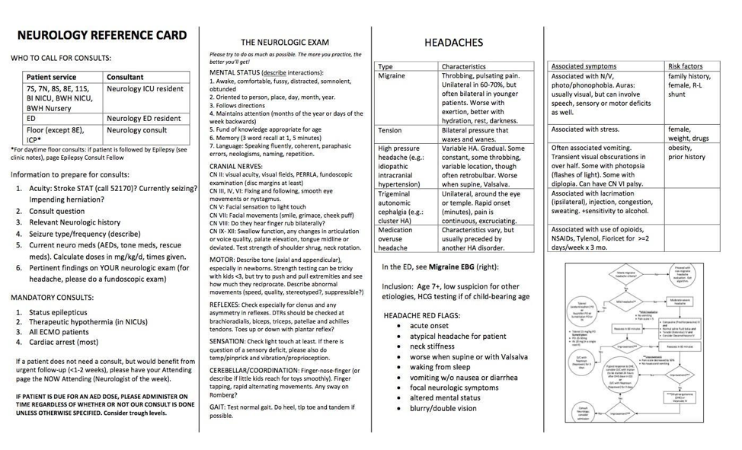 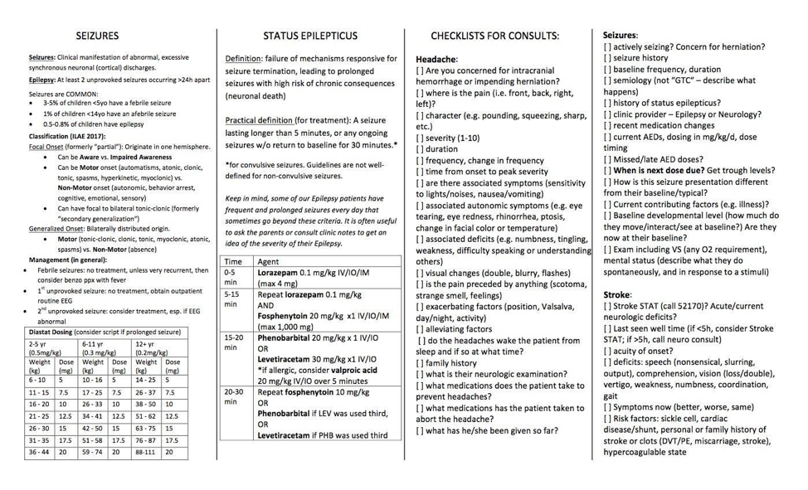

# Newborn Nursery

## Rotation Specific Entities

**BMC** Black binder and printouts on walls in work room include all clinical practice guidelines/approaches **BWH** All clinical practice guidelines are available online via BWH PikeNotes

## Gestational Age

**Early Preterm** * <34 0/7

**Late Preterm** ** 34 0/7 - 36 6/7

**Early Term** 37 0/7 - 38 6/7

**Full Term** 39 0/7 - 40 6/7

**Late Term** 41 0/7 - 41 6/7

**Postterm** 42 0/7+

*Use Fenton growth chart for late preterm. If between 37 0/7 and 37 6/7, chart on Fenton, Olsen and WHO and take better number

**“Great pretenders” - risk of resp distress, apnea, temp dysregulation, poor feeding

## Normal Infant Feeding

* All babies typically lose up to 2-3% of BW/day, should not lose more than 10-12% of BW before discharge. Babies born by c-section may lose more weight than vaginal births (Mom and therefore baby get IV fluids during delivery). Usually start gaining on DOL4. Baby should regain BW by 10-14 days and should gain 20-30g/day for first month, or 5 oz per week (“an ounce a day and time off for weekends”).
* Babies usually awake for first 5-6 hrs and then sleepy for 24 hrs. Start waking up on DOL2 and are hungry (“all day cafe”). Sometimes if baby is not getting enough with feeds, may shut down and appear sleepy.

### Breastfeeding

Newborns who are **breastfed need to eat every 2-3 hours**, on demand. If showing hunger cues, feed, even if just fed. No such thing as newborn “using mother as a pacifier.” Cluster feeding (at breast for several hours) happens on Day 2-3, as baby tries to get milk to come in. Mother may feel tired and frustrated. Reassure that this is NORMAL. Milk usually comes in around 3-5 days.

#### Breastfeeding Tips

-Respond to **infant feeding cues** (early → late: stirring, turning head, mouth opening, hand in mouth, stretching, crying).

* **Infant latch**: Line up baby nose to nipple. Stroke baby lips with nipple. Aim nipple to roof of baby’s mouth. Support baby’s neck at the shoulders so head tips back and **bring baby onto breast (*not* breast to baby).** >> - Signs of a good latch: lips flanged outward, **most of areola hidden** in mouth, nose free
* Breast milk can sit out 8 hrs if freshly pumped, or 5 days in refrigerator. Can store 6-12 mos in freezer. Don’t refreeze thawed breastmilk.
* Mothers can hand express and/or pump to stimulate milk production. Holding baby skin to skin also stimulates because of hormone release. Hand expression is helpful especially for colostrum or if engorged. Can feed to baby via spoon or syringe.
* For determining if mom’s meds are safe during breastfeeding: **LactMed** (part of NIH ToxNet), **Hale’s Medications & Mother’s Milk** (physical book in BMC workroom or HalesMeds.com. Physical book in BWH nursery)

#### Contraindications to breastfeeding

Absolute: infant w/ galactosemia, mom w/ **HIV** or HTLV-1/2, mom actively using **illicit drugs, including marijuana or EtOH** (exception: moms in methadone program, see “NAS”), HSV lesion on breast. OK to feed expressed milk: mom w/ varicella or active TB. HCV positive mom ok to breastfeed unless nipples cracked or bleeding.

### Formula Feeding

* Formula fed babies eat **every 3-4 hours** (if sleeps > 4 hours, wake baby up). Infant stomach is size of a blueberry on DOL1 → lime at DOL7. Volume increases gradually over first several days. DOL1: 10-15 mL per feed, DOL2: 15-30 mL/feed; DOL3: 30-45 mL/feed, DOL4: 45-60 mL/feed. Give baby what last took and if not settled, feed more. Follow baby’s cues.
* Formula, in 60 mL bottles as supplied by hospital, needs to be consumed within 1 hour of starting feed and then discarded.

### Tongue Ties

Type Exam Image Mgmt Normal

Tongue appears flat and broad Tongue extends over bottom teeth Can swipe finger under tongue uninterrupted N/A N/A Type 4: Mild Posterior tie on tongue, may be submucosal N/A Generally nothing Type 3: Moderate Tie is proximal to 50% of length of tongue

Consider lactation consult Type 2: Severe

Tie is distal to 50% of length of tongue May create a hump or cupping

Frenulectomy if interfering with feeding Type 1: Complete Tie extends to tip of tongue

Likely frenulectomy

## Newborn Behavior

**Infant states**: newborn behavior related to state. There are 6 states, all normal. Infant’s ability to self-regulate is related to ability to move fluidly from one state to next, affected by gestational age and perinatal stress.

Deep sleep -> light sleep -> drowsy -> active alert -> fussy -> full cry

## Anticipatory Guidance / Discharge Teaching

### Feeding

**feed on demand**, only breastmilk or formula, **8-12x in 24h - “8 or more in 24.”** Wake up baby after 3-4h to feed.

### Normal Voiding / Stooling

Should have **as many wet diapers as days of life**, up to 6-8 after 1 week of life. Should have **at least 2-3 stools/day.** Color may change, should be yellow, seedy.. Bloody or white stools would be concerning.

### Cord Care

Keep **cord clean (sponge bath), dry, and uncovered by diaper**. Will fall off on its own in about 10 days.

### Circumcision Care

Leave dressing on for 24h. Use petroleum jelly on penis with every diaper change. Written for tylenol x 2 doses in hospital but most babies do not need it and do fine with being skin to skin for comfort.

### Safe Sleep

Baby should sleep on back in own crib with tight fitted sheet. NO loose blankets, stuffed animals, positioning aids. No propping on side. Swaddling is good. Tuck swaddle blanket under baby, or use velcro swaddler.

### Tummy Time

Give baby time on tummy. As newborn, can lie on parents chest. Person holding baby should put baby down if feeling sleepy. Don’t sleep with baby.

### Consoling

Babies cry to communicate. Never shake the baby. Can put baby in crib or pass baby to other caretaker if frustrated. Giving baby hand to suck on and swaddling help with consoling.

### Illness

* Visitors should wash hands before handling baby. Avoid crowds, passing baby among visitors, and people with colds, especially for first few months. Tell older sibs to touch baby’s feet, not hands and face (newborns can’t yet put their feet in mouths).
* **Infant fever (taken rectally) is > 100.4 F:** Seek medical attention if baby seems “off”: eating less than usual, making fewer wet diapers, fussy or lethargic.

## Hyperbilirubinemia

### Definition

Infants ≥ 35 wks GA: TB > 95th percentile (2004 AAP Guidelines/Bhutani nomograms)

### Pathophysiology

↑ RBC turnover, ↓ clearance (UGT1A1 activity), ↑ enterohepatic recirculation. **Within first 24 hours of life = ALWAYS pathologic.**

|  |  |
| --- | --- |
| **Indirect** | **Direct - ALWAYS pathologic** |
| - **Breastfeeding jaundice**: first week of life due to insufficient feeding and dehydration - **Breast *milk* jaundice**: persistent after first week of life, unknown mechanism, ?substance in milk blocks bilirubin breakdown - **ABO or Rh incompatibility**: suspect if set-up, previous child with hemolytic disease of the newborn, fetal hydrops, jaundice in the first 24 hours of life - Red cell membrane defects (spherocytosis and elliptocytosis) - G6PD deficiency - Sepsis - Decreased clearance – Crigler-Najjar syndrome, Gilbert syndrome - Intestinal obstruction | - **Anatomic** (intestinal obstruction, cysts, tumors, biliary atresia) - **Infection/sepsis** - Metabolic - Gestational alloimmune liver disease (neonatal hemochromatosis) |

### Evaluation

* **Healthy infants**: Obtain routine transcutaneous bili (TcB) @ DOL2 and plot on [bilitool.org](http://bilitool.org/) . If ABO/Coombs set-up, check TcB @ 12HOL and 24HOL. >> - Determine **follow-up frequency** based on **risk for developing severe hyperbili** (use risk zone, which is generated by nomogram + GA + presence of hyperbili risk factors [jaundice in first 24 hours, ABO incompatibility/positive direct Coombs, GA 35-36w, sibling required phototherapy, cephalohematoma, exclusive breastfeeding, East Asian race]) >> - Determine **phototherapy threshold** based on **neurotoxicity risk** (use GA + presence of neurotoxicity risk factors [isoimmune hemolytic disease, G6PD, asphyxia, lethargy, temp instability, sepsis/acidosis, albumin <3.0) >>> - If above phototherapy threshold, check total serum bili (TSB). Once TSB is used, TcB may not be used again.
* Consider checking CBC, retic, hemolysis labs (LDH, haptoglobin, smear), G6PD activity.

### Management

Reconsider early discharge (before 72 HOL) if bili high intermediate risk. Phototherapy as per BiliTool curves. If near exchange levels: aggressive phototherapy, aggressive hydration (IV+PO). IVIG for isoimmune hemolytic disease. Call blood bank before exchange transfusion

## Infant of a Diabetic Mother (IDM)

### Increased risks

**LGA** (BW ≥ 4000g or ≥ 90th percentile for GA) → birth injury (shoulder dystocia, clavicular fracture), preterm birth, **RDS/TTN, hypoglycemia** (maternal hyperglycemia → infant hyperinsulinism → hypoglycemia; resolves in 2-4d), hypertrophic cardiomyopathy (of interventricular septum), **hyperbili, polycythemia** (Hct > 65% → hyperviscosity → exchange transfusion if symptomatic)

### Congenital anomalies

**Transposition of great arteries**, double outlet RV, VSD, truncus arteriosus, hypoplastic L heart syndrome, **small L colon syndrome** → functional lower bowel obstruction (contrast enema is diagnostic and curative)

### Management

Obtain glucose at 2-4HOL, then pre-feed until glucoses stabilize. Consider checking Hct in first hours of life. Check Ca++/Mg if jittery or seizure

### Hypoglycemia

|  |  |  |  |
| --- | --- | --- | --- |
| **Glucose (mg/dl) | **<25** | **25-39** | **>=40** |
| **Mgmt** | **Admit to NICU** and give 2 cc/kg bolus of D10W followed by infusion of D10 | - Feed 10-15 mL colostrum / formula and re-check - **May give glucose gel 2x (with feed) in first 24 HOL before transferring to NICU** | - Check 3 **pre-feed POC glucoses <= 3 hours apart;** if normal, routine care |

* Risk Factors: IDM, LGA, SGA, late preterm or post-term, <2500g, discordant twin, maternal medications (e.g., propranolol)
* After 48 HOL, glucose levels should be >60
* If hypoglycemia persists, send critical labs. Consider diazoxide if hyperinsulinism.

## Neonatal Abstinence Syndrome (NAS)

### Pathophysiology

Behavioral dysregulation seen 2/2 drug withdrawal in infants chronically exposed in utero to opiods (methadone, buprenorphine, morphine, oxycodone, hydromorphone, heroin) and other substances (nicotines, benzodiazepines, SSRIs). Skyrocketing incidence.

### Presentation

* Irritability, hypertonia, tremors, poor sleep, poor feeding, vomiting, diarrhea, autonomic dysfunction (sweating, sneezing, tachypnea,fever), weight loss. Sx diminished in preterm infants 2/2 developmental immaturity of CNS.
* Timing of withdrawal depends on half life: Heroin - <24 hours, Methadone or Buprenorphine: 24-72 hours.

### Management

* **First line: Non-pharmacologic** >> - Parent rooming in, skin-to-skin, decreased stimulation, clustered care. BMC: Give mother NAS info packet on admission. >> - Consoling maneuvers: gentle hold (arms to midline), hand-to-mouth, voice of caregiver (especially parent), holding, swaddling, pacifier, feeding, skin-to-skin >> - Breastfeeding for eligible mothers on methadone or buprenorphine **(No relapses in the past 4 weeks, adequate prenatal care, treatment program)** >> - **24kcal/oz formula** if not breastfeeding
* **Withdrawal (inability to eat/sleep/console, autonomic sx): Pharmacologic** (at BWH, transfer to NICU, at BMC, follow NAS protocol available on intraweb)
* First-line opioid replacement therapy: methadone, morphine
* Second line therapy: Clonidine, phenobarbital
* 60-70% of infants exposed to opioids will need therapy, 40-50% if using ESC scoring. Increased risk with methadone and polypharmacy.
* Monitor for at least 5-7 days for infants exposed to methadone or buprenorphine

## Newborn ID

### Early Onset Sepsis

#### Pathophysiology

GBS >> GNRs (especially E. coli, also Klebsiella), some Gram + (Listeria, enterococci, Group D Strep). Risk of GBS sepsis is 40x higher with heavy maternal colonization.

#### Sepsis RFs

Preterm labor (<37w), maternal intrapartum fever > 100.4F or inadequately treated GBS, PROM (>18h), infant w/ tachycardia/tachypnea/respiratory distress/temp instability

#### Treatment

* **BMC and BWH Algorithm**: Use [Kaiser Neonatal Sepsis calculator](https://neonatalsepsiscalculator.kaiserpermanente.org/) to guide necessity of evaluation (full vs. limited) and/or for antibiotics
* **Empiric abx**: Ampicillin + Gentamicin x 48 hrs. Substitute cefotaxime/cefepime if suspect meningitis

### Hepatitis B

* Up to 90% of infants infected perinatally or in the first year of life will develop chronic HBV infection
* OK for HepB+ moms to breastfeed

|  |  |  |
| --- | --- | --- |
| **Maternal HBsAg** | **BW>2000g** | **BW<2000g** |
| **Positive** | Vaccine + HBIG within 12h (concurrently, different anatomic sites) | Vaccine + HBIG within 12h (concurrently, different anatomic sites) |
| **Unknown** | - Test mother - HepB vaccine in first 12h - HBIG ASAP if mom positive | - Test mother - HepB vaccine in first 12h - HBIG ASAP if mom positive or if results not available within 12h |
| **Negative** | - HepB vaccine at birth, within 24 hrs * if parents refuse, discuss again during nursery stay. If still refuses, at BMC must sign informed refusal form. | Delay 1st dose of HepB vaccine until 1 mo of age or hospital discharge, whichever is first |

### HIV

#### Management

Consult ID. Get maternal history, lab reports: If mom on ARV and infant low risk for acquiring HIV, testing on infant performed at 14 days, 21 days, 1-2 months, and 4-6 months. If mother not on ARVs or mom diagnosed during pregnancy, also test infant at birth.

#### Treatment

**Post-exposure prophylaxis ASAP** (within 6 hours of delivery) with **zidovudine** (dosage based on GA at birth and weight) + **nevirapine if mother not on ARVs**

### HSV

#### Pathophysiology

HSV acquired intrauterine (rare), **perinatal** (85% of infections; ↑ risk: **PROM**, fetal scalp monitor/forceps, vaginal delivery, primary infxn in mother – but **majority of infants w/ HSV born to mothers without known hx of HSV**)

#### Presentation

**Fever or other nonspecific signs of sepsis, coalescing vesicles on erythematous base**, seizures/focality on neuro exam, hepatomegaly, ascites

#### Workup

* **Asymptomatic**: Swab neonate from cleanest spot to least clean (same swab): conjunctivae, mouth, nasopharynx, rectum @ 24HOL for PCR and culture
* **Symptomatic**: LP: CSF lymphocyte pleocytosis/elevated protein, consider **EEG, PCR and culture of unroofed vesicle**

#### Treatment

IV Acyclovir 60 mg/kg per day divided q8h (initiate w/ any clinical suspicion; no need to start in asymptomatic infants) Duration depends on severity. Monitor renal function and ANC 2x/week.

# Neonatology (NICU)

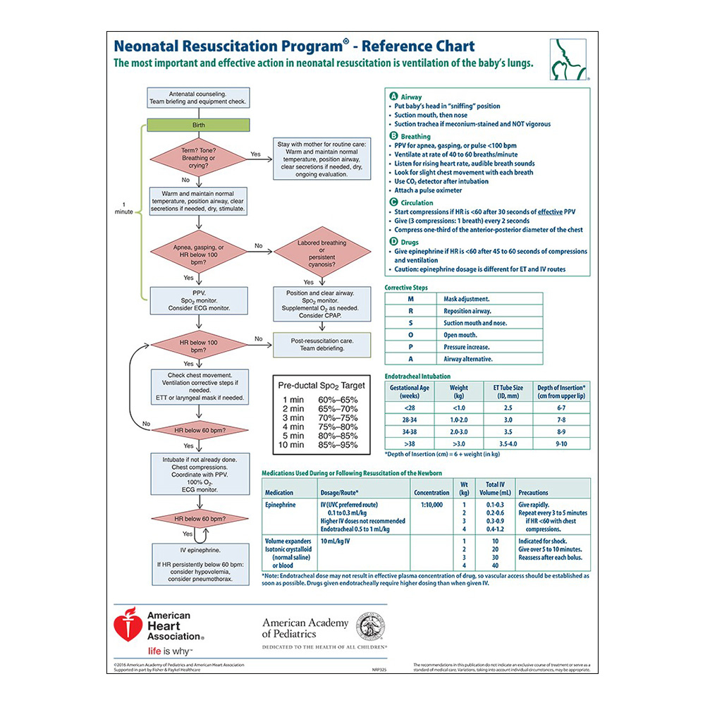

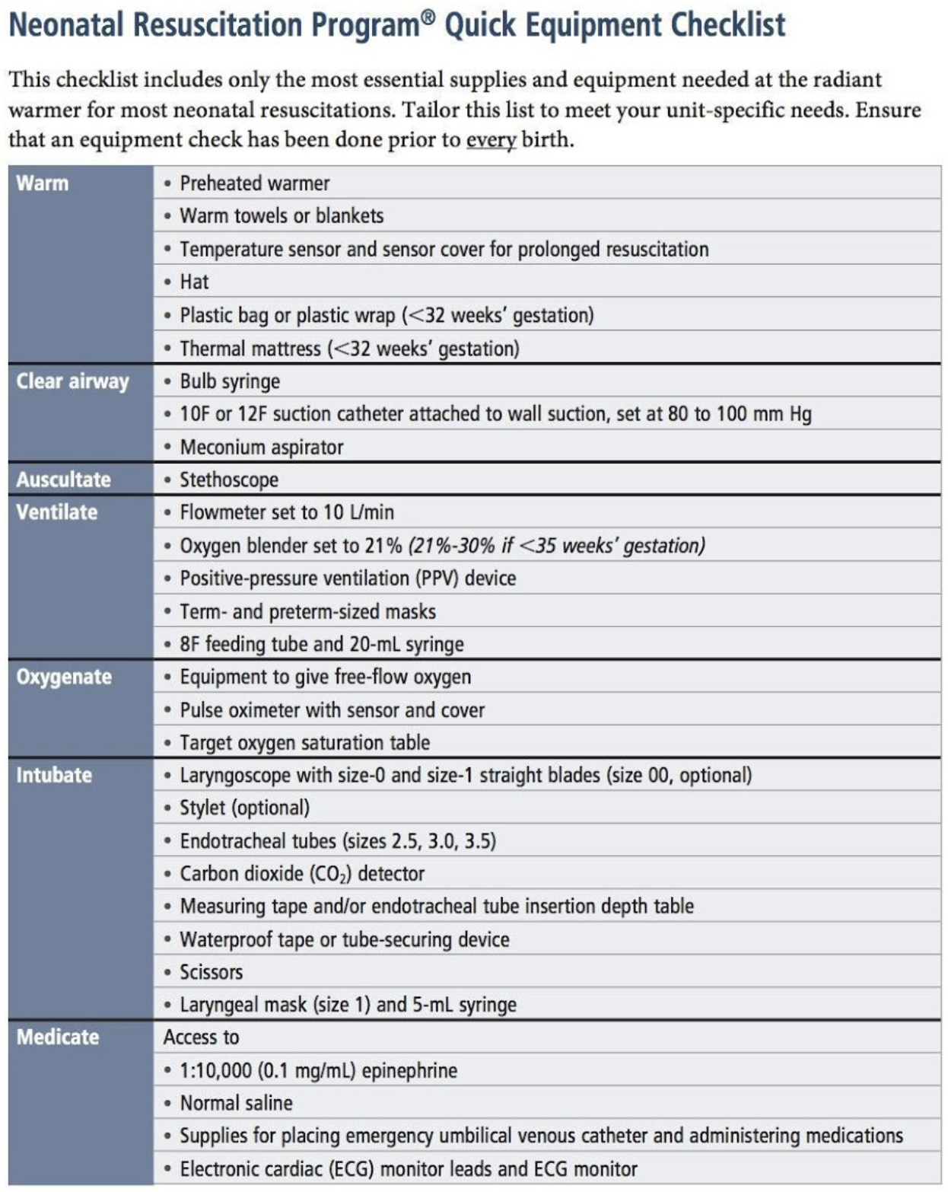

## APGAR Scoring

|  |  |  |  |
| --- | --- | --- | --- |
|  | 0 | 1 | 2 |
| HR | <60 | 60-100 | >100 |
| Color | Blue throughout | Pink body & blue extremities | All pink |
| Respiratory effort | No effort | Weak cry, hypoventilation | Strong cry |
| Tone | Limp | Some flexion w/o active movement | Active movement |
| Reflex irritability | No response | Grimace | Cry/cough/sneeze |

## Neonatal Respiratory Disorders & Delivery Room Pathology

* Can be divided into:
  + Upper airway blockage (choanal atresia, pharyngeal airway malformation)
  + Impaired lung function

### Choanal Atresia

#### History

Pink when crying, cyanotic when quiet. Inability to pass NG tube in one or both sides

#### Management

Oral airway, intubation

### Pharyngeal Airway Malformation

#### History

Persistent Retractions, poor aeration

#### Management

Prone positioning, posterior nasopharyngeal tube

### Congenital Diaphragmatic Hernia (CDH)

#### History

Assymetric lung sounds, cyanosis with bradycardia, scaphoid abdomen.

#### Diagnosis

Most likely on prenatal imaging in patients with prenatal care. Postnatally diagnosed with CXR

#### Management

Intubation, **avoid positive pressure**! Place orogastric tube.

### Pleural Effusion

#### History

Diminished aeration with poor osygenation/ventilation

#### Management

Intubation, needle thoracentesis +/- chest tube. Volume expansion if hemodynamically unstable. Fluid analysis to determine type and source of fluid.

### Pneumothorax

#### History

Persistent cyanosis, hypoxemia, +/- bradycardia associated with respiratory distress

#### Diagnosis

CXR

#### Management

Needle thoracentesis immediately, chest tube if recurrent

### Meconium Aspiration

#### History

Meconium stained fluid, respiratory distress and/or apnea if severe

#### Diagnosis

CXR

#### Management

Can deep suction upper airway. Tracheal suctioning not recommended. Intubation per NRP

#### Complications

Can cause lung inflamation and direct surfactant inactivation and one of the causes of persistnet pulmonary hypertension, there is a range of severity but can be quite severe!

### Persistent Pulmonay Hypertension (PPHN)

#### History

Asphyxia, mecoumium aspiration, intrinsic lung disease

#### Clinical Manifestations

Hypoxemia, hypotension

#### Diagnostics

CXR with decreased pulmonary vasculature. ECHO with increased R->L shunting.

#### Management

* Ultimate goal is to decrease the pulmonary vascular resistance and increase pulmonary blood flow.
* Oxygenation Index (OI): Helpful numeric index evaluating oxygenation to direct management decisions
  + **OI = FiO2 x MAP / PaO2**

### Respiratory Distress Syndrome (RDS)

#### Etiology

Surfactant deficiency, common in premature infants

#### Symtpoms

Hypoxia with respiratory distress

#### Diagnostics

CXR with ground glass opacities, low lung volumes, air bronchograms

#### Management

* CPAP or if severe respiratory distress/apnea intubation
* Surfactant administration if intubated. Can give 2 doses if still intubated 12 hrs after the 1st dose
* Minimize barotrauma and FiO2

### Transient Tachypnea of the Newborn (TTN)

#### Etiology

Delayed retention of amniotic fluid

#### History

Typically a term infant, higher risk with birth by C-section.

#### Clinical Manifestations

Tachypnea, respiratory distress, +/- hypoxemia

#### Diagnosis

CXR with prominent vasculature and fluid in the fissures

#### Management

Supportive care, usually improves in 4-6 hrs. If O2 needs or symptoms last longer than 24 hrs, question diagnosis.

## Neonatal Cardiology

***NOTE:*** *See Cardiology chapter for full details.*

### Blood Pressure for Premature Infants

* Can be controversial as there are no normatives in the literature, but rough rule of thumb:
  + First 1-2 DOL, MAP = GA (i.e. 24wk infant → goal MAP >24)
    - Some evidence that MAP should be > 30 mmHG even for ELBW
  + After first few DOL, goal MAP = GA + 5
  + For infants w/ **PPHN**, goal MAP should be based on pulmonary blood flow and urine output, even if it requires higher MAPs than typical for GA (sometimes 40-50 mm Hg)
* Key is to monitor **urine output, pulses, perfusion, trends in BUN/Cr**

### Patent Ductus Arteriosus (PDA)

#### Etiology

Failure of ductal tissue to close in the premature infant. Affects about 60% of infants <28 weeks.

#### Clinical Manifestations

* Continuous machine-like murmur
* Hypotension, widened pulse pressure, hyperactive precorium
* Worsening oxygenation and ventilation, secondary to pulmonary over-circulation
* Metabolic acidosis

#### Diagnosis

Echocardiogram

#### Management

* **Medical therapy:** Indomethacin or ibuprofen or tylenol
  + Generally contraindicated if large IVH, severe oliguria, or NEC
* **Surgical ligation**
* **Watch & wait:** w/ symptomatic support (i.e. ventilator management, pressors for MAP support)

## Neonatal Hematology

### Anemia

#### Definition

Depends on gestation and chronologic age

#### Differential

* **Iatrogenic:** Frequent blood draws, surgical/procedural blood loss
* **Hemorrhagic:** Placental abruption, umblical cord disruption at delivery, head trauma (subcaleal, cephalohematoma), NEC, twin-twin transfusion, IVH
* **Hemolytic:** Rh incompatability, ABO incompatability

#### Work-up

* CBC, retic, type and Coombs, smear, bilirubin, HUS or head imaging if risk for IVH
* At birth: Delivery history, PE, Kleinhauer-Betke on mother (determines if fetal blood is in maternal circulation) in addition to above

#### Management

* **NOTE:** Transfusion criteria for term and premature infants does not have robust data and is controversial. It tends to be ***facility dependent.***
* **Preterm:**
  + If intubated and acutely ill, Hct 35-40
  + If “feeding and growing,” Hct >30 w/ good reticulocyte
* **Term:**
  + If acultely ill, consider transfusing to goal Hct >40
  + If hemodynamically stable, goal Hct >25

### Polycythemia

#### Definition

Hct >65

#### Differential

Increased fetal production, placental insufficiency, thyrotoxicosis, gestational diabetes (GDM), genetic disorders (e.g. Trisomy 21, Beckwith-Wiedemann), hypertransfusion, delayed cord clamping, twin-twin transfusion

#### Work-up

* CBC, monitor for hypoglycemia, follow bili & electrolytes
* Monitor especially if there are neurologic symptoms or respiratory distress

#### Management

Partial exchange transfusion w/ normal saline, ideally w/ UVC

* **Indications:** Hct >65 w/ symptoms, >70 and asymptomatic

### Thrombocytopenia

#### Definition

Plt <150

#### Differential

* **Increased destruction/consumption:** Autoimmune, alloimmune (NAIT), infection/DIC/NEC, drug-induced/toxicity, hypersplenism, Kasabach-Merrit Syndrome, following transfusion
* **Decreased production:** Thrombocytopenia-absent radius, Fanconi anemia, Trisomy 13, 18, 21
* **Miscellaneous:** Asphyxia, pre-eclampsia, Type 2B Von-Willebrand

#### Work-up

* **Labs:** Repeat platelet count, coagulation studies
* **Imaging:** Consider HUS
* Exam for evidence of bleeding
* Maternal history including maternal platelet count

#### Management

Depends on etiology, symptoms, and upcoming needs (i.e. procedures)

* **Platelet goals:**

|  |  |  |
| --- | --- | --- |
| GA | Symptomatic | Asymptomatic |
| Term | >50-100k | >20-30k |
| Pre-Term | >100k | >50k |

* Management specific to **Neonatal Alloimmune Thrombocytopenia (NAIT):**
  + Goal plts >20-30k if no active bleeding (use antigen negative platelets to transfuse)
  + Check HUS
  + Consider steroids or IVIG
  + Maternal platelet typing

## Neonatal Neurology

### Interventricular Hemorrhage (IVH)

#### Pathophygiolosy

Blood vessel/blood brain barrier development is premature leaving very delicate, fragile blood networks

#### Screening

* **Screening criteria (indications for HUS):** GA <32 wks, BW <1500g, low Hct, low plts, unstable BPs, prolonged hypotension, cardiopulmonary arrest, pneumothorax, asphyxia, pre/during ECMO
  + **Timing:** DOL 3, 7-10, 30, 60 (consider in first 24 HOL if very ill ELBW)

#### IVH Grading

* **Grade I:** Germinal matrix hemorrhage (GMH)
* **Grade II:** Intraventricular hemorrhage **without** ventricular dilation
* **Grade III:** Intraventricular hemorrage **with** ventricular dilation
* **Grade IV:** Grade III + parenchymal hemorrhage

### Therapeutic Cooling

#### BWH Protocol

***NOTE:*** Protocols are ***site-specific!*** This section reviews the **BWH** protocol. Access BMC info via the BMC Infonet.

* **Standard eligibility criteria:**
  + *>* 34 wks gestation
  + Any one of the following:
    - Sentinel event prior to delivery
    - Apgar score *<* 5 at 10 min
    - Requires PPV, intubation, or CPR at 10 min
    - pH *<* 7.1 from cord or blood gas within 60 min of birth
    - Abmormal base excess *<* -10 meq/L from cord or blood gas within 60 min of birth
  + Any one of the following:
    - Neonatal encephalopathy score *>* 4
    - Seizure or clinical concern for seizure
* **Exclusion criteria:**
  + **Absolute** contraindication: <34 wks gestation
  + **Relative** contraindications: Severe IUGR, <1750g, severe congenital anomalies/genetic syndromes/known metabolic disorders, major intracranial hemorrhage, overwhelming sepsis, uncorrectable clinically significant coagulopathy

#### Management

**Site-specific** as encompassed in respective protocols, but below are some general guides:

* **Cardiovascular monitoring**
* **Total fluid goal** of 60 ml/kg/day. Can do up to 10 mL/kg/day of eneteral feeding if clinically stable.
  + At BWH, infant will be on starter PN and then custom PN while cooled
* **Sedation:** Morphine 0.05 mg/kg loading dose, followed by 0.01 mg/kg/hr infusion. Can decrease to 0.005 mg/kg/hr after 12 hrs.
* **Neuromonitoring**
  + EEG for 24 hrs, can be switched to aEEG if EEG w/o seizures
  + HUS on admission
  + MRI on DOL 4 after re-warming, and after DOL 10-21
  + If leaving protocol early, consider MRI 24-48 hrs after rewarming
* **Seizures**
  + Drug of choice: Phenobarbital 20 mg/kg loading dose, w/ serum level 2-12 hrs
  + 2nd choice: Fosphenytoin 20 mg/kg
  + 3rd choice: Midazolam 0.05 mg/kg IV one time followed by 0.15 mg/kg/hr for 12 hours then taper over 24 hrs
* **Lab monitoring** (suggested)
  + **On admission:** Lactate, blood gas, CBC, PT/PTT/INR, fibrinogen, blood culture
  + **At 12 hrs:** BMP, Mg, ALT, AST

## Neonatal Infectious Disease

### Sepsis

* Use [Kaiser Early Onset Sepsis (EOS) risk calculator](https://neonatalsepsiscalculator.kaiserpermanente.org/) for > 34 wks
* Otherwise, use clinical illness in coordination w/ maternal fever, ROM, GBS status to help determine treatment

### TORCH infections

* **When to be concerned:** IUGR/SGA (<10th% for age), failed hearing screen, blueberry muffin rash, hepatosplenomegaly, unexplained direct hyperbilirubinemia
* Infections and how to diagnose them:
  + **Toxoplasmosis:** Newborn Screen (NBS)
  + **Syphilis (other):** Maternal screen
  + **Rubella:** Maternal screen
  + **CMV:** Urine CMV shell or Buccal CMV PCR
  + **HSV:** Maternal history or PCR/cultures from suspected lesions on baby. HSV PCR from blood/CSF.

### Vertical Transmission

#### Hep B

See Newborn Nursery chapter

#### HIV

Call ID consult w/ maternal labs and history to initiate treatment **AS SOON AS POSSIBLE!**

## Neonatal Endocrinology

### Hypoglycemia

#### Definition

Goal glucose value depends on age:

* 0-4 hours of life (HOL) = >40
* 4-24 HOL = >45
* 24-48 HOL = >50
* 48 HOL = >60

#### Risk factors

Infant of diabetic mother (IDM), birth weight <2500g, SGA (<10%ile) or LGA (>90%ile), preterm (<37w) or post-dates (>42w), 5-min Apgar <7, maternal meds (beta blocker, terbutaline given to mom w/i 48 hrs of delivery, respiratory distress > 1hr, family history of hypoglycemia, congenital syndrome or midline abnormalities

#### Management

Depends on age and value:

* If mild for age, can feed
* If severe for age, consider D10W 2 mL/kg bolus and/or maintenance D10W at 60 mL/kg/day

## Neonatal Gastroenterology

### Emesis in an Infant

#### Differential

**Medical vs. Surgical**

|  |  |
| --- | --- |
| Medical | Surgical |
| - Anxiety, excitement- Celiac disease- CAH- Improper feeding- Inborn errors of metabolism- Infection (sepsis, UTI, meningitis)- Esophageal dysmotility- Excessive crying- Food allergies- Gastroenteritis- GERD- Ingestion of maternal blood/mucous- Kernicterus- Milk protein allergy- NEC- Overfeeding | Annular pacreas- Appendicitis- Atresia, stenosis, webbing- Duplications- Esophageal atresia- Functional ileus- Hernias- Intussusception- Malrotation w midgut volvulus- Meconium ileus- Meconium plug syndrome- NEC w/ perforation- Pyloric stenosis- Testicular torsion- Tracheoesophageal fistula (TEF)- Tumors- Ulcers- Vascular rings |

**Bilious vs. Non-Bilious**

|  |  |
| --- | --- |
| Bilious **OR** Non-Bilious | Likely **NON**-Bilious |
| - Intestinal atresia- NEC- Meconium plug- Meconium ileus- Malrotation- Volvulus- Hirschsprung Disease | - Pyloric stenosis- Intussusception- Reflux |

#### Work-up

* **Imaging:** Always start w/ KUB!
  + Ultrasound for anatomic, NEC or intussusception
  + Consider contrast study
    - Upper if concern for malro/volvulus
    - Lower in concern for jejunal/ileal atresia
* Sepsis eval if concerned for NEC
* Bowel rest
* If concerned for surgical diagnosis, consult Surgery
* Further **lab evaluation** depending on clinical presentation/suspected etiology: CBCd, chem10, blood gas, lactic acid, LFTs, amylase/lipase, BCx, UA/UCx, stool guaiac, consider metabolic/endocrine work-up

### Acute Abdomen in the Neonate

|  |  |  |
| --- | --- | --- |
| “High” Obstruction | “Low” Obstruction | “Acquired” Disease |
| - Esophageal atresia- Duodenal atriesia- Duodenal web- Annular pancreas- Malrotation- Jejunal atresia | - Ileal atresia- Meconium ileus- Meconium plug- Hirchsprung disease- Anal atresia | - NEC- Hypertrophic pyloric stenosis- Incarcerated inguinal hernia- Gastroenteritis- Sepsis- Perforated stress ulcer |
| **Main symptom:** Emesis | **Main symptom:** Constipation |  |
| **KUB:** No distal bowel gas | KUB: Dilated small bowel loops (proximal to obstruction) and microcolon (distal to obstruction) |  |

### Indirect Hyperbilirubinemia

* **ALL infants:** Juandice in the **first 24 HOL** should **ALWAYS** be considered pathologic and prompt an **immediate** serum bilirubin, both total **and** direct
* Infants ***>* 35 wks GA:** Use [BiliTool](http://bilitool.org/)
* **Premature infants** have light level (LL) and exchange transfusion levels based on gestational age (use corrected GA):

|  |  |  |
| --- | --- | --- |
| Gestational Age (corrected) | Phototherapy at TsB | Exchange Transfusion at TsB |
| <28w 0/7 | 5 | 11 |
| 28w 0/7 to 29w 6/7 | 6 | 12 |
| 30w 0/7 to 31w 6/7 | 8 | 13 |
| 32w 0/7 to 33w 6/7 | 10 | 15 |
| 34w 0/7 to 34w 6/7 | 12 | 17 |

* Other management if approaching **exchange transfusion:**
  + Aggressive phototherapy
  + Aggressive hydration (IV + PO)
  + IVIG if Coombs positive
  + Consider steroids
  + Prepare for exchange transfusion (call blood bank)

### Neonatal Entercolitis (NEC)

#### Etiology

* Precise etiology unclear
* Affects 10% of premature infants, w/ increased incidence at lower gestational age
* **Risk factors:** Prematurity, IUGR, preinatal asphyxia, PDA, shock/hypotension, umbilical arterial catheter (UAC), congenital heart disease

#### Clinical Manifestations

* Abdominal distension/discoloration/redness, feeding intolerance, heme positive stools (may be grossly bloody)
* **Non-specific systemic symptoms,** including: lethargy, apnea, temperature instability, unexplained acidosis, hyperglycemia, poor perfusion
* **Lab abnormalities:** Hyponatremia, hyperkalemia, metabolic acidosis, leukocytosis or leukopenia, thrombocytopenia

#### Work-up

* **Labs:** CBCd, blood culture, electrolytes
* **Imaging:** KUB w/ left lateral decub

#### Management

* Supportive care
* Place replogle tube for decompression
* Antibiotics, start IVF/TPN
* Monitor labs and KUB serially
* Surgery consult

### Malrotation (+/- Mid Gut Volvulus)

#### Etiology

* Developing bowel fails to undergo usual counterclockwise rotation during 4th-10th wk of embryogenesis
* Peritoneal bands that usually attach bowel to central body axis are misplaced and compress duodenum, resulting in partial obstruction
* Volvulus results in intestinal obstruction
* Superior mesenteric artery may be compressed leading to ischemia

#### Clinical Manifestations

* Newborn <1mo w/ bilious emesis
* Associated w/ diaphragmatic hernia, omphalocele, gastroschisis

#### Work-up

* **KUB:** Usually unremarkable, may have signs of small bowel obstruction
* **UGI:** Abnormal position of duodenal-jejunal junction. Volvulus appears as spirla corkscrew of duodenum.
* **US:** May show volvulus in small bowel

#### Management

Emergent surgical intervention

* **Modified Ladd’s Procedure:**
  + Division of peritoneal bands around the duodenum
  + Colon placed on the left w/ duodenum on the right, to broaden the mesentery
  + Appendectomy preformed so no confusion w/ future abd pain

### Duodenal Atresia

#### Etiology

Embryogenic. 1 in 5,000 live births. 25% have Trisomy 21.

#### Clinical Manifestations

Bilious vomiting hours after birth w/o abdominal distention

#### Work-up

KUB shows **double bubble sign** (gaseous distension of stomach and proximal duodenum)

#### Management

* NPO w/ NG suction
* Surgical consult for duodenoduodenostomy

### Jujonoileal Atresia

#### Etiology

* Mesenteric vascular accident during fetal life
* 1 in 3,000 live births

#### Clinical Manifestations

Bilious vomiting hours after birth w/ abdominal distension, failure to pass meconium; hyperbilirubinemia

#### Work-up

KUB shows air-fluid levels

#### Management

* NPO w/ NG suction
* Surgical consult for resection and anastomosis

### Meconium ileus

#### Etiology

5% of newborns with cystic fibrosis, and in 1 per 5,000 to 10,000 live births

#### Clinical Manifestations

Abdominal distension and vomiting hours after birth, failure to pass meconium

#### Work-up

* KUB shows distension, air fluid levels
* Contrast enema shows microcolon +/- inpacted meconium pellets

#### Management

* NPO w/ NG suction
* Water soluble contrast enema
* Surgical enterostomy if needed

# Oncology

## Order Sets & PowerPlans

*Use these whenever possible!*

* Onc Admit Order Set
* Onc New ALL Order Set (induction)
* Onc Anti-Emetics
* Onc Constipation Plan
* Onc Sepsis (Fever & Neutropenia) Plan
* Onc Tumor Lysis Syndrome - one for allopurinol, one for rasburicase
* Onc Platelets Plan
* Onc pRBC Plan
* Onc PJP Prophylaxis
* Onc CVL Occlusion Plan
* Onc / ICU Intermittent Electrolyte Replacement Plan

## Common Pediatric Cancers

### Hematologic Cancers

#### B-ALL

##### Presentation

Non-specific/constitutional, bone pain, fever, malaise, lymphadenopathy, HSM, cytopenias, unilateral testicular enlargement

##### Epidemiology

* Peak incidence 2-5 yrs, M>F, 70-80% ALL
* Increased risk in Down syndrome (age >5 yr), NF 1, Bloom syndrome, and ataxia telangiectasia

##### Key Early Diagnostics

* BM Biopsy showing >25% lymphoblasts (note <25% + mediastinal mass = lymphoma)
* Peripheral and BM Flow Cytometry (FC): determines type (B=CD19, CD20. T=CD2, CD3, CD5, CD7, CD4, CD8)
* CNS Status via LP: *CNS1* no blasts after cytospin. *CNS2* WBC 1-5 blasts on cytospin. *CNS3* ≥5 blasts or other sx of CNS involvement. For CNS2&3, LP w IT done 2x/wk until blasts clear
* FISH: ETV6/RUNX1, BCR/ABL1, KMT2A, intrachromosomal amplification of 21 (iAMP21)
* Cytogenetics: assess for trisomies 4/10/17, hyperdiploid (favorable); hypodiploid (unfavorable)
* Rapid Heme Panel: NGS sent on BM Bx. See below for favorable/adverse biology
* ClonoSeq: NGS assay used to identify specific clone of leukemia cells. Will be used to assess Minimum Residual Disease (MRD) after Induction (can also be done by FC)

##### Risk Stratification (DFCI 16-001)

Age & presenting WBC count historically used as they are proxies for biology – as we learn more about specific biology of ALL, we will rely less on these imprecise measures.

* **Initial Low risk:** WBC <50K/uL, age <15 + CNS-1 or CNS-2 + no adverse biology. Often ETV6-RUNX1 (aka TEL/AML1) or hyperdiploid (51-65 chromosomes)
* **Initial High Risk:** WBC ≥50K/uL or age ≥15 or CNS3 or iAMP21 or adverse biology. Receive 4 drug induction (+doxorubicin). If BCR-ABL1+ (Ph+ ALL), get dasatinib/TKI
* **Initial Very High Risk:** Adverse biology by day 10 = KMT2A/MLL (FISH or RHP), t(17,19) (FISH), ≤40 chromosomes (cytogenetics), IKZF1 deletion (RHP). → 4 drug induction
* Risk group is re-stratified at Day 32. *Undetectable disease* (MRD <10-4) = best prognostic sign.

##### Standard Treatment

* Once reached MRD status, complete 2 more years of chemotherapy w/ oral dexamethasone, IV vincristine, 土 IV doxorubicin (HR or VHR), IV/IM asparaginase, oral 6-MP, IV methotrexate, IT MTX
* Phases: steroid prophase → Induction → Consolidation → Continuation
* Outcomes: Excellent 5 yr OS 92%, EFS 86% (DFCI 05-001)

#### T-ALL

##### Presentation

Anterior mediastinal mass (airway compression, SVC syndrome), hyperleukocytosis, constitutional symptoms similar to B-ALL

##### Epidemiology

* Peak incidence 15-19 yrs (“T” = teens), M>F, ~15% ALL
* T-ALL and T-cell lymphoblastic lymphoma (NHL) distinguished by BM involvement (Leukemia if >25% blasts in marrow)

##### Diagnostics

See details in B-ALL above

##### Risk Stratification

All T-ALL is *Initial High Risk*

##### Treatment

All T-ALL gets 4 drug induction, otherwise similar chemo as B-ALL

##### Outcomes/Prognosis

Slightly worse than B-ALL, 5 yr OS 89%, EFS 82% (DFCI 05-001)

#### AML

##### Presentation

* Non-specific/constitutional symptoms, cytopenias. Hyperleukocytosis (tumor lysis syndrome, DIC).
* **Extramedullary symptoms:** HA, lethargy, AMS, CN palsy, myeloid sarcomas/ chloromas

##### Epidemiology

* AML accounts for ~ 20% of all acute leukemias
* **Down’s Syndrome:** 150x risk of AML. 20% of Transient Abnormal Myelopoiesis of DS (presents peri-natally with megakaryoblasts that self-resolve, usually due GATA1 mutation) becomes ML-DS by age 4
* **Therapy-related AML:** secondary malignancy, typically assoc. with alkylating agents and topoisomerase inhibitors

##### Diagnostics

BM Bx, LP, FC (common AML markers CD13, CD15, CD34, CD117, MPO), FISH, cytogenetics, Rapid Heme NGS

##### Risk Stratification

* **Favorable:** t(8;21)(q22;q22 = RUNX1-RUNX1T1, inv(16)(p13.1q22) or t(16;16)(p13.1;q22); CBFB-MYH11, Mutated NPM1 without FLT3-ITD (normal karyotype), Mutated CEBPA (normal karyotype)
  + t(15,17)/PML-RARA: APML subtype, high risk of DIC, treat with All-trans-retinoic acid (ATRA) and arsenic (ATO). Excellent outcomes (OS >95% Creutzig PBC 2017 and Spezza BJH 2020).
* **Intermediate:** sub-stratified based on response to induction therapy (MRD by FC)
* **Adverse:** t(6;9)(p23;q34); DEK-NUP214, Monosomy 5 or del(5q); Monosomy 7; Complex karyotype; High allelic ratio FLT3-ITD

##### Treatment

* **High intensity induction chemo:** ADE (cytarabine, daunorubicin, etoposide) - All done inpatient
* **Consolidation** (cytarabine based) **OR HCT if intermediate/high risk**

##### Outcomes/Prognosis

Poor. 3 yr OS ~65%, EFS ~45% (AAML1031)

#### Hodgkin’s Lymphoma

##### Presentation

Lymphadenopathy, constitutional B-symptoms, mediastinal mass effect, splenomegaly

##### Epidemiology

* **Bimodal:** Peak incidence late teenage years, most common childhood cancer in 15-19 yo; second peak in adults age >50
* Association with EBV infection

##### Risk Stratigication & Staging

* Risk stratification based on Ann Arbor staging with Cotswolds modifications for HL:
  + **Stage I**: involvement of single lymph node (LN) region
  + **Stage II**: involvement of ≥2 LN regions on same side of diaphragm
  + **Stage III**: involves LN regions on both sides of the diaphragm
  + **Stage IV**: Diffuse or disseminated involvement of one or more extranodal organs or tissue beyond that designated E (contiguous extranodal disease), with or without associated lymph node involvement.
  + All cases are subclassified to indicate the **absence (A) or presence (B) of “B symptoms”** (systemic symptoms of significant unexplained fever, night sweats, or unexplained weight loss exceeding 10% of body weight during the six months prior to diagnosis)
* ***High Risk disease = IIIB and IVB***. Poor prognosis associated with higher stage, presence of B symptoms, presence of bulky disease, extranodal extension

##### Treatment

Combination chemotherapy (many different regimens) +/- Involved Field Radiation Therapy

##### Outcomes/Prognosis

Excellent. Low risk disease 5 yr EFS >90%, high risk 5 yr EFS ~85%.

#### Non-Hodgkin’s Lymphoma

##### Presentation

Varies by location and type. Lymphadenopathy, mediastinal mass, palpable mass, intussusception, cranial nerve palsy.

##### Epidemiology

* Median age: 10 yrs, increase incidence with age
* Increased risk in congenital and acquired immunodeficiency syndromes
* Association with EBV infection

##### Notes about Grouping, Staging, or Potential Prognostic Features

* **Risk stratification** based on Murphy (St. Jude’s) staging system
* **More common subtypes** include: **Burkitt lymphoma, diffuse large B cell lymphoma, lymphoblastic lymphoma** and **anaplastic large cell lymphoma**
* **Post-transplant lymphoproliferative disease** frequently resembles non-Hodgkin lymphoma in a recipient of a solid organ transplant or stem cell transplant, and is also typically staged using Murphy (St. Jude’s) staging system

### Musculoskeletal Tumors

#### Rhabdomyosarcoma

##### Presentation

Always on Ddx, can occur anywhere. Most common head/neck/GU.

* **Head & neck:** Orbital tumors (proptosis, ophthalmoplegia, parameningeal lesions.
* **GU** (botryoid RMS): Hematuria, urinary obstruction, pelvic mass, constipation
* **Extremities:** Painful mass +/- overlying erythema

##### Epidemiology

* Most common soft tissue tumor in childhood, majority of cases <6 yrs, M>F
* Associated with neurofibromatosis, Li-Fraumeni (anaplastic RMS), Beckwith-Wiedemann, and Costello syndromes

##### Types & Outcomes/Prognosis

Prognosis is based on histology, TNM stage, clinical group. Histologic subtypes:

* **Embryonal:** Intermediate prognosis (5 yr EFS 77%)
  + **Botryoid:** Rare variant of embryonal RMS occuring in infants, favorable prognosis
* **Alveolar:** Poorer prognosis, most with PAX3- or PAX7-FOXO1 fusions (5 yr EFS 55-65%)
* **Anaplastic:** Rare variant associated with Li-Fraumeni syndrome

##### Treatment

1. Surgical control of local disease
2. Radiation therapy
3. VAC Chemotherapy (Vincristine, actinomycin-d, cyclophosphamide)

#### Osteosarcoma

##### Presentation

* Localized bone pain, tender mass, pathological fracture
* Predilection for long bone metaphysis (femur, tibia, humerus)
* Typically metastasizes to lung

##### Epidemiology

* Peak incidence 13-16 yrs, M>F. Most common primary bone malignancy.
* Associated with Li-Fraumeni, Rothmund-Thomson, Bloom and Werner syndromes

##### Risk Factors

High risk factors: Metastatic; axial primary site; <90% tumor necrosis after initial chemotherapy

##### Treatment

“MAP” = MTX + anthracycline (doxo) + cisplatin → surgical resection. Not radiosensitive.

##### Outcomes/Prognosis

Localized ~60-70% 3 year EFS. Metastatic / unresectable poor (10-30% 2 yr OS).

#### Ewing Sarcoma

##### Presentation

* Localized pain/swelling, tender soft tissue mass, pathological fractures
* Predilection for axial skeleton, pelvis and diaphysis (midshaft) of long bones
* Metastases to lung and bone/marrow

##### Epidemiology

* Peak incidence 10-15 yrs but wide age distribution, M>F, Caucasians>AA. 2nd most common primary bone malignancy.
* Increased risk: Li-Fraumeni, MEN2. 95% have EWS fusion (most commonly EWS-FLI1 / t(11,22), detected by FISH).

##### Treatment

Induction chemo (VDC/IE) 4-6 cycles → surgery. RT for metastatic disease (radiosensitive)

##### Outcomes/Prognosis

Localized 70-80% 5 year OS. Metastatic poor (~30% 5 year OS).

### Nervous System Tumors, managed by Neuro-Oncologists

#### Medulloblastoma

##### Presentation

Cerebellar mass, hydrocephalus, increased ICP. Midline tumors: gait ataxia or truncal instability; lateral cerebellar: limb discoordination. Dizziness, diplopia.

##### Epidemiology

* Peak incidence 5-9 yrs. Most common malignant brain tumor of childhood.
* Associated with Gorlin syndrome, familial adenomatous polyposis

##### Risk Stratification & Outcomes/Prognosis

* **High-risk factors:** Age, extent of disease (modified Chang criteria), histopathologic subtype, and molecular subtype
* Tumors with WNT signaling pathway mutations have the best prognosis (>95% 5-year OS); “group 3” (MYC mutations) have the worst

#### Gliomas

##### Presentation

Depending on location, size and rate of growth: Seizures, hemiparesis, ataxia, increased ICP, cranial neuropathies

##### Epidemiology

Associated with NF1, Li-Fraumeni, Tuberous Sclerosis, von Hippel-Lindau, familial adenomatous polyposis

##### Risk Stratification & Outcomes/Prognosis

Several distinct entities based on histopathology:

* Low grade (WHO I/II) glioma excellent outcomes (85-95% 5 y-yr OS)
* Most common pilocytic astrocytoma
* High grade (e.g. Diffuse intrinsic pontine glioma) very poor (median survival 10-12 months)

### Nervous System Tumors, managed by Non-Neuro Oncologists

#### Neuroblastoma

##### Presentation

All a function of location. Adrenal/abdominal; thoracic (respiratory distress, Horner’s syndrome, nerve root/spinal cord compression). Mets causing pain, proptosis/raccoon eyes. Paraneoplastic symptoms (catecholamine production).

##### Epidemiology

Median age of diagnosis 18 mos, increased incidence in Caucasian population

##### Risk Stratification & Outcomes/Prognosis

* **High-risk features:** Age (<1yo 5yr EFS = 95% vs >1yr = 65%), MYCN amplification, metastatic, crossing the midline
  + **Exception:** “MS” (formerly 4S) disease (<1 yr, mets to skin, liver, <10% BM only), very favorable

##### Diagnostics

Urine VMA and HVA; CT/MRI, biopsy, MYCN amplification, 123I-MIBG or PET scan

##### Treatment

Varies based on stage (observation only vs very intense chemo) and new vs. relapsed: Chemotherapy induction, surgical resection, auto-HCT consolidation, dinutuximab, 131I-MIBG

#### Retinoblastoma

##### Presentation

Leukocoria (54%), strabismus, nystagmus, red eye, decrease vision, iris heterochromia

##### Epidemiology

* Median age at diagnosis is 18 mos, later with unilateral disease. Majority present <5 yo
* Germline mutations in RB1 (associated with sarcomas and melanoma)

##### Risk Stratification & Outcomes/Prognosis

Poor prognosis: Delay in diagnosis >6 mos, h/o intraocular surgery, cataract, use of external beam radiotherapy, invasion of local anatomy, tumor anaplasia

### Kidney Tumors

#### Wilm’s Tumor

##### Presentation

Abdominal mass, abd pain, hematuria, fever, HTN

##### Epidemiology

* Median age at diagnosis 4 yo, typically <15 yo
* Bilateral disease 5-7%; if bilateral, more likely to have associated syndrome: WAGR syndrome, Beckwith-Wiedemann, Denys-Drash, and Bloom syndrome

##### Risk Stratification & Outcomes/Prognosis

* **High-risk features:** “Anaplastic” histology, bilateral disease, metastatic disease
* National Wilms Tumor Study (NWTS) staging system (post-resection and pre-chemo) - prognosis based on anatomic extent of the tumor

### Liver Tumors

#### Hepatoblastoma

##### Presentation

Asymptomatic abdominal mass, hemihyperplasia, sexual precocity (synthesis of ectopic gonadotropins), anorexia

##### Epidemiology

* Children <3 yrs
* Associated with: Low birth weight (<1000 g), Beckwith Wiedmann syndrome, trisomy 18, trisomy 21, Acardia syndrome, Li-Fraumeni syndrome, and familial adenomatous polyposis

##### Risk Stratification & Outcomes/Prognosis

Risk stratification based on: PRE-Treatment EXTent of disease (PRETEXT) group, histology, AFP level

#### Hepatocellular Carcinoma

##### Presentation

Abdominal mass, anorexia, weight loss, jaundice

##### Epidemiology

* Peak incidence 15-19 yrs, rarely diagnosed <5 yrs
* Increased risk in: Alagille syndrome, glycogen storage diseases, biliary atresia, infantile cholestasis, perinatally acquired HepB, tyrosinemia

##### Risk Stratification & Outcomes/Prognisis

Risk stratification based on staging: Location, resectability, and response to any pre-surgical therapy

### Germ Cell Tumors

#### Teratoma

##### Presentation

* **Sacrococcygeal:** Prenatal diagnosis via U/S, or caudal mass at birth.
* **Ovarian:** Abd mass, abd pain, distension, emesis, obstructive symptoms
* **Testicular:** Testicular mass, +/- pain

##### Epidemiology

* **Sacrococcygeal:** Congenital
* **Ovarian:** Increase incidence with age, peak incidence 15-19 yrs, can be bilateral
* **Testicular:** More common <5 yrs

##### Risk Stratification & Outcomes/Prognosis

Worse prognosis based on malignant transformation and anatomic extent of the tumor. Late presentation associated with worse prognosis (esp Sacrococcygeal)

##### Diagnostics (shared among all GCTs)

* **Biopsy**
* **Imaging:** Primary site + Abdomen/Pelvis + chest for mets
* **Tumor markers:** Establish baseline, use fall to monitor response to treatment
  + AFP: See Onc internal page for age-adjusted normal values. T1/2 7-days.
  + B-HCG: T1/2 3.5 days

#### Yolk Sac Tumor

##### Presentation

* **Testis:** Painless testicular mass, torsion, elevated AFP
* **Ovary:** Abd/pelvic mass, abd pain, torsion, ascites
* **Intracranial:** See germinoma

##### Epidemiology

Prepubertal children, M=F, pure yolk sac tumors median age 1.5 yrs. Bimodal distribution in puberty.

#### Germinoma (Neuro-Onc)

##### Presentation

Depends on location. Intracranial (increased ICP and cranial nerve compression); suprasellar regions (hypothalamic/pituitary dysfunctions, optic nerve compression), elevated B-HCG.

##### Epidemiology

Median age at diagnosis 10-12 yrs. Germinomas account for 60-65% of all pediatric intracranial GCTs.

##### Risk Stratification & Outcomes/Prognosis

Risk stratification based on histopathology

## Common Chemotherapies

|  |  |  |  |  |  |  |  |
| --- | --- | --- | --- | --- | --- | --- | --- |
| Class - Drugs | Mechanism | Used in | Pharma/Metabolism/Excretion | Short-term side effects | Long-term side effects | Notes |  |
| **Alkylating agents** Cyclophosphamide Ifosfamide Melphalan Busulfan Procarbazine Dacarbazine Temozolomide | Attaches an alkyl group to guanine in DNA; prevents replication and causes damage | NBL Sarcoma WT BTs Lymphoma | Antagonized by MGMT enzymes; cyclophos via urine, ifos via liver | N/V/D Mucositis Myelosuppression Hemorrhagic cystitis SIADH IFOS-encephalopathy | Secondary malignancy Infertility (high doses) | Co treat w/ Mesna and hyper-hydration for cystitis IFOS-encephalopathy - methylene blue Biomarker: MGMT promoter methylation (gliomas) |  |
| **Platinum Analogues** Cisplatin Carboplatin Oxaliplatin | “Alkylating-like” (no alkyl group); crosslinks w/ DNA, prevents replication and causes damage | Sarcomas WT BTs GCTs Testicular | Urine excretion | N/V/D Nephrotoxicity Electrolyte wasting (Mag, K) | Secondary neuropathy Ototoxicity | Hyperhydration for renal protection |  |
| **Anti-folate agents** Methotrexate Pemetrexed | Analog of folic acid, impairs DHFR, thus impairs DNA synthesis | ALL Lymphoma | Hepatic metabolism, but urinary excretion. Elimination is person-specific | Myelosuppression Mucositis Transaminitis Kidney failure Encephalopathy | - | Hyperhydration Urine alkalinization Monitor serum levels Leucovorin Glucarpidase if unable to clear MTX |  |
| **Anti-metabolites** 6-Mercaptopurine Cytarabine (Ara-C) | Nucleoside analogue, incorporated into DNA and interrupts replication | Leukemia Lymphoma IT for CNS disease | Kidney (6MP) Liver (cytarabine) | Myelosuppression N/V/D Mucositis Bowel necrosis Fevers (AraC) Neurotoxicity Infections (esp strep viridans) | - | TPMT genotype (6MP) to guide dosing |  |
| **Topoisomerase inhibitors** *Topo I inhibitors* Topotecan Irinotecan *Topo II inhibitors* Etoposide (VP16) | Inhibits Topo I/II during S phase, preventing DNA replication | Solid tumors | Liver (etoposide) Urine (topotecan) | Metallic food taste Myelosuppression Hypotension Diarrhea (irinotecan) | Secondary malignancy | Irinotecan-induced diarrhea Prophylaxis: Cefixime Acute onset: atropine >8h: loperamide UGT1A1 genotype (irinotecan) |  |
| **Anthracyclines** Doxorubicin Daunorubicin Idarubicin Mitoxantrone | Antibiotic from Streptomyces bacteria; Intercalates between DNA/RNA hybrids in replication. | Leukemia Sarcomas Lymphoma | Liver | Myelosuppression Mucositis Skin reactions (hand-foot syndrome) | Heart failure (cumulative dose-dependent) | Dexrazoxane may be used in limited cases for patients at highest risk of developing cardiotoxicity |  |
| **Asparaginase** PEG- Non-PEG (Erwinia)- | Bacterial enzyme, converts asparagine to aspartic acid and ammonia. Inhibits protein synthesis | ALL AML | PEG half life 5-7 days, Non-PEG half life <24 hours | Anaphylaxis Coagulopathy/Thrombosis Hyperammonemia Encephalopathy Hemorrhagic pancreatitis Transaminitis | - |  |  |
| **Vinca alkaloids** Vincristine Vinblastine Vinorelbine | Inhibits mitotic M phase by preventing microtubule function | ALL Lymphoma Sarcoma CNS NBL WT | Liver | Neurotoxicity Peripheral neuropathy SIADH Constipation Seizures Hypotension | - | Bowel regimen |  |

**Legend**: *Diseases*: ALL, acute lymphoblastic leukemia; AML, acute myeloid leukemia; BTs, brain tumors; NBL, neuroblastoma; WT, Wilms tumor *Side effects*: SIADH, syndrome of inappropriate ADH; N/V/D, nausea/vomiting, diarrhea *Genes*: DHFR, dihydrofolate reductase; MGMT, O-6-methylguanine-DNA methyltransferase; UGT1A1, UDP glucuronosyltransferase 1; TPMT, thiopurine S-methyltransferase *Other*: IT, intrathecal; PEG, polyethylene glycol

## Common Targeted Therapies

|  |  |  |  |  |  |  |
| --- | --- | --- | --- | --- | --- | --- |
| Drug | Mechanism | Used in | Pharma/Metabolism/Excretion | Short-term side effects | Long-term side effects | Notes |
| Imatinib | Kinase inhibitor of BCR-ABL fusion, PDGFR and c-Kit | Ph+ ALL GIST CML | Liver | Nausea Diarrhea Myalgias | Cardiac toxicity, delayed linear growth (pre-pubescent) | Genetic markers for use: -BCR-ABL fusion -PDGFR mutation |
| Dasatinib | Kinase Inhibitor of ABL, Src, c-Kit | Ph+ ALL CML | Liver | Myelosuppression Pleural effusion | Pulmonary hypertension | BCR-ABL fusion |
| Sorafenib | Multi-kinase inhibitor (BRAF, VEGFR, PDGFR, FLT3 | FLT 3+ AML RCC Liver tumors | Liver | Hemorrhage Electrolyte wasting (low PO4, Ca, K) Myelosuppression Cardiac toxicity | - | FLT3 internal tandem duplication in AML |
| Crizotinib | Kinase Inhibitor of ALK, ROS1, and NTRK1 | Lymphoma NBL Others | Liver | Nausea Vomiting Diarrhea | - | Mutation or fusion of ALK, ROS1, NTRK1 |
| Entrectinib/Iarotrectinib | Kinase inhibitor of NTRK1-3, Entrect. also ROS1 & ALK | Infantile fibrosarcoma, high grade gliomas | Liver | Parasthesias dizziness | Weight gain | NTRK1, NTRK2, NTRk3, or ROS fusions |
| Rituximab | Monoclonal antibody against CD20 (B-cell lineage marker) | ALL Lymphomas | - | Infusion reactions Pulmonary toxicity | Reactivation of viruses |  |
| Dinutuximab (ch14.18) | Monoclonal antibody against GD2 glycolipid | NBL | - | Capillary leak syndrome Hypotension Neuropathic pain Hyper-sensitivity reactions | - |  |
| blinatumomab | Bispecific T-cell engager (anti-CD3 and anti-CD19) | B-ALL (relapsed / HR) | - | Cytokine release syndrome | - | Requires continuous infusion |
| Inotuzumab ozogomicin | Antibody drug conjugate against CD-22 | B-ALL (relapsed) | - | Hepatotoxicity, infection | Increased risk of SoS after HCT |  |

## Oncologic Emergencies

### Tumor Lysis Syndrome (TLS)

#### Definition

* Massive tumor cell lysis and the release of large amounts of intracellular contents (PKU Phosphate, potassium and uric acid) into systemic circulation
* Most often occurs after the initiation of cytotoxic therapy in patients with high-grade lymphomas (particularly the Burkitt subtype) and ALL
* Can also occur spontaneously and with other tumor types that have a high proliferative rate, large tumor burden, or high sensitivity to cytotoxic therapy

#### Pathogenesis

* Rapid lysis of tumor cells → large amounts of intracellular contents (potassium, phosphate, and nucleic acids) → hyperkalemia, hyperphosphatemia, secondary hypocalcemia, hyperuricemia
* Purines are metabolized to hypoxanthine and xanthine, and then to uric acid via xanthine oxidase. Uric acid is poorly soluble in water leading to crystal precipitation and deposition in the renal tubules and AKI.
* **Allopurinol** competitively inhibits xanthine oxidase, blocking the metabolism of hypoxanthine and xanthine to uric acid. Xanthine is less soluble than uric acid so allopurinol can exacerbate AKI.
* Cancer cells have ~4X higher Phos than normal cells. Hyperphosphatemia can lead to secondary hypocalcemia and renal calcium phosphate precipitation. Hypocalcemia may also cause cardiac arrhythmias.
* Elevated uric acid and phosphate worsen the severity of AKI (increases precipitation of each other)

#### Clinical Manifestation

* **Hyperuricemia:** Lethargy, nausea, and vomiting
* **Hyperphosphatemia and hypocalcemia:** Anorexia, cramping, vomiting, spasm, tetany, seizures, altered consciousness, cardiac arrest
* **Hyperkalemia:** Widened QRS; peaked T waves
* **Acute Renal Failure:** 2/2 Uric acid and calcium phosphate deposition

#### Diagnostic Studies

* CBC, Chem 10, LFT’s, LDH, Uric acid → Close attention to K, Ca, Phos, BUN/Cr and LDH
* Obtain labs (chem 10, uric acid, LFTs) q4-8 hrs depending on severity
* Urinalysis may show many uric acid crystals but can be normal due to lack of output from the obstructed nephrons
* Monitor urine output closely

#### Treatment

* ***NOTE:*** Use Onc Tumor Lysis Syndrome Order Set in PowerChart (there is one for rasburicase and one for allopurinol)
* **Hydration:** Goal of 3000 mL/m2/day, Consider D5W NS or D5W1/2NS, restrict potassium
  + Benefits unclear for alkalinization of urine (pH 7-8); can consider if appropriate
* **Hyperuricemia:**
  + **1st line = Allopurinol:** *Prevents further UA formation*. Competitively inhibits xanthine oxidase, blocking metabolism of hypoxanthine and xanthine to uric acid, does not reduce the preexisting serum uric acid. Do not use if risk of AKI.
  + **Rasburicase:** *Rapidly reduces existing UA*. Recombinant version of urate oxidase; leads to degradation of uric acid to allantoin (excreted renally). Consider if Uric acid >5 or unable to hyperhydrate
    - *Test for G6PD first*. Contraindicated in patients with G6PD deficiency because hydrogen peroxide, a breakdown product, can cause methemoglobinemia and hemolytic anemia.
    - Order “Uric acid, post-rasburicase” (in Order Set) to check levels
* **Hyperkalemia:** Calcium gluconate to reduce risk of dysrhythmia. Insulin plus glucose or beta-agonists for quick control. Kayexalate for excretion.
* **Hyperphosphatemia:** Hyperhydration
* **Hypocalcemia:** IV calcium, careful to not worse calcium phosphate deposition if phos still high.

### Fever and Neutropenia

#### Definition

(Absolute neutrophil count (ANC) <500 cells/uL **OR** ANC expected to decrease to <500 cells/uL during the next 48 hours) **AND** fever > 38.5C once or > 38.0C twice (separated by ≥1 hour) in a 24 h period

* **“Functional neutropenia”** refers to patients whose hematologic malignancy results in qualitative defects (impaired phagocytosis and killing of pathogens) of circulating neutrophils (e.g. prior to starting chemo)
  + These patients should also be considered to be at increased risk for infection, despite a “normal” neutrophil count

#### Risk Stratification

* **“High Risk” Population:**
  + Patient with prolonged and profound neutropenia (ANC <100/mm3 for >7-10 days)
    - AML in all phases of therapy (except APML maintenance)
    - ALL in all phases of therapy EXCEPT continuation
  + Patients with Down Syndrome with ANY oncologic diagnosis
  + Patients with clinical features of severe infection (i.e. septic shock, typhlitis)
* **“Standard Risk” Population**
  + Solid tumor patients (most)
  + ALL: Continuation phase of therapy only
  + Patients with an anticipated duration of profound neutropenia lasting ≤ 7 days

#### Pathogenesis

Patients can have absolute or functional leukopenia (secondary to oncologic conditions and/or cytotoxic drugs). Impairs ability of host to defend against invasion by microorganisms.

#### Microbiology

* **Gram-positive infections predominate**
  + Coagulase-negative staph, strep pneumo, staph aureus, strep viridans, B. Cereus
  + Risk factor for S. Virdans bacteremia: high-dose IV cytarabine
* **Gram-negative infections are also common**
  + Pseudomonas aeruginosa, stenotrophomonas maltophilia, E. coli, Serratia, Klebsiella

#### Clinical Manifestations

* **Fever:** Focal source of infection (skin/soft tissue/lungs/etc)
* **Physical exam:** Thorough exam assessing for signs of infection including vitals, skin folds, line sites, oropharynx, perineum. Inflammation in neutropenic patients can be subtle.
  + *** **NO rectal exam or rectal temperatures** ***
* **Typhlitis (neutropenic enterocolitis):** Microbial infection leads to necrosis of layers of bowel wall. Cecum typically affected (possibly secondary to diminished vascularization), can also involve ascending color and terminal ileum.
  + **Signs/symptoms:** Abdominal pain (often RLQ), distention, cramping, nausea/vomiting, watery/bloody diarrhea, hematochezia. If peritoneal signs and shock, consider bowel wall perforation.
  + **Work-up:** Plain film to r/o free air, Contrast CT, blood and stool cultures, and C. diff assay
  + **Diagnosis:** CT with contrast demonstrating bowel wall thickening, mesenteric stranding, bowel dilatation, pneumatosis + fever + abdominal pain

#### Diagnostic Studies

* **Labs:** CBCd. LFT’s, amylase and lipase if abdominal symptoms. Consider chemistries as clinically relevant (PN dependence, dehydration, etc).
* **Cultures:**
  + Anaerobic and aerobic blood cultures should be obtained from each lumen of any indwelling catheters, and a peripheral vein. Obtained q24h for temperature > 38.5C from one lumen thereafter.
  + Urinalysis and urine culture: Clean-catch urine or catheter specimen (if < 2 years, consider catheter specimen)
  + Skin, sputum, throat swabs and cultures as indicated
  + CSF usually not obtained for analysis or culture unless clinically warranted (seizure, change in mental status) **Imaging:** CXR in patients with respiratory symptoms. KUB with abdominal symptoms.

#### Treatment

* ***NOTE:*** Use Onc Sepsis/F&N Order Set
* **Key Treatment Principles:**
  + Empiric antibiotic regimen must provide reliable coverage against Pseudomonas
  + Antipseudomonal coverage must remain active until ANC count recovery (even if a gram positive organism is isolated)
  + Vancomycin rule-out for 48 hours to provide empiric coverage for B. Cereus
* **Antibiotic Discontinuation Criteria**
  + ALL, AML (except Continuation phase), Advanced stage Burkitt/B-cell lymphoma
    - Blood cultures negative at 48 hrs
    - Patient well-appearing
    - ANC rising post-nadir: ANC > 200 x 2 days
      * *Exception:* Febrile at time of new ALL dx, then cultures negative @48-72 hours and afebrile since, can switch to prophylaxis (see below) w/o count recovery per 16-001
  + All other diagnoses:
    - Blood culture negative at 48 hrs
    - Afebrile x 24 hrs
    - Patient well-appearing
    - Counts rising post nadir and ANC > 200
    - Discharge patient on oral Augmentin + Ciprofloxacin until ANC > 500. Use clindamycin for penicillin allergies.

##### High-Risk Patient w/ Fever

|  |  |
| --- | --- |
| Clinical Condition | Empiric Treatment |
| Hemodynamically stable | Cefepime 50mg/kg/dose q8h (max 2000mg/dose) **AND** Vancomycin x48hrs- If **cephalosporin allergy:** Aztreonam 30mg/kg/dose q6h **AND** Vancomyci x48hrs |
| + Abd or perirectal pain | ADD metronidazole 7.5mg/kg/dose q6h |
| Hemodynamically UNSTABLE | Meropenem 20mg/kg/dose q8h **AND** Vancomycin x48hrs |
| Pts receiving cefepime prophylaxis at time of fever | Meropenem 20mg/kg/dose q8h **AND** Vancomycin x48hrs |
| Carbapenem allergy or anaphylactic PCN allergy | Aztreonam 30mg/kg/dose q6h **AND** Vancomycin q8h x48hrs **AND** Tobramycin |
| Fever lasting *>* 5-7 days | Consider Micafungin 3mg/kg/dose q24h- Obtain serum galactomannan & BD-glucan PRIOR to initiation |

##### Standard-Risk Patient w/ Fever

|  |  |
| --- | --- |
| Clinical Condition | Empiric Treatment |
| Hemodynamically stable | Cefepime 50mg/kg/dose q8h- If **cephalosporin allergy:** Aztreonam 30mg/kg/dose q6h **AND** Clindamycin 10mg/kg/dose |
| + Abd pain or perirectal pain | **ADD** Metronidazole 7.5mg/kg/dose q6h |
| + Skin/soft tissue infection/mucositis | **ADD** Vancomycin |
| Hemodynamically UNSTABLE | Use High Risk Algorithm (above) |
| Fever lasting *>* 72 hrs | Discontinue clindamycin (if receiving) and **ADD** Vancomycin |
| Fever lasting *>* 5-7 days | Consider Micafungin 3mg/kg/dose q24h- Obtain serum galactomannan & BD-glucan PRIOR to initiation |

#### Prophylaxis

##### Antimicrobial

|  |  |  |
| --- | --- | --- |
|  | ALL | AML |
| Agent of choice | Levofloxacin | Cefepime |
| When to initiate | During induction in all afebrile pts | During induction 1 in all afebrile pts w/ ANC <1000 and falling |
| When to discontinue | ANC *>* 200 post-nadir during induction | ANC >100 post-nadir and rising following each cycle of chemotherapy |
| Dosing | - 6mos to 5yrs: 10mg/kg/dose IV/PO q12h- >5yrs: 10mg/kg/dose IV/PO q24h | 50mg/kg/dose IV q12h (all ages) |

##### Antifungal

* **Patient population:**
  + **AML:** All patients during all phase of therapy
  + **ALL:** Patients receiving doxorubicin during induction per DF 16-001 + relapsed patients
* **Agents:** Micafungin, voriconazole

##### PJP Prophylaxis

* **Patient population:** All oncology patients. For ALL, start when in CR.
* **Agents:** Bactrim (preferred, dosed 3 days/wk 5mg/kg up to 160mg PO), atovaquone, pentamidine

##### Antiviral

* **Patient population:** Generally reserved for patients with a h/o HSV infection during prior cycles
* **Agents:** Valacyclovir

### Anterior Mediastinal Mass & Superior Vena Cava Syndrome

#### Pathogenesis

Compression of mediastinal structures by an anterior mediastinal mass leading to upper body venous congestion and airway obstruction

#### Differential

**For anterior mediastinal masses: “4 T’s”**

* Thyroid mass
* Thymoma
* Teratoma (malignant)
* (Terrible) lymphoma/ T-ALL

#### Clinical Manifestations

* Cough/dyspnea/wheezing (40-70% of pts). Arm, neck and/or facial swelling (>60%) from decreased blood return, also predisposes to venous clot formation. Plethoric/ruddy facies (13-23%). Also, dysphagia, orthopnea, hoarseness. Symptoms exacerbated when lying supine or valsalva.
* Headache, anxiety, and altered mental status (secondary to CO2 retention)
* Increased ICP, can cause life-threatening cerebral edema
* Pleural effusion present in ~40-60%
* Shock if cardiopulmonary compromise; pericardial effusion possible

#### Diagnostic Studies

* **Imaging:** CXR, thoracic and abdominal CT, echoc (if suspicion for cardiac compromise) and chest ultrasound with Doppler (if suspicion for SVC thrombosis)
* **Labs:** CBC, tumor lysis labs, consider tumor marker evaluation, BM aspirate if peripheral blasts present
* Diagnosis by least invasive method possible to avoid sedation (peripheral lymph node biopsy, bone marrow, pleurocentesis, pericardiocentesis)

#### Management

* Anesthesia and ORL consult. Consider ICU transfer.
* Immediate supportive care: O2, elevate HOB to 30 degrees
* Empiric chemotherapy may be necessary based on specific circumstances
* Therapy depends on most likely diagnosis, but radiation therapy, steroids, chemotherapy and diuretics are options to consider
* Surgical resection of chemo/radio-resistant tumors (in rare cases)
* Anticoagulation as appropriate if SVC syndrome is due to thrombus

### Spinal Cord Compression

#### Pathogenesis

* Epidural compression can result from perivertebral tumors extending through intervertebral foramen as well as bulky metastatic disease in vertebral bodies
* Most common etiologies: Sarcoma, neuroblastoma, germ cell tumors, lymphoma and CNS metastases
* Compression of venous plexus leads to cord edema, hemorrhage, and ischemia
* Prognosis is based on duration of symptoms and time to diagnosis and treatment; in general survival for patients with spinal cord compression is <1 year
* May occur at any spinal level (15% cervical spine, 60% thoracic spine, 25% lumbosacral spine)

#### Clinical Manifestations

* **Focal back pain in a known oncology patient is considered spinal cord compression until proven otherwise!**
* Back pain (80-90% of patients), weakness (35-75%), paresis, sensory abnormalities, paraplegia or quadriplegia, urinary and/or fecal incontinence, or constipation
* Prolonged cord compression causes irreversible paralysis, sensory loss and sphincter incompetence

#### Physical Exam

* Complete neurologic evaluation including rectal tone, with attention to level of deficit and sensory abnormalities
* Pain is often aggravated by movement, straight-leg raise, neck flexion, recumbency or Valsalva maneuver

#### Diagnostic Studies

* MRI w/ + w/o gadolinium. Obtain emergently if back pain is associated w/ focal neurologic deficits or refusal/inability to walk
* Following MRI, consider LP with cytology studies
* Spine radiographs are generally not helpful (positive in 1/3rd of cases)

#### Treatment

**Goal is rapid decompression of tumor**

* Dexamethasone load 1-2 mg/kg, then 0.25– 0.5mg/kg IV q6hr (children) or 10mg IV bolus (adolescents/adults) followed by 6mg q6hr
* Consult Neurosurgery to evaluate for surgical decompression and laminectomy
* Consult Radiation Oncology to evaluate for emergent XRT
* Chemotherapy may be helpful in select tumors if specific tumor type is known or highly suspected and is likely therapy-responsive (e.g. lymphoma, neuroblastoma)
* Surgical resection may be best option if tumor type unknown or if mass persists despite radiotherapy, steroids, and/or chemotherapy

### Hyperleukocytosis & Leukostasis

#### Definition

Definition varies by disease. Occurs more commonly with AML (10-20%) and very rarely in ALL.

* AML: WBC >100,000
* ALL: WBC >300,000
* Chronic phase CML: WBC >600,000

#### Pathogenesis

* Increased blood viscosity as a direct complication of a large population of leukemic blasts that are less deformable than mature leukocytes
* White blood cell plugs in the microvasculature causing symptoms of decreased tissue perfusion
* This causes local hypoxia, and can lead to increased production of cytokines, resulting in endothelial damage

#### Clinical Manifestations

* **Neurological:**
  + Visual changes, headache, dizziness, tinnitus, gait instability, confusion, somnolence, and, occasionally, coma
  + Increased risk of intracranial hemorrhage (persists for at least a week after the reduction of white cell count)
* **Pulmonary:**
  + Dyspnea, hypoxia, possible diffuse interstitial or alveolar infiltrates on imaging studies
  + Occasionally, patients develop dyspnea and worsening hypoxemia following the initiation of chemotherapy due to the lysis of leukemic cells trapped in the lungs (eg, acute lysis pneumopathy)
  + Note: Measured arterial pO2 can be falsely decreased in patients with hyperleukocytosis, since the WBCs in the test tube utilize oxygen. Pulse oximetry provides a more accurate assessment of O2 saturation in this setting
* **ID:** ~80% of patients with leukostasis are febrile, which may be due to inflammation associated with leukostasis or infection 0 **Other:** Less common signs or symptoms include electrocardiographic signs of myocardial ischemia or right ventricular overload, worsening renal insufficiency, priapism, acute limb ischemia, or bowel infarction

#### Physical Exam

Careful neurologic exam including fundoscopic exam

#### Diagnostic Studies

* **Labs:** CBCd, tumor lysis labs (see above), coagulation panel
  + Measured arterial pO2 can be falsely decreased because WBCs in the test tube utilize oxygen. Pulse oximetry will be more accurate. 0 **Imaging:** CXR and/or non-contrast head CT/MRI for neurologic abnormalities

#### Treatment

* **Supportive care:** This is the most important initial treatment
  + **Hyperhydration**
  + Close monitoring for DIC (especially AML & APML patients)
  + Maintain platelets >20K given bleeding risk
  + Judicious use of pRBC transfusion as this increases viscosity
* **Leukapheresis:** Variable implementation as a clear benefit for patient outcome is not established. Generally, may be considered as an option for WBC >100,000, more common in AML than ALL. - Contraindications may include hemodynamic instability (may be worsened by leukapheresis), patient unable to have central access, cardiovascular comorbidities
* **Low dose-chemotherapy:** For cytoreduction purposes
  + Generally “pre-induction” therapy with cytarabine or hydroxyurea
  + May rapidly lower WBC count and cause tumor lysis syndrome

### Increased ICP

#### Definition

Normal ICP values vary w/ age but are generally 5-10 mmHg in infants and 10-15 mmHg in adolescents/adults. Symptoms generally when ICP >20 mmHg, though this can vary with age.

#### Pathogenesis

Blockage of CSF flow, usually by compression of the third of fourth ventricle by an infratentorial tumor

#### Clinical Manifestations

* **Infants:** Oersonality/behavior changes, head holding or banging, vomiting, lethargy, loss of milestones, seizures, increased head circumference, bulging fontanelle, distension of scalp veins, strabismus
* **Older children:** Headache (classically in the morning and occipital), vomiting (often without nausea), diplopia, ataxia, hemiparesis, dizziness, lethargy, speech disturbances, neck stiffness and coma

#### Physical Exam

* **Vital signs:** Classic Cushing’s triad hypertension (systolic with widened pulse pressure), irregular respirations and bradycardia (late sign of increased ICP)
* **Physical eam:** Complete neurologic exam with attention to mental status and cranial nerves
* **Classic herniation syndromes:**
  + **Transtentorial:** Ipsilateral papillary dilation +/- contralateral hemiparesis
  + **Foramen magnum:** Depressed LOC, Cushing’s triad

#### Diagnostic Studies

* **Labs:** None needed. Do not obtain LP given risk of herniation!
* **Imaging:** Emergent CT or MRI

#### Treatment

* ***NOTE:*** *See Critical Care chapter for detailed management*
* Goals are to maintain cerebral perfusion, control ICP and prevent herniation or seizures
* Transfer to ICU; involve Neurosurgery
* Neuroprotective measures: Elevate HOB 30 degrees, maintain normothermia & normoglycemia, keep patient calm
* 3-5cc/kg bolus of 3% hypertonic saline
* 0.5-1g/kg bolus of mannitol
* Hyperventilation to reduce CO2 in severe cases
* Intubation if concern for respiratory abnormalities

![onc card 1](images/onc_card_1)

![onc_card_2](images/onc_card_2)

# Pain

## Chronic Pain

### Complex Regional Pain Syndrome (CRPS)

#### Management

Aggressive physical therapy (desensitization is the mainstay, but can use a block to facilitate physical therapy), avoiding immobilization at all cost, cognitive behavioral therapy (CBT), medications (see below adjuncts)

### Sickle Cell Disease

#### Management

Can have **ACUTE** (acute chest, vaso occlusive episodes) and **CHRONIC** components

* Management of **ACUTE** episodes is **opiate** driven. See section below for common dosing strategies and delivery methods.
  + For opiate sparing in acute episodes, can add **ketamine** infusions and **regional blocks**
    - Max dose ketamine infusion is 6 mcg/kg/min, typically starts at 3 mcg/kg/min
    - Side effects of ketamine infusions can be hallucinations at high doses
* Management of **CHRONIC** episodes is driven by CBT, PT, avoidance of triggers of further acute episodes, and neuropathic pain medications to manage neuropathic pain components (such as gabapentin, duloxetine)

### Adjunct Pain Medications Often Used in Chronic Pain

* Duloxetine (SSNRI directed towards neuropathic pain symptoms)
* Magnesium
* Lidocaine patches
* Voltaren gel (NSAID gel to be used topically on area of pain)
* Ketorolac
* Gabapentin (neuropathic pain)
* Clonidine
* Baclofen (muscle relaxant)
* Tizanidine (muscle relaxant)

## Acute Pain

### Post-Surgical Pain

* Opiates in form of PCA or rescue doses
* Nerve blocks w/ catheters, typically for extremity surgeries:
  + Differentiate between **compressible** and **non-compressible** nerve blocks:
    - **Compressible:** Interscalene, TAP, intercostal, femoral, adductor canal, sciatic, popliteal fossa
    - **Non-compressible:** Supraclavicular, retroclavicular, infraclavicular, paravertebral, lumbar plexus

### Acute Infectious Pain

* **Abdominal sources** (e.g. appendicitis, acute cholecystitis): Pain is typically managed w/ combo of non-opiates (NSAIDs, acetaminophen) and opiates
  + Be wary of NSAID-induced **gastritis** and opiate-induced **constipation**
* **Soft tissue sources** (e.g. necrotizing fasciitis, burns, cellulitis)

### Acute Sickle Cell Pain

See above under Chronic Pain section

## Cancer Pain Management

### Patient-Controlled Analgesia (PCA)

NOTE: Use order sets!

#### PCA Notation

* **PCA notation:** e.g. morphine PCA for 15kg pt → 0.375mg/12min/0.225mg/hr/1.5mg/hr
  + This means **bolus dose** is 0.375mg, the patient or nurse can deliver it every 12 minutes maximum (**lock-out**), and the **continuous rate** is 0.225mg/hr, with a **max hourly rate** of 1.5mg/hr

#### PCA Dosing

* **Morphine PCA**
  + Standard bolus dose 0.025mg/kg (usual max 1.8mg)
  + Usual lock-out of 7-12 minutes
  + Usual continuous 0.015mg/kg/hr
  + Max dose 1mg/hr (you don’t need to have a continuous rate)
  + Max hourly dose rate calculated as 0.1mg/kg
* **Hydromorphone PCA**
  + Standard bolus dosing 0.005mg/kg, usual max of 0.3mg
  + Usual lock out 7-12 minutes
  + Continuous 0.003mg/kg/hr (usual max 0.2mg/hr)
  + Hourly dose limit 0.02mg/kg
* **Fentanyl PCA**
  + 0.25mcg/kg (usual max 18mcg)
  + Lock out 7-12 minutes
  + Continuous dose 0.15mcg/kg/hr
  + Hourly dose limit 1mcg/kg.

### Neuraxial Catheters with Pump

#### **Intrathecal** vs. **epidural** catheters:

* **Intrathecal catheter:** The catheter sits beyond the pia mater, inside the same area as the spinal cord. Typically only used for end-of-life pain, often will cause a dense motor block. Narrow therapeutic index.
* **Epidural catheter:** The catheter sits in the epidural space right above the dura mater. Used for post-operative pain (lumbar epidural for lower abdominal or pelvic procedures, thoracic epidural for thoracic or large abdominal procedures), as well as for cancer pain. Often able to achieve a strictly sensory block, though motor block common w/ lumbar epidurals.

#### How to check a level

* **Ice:** Place ice on areas of different dermatomes below the block site; when the patient feels that the sensation is less cold compared to an area above the block or on the arm, you have the area of your block. Check bilaterally, as one-sided blocks can be common with epidurals.
  + Checking a level w/ ice will show you the earliest onset of a block, as temperature is blocked before pain.
* **Pinprick:** Using cocktail sword, blunt needle, or twisted up alcohol wipe wrapper, poke areas of different dermatomes below the level of the suspected block. Ask for any difference in sensation to a poke above the level of the block or on an arm.

#### Notation for patient- or nurse-controlled epidural anesthesia

* e.g. Bupivacaine 0.125% running at 6/2/20/12
  + This means that the epidural is infusing 0.125% bupivacaine at a **rate** of 6cc/hr, with a 2cc **bolus** that the patient can give themselves every 20min (also called a 20min **lock-out**), for a **total hourly dose max** of 12cc

#### Common neuraxial questions from nursing

* **Hypotension**
  + Due to blocked sympathetic activity causing vasodilation; or, if intrathecal catheter and level too high, due to inhibition of cardiac accelerator fibers and bradycardia paired with vasoplegia
  + More common w/ intrathecal than epidural catheters, and more common w/ thoracic than lumbar epidurals
  + **Steps to interrogate:** Pause the pump, check a level. If too high, keep the pump off. If appropriate, consider fluid bolus or decreasing rate of local anesthetic or concentration of local anesthetic.
* **Motor block**
  + Occurs more commonly w/ intrathecal catheters, or lumbar vs. thoracic epidurals
  + If occurring and not desired, call the Pain Service
* **Fluid under tegaderm covering catheter site**
  + Possibly due to catheter migration, can also be due to sweat
  + **Steps to interrogate:** Check numbers on catheter to see if matches the procedure note; if the catheter has been displaced, contact the Pain Service. Also check to see if the patient still has a level, indicating a likely functioning block.
* **Catheter inadvertent removal**
  + Call post-operative Pain Service. Make note of whether patient is on anticoagulation and timing of last dose if so, they will want to know!

# Pediatric Advanced Care Team (PACT) “CODE CARD”

## Pediatric Palliative Care (PPC)

Physical, psychosocial, and spiritual support for children with life-threatening illnesses and their families. PPC focuses on comfort and quality of life, *and may be provided alongside disease-directed treatment.*

## Specialty PPC at BCH

### PACT Teams

-**Team A:** NICU, CCS, Neurology, Metabolism, Genetics -**Team B:** Oncology, Cardiology, Pulmonary, other solid organ transplant, Immunology -Both staffed by an NP, social worker, fellow, and attending who provide interdisciplinary care alongside the primary care team

### Requesting a PACT Consult

-Introduce the concept of PACT to the child and family (see below). If you are not sure how to best do this, ask PACT! -Page PACT clinician on call; provide **reason for and urgency** of the referral, and the requesting **attending physician.**

### Introducing PACT to Families: Sample Language

*”To best meet these goals that we have been discussing, we believe it would be helpful to have PACT visit with your family. PACT is a team that works with us, and they specialize in optimizing your child’s quality of life by helping to manage symptoms and by providing additional layer of support to your child and your family. They can also think with you about your child’s care, and how it can best align with your goals and what is most important to you. PACT would work with your child’s other teams to provide your child with the best care possible.”*

## Primary PPC: Skills for All Clinicians

### PROMOTING CHILD WELLBEING

#### Quality of Life

-Integrated Therapies: massage therapy, guided imagery, Reiki, yoga, meditation -Unit-based Child Life Specialists -Pet Therapy: Center for Families: (617-355-6279) -Make-A-Wish Foundation: (800)-722-WISH

#### Symptoms: Non-Pharmacologic Approaches

-Limit non-essential painful procedures -Address coincident depression and anxiety -Fatigue: consider contributing factors (anemia, depression, drug effects), address sleep hygiene, encourage gentle exercise -Dyspnea: consider suctioning, repositioning, loose clothing, a fan, limitation of IV fluids, breathing and relaxation exercises -For nausea/vomiting: consider dietary modifications (bland or soft foods, adjust timing or volume of feeds), aromatherapy (peppermint, lavender), acupuncture or acupressure #### Pain: Pharmacologic Approaches

**WHO Pain Ladder**

|  |  |  |
| --- | --- | --- |
| Pain Level | Drug Class | Specific Agent |
| Step 1: mild to mod | Non-opioid +/- adjuvant | Acetaminophen or NSAID |
| Step 2: mod to severe | Opioid +/- non-opioid +/- adjuvant | Morphine (usually the starting agent of choice) |

**Standard Opioid Starting Doses and Intervals**

|  |  |  |
| --- | --- | --- |
| Opioid | Enteral (PO) | Parenteral (IV) |
| Morphine | 0.2-0.3 mg/kg (10-15 mg) Q3-4h | 0.1 mg/kg (5 mg) Q2-4h or 0.03 mg/kg/h (1.5 mg/h) |
| Oxycodone | 0.1-0.2 mg/kg (5-10 mg) Q3-4h | n/a |
| Hydromorphone | 0.04-0.08 mg/kg (2-4 mg) Q3-4h | 0.015-0.02 mg/kg (0.75-1 mg) Q2-4h or 0.0006 mg/kg/h (0.3 mg/h) |
| Fentanyl | n/a | 0.5-1 mcg/kg (25-50 mcg) Q60 min, or 0.5-1 mcg/kg/h (25-100 mcg/hr) |

**Doses in parenthesis are for children >50kg. For infants <6 mos, initial per-kg doses begins at 25% of the above per-kg doses. All doses approximate; adjust according to clinical circumstances.*

#### KEY TIPS: Prescribing Opioids

* Prescribe a bowel regimen that includes a stool softener AND laxative *(“mush and push!”)*
* When speaking with patients and families, use the term “opioid” (a medical term) rather than “narcotic” (a legal/regulatory term)
* Reassure families that their child will not become a “drug addict” on the appropriate opioid regimen. Educate them on the difference between addiction and dependence
* Increase opioid dose based on clinical response; the “right dose” is the dose that best controls pain with the fewest side effects.
* Dose increases are based on a percentage of the current dose:
* 30% increase for mild pain
* 50% increase for moderate pain
* 75-100% increase for severe pain
* If discharging a patient with opioids, consider prescribing naloxone in the event opioid is misused and overdose occurs

#### KEY TIPS: Breakthrough Pain (BTP)

* BTP is a transitory flare of moderate to severe pain that occurs on a background of otherwise adequately controlled pain.
* BTP is different from end-of-dose failure (EDF). EDF is pain at the end of a dosing interval of an ATC analgesic.
* For BTP: increase daily dose of opioid by 50-100% of the total amount of breakthrough medication given in past 24 hrs.
* Each subsequent dose of the breakthrough opioid should equal 10-15% of the total daily opioid requirement.

**Equianalgesic Conversions** | Opioid | PO (mg) | IV/SQ (mg) | |—————|———|—————| | Morphine | 30 | 10 | | Oxycodone | 20 | n/a | | Hydromorphone | 7.5 | 1.5 | | Fentanyl | n/a | 0.1 (100 mcg) |

#### Sample Opioid Calculations

***Same Opioid, Changing the Route:***

***Ex:*** *90 mg q12hr SR morphine PO -> morphine IV infusion* - Calculate 24 hr dose: 90 mg q12 * 2 = 180 mg PO/24 hrs - Use PO to IV equianalgesic ratio: 30 mg PO = 10 mg IV - Use ratios to calculate new dose: 180/x = 30/10; x= (180*10)/30 = 60 mg IV/24hr = 2.5 mg/hr IV infusion

***Changing the Opioid (Equianalgesic Conversion)*** ***Ex:*** *90 mg q12hr SR morphine PO -> hydromorphone PO* - Calculate 24 hr dose: 90 mg q12 * 2 = 180 mg PO/24 hrs - Use equianalgesic ratio: 30 mg morphine PO = 7.5 mg hydromorphone PO - Use ratios to calculate dose of new opioid: 180/x = 30/7.5; x = (180*7.5)/30 = 45 mg hydromorphone PO/24 hr* ***Reduce dose by 25-30% to account for cross-tolerance:*** *45*  0.3 = 13.5; 45 mg-13.5mg=32 mg/24 hr (or about 5 mg q4hr)

#### Proper Use of Naloxone

* Opioid antagonists can reverse opioid-induced respiratory depression; however, they also may reverse analgesic effects.
* Naloxone should NOT be administered for a depressed RR but normal O2 saturation, or for a patient who is arousable.
* In either of those cases, simply reduce the opioid dose, provide physical stimulation, and continue to monitor the patient closely.
* If naloxone is needed: dilute 0.4 mg (1 ml) in 9 ml of NS, and give IV in 1-2 ml increments at 2-3 min intervals until response
* If administered, be prepared for analgesia to be reversed

#### Adjuvant Agents:

Primary purpose is typically not analgesic, yet they may relieve pain.

|  |  |
| --- | --- |
| Adjuvants | Comments |
| Tricyclics: *Nortriptyline* | May cause anticholinergic effects (amitriptyline > nortriptyline) constipation, dry mouth, postural hypotension. Can also prolong QT |
| Gabapentanoids: *Gabapentin* *Pregabalin* | Titrate up gradually to prevent dizziness or drowsiness |
| α-agonist: *Clonidine* | Acts as an opioid sensitizer, can reduce withdrawal symptoms. May have synergistic sedative and respiratory effects with opioids |
| Antispasmodics: *Baclofen* *Diazepam* | Baclofen may cause dizziness, drowsiness, constipation, confusion; rarely seizures or hallucinations Diazepam can cause drowsiness; relieves myoclonus (neurotoxicity) from opioids. synergistic sedative and respiratory effects with opioids |
| NSAIDS: *Celecoxib* | Celecoxib is a selective COX-2 inhibitor with little platelet inhibition (= less bleeding risk) than other NSAIDs |

### COMMUNICATING EFFECTIVELY

#### KEY TIPS: Language

|  |  |
| --- | --- |
| Instead of Saying: | Try Saying: |
| “Our hypoplast” or “CF-er” | “The child with hypoplastic left heart disease”; “The young man living with CF” |
| “Your child failed the treatment plan” | “Our treatments were not successful in curing your child” |
| “I know how you feel”, or “I know how difficult this situation is for you” | “I can only imagine how difficult this situation is for you” |
| “Do you want us to do everything”? | “What is your understanding of the decision to attempt life-sustaining interventions?” |
| “Are you ready to sign the Do Not Resuscitate (DNR) orders?” | Do you agree with the medical recommendation for a “Do Not Attempt Resuscitation” (DNAR) order for your child? |
| “We are going to withdraw support” or “We will be pulling the ventilator now” | “We will stop mechanical ventilation, but will continue to provide maximal efforts to manage your child’s symptoms” |

#### Managing Emotion (NURSE mnemonic)

One of the most important skills in difficult conversations. When emotion is running high, *before moving forward with the conversation*, do the following: **N**ame the emotion (“It sounds like you’re really frustrated.”) **U**nderstand the core message (“If I understand you correctly, you are worried that…”) **R**espect: (“I’m really impressed that you’ve taken care of Steven at home for so long.”) **S**upport: (I will do my best to be sure that you have what you need.”) **E**xplore: (“Could you say more about what you mean when you say that…?”)

#### Discussing Goals of Care

* Goals of care are different for everyone. The only way to understand a child/family’s goals of care is to ***ASK***.
* Goals of care may include: physical and psychological comfort; attending prom, graduation, or other important events; speaking; eating favorite foods; sleeping in own bed at home.
* **Important questions to ask:** *What do you expect in the future? What are the most important things that you are hoping for your child right now? What are you most worried about?*

#### Sharing Difficult News

1. Establish a shared agenda
2. Ask family about their current understanding of situation
3. Provide *succinct* medical update
4. Forecast the medical possibilities; consider presenting worst, best, and most likely scenarios
5. As patient/family their goals and hopes in light of the information
6. Offer a medical recommendation based on the medical situation and the goals of care of the patient and family
7. Offer resources to help the family think through options (social worker, chaplaincy, Courageous Parents Network videos on the web).
8. Lay out the plan, including a time to meet again. 9.Document discussion.

#### Discussing Life-Sustaining Therapies (LST)

* Avoid mechanical descriptions of CPR, such as “starting the heart” or “putting on a breathing machine.”
* Use neutral, non-judgmental language to describe options; for instance, avoid describing cardiac resuscitation in terms of broken ribs and painful electroshock.
* Avoid saying, “Do you want us to do everything?”
* Many families believe CPR WILL restore their child to their baseline. It is helpful to describe it as an ATTEMPT to reverse death. Use of the word “die” also helps to clarify this.

***Talking About the Role of LST: Sample Language*** *We all share the hope that your child will live as long as possible. But that is usually not the only goal. We also want your child to live as well as he possibly can, and some of the treatments that we use to extend life may alter his quality of life in ways that may not be what you would wish for him. If the time comes when critical decisions need to be made, you will have more control over the situation if we all understand and agree about what is most important for you and your child. Talking about these possibilities does not mean that we are giving up – we think of this strategy as hoping for the best, but planning for the worst. In case your child does not get better, what are you hoping for?*

### CARING FOR A CHILD FACING END OF LIFE

#### BEFORE the Child’s Death:

* If there is a possibility that a child may die during your shift, introduce yourself to the child and family as soon as you arrive.
* Familiarize yourself with the child’s history by speaking with the child’s nurse and/or other caregivers.
* Involve chaplaincy, child life, and other supportive services based on family preferences.
* Determine whether autopsy and organ donation have been discussed with the family. If not, address these issues with the family. If they agree, obtain informed consent.

#### KEY TIPS: Organ Donation

* Donation is not limited to whole organs; families may choose to donate specific tissues, such as corneas, heart valves, pericardium, bone, veins, or skin.
* Call the New England Organ Bank (NEOB) at 1-800-446-6362 to determine eligibility and discuss procurement logistics before donation is offered to the family.

#### AT the Time of Death:

* If you did not know the child prior to death, familiarize yourself with the child’s history before speaking with the family.
* Consider asking the child’s nurse to introduce you to the family and provide additional support. ***In the Room:***
* Introduce yourself to the family, including your role and your relationship to the deceased child.
* Express your sympathy, and allow the family to express their emotions before beginning.
* Explain that you are going to examine their child. Reassure the family that they may stay if they wish. ***Pronouncement:***
* Identify the patient by his or her hospital ID band.
* Ensure that the patient does not rouse to verbal or tactile stimuli. *Avoid painful and unnecessary stimuli.*
* Listen and feel for the absence of heart sounds and of pulse.
* Look and listen for the absence of spontaneous respirations.
* Note the position of the pupils and the absence of pupillary light reflex.

#### AFTER the Child’s Death:

* **Autopsy and Organ Donation** (If not discussed prior)
* **Notify the New England Organ Bank (NEOB)**: Massachusetts mandates that the NEOB be notified for all hospital deaths. Call **1-800-446-6362** within 1 hour of death to inform the NEOB of the family’s wishes regarding donation.
* **Notify Massachusetts Medical Examiner (ME)**: Call **1-617-267-6767**. This is legally mandated for all deaths of children <18 years, including anticipated home deaths +/- hospice.
* Documentation: Date/time of death; presence of family at time of death; physical exam findings; date/time of physical assessment of patient; family and attending physician notified; family accepts/declines autopsy and/or organ donation; New England Organ Bank notified; Medical Examiner notified.
* **Notify the attending physician** and other relevant clinicians
* **Report of Death:** The physician who pronounced the patient must complete the “Report of Death” form and bring it to the Admitting Department (or the Emergency Dept during off-hours).
* **Sign the Certificate:** Provide your pager number, so that you may be reached later to sign the typed Death Certificate.

#### Writing a Condolence Note

* Name the deceased and acknowledge the loss.
* Express your sympathy, using words that remind the bereaved that they are not alone in their feelings of sadness and loss.
* Avoid statements such as *I know how you feel*
* Note those special qualities or characteristics that you appreciated about the person.
* Recall a memory about the person, and capture what it was about the person in the story that you admired. Humor is ok – funny stories are often appreciated.
* Remind the bereaved of their personal strengths (patience, optimism, faith, resilience) that will help them to cope.
* Offer help during this difficult time, and be specific about your offer. Never make an offer that you cannot fulfill.
* End your letter with a phrase of sympathy: e.g. “You are in my thoughts”

***Online PPC Resources*** - PACT webpage on the BCH internal website - Fast Facts: <https://www.mypcnow.org/fast-facts/> - Vital Talk (communication): <https://www.vitaltalk.org> - For confirming opioid calculations and conversions:GlobalRPH.com has a helpful opioid calculator

***Medical Disclaimer*** The information contained on this reference card is provided as a supplemental resource and guide. This information is not a substitute for medical advice. Dana-Farber Cancer Institute, Inc. does not assume any liability or responsibility for damage or injury (including death) to any person or property arising from any use of or reliance upon any information, ideas, or instructions through use of this reference card.

*Created by Erica Kaye MD & Christina Ullrich MD, MPH Copyright 2011 Dana-Farber Cancer Institute, Inc. Revised 30 April 2020 by Christina Ullrich, MD, MPH*

# Primary Care

## Developmental Milestones

|  |  |  |  |  |
| --- | --- | --- | --- | --- |
|  | Gross Motor | Fine Motor | Social Language/Self-Help | Verbal Language |
| First Visit | Reflexively moves arms and legs, Lifts head briefly when on stomach | Keeps hands in fists | Periods of wakefulness, Looks at parent when awake, Calms when picked up | Cries with discomfort, Calms to parent’s voice |
| 2m | Lifts head and chest when on stomach, Keeps head steady when sitting | Opens and shuts hands, Briefly brings hands together | Smiles responsively, Makes sounds to show happiness/upset | Makes cooing sounds |
| 4m | Supports self on elbows and wrists when on stomach, Rolls from stomach to back, Pushes down on legs when feet on hard surface | Keeps hands unfisted, Plays with fingers in midline, Grasps objects | Laughs, Looks for caregiver when upset | Turns to voices, Makes extended cooing sounds, Begins to babble |
| 6m | Rolls from back to stomach, Sits briefly without support, Supports weight on legs while held “standing” | Passes toys between hands, Rakes small objects, Bangs small objects on surfaces | Pats or smiles at own reflection, Looks when name is called, Knows familiar faces | Babble, “ga”, “ma”, “ba”, Responds to sounds by making sounds |
| 9m | Sits well without support, Pulls to stand, Crawls | Picks up food to eat, Picks up small objects with 3 fingers and thumb, Lets go of objects intentionally, Bangs objects together | Uses basic gestures (wave bye), Looks for dropped objects, Turns when name is called, Plays Peek-a-boo, May be afraid of strangers | Says “Dada” “Mama” nonspecifically, Copies sound that parent makes, Looks around when hearing things like “where’s your bottle?” |
| 12m | Cruising, May take first independent steps, Stands without support | Uses 2-finger pincer grip, Picks up food to eat, Drops objects in a cup, Uses index finger to point | Looks for hidden objects, Imitates new gestures, May be shy or nervous with strangers, Cries when parents leave | Uses “Dada” “Mama” specifically, Uses 1 other word, Makes sounds with changes in tone, Follows directions with gestures |
| 15m | Squats to pick up objects, Crawls up a few steps, Runs | Makes marks with crayon, Drops objects in and takes objects out of container | Imitates scribbling, Points to ask for something | Uses 3 words other than names, Follows directions without a gesture |
| 18m | Walks up steps with 2 feet per step, Sits in small chair, Carries toy while walking | Scribbles spontaneously, Drinks from a cup, Eats with a spoon | Engages with others for play, Helps dress and undress self, Points to pictures in book, Uses words to ask for help | Identifies at least 2 body parts, Names at least 5 familiar objects |
| 2y | Jumps on 2 feet, Kicks a ball, Begins to run, Walks up and down stairs holding on | Stacks objects, Turns book pages, Draws lines and circles, Uses hands to turn objects (i.e. door) | Plays alongside other kids, Takes off some clothing, Shows defiant behavior and more independence, Copies others | Uses 50 words, combines two to four words in short phrases, 50% understandable speech, Follows 2-step command, Names 5 body parts, Repeats words overheard in conversation (careful!) |
| 3y | Pedals a tricycle, Jumps forward, Climbs on and off chair/couch, Runs well | Draws a circle, Draws a person with head and 1 body part, Cuts with child scissors | Puts on coat, jacket by themselves, Eats independently, Enters bathroom and urinates independently, Imaginative play, shares | 3 word sentences, 75% of words are understandable to strangers, Tells a story from a book, Understands simple prepositions, Carries on conversation with 2-3 sentences |
| 4y | Skips on 1 foot, Climbs stairs, alternating feet without support | Draws simple cross, Draws person with 3 body parts, Unbuttons/buttons, Grasps pencil with thumb and fingers | Enters bathroom and has bowel movement independently, Brushes teeth, Dresses and undresses self, Well-developed imaginative play, Cooperates with others | Tells stories, words 100% intelligible to strangers, Follows simple rules in game, Draws recognizable pictures |
| 5y/6y | Balances on 1 foot, hops, skips | Can draw person with 6 body parts, Copies squares and triangles, Prints some letters/numbers, Can tie a knot | Follows simple directions, Dresses with minimal assistance, Aware of gender, Wants to please friends, wants to be like friends | Counts to 10, Names 4 or more colors, Speaks very clearly, Tells a simple story using full sentences |

*Milestones from Bright Futures and CDC* Early Intervention is responsible for assessing developmental delays and providing appropriate support in children birth through 2 years and 9 months. The Public School System is responsible for assessing deficits and providing appropriate support after 2.9 years. Their initial assessment is called a “TEAM evaluation”. An IEP is developed after the TEAM evaluation.

## Red Flags

**REGRESSION** (loss of skills) & **PARENTAL CONCERN** are red flags at any age - Asymmetry - Idiosyncratic speech, disordered sequence of development - Poor intelligibility for age - Abnormal tone or movement patterns at any age, spasticity, hypotonia, absent DTRs - Persistent primitive reflexes - Lack of developmentally appropriate response to visual stimuli - Immature play (like younger child) - Stereotypic play; lack of pretend - School failure (either for specific subjects like reading or math, or generalized) - Always check vision and hearing if any concerns – can be assessed as young as newborn - Emotional dysregulation - Abnormal attachment patterns (over-clingy, indiscriminate) - Using one hand exclusively at any age - Problems w/ feeding and/or swallowing

Age-Specific: - Poor head control at **5 mos** - Limited social smiling and shared enjoyment by **6 mos** - Parent suspects hearing loss, babbling stops at **>6 mos**, lack of response to sound (check hearing!) - Lack of transfer at **7 mos** - Not sitting independently w/ hands-free at **8 mos** - Not rolling back-front, not taking weight well through the legs when held at **9 mos** - Limited gestures like pointing response to name, joint attention by **12 mos** - No single words by **15 mos** - Not walking by **18 mos** - Limited social imitative play by **18 mos** (e.g. imitating housework) - No combos by **24 mos** - Limited pretend play (e.g. feeding doll) by **24 mos** - Stutter past **3 ½ yrs** (or earlier if anxiety/mannerisms) - Delayed self care (ADLs) at **4 yrs** - Delayed printing at school entry - No friends at school age

## Newborn Visit

### HPI

#### BIRTH/PREGNANCY HISTORY

G/Ps, prenatal labs Gestational age, birth method, GBS status, whether sepsis r/o required at birth

#### IN/OUTs

Feeding (8-12/24 hrs): breastfed vs. formula vs. mixed- go over feeding cues (rooting, hands to mouth, fussing) No more than around 4 hours w/o feeding. Stool: transitioning from meconium (black, sticky) -> green -> yellow and seedy Urine: multiple times per day (# of voids = days of life up until DOL 6, then >6/day)

#### SLEEP

Supine, in own separate space on flat, firm mattress w/o pillows, blankets, or stuffed animals. Discuss dangers of co-sleeping Room sharing recommended for first 6 months Discuss harm reduction (no alcohol/smoking, consider bringing bassinet into bed) if family is going to cosleep

#### DEVELOPMENT

See chart above

#### SOCIAL

Who lives at home, who is involved w/ care Screen for postpartum depression/baby blues Assess mood of primary caretaker, can be exhausting and difficult time

### Exam

Full exam including red reflex, Ortolani and Barlow maneuvers, umbilical exam Weight check: % of birth weight (should regain BW by 10-14 days) Check for dysmorphic features

### A/P

#### Immunizations/Supplements

Has child received Hep B in nursery? If no, give today. Vitamin D (400 IU daily) if exclusively breastfeeding or taking <32 oz of formula.

#### Anticipatory Guidance

* When to call: jaundice, temperature >100.4F, decreased feeding, decreased urine
* Development: Impossible to spoil an infant, intermittent tummy time when supervised
* Sleep: Safe sleep as above
* Nutrition:
  + If formula fed, go over how to properly mix formula, should take about 3-4 oz every 3-4 hours
  + If breastfeeding, go over safe storage of breastmilk
  + Breastmilk rule of 4’s - can be left at room temperature (77 F or colder) for 4 hours, refrigerator (40 F) for 4 days or freezer (<0F) for up to 6 months (best) to 12 months (acceptable)
* Safety: Rear facing car seat, avoid smoke, avoid hot liquids while holding baby, umbilical stump care
* Caregiver: Normalize caregiver feelings, offer community supports, can introduce idea of planning ahead re day care but may be too early and overwhelming at this stage for some families

#### Follow Up

* Determine if infant needs weight check
* 1 month visit

## 2 Month WCC

### HPI

#### IN/OUTs

Feeding (8-12/24 hrs): breastfed vs. formula vs. mixed Stool: yellow and seedy Urine: multiple times per day

#### SLEEP

Supine, in crib w/o pillows, blankets, or stuffed animals. Discuss co-sleeping

#### DEVELOPMENT

See chart above

#### SOCIAL

Mother’s mood: screen for postpartum depression, plan for childcare, caretaker’s mood and supports

### Exam

Full exam including red reflex, Ortolani and Barlow maneuvers Weight, length, height: head circumference, growing along curve

### A/P

#### Immunizations/Supplements

* Vaccines: Hep B #2, Hib #1, DTaP #1, IPV #1 , PCV #1, Rotavirus #1 (NOTE: CHPCC gives HepB # 2 @ 1 month)
* Vitamin D (400 IU daily) if exclusively breastfeeding (should start at newborn visit)

#### Anticipatory Guidance

* When to call: Temperature, decreased feeding, decreased wakefulness
* Development: Risk of falling once learn to roll, unswaddle arms at night once rolling, develop a plan for fussy periods
* Sleep: safe sleep, place in crib before fully asleep
* Nutrition: If formula feeding, should take about 3-6 oz 5-8 times per day, wait to introduce solids until 4-6 months, no water or cow’s milk
* Safety: Rear facing car seat, avoid smoke, hand on baby at all times while on high surfaces
* Caregiver: Go over caregiver supports, family planning, daycare options
* Dental: Avoid putting to bed w/ bottle

#### Follow Up

4 month CPE

## 4 Month WCC

### HPI

#### IN/OUTs

Feeding Q4-5 hours. breastfed vs. formula vs. mixed Assess if started any purees/table foods Stool: yellow and seedy Urine: multiple times per day Assess family history of severe food allergy/eczema

#### SLEEP

Supine, in crib w/o pillows, blankets, or stuffed animals

#### DEVELOPMENT

See chart above

#### SOCIAL

Who lives at home; Mother’s mood: screen for postpartum depression, childcare plans

### Exam

Full exam including red reflex, Ortolani and Barlow maneuvers Weight, length, height: head circumference, growing along curve

### A/P

#### Vaccines/Supplements

Vaccines: Hib #2, DTaP #2, IPV #2, PCV #2, Rotavirus #2 Poly-Vi-Sol + IRON if > 50% breastfed or taking <32 oz formula per day

#### Anticipatory Guidance

* When to call: Temperature, decreased feeding, decreased wakefulness
* Development: Provide safe opportunities to explore, continue tummy time, calming strategies for fussy periods, unswaddle arms at night once rolling, begin to learn baby’s temperament
* Sleep: Place in crib before completely asleep, back to sleep, decrease overnight feeds
* Nutrition: If formula feeding should take about 4-6 oz 4-6 times per day, introduce solids (1 at a time), introduce peanut (peanut butter in baby oatmeal is good option), discuss dietary sources of iron (iron fortified cereal, pureed meat, dark leafy greens), discuss choking hazards
* Safety: Start baby proofing, keep small objects away from baby, keep one hand on baby, rear facing car seat
* Caregiver: Go over caregiver supports, family planning, daycare options
* Dental: Avoid putting to bed with bottle

#### Follow Up

6 month CPE

## 6 Month WCC

### HPI

#### IN/OUTs

Feeding Q4-5 Hours, breastfed vs. formula vs. mixed Ask if started solids (if so, stool might be less frequent, firm/hard, constipation) Stool: yellow and seedy Urine: multiple times per day

#### SLEEP

Supine, in crib w/o pillows, blankets, or stuffed animals

#### DEVELOPMENT

See chart above

#### SOCIAL

Who lives at home; Mother’s mood: screen for postpartum depression, childcare plans

### Exam

Full exam including red reflex, Ortolani and Barlow maneuvers Teeth? Weight, length, height: growing along curve

### A/P

#### Vaccines/Supplements

Vaccines: Hep B #3, Hib #3, DTaP #3, IPV #3 , PCV #3, Rotavirus #3 Eligible for flu vaccine (need two to complete series, separated by 1 month) Continue Poly-Vi-Sol + IRON if > 50% breastfed or taking <32 oz formula per day

#### Anticipatory Guidance

* When to call: Temperature, decreased feeding, decreased wakefulness
* Development: Engage in reciprocal play, read to baby
* Sleep: Safe sleep, put baby to sleep awake but drowsy, try to eliminate night time feeds
* Nutrition: If formula feeding, should take about 6-8 oz 3-5 times per day, continue to work on solid food introduction (1 at a time), ensure baby has had peanut, go over dietary sources of iron (iron fortified cereal, pureed meat, dark leafy greens), discuss choking hazards, delay cow’s milk until1 year old, okay to offer small amounts of water
* Safety: Baby proof home, keep small objects away, give poison control number (1-800-222-1222), rear facing car seat, avoid baby walkers, don’t leave baby alone in the tub
* Caregiver: Use trusted child care providers
* Dental: Brushing/wiping down teeth to build habits

#### Follow Up

9 month CPE

## 9 Month WCC

### HPI

#### IN/OUTs

Feeding Q4-5 hours. breastfed vs. formula vs. mixed Solids, no overnight feeds Stool: might be less frequent since starting solids, ask if stool if firm/hard and if pt having abdominal distention (these are signs of constipation) Urine: multiple times per day

#### DEVELOPMENT

See chart above

### Exam

Full exam Weight, length, height: growing along curve (head circum)

### A/P

#### Vaccines/Supplements/Screenings

Vaccines: check that have received 3 of: Hep B, Hib, DTaP, IPV, PCV, Rotavirus Eligible for flu vaccine (needs 2 to complete series) CBC and lead screening Continue Poly-Vi-Sol + IRON if > 50% breastfed or taking <32 oz formula per day

#### Anticipatory Guidance

* When to call: Temperature, decreased feeding, decreased wakefulness
* Development: Develop daily routine, allow for safe exploration, discuss separation anxiety, read/talk/sing together, avoid screens if possible, focus on positive reinforcement/redirection for discipline, start to learn baby’s temperament
* Sleep: Eliminate overnight feeds, develop bedtime routine
* Nutrition: If formula feeding should take about 7-8 oz 3-4 times per day, increase table food to 3 meals and 2-3 snacks, start to introduce more textures, avoid juice, avoid cow’s milk until 1, encourage starting to wean from bottle to cup, discuss choking hazards
* Safety: Rear facing car seat until age 2 or highest weight allowed by manufacturer , keep small objects away, avoid baby walkers, poison control number (1-800-222-1222), be within arm’s reach near water/pools/bathtubs
* Dental: Brush teeth, avoid bottle in bed

#### Follow Up

12 month CPE , 1st dental visit at 1 year old or w/i 6 months of 1st tooth eruption

## 12 Month WCC

### HPI

#### IN/OUTs

Goals to have social meals, eat w/ family if feasible, 3 meals and 2-3 snacks spaced evenly. Transition from formula to whole milk Solids, no overnight feeds Stool: might be less frequent since starting solids, ask if stool if firm/hard and if pt having abdominal distention (these are signs of constipation) Urine: multiple times per day

#### DEVELOPMENT

See chart above

### Exam

Full exam - ensure testes are descended bilaterally Weight, length, height: growing along curve (head circum)

### A/P

#### Vaccines/Supplements/Screenings

Vaccines: PCV#4, MMR#1, VZV#1 Eligible for flu vaccine (needs 2 to complete series) CBC/lead screening if not done at 9 months Ensure ferrous sulfate started if evidence of iron deficiency anemia

#### Anticipatory Guidance

* When to call: Temperature, decreased feeding, decreased wakefulness
* Development: Develop daily routine, focus on positive reinforcement/redirection for discipline, limit screen time, read/sing/talk together, options for developmentally appropriate play
* Sleep: Continue 1 nap a day, nightly bedtime routine, try to introduce a comfort object (blanket, stuffed animal) to help with any nighttime awakenings
* Nutrition: Should be transitioned to cow’s milk (limit 16-24 oz per day), transition to cup from bottle, 3 meals with 2-3 snacks per day, trust a toddler to know how much to eat, continue to introduce textures, discuss choking hazards
* Safety: Rear facing car seat until age 2 or highest weight allowed by manufacturer , childproof home, poison control number (1-800-222-1222), be within arm’s reach near water/pools/bathtubs, discuss gun safety
* Dental: Make first dental appointment, brush teeth twice a day with plain water, no bottle in bed

#### Follow Up

15 month CPE, 1st dental visit at 1 year old or w/i 6 months of 1st tooth eruption

## 15 Month WCC

### HPI

#### IN/OUTs

Eat w/ family, 3 meals and 2-3 snacks spaced evenly. Drinks whole milk Solids, no overnight feeds Stool: might be less frequent since starting solids, ask if stool if firm/hard and if pt having abdominal distention (these are signs of constipation) Urine: multiple times per day

#### DEVELOPMENT

See chart above

### Exam

Full exam including red reflexes and dental exam Weight, length, height: growing along curve (head circum)

### A/P

#### Vaccines

HepA#1, DTap#4, Hib#4, flu if hasn’t had

#### Anticipatory Guidance

* When to call: Temperature, decreased feeding, decreased wakefulness
* Development: Try to allow child to choose between 2 options, stranger anxiety is normal at this age, read/sing/talk together, focus on positive reinforcement/redirection for discipline, limit screen time
* Sleep: Maintain consistent bedtime routine, try to introduce a comfort object (blanket, stuffed animal) to help with any nighttime awakenings, should still take 1 daily nap
* Nutrition: Should be transitioned to cow’s milk (limit 16-24 oz per day), fully transition to cups from bottles, 3 meals with 2-3 snacks per day, trust a toddler to know how much to eat, continue to introduce textures, discuss choking hazards
* Safety: Rear facing car seat until age 2 or highest weight allowed by manufacturer , childproof home, poison control number (1-800-222-1222), be within arm’s reach near water/pools/bathtubs, discuss gun safety
* Dental: Ensure they have had first dental visit, twice daily brushing, no bottle in bed

#### Follow up

18 month CPE, 1st dental visit at 1 year old or w/i 6 months of 1st tooth eruption

## 18 Month WCC

### HPI

#### IN/OUTs

Eat w/ family, 3 meals and 2-3 snacks spaced evenly. Drinks whole milk Starts developing preferences, important to introduce healthy foods multiple times Stool: might be less frequent since starting solids, ask if stool if firm/hard and if pt having abdominal distention (these are signs of constipation) Urine: multiple times per day

#### DEVELOPMENT

See chart above

### Exam

Full exam including red reflexes and dental exam Weight, length, height: growing along curve (head circum)

### A/P

#### Vaccines/Screenings

Vaccines: Catchup and flu MCHAT for Autism

#### Anticipatory Guidance

* When to call: Temperature, decreased feeding, decreased wakefulness
* Development: Reinforce limits and appropriate behavior, focus on positive praise, allow child to choose between 2 options when possible, limit screen time, talk/read frequently with your child in simple words to help with language
* Sleep: Maintain consistent bedtime routine, try to introduce a comfort object (blanket, stuffed animal) to help with any nighttime awakenings, should still take 1 daily nap
* Nutrition: Ensure no more than 16-24 oz cow’s milk daily, ensure no more bottle, trust a toddler to know when they are full, try to have family meal times, often have to offer a new food several times
* Safety: Rear facing car seat until age 2 or highest weight allowed by manufacturer , childproof home, poison control number (1-800-222-1222), be within arm’s reach near water/pools/bathtubs, discuss gun safety, install stair/window gates now that child is walking/climbing
* Dental: Ensure they have had first dental visit, twice daily brushing, no bottle in bed

#### Follow up

2 year CPE, 1st dental visit at 1 year old or w/i 6 months of 1st tooth eruption

## 2 Year Old WCC

### HPI

#### IN/OUTs

Eat w/ family, 3 meals and 2-3 snacks spaced evenly. Transition to 1-2% milk. Starts developing preferences, important to introduce healthy foods multiple times Beginning of awareness of urges to urinate and stool, discomfort in diaper, interested in toileting

#### DEVELOPMENT

See chart above

### Exam

Full exam Weight, height: growing along curve (head circum) Observe coordination, language (expressive and receptive), socialization

### A/P

#### Vaccines/Screenings

Vaccines: HepA#2 and flu CBC and lead MCHAT for autism screening

#### Anticipatory Guidance

* When to call: Temperature, decreased feeding, decreased wakefulness
* Development: Help child recognize emotions, encourage play with other children, start looking for signs of toilet training readiness, limit screen time to 1-2 hr/day, establish a routine and stick to it, clear/consistent limits and a lot of positive praise, read together daily, can start thinking about preschool enrollment around 2.5
* Sleep: Maintain consistent bedtime routine, try to introduce a comfort object (blanket, stuffed animal) to help with any nighttime awakenings, if awakening at night, provide quick reassurance and return to bed
* Nutrition: Ensure no more than 16-24 oz cow’s milk daily, ensure no more bottle, trust a toddler to know when they are full, try to have family meal times, often have to offer a new food several times
* Safety: Rear facing car seat until age 2 or highest weight allowed by manufacturer, childproof home, poison control number (1-800-222-1222), be within arm’s reach near water/pools/bathtubs, discuss gun safety, install stair/window gates now that child is walking/climbing, wear helmets on bikes/scooters, teach street safety
* Dental: Brush teeth twice daily

#### Follow up

2.5-3 year CPE, 1st dental visit at 1 year old or w/i 6 months of 1st tooth eruption

## 3 Year Old WCC

### HPI

#### IN/OUTs

Eat w/ family, 3 meals and 2-3 snacks spaced evenly. 1-2% milk. Starts developing preferences, important to introduce healthy foods multiple times Beginning of awareness of urges to urinate and stool, discomfort in diaper, interested in toileting

#### DEVELOPMENT

See chart above

### Exam

Full exam Weight, height: growing along curve Observe language and socialization

### A/P

#### Vaccines/Screenings

Vaccines: MMRV and flu CBC and lead Begin BP screening

#### Anticipatory Guidance

* When to call: Temperature, decreased feeding, decreased wakefulness
* Development: Encourage child to talk about feelings/experiences, encourage age appropriate imaginative/interactive play, continue to read together and allow child to “tell” the story, limit screen time to 1-2 hrs/day
* Sleep: Maintain consistent bedtime routine, try to introduce a comfort object (blanket, stuffed animal) to help with any nighttime awakenings, if awakening at night, provide quick reassurance and return to bed
* Nutrition: Ensure no more than 16-24 oz cow’s milk daily, trust a toddler to know when they are full, try to have family meal times, often have to offer a new food several times, limit juice
* Safety: Forward facing car seat, switch to booster when child is at the highest weight allowed by carseat, teach street safety, discuss gun safety, wear helmets on bikes/scooters, can discuss protective factors of family/child resilience, poison control number (1-800-222-1222), be within arm’s reach near water/pools/bathtubs
* Dental: Brush teeth twice daily

#### Follow up

yearly CPE, yearly dental visit

## 4 Year Old WCC

### HPI

#### IN/OUTs

Eat w/ family, 3 meals and 2-3 snacks spaced evenly. 1-2% milk. Starts developing preferences, important to introduce healthy foods multiple times Should be toilet trained

#### DEVELOPMENT

See chart above

### Exam

Full exam Weight, height: growing along curve Observe language and socialization

### A/P

#### Vaccines/Screenings

Vaccines: DTAP, IPV and flu CBC and lead Hearing and vision screening

#### Anticipatory Guidance

* When to call: Temperature, decreased feeding, decreased wakefulness
* Development: Encourage child to talk about feelings/experiences, make opportunities for daily play, continue to read together and allow child to “tell” the story, limit screen time to 1-2 hrs/day, ask about plans for kindergarten
* Sleep: Maintain consistent bedtime routine, try to introduce a comfort object (blanket, stuffed animal) to help with any nighttime awakenings, if awakening at night, provide quick reassurance and return to bed, might eliminate daytime naps
* Nutrition: Ensure no more than 16-24 oz cow’s milk daily, try to have family meal times, limit juice
* Safety: Forward facing car seat, switch to booster when child is at the highest weight allowed by carseat, teach street safety, discuss gun safety, wear helmets on bikes/scooters, can discuss protective factors of family/child resilience, poison control number (1-800-222-1222), be within arm’s reach near water/pools/bathtubs, discuss rules for safety with adults (no secrets, safe touching)
* Dental: Brush teeth twice daily w/ pea-sized amount of toothpaste

#### Follow up

yearly CPE, yearly dental visit

## School Age (~5-10)

### HPI

#### IN/OUTs

Emphasize healthy eating and continue to introduce healthy foods even if child does not like. Limit calorie containing beverages. Typically toilet training; screen for enuresis/encopresis

#### DEVELOPMENT

Assess school readiness (language understanding and fluency, communication of feelings). Provide opportunities for socialization and structured learning experiences like early childhood programs or pre-school. School readiness includes SDH, think about organizations that could help your family navigate school system, particularly if there are any special needs

### Exam

Full exam including back exam for scoliosis Weight, height: growing along curve

### A/P

#### Vaccines/Screenings

9y Vaccines: HPV and flu (second HPV in 6mo or at next WCC visit) BP screening yearly Hearing and vision screening at 5y Obesity screening LIpid screening once between 9-11

#### Anticipatory Guidance

* Discuss 5-2-1-0 rule for nutrition: 5 servings of fruits/veggies, 2 hours or less of screen time daily, 1 hour of physical activity and 0 sugary beverages
* Safety: emphasize accident prevention including drowning prevention and water safety/firearm safety, teach child how to be safe with other adults (safe touching, no secrets), always wear a seatbelt, always wear helmets on bikes/scooters, discuss street safety
* Address SDH and protective factors of family/child resilience

#### Follow up

Yearly CPE, twice yearly dental visit

## Middle School (~11-13)

### HPI

#### IN/OUTs

Emphasize healthy eating and continue to introduce healthy foods even if child does not like. Limit calorie containing beverages. Allow child to choose between healthy options and be involved in food preparation.

#### DEVELOPMENT

Evaluate for school challenges. Discuss bullying, peer group, after school activities.

### Exam

Full exam Weight, height: growing along curve

### A/P

#### Vaccines/Screenings

11y Vaccines: TDap#1, MCV#1 and flu BP screening Lipid screening once between 9-11 Obesity screening

#### Anticipatory Guidance

* Talk to child alone or discuss that this will happen at next visit.
* Discuss 5-2-1-0 rule for nutrition: 5 servings of fruits/veggies, 2 hours or less of screen time daily, 1 hour of physical activity and 0 sugary beverages
* Discuss puberty and sexuality and gender identity.
* Discuss drugs, tobacco products, and alcohol
* Discuss mental health, mood, and how to seek help
* Firearm and fire safety.
* Always wear seatbelt and helmet
* Consistent limit setting and encourage positive behaviors
* Address SDH and protective factors of family/child resilience

#### Follow up

Yearly CPE, Twice yearly dental visit

## Adolescence (~13-18)

### HPI

#### IN/OUTs

Emphasize healthy eating and healthy choices. Discuss what child purchases and chooses for his or herself.

#### DEVELOPMENT

Evaluate for school challenges. Discuss bullying, peer group, after school activities. Discuss college preparation and resources for college assistance.

### Exam

Full exam Weight, height: growing along curve

### A/P

#### Vaccines/Screenings

16y Vaccines: MCV#2 and flu BP screening Obesity screening Yearly GC/CT in sexually active females

#### Anticipatory Guidance

* Talk to child alone
* Discuss 5-2-1-0 rule for nutrition: 5 servings of fruits/veggies, 2 hours or less of screen time daily, 1 hour of physical activity and 0 sugary beverages
* Assess satisfaction with current weight and risk factors for eating disorders
* Continue to discuss sexuality and gender identity. Discuss safe sexual practices.
* Discuss drugs, tobacco products, and alcohol.
* Discuss mental health, mood, and how to seek help. Assess for suicide risk.
* Firearm safety
* Consistent limit setting and encourage positive behaviors = Always wear seatbelt and helmet
* Address SDH and protective factors of family/child resilience

#### Follow up

Yearly CPE, Twice yearly dental visit

## Vaccine Schedule (Birth to 18 years)

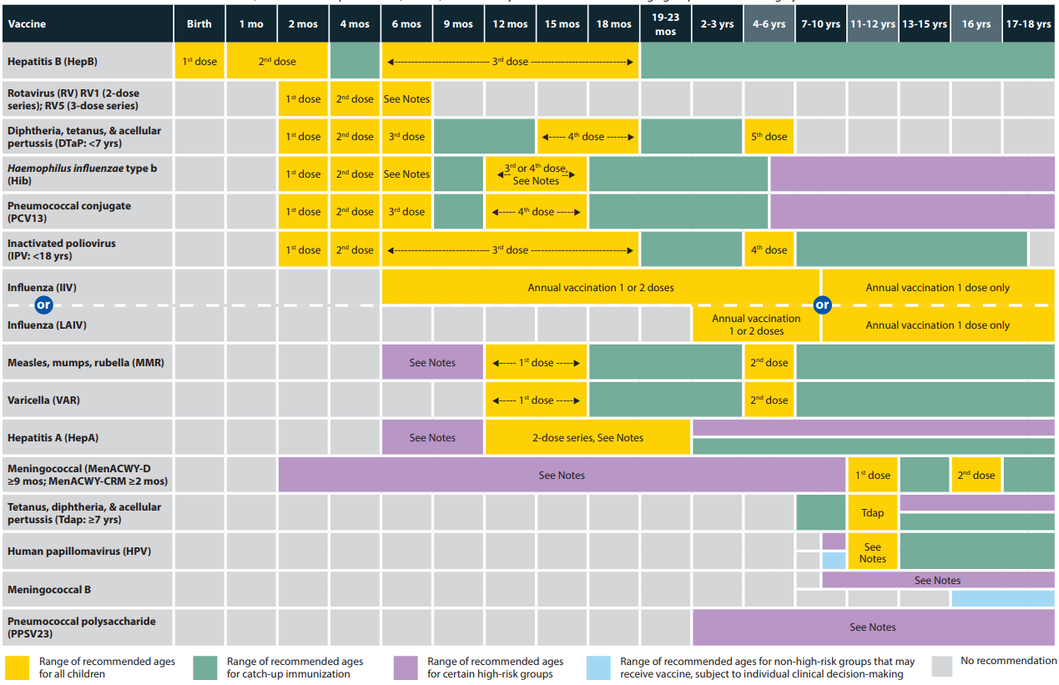

vaccine_schedule_birth_to_18

Recommended Child and Adolescent Immunization Schedule by Medical Indication: <https://www.cdc.gov/vaccines/schedules/downloads/child/0-18yrs-child-combined-schedule.pdf>

## CHPCC Vaccine Schedule

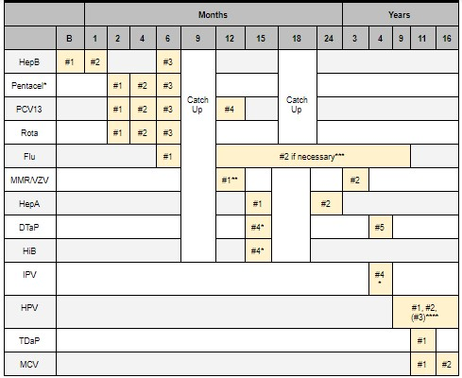

CHPCC_vaccine_schedule

* PENTACEL = HiB + DTaP + IPV. PEDIARIX = HepB + DTap + IPV. KINRIX = DTaP + IPV ** MMR + VZV (separate) given @ 12m, combined MMRV @ 3 y/o ***Children 6m - 9y who have never had flu vaccine require 2 doses, 4 weeks apart.*** *If HPV course started before 15th birthday, only need two doses. Each dose should be 6-12m apart.

## CHPCC Screening Schedule

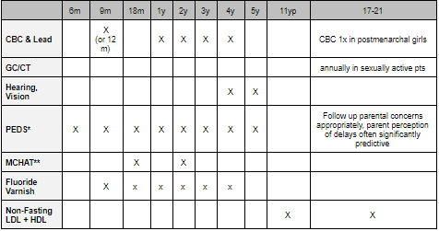

CHPCC_screening_schedule

## BMC Clinic Screening Questionnaire Schedule

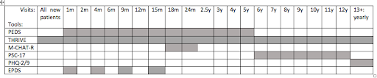

BMC_clinic_screening

## Autism Management in Primary Care Clinic (**CHOP EBG)

### Who to Screen

All children at 18 mo and 24 or 30 mo Any child over 12 mo with concerns Risk factors for ASD: sibling w/ ASD, unusual social responses, genetic disorder

### How to Screen

PEDS questionnaire @ every visit Do you have any concerns about your child’s development or behavior?” MCHAT-R or MCHAT-R/F (modified checklist for autism in toddlers) @ 18mo, 24mo

### Developmental Red Flags

Diminished, atypical, or no babbling by 12 months Diminished, atypical, or no gesturing (e.g., pointing, waving bye-bye) by 12 months Lack of response to name by 12 months No single words by 16 months Diminished, atypical, or no two-word spontaneous phrases (excluding echolalia or repetitive speech) by 24 months Loss of any language or social skill at any age Lack of joint attention

### Positive screening - what now?

Formal audiology testing EI referral (<5 years old), EI services end at 2 years and 9 months DBP or ASK clinic referral for all Other specialty referrals as needed

### Follow up

1 month after positive screening w/ primary provider for continuity Ensure EI referral was placed, answer family questions, make sure school is involved for children > 2.9 years

## ADHD

### EBGs

ADHD, adolescents; ADHD, pre-school and school-age

### ADHD Definition

Persistent and pervasive inattention, hyperactivity, and/or impulsivity affecting cognitive, academic, behavioral, emotional, and social functioning in more than one setting.

### How to Screen

PSC-17, attention score >/= 7 should prompt further assessment for ADHD Age >/= 4 years: Vanderbilt Assessment Scales (Diagnostic) (print from internet) - To be filled out by parent and teacher - Obtain detailed information from teacher, including report cards, IEP

### Common Coexisting Disorders

Learning disabilities Tic disorders Anxiety Depression OCD ODD Substance abuse

### Additional Evaluation PRN

* PT/OT for motor deficits
* Speech/language eval if needed
* Labs/imaging if risk factors for alternate organic diagnosis:
  + Blood lead levels, TSH, neuroimaging, EEG

### Considerations Prior to Initiating Pharmacotherapy

* Age: If <6, start with short acting and ensure they are also in behavioral therapy
* Make sure to document baseline height, weight, BP, HR and allergies
* Make sure to ask about personal hx of substance use, can consider nonstimulant or vyvanse (prodrug, thus lower abuse potential) if hx of SUD
* Take a thorough history including personal hx of cardiac disease, epilepsy, tics or comorbid psychiatric conditions and family hx of cardiac disease or sudden cardiac death
  + If any concerning cardiac personal or family hx: obtain ekg and consider discussion with cardiology prior to starting stimulant medications
* Consider subspecialty consultation if age <6, significant psychiatric comorbidities, cardiac concerns, hx of epilepsy or tourette syndrome *See medication chart below for more information about common ADHD medications

### Follow Up

See patient for dose titration follow up every 1-2 weeks - Uptitrate dose until symptom remission, max FDA approved dose or patient experience treatment limiting side effects - If patient is experiencing significant side effects or not having symptom remission can switch drug class (ie methylphenidate to amphetamine) - If patient is well controlled in the AM and experiencing relapse of symptoms in afternoon, can consider adding in afternoon short acting medication - Make sure to document height, weight, BP and HR at each follow up visit Repeat vanderbilt forms once patient at stable dose of medication - All children with ADHD qualify for a 504 - have provide a diagnosis letter to school See patient in clinic every 3-6 months once at stable dose of medication with tolerable side effects

### General Prescribing Principles

* In children 6 years and older, long-acting formulations are first line (improved compliance, lower abuse potential
* In children <6 years, short-acting formulations are first line. In this age group, medication should always be used in conjunction with therapy.
* Increase dose until either 1) symptoms are in remission, 2) patient encounters dose-limiting side effects, or 3) maximum daily dose is reached
* Before switching medication class 1) maximize dose, 2) optimize dosing schedule, and 3) manage side effects

### Stimulants

#### Methylphenidates

*First Line* | Drug Name | Starting Dose & Titration | Duration of Action | Notes | |——————|———————————————————————————————————————————————————————————-|——————–|————————————————————————————————| | Ritalin | Start with 5 mg 1-2 times per day and increase by 5 mg per week until good control achieved. May need additional reduced dose in the afternoon. Max daily dose: 60 mg | 3-4 hrs | Oral solution or chewable tablets | | Ritalin SR or LA | Start with 20 mg in the morning and increase by 20 mg per week until good control achieved. May need second dose or regular Ritalin dose in the afternoon. Max daily dose: 60 mg | 4-8 hrs | Capsules can be opened and sprinkled. Offers steady release of medication throughout the day | | Focalin | Start with 2.5 mg per day and increase by 2.5-5 mg per week until good control achieved. Max daily dose: 40 mg | 3-4 hrs | Focalin is twice as potent as other methylphenidates, so halve dose when converting to Focalin | | Focalin XR | Start with 5 mg per day and increase by 5 mg per week until good control achieved. Max daily dose: 30 mg | 8-12 hrs | Capsules can be opened and sprinkled | | Concerta | Start at 18 mg each morning and increase by 18 mg each week until good control achieved. Max daily dose: 72 mg | 8-12 hrs | Not ideal for children who cannot swallow pills |

#### Amphetamines

*Second Line* due to higher incidence of side effects

|  |  |  |  |
| --- | --- | --- | --- |
| Drug Name | Starting Dose & Titration | Duration of Action | Notes |
| Adderall | Start with 5 mg 1-2 times per day and increase by 5 mg per week until good control achieved. Max daily dose: 40 mg | 4-6 hrs |  |
| Adderall XR | Start with 10 mg in the morning and increase by 10 mg per week until good control is achieved. Max daily dose: 40 mg | 8-12 hrs | Capsules can be opened and sprinkled |
| Vyvanse | Start with 30 mg in the morning and increase by 10-20 mg per week until good control achieved. Max daily dose: 70 mg | 10-12 hrs | Capsules can be opened and sprinkled. Low abuse potential. |

*Stimulant Side Effects: Anorexia/weight loss, insomnia, irritability, headache, stomachache, increased BP/HR, tics (rare)*

#### Non-Stimulants

*Third Line* ##### Norepinephrine Reuptake Inhibitors | Drug Name | Starting Dose & Titration | Duration of Action | Notes | |————————-|————————————————————————————————————————————————————-|——————–|——————————–| | Atomoxetine (Strattera) | Start with 0.5 mg/kg/day and increase after at least three days to target dose of 1.2-1.4 mg/kg/day. Max daily dose: 1.4 mg/kg or 100 mg, whichever is less | 24 hrs | Takes 4-6 weeks to see effects |

*NRI side effects: Nausea, GI upset, insomnia, sedation, decreased appetite*

##### Alpha Agonists

|  |  |  |  |
| --- | --- | --- | --- |
| Drug Name | Starting Dose & Titration | Duration of Action | Notes |
| Clonidine ER (Kapvay) | Start with 0.1 mg at bedtime and increase by 0.1 mg per week until good control achieved. Max daily dose: 0.4 mg | 12-24 hrs | Helpful for use as sleep aid as well |
| Guanfacine ER (Intuniv) | Start with 1 mg per day and increase by 1 mg per week until good control achieved, target dose 0.05-0.12 mg/kg/day. Max daily dose: 7 mg | 12-24 hrs | First line in Tourette’s |

*Alpha agonist side effects: hypotension, sedation, lightheadedness, dry mouth*

## Anxiety

### Types of Anxiety Disorders

Selective mutism, separation anxiety disorder, phobias, OCD, social anxiety disorder, generalized anxiety disorder, panic disorder - Important to screen in patients with ADHD and to screen for ADHD in those with anxiety–often linked

### How to Screen

PSC-17 (Pediatric Symptom Checklist): 4 year olds + - Looks at psychosocial functioning, externalization and internalization SDQb (Strengths and Difficulties Questionnaire): 3 year olds + - Sensitivity: 63% to 94% for emotional symptoms = Specificity: 88% to 98% conduct problems - Separate scale assesses impact of symptoms on global functioning ASQ-SE (Ages and stages questionnaire—social emotional): 6-60 months - Screens for social-emotional communicative, motor, problem- problems - Sensitivity: 71% to 85% - Specificity: 90% to 98%

### Positive Screening

Obtain detailed hx re: symptoms, freq, duration, severity, degree of distress or interference Consider SW involvement as needed Behavioral Health/Psych referral

### Initial treatment (school aged)

CBT Fluoxetine 10 mg daily - can uptitrate to 20 mg daily **What if symptoms persist?** (school age): SSRI treatment in consult w/ psych, see medication table below for further recommendations

## Depression

### Background

Extremely significant cause of morbidity/mortality in children, >⅓ children experience a psychiatric disorder by childhood

Cormorbidity with ADHD very common, important to screen for both

Many types but most often will see: 1. Unipolar major depression (MDD): at least 2 weeks of depression plus 4 neurovegetative symptoms, no hx of mania 2. Persistent depressive disorder (Dysthmia): depression for >2 years and at least 2 other symptoms (or MDD that persists for 2 years+)

### Neurovegetative Symptoms (SIGECAPS)

**S**leep disruption **I**nterest deficit **G**uilty Feelings **E**nergy deficit **C**oncentration deficit **A**ppetite disorder **P**sychomotor Changes **S**uicidality

### How to Screen

Always screen for history of mania or bipolar symptoms (25-30% of Bipolar Disorder starts with depressive episode) - Use PSC internalizing scale for anxiety/depression - PHQ-9 *Important to consider referral to psychiatrist for severe symptoms, significant comorbidities and for children <12

### Therapy

Should always be concurrent with starting medications (or offered), particularly in younger children. See tables below re medication management

### Follow Up

Follow up 2 wks after initiation and then 2-4 wks after, monitoring closely Most symptom improvement in 6-8 wks with some mild effects seen at 2 wks

## Medication Management: Anxiety and Depression

### Side Effects/Precautions with SSRI use (see chart below for medication recs)

Black box warning: - Increase in suicidality/self harm after dose initiation or increase in dose - Important to monitor closely during any initiation or changes - Often suicidality exists prior to starting medication and important to assess prior and during medication management SSRI Activation Syndrome/Induced Mania - Irritability, restlessness, agitation, impulsivity, hyperactivity, manic symptoms, psychosis - Often emerges with initiation of SSRI or dose increase - Risk higher in younger children and those at risk for bipolar disorder QTc prolongation/cardiac events seen in escitalopram and citalopram in particular, consider closer monitoring or avoiding in patients with cardiac history Avoid Wellbutrin in patients with eating disorders or seizure history - Important to do good diet history prior to initiation given common disordered eating, particularly in adolescents Serotonin syndrome Most common mild side effects: GI, HA, sleep disturbances

### Anxiety

|  |  |  |
| --- | --- | --- |
| SSRI | Range | Notes |
| Sertraline (Zoloft) | 50-200 mg | FDA approved pediatric OCD age 6+ (POTS), often requires high doses for OCD |
| Fluvoxamine (Luvox) | 100-300 mg | FDA approved pediatric OCD ages 8+, BID dosing, monitor for drug/drug interactions |
| Fluoxetine (Prozac) | 20-40 mg | FDA approved pediatrics OCD 7+, long half-life, behavioral activation |
| Escitalopram (Lexapro) | 20-40 mg | FDA-approved pediatric depression, dose related QTc prolongation; lower side effect profile |
| Citalopram (Celexa) | 20-40 mg *Do not exceed 40 mg daily given QTc prolongation | Dose related QTc prolonging; lower side effect profile |

### Depression

First line: SSRI | SSRI | Range | Notes | |————————|———-|——————————————————————————————————————-| | Fluoxetine (Prozac) | 20-40 mg | FDA approved pediatric depression age 8+, most consistent evidence, long half-life, assoc w behavioral activation | | Escitalopram (Lexapro) | 20-40 mg | FDA approved for adolescent depression 12+, well tolerated | | Sertraline (Zoloft) | 5-200 mg | FDA approved pediatrics OCD 7+ | | Citalopram (Celexa) | 20-40 mg | QTc prolongation concern but lower side effects otherwise; do not exceed 40mg daily |

Second line: another SSRI -Try increasing dose of first before switching to a second -Switch to second SSRI if one is not working or side effects bothersome with first attempt

Third line: Refer to specialist; medications include venlafaxine, bupropion, mirtazapine, duloxetine -Should be done in conjunction with a specialist

## BMC Primary Care Clinic Resources

### Asthma Education

**WHAT**: 5-10 minute check in w/ patients to review triggers, spacer teaching, med teaching, Asthma Action Plan,, screening for in home asthma services such as Breathe Easy **WHEN**: Monday-Friday 9am-5pm. Appropriate for any patient w/ asthma here for WCE, urgent visit, etc. **HOW**: Reachable via pager 8818p

### Reach out and Read (ROR)

**WHAT**: Program to promote early literacy **WHO**: Age child 6 months – 5 years **HOW**: Kids ages 6 months – 5 years receive a book at every well child visit. **WHERE**: The ROR books are located in the little office next to the nursing office in the main primary care clinic hallway – they are next to a bunch of stickers too!!

### Lactation Resources

**WHAT**: We have lactation consults (both in the clinic and in the newborn nursery) who can often help mom’s during the newborn visits. **WHO**: Any mom who is breastfeeding or attempting to breastfeed, especially those who have babies who aren’t gaining good weight. Also appropriate to call them if moms have questions about pumping, latch, nipple pain, etc. **WHEN**: Anytime during PC clinic **HOW**: You can page the Child Life Specialist who is usually in clinic and can come work w/ moms! You can also page a lactation consultant from the newborn nursery but it is very likely that they will be too busy to come during your visit.

### Food Pantry

**WHAT**: Provides food resources (including fresh fruits and vegetables) to patients w/ food insecurity, chronic illness, etc. **WHO**: Anyone who gets a referral; immigration status DOES NOT matter and you don’t need to document income when you refer, you just need to place the referral **WHEN**: Open Monday – Friday; 10:00 AM – 4:00 PM; pts can go 2x monthly **HOW**: Write a prescription for your patient in EPIC (they MUST have a Rx)

### Street Cred

**WHAT**: Organization started by BCRP alum Lucy Marcil to help families get the maximum amount on their tax returns **WHO**: For all pts w/ income <54,000 **HOW**: Refer patients to street cred (use .STREETCRED in the EMR) [info@mystreetcred.org](mailto:info@mystreetcred.org) (617) 414-5946

### Child Witness to Violence Project

**WHAT**: Provides social support and counseling for young (< 8y) children who have witnessed domestic violence. Run under the auspices of the DBP clinic. **WHERE**: Counseling happens at BMC but there is no documentation left in the chart. This can be tricky because you will not know if your patients are receiving services based on chart review alone. **HOW**: Call (617) 414-7425

## BMC Pediatrics Specialty Outpatient Clinics

### CCP Clinic

**WHAT**: Primary care home for patients w/ complex medical problems including NICU grads, patients w/ complex genetic disorders, etc. **WHO**: All patients w/ multiple medical problems and/or exceptionally complex social situations AND their siblings **HOW**: Talk to Dr. Jack Maypole (BCRP alum!)

### GROW Clinic

**WHAT**: BMC based clinic for kids w/ FTT, provides comprehensive wrap around services including social work and home visits performed by a dietician. Not a PCP **WHO**: For FTT kiddos (I think only less than age 5) **HOW**: Talk to the Grow clinic patient navigator (refer in EPIC)

### Baby Steps Clinic

**WHAT**: Provides coordination of care for babies who are preterm or have had complicated newborn courses; NOT primary care. Comprehensive team including pediatrician, nutritionist, OT, dieticians and close communication w/ neuro and GI **WHO**: For any baby who had a tough newborn course, is having difficulty gaining weight or other challenges. (All preterm) **HOW**: This is usually done when the baby leaves the nursery but if you think a baby would benefit from this clinic as well you can place a referral in EPIC

## SoFAR Clinic

**WHAT**: Primary Care Clinic for moms w/ a history of substance use and their babies (babies w/ a history of NAS) or exposure **WHO**: Babies born to moms who struggled w/ substance use during pregnancy and their siblings. Moms get care too–Dyadic approach! **HOW**: Usually referred to the clinic from the newborn nursery but this can also be done on the outpatient side. Reach out to SoFar clinic SW to schedule an intake for the family.

### Teen and Tot Clinic

**WHAT**: Primary Care Clinic for teen moms and their babies – teen girls can get prenatal care in a centering group by midwife. Teen girls and children are seen together during primary care visits. The clinic also has a patient navigators and is run by Dr. Pierre-Joseph **WHO**: Teen moms and their babies/pregnant teens who have elected to become parents **HOW**: Page Adrian Stevenson (teen and tot patient navigator) or talk to Dr. Adolphe or Dr. Pierre-Joseph to transfer maternal/newborn care to teen and tot. Adrian will talk to the mom and do an intake

### IEP Clinic

**WHAT**: Clinic that is run by BMC preceptor Dr. Adolphe that bridges primary care w/ DBP, Helps w/ ADHD, ASD, learning/intellectual disorders. Appropriate for kids w/ IEP who aren’t making progress or accessing the curriculum well or if parents have questions about the IEP. **WHEN**: Usually takes patients ~ 1 month to get in (for now)… if you need help sooner or in the meantime, reach out to Dr. Adolphe directly. **HOW**: Place a referral in EPIC

### Family Planning Services

Birth control counseling, STD testing, options counseling, for patients of ANY AGE, same-day birth control available page Teakia Brown

### Pain Clinic

For kids with chronic pain (including functional), MD, acupuncturist, psychologist, PT

### CATALYST Clinic

Teens with substance use disorder

### Menstrual Disorders Clinic

Joint Adolescent/Heme Clinic

### Lead Clinic

Sean Palfrey, for kids with elevated lead

### CATCH Clinic

For gender affirming care

### Embedded Child Psychiatrist

Andrea Spencer available for “curbside consults” and “co-management of patients with behavioral health concerns”– page directly or refer to Integrated Behavioral health

## BMC Indications for Social Work Consult

Child Abuse Neglect Domestic Violence Sexual assault Mental health (depression, anxiety, psychosis, PTSD, etc.) Thoughts of suicidal ideation/homicidal ideation Substance abuse Family bereavement Newly diagnosed chronic or fatal illness Witnessing/part of community violence Family distress or dysfunction Bullying

Liz Renzella #3433, 4-7756 Jill Baker #2610, 4-7799

## BMC Clinic Tips

Always review medications, allergies, etc by going to the A/P section of epic and clicking “mark all as reviewed” You can delete a note by clicking the “X” by the “sign note” or “pend note” drop down When ordering immunizations, use the order sets, which are present under “A/P” order section - Simply check off the box and sign the orders Huddle w/ your nurse and CA prior to clinic to discuss patients that may be late, clinic flow goals, complex patients, anticipated orders You know a patient is roomed when their vitals populate into your note To promote continuity, staple your card to the after visit summary **You must import the flowsheets for the developmental screens into your note & indicate positive or negative** **You must send your notes to your preceptor w/i 48 hours for signing and billing**

## CHPCC Co-Located “Specialty” Clinics

Refer patients with a PowerChart Order

### Asthma Clinic

In-depth education or intervisit care, including home visits, for asthma patients requiring more frequent visits and/or asthma patients with more severe disease

### Advocating Success for Kids (ASK)

A multidisciplinary team (developmental medicine, educational specialist, social worker, and primary care) assists children who are having academic difficulties, such as from ADHD or a learning disability, who are not making adequate progress despite having an IEP, and also conducts evaluations for autism spectrum disorder and other developmental delays

### Rainbow

A multidisciplinary team to coordinate care for our clinic’s medically complex children. Owing to their medical complexity, patients with a “Rainbow” distinction get longer patient visits, intervisit monitoring, and additional nursing, social work, and case management support.

### RASH

Have your patients’ skin concerns addressed quickly, in a primary care setting, by pediatricians. This is generally far faster than a referral to dermatology.

### Young Parents Program (YPP)

A teen-tot clinic that provides primary care for adolescent parents and their children. Dedicated YPP staff provide longitudinal supports.

## CHPCC Contacts

Fax: 617-730-0505 Charge RN: 84706 Front Desk: 58944 SW Pager: 0170 Child Life: 84708 Dental Clinic: 5654 Lactation: 56445 Newborn Pager (for scheduling visits): 5222 Navigator: 5931 YPP: 7718

# Psychiatry

## Consulting Psych

* Place “Psychiatry Consult” order in PowerChart. Will allow you to select an indication (including Agitation plan, Psychiatric Disposition, etc). What you write in Order Comments = what Psych uses to prioritize urgency and assign consult. Must obtain patient/guardian consent prior to placing consult.
* If patient seen in ER by Psych SW and officially boarding for inpatient LOC, as of Sept 2020 this is a new option to select on consult order
* Reasons to page Psych on-call on nights/wknd: Severe agitation, active SI w/ plan/intent, psychosis, behavior interfering w/ essential medical care

## A/P Template for Patients Awaiting Inpatient Psych Placement

**Use the Behavioral Healthy Safety Plan order set!**

Assessment: _ is a _ y/o M/F w/ PMH __ who presents w/ concerning __ SI that makes him/her unsafe for discharge home. S/He has been medically cleared and is awaiting placement at an inpatient psychiatric facility. We will continue to provide a safe environment and follow along w/ Psychiatry.

Plan:

– Medical clearance - Utox, urine HCG - EKG (document baseline QTc)

– Behavioral plan - Supervision: 1:1 sitter vs. security, safety tray, safety check prior to any room changes - Activity level: Start w/ confined to room (Psych will decide when out-of-room privileges are ok, e.g. supervised walks around unit or visit to playroom at RN’s discretion - Electronics: Start w/ no phone or internet (Psych will decide if/when permitted and w/ what level of supervision/restrictions)

– Agitation plan, per Psychiatry on [date] - Mild agitation: Utilize behavioral strategies - Moderate agitation: Ativan OR Haldol , ALWAYS WITH Benadryl . Call BRT to help prevent further escalation to severe agitation. - Severe agitation: Olanzapine PO/IM (Zydis ODT for PO) OR Haldol PO/IM , ALWAYS WITH Benadryl PO/IM PRN. Call 5-5555 to activate Behavioral Rapid Response (summons Psych, BRT, Security). Call on-call Psych if requires IM or if not responding within 20-30min or if need further guidance. - If administering antipsychotics, daily EKG to monitor QTc (target < 450) - PO’s should be ordered as PRNs, IM must be one-time in the moment and can only be ordered by PGY2 or higher

– Dispo: pending placement to inpatient psych when available bed identified

**Note: dosing for agitation meds is written as __ mg q_ NTE __ from all sources in 24hrs. Dosing recommendations per table below:**

## Agitation

### Identifying Agitation

Mild: Pacing, worrying, agitated but cooperative Moderate: Swearing, threatening, yelling, screaming, clenching fists, pacing, superficial self-injury, request for meds Severe: Imminent risk of harm to self or others, aggression to others/self, destruction of property

### Non-Pharm Management

BRT is your best friend!

#### Prevention

Identifying triggers: - Stimuli that trigger upsetting feelings or problematic behaviors (precipitant to behavior) - Environmental or emotional

Patients at risk: ASD, developmental delay, trauma Think about the 4 functions of any behavior: Attention, escape, sensory, tangibles/access

#### Ways to respond

Recognize and respond to initial signs of agitation or inappropriate behavior w/ redirection. Avoid using the word “no.” Avoid non-specific comments such as “behave” or “calm down”

Ignore behavior that is disruptive, but not harmful. Make a blank non-smiling face, avoid eye contact and turn away. As soon as the child stops the unwanted behavior, smile and make eye contact. Give the child a space - somewhere calm and safe - where they can go when they feel overwhelmed. Do not simply react; try to understand the reasons behind the behavior.

#### Managing the situation

Managing the situation Start by asking “what do you want?” Try the SAVE mnemonic: Support ”Let’s work together…”, Acknowledge “I see this has been hard for you.”, Validate ”I’d probably be reacting the same way if I was in your shoes.”, Emotion naming ”You seem upset.” or similar communication efforts when talking with the patient.

Strategies will differ based on degree of agitation: **Mild** Listen, validate, problem-solve Stay w/ the patient, have them sit w/ you Maintain calm demeanor Eliminate distractions Empathic listening Utilize supportive eye and verbal communication, gestures, posture, and facial expressions Utilize preferred activities (eg music)

**Moderate** Redirect, problem-solve Allow individual to vent Validate feelings

**Severe** Direct, clear communication Call 5-5555 to activate Behavioral Rapid Response (summons Psych, BRT, Security) Maintain safe distance (4ft); intervene if danger is imminent Interrupt individual’s focus Body language techniques Positive verbal command Throwing/dropping an object Moving as an escape technique Medications (PO vs. IM), potential need for restraint.

### Restraints

Ordering restraints for violent or self-destructive/injurious behavior: - **CANNOT** be written PRN! Appropriate restraint order must be placed immediately upon initiation of restraint. - Ordering clinician must perform face-to-face within 1hr - Order cannot be written by an intern, must be junior/senior resident

### Pharmacologic Management

See A/P Template section above, as well as Rapid Reference chapter

Psychiatry will determine an appropriately tailored pharmacologic agitation plan, but these guidelines are a good starting place if you don’t yet have a formal plan in place:

#### Medication Recommendations - Moderate Agitation

Parenteral medication orders for agitation may not be ordered PRN. Place 1 time orders at the time the medication is needed.

|  |  |  |
| --- | --- | --- |
| Parameter | Child (weighing 25-50 kg) | Adolescent (weighing > 50 kg) |
| Preferred Agent(s) | Diphenhydramine or Lorazepam | Diphenhydramine or Lorazepam |
| **Administration Route** For escalating patients who refuse PO and for whom there is significant concern for imminent and serious risk of harm to self or others, please progress to severe agitation IM plan below. IM medications usually require physical holds or restraints and should only be involuntarily administered if there is significant risk of harm | PO | PO |
| Initial Dosing | Diphenhydramine 25 mg or Lorazepam 0.5 - 1 mg | Diphenhydramine 50 mg or Lorazepam 1- 2 mg |
| Repeat dosing (60 minutes after initial dose if ineffective) | Diphenhydramine 25 mg or Lorazepam 0.5 - 1 mg | Diphenhydramine 25 mg or Lorazepam 1 – 2 mg |
| Subsequent Frequency | Q4 – 6 hours Not to exceed 100 mg of diphenhydramine or 2 mg of lorazepam in 24 hours | Q4 – 6 hours Not to exceed 150 mg of diphenhydramine or 4 mg of lorazepam in 24 hours |

PO’s should be ordered as PRNs, IM must be one-time in the moment and can only be ordered by PGY2 or higher Prescribers to use discretion and order lower or higher doses as appropriate.

#### Medication Recommendations - Severe Agitation

Parenteral medication orders for agitation may not be ordered PRN. Place 1 time orders at the time the medication is needed.

|  |  |  |
| --- | --- | --- |
| Parameter | Child (weighing 25-50 kg) | Adolescent (weighing > 50 kg) |
| Preferred Agent(s) | Olanzapine* (ODT for PO) or Haloperidol and Diphenhydramine** or Lorazepam | Olanzapine* (ODT for PO) or Haloperidol and Diphenhydramine** and/or Lorazepam |
| Administration Route | PO or IM | PO or IM |
| Initial Dosing | Olanzapine 2.5 mg or Haloperidol 2 mg and Diphenhydramine 25 mg or Lorazepam 0.5-1 mg | Olanzapine 5 mg (can use 7.5mg for patients weighing > 70kg) or Haloperidol 5 mg and Diphenhydramine 50 mg and/or Lorazepam 1-2 mg (can use Haloperidol, Diphenhydramine and Lorazepam combined for patients weighing > 70kg) |
| Repeat dosing (45 minutes after initial dose if ineffective***) | Olanzapine 2.5 mg or Haloperidol 1 mg and Diphenhydramine 25 mg or Lorazepam 0.5-1 mg | Olanzapine 5 mg or Haloperidol 2.5 mg and Diphenhydramine 25 mg and/or Lorazepam 1-2 mg |
| Subsequent Frequency | Q4hr Do not exceed: Olanzapine 10 mg in 24 hours Haloperidol 5 mg in 24 hours Diphenhydramine 100 mg in 24 hours Lorazepam 3 mg in 24 hours | Q4hr Do not exceed: Olanzapine 15 mg in 24 hours Haloperidol 10 mg in 24 hours Diphenhydramine 150 mg in 24 hours Lorazepam 6 mg in 24 hours |

* **Do NOT use IM olanzapine within 4 hours of IM/IV lorazepam due to risk of cardiopulmonary depression.** ODT = orally disintegrating tablet. ** Use of diphenhydramine with haloperidol is preferred to haloperidol alone to avoid risk of acute dystonic reactions. The use of haloperidol in combination with Fluoxetine (Prozac) or Citalopram (Celexa) can significantly increase the risk of QT prolongation and should only be used if benefits outweigh the risks.  
  Consult formulary for complete information. *** If pharmaceutical interventions are not effective, patients at risk for self-harm or harming others may require physical restraints, turning off the lights and an urgent psychiatry evaluation.

**The use of haloperidol in combination with Fluoxetine (Prozac) or Citalopram (Celexa) can significantly increase the risk of QT prolongation and should only be used if benefits outweigh the risks.**

## Medications That Cause Psychiatric Side Effects

### Selected Meds

Steroids: Aggressiveness/agitation, mania, depression, anxiety, psychosis Procainamide, quinidine: Confusion, delirium Albuterol: Anxiety, confusion Isoniazid: Psychosis Tetracycline: Depression Nifedipine, verapamil: Depression Cimetidine: Depression, confusion, psychosis

### Psychosis

Sympathomimetics, analgesics, antibiotics (e.g. isoniazid, antimalarials), anticholinergics, anticonvulsants, antihistamines, corticosteroids, antiparkinsonian agents.

### Agitation/Confusion/Delirium

Benzos, antipsychotics, anticholinergics, antihistamines, antidepressants, antiarrhythmics, antineoplastics, corticosteroids, NSAIDs, antiasthmatics, antibiotics, antihypertensives, antiparkinsonian agents, thyroid hormones

### Depression

Antihypertensives, antiparkinsonian agents, corticosteroids, calcium channel blockers, NSAIDs, antibiotics, peptic ulcer drugs.

### Anxiety

Sympathomimetics, antiasthmatics, antiparkinsonian agents, hypoglycemic agents, NSAIDs, thyroid hormones.

### Sedation/Poor concentration

Antianxiety agents/hypnotics, anticholinergics, antibiotics, antihistamines.

## Capacity Assessment

Capacity vs competency: Capacity is a one-time assessment by a clinician. Competency is a legal decision based on accumulated evidence that requires court hearing/proceeding.

|  |  |
| --- | --- |
| Patient (18yo+)/family must… | Assessment |
| Communicate a clear and stable choice | Ask patient to indicate a choice. Frequent reversals may indicate lack of capacity. |
| Understand relevant information | Ask patient to explain their understanding of the information given by physician (diagnosis, prognosis, proposed intervention, risks/benefits of intervention and alternatives, including no intervention) |
| Appreciate the situation and its consequences |  |
| Manage the information in a rational manner | Does patient weigh risks/benefits logically? |
| Is there true imminent risk? | EX: patient indicating they are suicidal but meet all 4 criteria above. |

## Depression & Anxiety

### Diagnosis

Major Depressive Episode: **2 wks of**: Depressed mood (or irritability, which is more common in children) OR anhedonia, PLUS 4+ of remaining SIGECAPs (**S**leep change, **I**nterest loss, **G**uilt/worthlessness, **E**nergy loss/fatigue, **C**ognition/concentration, **A**ppetite change, **P**sychomotor change, **S**I) - Ddx: Hypoactive type (wax/wane, acute-onset, possibly 2/2 underlying medical illness or iatrogenic), adjustment disorder (needs psychotherapy only), delirium

### Management

According to TADS and CAMS (2 large RCTs w/ govt oversight), combination therapy of SSRI + CBT is superior to monotherapy w/ either! CBT or SSRI is superior to placebo. No SSRI-associated suicidal events in either study, but when initiating SSRI it is important to monitor carefully (wks 1-4: weekly; wks 5-12: every other week) for any signs of ↑ suicidality - **NEVER** prescribe paroxetine (Paxil) to adolescents (black box warning for suicide)

**SSRIs are 1st line**: Help ⅔ of pts in first trial over **4-8 wks**. ⅔ of nonresponders respond to 2nd trial. - **Sertraline (Zoloft)** and **Fluoxetine (Prozac)** are most commonly used, least SE (used in TADS, CAMS). - Mild serotonergic side-effects (hyperhidrosis, nausea, headache, tremulousness, diarrhea) can happen w/ SSRI/SNRI initiation and/or uptitration, usually goes away in 2-3 days

## Suicide

* If you don’t directly ask about suicide, you won’t hear about it. NEVER assume! You don’t have to be depressed to be suicidal.
* ~4% of patients coming in to ED (for all complaints) are suicidal.
* Adolescents more likely to kill selves by firearm; children by strangulation

**ASQ: Adolescent Suicide Screening Tool** In the past few weeks, have you wished you were dead? In the past few weeks, have you felt that you or your family would be better off if you were dead? - Yes to 1 or 2 (passive SI): Counsel, supportive listening, referrals In the past week, have you been having thoughts about killing yourself? Have you ever tried to kill yourself? Are you having thoughts of killing yourself right now? - Yes to 3 or 5 (active SI): Immediate consult from ER/floor/outpt mental health clinician

## Antidepressants

### Selective Serotonin Reuptake Inhibitors (SSRIs)

#### Mechanism of Action

5-HT-specific reuptake inhibitor

#### Use

Depression, Gen. anxiety disorder, Panic disorder, OCD, bulimia, social anxiety disorder, PTSD, premature ejaculation, premenstrual dysphoric disorder - It normally takes **4–8 weeks** for antidepressants to have full effect. **Fluoxetine** (Prozac), **Paroxetine** (Paxil), **Sertraline** (Zoloft), **Citalopram** (Celexa), **Escitalopram**  
(*Fl* ashbacks *par* alyze *se* nior *cit* izens) Paroxetine → short half-life → discontinuation syndrome (flu-like sxs, dizzy, diaphoretic, “electric shock,” + depression). Do not use in adolescents due to black box warning for suicide. Fluoxetine → long half-life → no need to taper/good for poor compliance, P450 inhibitor, can ↑antipsychotics → ↑SEs Citalopram/Escitalopram → Dose dependent QTc prolongation (usually minimal)

#### Side Effects

GI distress, SIADH, sexual dysfunction (anorgasmia, ↓ libido), insomnia, anorexia, ↑ suicidality in adolescents , QTc prolongation, mildly ↓ Na (i.e. 128)

Serotonin syndrome: 2 meds that ↑ serotonin (MAOis, SNRIs, TCAs, Opoids, Tramadol, Linezolid) → ↑↑ serotonin in brain. (ex: triptan/SSRIs)

**3 A’s**: neuromuscular **A**ctivity (clonus, hyperreflexia, hypertonia, tremor, seizure), **A**utonomic stim (hyperthermia, diaphoresis, diarrhea), and **A**gitation. Tx: cyproheptadine (5-HT2 receptor antagonist) or benzodiazepines

### Serotonin-Norepinephrine Reuptake Inhibitors (SNRIs)

#### Mechanism of Action

Inhibit 5-HT and NE reuptake

#### Use

Depression, general anxiety disorder, diabetic neuropathy. **Venlafaxine** → also indicated for social anxiety disorder, panic disorder, PTSD, OCD, menopausal depression (b/c of NE effects) **Duloxetine** → also used for neuropathy (vs. Amitriptyline is better in suicidal patient who might overdose)

#### Examples

Venlafaxine (Effexor), Duloxetine (Cymbalta), desvenlafaxine, levomilnacipran, milnacipran.

#### Side Effects

↑ BP most common; also stimulant effects, sedation, nausea

### Tricyclic Antidepressants (TCAs)

#### Mechanism of Action

Block reuptake of NE and 5-HT. (-triptyline, -pramine –doxepin)

#### Use

Major depression, OCD (clomipramine), peripheral neuropathy, chronic pain, migraine prophylaxis.

#### Examples

3° amines: -Amitriptyline (pain/migraines), Imipramine (enuresis), clomipramine (OCD), doxepin 2° amines: -Nortriptyline, amoxapine, desipramine (ADHD)

#### Side Effects

Tri-C’s: CNS toxicity (Convulsions/Coma), Cardiotoxicity (arrhythmia -Na+ channel inhib, ↑QT int), antiCholinergic (urinary retention); Sedation, α1-blocking effects (postural hypotension), anticholinergic SEs (tachycardia, urinary retention, dry mouth) 3° TCAs (amitriptyline) have more anticholinergic effects than 2° TCAs (nortriptyline). QRS duration >100 msec → assoc. w. ↑risk of arrhythmias and/or seizures =indication for Tx: NaHCO3-stabilizes myocardium, alkalinize urine Confusion/hallucinations in elderly due to anticholinergic side effects (use nortriptyline)

### Monoamine Oxidase Inhibitors (MAOIs)

Note: Rarely used anymore

#### Mechanism of Action

Nonselective MAO inhibition → ↑ levels of amine neurotransmitters (NE, 5-HT,dopamine)

#### Use

Atypical depression (hypersomnia, ↑ appetite, heavy extremities, ↑ sensitivity to interpersonal rejection) Anxiety - Selegiline → only antidepressant that comes in dermal patch form (good for patient that cannot tolerate PO)

#### Examples

Phenelzine, Isocarboxazid, Tranylcypromine, (MAO Takes Pride In Shanghai), Selegiline (selective MAO-B inhibitor – Parkinson’s, Transdermal).

#### Side Effects

**Hypertensive crisis** (tyramine (cheese, wine)) → ↑↑ BP, HA, sweating, N/V, photophobia, autonomic instability, stroke/death Tx: Nitroprusside, Phentolamine **Serotonin Syndrome**: MAOIs are contraindicated in combo w/ SSRIs, TCAs, Tramadol, Linezolid, St. John’s wort, meperidine, dextromethorphan - Wait 2 weeks after stopping MAO inhibitors before starting serotonergic drugs or stopping dietary restrictions. Linezolid is a weak MAOI, and warrants avoidance of norepi and serotonergic drugs (big problem in CF patients w/ depression), otherwise risk hypertensive urgency and/or serotonin syndrome, respectively

### Norepinephrine-Dopamine Reuptake Inhibitors (NDRIs)

#### Mechanism of Action

↑ norepinephrine and Dopamine via unknown mechanism

#### Use

MDD w/ sexual side effects from SSRI’s, MDD w/ wt gain/hypersomnia (bupropion is PRO penis, not Bulemic). Smoking cessation.

#### Examples

Bupropion (Wellbutrin)

#### Side Effects

Seizures (in anorexic/bulimic or hx seizures), stimulant effects (tachycardia, insomnia), headache No sexual side effects

### Alpha2-Adrenergic Receptor Antagonists

#### Mechanism of Action

α2-antagonist (↑release of NE and 5-HT), potent 5-HT2 /5-HT3 receptor antagonist and H1 antagonist (sleepy/appetite effects)

#### Use

Major depression (especially in patient w/ weight loss and/or insomnia) → EX: cancer patient w/ N/V, ↓appetite, + MDD

#### Examples

Mirtazapine (Remeron)

#### Side Effects

Sedation (desirable in depressed patients w/ insomnia), ↑appetite, wt gain (may be desirable in elderly/anorexic), dry mouth.

#### Notes

Adrenergics like guanfacine and clonidine are very useful in hyperactive ADHD and sometimes PTSD/irritability in general. Mirtazapine/Remeron is a multi-receptor drug and most of its psychotropic effect is from 5-HT activity, actually.

### Serotonin Receptor Antagonists and Agonists

#### Mechanism of Action

Primarily blocks 5-HT2, α1-adrenergic, and H1 receptors; also weakly inhibits 5-HT reuptake.

#### Use

Insomnia (high doses are needed for antidepressant effects)

#### Examples

Trazodone (Desyrel) and Nefazodone (Serzone)

#### Side Effects

Sedation, nausea, priapism, postural hypotension. Called traZZZoBONE → b/c sedative and male-specific side effects.

### Nicotinic ACh Receptor Partial Agonist

#### Use

Smoking cessation

#### Examples

Varenicline (Chantix)

#### Side Effects

Sleep disturbance, mood changes, suicidality, cardiovascular events

## Antipsychotics

### Typical Antipsychotics (1st Generation)

#### Mechanism of Action

Block D2 receptors (↑[cAMP]) → Low/High Potency can cause QT prolongation(450 = number you are looking for)

#### Use

Schizophrenia (helps positive sx, little effect on neg sx), psychosis, bipolar disorder, delirium, Tourette syndrome, Huntington disease, OCD

#### Low Potency

Chlorpromazine,(Corneal deposition), Thioridazine(reTinal deposition) → **C**heating **T**hieves are **LOW** - Blocks HAM – Histamine (sedation), α1 (orthostatic hypoTN), Muscarinic (dry mouth, constipation)

#### High Potency

Trifluoperazine, Fluphenazine, Haloperidol → Try to Fly High - Libido, osteoporosis, amenorrhea, gynecomastia Tuberoinfundibular: block dopa → ↑ prolactin→ ↓GnRH → ↓ FSH/LH  
- Extrapyramidal symptoms - Nigrostriatal: ACTH/dopamine in balance → block dopamine → ↑ACTH

|  |  |  |  |
| --- | --- | --- | --- |
| ADAPT | Time | Extrapyramidal Symptoms | Management |
| Acute Dystonia | Hrs-days | Muscle spasm, torticollis, stiffness, oculogyric crisis | IM: (1) Benztropine (2) Diphenhydramine (antihistamine and anticholinergic effects) (3) Lorazepam |
| Akathisia | Days -mos | Restlessness, ↑risk for suicide | Propranolol |
| Parkinsonism | Days- mos | Bradykinesia, tremor, rigidity, mask-like facies, | 1. Benztropine (NOT L-dopa b/c ↑ dopamine → ↑ psychosis) 2. Trihexyphenidyl, maybe amantadine |
| Tardive dyskinesia | Mos-yrs | Repetitive orofacial movements - dopamine hypersensitivity | 1. STOP antipsychotic (may worsen when first stop) 2. START atypical -> Quetiapine or Clozapine |

Neuroleptic malignant syndrome: Fever (>103), Rigidity, ↑ CPK → rhabdo, AKI - Due to dopamine dysregulation. Caused by: typical/atypical antipsychotics, antiemetics, antiparkinson med withdrawal, infection, surgery - FEVER: Fever, Encephalopathy (AMS), Vitals unstable, ↑ Enzymes, Rigidity (lead pipe), leukocytosis - Compare to Serotonin Syndrome → NMS (↑↑Rigidity), SS (↑DTRs/clonus, GI sxs) - Tx; (1) STOP drug (most important intervention) (2) Hydrate, cooling blankets If no response to stopping drug →(3) Dantrolene (inhibition of Ca2+ release)/ Bromocriptine/Amantadine (4) ECT

#### Notes

IV and IM carry more risk of QTc and torsades than PO Our hospital has policy that only can get IV haloperidol while on telemetry (ICUs and 8E)

### Atypical Antipsychotics (2nd Generation)

#### Mechanism of Action

Blocking D2 receptor AND serotonin 2A receptor blockade

#### Use

Schizophrenia (better neg sx coverage than typicals), bipolar disorder, OCD, anxiety disorder, depression, mania, Tourette syndrome

#### Side Effects

ALL SE’s: Metabolic side effects → sleepy and fat, → W/u: EKG, Lipids, BMI - Olanzapine → Obesity (metabolic syndrome) - Risperidone → ↑prolactin (↓dopamine activity in tuberoinfundibular pathway→ gynecomastia, galactorrhea, amenorrhea) - Quetiapine → best for movement disorders (ex: Parkinson’s) - Ziprasidone → starts w/ Z worst for the qTC, ↓metabolic effects - Aripiprazole → light and “ari” → doesn’t put you to sleep/lead to weight gain; partial agonist at D2 - Clozapine → D4 blockade is primary effect, must watch closely → monitor WBC and ANC – 3 good: best efficacy (if nothing else working), ↓ risk of suicide in schizophrenia (lithium only other), good for Lewy Body Dementia – 6 bad (1) Agranulocytosis (CBCd before/wkly for 1st 6 mo→ ANC <1500 → Tx: STOP. (2) Myocarditis (EKG, troponins, etc) (3) ↓ Seizure threshold (most common) (4) Wt gain (worse than olanzapine) (5) Sedation (6) Sialorrhea Others in this class not already mentioned above: Asenapine, Iloperidone, Lurasidone, Paliperidone

## Mood Stabilizers

### Lithium

#### Mechanism of Action

Not established; possibly related to inhibition of phosphoinositol cascade → inositol = buzzword

#### Use

Mood stabilizer for bipolar disorder; blocks relapse and acute manic events. - Drug of choice in acute mania and as prophylaxis for both manic/depressive episodes in bipolar & schizoaffective disorders. - It is also used in cyclothymic disorder and unipolar depression - Excellent at low doses for anti-suicidality *Contraindications*: chronic kidney disease, heart disease, hyponatremia or diuretic use *Therapeutic range*: 0.8-1.2 mEq/L

#### Side Effects

Lithium SEs: Movement (tremor), Nephrogenic Diabetes Insipidus HypOthyroidism, Pregnancy problems (Ebstein anomaly) (LMNOP). Skin problems (acne, psoriasis). - Prior to starting: ECG, BUN, creatinine, Ca2+, u/s,, thyroid function tests, CBC, and a pregnancy test Almost exclusively excreted by kidneys; most is reabsorbed at PCT w/ Na+ - ↑ Li+ levels: NSAIDs, Aspirin, Thiazides, ACEi/ARBs, Metronidazole, Dehydration, Salt depr, Sweating (salt loss), ↓renal fxn - ↓ Li+ levels: K+ sparing diuretics, Theophylline, CCB/Furosemide may ↑/↓ **Acute Lithium toxicity**: tremor, diarrhea, vomiting, weakness, polyuria, polydipsia, ataxia, cognitive impairment **Chronic Lithium toxicity**: nephrogenic diabetes insipidus, thyroid dysfunction, hyperparathyroidism

### Valproic Acid (Depakote)

#### Mechanism of Action

↑ Na+ channel inactivation, ↑ GABA concentration by inhibiting GABA transaminase

#### Use

Bipolar (acute mania, mixed features, rapid cycling), Migraine prophylaxis, Myoclonic seizures

#### Side Effects

Hepatotoxicity (measure LFTs)/↑ ammonia, Hemorrhagic Pancreatitis, ↓ plts, neural tube defects, tremor, wt gain/PCOS, hair loss

### Carbamazepine (Tegretol)

#### Mechanism of Action

Blocks Na+ channels

#### Use

Bipolar (esp. mania w/ mixed features and rapid-cycling), Antiepileptic, Trigeminal neuralgia

#### Side Effects

cyt P-450 inducer (↓ Warfarin effects → bleed, ↓ OCP effects → pregnancy), blood dyscrasias (agranulocytosis (↓ ANC), aplastic anemia), liver toxicity, teratogenesis, SIADH, Stevens-Johnson syndrome, Diplopia, ataxia

### Buspirone (BuSpar)

#### Mechanism of Action

Stimulates 5-HT1A receptors

#### Use

Generalized anxiety disorder

#### Side Effects

Does not cause sedation, addiction, or tolerance. Takes 1–2 wks to take effect. Does not interact w/ alcohol (vs barbiturates, benzodiazepines)

### Benzodiazepines

#### Mechanism of Action

Facilitate GABA-A action by ↑ freq of Cl− channel opening. ↓ REM sleep. “Frenzodiazepines” ↑ frequency. Benzos, barbs, and alcohol all bind the GABA-A receptor, which is a ligand-gated Cl− channel. Most have long half-lives/active metabolites (except: Alprazolam, Triazolam, Oxazepam, Midazolam→ short acting, ↑ addictive potential)

#### Use

Anxiety, akathisia, spasticity, status epilepticus (Lorazepam, diazepam), eclampsia, detoxification (esp. alcohol withdrawal/DTs), night terrors, sleepwalking, general anesthetic (amnesia, muscle relaxation), hypnotic (insomnia)

#### Examples

Diazepam (Valium), Clonazepam (Klonopin), Lorazepam (Ativan), temazepam, oxazepam (safer for impaired liver), midazolam (Versed), triazolam, chlordiazepoxide (long-acting, used to treat EtOH withdrawal, but not in liver failure), Alprazolam (Xanex).

#### Side Effects

Dependence, Additive CNS depression effects w/ alcohol (drowsiness, impaired intellect, motor coordination, amnesia) - Less risk of respiratory depression and coma than in barbiturates.

Overdose tx: Flumazenil (competitive antagonist at GABA benzodiazepine receptor) - Can precipitate seizures by causing acute benzodiazepine withdrawal → withdrawal can be life threatening

### Barbiturates

#### Mechanism of Action

Facilitate GABA-A action by ↑ duration of Cl− channel opening → ↓ neuron firing (barbiturates → ↑ duration). Contraindicated in porphyria.

#### Use

Sedative for anxiety, seizures, insomnia, induction of anesthesia (thiopental).

#### Examples

Phenobarbital, pentobarbital, thiopental, secobarbital

#### Side Effects

Respiratory/cardiovascular depression (can be fatal); CNS depression (exacerbated by alcohol use); dependence - Drug interactions (induces cytochrome P-450)

Overdose Tx: supportive (assist respiration and maintain BP)

### Non-Benzodiazepine Hypnotics

#### Mechanism of Action

Act via the BZ1 subtype of the GABA receptor. Effects reversed by flumazenil. Sleep cycle less affected as compared w/ benzodiazepine hypnotics

#### Use

Insomnia. Should be used short-term (weeks-months), although ↓ risk of dependence compared to benzos as sleep aid.

#### Examples

Zolpidem (Ambien), Zaleplon (Sonata), esZopiclone (Lunesta). “All ZZZs put you to sleep.”

#### Side Effects

Sleep-walking, ataxia, headaches, confusion. Short duration because of rapid metabolism by liver enzymes. Unlike older sedative-hypnotics, cause only modest day-after psychomotor depression and few amnestic effects.

## Other Psychotropic Medications

### Stimulants

#### Mechanism of Action

↑ catecholamines in the synaptic cleft, especially norepinephrine and dopamine

#### Use

ADHD, narcolepsy (modafinil), appetite control

#### Examples

Methylphenidate (Ritalin, Concerta), Dextroamphetamine (Adderall), methamphetamine, Modafinil (Provigil). Atomoxetine (Strattera) is not technically a stimulant, in its own class.

#### Side Effects

Hypertension, weight loss, insomnia, exacerbation of tics, ↓ seizure threshold

### Acetylcholinesterase Inhibitors

#### Mechanism of Action

Inhibits AChE → ↑ ACh in synaptic cleft

#### Use

Mild-moderate dementias (neurocognitive disorders) → ex: Alzheimer’s (Donepezil/Rivastigmine)

#### Examples

Donepezil (Aricept), Galantamine (Razadyne), Rivastigmine (Exelon)

### NMDA (Glutamate) Receptor Antagonist

#### Mechanism of Action

Antagonist at NMDA (glutamate) receptor

#### Use

ADHD, narcolepsy (modafinil), appetite control

#### Examples

Memantine (Nemenda)

## Electroconvulsive Therapy (ECT)

### Definition

Small electric current to produce generalized seizure for 20-30 seconds under general anesthesia

### Indications

Used in: Unipolar/bipolar depression, catatonia, bipolar mania. For: Treatment resistance, psychotic features, emergent conditions (pregnancy, refusal to eat/drink, imminent risk for suicide), pharmacotherapy contraindicated due to comorbid illness/poor tolerability, hx of ECT response.

### Safety

No absolute contraindications Increased risk: severe cardiovascular disease, recent MI, space-occupying brain lesion, recent stroke, unstable aneurysm

### Side Effects

Most common: amnesia (anterograde or retrograde; anterograde resolves rapidly, retrograde persists) – rare w/ unilateral ECT and many experts think repeated general anesthesia may be major contributor

## Psychotherapy

|  |  |  |  |
| --- | --- | --- | --- |
| Modality | Duration | Patient | Focus |
| Cognitive behavioral therapy (CBT) | Time limited | Anxiety, mood, personality, somatic symptom, eating disorder Maladaptive thoughts, avoidance behavior, ability to participate in homework | Combines cognitive/behavioral tech Challenges maladaptive thoughts Targets avoidance w/ behavioral techniques (relaxation, exposure) |
| Dialectical behavioral therapy (DBT) | Varies | Borderline personality disorder; self-injury | Improves emotion regulation, mindful awareness, distress tolerance Manages self-harm |
| Interpersonal psychotherapy | Time limited | Depressed w/ relationship conflicts | Links current relationships conflicts to depressive symptoms |
| Supportive psychotherapy | Ongoing | Lower functioning; in crisis, psychotic | Therapist as guide Reinforces coping skills / builds adaptive defenses |
| Motivational interviewing | Varies | Substance use disorder | Addresses ambivalence and enhances motivation to change Nonjudgmental; acknowledge resistance |
| Biofeedback | Varies | Prominent physical symptoms; pain disorders | Improves awareness and control over physiological reactions Lowers stress levels, integrates mind/body |

# Pulmonology

## Asthma – ED/Inpatient: EBG

### History to Elicit

Time of onset, causes/triggers, symptom severity, prior treatments before presentation, last time of medications, last dose of oral steroids and past requirements for oral steroid doses ### Exam * Tachypnea, hypoxia, altered mental status, accessory muscle use, URI symptoms, wheezing, prolonged expiratory phase, eczema, rash, signs of pneumonia/pneumothorax * Red flags: dehydration, cyanosis/pallor, decreased aeration, AMS, admission w/i 1 year, ICU admission w/i 3 years, PCP/ED visit w/i 72 hours

### Etiology

Trigger → Production of IgE antibodies, overstimulation of mast cells/eosinophils → Inflammation, airway smooth muscle constriction, mucus production, edema → hyper-responsiveness of airway, obstruction, air-trapping → airway remodeling

### Work-up

* Assess severity w/ amount of dyspnea, RR, retractions, inspiratory vs. expiratory wheezes, and SpO2 (determines the HASS score).
* Not routinely recommended: CXR (unless prolonged fever, asymmetry post-albuterol, severe symptoms, hypoxemia, aspiration concern), viral testing, blood gas (if respiratory failure is suspected)

### Order Sets

“Asthma admit plan” (includes albuterol, Unineb, etc orders)

### Treatment

|  |  |
| --- | --- |
| Drug | Use |
| **Albuterol** | -For mild-severe exacerbation MDI or nebulizer, base frequency on severity -For MDI must use an aerochamber. In general, use w/ face mask (<6 mos = small orange facemask, 6 mos-6 yrs = medium yellow facemask, >6 years = large blue facemask) |
| **UniNeb** | For moderate-severe exacerbation 3 albuterol + 3 ipratropium over 1 hr |
| **Systemic Corticosteroids** | For moderate-severe exacerbation Dexamethasone Prednisone, prednisolone, or methylprednisolone |
| **Epinephrine** | For severe exacerbation Administer by EpiPen if able |
| **Magnesium Sulfate** | For severe exacerbation Administer w/ 20 cc/kg bolus of normal saline before dose to decrease risk of hypotension |
| **Terbutaline** | For severe exacerbation |
| **Heliox** (80% He + 20% O2) | For severe exacerbation Contraindications: Requiring FiO2 >0.6 to maintain SpO2 >92%, Need for PPV, PTX, pneumopericardium, pneumoperitoneum |

*During flu season, also empirically treat for flu as patients with asthma are at high risk ### Discharge Criteria*  HASS <7 * Pulse ox >94% * None or mild tachypnea * Normal mental status * None or minimal WOB * Good aeration * Mild expiratory wheeze only or clear * Access to necessary medications, devices, and appropriate follow up

## Asthma – Outpatient: EBG

### History to Elicit

Symptoms, nocturnal awakening, missed school, hospitalizations (ED, ICU, ETT), triggers, controllers, albuterol use, adherence, atopic history, vaccines, requirement for oral steroid courses.

Many of these factors go into the Asthma Predictive Index (wheezing episodes per year, asthma family history, eczema, allergic rhinitis, wheezing apart from colds, peripheral eosinophila >=4%)

### Presentation

SOB, coughing, wheezing, chest tightness

Exam: Tachypnea, hypoxia, altered mental status, accessory muscle use, URI symptoms, wheezing, prolonged expiration, eczema, rash

### Etiology

Trigger → Production of IgE antibodies, overstimulation of mast cells/eosinophils → Inflammation, airway smooth muscle constriction, mucus production, edema → hyper-responsiveness of airway, obstruction, air-trapping → airway remodeling

### Workup

PFTs +/- provocation test, other testing as suggested by differential diagnosis (immune work-up, GERD evaluation, allergy testing, sweat test, etc.)

### Severity Classification

|  |  |  |  |  |
| --- | --- | --- | --- | --- |
| Variable | Intermittent | Mild | Moderate | Severe |
| Symptom frequency | ≤2 d/wk | >2 d/wk | Daily | Throughout day |
| Nighttime awakenings | 0-4 yr: 0 ≥5 yr: ≤2/mo | 0-4 yr: 1-2/mo ≥5 yr: 3-4/mo | 0-4 yr: 3-4/mo ≥5 yr: ≥1/wk | 0-4 yr: >1/wk ≥5 yr: >7/wk |
| Interference w/ activity | None | Minor | Some | Extreme |
| SABA use | ≤2 d/wk | 0-4 yr: >2d/wk ≥5 yr: >2/wk | Daily | Throughout day |
| FEV1% predicted | >80% | >80% | 60-80% | <60% |
| Treatment | Step 1 | Step 2 | Step 3 | Step 3 |

### Stepwise Approach to Asthma Treatment

|  |  |  |  |  |  |  |
| --- | --- | --- | --- | --- | --- | --- |
| Age | Step 1 | Step 2 | Step 3 | Step 4 | Step 5 | Step 6 |
| 0-4 | SABA PRN | Low dose ICS | Medium dose ICS | Medium dose ICS + (LABA OR montelukast) | High dose ICS + (LABA OR montelukast) | High dose ICS + (LABA or montelukast) + PO steroids |
| 5-11 | SABA PRN | Low dose ICS | Low dose ICS + LABA or LTRA OR Medium dose ICS | Medium dose ICS + LABA | High dose ICS + LABA | High dose ICS + LABA + PO steroids |
| >12 | SABA PRN | Low dose ICS | Low dose ICS + LABA OR Medium dose ICS | Medium dose ICS + LABA | High dose ICS + LABA | High dose ICS + LABA + PO steroids |

## Bronchiolitis: EBG

### Presentation

URI symptoms → cough, wheezing/rales, increased WOB, peak symptoms 4-7 days of illness

Exam: rhinorrhea, cough, tachypnea, retractions, nasal flaring, grunting, crackles, wheezing

### Differential

Viral URI, asthma exacerbation, PNA, croup

Red Flags: apnea, respiratory failure, pneumothorax, bacterial PNA superinfection, dehydration

### Workup

Assess severity (mental/hydration/respiratory status); no routine indication for labs or CXR but consider if concern for bacterial superinfection

### Treatment

|  |  |
| --- | --- |
| Location | Treatment |
| **Outpatient** | Supportive w/ bulb suction, hydration, tylenol/motrin |
| **Inpatient** | Absolute admission criteria: Apnea prior to admission <37 weeks GA and age <48 weeks post-conception Age <1 month RA sat persistent <92% RR persistent >70 for <12 months and >60 for >20 months Severe retractions Unable to feed Wall suction, IVF, chest PT, supp O2 to maintain SpO2 >90%, spot check SpO2HFNC - see ICP section for Bronchiolitis Pathway |
| **ICU**(if hypoxia respiratory failure) | Wall suction, IVF, chest PT, supp O2 to maintain SpO2 >90%, CPAP/BiPAP, consider albuterol, HTS, rac epi though little evidence to support benefits of therapy, NPO for aspiration risk |

### Prevention

Palivizumab for 1st 1-2 years of life depending on indication. Indications may include HD significant congenital heart disease, CLD of prematurity (<32 weeks + supp O2 for 1st 28 days of life or BPD in children <2 years who required medical therapy within 6 months of RSV season, born at <29 weeks gestation, anatomic pulmonary disorders, immunocompromised

## Approach to Cough

### Definition

Acute (less then 4 weeks) or chronic (>4 weeks)

### History to Elicit

* Age and circumstances of onset
* Nature of cough (dry vs. wet)
* Triggers
* Associated symptoms (particularly wheezing or allergy symptoms)
* History of atopy/eczema
* History of recurrent infections
* History of travel
* Timing (night/day vs daytime only)

### Exam

Look for increased work of breathing, wheezing, atopy, boggy turbinates, conjunctivitis, dysmorphisms, cardiac abnormalities

### Differential Diagnosis

|  |  |
| --- | --- |
| Age | DDx |
| Infant | Chlamydia, viral (RSV, CMV, rubella), bacterial (pertussis), pneumocystis jiroveci, tracheoesophageal fistula, vascular ring, airway malformation (bronchogenic cyst, CPAM), pulmonary sequestration, CF, reactive airway disease/asthma, reflux, aspiration, interstitial lung disease, PCD, immunodeficiency, toxic exposures |
| Preschool to School age | Inhaled FB, mycoplasma, bacterial (pertussis), reactive airway disease/asthma, CF, bronchiectasis, PCD, viral, passive smoke inhalation, reflux, aspiration, interstitial lung disease, allergic rhinitis, sinusitis, croup, hypersensitivity pneumonitis |
| School age to Adolescence | Reactive airway disease/asthma, infectious, CF, psychogenic/habit cough, cigarette smoking, interstitial lung disease, reflux, aspiration, smoking, allergic rhinitis |

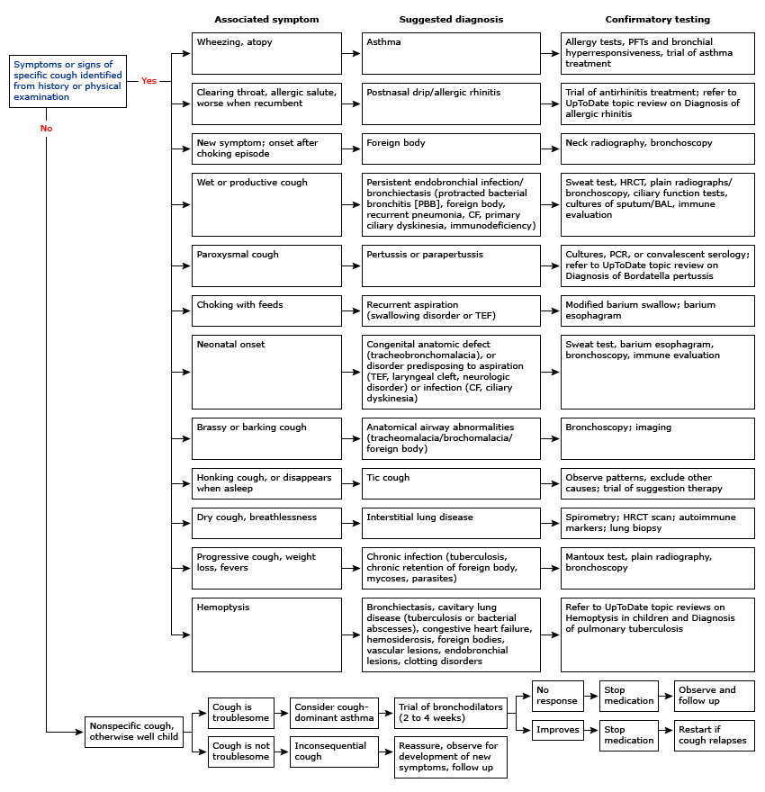

## Cystic Fibrosis: EBG

### Clinical Manifestations

* Pulmonary: Chronic airway disease w/ infection (H flu, S. aureus, P aeruginosa, Burkholderia, Steno, MRSA, atypical), bronchiectasis, air trapping, hypoxemia, hypercarbia
* Sinus: Sinus infections, nasal polyposis
* GI: Meconium ileus, constipation, distal intestinal obstructive syndrome, deficiencies in A, D, E, K, biliary disease
* Endocrine: CF related diabetes, osteoporosis from vitamin D deficiency
* MSK: Hypertrophic osteoarthropathy
* Reproduction: Congenital absence of vas deferens
* Renal: Nephrolithiasis due to chronic metabolic acidosis
* Hematologic: Recurrent venous thrombosis due to chronic inflammatory state

### Diagnosis

* Diagnostic Criteria: CF in 1+ organ system AND evidence of CFTR dysfunction through either elevated sweat chloride, two disease causing mutations, or abnormal nasal transepithelial potential difference
* Sweat Test: <=29 normal, 30-59 intermediate, >=60 abnormal
* Newborn Screen: Massachuesetts NBS measures immunoreactive trypsinogen (IRT) by radioimmunoassay or enzyme-linked immunoassay. If elevated, then DNA is run to look for CFTR mutations.
* CFTR Genetic Analysis

### Pulmonary Exacerbations

Symptoms: Increased cough, change in sputum color/quantity, decreased appetite, weight loss, tachypnea

### Chronic Pulmonary Treatment

* Agents to increase mucus clearance: Albuterol → Inhaled hypertonic saline → Pulmozyme → Chest PT (baseline in 2x per day and during illness increased to 3-4x)
* Anti-inflammatory therapy: Consider azithromycin
* Persistent Pseudomonas Colonization: Inhaled tobramycin and aztreonam
* Vaccines: pneumococcal, yearly influenza
* Supplemental O2: If intermittent or chronic hypoxemia
* Nutritional support: pancreatic enzymes, replacement of fat-soluble vitamins, nutritional counseling
* CFTR modulators: * Ivacaftor “Kalydeco” (CFTR potentiator for C551D mutation) * Lumacaftor/Ivacaftor “Orkambi” (CFTR potentiator + corrects the F508del mutation and increases amount of functional CFTR at surface) * Tezacaftor/Ivacaftor “Symdeko” (CFTR modulator for F508del mutation) * Elexacaftor/Ivacaftor/Tezacaftor “Trikafta” (CFTR potentiator + corrects F508del mutation)
* Annual Screening: OGTT if >12, audiogram

### Treatment CF Exacerbations

* Home meds
* Antibiotics
* Pulmonary clearance regimen
* Bowel regimen

### Admission Labs

* Use “Pulmonary Cystic Fibrosis CPG admit order set”: CBC w/ diff, coags, electrolytes, LFTs, CRP, IgE, IgG, C3, C4, UA
  + Vitamin levels if not done within 6 months (25OH Vit D, PTH, Vit A, Vit E)
  + Urine HcG for women >13
  + Urine specific gravity if starting nephrotoxic IV agent; if >1.012, give 20 cc/kg NS bolus prior to starting

### Lab monitoring:

* Qweek (CBC diff, LFTs, CRP), Qmon/Thurs (BUN/Cr, Abx trough)

### Antibiotics:

* Tailor antibiotic regimen based on previous sputum cultures and antibiotic regimens to provide optimal coverage
  + Pseudomonas aeruginosa: aztreonam, cefepime, ceftazidime, ciprofloxacin, colistimethate, meropenem/imipenem, piperacillin/tazobactam, tobramycin, amikacin, ceftazidime, colistin
    - Inhaled options: tobramycin, aztreonam, amikacin
  + MRSA: vancomycin, linezolid, ceftaroline, bactrim, minocycline, doxycycline, clindamycin
    - Inhaled option: vancomycin
  + MSSA: augmentin, unasyn, cefepime
  + Stenotrophomonas maltophilia: bactrim, minocycline, levofloxacin
  + Haemophilus influenzae: augmentin, azithromycin, ceftriaxone, cefuroxime, cefotaxime, ciprofloxacin, levofloxacin, moxifloxacin, doxycycline, bactrim, unasyn
  + Achromobacter: meropenem, zosyn, bactrim, ceftazidime, cefepime, colistimethate, tobramycin
  + Burkolderia cepacia complex: meropenem, ceftazidime, minocycline, doxycycline, zosyn, bactrim

|  |  |  |  |
| --- | --- | --- | --- |
| Class | Antibiotic | Side Effects | Monitoring |
| Amino-glycoside | Tobramycin | OtotoxicityNephrotoxicityPhototoxicity | Peak/trough w/ 2nd dose, goal peak is 20-40, tough < 1 (IV only) |
| Amino-glycoside | Amikacin | OtotoxicityNephrotoxicityPhototoxicity | PeakAFB= 20-30PSA or Short term dosing=40-60Trough < 2.5 |
| B lactams | MeropenemImipenem | TransaminitisGI intolerance |  |
| B lactams | Ceftaroline (5th generation cephalosporin) |  |  |
| Oxazolidinones | Linezolid | Serotonin syndrome (w/ concurrent SSRI, avoid aged chees, meat, red wine, fava beans) |  |
| Sulfonamide | Trimethoprim- Sulfamex-thoxasole (TMP- SMX, or Bactrim) | Photosensitivity, SJS |  |
| Polycationic | Polymyxin E (Colistin) | Pulmonary toxicity (respiratory failure following inhalation, bronchoconstriction, Nephrotoxicity)Paraesthesias |  |
| Glycopeptide | Vancomycin | Nephrotoxicity, red man syndrome, eosinophilia, DRESS | No peak, goal trough 15-20 (for continuous vanc: q24 until goal level 20-30) |
| Tetracycline | Tigecycline**Minocycline | Photosensitivity, pancreatitis, hepatotoxicity, acute, intracranial hypertension, renal failure, photosensitivity |  |

### Pulmonary Clearance:

Order: Bronchodilator → Hypertonic saline → Pulmozyme → Chest PT → Inhaled steroid and/or inhaled antibiotic

1. Bronchodilators = albuterol, levalbuterol, ipratropium, duoneb
2. Hypertonic saline = 7% usually BID
3. Pulmozyme = 2.5 neb daily or BID (occasionally also 5 mg neb Qday)
4. Chest PT = TID to QID

### Bowel Regimen

Prevention of distal intestinal obstruction syndrome Options:

1. Miralax
2. Dulcolax (oral or PR)
3. Lactulose
4. Mucomyst enema
5. SMOG enema

## Hemoptysis (CF)

### Definition

Acute bleeding >240 cc in 24 hours or recurrent bleeding of >100 cc daily for several days

### Management

* Call for help
* Assess site of bleeding on auscultation and place patient with that side down
* Interventions: attempt to identify bleeding source, hemostasis interventions, chest CT, bronchial artery embolization, tranexamic acid, ECMO
* ORL and GI consult to help evaluate for hematemesis vs. hemoptysis
* Treatment is all guided by the volume of hemoptysis
  + **Scant**: anything from blood-streaked mucous to a teaspoon (5 mL)
    - Consider stopping NSAIDS, but guidelines recommend continuing the rest of the pulmonary clearance regimen!
    - Ensure vitamin K replete
  + **Mild/moderate**: approximately between an ounce and half a cup
    - Here’s where you might consider decreasing pulmonary clearance regimen, weighing the risks of bleeding with the need to remove the inspissated mucous causing the problem
    - Hypertonic saline is more caustic/irritating than dornase alfa
    - If your patient is bleeding so much that you’re considering holding their BIPAP to avoid destabilizing a clot, they should be in a higher level of care
    - Consider tranexamic acid (inhaled or IV) to stabilize clot
    - Bronchoalveolar embolization of the bleeding arteries by interventional radiology is the gold standard treatment
  + **Massive**: more than a cup * Bleeding lung down to the bed to maximize gas exchange in the other lung * ICU stat or code blue

### Clinically stable patient with hemoptysis

|  |  |  |  |
| --- | --- | --- | --- |
| Volume | Scant | Mild/moderate | Massive |
| NSAIDS | No consensus | Stop | Stop |
| Chest PT | Do not stop | No consensus | Stop |
| Hypertonic saline | Do not stop | No consensus | Stop |
| Dornase alfa | Do not stop | No consensus | Stop |
| BIPAP | Do not stop | No consensus | Stop |
| Other considerations | Vitamin K repletionLocation of pain? | Tranexamic AcidIR embolization | Bleeding lung downICU stat |

Source: Cystic Fibrosis Pulmonary Guidelines: Pulmonary Complications: Hemoptysis, 2010 (consensus-based, national guidelines)

## Pneumothorax

### Types

Spontaneous, traumatic, tension ### Presentation Chest pain, SOB, no symptoms, decreased breath sounds, hypoxia, if tension (hypotension, tachycardia, JVD) ### Workup CXR (If concern for tension physiology, skip CXR and go straight to management) ### Management * ABCs, supplemental O2 if hypoxia * Unstable: chest tube placement * Tension: needle decompression 2nd ICS at MCL * Stable/Small: observation * Stable/Large: chest tube or pigtail catheter, VATS w/ pleurodesis if continued air leak (typically after 72 hours)

## Pneumonia: EBG

### Presentation

Fever, cough, dyspnea, pleuritic pain, respiratory distress ### Etiology * Neonatal: GBS, E. coli, K. pneumoniae, HSV * Infants: viral, S. pneumoniae, C. trachomatis * Pre-school age: viral, S. pneumoniae, S. pyogenes, S. aureus, B. pertussis * School-aged: M. pneumoniae, C. pneumoniae, S. pneumoniae, S. aureus

### Differential

Asthma, pleural effusion/empyema, FB aspiration ### Workup CXR, RVP, ESR/CRP, procalcitonin (although WBC, ANC, CRP, and procal do not correlate with illness severity)

### When to Hospitalize

Moderate-severe respiratory distress, SpO2 <90%, infants <6 mos, concern for virulent pathogen (MRSA), unable to tolerate PO intake ### Treatment * Outpatient: amoxicillin * Inpatient: ampicillin * Alternatives: add azithromycin if concern for atypicals, vancomycin if concern for s. aureus * Duration: 10 days, 2-4 weeks if parapneumonic effusion

## Pleural Effusions

### Presentation

* Pain w/ inspiration, hypoxemia, hypercarbia
* Exam: decreased breath sounds, dullness to percussion

### Differential

* Transudative: Decreased plasma oncotic pressure (nephrotic syndrome, cirrhosis, hypoalbuminemia) OR increased capillary hydrostatic pressure (HF, cirrhosis)
* Exudative: Increased capillary permeability (parapneumonic effusions, TB, AI disease, malignancy)
* Chylothorax: Secondary to lymphatic abnormalities

### Workup

* Imaging: CXR, US, CT
* Diagnostic thoracentesis (consider if >10 mm fluid from lung to chest wall, need for definitive diagnosis, respiratory compromise)
  + Light’s Criteria: Exudative if 1+ of (1) Pleural fluid protein:serum protein ratio ≥0.5, (2) Pleural fluid LDH:Serum LDH ratio >0.6, (3) Pleural fluid LDH >66% ULN of normal serum LDH

### Treatment

* Transudative: address underlying problem
* Chylothorax: Drainage, restrict to medium chain TGs as main source of dietary fat
* Parapneumonic effusions (pleural fluid + pneumonia, abscess or bronchiectasis)
  + Uncomplicated: Antibiotics
  + Complicated: Antibiotics + drainage +/- fibrinolytics +/- VATS
* Consider chest tube if: persistent fever, toxic appearing, large effusion, complicated pleural effusion or empyema

## Obstructive Sleep Apnea

### Presentation

* Snoring (>3 nights/wk), labored/obstructive breathing, daytime sleepiness, learning difficulties, FTT
* Exam: tonsillar hypertrophy, adenoidal faces, micrognathia, HTN, overweight

### Differential

Central sleep apnea, narcolepsy ### Workup Polysomnography to assess severity via apnea-hypopnea index (AHI) → >5 AHI warrants treatment ### Treatment CPAP, adenotonsillectomy if adenotonsillar hypertrophy, topical intranasal steroids or montelukast

## Tuberculosis

### Symptoms

Most common presentation in children is pulmonary disease +/- intrathoracic adenopathy. Other sxs include:

* Pulm: Chronic cough >3 wks w/ weight loss, fever, diaphoresis, miliary TB
* CNS: Meningitis, communicating hydrocephalus, stroke, increased ICP
* Abd: Ascites, abdominal pain, jaundice, chronic diarrhea
* MSK: Joint effusion, Pott’s disease
* Derm: Warty/papulonecrotis lesions, erythema nodosum
* Renal: Sterile pyuria, hematuria
* Ocular: Iritis, neuritis, conjunctivitis

### Workup

* Bacteriologic Diagnosis
  + Infants: 3 early morning gastric aspirates for AFB, Cx, PCR
  + Children/Adolescents: 3 sputum for AFB, Cx, PCR
  + PCR: Xpert MTB/RIF detects M. tuberculosis and rifampin resistance
* Clinical Diagnosis
  + Recent close contact w/ known infectious case + positive tuberculin skin test (TST) or interferon-gamma release assay (IGRA) + suggestive findings on CXR or exam

### Treatment

* General: Rifampin, INH, pyrazinamide, ethambutol (RIPE) 2 mo → rifampin and INH (RI) for 4 mos
* TB Meningitis: RIP + streptomycin (SM) 2 mo → RI for 7-10 mo
* Osteoarticular: RIPE 2 mo → RI 7-10 mos
* Relapse: RIPE + SM 2 mo → RIPE 1 mo → RIE 5 mo

## Pulmonary Function Tests

* Indications:
  1. Determine the nature of an unknown disease process
  2. Study progression of known disease (asthma, CF)
  3. Evaluate effect of therapy
  4. Establish a baseline in pts whose lung function is affected by a disease
* Difficult to reliably obtain in children <6
* Reference values depend on age, height, gender, race

### Definitions

#### Forced vital capacity (FVC)

Measures total amount of air you can exhale w/ force after you inhale as deeply as possible

#### Forced expiratory volume 1 (FEV1)

Measures the amount of air you can exhale w/ force in one breath. The amount of air you exhale measured at 1 second #### Forced expiratory flow 25% to 75% This measures the air flow over the middle half of the FVC #### Peak expiratory flow (PEF): The maximum flow rate obtained during a forced exhalation. It is usually measured at the same time as your forced vital capacity (FVC) #### Total lung capacity (TLC) This measures the total volume of air in your lungs after you inhale as deeply as possible #### Functional residual capacity (FRC) This measures the amount of air in your lungs at the end of a normal exhaled breath #### Expiratory reserve volume (ERV) This measures the difference between the amount of air in your lungs after a normal exhale (FRC) and the amount after you exhale w/ force (RV)

## Obstructive vs. Restrictive Lung Disease

|  |  |  |
| --- | --- | --- |
|  | Obstructive | Restrictive |
| **Definition** | The airways are narrowed, usually causing an increase in the time it takes to empty the lungs. Affect flow. | Either a loss of lung tissue, a decrease in the lungs’ ability to expand, or a decrease in the lungs’ ability to transfer oxygen to the blood. Affect volume. |
| **FVC** | Decreased | Decreased |
| **FEV1** | Decreased | Decreased |
| **FEV1/FVC** | Decreased | Normal or increased |
| **TLC** | Normal | Decreased |
| **Differential Diagnosis** | Asthma, bronchiectasis, bronchiolitis obliterans, cystic fibrosis, alpha 1 antitrypsin deficiency | Chest wall: ankylosing spondylitis, kyphosis, obesity, scoliosisDrugs: amiodarone, methotrexate, nitrofurantoinInterstitial lung disease: pneumonia, hypersensitivity pneumonitis, idiopathic pulmonary fibrosis, sarcoidosis, exposures (asbestos, beryllium) Neuromuscular disorders: Guillain-Barre syndrome, muscular dystrophy, myasthenia gravis |
| **Extent of Defect** | % of predicted FEV1: Normal >80%, Mild ~80%, Moderate 60-80%, Severe <60% FEF 25-75: Decreased | % of predicted TLC: Normal >80%, Mild 70-80%, Moderate 60-70%, Severe <60% |
| **Pattern** |  |  |

## Bronchodilator/Bronchoprovocation Testing in Asthma

* Response to bronchodilator: significant if FEV1 improved by >12-15%
* Exercise challenge: 12-15% decrease in FEV1 is indicative of airway responsiveness
* Cold air challenge: 12-15% decrease in FEV1 is indicative of airway responsiveness

## EVALI (E-Cigarette and Vaping Associated Lung Injury)

### Presentation

* Shortness of breath, cough, chest pain, pleuritic chest pain, hemoptysis, fever, chills.
* Commonly also includes GI symptoms such as nausea, vomiting, diarrhea, abdominal pain.
* Can have hypoxemia, tachycardia, and tachypnea.

### Etiology/Pathophysiology

* Acute lung injury with pathologic findings of acute fibrinous pneumonitis, diffuse alveolar damage, eosinophilic pneumonia, or organizing pneumonia.
* No infectious etiology identified. Majority related to THC or vitamin E acetate in vaping compound but exact cause is unknown.

### Differential

* Community-acquired pneumonia
* Acute eosinophilic pneumonia
* Organizing pneumonia
* Lipoid pneumonia
* Diffuse alveolar hemorrhage
* Hypersensitivity pneumonitis
* Respiratory bronchiolitis interstitial lung disease
* Giant cell pneumonitis

### Proposed Criteria for Diagnosis

* Clinical symptoms as above (pneumonia-like syndrome, dyspnea, hypoxemia)
* Use of e-cigarette in the past 90 days
* Exclusion of lung infection or plausible alternate diagnosis
* Lung opacities on CXR or CT

### Workup

* CXR +/- CT
* CBC with diff
* Influenza PCR or rapid test
* Respiratory viral panel
* Sputum culture +/- blood culture
* Urine antigen test for Legionella and Strep pneumo
* Testing for HIV-related opportunistic infections if indicated by history
* Consider bronchoscopy and bronchoalveolar lavage

### Consults

* Pulmonary
* Infectious Diseases

### Treatment

* Empiric antibiotics for CAP
* Systemic glucocorticoids (with guidance of pulmonary team)
* Supportive care

# Rheumatology

## Pediatric approach to rheumatic disease

* Rheumatology is a field of many unknowns, however, it occurs when chronic inflammation affects the MSK system, blood vessels, and other tissues, presenting with periods of exacerbation and remission
* History is essential: constitutional sx, joint/muscle sx (limp, stiffness, regressing milestones, problems walking/with stairs/dressing), pain, rashes, ulcers, chest pain
* Physical exam: focus on eyes, skin, muscle, joints
  + For arthritides see below
* Vaccinations: A few guidelines, but contact Rheumatology for guidance
  + Varicella, live virus/bacteria vaccines: contraindicated in children taking high dose steroids and biologics
  + IVIG: children should wait anywhere from 8-11 months after the last dose for immunizations. PPSV23 and PCV13 should be given to children on immunosuppressants
  + Most importantly, consider the whole picture when arriving at a diagnosis. Presentation, personal/family history, labs must all be taken into account. Autoantibody testing is helpful, however, it is not always diagnostic.

## Inflammatory markers and autoantibodies

|  |  |
| --- | --- |
| Marker | Description |
| **CRP** | -Acute phase reactant, produced by liver in response to pathogens/inflammation/tissue damage. -Level rises ~ 4-6 hours after injury/infection, peak at ~24-72 hours, then falls after appropriate treatment -CRP can be normal in SLE, JDM/PM, scleroderma, and Sjorgen’s |
| **ESR** | -Acute phase reactant, non-specific marker of inflammation -Rate at which RBCs settle through plasma to form sediment at the bottom of a tube -Slower rise and slower fall compared to CRP -May be elevated due to anemia or hypergammaglobulinemia -May fall quickly in DIC or other conditions that consume or decrease production of fibrinogen |
| **ANA** | -Autoantibodies directed against antigens predominantly found in the nucleus -Conditions associated w/ (+) ANA: —*Autoimmune*: SLE, MCTD, Sjogren’s, Juvenile Ssc, JIA, JDM, autoimmune hepatitis, Graves’, Hashimoto’s —*ID*: EBV, HIV, TB, SBE —*Systemic inflam.*: lymphoproliferative disorders, interstitial pulmonary fibrosis, asbestosis -Medications associated w/ (+) ANA and drug-induced lupus (+anti-histone Ab): —Procainamide (90%), Hydralazine (65%), Anti-TNF agents (especially infliximab), INH, Quinidine, Phenytoin, Sulfasalazine, Minocycline, Lithium, chlorpromazine -Titers do not correlate w/ disease severity -Can be found in 10-15% of healthy children, most of whom do not develop autoimmune disease |
| **ANCA** | -Ab targeting antigens in cytoplasmic granules of neutrophils; highly sensitive for vasculitides that have predominant pulmonary and renal involvement -Not used on its own for screening patients, as they can be found in non-vasculitides -**Cytoplasmic (c-ANCA)**: antibody to proteinase-3 & positive in about 90% of patients w/ Granulomatosis w/ Polyangiitis (formerly Wegener’s granulomatosis) -**Perinuclear (p-ANCA)**: antibody to myeloperoxidase & associated w/ microscopic polyangiitis, Churg-Strauss, Ulcerative colitis -Titers often do not correlate w/ disease severity |
| **RF** | -IgM autoantibody that reacts to Fc portion of IgG antibodies-Present in 2-7% of children w/ JIA -Useful for predicting erosive disease in polyarticular JIA -Higher titers can be seen in Sjogren’s Syndrome, MCTD, GPA-Also seen in infections: Chagas, SBE, Hep C, EBV -Circulating immune complexes may give false positive RF results |
| **dsDNA** | -IgG, directed toward ds-DNA -High specificity for SLE -Rising levels associated with flares |
| **SSA/Ro SSB/LA** | -Sjogren’s syndrome-Cutaneous lupus -Neonatal lupus/congenital heart block-La less common and usually not found w/o Ro |
| **CCP (ACPA)** | -High specificity, low sensitivity for JIA-Adults: 70-80% of RA, predicts erosive disease |
| **Sm (Smith)** | -High specificity, 30% of juvenile SLE, 60% of adult SLE-Remains positive when SLE in remission |
| **RNP** | ->95% MCTD-SLE |
| **Scl-70** | -Systemic sclerosis-Assoc. w/ pulmonary fibrosis |
| **Jo-1** | -20% of DM/PM-Associated w/ ILD-Mechanic hands-Most frequent Ab in antisynthetase syndrome |

## Childhood Vasculitides

|  |  |  |  |  |
| --- | --- | --- | --- | --- |
| *Most Common | Age | Symptoms/Signs | Biopsy/Labs | Treatment |
| ***Large Vessel*** |  |  |  |  |
| **Takayasu’s arteritis** | FemalesHigher in Asian pop Adol. | Pulseless DiseaseBlood pressure dif >10 between limbsBruit over aorta, carotids | Granulomatous inflammation of the aortaelevated ESR/CRP | SteroidsAntiplatelet drugsSurgery |
| ***Medium Vessel*** |  |  |  |  |
| **Polyarteritis nodosa**\* | Middle childhood | Livedo reticularis, skin nodules, myalgia, HTN, renal involvement | Transmural fibrinoid necrosisUrinalysis: proteinuria/hematuria | SteroidsCyclophosphamide/azathioprineanti-TNF biologics |
| **Kawasaki Disease**\* | Young children (higher in Asian pop.) | CRASH: Conjunctivitis, Rash, Adenitis, Strawberry tongue, Hand/foot swellingCoronary artery aneurysms | Complete: clinical Incomplete: clinical + labs (see below)Cardiac echo | IVIGAspirinSteroids |
| ***Small Vessel*** |  |  |  |  |
| **Microscopic polyangiitis** | 9-12 yo | HTN, hematuriaHemoptysisPurpura, ulcers | p-ANCANo granulomasNecrotizing glomerulonephritis | SteroidsCyclophosRituximab |
| **Granulomatosis w/ Polyangiitis (Wegener’s)** | Young adults (20s)F>M | Hemoptysis/alveolar hemorrhageChronic sinusitis, otitis, mastoiditis | c-ANCANecrotizing granulomas in upper/lower airway, focal segmental necrotizing GNUrinalysis: proteinuria/hematuria CXR: nodules | MTXSteroidsRTX/CYCPheresis (severe) |
| **Eosinophilic granulomatosis w/ polyangiitis (Churg-Strauss)** | 12yoF>M | Asthma, allergic rhinitis,sinusitisPeriph. NeuropathyCardiomyopathy | p-ANCAEosinophiliaExtravascular necrotizing granulomas | SteroidsCyclophosMepolizumab |
| **Henoch-Schonlein Purpura (HSP)**\* | Most common vasculitis in children3-15yoM>F | Palpable purpuraArthritis/arthralgiasAbdominal painRenal disease (IgA nephro) | IgA mediatedUrinalysisRenal/skin biopsyAbd U/S: intussusception | SupportiveNSAIDsHydrationSteroids |
| **Behcet disease** | Age of onset varies | Aphthous stomatitisGenital ulcerationUveitis, erythema nodosum, purpura, acneiform lesions, pathergyDVT, arterial aneurysm | Associated with HLA-B51Involves arterial and venous system, occlusive vasculitisElevated ESR/CRP | Ulcers: sucralfate/GCs/infliximabUveitis: azathioprine/GCsGCs, DMARDs, Biologics |

## Henoch-Schonlein Purpura (IgA vasculitis)

**Etiology**:

* No clear etiology
* Frequently preceded by upper respiratory infections (esp streptococcus, staphylococcus, and parainfluenza) or immunizations

**Pathophysiology**:

* Deposition of IgA-containing immune complexes in vessel walls of affected organs and in kidney mesangium activates alternative complement pathway (w/ deposition of C3)
* HSP nephritis and IgA nephropathy are histologically identical

**Clinical Manifestations**:

* Palpable purpura: symmetric, lower limb predominance
  + Present in all cases, but may not be presenting symptom
* Arthralgias/arthritis: oligoarticular, large lower extremity joints (knees, hips, ankles)
  + Occurs in ¾ of cases
* Abdominal pain: diffuse pain, colicky, worse after meals, often w/ nausea or vomiting
  + Occurs in 2/3 of cases
  + 3-4% of HSP patients develop intussusception
* Renal disease: hematuria is most common, but proteinuria/hypertension may be seen
  + Occurs is 20-50% of cases
  + Usually delayed 1-2 weeks after onset
  + <15% children have long-term kidney damage, <1% develop renal failure

**Diagnosis**:

* Palpable purpura (w/o thrombocytopenia or coagulopathy), and ≥1 of the following:
  + Abdominal pain
  + Arthritis/arthralgias
  + Biopsy w/ leukocytoclastic vasculitis (skin) or glomerulonephritis w/ IgA deposition (renal)
* Urinalysis (screen for renal involvement), CBC (Plt normal to elevated), IgA level (NOT helpful)
* Abdominal ultrasound if c/f intussusception

**Treatment**:

* Self-limited, supportive care
* Mild/moderate pain: naproxen
* F/u with PCP for weekly/biweekly urinalysis and BP checks for 1-2months
* Severe pain: steroids reduce sx but do not change clinical course, requires taper (4-8wks)
* Severe renal involvement: proteinuria/hematuria, requires closer follow-up and steroids

## Kawasaki Disease

**Epidemiology**:

* Acute, self-limited systemic vasculitis of medium-sized arteries in infants/children
* Average age of onset ~ 2 years w/ 80% occurring in those < 4 years old
* Incidence in US: 17-18/100,000, M:F = 1.6:1
* Incidence doubled for Asian Americans, highest incidence in Japan
* Increased rates in winter & spring

**Pathophysiology**:

* May be related to infectious triggers
* Vasculitis begins as a neutrophilic infiltrate; plasma cells producing IgA in vessel walls

**Clinical Manifestations**:

* Classical criteria = fever ≥ 5 days w/ ≥ 4/5 classical criteria, w/o alternative diagnosis
  + *Conjunctivitis*: Bilateral bulbar conjunctival injection (non-exudative & limb sparing)
  + *Rash*: Polymorphous rash (maculopapular, diffuse erythroderma, or erythema multiforme-like)
  + *Adenopathy*: Cervical lymphadenopathy (≥1 lymph node, > 1.5 cm in diameter), usually unilateral
  + *Serositis*: Injected/fissured lips, injected pharynx, or strawberry tongue.
  + *Hand/Feet*: Erythema of palms/soles, edema of hands/feet (acute), periungual desquamation (convalescent)

#### **Complete KD**:

* Fever ≥ 5 days and ≥ 4 principal clinical features OR fever ≥ 4 days and 5 clinical features

#### **Incomplete (Atypical) KD**:

* 2 possible diagnostic criteria:
  + 1. 0 or 1 clinical criteria in a child <6 months old and fever >7 days PLUS positive echo
    2. Fever ≥ 4 days + 2-3 clinical criteria + elevated ESR/CRP + ≥ 3 supplemental labs OR positive echo
  + Supplemental labs:
    - Anemia for age
    - ALT > 50 units/L
    - Platelet count > 450,000 after 7th day of fever
    - WBC > 15,000/mm3
    - UA w/ > 10 WBC per hpf (sterile pyuria)
    - Albumin < 3.0 g/dL

**Other clinical findings**

* Neuro: Irritability, hearing loss, facial nerve palsy
* Cardiac: Coronary artery aneurysms, depressed myocardial function, pericardial effusion, prolonged PR interval.
  + *Risk factors for CA aneurysms include*: male, <1 y/o, prolonged fever, elevated CRP, low platelets, low albumin levels on diagnosis
* GI: Pain, vomiting/diarrhea, hepatitis, acute acalculous distention of the gallbladder
* MSK: Arthritis, arthralgias (pleocytosis of synovial fluid)
* GU: Urethritis/meatitis, hydrocele

**Studies**

* Echocardiogram w/i 24 hours (abnormal echo= coronary artery Z score ≥ 2.5)

**Treatments**

* IVIG (2g/kg) infused over 12 hours→ repeat, if febrile, 36 hours after first infusion.
* Aspirin: medium dose (30-50 mg/kg/d divided QID) until afebrile x 48 hours. Then low dose (3-5 mg/kg/d). (consider starting w/ low dose for age ≤ 6 mo)
* Corticosteroids: trials indicate that steroids may be effective as primary/rescue therapy.
* Repeat echo post-treatment, either before or after discharge, to observe improvement
* Patients w/ severe CA dilation may need long-term anticoagulation therapy
* Under study: infliximab, cyclosporine, other immunomodulatory agents

## Polyarteritis Nodosa

**Etiology**:

* Focal, segmental, fibrinoid necrosis of walls of medium/small arteries leading to aneurysms
* Rarely caused by loss-of-function mutation in adenosine deaminase 2

**Cutaneous PAN**:

* Nodular, painful, non-purpuric lesions, +/- livedo reticularis, w/o systemic involvement (as in sPAN)
* Ass. w/ fever, elevated acute phase reactants, myalgia, arthralgia, non-erosive arthritis
* Biopsy: necrotizing non-granulomatous vasculitis
* Labs: ANCA neg, may see + ASO (up to ⅓ of cases are triggered by a strep infection)

**Systemic PAN**:

* EULAR/PRINTO/PRES Criteria: biopsy for histopathology (necrotizing vasculitis) OR angiography (aneurysms, stenosis, occlusions), AND ≥ 1 of:
  + Skin: livedo reticularis, tender subcutaneous nodules, superficial/deep skin infarctions
  + Rheum: Myalgia or muscle tenderness
  + Cardio: HTN
  + Neuro: Peripheral neuropathy, sensory or motor mononeuritis multiplex
  + Renal: proteinuria, hematuria, RBC casts, GFR <50% normal for age
* Labs: ANCA negative

**Laboratory Studies**:

* ANCA, ANA, C3/4, CRP, ESR
* Urinalysis, Cr
* Consider other causes: infectious, thrombotic, other autoimmune diseases

**Complications**:

* Acute: organ failure (cardiac, pulmonary, renal), thrombi, hemorrhage, infection
* Chronic: HTN, ischemic cardiomyopathy, CKD, mesenteric arteritis, hearing loss, orchitis

**Treatment**:

* Mild (normal renal function, no significant/life-threatening complications): Steroids, may add Azathioprine or MTX
* Moderate to severe (ex: kidney involvement, proteinuria, neuro/cardiac/GI complications): Steroids + Cyclophosphamide, with eventual switch from Cyclophosphamide to Azathioprine or MTX, TNF inhibitors useful as well, especially in cutaneous PAN and DADA2
* Pheresis considered in organ threatening disease
* HTN: ACE Inhibitor

## Connective Tissue Disorders

### *SLE*

**Clinical**:

* Rash (malar, discoid), photosensitivity, serositis, nephritis, oral/nasal ulcers, seizure, psychosis, arthritis

**Lab markers**:

* Cytopenias (+)
* anti-RNP (30%)
* +anti-dsDNA (40-60%, assoc w SLE activity and lupus nephritis)
* +anti-Smith (30%, w/ high specificity, remains + in remission)
* +anti-SS-A (Ro, 40%)
* +anti-SS-B (La, 10-15%, more specific than Ro)
* Low C3/C4

### *Juvenile Polymyositis*

**Clinical**:

* Proximal muscle weakness (symmetric) +/- tenderness
* Makes up 3-6% of childhood idiopathic inflammatory myopathies

**Lab markers**:

* CK
* Aldolase
* LDH
* AST and ALT (rarely nl unless “burnt out”)
* (+)anti-Jo-1 (20%, a/w ILD, mechanic hands)
* (+)anti-mi2 (5-7%, a/w acute onset, shawl sign, good prognosis)

### *Juvenile Dermatomyositis*

**Clinical**:

* Proximal muscle weakness (symmetric) +/- tenderness
* Rash (heliotrope on upper eyelids, shawl sign on back, V-sign on chest)
* Nailfold capillary changes (dilation, tortuosity)
* Gottron’s papules or scaly eruption over extensor surfaces such as knuckles (pathognomonic)
* Skin ulcerations - indicate worse prognosis
* Most common idiopathic inflammatory myopathy of childhood (85% of all such myopathies)

**Other**:

* ILD in 10%, upper esophageal involvement (dysphagia) in 25%; may cause life-threatening aspiration

**Lab markers**:

* (+)anti-Jo-1 (20%, a/w ILD, mechanic hands)
* (+)anti-Mi2 (5-7%, a/w acute onset, shawl sign, good prognosis)
* (+)anti-MDA5 (ILD, poor prognosis)

### *Sjogren’s*

**Clinical**:

* Sicca sx (dry mouth/eyes)
* Vasculitis
* Interstitial nephritis
* Neuropathy; 5% lifetime risk of NHL

**Lab markers**:

* (+)ANA
* (+)anti-SS-A (Ro, 70%)
* (+)anti-SS-B (La, 50-70%, more specific)
* (+)RF

### *Scleroderma*

**Clinical**:

* Skin tightening & thickening prox to forearms
* Nail fold capillary dilatation & dropout
* ILD & later stages PAH
* GI dysmotility
* Renal crisis (tx w/ ACE-I)

**Lab markers**:

* (+)anti-Scl 70 (30%)
* (+)anti-centromere (15%)

### *CREST*

**Clinical**:

* Calcinosis
* Raynaud’s phenomenon
* Esophageal dysmotility
* Sclerodactyly
* Telangiectasias

**Lab markers**:

* (+)anti-centromere (60%), associated with PAH
* (+)anti-Scl 70 (15%)

### *Mixed Connective Tissue Disease*

**Clinical**:

* Overlapping features of SLE
* Polymyositis
* Systemic sclerosis
* Raynaud phenomenon
* Swollen fingers
* Arthritis
* Inflam myopathy
* Pleuritic
* Pulm fibrosis, etc.

**Lab markers**:

* Anti-U1-RNP (Ribonucleoprotein) should be positive

**Treatment**:

* NSAIDs
* Corticosteroids
* ACE-I
* Supportive measures

## Systemic Lupus Erythematosus

**Definition**:

* Multiorgan system autoimmune disorder with markedly variable presentations/course

**Epidemiology**:

* F>M
* Most often after age 8 yo
* Median age of onset for juvenile SLE 12-13 yo
* More common in people of Asian, African, and Hispanic race/ethnicity vs Caucasian

**Other presenting symptoms**:

* Constitutional: Fever, Weight loss, Anorexia
* Physical exam: Raynaud’s, LAD, HSM, HTN

**Neonatal Lupus Erythematosus (NLE)**:

* 1-2% of Infants born to mothers w/ anti-Ro and/or anti-La antibodies (transplacental)
* Auto-Ab interfere w/ development of cardiac conduction system → permanent AV block -Flat/erythematous, annular, photosensitive rash that spontaneously resolves ~6 mo of age (as maternal Abs dissipate)
* No increased risk of autoimmune diseases later in life

|  |  |
| --- | --- |
| SLICC Criteria (Not validated in children/adolescents) | 4+ criteria, including 1+ clinical and 1+ immunologic (serial or simultaneously), w/o alternative explanation OR SLE nephritis with +ANA/+dsDNA |
| **Acute cutaneous lupus** | Malar rash, bullous, TEN variant, photosensitive rash |
| **Chronic cutaneous lupus** | Discoid, hypertrophic/verrucous, panniculitis, mucosal, chilblains, erythema timidus |
| **Non-scarring alopecia** | Diffuse thinning or hair fragility with visible broken hairs |
| **Oral/Nasal Ulcers** | Palate, buccal, tongue, or nasal |
| **Joint Disease** | Synovitis in 2+ joints (swelling/effusion) OR 2+ joint tenderness + >30m AM stiffness |
| **Serositis** | Pleurisy or pericardial pain ≥1d, pleural or pericardial effusion, pleural or pericardial rub, pericarditis on TTE |
| **Renal** | ≥ 500 mg protein/day or RBC casts |
| **Neuro** | Seizures, psychosis, mononeuritis multiplex, myelitis, peripheral/cranial neuropathy |
| **Hemolytic anemia** | Autoimmune (direct Coombs+), thrombotic MAHA (TTP, HUS) |
| **Leuko/lymphopenia** | Leukopenia <4000/mm^3, lymphopenia <1000/mm^3 |
| **Thrombocytopenia** | <100,000/mm^3, including ITP, TTP |
| **Immuno** | ANA (+) , Anti-dsDNA (+) or >twofold reference range on ELISA |
| **Low complement** | Low C3, C4, or CH50 |
| **Direct Coombs test** | Positive in absence of hemolytic anemia |
| **Antiphospholipid** | Lupus anticoagulant, RPR (false positive), anticardiolipin Ab, or beta 2-glycoprotein I |

**Treatment**:

* Initial: Hydroxychloroquine (< max 5 mh/kg/d, need regular ophtho evals for visual field testing and color vision) + glucocorticoids (IV or PO depending on severity)
* Mild: No renal/organ involvement→hydroxychloroquine, NSAIDS - arthralgia, Dapsone - derm, MT - arthritis. Can use LD prednisone (<0.35 mg/kg/d), but if needs >3 mo consider second-line agent (ex: MMF)
* Mod: Renal/organ involvement → consider MMF, azathioprine, rituximab, systemic steroids
* Severe: Substantial renal/neuro disease → cyclophosphamide
* Flares:Steroids + MMF, or cyclophosphamide if already on MMF/azathioprine

## Inflammatory Myopathies

|  |  |  |  |
| --- | --- | --- | --- |
|  | Polymyositis | Dermatomyositis | Inclusion Body Myositis |
| **Path** | CD8+ T cells | CD4+ T Cells | Inflam/neurodegen |
| **Clinical** | Symmetric proximal muscle weakness (shoulders) | Symmetric proximal muscle weaknessGottron papules, heliotrope (periorbital) rash,“shawl+face ’rash,“mechanics hands” | Distal >> Proximal muscle weakness (Extremely rare in children) |
| **Labs** | Increased CK, ANA (+) | Increased CK, ANA (+) | Increased CK, ANA (+) |
|  | Anti-MI-2/MJ | Anti-Jo-1 (Anti-tRNA-synthetase) | Anti-cN1A |
|  | Bx: Endomysial inflam | Bx: Perimysial inflam/atrophy (myopathic), Von Willebrand Factor Ag | Bx: Basophilic rimmed vacuoles, ragged-red fibers |
| **Assoc.** | Autoimmune (Crohn’s, Vasculitis, Sarcoidosis, MG) | Lipodystrophy, Calcinosis, ILD, GI bleedJuvenile DM NOT assoc. w/ malignancy like adults | - |
| **Treatment** | Steroids (prednisone) followed by long-term immunosuppression (MTX, cyclosporine) | Steroids (prednisone) followed by long-term immunosuppression (MTX, cyclosporine) | Not steroid responsive |

## Sjogren Syndrome

**Pathophysiology**:

* Inflammatory autoimmune disorder of exocrine glands (salivary/lacrimal glands)

**Exocrine features**:

* Keratoconjunctivitis sicca → dry mouth, salivary hypertrophy, Xerosis of skin
* Xerophthalmia (dry eyes, conjunctivitis, sensation of sand in eyes)
* Xerostomia (dry mouth, dysphagia, enlarged parotid glands, dental caries)

**Extraglandular features**:

* Arthritis/arthralgias, Raynaud phenomenon, Cutaneous vasculitis, ILD

**Lab tests**:

* Anti-SSA (Anti-Ro) Abs and Anti-SSB (Anti-La) Abs
* Schirmer Test – objective signs of decreased lacrimation
* Salivary gland biopsy w/ focal lymphocytic sialadenitis

**Treatment**:

* Dry eyes: Artificial tears, cyclosporine drops
* Dry mouth: Muscarinic agonists – pilocarpine, cevimeline
* Arthritis: Hydroxychloroquine or methotrexate

## Pediatric arthritides: Approach to Joint Disease

**Questions to consider**:

* Which joint(s) is/are affected?
* For how long? Persistent vs. intermittent?
* Is there morning stiffness?
* Has the distribution changed over time?
* Does anything make joint pain better or worse (e.g. movement or prolonged inactivity)?
* What are associated symptoms (fever, rash, weight loss, etc.)?
* Family history of arthritis or autoimmune disease?
* Any exposures (camping, sexual activity, viral illness, etc.)?

**Differential for joint pain**

* ***Trauma/Overuse***: LCP, SCFE, patellar tendonitis, patellofemoral syndrome (sports med!)
* ***Infection***:
  + Septic arthritis (red, hot, angry, WBC >50K on joint tap)
  + Lyme Disease (may or may not have seen tick or noticed other Lyme symptoms)
  + Endocarditis (persistent fever and positive cultures)
  + Rheumatic Fever (h/o strep throat)
  + Transient Synovitis (h/o recent URI)
* ***Inflammatory/Autoimmune***:
  + Lupus
  + JIA
  + sJIA

## Juvenile Idiopathic Arthritis

* International League Against Rheumatism (ILAR) → 6 sub-categories+ “undifferentiated” category (not shown)
* Controversy as to whether juvenile and adult inflammatory arthritides should be considered distinct from each other based on genetic and clinical parallels

**Definitions**:

* ***JIA***: Clinical diagnosis based on having objective signs of arthritis in ≥1 joint for ≥ 6 weeks in a child < 16 after other types of childhood arthritis have been excluded
* ***Oligoarticular***: up to 4 joints affected in first 6 months after diagnosis. Can be “persistent” or “extended”, based on whether stays limited past the 6 month mark
* ***Polyarticular***: affects more than 5 joints in first

|  |  |  |  |  |  |  |
| --- | --- | --- | --- | --- | --- | --- |
| Subtype | Age | F: M | % JIA | Pattern | Extra-articular/Notable Features | Treatment |
| **Systemic** | 1-5 | 1:1 | 5-15 | Polyarticular (U/L ext, neck, hips) | Recurrent fever and evanescent rash; organ dysfxn; MAS, *note uveitis rare in this population | NSAIDS, MTX, IL-1 inhibitor, IL-6 inhibitor |
| **Oligo** | 2-4 | 5:1 | 30-50 | Knee, ankle, wrist, elbow | <5 joints | Uveitis |
| **Poly RF(-)** | 2-4 | 8-12 | 3:1 | 10-30 | Symmetric; small joints (e.g. hands)>5 joints | Uveitis |
| **Poly RF(+)** | 9-12 | 3:1 | <10 | Symmetric; small joints (e.g. hands) >5 joints | Rheumatoid nodules, *note uveitis rare in this population | NSAIDS, MTX, anti-TNF |
| **Psoriatic** | 2-4 | 9-11 | 2:1 | 5-10 | Knees, ankles, tenosynovitis of digits “sausage” | Uveitis, Psoriasis or FmHx, Dactylitis, Nail Changes |
| **Enthesitis-related** | 9-12 | 1:3 | 5-10 | Sacroiliac/axial | IBD, HLA-B27 positivity | NSAIDS, steroids, sulfasalazine, anti-TNF |

## Systemic JIA (Still’s disease)

* Complex pathogenesis: autoimmune (genetic risk factor in MHC complex) vs. autoinflammatory (F=M, cyclic fevers, response to IL1 inhibitors)
  + Fever and rash may precede chronic arthritis
  + Early disease is mediated by inflammatory cytokines IL-1, IL-6 etc
  + Macrophage activation syndrome is a complication associated with sJIA
  + ILAR classification: Arthritis in ≥1 joint with or preceded by fever for ≥2 weeks that manifests as a daily or “quotidian” in timing for at least 3 days + one or more of the following:
    - Evanescent erythematous rash (i.e. comes and goes, often worse with fever)
    - Lymphadenopathy
    - Hepato/splenomegaly
    - Serositis

**Treatment**:

* Cytokine inhibitors can attenuate disease progression (ie.anakinra and canakinumab)
* For patients that develop chronic arthritis, co-stimulatory blockade of T-cells has anecdotally provided benefit (e.g. abatacept)

## Macrophage Activation Syndrome (MAS)

* A secondary form of hemophagocytic lymphohistiocytosis (HLH)
* Dysregulation of the immune system with ineffective cytotoxic T and NK cell response leading to cytokine storm and over activation of macrophages
* Can occur with most systemic/rheumatic disorders (ie KD, SLE) OR in the setting of viral illnesses such as EBV
* Incidence is much higher in sJIA (~10-20%)
* PRINTO diagnostic criteria for MAS in SJIA:
  + Fever and serum ferritin > 684ng/mL + any two of the following:
    - Platelet count ≤ 181*109/L
    - AST (>48U/L)
    - Triglycerides > 156mg/dl
    - Fibrinogen ≤ 360 mg/dl

**Workup and Treatment**

* BCH EBG available → Page 1 = workup (not shown); Page 2 = Treatment (below)
* Multidisciplinary treatment of patient including Rheum and Immunology ![MAS](MAS.png)

## Fever of Unknown Origin

* Age >3 months
* Parent report of fever measured at >38 C daily for >=7 days
* No source identified during prior workup
* BCH EBG available

**Initial Workup**:

* Chem 10, LFTs, Ferritin
* IgG level
* LDH, Uric acid
* UA, Urine culture
* Blood culture
* EBV, CMV
* Viral respiratory testing, CXR
* Additional possible testing on individual basis: HIV, PPD/T-spot, Bartonella IgG and IgM, peripheral blood smear, echocardiogram

**Consults**:

* Infectious Disease
* Rheumatology (if >=1 met):
  + Age <12 months with ESR >=40 mm/hr or CRP >3 mg/kL
  + Ferritin >=500
  + IgG level >=2000 mg/dL
  + Joint symptoms
  + Rash (especially malar, heliotrope, or livedo reticularis)
  + Serositis
  + Inflammatory eye disease
  + 1st degree relative with rheumatologic disease
* GI
  + Poor growth
  + Prominent GI symptoms
  + Anemia
  + Elevated inflammatory markers
* Immunology
  + Recurrent and/or opportunistic infections
  + Failure to thrive
* Oncology
  + Abnormal CBC (cytopenias, blasts)
  + Elevated LDH and/or uric acid

## Autoinflammatory Diseases

**Autoimmune vs. Autoinflammatory**

* In broad strokes, autoinflammatory conditions are thought to be due to disruptions in innate immunity, whereas autoimmune conditions are due to disruptions in immune tolerance/adaptive immunity
* Autoinflammatory conditions often have mutations in genes related to the inflammatory cascade leading to uncontrolled inflammation with high levels of pro-inflammatory cytokines, fevers + rashes, and a similar incidence in males and females; biologics that block IL-1 and IL-6 can be helpful
* Autoimmune conditions may have auto-antigens and auto-reactive T-cells and B-cells; fever is not a core feature, although may be present; usually F>M; drugs that inhibit T-cells and B-cells are more useful (e.g. calcineurin inhibitors, MTX, rituximab)
* These divisions are not black and white, and most diseases are thought to lie on the spectrum and/or develop in immune pathophysiology over time (see sJIA)

**Diagnosis**

* Careful H&P (r/o malignancy, infection, cyclic neutropenia) → may confirm w/targeted genetic testing

**Categories**

* Includes both periodic fever syndromes as well as non-periodic fever syndromes

### Periodic Fever Syndromes

|  |  |  |  |  |  |
| --- | --- | --- | --- | --- | --- |
|  | FMF (Familial Mediterranean Fever) | TRAPS (TNF Rec.-associated Periodic Syndrome) | HIDS (Hyper IgD Syndrome a.k.a. Mevalonate kinase deficiency (MDK)) | MWS (Muckle Wells Syndrome) | PFAPA (Periodic Fever, Aphthous stomatitis, Pharyngitis, cervical adenitis) |
| **Inherit**. | AR | AD | AR | AD | Sporadic |
| **Protein Defect** | Pyrin | TNF receptor | Mevalonate kinase | Cryopryrin | Unknown |
| **Ethnicity** | Jewish, Turkish, Italian, Arab | Any | Dutch, French | Northern European | Any |
| **Flare Duration** | 1-3 days | >7-14 days | 3-7 days | 2-3 days | 3-4 days |
| **Interval Between Events** | Variable | Variable (days- wks) | Fixed (4-8 wks) | Variable URI trigger | Fixed (2-8 wks) |
| **Age of Onset** | School age | School age | Infancy | School age | Early childhood |
| **Clinical** | SerositisPeritonitisRenal amyloidosis (if untreated) | Eye stuff (periorbital edema/pain, conjunctivitis)Limb painAbdominal painAmyloidosisRash | LADAbdominal painDiarrheaArthralgiasVomitingOral UlcersDevelopmental Delay (with complete enzyme deficiency) | Sensorineural hearing lossRecurrent hivesAmyloidosis | Multiple fever spikes per a daySore throatMouth soresCervical LAD |
| **Treatment** | ColchicineIL-1 inhibitor (if resistant to colchicine) | SteroidsEtanerceptSome evidence for IL-1 inhibitors | NSAIDS/GCs/IL-1 inhibitor during attacksIL-1 blockade or etanercept for maintenance | IL-1 Inhibitor | SteroidsTonsillectomy |

### Autoinflammatory Disorders without Periodic Fever

* Chronic recurrent multifocal osteomyelitis (CRMO)
  + Multifocal, non-infectious osteomyelitis, diagnosed with whole body MRI
  + Pts may only be symptomatic in one location, making dx difficult
  + Red flags for CRMO (vs. infectious OM) include: clavicular lesions, bilateral/symmetric lesions, concurrent spondylarthritis/IBD/psoriasis/palmoplantar pustulosis, or OM that never had positive cultures and is persistently unresponsive to antibiotics
* Deficiency of the interleukin-1 receptor antagonist (DIRA)
* Pyogenic arthritis, pyoderma gangrenosum, and acne (PAPA)
* Juvenile systemic granulomatosis (Blau Syndrome)
* Chronic atypical neutrophilic dermatitis w/ lipodystrophy and elevated temperature (CANDLE)

## Common Rheumatology Medications

|  |  |  |  |
| --- | --- | --- | --- |
| Medication | Indication | MOA | Side Effects |
| **Glucocorticoids** | JIA, JRA, SLE, vasculitides | Activate the glucocorticoid receptor, decrease chemo/cytokine production, multiple genomic and nongenomic mechanisms | Cushing syndrome, growth suppression, osteoporosis, avascular necrosis, lymphopenia, psychosis, cataracts, myopathy, diabetesIV methylprednisolone: hyper or hypotension, bradycardia, hyperglycemia, acute psychosis |
| **Hydroxychloroquine** (Disease modifying antirheumatic drug/DMARD) | JDM, SLE, Sjogren’s | Alters pH of lysosomes, decreasing immune recognition of autoantigens | Retinopathy, N/V, hemolytic anemia in G6PD deficiency |
| **Methotrexate** (DMARD) | JIA, RA,JDM, vasculitis, SLE | Dihydrofolate reductase inhibitor, give with folic acid | Hepatotoxicity, Pancytopenias, GI discomfort, Stomatitis |
| **Sulfasalazine** (DMARD) | JIA, RA, IBD | Interferes with enzymes that produce leukotrienes, prostaglandins | Maculopapular rash on sun exposed area, Stomatitis, SJS, not given in G6PD def |
| **Leflunomide** (DMARD) | JIA, RA, Psor. arthritis | Pyrimidine synthesis inhibitor | Hepatotoxicity, GI upset |
| **Cyclophosphamide** | Vasculitis, scleroderma, lupus nephritis | Alkylating agent | Cytopenia, Hemorrhagic cystitis, Pulmonary fibrosis, Skin/bladder cancer (adults) |
| **Azathioprine** | DM/PM, SLE, vasculitis | Antimetabolite | GI upset, myelotoxicity |
| **Abatacept, Rituximab, Tocilizumab** (Biologics) | JIA, uveitis, RA | Non-TNF inhibitorsAbatacept (hIgG1+CTLR4, prevents APCs from activating T-cells)Rituximab (anti-CD20,promotes B cell death)Tocilizumab (anti-IL6) | Infection (TB), infusion reaction, GI upset/perforation |
| **Adalimumab, Etanercept, Infliximab** (Biologics) | JIA, RA, Psoriatic arthritis, AS psoriasis, IBD, vasculitis (TA, DADA2) | TNF inhibitors | Infection (TB, fungal), lymphoma, MS |
| **IVIG** (biologic) | KD | Prepared from pooled human plasma, neutralize autoantibodies/cytokines/complement | Anaphylactoid reaction, thromboembolism, aseptic meningitis, renal failure, hemolysis, do not give to IgA deficient pts |

# Sports Medicine

## General Approach to the MSK Exam

1. **History**
   * Mechanism, chronicity, exposures, associated symptoms
   * **Red flags:** B symptoms, major trauma
2. **Inspection:** Compare to contralateral side. Make sure to EXPOSE for best exam.
   * Look for asymmetry, atrophy, deformity, ecchymosis, erythema, scars
   * **Red flags:** Erythema (sign of infxn), deformity concerning for major trauma
3. **Palpation**
   * Feel for anatomic points of interest
   * **Red flags:** Warmth (sign of infxn), diminished sensation (sign of neurologic deficit)
4. **Range of motion (ROM):** Active first, then passive
   * Look for pain w/ motion, limited ROM (and distinguish whether due to pain, effusion, mechanical problem)
5. Strength
   * Graded from 0-5 out of 5:
     + 5/5 = full strength
     + 4/5 = movement against some resistance
     + 3/5 = movement against gravity
     + 2/5 = movement but not against gravity
     + 1/5 = muscle flicker
     + 0/5 = no contraction
   * **Red flags:** Diminished strength if not due to pain (sign of neurologic deficit)
6. **Special testing** is joint specific - see relevant sections below

## Fractures

### Salter-Harris Classification for Physeal Fractures

|  |  |  |  |  |  |
| --- | --- | --- | --- | --- | --- |
|  | Type I | Type II | Type III | Type IV | Type V |
| Lesion |  |  |  |  |  |
| Details | Often involves growth plate | **Most common!** Growth plate + metaphysis | Growth plate + epiphysis + joint space | Metaphysis + growth plate + epiphysis + joint space | Compression of growth plate |
| Implications | Good prognosis | Good prognosis | Threatens growth and articular integrity | Threatens growth and articular integrity | Very high risk for growth arrest |
| Management | - **Dx:** Usually clinical dx (XR negative unless displaced); contralateral XR may be useful - Immobilization (cast vs. splint) for *>* 3 wks | Immobilization (cast vs. splint) for *>* 3 wks | - Immediate Ortho consult - Likely reduction (anatomic vs. surgical) | - Immediate Ortho consult - Likely reduction (anatomic vs. surgical) | - Immediate Ortho consult - Likely reduction (anatomic vs. surgical) |

## Pre-Participation Physical

#### History

* **Goal:** Elucidate conditions that might preclude or limit sports participation
* Cardiac history
* Dyspnea on exertion → consider exercise induced asthma or vocal cord dysfunction
* History of head trauma
* History of “burners” or “stingers” (from transient brachial plexus compression/stretching) → if recurrent, may need C-spine XR
* Disordered eating (esp/ in sports w/ weight requirements)
* Substance abuse
* **Family history:** Sudden death, congenital heart disease, arrhythmias, Marfan syndrome

#### Physical Exam

Special attention to **CV**, **resp**, and **MSK** (assess ROM, symmetry, stability)

#### Cardiac Testing

* e.g. EKG, echo, exercise testing
* ONLY if clinically indicated, though highly controversial and recommendations worldwide differ. Current AHA/AAP PPE guidelines currently **do not recommend** global EKG/echo.

#### Clearance

* Increased risk of injury?
* Would treatment make athlete safe to participate?
* Can limited participation be allowed while treatment is undergone?
* Limitations for some or all sports?

## Upper Extremity: Elbow, Forearm & Wrist

### Anatomy

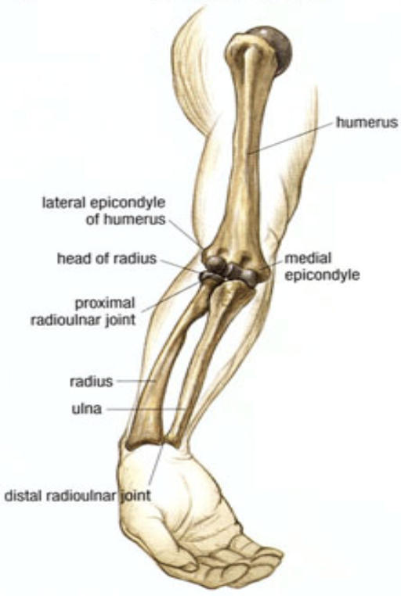

### Exam Pearls

* Rapid elbow/forearm neurovascular exam:
  + **Brachial artery:** Brachial + radial pulses, perfusion check
  + **Median nerve:** Sensation over palmar side of digits 1-3
  + **Anterior interosseous nerve** (motor-only branch of median nerve): “OK” sign 👌, grip strength
  + **Radial nerve:** Wrist extension, thumbs-up sign 👍
  + **Ulnar nerve:** Spread fingers against resistance

### Supracondylar Fracture

#### Description/Mechanism

Usually fall on outstretched hand (FOOSH) with elbow hyperextension

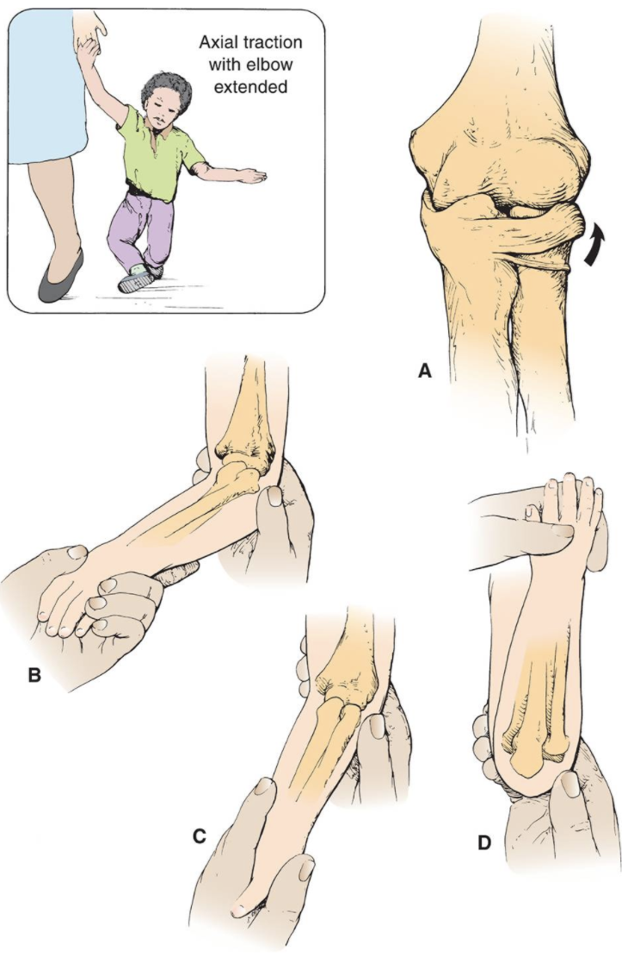

#### Diagnosis

* **Exam:** Gross deformity, limited active elbow motion
* **Imaging:** AP + lateral XR. Findings may be subtle (posterior fat pad sign on lateral film)

#### Management

* Ortho consult
* Usually surgical fixation for displaced fractures

### Nursemaid’s Elbow (Subluxation of Radial Head)

#### Description/Mechanism

Traction on arm with extended elbow (e.g. swinging child through the air)

#### Diagnosis

* **Exam:** No deformity, elbow held in passive pronation with slight flexion, refusing to use arm
* **Imaging:** Unnecessary unless suspect fracture based on H&P, or if reduction unsuccessful

#### Management

Stabilize elbow w/ one hand → supinate forearm and flex elbow (will usually feel/hear click)

### Distal Radius Fracture

#### Description/Mechanism

* FOOSH
* **Most common pediatric fracture**

#### Diagnosis

* **Exam:** Pain, ecchymosis, swelling
* **Imaging:** AP + lateral XR of wrist and forearm; consider AP + lateral of elbow if tender or if diaphyseal fractures present

#### Management

* Ortho consult
* Depending on severity, may require anything from immobilization to ORIF

## Upper Extremity: Shoulder

### Anatomy

* **Rotator cuff** muscles (mnemonic: **SITS** → **AEEI**)
  + **S**upraspinatus → **A**bduction
  + **I**nfraspinatus and **T**eres Minor → **E**xternal rotation x2
  + **S**ubscapularis → **I**nternal rotation

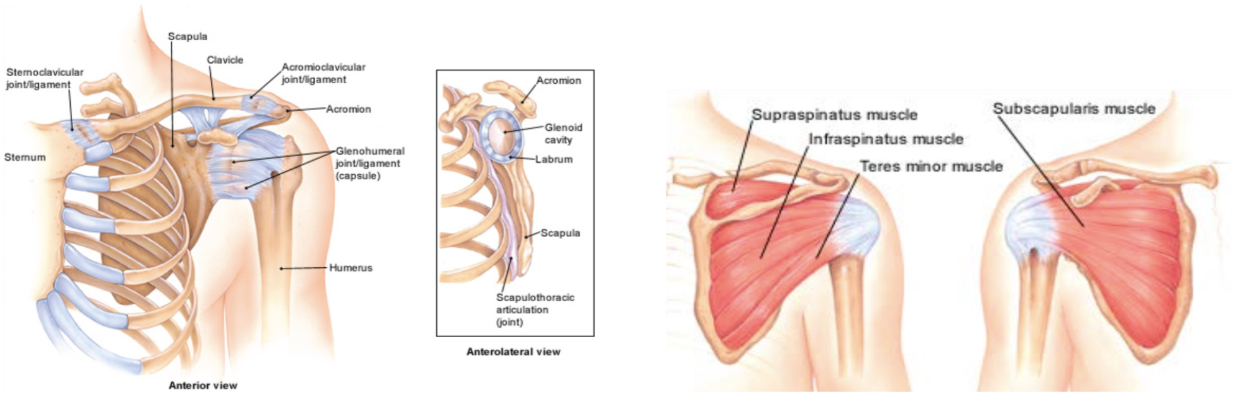

### Exam Pearls & Special Tests

* **Empty can test:** Strength in internal rotation/thumb down position. Tests **supraspinatus**.
* **Scarf test:** Pain w/ cross arm adduction. Tests **AC joint**.
* **Lift-off test:** Strength in lifting dorsum of hand off back. Tests **subscapularis**.
* **Impingement test:** Pain w/ passive internal rotation/forward flexion. Tests **subacromial impingement**.

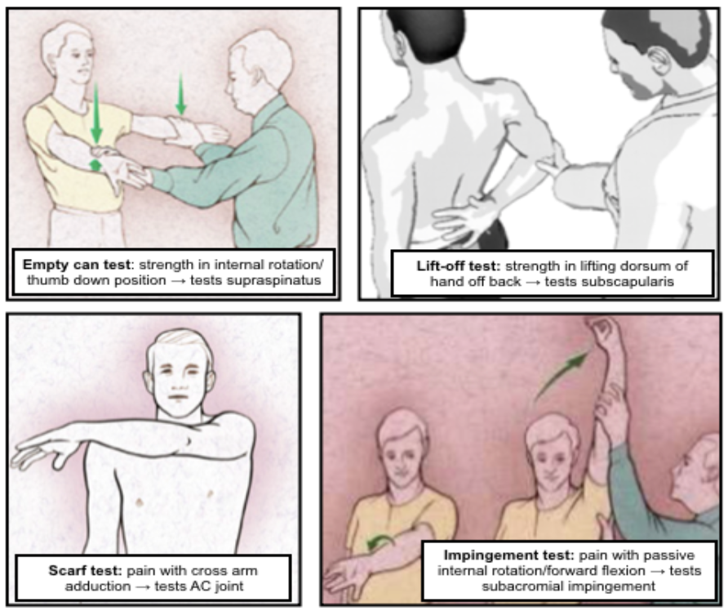

#### Common Associations

* **Scapular winging** i/s/o recent trauma or viral illness → likely serratus anterior or trapezius dysfunction
* Inability to passively/actively rotate affected arm externally s/p seizure → likely posterior shoulder dislocation
* **Supraspinatus/infraspinatus wasting** → likely rotator cuff tear or suprascapular nerve entrapment
* Decreased cervical ROM w/ pain radiating below elbow → likely cervical disc disease
* Shoulder pain in a throwing athlete w/ anterior glenohumeral joint pain/impingement → likely glenohumeral joint instability
* Pain or “clunking” sound w/ overhead motion → likely labral disorder

### Proximal Humeral Fracture

#### Description/Mechanism

* FOOSH
* Direct blow to lateral shoulder

#### Signs & Symptoms

History of trauma, severe shoulder pain, pain w/ arm movement

#### Diagnosis

* **Exam:** tenderness, swelling, shoulder asymmetry, arm shortened and held in extension
* **Imaging:** AP + axillary XR of humerus
  + Also get scapular “Y” view if concerned for shoulder injury
  + Suspect Salter-Harris I if negative XR + tenderness at physis

#### Management

* Immobilization
* Likely Ortho consult, esp. if more severe (a/w shoulder dislocation, neurovascular compromise, etc.)

### Dislocation

#### Description/Mechanism

* Majority of dislocations are **anterior**
* Blow to abducted/externally rotated/extended arm
* FOOSH
* Forceful forward swinging of arm

#### Diagnosis

* **Exam:** Arm abducted and externally rotated w/ resistance to all movement, loss of rounded appearance of shoulder. Evaluate for sensory loss over lateral deltoid (2/2 axillary nerve dysfunction).
* **Imaging:** AP + scapular “Y” + axillary XR to confirm dx and exclude fractures (can be repeated post-reduction if unsure of success)

#### Management

Reduction (variety of techniques exist) → immobilization and referral to Sports Med/Ortho for prevention of recurrent dislocation

### Rotator Cuff Injury

#### Description/Mechanism

* Includes **impingement** (inflammation & pinching of rotator cuff tendons) and rotator cuff **tears**
  + Impingement very common, tears very uncommon in youth athletes
* Overuse or acute injury, usually involving throwing or overhead activities

#### Signs & Symptoms

Pain in upper arm, worse w/ overhead activity or lying on affected side

#### Diagnosis

* **Exam:** Pain/weakness w/ testing of rotator cuff muscles; positive empty can, lift off, Hawkins, and/or impingement tests (see above)
* **Imaging:** XR only if bony pathology suspected; MRI best

#### Management

* Can start w/ conservative management (NSAIDs, PT)
* Chronic, symptomatic tears → consider surgical intervention

### Little Leage Shoulder (Proximal Humeral Epiphysiolysis)

#### Description/Mechanism

* Overuse injury from throwing causing microfractures in humeral epiphysis
* Most common in **11-16yo** athletes

#### Signs & Symptoms

Progressive shoulder pain w/ throwing, localized to proximal humerus, usually lateral

#### Diagnosis

* **Exam:** TTP at proximal lateral humerus over deltoid
* **Imaging:** AP XR of both arms in external and internal rotation; can get MRI if dx unclear

#### Management

* Rest x3 mos (minimum) + PT, then gradual progression to throwing
* Can still bat and play positions that do not require a lot of throwing

### Acromioclavicular (AC) Joint Injury

#### Description/Mechanism

* Ranges from sprain of AC ligaments to full ligamentous rupture w/ clavicular displacement
* Usually fall onto or direct blow to shoulder

#### Diagnosis

* **Exam:** Tenderness, swelling, asymmetry at AC joint, prominent distal clavicle; + scarf test
* **Imaging:** XR (abnormal in more severe injury, may be normal if joint space not widened)

#### Management

* Less severe injury (no separation of joint capsule) → sling 1-2 wks, ice, NSAIDs → early motion as able, including flexion/extension at elbow
* More severe injury → likely surgical intervention

### Clavicular Fracture

#### Description/Mechanism

Classified by location: most common is **midshaft fracture** > distal third > proximal third

#### Diagnosis

* Exam: Arm held adducted close to body, often supported w/ opposite hand; point tenderness, crepitus
  + **Neurovascular** and **respiratory** exam **crucial** due to risk of brachial plexus and lung injury
* Imaging: XR

#### Management

* Most heal well w/ sling, but indications for surgery are controversial
* Any sign of neurovascular compromise → acute reduction needed

## Lower Extremity: Hip

### Anatomy

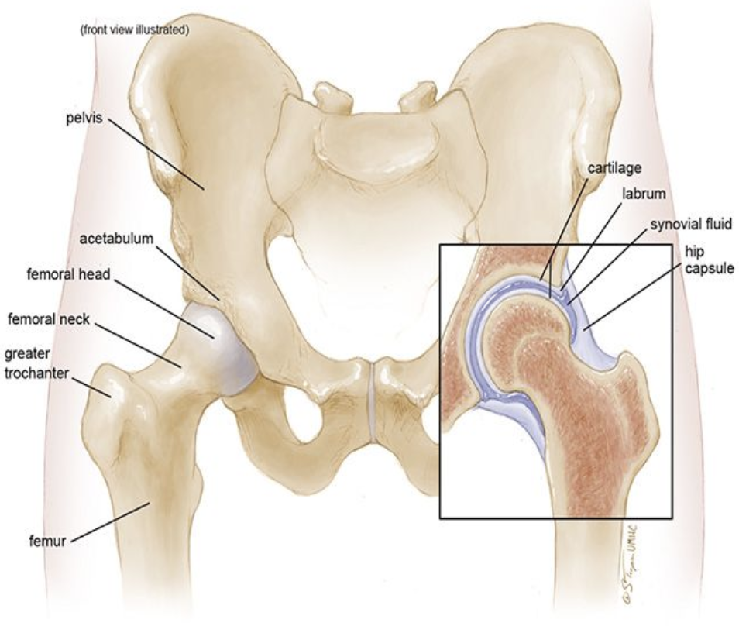

### Exam Pearls & Special Tests

* Hip pain can refer to groin, thigh, or knee, or can present as limp/refusal to walk w/o complaint of pain
  + Pain from intra-articular pathology often localizes to groin
* **Barlow/Ortolani:** Remember to apply gentle anterior pressure to the trochanter during abduction (Ortolani test)
* **Trendelenburg test:** Positive when patient stands on one leg and the contralateral hip drops, indicative of gluteals/hip abductor weakness
* **FABER** (Flexion, Abduction, External Rotation): Test for hip or SI joint pathology
* **FADIR** (Flexion, Adduction, Internal Rotation): Test for hip impingement
* **Log roll test:** Patient on back w/ leg fully extended and relaxed, examiner passively rotates leg and hip internally and externally. Pain should yield high suspicion for intra-articular pathology.

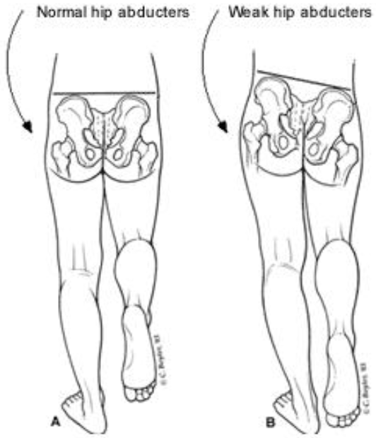

### Legg-Calve-Parthes Disease

#### Description/Mechanism

* Avascular necrosis (AVN) of the hip
* Most common age **5-7yo, M > F,** bilateral in 10-20%

#### Signs & Symptoms

Activity-related hip pain and/or limp (acute or chronic)

#### Diagnosis

* **Exam:** Trendelenburg gait, decreased hip abduction and internal rotation
* **Imaging:** XR often normal early in course, bone scan or MRI more suggestive of dx

#### Management

* Non-weight bearing and restoration of motion (crutches), NSAIDS, PT, aquatherapy
* Severe cases may require spica casting or surgery

### Slipped Capital Femoral Epiphysis (SCFE)

#### Description/Mechanism

* Displacement of the capital femoral epiphysis from the femoral neck through the physeal plate
* Commonly ages **10-16yo, M > F,** bilateral in 20-40%

#### Signs & Symptoms

Groin pain, knee pain, limp

#### Diagnosis

* **Exam:** Decreased hip ROM, hip externally rotated at rest, leg length discrepancy
* **Imaging:** AP + frog leg lateral hip XR. Look for “ice cream scoop falling off the cone, S-sign (frog leg) + Klein’s Line (AP) for subtle cases.

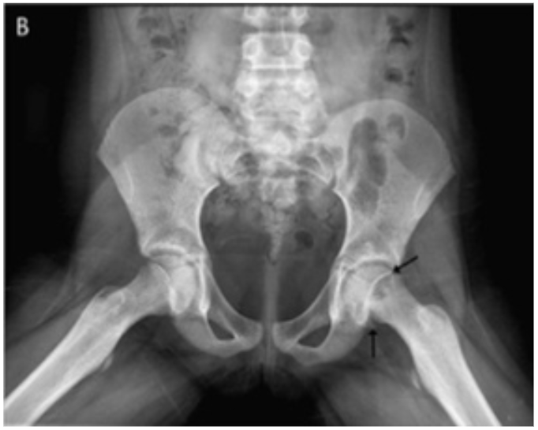

### Developmental Dysplasia of the Hip (DDH)

#### Description/Mechanism

* Abnormal development of shallow acetabulum causing hip joint instability
* **F > M**

#### Diagnosis

* **Exam:** Positive Barlow/Ortolani (only reliable in ages **<3mo**). Limitation of hip abduction or positive Galeazzi (asymmetric knee heights when hips & knees flexed) in ages **>3mo**.
* **Imaging:** US until age 4-6mos, AP XR pelvis w/ hip in 20-30 degree flexion after age 4-6mos

#### Management

* Ortho referral
* Depending on age at diagnosis/referral and severity, may be treated w/ anything from observation to harness to operative management

### Femoroacetabular Impingement (FAI)

#### Description/Mechanism

* Trapping of femoral neck against anterior acetabulum
* Acetabular overcoverage (Pincer impingement) vs decreased head-neck offset (CAM impingement) vs both
* Common in athletes
* Difficult to differentiate from hip flexor tendinitis

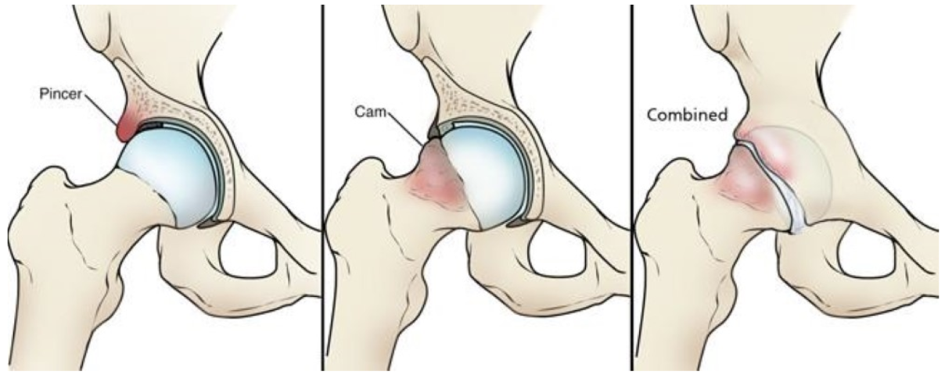

#### Diagnosis

* **Exam:** Pain on hip flexion passively or against resistance, impact/running, deep flexion; pain is usually anterior or into groin.
* **Imaging:** XR AP Pelvis and Dunn laterals bilaterally
  + Can have skeletal setup and still not be their pain cause

#### Management

Safe to start with PT unless having mechanical/catch/lock symptoms or difficulty weight bearing (in which case, refer to Sports Med/Ortho)

## Lower Extremity: Knee

### Anatomy

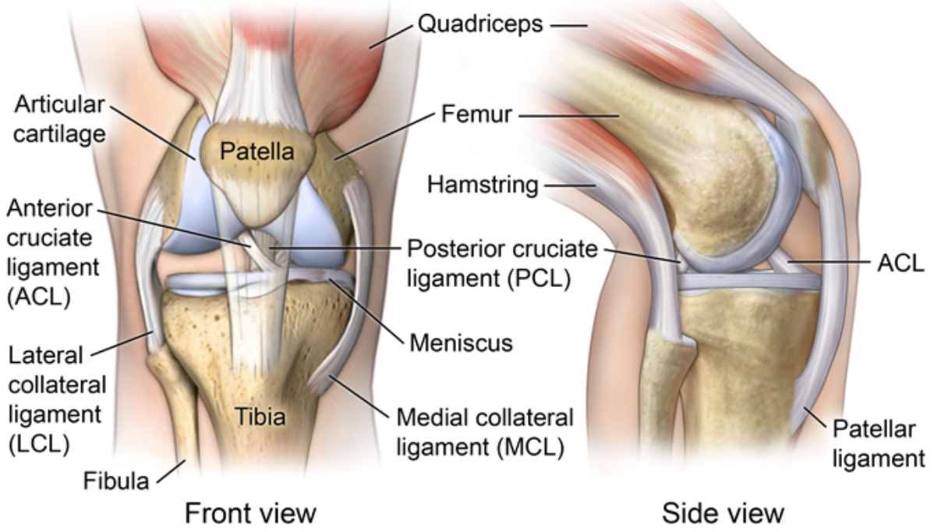

### Exam Pearls & Special Tests

* **Ober test:** Positive if superior leg doesn’t drop towards table when released. Tests **IT band**.
* **Anterior drawer test:** Anterior translation (keep foot stabilized) compared to contralateral knee. Tests **ACL**.
* **Valgus/varus stress test:** Laxity/pain w/ valgus/varus at 0° and 30°. Tests **MCL/LCL** (respectively).
* **McMurray test:** Pain/click w/ knee extension w/ tibia internally/externally rotated. Tests **lateral/medial meniscus** (respectively).

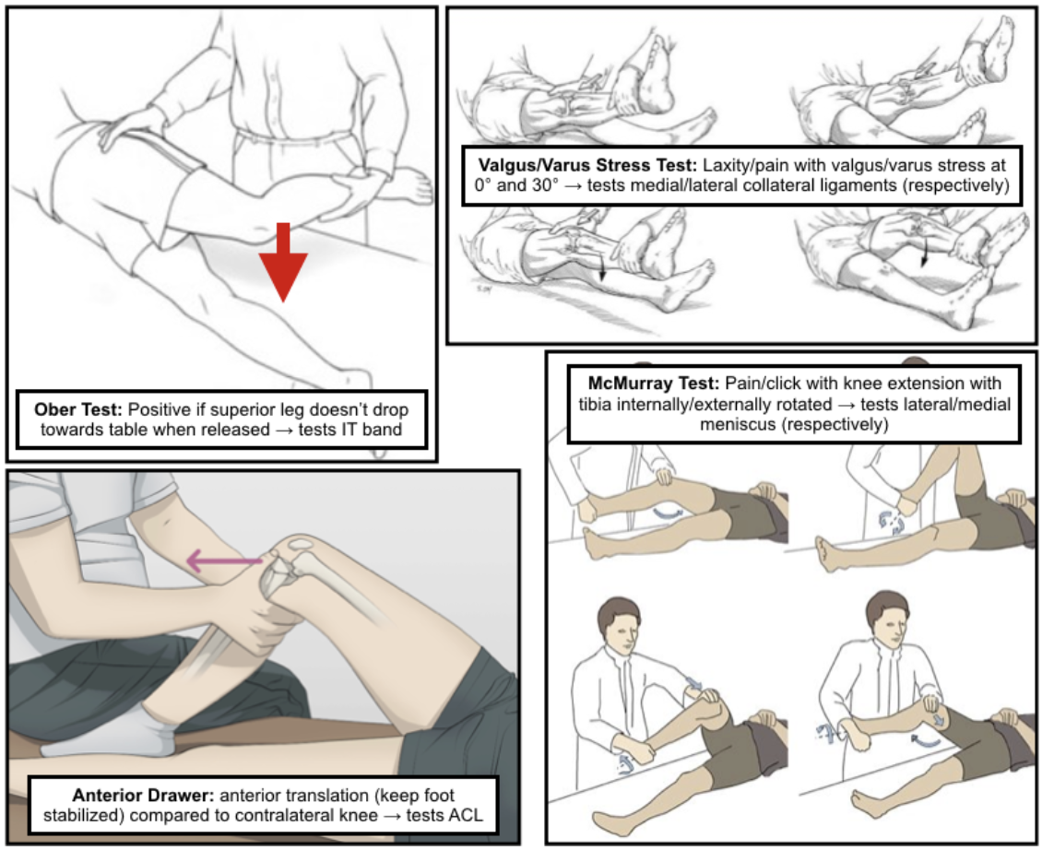

### Osgood-Schlatter Disease

#### Description/Mechanism

* Traction apophysitis of tibial tubercle at patellar tendon insertion
* Often children who play jumping sports and/or are undergoing rapid growth spurt
* Corollary process at inferior patellar pole = **Sinding-Larsen-Johansson Syndrome**

#### Signs & Symptoms

* Gradually worsening anterior knee pain, exacerbated by kneeling, jumping, stairs, walking uphill
* Can be asymmetric or bilateral
* Pain relieved by rest

#### Diagnosis

* **Exam:** Prominence of and TTP at the tibial tubercle, pain w/ resisted knee extension or squatting
* **Imaging:** Not routinely indicated unless to rule out other dx

#### Management

* Usually conservative: Pain management, PT for strengthening
* Continuation of activity, as long as not prolonged squatting/kneeling (e.g. playing)

### Patellofemoral Pain Syndrome (PFPS)

#### Description/Mechanism

Abnormal tracking of patella causes anterior knee pain w/o intra-articular pathology

#### Signs & Symptoms

* Anterior knee pain worsened w/ prolonged sitting (theater sign) or descending stairs
* Pain w/ running/impact activity (aka Runner’s knee)

#### Diagnosis

* **Exam:** Positive J-sign (lateral patellar tracking during terminal knee extension), positive patella mobility test (medial glide < ¼ or > ¾ patella width suggesting hypo- or hypermobility)
* **Imaging:** Not routinely indicated unless to exclude other dx

#### Management

* Conservative treatment, PT for strengthening
* Avoid long-term NSAID use

### Anterior Cruciate Ligament (ACL) Injuries

#### Description/Mechanism

* Cutting/pivoting motion causing valgus stress on knee, can be due to direct blow causing hyperextension/valgus deformation
* Medial meniscus and MCL often injured at same time (**Unhappy Triad**)

#### Signs & Symptoms

“Pop” at time of injury, swelling, feeling of knee “giving out”

#### Diagnosis

* **Exam:** Joint effusion, positive anterior drawer test
* **Imaging:** MRI > XR, but can get XR to evaluate for associated injury/fracture

#### Management

* Ortho/Sports Med referral
* Operative management in majority of cases, ideally w/ period of pre-operative rehabilitation to optimize outcomes

### Meniscus Injuries

#### Description/Mechanism

* Direction change w/ knee rotation, planted foot, and flexed knee
* Commonly in sports w/ lots of deceleration and direction change

#### Signs & Symptoms

* Often insidious onset of pain/swelling in 24h after injury
* Pain worse w/ twisting/pivoting
* Can have locking/popping/catching sensation

#### Diagnosis

* **Exam:** Joint line tenderness, inability to fully extend/squat/kneel, positive McMurray test
* **Imaging:** MRI > XR (plain films often negative)

#### Management

* Ortho/Sports Med referral
* Management varies from conservative to operative (usually arthroscopic)

### Iliotibial (IT) Band Syndrome

#### Description/Mechanism

Tight IT band sliding over lateral femoral epicondyle

#### Signs & Symptoms

Diffuse lateral knee pain, worsened w/ activity or w/ prolonged sitting w/ knee in flexed position

#### Diagnosis

* **Exam:** TTP in lateral knee, positive Ober test
* **Imaging:** Not routinely indicated

#### Management

* Activity modification
* NSAIDs
* Stretching/strengthening regimen

### Osteochondritis Dissecans

#### Description/Mechanism

* Acquired subchondral bone lesion which can progress to involve cartilage causing separation from underlying bone; most common in knee
* Mechanism unknown; proposed to be due to repetitive trauma vs. inflammation
* Can lead to **osteoarthritis** if not recognized/treated

#### Signs & Symptoms

* May be incidental finding on imaging vs. non-specific activity related knee pain
* May have swelling or symptoms of catching/locking if lesions are unstable

#### Diagnosis

* **Exam:** No specific findings
* **Imaging:** 4-view XR (AP, lateral, sunrise, tunnel) of knee, MRI to further delineate known OCD lesion and determine management (or if XR negative but high clinical suspicion)

#### Management

* Referral to Ortho/Sports Med
* May be treated conservatively (non-weight-bearing or activity limitation) vs. operatively (if lesions are unstable or unresponsive to conservative treatment)

## Lower Extremity: Ankle/Foot

### Anatomy

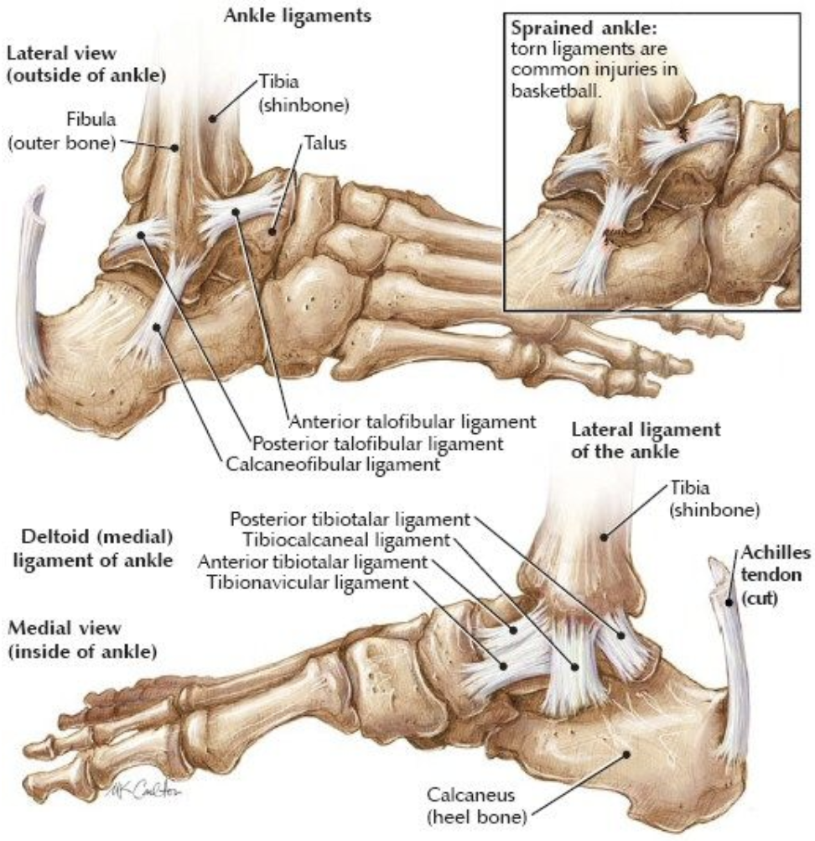

### Exam Pearls & Special Tests

* **Mid-calf squeeze:** Positive if generates pain in ankle. Tests **tibiofibular syndesmosis**.
* **Anterior drawer test:** Anterior translation comapred to contralateral ankle. Tests **ATFL**.
* **Talar tilt:** Range of inversion compared to contralateral ankle. Tests **CFL**.
* **Ottawa ankle rules** (when to get XR of ankle/foot, validated for >18yo):
  + **Ankle:** Pain in malleolar zone + EITHER of:
    - Bony tenderness at posterior edge of lateral/medial malleolus
    - Inability to bear weight both immediately after injury + at time of exam
  + **Foot:** Pain in midfoot zone + EITHER of:
    - Bony tenderness at base of 5th metatarsal or navicular bone
    - Inability to bear weight both immediately after injury + at time of exam

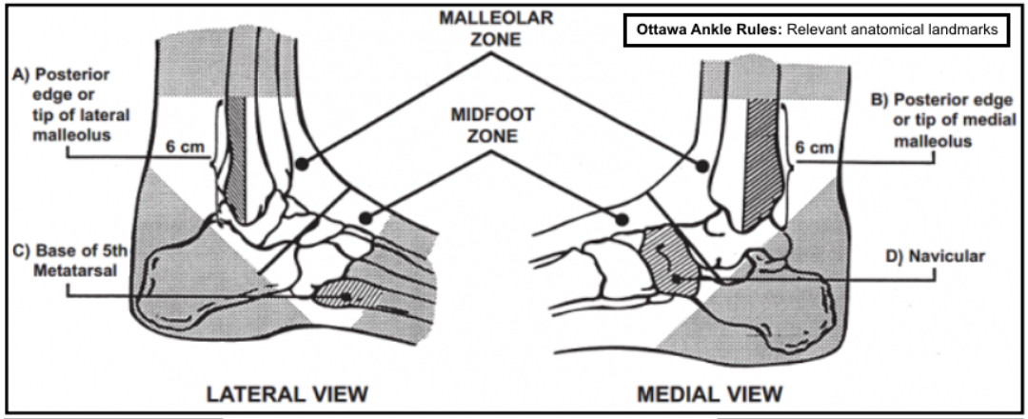 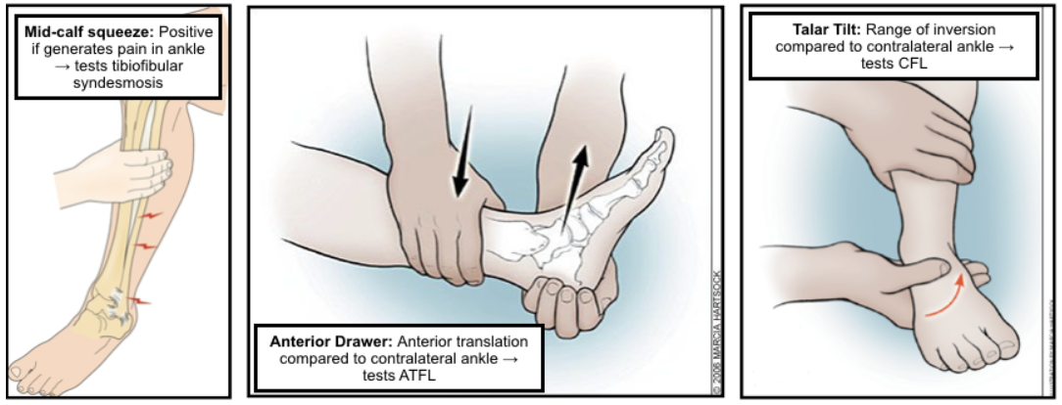

### Ankle Sprain

#### Description/Mechanism

* Ligamentous stretching/tearing
* **Lateral:** Inversion of plantar-flexed foot; injuries **ATFL** most commonly
* **Medial:** Eversion or abduction/ external

#### Signs & Symptoms

Pain, swelling (diffuse or localized), +/- inability to bear weight

#### Diagnosis

* **Exam:** Swelling, TTP, positive anterior drawer/talar tilt (lateral sprain), positive mid-calf squeeze (high sprain), squeeze test for syndesmotic injury
* **Imaging:** Not routinely indicated unless concern for fracture (see Ottawa rules above) or clinical uncertainty

#### Management

* Short period of complete immobilization (longer depending on severity), supportive device (lace-up brace or elastic bandage)
* ROM/strength exercises (can be w/ formal PT, esp. in case of recurrent ankle sprains) are critical to restoring function and proprioception
* For HIGH ankle sprains, consult Ortho/Sports Med (may need acute surgical stabilization if severe)

### Sever’s Disease

#### Description/Mechanism

* Traction apophysitis of calcaneal growth plate at site of Achilles insertion; often children who play sports w/ jumping/heel striking and/or are undergoing rapid growth spurt
* Essentially Osgood-Schlatter at the calcaneus

#### Signs & Symptoms

Chronic heel pain w/ insidious onset, worse w/ activity or wearing non-supportive footwear

#### Diagnosis

* Exam: TTP at calcaneal apophysis or w/ “calcaneal compression test”
* Imaging: Not routinely indicated unless diagnosis unclear or to rule out fracture

#### Management

Painful activity → gradual return to play, use of heel cup for support, ice and stretching

### Spiral/Oblique Fracture

#### Description/Mechanism

* **“Toddler’s fracture”** in 9mo-3yo
* Rotation around fixed foot → distal tibial fracture; often minimal trauma in toddlers, higher impact injury in older children
* ~30% of tibial fractures have associated fibular fracture
* Spiral fractures in **NON-ambulatory** child → concern for **NAT**

#### Signs & Symptoms

Limp, refusal to bear weight

#### Diagnosis

* **Exam:** Point tenderness over distal ⅓ of tibia
* **Imaging:** AP + lateral XR of the tibia and fibula; fractures may be occult (not seen on imaging)

#### Management

* Immobilization in long leg posterior splint/cast
* Ortho referral

### Congenital Clubfoot

#### Description/Mechanism

* Idiopathic vs. due to intrinsic (e.g. neurologic) or extrinsic (e.g. fibroids) factors
* 1:1000 live births, **M > F**

#### Diagnosis

* **Exam:** Fixed (e.g. not correctable) deformity of the foot w/ plantar flexion and inversion + rotation, calf atrophy
* **Imaging:** Usually dx on prenatal US, XR minimally useful initially

#### Management

* Ortho referral (usually done in nursery prior to d/c)
* Serial casting → Achilles tenotomy → bracing

## Spine

### Anatomy

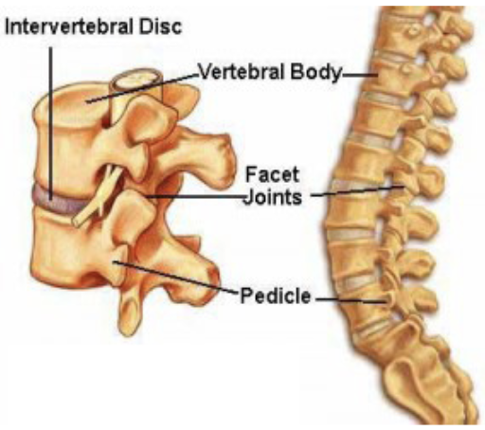

### Exam Pearls & Special Tests

* **Straight leg raise:** Patient lying supine → flex at hip w/ knee straight (best if cervical spine flexed and ankle dorsiflexed) → assess for sciatic pain (sign of herniated disc)

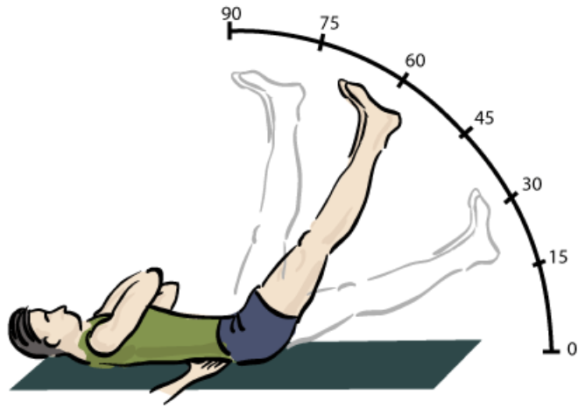

### Scoliosis

#### Description/Mechanism

* Lateral curvature of the spine *>* 10°
* Idiopathic (80%) vs. congenital vs. neuromuscular

#### Diagnosis

* **Exam:** Adam’s forward bend test + inclinometer. Shoulder/torso asymmetry, rib prominence, paraspinal muscle prominence.
* **Imaging:** XR w/ Cobb Angle *>* 10°

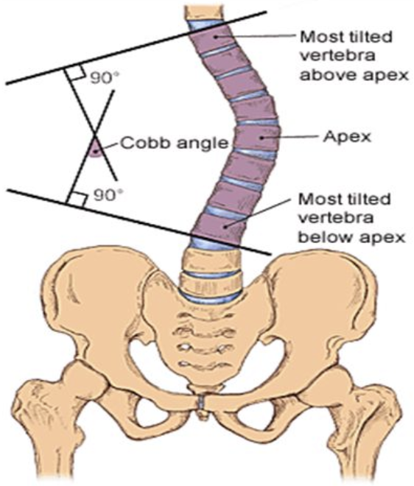

#### Management

* *<* 25° → observation
* 25-45° + skeletal immaturity → bracing
* 45° → consider surgical intervention

### Spondylolysis & Spondylolisthesis

#### Description/Mechanism

* **Spondylolysis:** Bony defect in pars interarticularis (usually L4 and L5)
* **Spondylolisthesis:** Displacement of vertebral body relative to inferior vertebral body
* Caused by repetitive microtrauma
* **Most common causes of back pain in children >10yo**; often in athletes engaged in sports w/ repetitive extension, flexion, and rotation

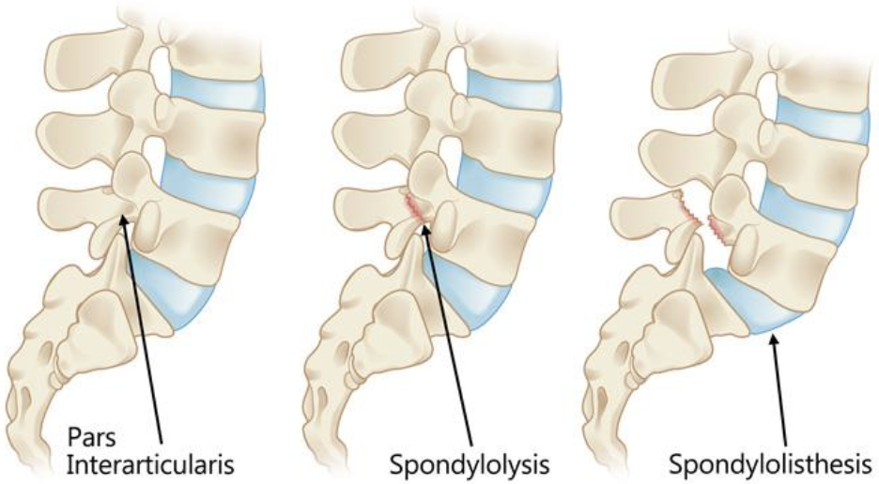

#### Signs & Symptoms

* Low back pain that worsens w/ activity, improves w/ rest
* **Spondylolisthesis:** May have radicular or cauda equina symptoms

#### Diagnosis

* **Imaging:**
  + MRI is now study of choice
  + XR: Poorly sensitive and do not assess acuity, but might be required prior to MRI
    - Standing AP, lateral, oblique views: Visualize defect
    - Flexion and extension views: Assess stability

#### Management

* **Spondylolysis** and **low-grade spondylolisthesis** → conservative (rest from sports for *>* 3 mos, NSAIDs, PT, back bracing)
* **Higher-grade spondylolisthesis** (or failure of conservative management) → consider surgical intervention

### Spondyloarthropathies

#### Signs & Symptoms

* Insidious onset
* Often misdiagnosed w/ recurrent strains/sprains
* Pain worse at night, improves w/ activity

## Head

### Mild Traumatic Brain Injury (TBI) (Concussion)

Including Graduated Return-to-Sport Program

\***See** ED chapter** for Mild TBI section*

# Toxicology

## Key Resources

* Poison Control: **1-800-222-1222**
* BCH Toxicology Fellow/Attending (on call 24/7)
* BCH Chemistry Fellow (daytime hours, can help interpret labs and select specialized testing)
* Hazmat Team: Boston Fire Department
* MSDS: Material Safety Data Sheets
* www.maripoisoncenter.com
* www.aapcc.org

## Approach to Poisoned Patient

### Stabilization

Airway, Breathing, Circulation, Disability, Drugs/D-Stick, Decontamination

### Physical Exam

**Vital signs** **Neuro**: MS, tone, clonus, abnormal movements **Eyes**: pupils, EOM, nystagmus **Mouth**: corrosive lesions, odors **CV**: rate, rhythm, perfusion **Resp**: rate, depth of respirations, air entry, wheeze **GI**: motility (?bowel sounds), corrosive effects (i.e. vomiting) **Skin**: color, bullae, burn, sweat, track marks

### History

* **AMPLE**: **A**llergies, **M**eds/Toxins (everyone in home), **P**ast medical history, **L**ast meal, **E**vents
* **Known toxin**: amount, time since ingestion, early sx, home tx
* **Concern for poisoning**: h/o pica or ingestions, meds in home, recent illnesses, visitors/events

### Basic Labs

Consider ABG, co-oximetry, CBC, D-stick, EKG, Chem, LFTs, serum OSM, UA, urine/serum tox

### Tox Screens

* Substances included, limits of detection vary hospital to hospital
* Urine drug screens rarely inform acute management decisions
* **Urine tox screens**: detect amphetamines, MDMA, barbiturates, benzos, cocaine, opioids, +/- THC
  + Qualitative (+/-)
  + Does not detect synthetic cathinones (i.e. “bath salts”); false + and false - (esp benzos, synthetic opioids) common
  + ADHD drugs: adderall → positive amphetamine
* Urine THC - must order separately at BMC
* Expanded opioid panel, urine (BMC): detects buprenorphine, oxycodone, methadone, fentanyl
* **Extended tox screen**: GC/MS, urine better than serum, send out test
* **Meconium tox**: amphetamines, THC, cocaine, opiates, PCP
* **Serum tox**: APAP, ASA, EtOH (quantitative),TCAs (qualitative) **Specific drug levels**: can request agents not on tox screens (digoxin, lithium, AEDs, iron, etc.)

### Management

* Can I decontaminate?
* Can I enhance the elimination of the toxin? (www.extrip-workgroup.org)
* Is there an antidote?
* How can I provide the best, targeted supportive care?

## Toxidromes

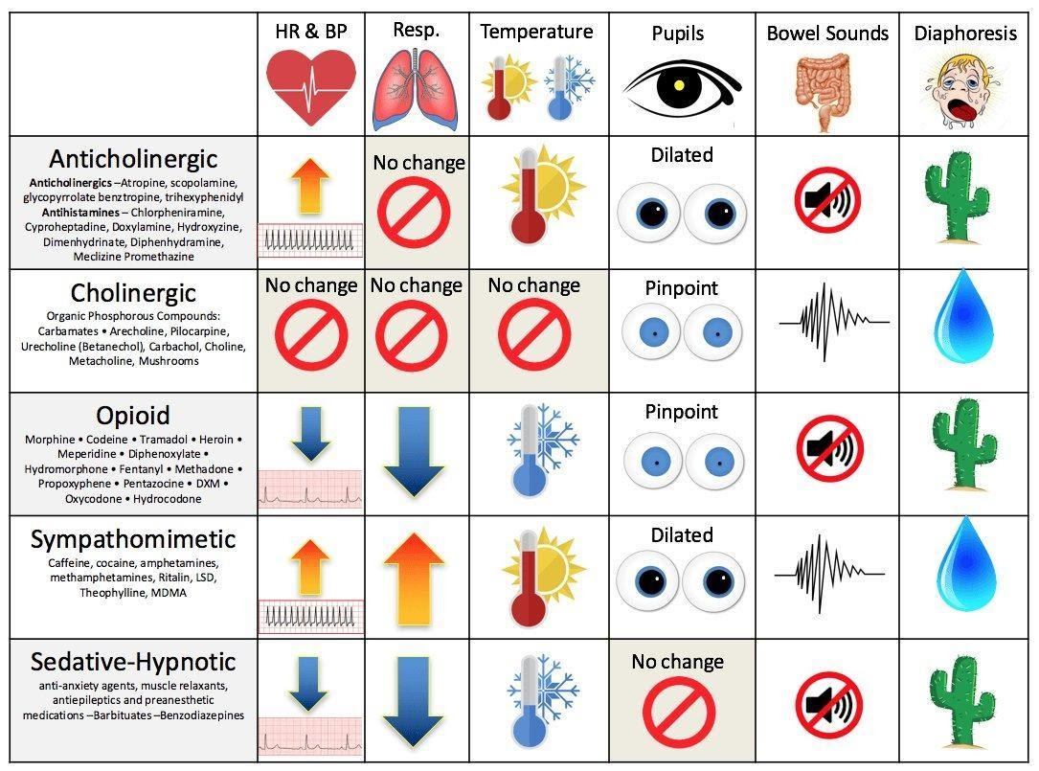

toxidromes_table

## Differential Diagnosis (non-exhaustive)

### Temperature

**Hyperthermia: NASA** - NMS, nicotine - Antihistamines, alcohol withdrawal, anesthetics - Salicylates, sympathomimetics, serotonin syndrome - Anti: -cholinergics, -depressants, -psychotics

**Hypothermia: COOLS** - Carbon monoxide - Opioids - Oral hypoglycemics - Liquor - Sedative-hypnotics

### Heart Rate

**Tachycardia: FAST** - Free base or other forms of cocaine - Anticholinergics, antihistamines, antipsychotics, amphetamines - Sympathomimetics - Theophylline, TCAs, thyroid hormones

**Bradycardia: PACED** - Propranolol (beta-blockers), poppies (opioids), physostigmine - Anticholinesterase drugs, antiarrhythmics - Clonidine, calcium channel blockers - Ethanol or other alcohols - Digoxin, digitalis

### Blood Pressure

**Hypertension: CT SCAN** - Cocaine - Thyroid supplements - Sympathomimetics - Caffeine - Anticholinergics, amphetamines - Nicotine

**Hypotension: CRASH** - Clonidine, calcium channel blockers - Rodenticides (containing arsenic, cyanide) - Antidepressants, aminophylline, antihypertensives - Sedative-hypnotics - Heroin (opioids)

### Respiratory Rate

**Tachypnea: PANT** - PCP - Aspirin and other salicylates, acute lung injury (hydrocarbons, vaping) - Noncardiogenic pulmonary edema - Toxin-induced metabolic acidosis

**Hypopnea: SLOW** - Sedative-hypnotics (benzodiazepines, barbiturates) - Liquor - Opioids - Weed

### Blood Glucose

**Hyperglycemia: CAPT ABC** - Corticosteroids - Antibiotics (quinolones) - Protease inhibitors - Thiazides - Atypical antipsychotics - Beta-agonists - Corticosteroids **Hypoglycemia: HOBBIES** - Hypoglycemics (oral) - Other (quinine, unripe ackee fruit) - Beta-blockers - Insulin - Ethanol - Salicylates (late)

## Acetaminophen Overdose

### Toxic Dose

200 mg/kg (7.5-10 g in older pts) as a single acute overdose

### Pathophysiology

Saturation of glucuronidation/sulfate conjugation pathway → ↑ metabolism via P450 pathway and depletion of glutathione → build up of toxic NAPQI → hepatotoxicity +/- renal toxicity

### Symptoms

See chart below

### Evaluation

Acetaminophen levels (at ≥ 4 hours post-ingestion, LFTs, coags, electrolytes, BUN/Cr, UA w/ tox screen (serum and urine), urine pregnancy for females

### Management

* Activated charcoal if w/i 1-2 hrs of ingestion and no contraindications (unprotected airway and decreased LOC)
* Goal: Initiate NAC ≤ 8 hours of ingestion (or ASAP if >8 hours post-ingestion)
* APAP level → apply NOMOGRAM → estimate risk of hepatotoxicity
* KEY POINT: NOMOGRAM can ONLY be used for: single acute ingestion, known time of ingestion, ingestion w/i 24hrs of presentation. Also, caution if coingestants that may affect GI motility
  + Risk of hepatotoxicity → give N-acetylcysteine
  + IV: loading dose of 150mg/kg over 1 hour, then 50 mg/kg over 4 hours, then 100 mg/kg over 16 hours; check APAP levels, LFTs, coags 2 hours before 16h infusion is scheduled to end
  + PO/NG: Loading dose 140mg/kg then 70mg/kg 14hrs x24 hours
  + Guidelines for stopping NAC: clinically well, improving LFTs, normalizing coags, APAP level <10 (if patient does not meet guidelines, continue NAC (100mg/kg IV over 16 hours) until they meet criteria.
* King’s College Criteria for Liver Transplant:
  + pH < 7.3 or
  + INR > 6.5 AND serum creatinine > 3.4mg/dL AND grade III - IV encephalopathy
  + West Haven Criteria for encephalopathy:
    - I: Changes in behavior with minimal change in level of consciousness
    - II: Gross disorientation, drowsiness, possible asterixis, behavior changes
    - III: Marked confusion, incoherent speech, sleepy but arousable to voice
    - IV: Comatose, unresponsive to pain, decorticate/decerebrate positioning

### Rule of 150

* Potentially toxic dose: 150mg/kg
* Treatment line: 150mcg/mL at 4 hours
* Loading dose of NAC 150mg/kg over one hour

**Acute APAP Toxicity: 4 stages** | | **Symptoms** | **Labs** | |—————————|—————————————————————————————————————————————————————–|————————————————-| | **Stage 1**: 0-24 hours | N/V, diaphoresis, malaise May be asymptomatic | Labs, PE generally normal | | **Stage 2**: 24-72 hours | Initial symptoms resolve RUQ pain, liver enlargement/tenderness | AST/ALT, ↑ PT/INR, renal dysfunction, ↑ amylase | | **Stage 3**: 72-96 hours | N/V, diaphoresis return - Jaundice, hepatic encephalopathy, hyperammonemia, bleeding, hypoglycemia, lactic acidosis - Renal failure, multi organ failure, death | LFTs peak | | **Stage 4**: 4-14 days | Recovery phase Slow normalization of symptoms and lab values (Symptoms typically normalize well before transaminases do) | Slow normalization |

## Aspirin Overdose

### Toxic Dose

150 mg/kg

### Pathophysiology

* Stimulates medullary respiratory center → ↑RR, hyperpnea, respiratory alkalosis
* Inhibits Kreb’s cycle enzymes → lactic acidosis, ketoacidosis
* Inhibits platelet function + vitamin-K dependent clotting factors → coagulopathy

### Symptoms

* Mild toxicity: GI upset, tinnitus and tachypnea
* Moderate toxicity: fever, diaphoresis, tachycardia, agitation, confusion
* Severe toxicity: coma, pulmonary edema, seizures

### Evaluation

Serum salicylate level (normal <30 mg/dL), ABG (primary respiratory alkalosis, primary anion-gap met acidosis), glucose (elevated - early, low - late), Electrolytes (hyper/hyponatremia, hypokalemia) +/- LFTs, CBC, coags, UA, serum/urine tox screen. Resulting acidosis and electrolyte changes MAY demonstrate EKG changes (ex. widened QRS, AV block, arrhythmias)

### Management

* GI decontamination: activated charcoal (consider repeat dose, prone to bezoar formation)
* Aggressive fluid resuscitation (lots of insensible losses)
* Urine alkalinization: goal URINE pH = 8, goal SERUM pH 7.45-7.55 to enhance ion trapping; can use D5 W150 mEq/L Na-bicarb
* Potassium repletion
* Follow salicylate levels q1-2 hours
* Hemodialysis (ASA level >90-100mg/dL (acute overdose), >60 mg/dL (chronic overdose), severe acidosis or electrolyte disturbances, renal failure, pulm edema, neurologic symptoms, deterioration despite interventions)

## Beta-Blocker Overdose

### Toxic Dose

“One pill can kill” in toddlers

### Pathophysiology

adrenergic antagonist → ↓ sympathetic outflow

### Symptoms

Bradycardia, hypotension, bronchospasm, coma, seizures, hypoglycemia

### Evaluation

DS (hypoglycemia), EKG (brady, AV block, accelerated junctional rhythm), serum/urine tox (in cases of suspected intentional ingestions)

### Management

* GI decontamination: activated charcoal (consider whole bowel irrigation) if indicated and no contraindications
* Glucagon bolus: 0.15 mg/kg then infusion of 0.05-0.1 mg/kg/hr (for symptomatic bradycardia)
* Fluids +/- pressors for hypotension
* Hyperinsulinemia/euglycemia (HIE) therapy: sometimes used in severe BB OD

## Calcium Channel Blocker Overdose

### Toxic Dose

“One pill can kill” in toddlers; individual drug selectivity for cardioactive vs vasoactive effects lost in significant overdose

### Pathophysiology

Block L-type Ca channel blockers (affect myocyte contractility, SA nodal AP initiation)

### Symptoms

Bradycardia, hypotension, coma, seizures, dihydropyridine CCBs (amlodipine, nifedipine, etc) can present w/ TACHYcardia and relative hypotension, HYPERglycemia

### Evaluation

DS (hyperglycemia), EKG (bradycardia, AV block, accelerated junctional rhythm, wide QRS, ST changes), serum/urine tox (in cases of suspected intentional ingestions)

### Management

* GI decontamination: activated charcoal (consider whole bowel irrigation) if indicated and no contraindications
* IV calcium chloride or calcium gluconate
* HIE (hyperinsulinemia/euglycemia) therapy: 1 unit/kg bolus of regular insulin then 0.5-1+unit/kg/hr infusion
* Intralipid 20%: 1.5ml/kg during 2-3 mins, followed by 0.25 ml/kg/min IV x 30-60 min (consult Tox)

## Antidepressants: SSRIs and SNRIs

### Toxicity

* SSRIs: less toxic than MAOIs or TCAs; most fatalities due to co-ingestion
* SNRIs: greater toxicity than SSRIs (but less than MAOIs or TCAs)

### Pathophysiology

Inhibit serotonin +/- norepinephrine reuptake (primarily in CNS)

### Symptoms

* Vomiting, CNS depression, tachycardia
* Serotonin syndrome: altered mental status, neuromuscular hyperexcitability (clonus, rigidity, hyperreflexia), autonomic instability (hyperthermia, tachy, HTN) → can lead to rhabdo, seizures, renal failure, DIC

### Evaluation

Electrolytes, serum/tox screen, EKG (↑QTc, rare ↑ QRS w/ some SNRIs); levels not helpful

### Management

* Decontamination and supportive care
* Benzos and/or serotonin antagonists (cyproheptadine) for serotonin syndrome, consider cooling and paralysis for severe serotonin syndrome

## Antidepressants: TCAs

### Toxic Dose

“One pill can kill” in toddlers

### Pathophysiology

Peripheral and central anticholinergic, peripheral alpha-1 adrenergic blockade, inhibits CNS NE and serotonin reuptake, blocks cardiac fast Na channels, blocks GABA receptors

### Symptoms

* Anticholinergic toxidrome (see toxidrome chart)
* Neurotoxicity (seizures, coma)
* Cardiovascular toxicity (arrhythmias, refractory hypotension, widened QRS)

### Evaluation

Electrolytes, CK, D-stick, urinalysis, tox screens, TCA level not useful (other than to confirm ingestion), EKG (prolonged QRS (>100ms a/w seizure, dysrhythmias), sinus tach, vent arrhythmias, lead aVR prominent R waves)

### Management

* Gastric decontamination, close monitoring, EKGs
* NaHCO3 titrated to serum pH 7.45-7.55 (indicated for QRS > 100ms w/ other signs of TCA toxicity, vent. arrhythmias, CV collapse, seizures). Mechanism: increase pH -> increase non-ionized TCA = cannot bind sodium channels. Also increases gradient across cardiac cell membranes -> attenuates TCA-induced blockade of rapid sodium channels.
* Supportive care (treat refractory hypotension w/ alpha-agonist pressors)
* For severe TCA overdoses, consider intralipid

## Antidepressants: Buproprion

### Toxic Dose

“One pill can kill” in toddlers

### Pathophysiology

Dopamine and NE reuptake inhibitor w/ some serotonin reuptake blockade; contraindicated in eating disorder patients given ↑ seizures

### Symptoms

Seizures, agitation, HTN, tachycardia, arrhythmias

### Evaluation

Levels not helpful, electrolytes, EKG (QRS and QTc prolongation). May cause +amphetamine screen

### Management

Supportive care, benzos for seizures, admit for >24 hours to monitor for late onset seizures if ingested Wellbutrin SR, ↑ QRS treated w/ IV sodium bicarb (though may not be as effective)

## Iron

### Toxic Dose

* < 20mg/kg **elemental iron** usually asymptomatic
* 20-60 mg/kg: variable response
* 60 mg/kg: greatest risk of serious toxicity (death reported at 60-300+ mg/kg)

### Pathophysiology

Direct caustic effect on GI mucosa → hemorrhagic necrosis; multisystem toxicity 2/2 mitochondrial poison; iron absorbed at duodenum/jejunum

### Symptoms

*If no significant GI symptoms w/i first 6 hrs after overdose, very low likelihood of significant toxicity*

|  |  |
| --- | --- |
| **Phase I (30min – 6h)** | **GI sx**: vomiting, diarrhea, GI bleeding |
| **Phase II (6h – 24h)** | Latent period: apparent improvement |
| **Phase III (4h-4days)** | **Hepatotoxicity**: hepatocellular injury, AG metabolic acidosis (↑ lactic acid), coma, seizures, multi-organ failure, shock **Labs**: ↑ bili, ↑ LFTs, ↑ glucose, ↑ PT/INR, ↑ BUN |
| **Phase IV (2-8 wks)** | **Late effects**: possible bowel obstruction secondary to strictures |

### Evaluation

KUB (radio-opaque pills), Fe level, VBG/ABG, lytes, BUN/Cr, glucose, LFTs, PT/INR, CK

### Management

Support ABC’s, replace fluid/blood losses, GI decontamination, IV deferoxamine (severe sx, iron level > 500 mcg/d w/ clinical symptoms, sig AG met acidosis)

## Lead

### Toxic Dose

No safe lead level exists

### Pathophysiology

Interferes w/ interactions of divalent cations and sulfhydryl groups leading to widespread physiologic effects and clinical toxicity

### Symptoms

* Lower levels: Abdominal pain, constipation, anorexia, vomiting, developmental delays, aggression, hyperactivity
* Higher levels: drowsiness, clumsiness, ataxia
* Severe levels: decreased consciousness, coma, seizures, death (usually 2/2 cerebral edema)

### Evaluation

Lead levels, CBC (microcytic anemia + basophilic stippling of RBC), FEP (free erythrocyte protoporphyrin), BUN/Cr, AST/ALT, x-ray (radiopaque flecks)

### Management

* CDC Child Lead Poisoning Program: <https://www.cdc.gov/nceh/lead/default.htm>
* See also BCH lead poisoning EBG
* Prevention is key: screening and lead levels at WCC (9-12 mo, 2 years)
* Gastric decontamination: whole bowel irrigation
* Chelation therapy (depending on lead levels)
* **Seminal Article**: CDC. Managing elevated blood lead levels among young children: Recommendations from the Advisory Committee on Childhood Lead Poisoning Prevention, Atlanta: CDC; 2002
* BCH has a separate Environmental Health clinic and service that can assist w/ management

## Drugs of Abuse

### Ethanol

#### Hx/PE

Euphoria, loss of coordination, ataxia, slurred speech, nystagmus, nausea, vomiting, hypoglycemia (especially in young children), seizures, coma, respiratory depression

#### Dx

Blood ethanol level, D-stick

#### Management

Supportive; secure airway if unresponsive, no gag reflex

### Marijuana

#### Hx/PE

Pupils unchanged, injected conjunctiva, tachycardia, increased appetite, euphoria, anxiety, time-space distortions, panic reaction, psychotic reaction; can cause ataxia and significant sedation in toddlers. Ask about routes of exposure (smoking, vaping, dabbing, edibles, etc.); edibles particularly problematic in young children.

#### Dx

Urine drug screen (note, synthetic cannabinoids not detected on standard urine toxicology screens

#### Management

Supportive care, can treat w/ anxiolytics if needed. Some young children may require airway protection due to degree of sedation.

### Stimulants (Amphetamines, Cocaine, Ecstasy/MDMA, “Bath Salts”)

#### Hx/PE

Tachycardia, hyperthermia, mydriasis, diaphoresis, restlessness, tremors, panic, agitations, psychosis, seizures

#### Dx

Urine drug screen; EKG (cocaine may cause QRS widening); troponin if chest pain; CK if concern for rhabdo; electrolytes (hyponatremia w/ MDMA)

#### Management

Supportive care including fluids, avoid beta blockers in HTN due to unrestrained alpha-agonism, benzos for agitation, HTN, and tachycardia

### Opioids

#### Hx/PE

Respiratory depression (hallmark), miosis, CNS depression, hypotension, hypothermia, pulmonary edema

#### Dx

Urine drug screen (extended screen available at BMC, typically done as send-out at BCH); EKG (methadone can cause QTc prolongation)

#### Management

Naloxone for severe respiratory/CNS depression, titrate dosing to severity of presentation (may precipitate withdrawal in chronic users); otherwise supportive

#### Notes

Opioids are one of the “one pill can kill” medications in toddlers

1. Lehman, et al., Transient focal neurologic symptoms correspond to regional cerebral hypoperfusion by MRI: A stroke mimic in children. American Journal of Neuroradiology. July 2017.
2. Jones, H. Guillain-Barre Syndrome: Perspectives w/ Infants and Children. Seminars in Pediatric Neurology June 2000.
3. Shahrizaila, N, and Yuki, N. Bickerstaff brainstem encephalitis and Fisher Syndrome: anti-GQ1B antibody syndrome. Journal of Neurology, Neurosurgery and Psychiatry 84(5). 2013.
4. Peragallo, J. Pediatric Myasthenia Gravis. Seminars in Pediatric Neurology. May 2017.
5. Lehman, et al., Transient focal neurologic symptoms correspond to regional cerebral hypoperfusion by MRI: A stroke mimic in children. American Journal of Neuroradiology. July 2017.
6. Lehman, et al., Transient focal neurologic symptoms correspond to regional cerebral hypoperfusion by MRI: A stroke mimic in children. American Journal of Neuroradiology. July 2017.
7. Lehman, et al., Transient focal neurologic symptoms correspond to regional cerebral hypoperfusion by MRI: A stroke mimic in children. American Journal of Neuroradiology. July 2017.
8. Lehman, et al., Transient focal neurologic symptoms correspond to regional cerebral hypoperfusion by MRI: A stroke mimic in children. American Journal of Neuroradiology. July 2017.
9. Lehman, et al., Transient focal neurologic symptoms correspond to regional cerebral hypoperfusion by MRI: A stroke mimic in children. American Journal of Neuroradiology. July 2017.
10. Jones, H. Guillain-Barre Syndrome: Perspectives w/ Infants and Children. Seminars in Pediatric Neurology June 2000.
11. Shahrizaila, N, and Yuki, N. Bickerstaff brainstem encephalitis and Fisher Syndrome: anti-GQ1B antibody syndrome. Journal of Neurology, Neurosurgery and Psychiatry 84(5). 2013.
12. Peragallo, J. Pediatric Myasthenia Gravis. Seminars in Pediatric Neurology. May 2017.
13. Ayers, T. et al. Acute Flaccid Myelitis in the United States: 2015-2017. Pediatrics. 2019;144(5) Epub 2019 Oct 7
14. Thompson et al., Infant Botulism in the age of botulism immune globulin. Neurology. June 2005.
15. Krupp et al. International Pediatric Multiple Sclerosis Study Group criteria for pediatric multiple sclerosis and immune-mediated central nervous system demyelinating disorders: revisions to the 2007 definitions. Multiple Sclerosis Journal. April 2013.
16. Lehman, et al., Transient focal neurologic symptoms correspond to regional cerebral hypoperfusion by MRI: A stroke mimic in children. American Journal of Neuroradiology. July 2017.
17. Jones, H. Guillain-Barre Syndrome: Perspectives w/ Infants and Children. Seminars in Pediatric Neurology June 2000.
18. Shahrizaila, N, and Yuki, N. Bickerstaff brainstem encephalitis and Fisher Syndrome: anti-GQ1B antibody syndrome. Journal of Neurology, Neurosurgery and Psychiatry 84(5). 2013.
19. Peragallo, J. Pediatric Myasthenia Gravis. Seminars in Pediatric Neurology. May 2017.
20. Ayers, T. et al. Acute Flaccid Myelitis in the United States: 2015-2017. Pediatrics. 2019;144(5) Epub 2019 Oct 7
21. Thompson et al., Infant Botulism in the age of botulism immune globulin. Neurology. June 2005.
22. Krupp et al. International Pediatric Multiple Sclerosis Study Group criteria for pediatric multiple sclerosis and immune-mediated central nervous system demyelinating disorders: revisions to the 2007 definitions. Multiple Sclerosis Journal. April 2013.
23. Krupp et al. International Pediatric Multiple Sclerosis Study Group criteria for pediatric multiple sclerosis and immune-mediated central nervous system demyelinating disorders: revisions to the 2007 definitions. Multiple Sclerosis Journal. April 2013.
24. Pidcock FS, et al. Acute transverse myelitis in childhood: center-based analysis of 47 cases. Neurology. 2007;68(18):1474.
25. Dalmau, J. Clinical experience and laboratory investigations in patients w/ anti NMDAR encephalitis. Lancet Neurology. January 2011.
26. Tremolizzo et al. Positive signs of functional weakness. J Neurological Sciences. March 2014.